KINGDOM OF ESWATINI
Ministry of Labour and Social Security
Measurement and Testing Unit

System Design Document
SDS Test System
Online Self-Directed Search Career Assessment Platform
Document Version | 1.1
Date | April 2026
Author | SDS Development Team
Client | Ministry of Labour and Social Security — Kingdom of Eswatini
Contact | Sibusiso Baartjies | sibusiso@datamatics.co.sz | 78026341
Classification | Confidential

This document is the property of the Ministry of Labour and Social Security of the Kingdom of Eswatini. It contains confidential technical design information restricted to authorized personnel only.

Table of Contents
1. System Overview
2. Architecture
3. Technology Stack
4. System Components
5. Data Model
6. API Design
7. Security Architecture
8. Authentication & Authorization
9. Frontend Architecture
10. Backend Architecture
11. Database Design
12. Integration Patterns
13. Performance Considerations
14. Scalability
15. Deployment Architecture
16. Monitoring & Logging
17. Error Handling
18. Testing Strategy
19. Data Migration Strategy
20. Compliance & Governance
21. Design Decisions & Rationale
22. Glossary
Appendix A: Use Case Diagrams
Appendix B: Sequence Diagrams
Appendix C: Activity Diagrams
Appendix D: State Machine Diagram
Appendix E: Component & Deployment Diagrams
Appendix F: Class & ER Diagrams
Appendix G: Algorithm & Infrastructure Diagrams
Appendix H: UI Wireframes
Appendix I: Approval of Signatures

1. System Overview

1.1 Purpose
The Online Self-Directed Search (SDS) Test System is a comprehensive career assessment platform for the Ministry of Labour and Social Security of the Kingdom of Eswatini. It implements Holland's RIASEC model to help individuals identify suitable career paths based on their interests, abilities, and personality traits.

1.2 Key Business Requirements
Career Assessment | Implement the complete SDS questionnaire with 228-question RIASEC scoring
User Management | Support multiple user types with role-based access control (49 permissions, 13 modules)
Institution Integration | Link with local educational institutions and employers
Reporting & Analytics | Comprehensive analytics for administrators and counsellors
Data Protection | Compliance with Eswatini Data Protection Act 2022 and GDPR principles
Multi-language Support | English and siSwati language support throughout
Accessibility | WCAG 2.1 AA compliance for inclusive access

1.3 Stakeholders
Stakeholder | Role
Test Takers | High school students, university students, professionals seeking career guidance
Test Administrators | School counsellors and career guidance professionals managing student assessments
System Administrators | Ministry IT staff managing platform configuration, security, and maintenance
Institutions | Educational institutions and employers connected to the platform
Ministry of Labour | Government oversight body, primary system owner, and policy maker

2. Architecture

2.1 High-Level Architecture
The SDS Test System follows a three-tier web application architecture. The system context diagram below shows all external actors and the platform's interactions with each:

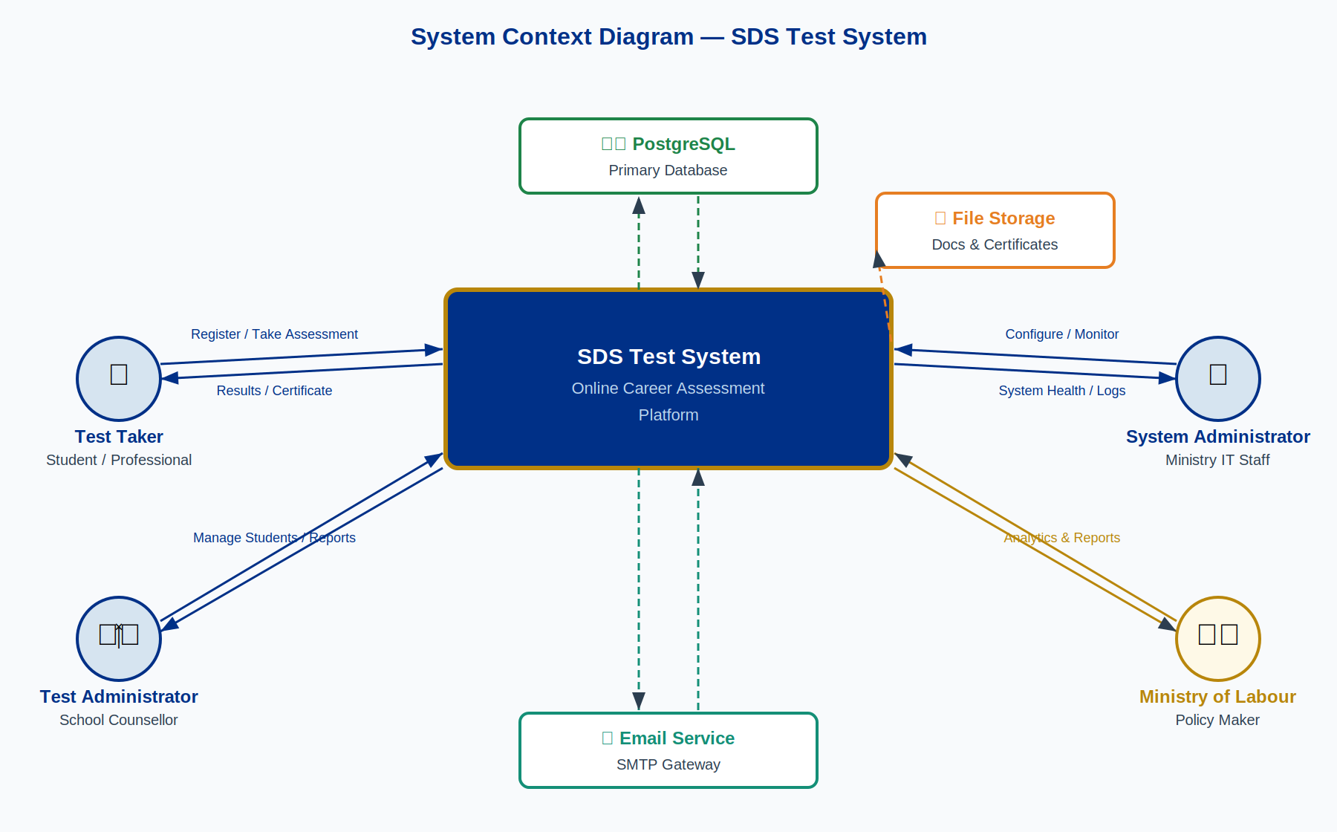
Figure 1: System Context Diagram — SDS Test System

2.2 Architectural Patterns
Pattern | Application in SDS
Model-View-Controller (MVC) | Backend follows MVC with an explicit service layer between controllers and models
Component-Based Architecture | React SPA built with Atomic Design (Atoms → Molecules → Organisms → Templates → Pages)
Repository Pattern | Data access abstracted via Sequalize ORM, isolating DB logic from business logic
Service Layer Pattern | Business logic separated into dedicated service classes away from HTTP controllers
Middleware Pattern | Express middleware chain handles cross-cutting concerns (auth, validation, rate limiting, logging)
Observer Pattern | Event-driven audit logging decoupled from core business operations via emitted domain events

2.3 Design Principles
Principle | Description
Separation of Concerns | Clear enforced boundaries between presentation, business logic, and data layers
Single Responsibility | Each component, service, and module has exactly one well-defined purpose
Dependency Inversion | High-level business modules do not depend directly on low-level infrastructure
Open/Closed Principle | System components are open for extension via configuration without modifying core code
Don't Repeat Yourself (DRY) | Shared utilities, reusable components, and centralized validation prevent code duplication

3. Technology Stack

3.1 Frontend Stack
Technology | Version | Purpose
React | 18 | SPA framework with hooks, concurrent rendering, and Suspense
React Router | v6 | Client-side routing with lazy loading and route-based code splitting
Tailwind CSS | 3+ | Utility-first CSS framework with Ministry design system tokens
Lucida React | — | Consistent icon library across all UI components
Axios | — | HTTP client with interceptors, token refresh, and retry logic
React Query | — | Server state management, background prefetching, and client-side cache
React Hook Form | — | Performant form handling with built-in validation
React PDF | — | Client-side PDF generation for certificate previews

3.2 Backend Stack
Technology | Version | Purpose
Node.js | 18+ | JavaScript runtime with ES2022 and built-in fetch API
Express.js | 4 | Lightweight web application framework with middleware support
Sequalize | 6 | ORM providing model definitions, migrations, and query abstraction
PostgreSQL | 14+ | Primary RDBMS with UUID primary keys and JSONB support
JWT | — | Stateless authentication via RS256-signed access and refresh tokens
bcrypt | — | Password hashing with 10-round salt
Winston | — | Structured JSON logging with configurable transports
Multer | — | Multipart form data and file upload handling with MIME validation
PDFKit | — | Server-side PDF generation for certificates and formal reports

3.3 Development & Quality Tools
Tool | Purpose
Jest | Unit and integration testing for both frontend and backend
Cypress | End-to-end automated browser testing for critical user journeys
ESLint + Prettier | Code quality enforcement across the entire codebase
Husky | Git pre-commit hooks ensuring linting and tests pass before any commit
Artillery | Load and performance testing — 500+ concurrent user simulation
nodemon | Development server with automatic restart on file changes

4. System Components

4.1 Component Overview
The component diagram below shows how the three major software packages (Frontend, Backend API, and External Services) interact through well-defined interfaces:

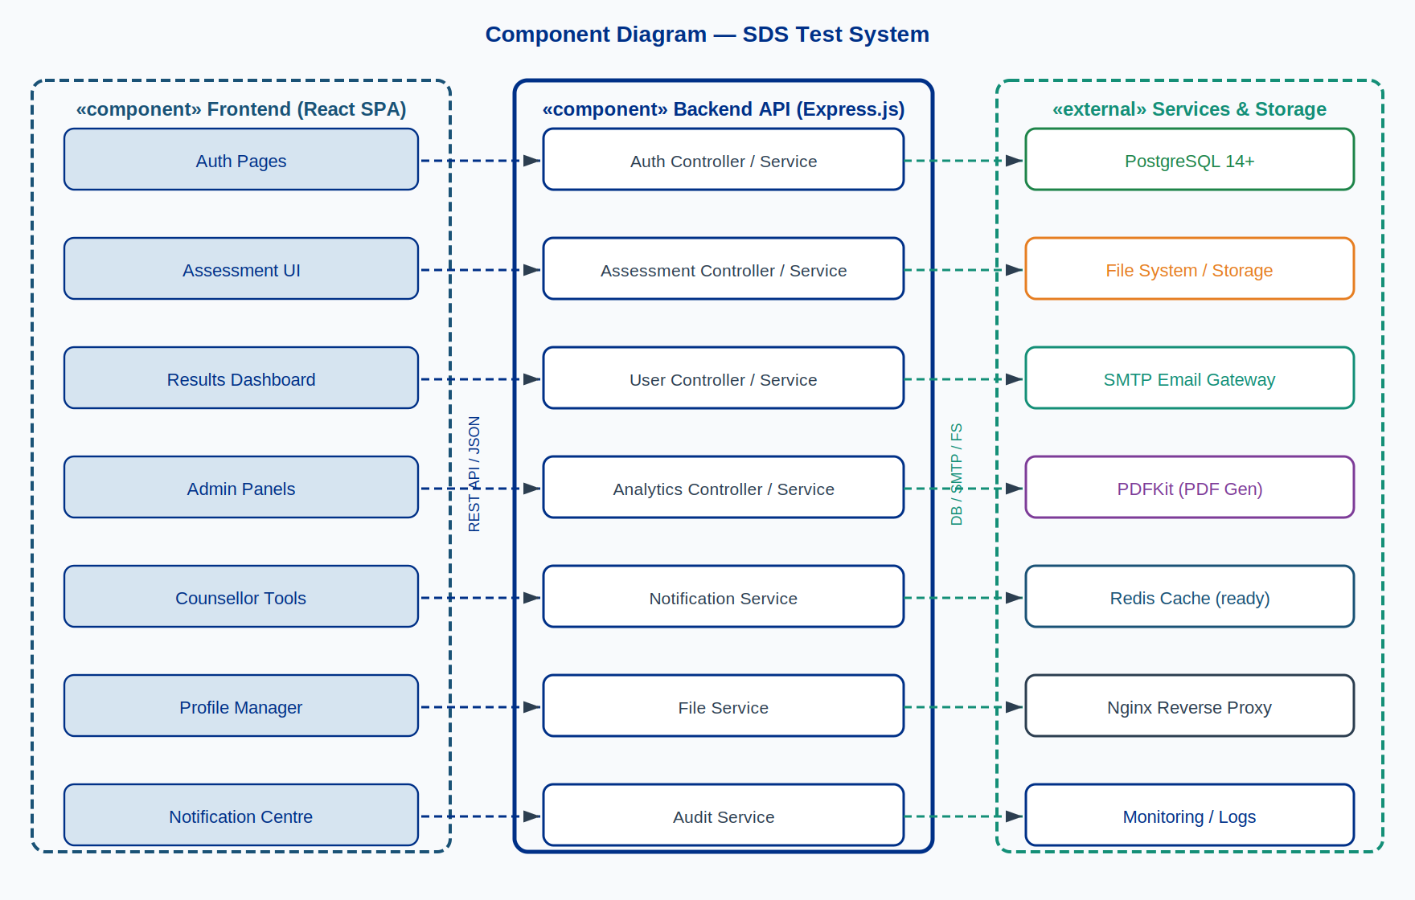
Figure 2: Component Diagram — SDS Test System

4.2 Frontend Structure
src/
├── components/ # Reusable UI components
│ ├── ui/ # Atoms: Button, Input, Modal, Badge
│ ├── layout/ # Organisms: Header, Sidebar, Footer
│ └── common/ # Shared business-level components
├── features/ # Feature-scoped component trees
│ ├── admin/ # System administration panels
│ ├── counselor/ # Test administrator / counsellor tools
│ ├── assessment/ # SDS assessment engine components
│ └── analytics/ # Reporting and analytics dashboards
├── pages/ # Route-level page components
├── services/ # Axios API service layer
├── hooks/ # Custom reusable React hooks
├── context/ # React context providers (Auth, Theme, i18n)
└── utils/ # Pure utility and helper functions

4.3 Backend Structure
src/
├── controllers/ # HTTP handlers: parse input, call service, format response
├── services/ # Business logic: orchestrate operations and transactions
├── models/ # Sequelize schemas, associations, query scopes
├── routes/ # Express route definitions with middleware chains
├── middleware/ # Auth, RBAC, validation, rate limiting, logging
├── utils/ # Shared helpers: date, encryption, file, pagination
├── validations/ # Joi input validation schemas per endpoint
└── templates/ # Handlebars email templates and PDFKit layouts

4.4 Core Backend Services
Service | Responsibilities
Authentication Service | JWT issuance/validation, refresh token rotation, bcrypt hashing, OTP management
Assessment Service | Session creation, question sequencing, answer persistence, RIASEC scoring, Holland code generation
User Service | User CRUD, profile updates, role assignment, bulk CSV import, privacy controls
Analytics Service | Data aggregation, report generation, dashboard metrics, export formatting
Notification Service | SMTP email dispatch, in-app notification creation, template rendering, delivery tracking
File Service | Upload handling, MIME validation, secure storage, document retrieval
Audit Service | Event capture, immutable log persistence, audit report generation

5. Data Model

5.1 Class Diagram
The class diagram below shows the core domain objects, their attributes, key methods, and the relationships between them:

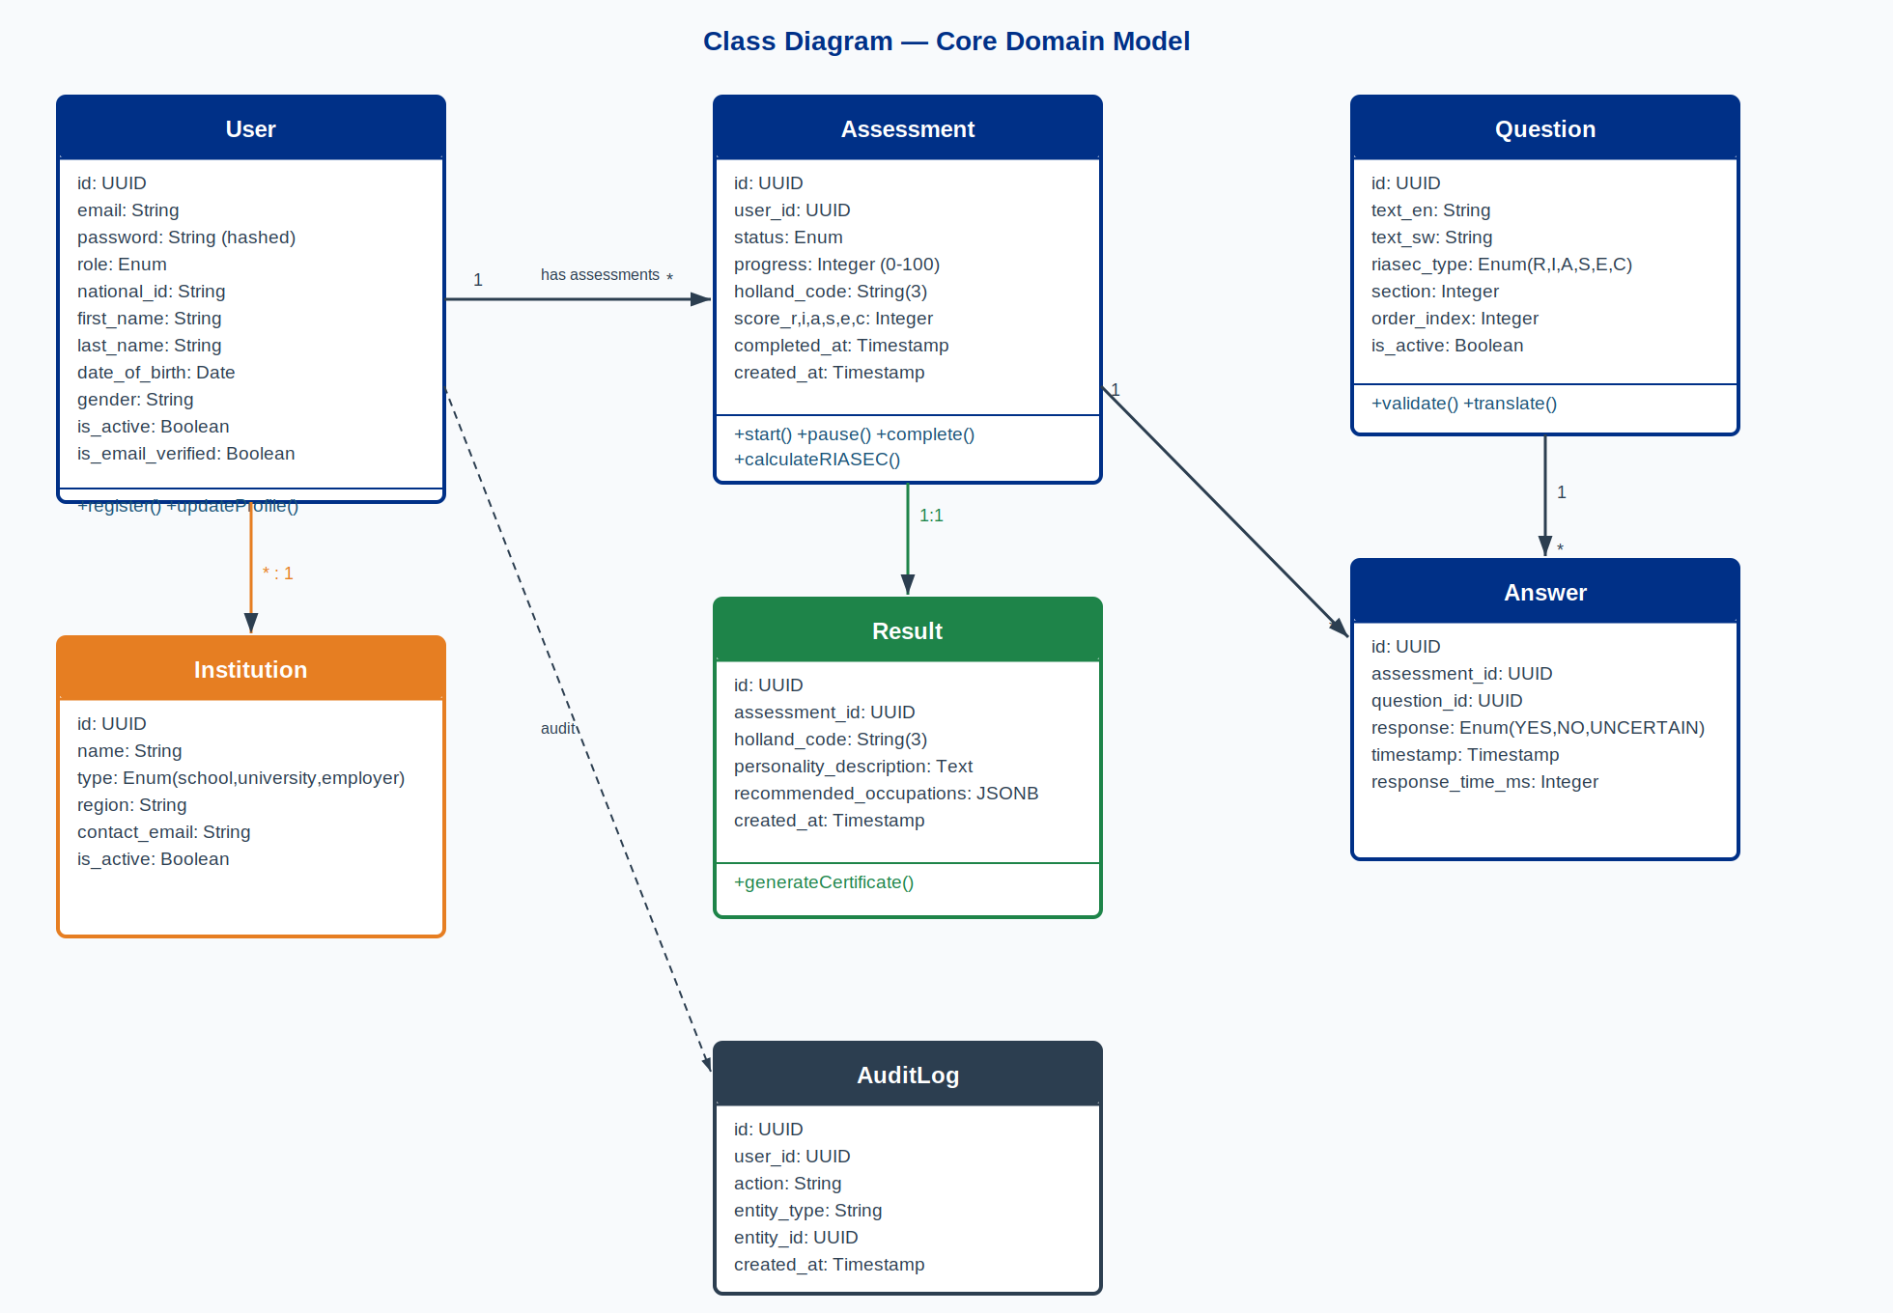
Figure 3: Class Diagram — Core Domain Model

5.2 Entity Groups

5.2.1 User Management
Entity | Description
Users | Central user entity with role, national ID, institutional affiliation, and account status
Permissions | 49 granular permissions across 13 functional modules
UserPermissions | Junction table resolving which users hold which permissions
EducationLevels | Lookup for educational attainment levels used in profiles and recommendations
Institutions | Schools, universities, and employers with type, region, and contact data
Occupations | Career occupations with Holland codes and education requirements

5.2.2 Assessment System
Entity | Description
Assessments | Test sessions with status, progress %, RIASEC raw scores, and Holland code
Questions | SDS questionnaire items with RIASEC dimension and section classification
Answers | User responses (YES/NO) with timestamps and response duration
Results | Processed outcomes including personality description and occupation recommendations
Certificates | Generated PDF completion certificates with unique verifiable identifiers

5.2.3 Content & Audit
Entity | Description
Subjects | Academic subjects with Holland code mappings for career recommendations
Courses | Educational courses linked to institutions with entry requirements
AuditLogs | Immutable log of all system events with actor, action, and timestamp
UserQualifications | User-uploaded qualification document records with metadata

6. API Design

6.1 RESTful API Structure
All endpoints are versioned under /api/v1/ and organised by resource domain:
/api/v1/
├── auth/ # login, register, refresh, logout, verify-email, reset-password
├── assessments/ # start, answer, progress, pause, complete, results
├── users/ # CRUD, bulk-import, role-assignment (admin only)
├── admin/ # system-config, audit-logs, system-health
├── counselor/ # student-lists, class-import, institution-reports
├── institutions/ # schools, universities, employers — CRUD + import
├── occupations/ # Holland code lookup, career recommendations
├── analytics/ # dashboards, custom reports, exports
├── notifications/ # list, read, preferences, mark-all-read
├── certificates/ # generate, download, verify
└── qualifications/ # upload, view, delete

6.2 Standard Response Envelope
{
"status": "success | error",
"data": { ... }, // Resource payload on success
"message": "Human-readable message",
"errors": [ ... ] // Field-level validation errors only
}

6.3 HTTP Status Code Reference
Code | Meaning | When Used
200 | OK | Successful GET, PATCH, or PUT
201 | Created | Successful POST creating a new resource
204 | No Content | Successful DELETE with no response body
400 | Bad Request | Input validation failure — errors array populated
401 | Unauthorised | Missing or expired authentication token
403 | Forbidden | Valid token but insufficient permissions
404 | Not Found | Requested resource does not exist
409 | Conflict | Duplicate national ID, email, or other unique constraint
429 | Too Many Requests | Rate limit exceeded — Retry-After header included
500 | Internal Server Error | Unexpected server error — generic message, full detail logged

7. Security Architecture

7.1 Defence in Depth
Layer | Controls
1. Network Security | HTTPS/TLS 1.3 everywhere; CORS whitelist policy; Content Security Policy headers via Helmet.js
2. Application Security | Input validation (Joi schemas); SQL injection prevention (parameterised Sequelize queries); XSS protection
3. Authentication Security | JWT RS256 signing; bcrypt hashing; httpOnly refresh token cookies; OTP email verification
4. Authorisation Security | RBAC with 49 granular permissions; checks enforced at endpoint and data layer
5. Data Security | AES-256 at rest for sensitive fields; TLS 1.3 in transit; PII minimisation by design
6. Audit Security | Immutable audit log; real-time anomaly alerting; regular vulnerability scans

7.2 Security Controls
Control | Library / Method | Purpose
Security Headers | Helmet.js | CSP, HSTS (max-age 1yr), X-Frame-Options, Referrer-Policy
Rate Limiting | express-rate-limit | 100 req/min global; 10/min on auth endpoints; lockout after 5 failed logins
Input Validation | Joi | Schema-based validation of all bodies, params, and query strings
SQL Injection Prevention | Sequelize ORM | Parameterised queries; no raw SQL string interpolation
XSS Protection | Input sanitisation | Server-side sanitisation before persistence; output encoding on API responses
CSRF Protection | SameSite cookies | SameSite=Strict on refresh token cookie; state-changing form protection

8. Authentication & Authorisation

8.1 Authentication Flow
The system uses stateless JWT authentication. Access tokens are stored in application memory only (never localStorage). The middleware stack diagram in Appendix G illustrates the request processing chain.
1. User submits email + password
2. Backend validates credentials against bcrypt hash
3. JWT access token (RS256, 1hr TTL) + refresh token issued
4. Access token stored in React app memory — NOT localStorage
5. Refresh token set as httpOnly, Secure, SameSite=Strict cookie
6. Axios interceptor auto-calls /auth/refresh when access token expires
7. Logout: refresh token invalidated server-side; cookie cleared

8.2 JWT Token Payload
{
"sub": "user-uuid",
"email": "user@example.com",
"role": "Test Taker | Test Administrator | System Administrator",
"permissions": ["assessments.view", "results.view", "certificates.download"],
"iat": 1640995200, // Issued at (Unix)
"exp": 1640998800 // Expires in 1 hour
}

8.3 Role-Based Access Control (RBAC)
Role | Permissions | Scope
System Administrator | 49 permissions | Full system access — all 13 modules, all operations
Test Administrator | 16 permissions | Student and test management within assigned institution
Test Taker | Basic permissions | Own assessment, results, profile, and certificates only

8.4 Permission Matrix (13 Modules, 49 Permissions)
Module | Permissions
users | view, create, update, delete, export
institutions | view, create, update, delete, export, import
questions | view, create, update, delete, import, export
occupations | view, create, update, delete, import, export
subjects | view, create, update, delete, import, export
assessments | view, create, update, delete, export
results | view, export
analytics | view, export
audit | view
notifications | view, manage
certificates | view, generate, download
permissions | view, manage
test_takers | manage

9. Frontend Architecture

9.1 Component Architecture
Pattern | Application
Atomic Design | Atoms → Molecules → Organisms → Templates → Pages hierarchy enforced via directory structure
Component Composition | Complex UIs built by composing single-purpose components via props and render props
State Management | Local state (useState) for UI; React Query for all server state and caching
Error Boundaries | Feature-level error boundaries prevent full-page crashes from isolated component failures
Code Splitting | React.lazy() + Suspense for route-level lazy loading; vendor chunk separation

9.2 State Management
// 1. Local UI state — ephemeral, component-scoped
const [isOpen, setIsOpen] = useState(false);

// 2. Server state — React Query handles fetch, cache, background sync
const { data, isLoading, error } = useQuery({
queryKey: ['assessment', sessionId],
queryFn: () => assessmentService.getSession(sessionId),
staleTime: 30 * 1000 // 30-second cache for active assessment
});

// 3. Global auth state — React Context (no external store needed)
const { user, permissions, logout } = useAuth();

9.3 Performance Optimisations
Optimisation | Technique
Memoisation | React.memo for pure components; useMemo for expensive derived data; useCallback for stable handlers
Virtual Scrolling | react-window windowed lists for student tables and question banks > 100 rows
Image Optimisation | WebP with JPEG fallback; lazy loading via Intersection Observer
Bundle Optimisation | Tree shaking; dynamic imports per route; vendor/commons chunk splitting
Caching Strategy | React Query client cache (configurable staleTime); HTTP ETag/Last-Modified headers; service worker for static assets

10. Backend Architecture

10.1 Service Layer Pattern
Every HTTP request flows through the following strict layer sequence. The middleware stack diagram in Section 10.2 illustrates the detailed request processing pipeline.
HTTP Request (inbound)
│
▼ Middleware chain (see Section 10.2)
Controller ← Parse HTTP; validate input; call service; format response
│
▼
Service ← Business logic; orchestrate operations; manage transactions
│
▼
Model ← Sequelize schema; query scopes; association definitions
│
▼
PostgreSQL ← Persistent data storage

10.2 Express Middleware Stack
All requests pass through the following middleware chain in strict order:

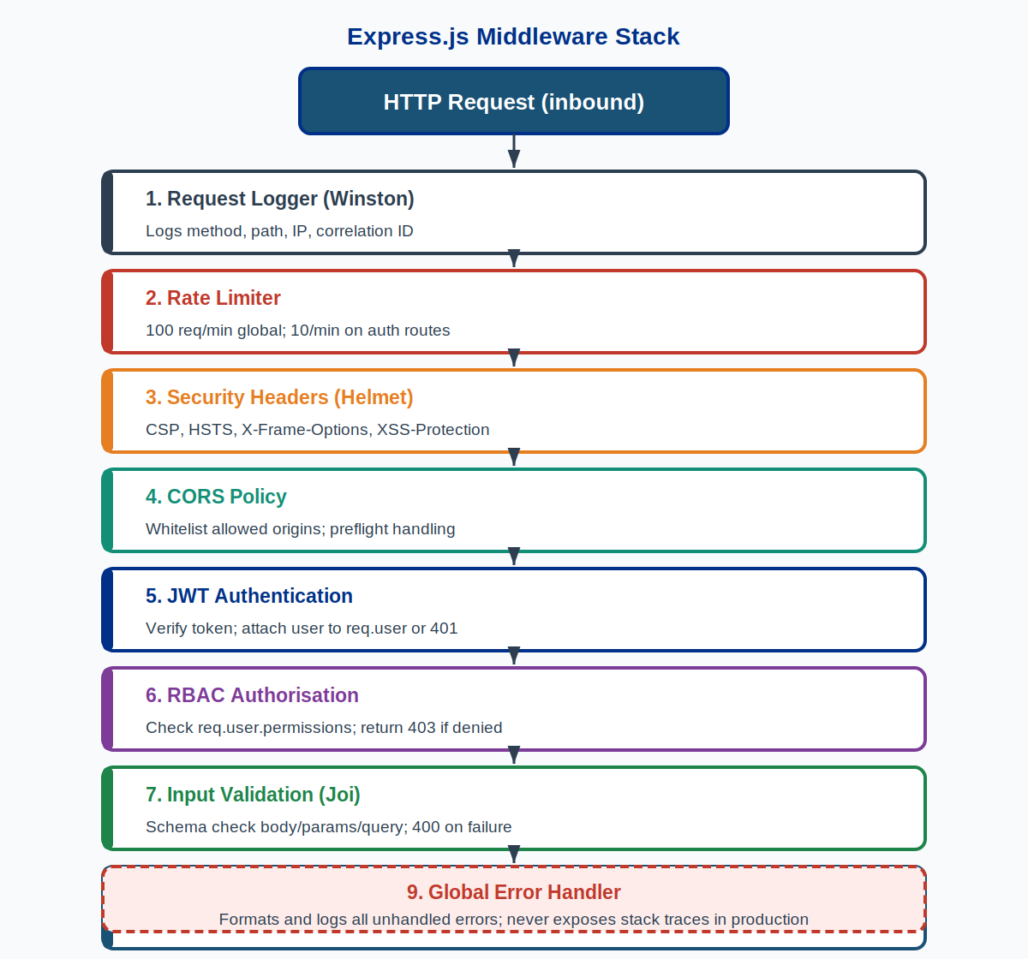
Figure 4: Express.js Middleware Stack

10.3 Layer Responsibilities
Layer | Responsibilities
Controller | HTTP request/response handling; input parsing; service delegation; error propagation; response formatting
Service | Business logic; data transformation; external service calls; complex query orchestration; transaction management
Model | Sequelize schema definition; data validation rules; association definitions; reusable query scopes and instance methods

11. Database Design

11.1 Entity-Relationship Diagram
The complete database schema with all tables, primary keys, foreign keys, and cardinality:

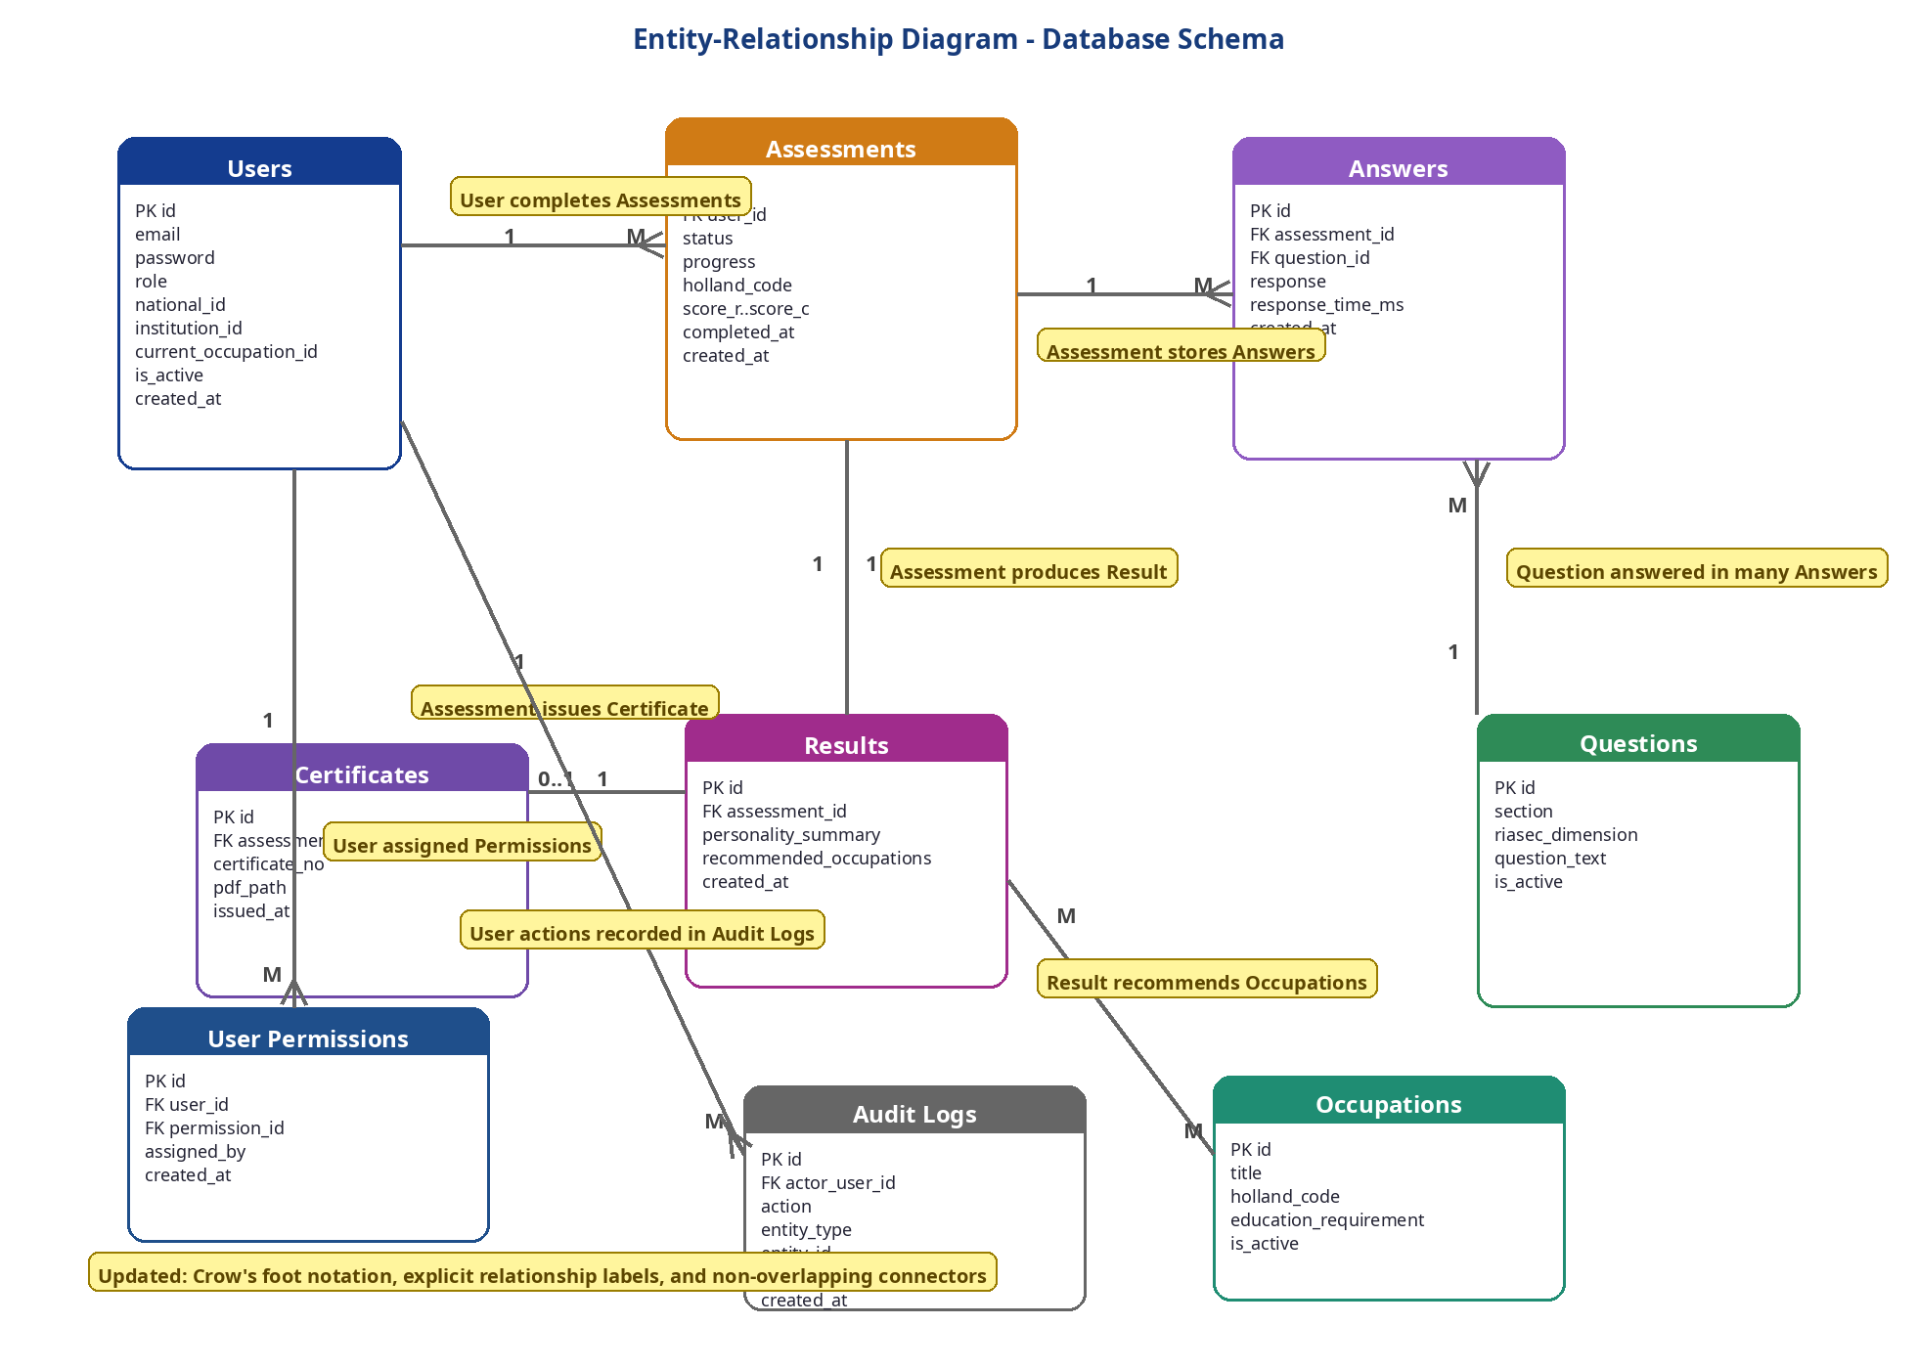
Figure 5: Entity-Relationship Diagram — Full Database Schema

11.2 Users Table Schema
CREATE TABLE users (
id UUID PRIMARY KEY DEFAULT gen_random_uuid(),
email VARCHAR(255) UNIQUE NOT NULL,
password VARCHAR(255) NOT NULL, -- bcrypt hash
role VARCHAR(50) NOT NULL, -- enum via application
national_id VARCHAR(13) UNIQUE, -- 13-digit Eswatini ID
first_name VARCHAR(100),
last_name VARCHAR(100),
date_of_birth DATE, -- auto-extracted from national_id
gender VARCHAR(20), -- auto-extracted from national_id
institution_id UUID REFERENCES institutions(id) ON DELETE SET NULL,
current_occupation_id UUID REFERENCES occupations(id) ON DELETE SET NULL,
is_active BOOLEAN DEFAULT true,
is_email_verified BOOLEAN DEFAULT false,
created_at TIMESTAMP DEFAULT CURRENT_TIMESTAMP,
updated_at TIMESTAMP DEFAULT CURRENT_TIMESTAMP
);

11.3 Assessments Table Schema
CREATE TABLE assessments (
id UUID PRIMARY KEY DEFAULT gen_random_uuid(),
user_id UUID NOT NULL REFERENCES users(id) ON DELETE CASCADE,
status VARCHAR(20) NOT NULL, -- in_progress | completed | paused | expired | abandoned
progress INTEGER DEFAULT 0, -- 0 to 100 (percentage of 228 questions answered)
holland_code CHAR(3), -- generated on completion e.g. 'RIA'
score_r INTEGER DEFAULT 0, -- Realistic raw score
score_i INTEGER DEFAULT 0, -- Investigative raw score
score_a INTEGER DEFAULT 0, -- Artistic raw score
score_s INTEGER DEFAULT 0, -- Social raw score
score_e INTEGER DEFAULT 0, -- Enterprising raw score
score_c INTEGER DEFAULT 0, -- Conventional raw score
completed_at TIMESTAMP,
created_at TIMESTAMP DEFAULT CURRENT_TIMESTAMP,
updated_at TIMESTAMP DEFAULT CURRENT_TIMESTAMP
);

11.4 Database Performance Optimisations
Optimisation | Implementation
Indexing Strategy | Composite indexes on (user_id, created_at); GIN index on JSONB results.recommended_occupations; index on assessments.status
Query Optimisation | Sequelize eager loading (include) prevents N+1; selective field projection reduces payload size
Connection Pooling | PgBouncer manages connection pool; pool size = CPU cores × 2; max 100 connections per instance
Read Replicas | Analytics and report queries routed to streaming replica to offload primary write database
Table Partitioning | Range partitioning on audit_logs.created_at and answers.timestamp for large-scale queries

12. Integration Patterns

12.1 Data Flow Diagram
The Level 1 DFD below shows how data flows between system processes, external actors, and data stores:

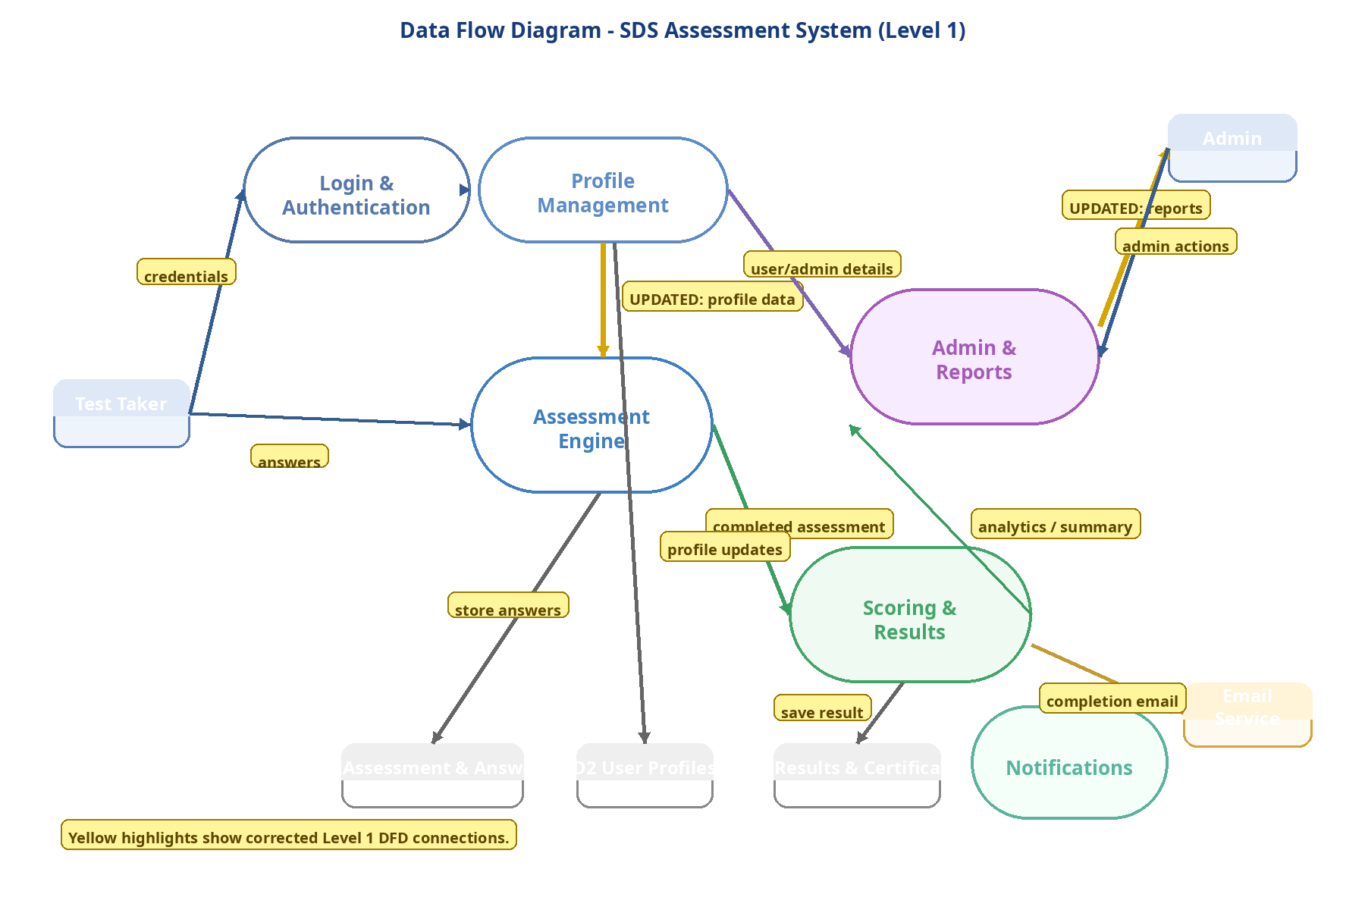
Figure 6: Data Flow Diagram — SDS Assessment System (Level 1)

12.2 External Service Integrations
Integration | Technology | Purpose
Email Service | SMTP (Nodemailer) | Transactional emails: verification, password reset, assessment completion, admin alerts
File Storage | Local filesystem | Document uploads and certificate PDFs; S3-compatible cloud migration path available
PDF Generation | PDFKit (server) | Formal certificate and report PDF generation with Ministry branding and unique codes
CSV Processing | Stream processing | Memory-efficient stream-based parsing for large bulk student import files
Analytics | PostgreSQL aggregations | Window functions and CTEs for dashboard metrics; Power BI export readiness

12.3 Design Patterns Applied
Pattern | Where Applied
Repository Pattern | Sequelize model layer abstracts all database access from service and controller layers
Service Locator | Dependency injection container manages service instantiation and lifecycle
Observer Pattern | Audit service subscribes to domain events emitted by services — decouples logging from business logic
Strategy Pattern | Different authentication strategies (JWT, OTP) implement a common validation interface
Factory Pattern | Database connection factory manages pool creation; model factory simplifies test fixture setup

13. Performance Considerations

13.1 Frontend Performance Targets
Area | Approach | Target
Initial Load | Route-level code splitting; CDN delivery of static assets | < 3 sec on 2 Mbps
Assessment UX | Questions pre-fetched in background; local state for instant UI updates | < 1 sec per question
Data Tables | Virtual scrolling for lists > 100 rows; paginated API responses | Smooth 60 fps scroll
Image Delivery | WebP with JPEG fallback; lazy loading via Intersection Observer | < 1 sec per image
Bundle Size | Tree shaking; dynamic imports; vendor chunk separation | < 200 KB initial JS

13.2 Backend Performance Targets
Area | Approach | Target
API Response | Optimised queries; selective field projection; N+1 prevention via eager loading | < 2 sec (p95)
Database Queries | Composite indexes; read replicas for analytics; query plan analysis | < 500 ms (p95)
File Uploads | Streaming multipart parsing; async storage; immediate 202 Accepted response | Non-blocking
PDF Generation | Background job queue for large reports; inline generation for certificates | < 5 sec
Caching | Redis-ready layer; React Query client cache; HTTP ETag headers | 40% DB load reduction

14. Scalability

14.1 Horizontal Scaling
Component | Horizontal Scaling Approach
Application Servers | Stateless JWT authentication enables multiple Node.js instances behind Nginx load balancer
Database | Streaming read replica for analytics; Citus or sharding when primary DB reaches capacity limits
File Storage | Local filesystem in Phase 1; S3-compatible object storage (MinIO or AWS S3) in Phase 2
Session Management | No server-side session state — JWT tokens eliminate sticky session requirements completely
Background Jobs | Bull queue with Redis enables distributed job processing across multiple worker instances

14.2 Capacity Planning
Concurrent Users | 500+ in initial deployment; architecture horizontally scales to 5,000+ without redesign
Database Scale | Millions of records supported; partitioning applied at 10M+ row thresholds per table
File Storage | Per-user and per-institution quotas configurable; cloud storage migration available
Network | Optimised payloads and HTTP/2 compression ensure full functionality on 2 Mbps connections
Annual Growth | Designed to accommodate 100% annual growth in user base for the first three years

15. Deployment Architecture

15.1 Deployment Diagram
The deployment diagram below shows the physical infrastructure, server roles, and network topology:

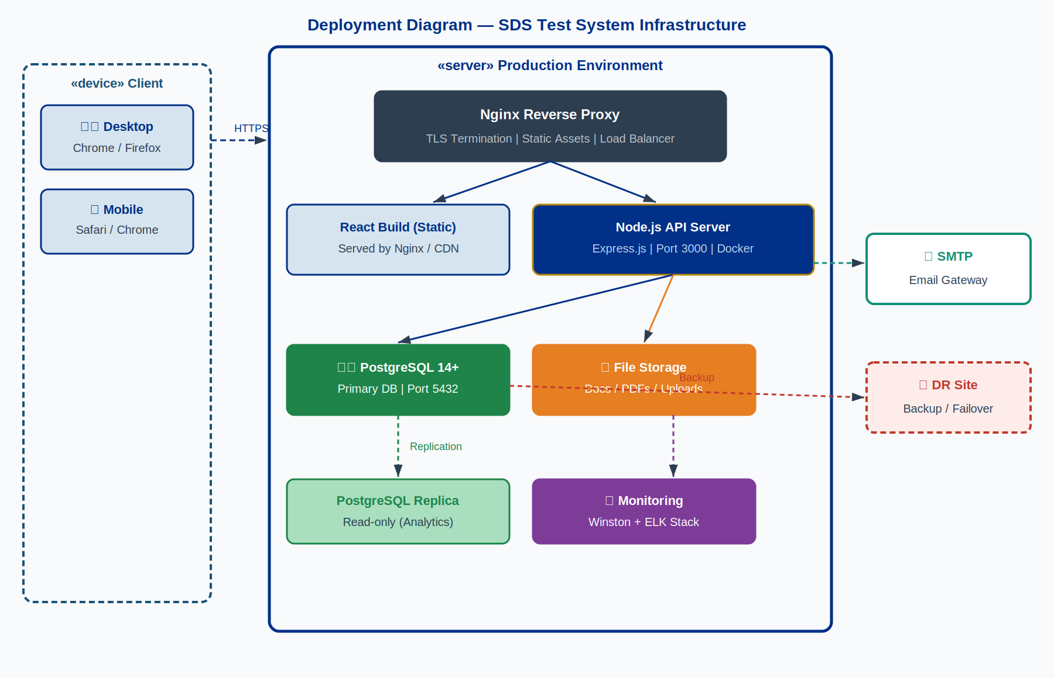
Figure 7: Deployment Diagram — Production Infrastructure

15.2 Environment Strategy
Environment | Purpose | Key Differences from Production
Development | Local developer workstations with hot-reload | Mock services; debug logging; relaxed CORS; no TLS
Staging | Production-like integration and UAT environment | Real services; anonymised data; full security controls
Production | Live system serving Ministry users | Full HA; real-time monitoring; automated backups; TLS
Disaster Recovery | Warm standby for business continuity | Tested failover; RTO < 4 hours; RPO < 1 hour

15.3 Deployment Pipeline
1. Developer opens Pull Request (feature → main branch)
2. GitHub Actions triggers automatically:
a. ESLint + Prettier code quality checks
b. Jest unit and integration test suite
c. React + Node.js build verification
3. Code review and approval by senior developer
4. Merge to main → Docker image built and tagged with commit SHA
5. Trivy / Snyk security vulnerability scan on Docker image
6. Auto-deploy to Staging environment
7. Cypress E2E test suite against Staging
8. Manual UAT sign-off by Ministry representative
9. Blue-green production deployment (zero downtime)
10. Post-deployment health checks and smoke tests
11. Rollback available within 15 min if health checks fail

15.4 Kubernetes Orchestration, Infrastructure as Code & CI/CD
15.4.1 Kubernetes Deployment
The production SDS Test System shall be deployed on Kubernetes using container images built from the project Dockerfiles. All workloads shall be defined as declarative Kubernetes manifests or packaged as Helm charts and version-controlled alongside the application source code. The deployment shall cover the React frontend (served via Nginx), the Node.js API server, the PostgreSQL primary database and read replica, and the supporting services (Redis cache, monitoring stack).
Kubernetes Capability | Design Detail
Workload manifests | Kubernetes Deployment, Service, ConfigMap, and Secret manifests (or Helm chart equivalents) delivered as part of the source code repository.
Horizontal auto-scaling | HorizontalPodAutoscaler (HPA) configured on the API server deployment. Scales on CPU utilisation (target 70%) and optionally on custom metrics (request rate). Minimum 2 replicas; maximum configurable per environment.
Self-healing | Liveness and readiness probes defined for all containers. Kubernetes automatically restarts failed containers and reschedules pods from unhealthy nodes. Rolling update strategy ensures zero-downtime deployments.
Namespace isolation | Separate Kubernetes namespaces for staging and production environments. Network policies restrict cross-namespace traffic. RBAC limits cluster access to authorised personnel only.
15.4.2 Infrastructure as Code (IaC)
All infrastructure required to build, deploy, and operate the SDS Test System shall be defined and delivered as Terraform templates (or an approved equivalent IaC toolchain). IaC artefacts shall be version-controlled, peer-reviewed, and stored in the project repository. The following infrastructure components shall be covered:
IaC Module | Scope
Compute & Kubernetes cluster | Node pool definitions, cluster configuration, and namespace provisioning.
Database | PostgreSQL instance provisioning, backup configuration, and read replica setup.
Networking & security | Firewall rules, load balancer, TLS certificate provisioning, DNS records, and network policy definitions.
Storage & container registry | Persistent volume configuration, object storage for file uploads, and container image registry provisioning.
Monitoring stack | Log aggregation, metrics collection, and alerting infrastructure provisioned as code.
15.4.3 CI/CD Pipeline Design
The CI/CD pipeline defined in Section 15.3 is implemented using GitHub Actions. Pipeline definition files are stored in .github/workflows/ within the source repository and form a required delivery artefact. The pipeline stages and their design responsibilities are as follows:
Pipeline Stage | Tools / Actions | Pass Criteria
Code Quality | ESLint, Prettier | Zero lint errors; consistent formatting enforced
Automated Tests | Jest (unit + integration), Cypress (E2E) | All tests pass; coverage targets met (80% FE, 90% BE)
Build | Docker build; image tagged with commit SHA; pushed to container registry | Image built and pushed successfully; build log retained
Security Scan | Trivy / Snyk container and dependency vulnerability scan | No Critical or High CVEs; scan report retained as pipeline artefact
Staging Deployment | kubectl apply / helm upgrade to staging Kubernetes namespace; Cypress E2E suite executed against staging | Staging health checks pass; all E2E tests pass; deployment log retained

16. Monitoring & Logging

16.1 Logging Strategy
Log Type | Format | Content
Application Logs | JSON (Winston) | Request method, path, status, response time, user ID, correlation ID
Audit Logs | JSON (immutable) | Actor, action, entity type, entity ID, before/after state, timestamp, IP
Error Logs | JSON (Winston) | Error type, message, stack trace, request context, severity level
Performance Logs | JSON (Winston) | Endpoint, duration, DB query count, cache hit/miss ratio
Security Logs | JSON (Winston) | Auth events, permission denials, rate limit hits, suspicious IP patterns

16.2 Alerting Thresholds
Alert Type | Threshold | Channel
Error Rate | Error rate > 1% over 5 minutes | PagerDuty + Slack #ops
Performance | p95 response time > 3 seconds | Slack #ops
Resource | CPU or Memory > 85% for 10 minutes | Slack #ops + email
Security | 5+ failed logins from single IP in 1 minute | PagerDuty + Security team
Database | Replication lag > 30 seconds | PagerDuty + DBA
Business | Zero assessment completions in 2 hours during business hours | Slack #ministry-ops

17. Error Handling

17.1 Error Classification
Error Type | HTTP Code | Handling Approach
Validation Errors | 400 | Joi schema errors mapped to field-level error objects in the errors array
Authentication Errors | 401 | JWT verification failure or expired token — client must re-authenticate
Authorisation Errors | 403 | Valid user but missing required permission — permission name included
Not Found Errors | 404 | Resource does not exist — resource type and ID in message
Conflict Errors | 409 | Duplicate unique constraint — field name included in response
Server Errors | 500 | Unexpected internal error — full trace logged; generic message to client
Network Errors | — | Axios retry (3 attempts, exponential backoff) before surfacing to user

17.2 Frontend Error Boundaries
Mechanism | Implementation
Error Boundaries | React error boundaries at feature module level catch render errors gracefully
Global Error Handler | Axios interceptor translates API and network errors to user-friendly messages
Fallback UI | Every error boundary renders a fallback card with retry action and support contact
Error Reporting | Unhandled errors reported to monitoring service with user context and component stack trace

18. Testing Strategy

18.1 Testing Pyramid
Level | Coverage | Framework | Scope
Unit Tests (70%) | 80%+ FE; 90%+ BE | Jest | Services, utilities, RIASEC scoring algorithm, React hooks
Integration Tests (20%) | API endpoints | Jest + Supertest | Full request-response cycle against test database
E2E Tests (10%) | Critical journeys | Cypress | Registration, assessment completion, results, certificate download

18.2 Test Coverage Targets
Scope | Target | Rationale
Frontend overall | >80% | Balance between coverage confidence and maintenance overhead
Backend overall | >90% | Higher target due to critical business logic concentration
Authentication paths | 100% | Zero tolerance for security regressions
RIASEC scoring algorithm | 100% | Core product value — accuracy is non-negotiable
Critical E2E journeys | 100% | All primary user journeys covered in automated E2E suite

19. Data Migration Strategy

19.1 Migration Management
Concern | Approach
Schema Versioning | Sequelize migrations with up() and down() methods for full reversibility
Data Seeding | Separate seed scripts populate reference data (228 questions, occupations, education levels)
Rollback Strategy | Every migration has a tested down() method; rollback executable within minutes
Staging Validation | All migrations run on staging with production-equivalent anonymised data before prod
Documentation | Each migration file includes a header comment: change, business reason, data assumptions

19.2 Migration Execution Process
1. Write migration with up() and down() methods; include rollback test
2. Peer review by second developer
3. Run on Staging with anonymised production-equivalent data
4. Verify application functionality post-migration on Staging
5. Test rollback procedure on Staging
6. Take verified backup of production database
7. Schedule within maintenance window; apply with monitoring active
8. Execute post-migration smoke tests
9. Confirm success; monitor error rates and slow queries for 24 hours

20. Compliance & Governance

20.1 Data Protection
Requirement | Implementation
Eswatini Data Protection Act 2022 | All data processing, storage, and transfer compliant with local legislation
GDPR Principles — Privacy by Design | Data protection built into architecture from inception; not retrofitted
Data Minimisation | Only fields strictly necessary for system function are collected
Purpose Limitation | Data collected for career assessment not used for unrelated purposes
Storage Limitation | Configurable retention policies auto-anonymise or delete data after defined periods
Right to Erasure | Complete user data deletion with cascade rules; audit log entry retained per legal requirement

20.2 Audit Requirements
Requirement | Implementation
Audit Trail | All user actions, data changes, and admin operations logged to immutable audit_logs table
Data Integrity | Database constraints, triggers, and application-level validation maintain consistent state
Access Control Audit | RBAC permission checks logged; access denials recorded with user, resource, and timestamp
Change Management | All production changes require PR review, staging validation, and documented approval
Incident Response | Documented runbook for security incidents; escalation path to Ministry IT security officer

21. Design Decisions & Rationale
This section documents the key architectural decisions made during design, the alternatives considered, and the rationale for the chosen approach.

Decision | Chosen Approach | Alternatives Considered | Rationale
Authentication mechanism | JWT stateless tokens (RS256) | Session-based (server-side store), OAuth2 only | JWT eliminates server-side session state, enabling horizontal scaling. RS256 asymmetric signing is more secure than HS256 for distributed systems.
Token storage | Access token in memory; refresh in httpOnly cookie | Both tokens in localStorage | localStorage is accessible to JavaScript, making it vulnerable to XSS attacks. httpOnly cookies prevent JS access entirely.
Frontend framework | React 18 with React Query | Angular, Vue, Next.js SSR | React's ecosystem maturity and team familiarity; React Query provides excellent server state management without Redux overhead. SSR not required as SEO is not a primary concern.
Database | PostgreSQL 14+ with Sequelize ORM | MySQL, MongoDB, Firebase | PostgreSQL's JSONB support offers flexibility for recommendation payloads; ACID compliance critical for assessment integrity; mature ecosystem; better analytical query support than MySQL.
PDF generation | PDFKit (server-side) | Puppeteer/headless Chrome, client-side React PDF | PDFKit produces consistent output without browser dependency; server-side generation ensures certificate authenticity and reduces client resource usage.
Scoring algorithm | Pure SQL aggregation + Node.js calculation | ML model, third-party scoring API | Holland's RIASEC is deterministic — no ML needed. Pure calculation is transparent, auditable, and zero-latency. Avoids vendor dependency for core functionality.
RIASEC scoring | YES=1, NO/UNCERTAIN=0 | Likert scale (YES=2, UNCERTAIN=1, NO=0) | Standard Holland self-directed search methodology uses binary YES/UNCERTAIN/NO with only YES responses counted. Maintains scientific validity and comparability.
Deployment approach | Containerised (Docker) + Nginx | Bare metal, PaaS (Heroku) | Docker ensures environment consistency; Nginx handles TLS termination and load balancing. More control than PaaS; less operational overhead than bare metal.

22. Glossary
SDS | Self-Directed Search — Holland's standardised career interest assessment tool
RIASEC | Holland's six personality/interest types: Realistic, Investigative, Artistic, Social, Enterprising, Conventional
Holland Code | 3-character code derived from the three highest-scoring RIASEC dimensions (e.g. 'RIA')
JWT | JSON Web Token — compact, URL-safe token for stateless authentication
RS256 | RSA Signature with SHA-256 — asymmetric signing algorithm used for JWT tokens
ORM | Object-Relational Mapper — Sequelize abstracts SQL queries into JavaScript model methods
RBAC | Role-Based Access Control — permissions granted to roles, not directly to individuals
WCAG | Web Content Accessibility Guidelines — W3C standard for web accessibility (target: 2.1 AA)
GDPR | General Data Protection Regulation — EU privacy framework applied as best practice
TLS | Transport Layer Security — cryptographic protocol securing all network communications
ACID | Atomicity, Consistency, Isolation, Durability — PostgreSQL transaction properties
UUID | Universally Unique Identifier — random 128-bit value used as primary key
JSONB | PostgreSQL binary JSON type — indexed, queryable flexible data storage
CSP | Content Security Policy — HTTP header restricting resource origins to prevent XSS
HSTS | HTTP Strict Transport Security — forces HTTPS for all future connections
DFD | Data Flow Diagram — shows how data moves between processes and data stores
RTO | Recovery Time Objective — maximum acceptable downtime (4 hours for critical functions)
RPO | Recovery Point Objective — maximum acceptable data loss (1 hour)
MFA | Multi-Factor Authentication — required for all administrator accounts
CDN | Content Delivery Network — distributes static assets geographically for faster load times

Appendix A: Use Case Diagrams

A.1 Test Taker Use Cases
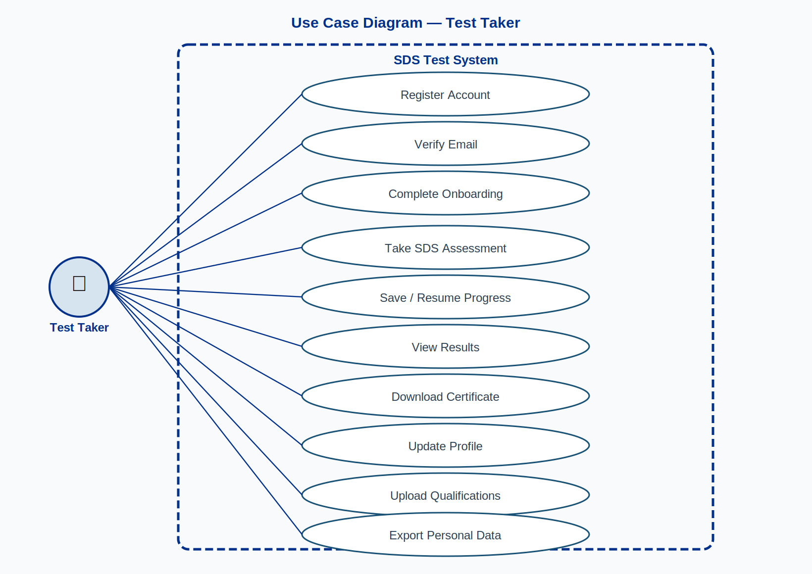
Figure A1: Use Case Diagram — Test Taker Role

A.2 Test Administrator Use Cases
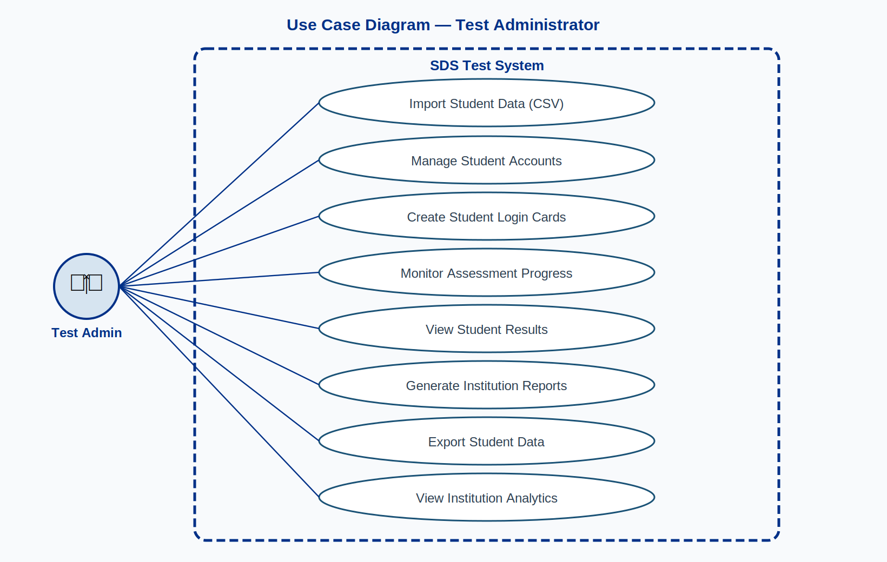
Figure A2: Use Case Diagram — Test Administrator Role

A.3 System Administrator Use Cases
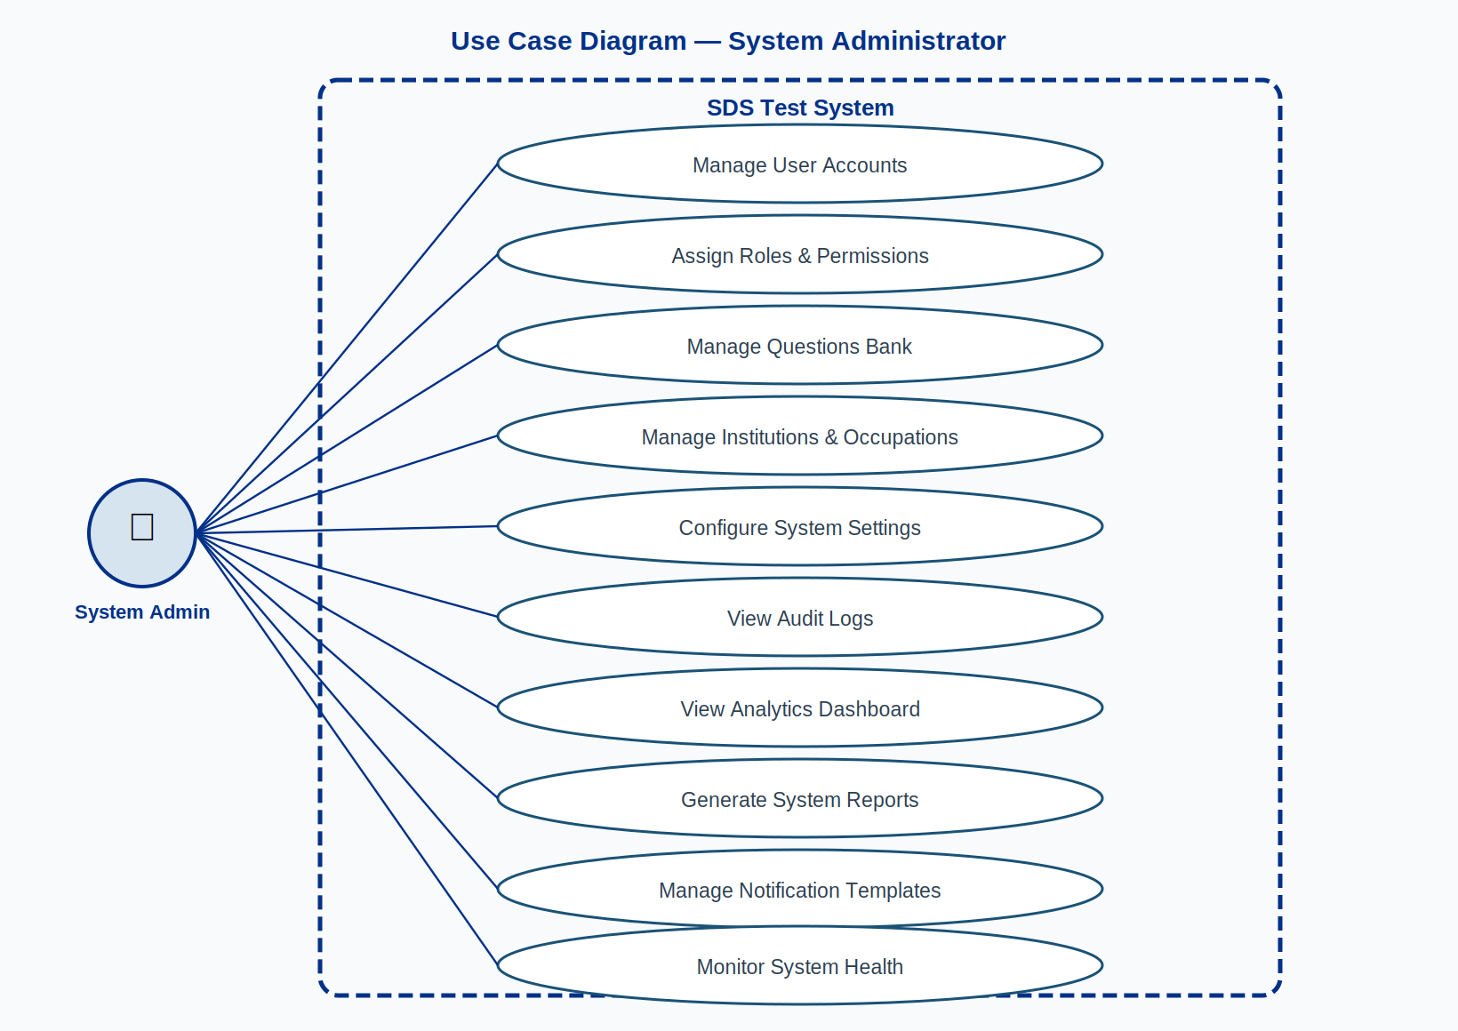
Figure A3: Use Case Diagram — System Administrator Role

Appendix B: Sequence Diagrams

B.1 User Login
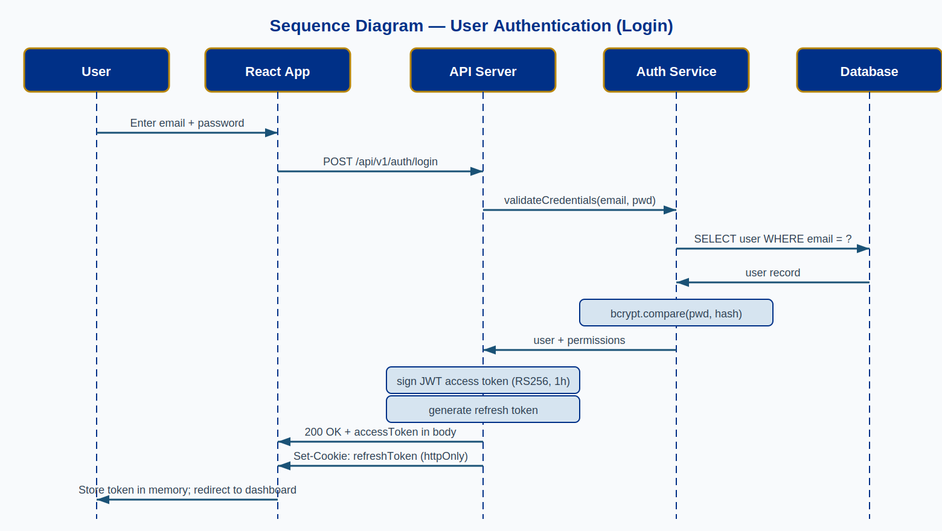
Figure B1: Sequence Diagram — User Authentication (Login)

B.2 User Registration & Email Verification
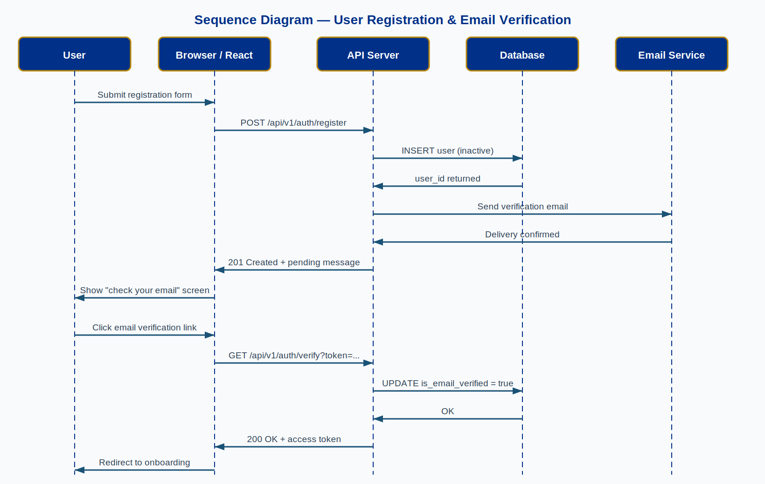
Figure B2: Sequence Diagram — Registration & Email Verification

B.3 SDS Assessment Completion
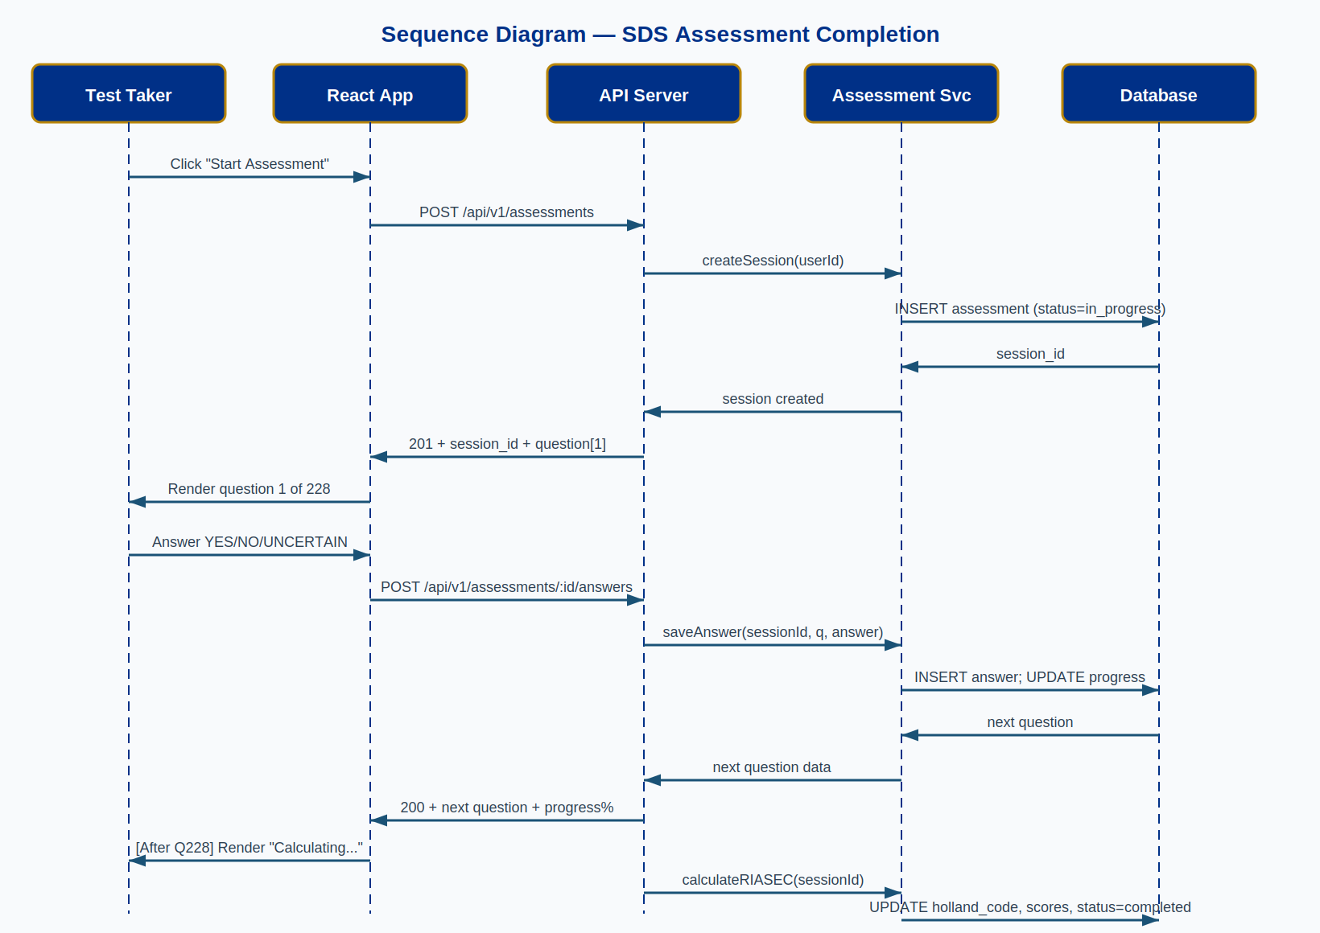
Figure B3: Sequence Diagram — Assessment Completion Flow

Appendix C: Activity Diagrams

C.1 User Registration Process
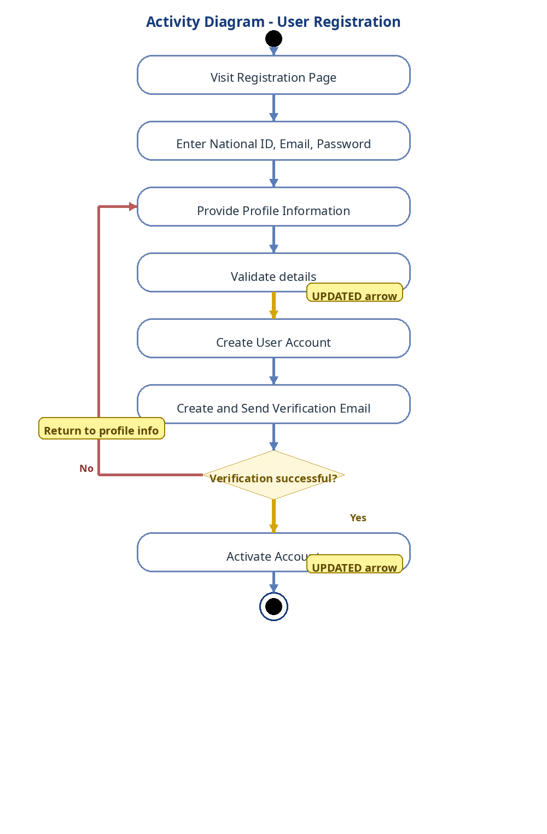
Figure C1: Activity Diagram — User Registration

C.2 Assessment Completion Process
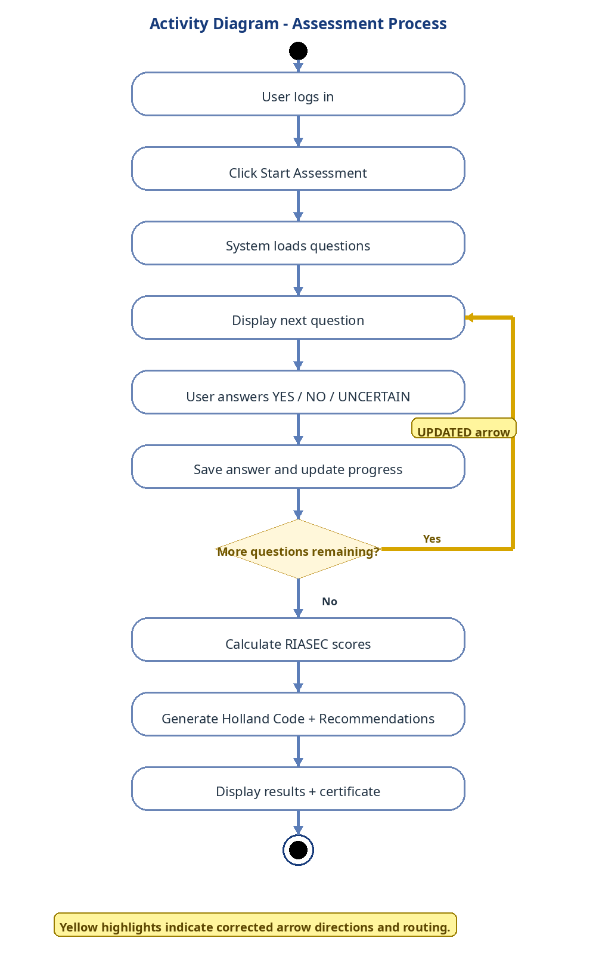
Figure C2: Activity Diagram — Assessment Process

Appendix D: State Machine Diagram

D.1 Assessment Session Lifecycle
The state machine below shows all possible states of an assessment session and the transitions between them:

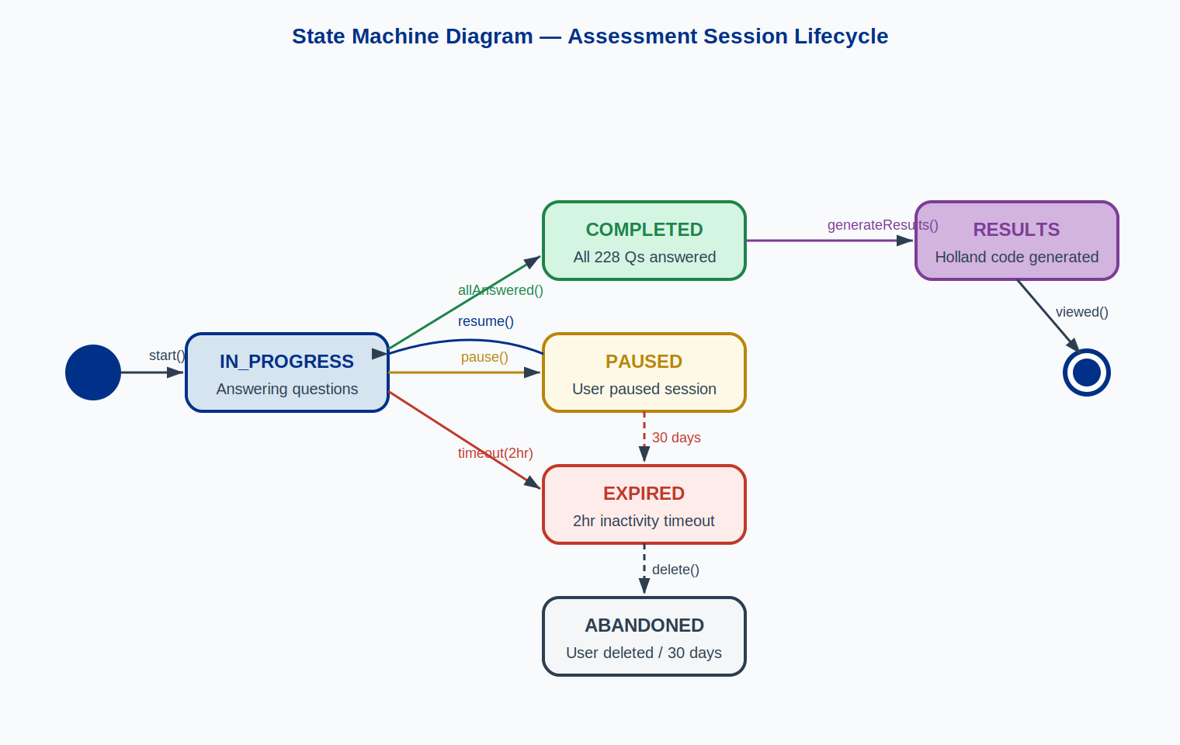
Figure D1: State Machine — Assessment Session Lifecycle
States and their meanings:
State | Description | Entry Condition | Exit Transitions
IN_PROGRESS | User is actively answering questions | User clicks 'Start Assessment' | → PAUSED (pause), → COMPLETED (all 228 answered), → EXPIRED (2hr timeout)
PAUSED | User has saved progress and exited | User clicks 'Save & Pause' | → IN_PROGRESS (resume within 30 days), → EXPIRED (30-day timeout)
COMPLETED | All 228 questions answered | Final answer submitted | → RESULTS (generateResults() called)
EXPIRED | Session timeout occurred | 2hr inactivity or 30-day pause limit | → ABANDONED (user deletes or admin purges)
ABANDONED | Session permanently closed | User deletes or admin purges | Terminal state — no further transitions
RESULTS | Holland code generated and visible | calculateRIASEC() completes | Terminal state — certificate available for download

Appendix E: Component & Deployment Diagrams

E.1 Component Diagram
Detailed view of the three software packages and their internal components and interfaces:


Figure E1: Component Diagram

E.2 Deployment Diagram
Physical infrastructure topology showing servers, containers, and network connections:


Figure E2: Deployment Diagram — Production Infrastructure

Appendix F: Class & ER Diagrams

F.1 Class Diagram

Figure F1: Class Diagram — Core Domain Model

F.2 Entity-Relationship Diagram

Figure F2: Entity-Relationship Diagram — Full Database Schema

Appendix G: Algorithm & Infrastructure Diagrams

G.1 RIASEC Scoring Algorithm
The diagram below illustrates the step-by-step algorithm used to calculate RIASEC scores and derive the Holland code from a completed assessment:

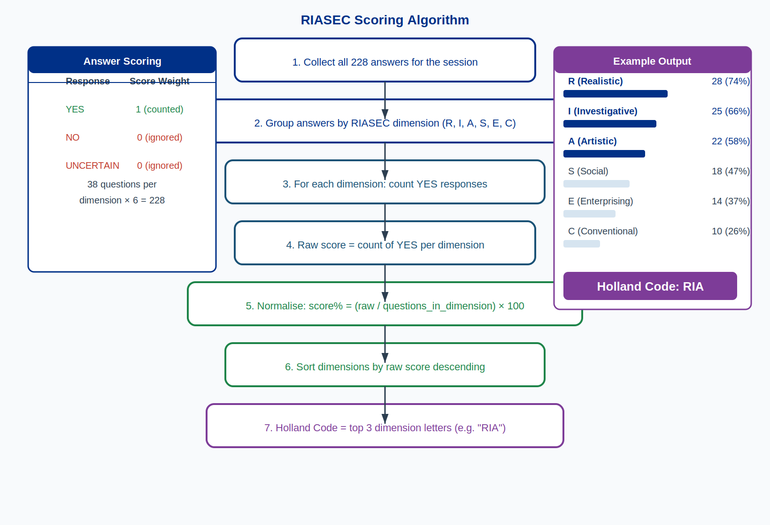
Figure G1: RIASEC Scoring Algorithm

G.2 RBAC Permission Visualisation
Which roles have access to which permission modules:

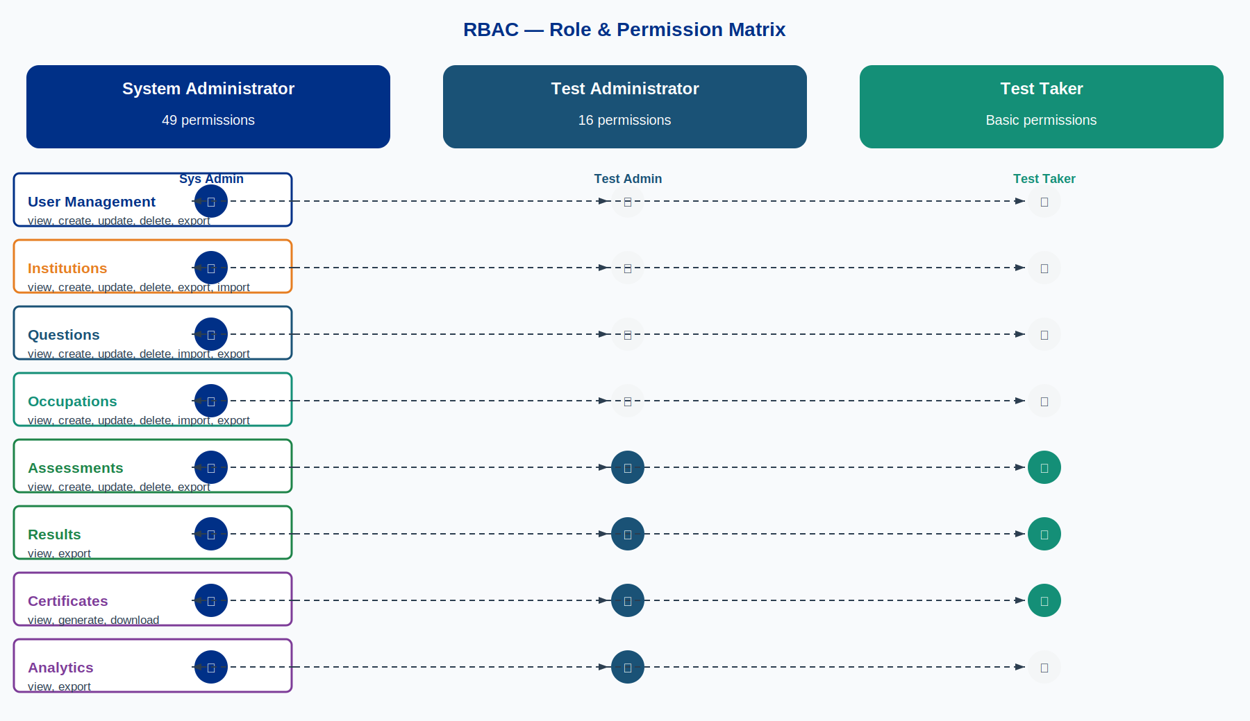
Figure G2: RBAC Role & Permission Matrix

Appendix H: UI Wireframes
These wireframes illustrate the intended user interface design. Final visual styling will follow the Ministry of Labour and Social Security brand guidelines. Wireframes are indicative of layout and interaction patterns.

H.1 Assessment Screen
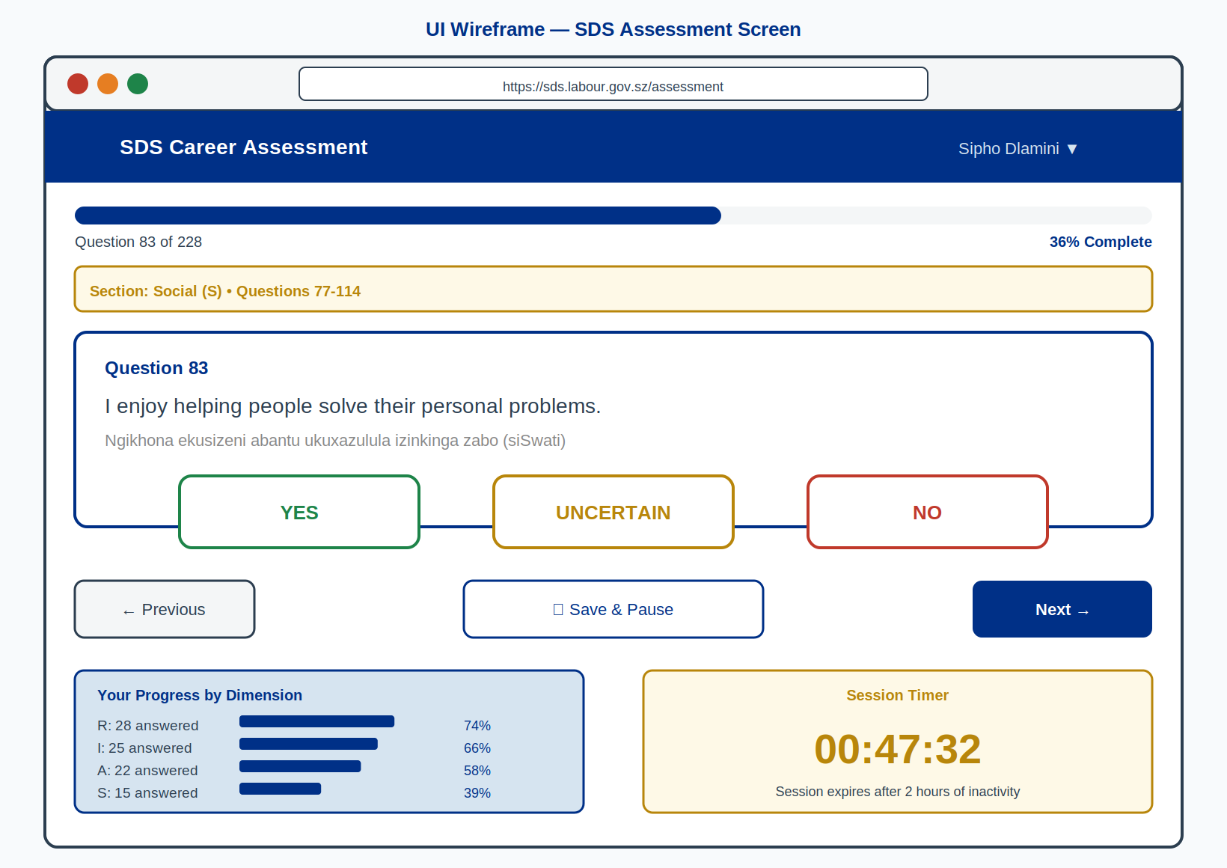
Figure H1: Wireframe — SDS Assessment Question Screen

H.2 Results & Recommendations Dashboard
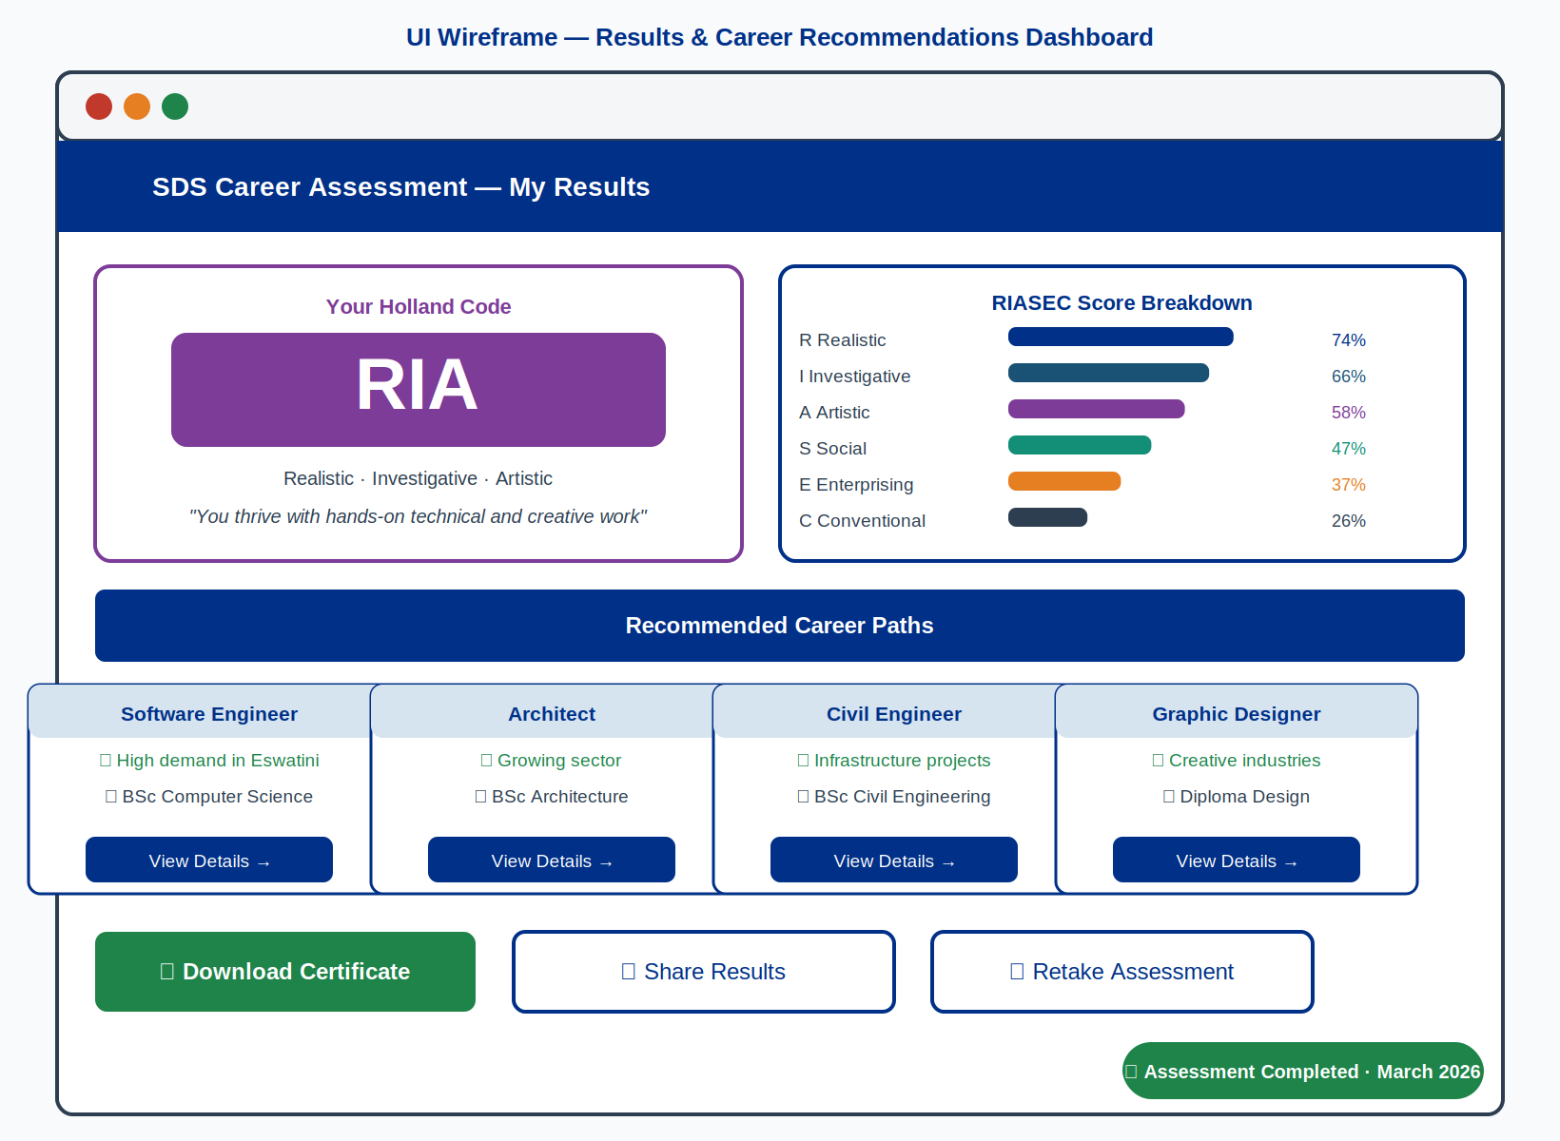
Figure H2: Wireframe — Results & Career Recommendations Dashboard

Appendix I: Document Approval
The following individuals are required to review and formally approve this System Design Document before implementation commences.

Role | Name | Signature | Date
Project Sponsor
Technical Lead
Quality Assurance Lead
Business Analyst
Ministry IT Representative

