МІНІСТЕРСТВО ОСВІТИ І НАУКИ

НАЦІОНАЛЬНИЙ УНІВЕРСИТЕТ «ЛЬВІВСЬКА ПОЛІТЕХНІКА»

Інститут комп'ютерних наук та інформаційних технологій

Кафедра систем штучного інтелекту



Лабораторна робота №5

з курсу “Дискретна математика ”

Виконав:  
 Збриський Костянтин

ст. гр. КН-110

Викладач:

Мельникова Н.І.

Львів – 2018

Варіант 13

1.

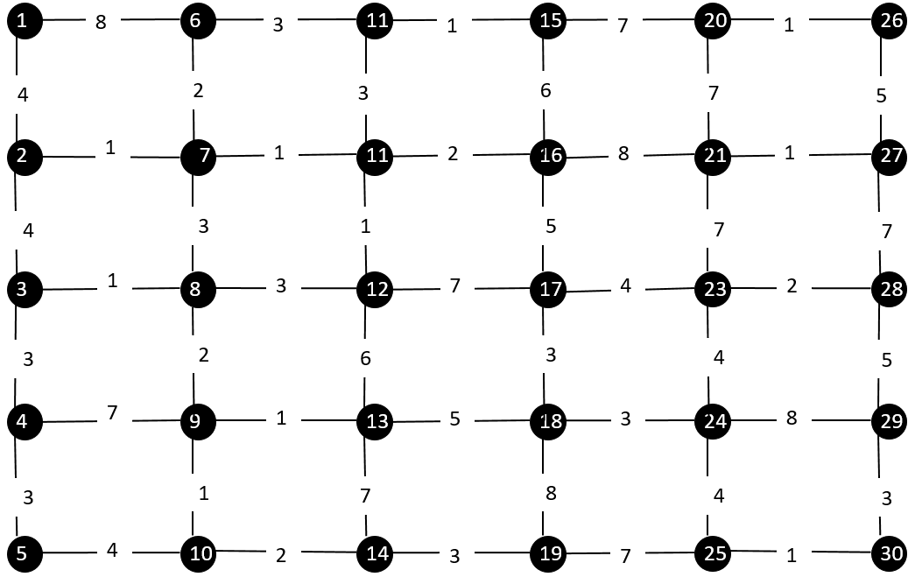

Результатом роботи буде такий граф

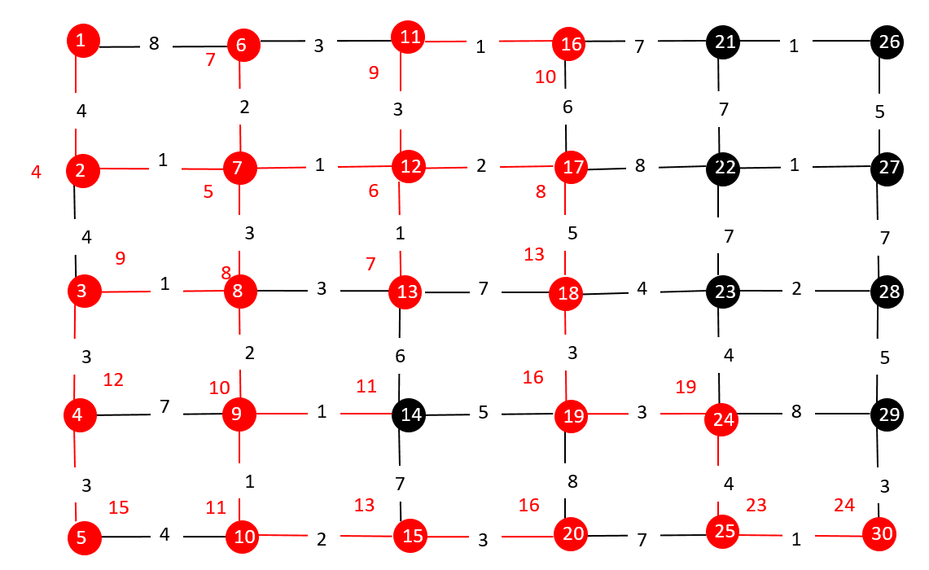

Мінімальний шлях від (V1 > V30) V1 > V2 > V7 > V12 > V17 > V18 > V19 > V24 > V25 > V30

Код програми

#include <iostream>

typedef struct vertex vertex;

typedef struct edge edge;

typedef struct min min;

typedef struct min {

int min;

int vertex1, vertex2;

vertex * to;

}min;

typedef struct vertex {

int vertex;

struct vertex * next;

min min;

int in_tree = 0;

int way = 1000;

int way_vertex1;

int way_vertex2;

struct vertex * way_to;

int annon = 0;

edge * head = nullptr;

}vertex;

typedef struct edge {

int vertex1, vertex2, price;

struct edge * next;

vertex * to;

}edge;

void add_vertex(vertex * & head, int vertex_value) {

vertex * new_vertex = new(vertex);

new_vertex->vertex = vertex_value;

new_vertex->min.min = 100;

if (!head) {

new_vertex->next = NULL;

head = new_vertex;

return;

}

vertex * tracer = head;

while (tracer->next != NULL) {

tracer = tracer->next;

}

tracer->next = new_vertex;

new_vertex->next = NULL;

}

// mb bug here

void find_min_l(vertex * & element) {

edge * tracer = element->head;

element->min.min = 100;

while (tracer != NULL) {

if (tracer->price < element->min.min) {

element->min.min = tracer->price;

element->min.vertex1 = tracer->vertex1;

element->min.vertex2 = tracer->vertex2;

element->min.to = tracer->to;

}

tracer = tracer->next;

}

}

void delete_edge(vertex * & head, int vertex1, int vertex2) {

vertex * tracer = head;

while (tracer != NULL) {

if ((tracer->vertex == vertex1) || (tracer->vertex == vertex2)) {

edge * tracer_edge = tracer->head;

edge * prev = tracer_edge;

if ((tracer_edge->vertex1 == vertex1 || tracer_edge->vertex1 == vertex2) && (tracer_edge->vertex2 == vertex1 || tracer_edge->vertex2 == vertex2)) {

edge * tmp = tracer_edge;

tracer->head = (tracer->head)->next;

delete tmp;

tracer_edge = head->head;

//if ((tracer_edge->vertex1 < -1) && (tracer_edge->next == NULL)) {

// tracer_edge = NULL;

//}

}

while (tracer_edge != NULL) {

if ((tracer_edge->vertex1 == vertex1 || tracer_edge->vertex1 == vertex2) && (tracer_edge->vertex2 == vertex1 || tracer_edge->vertex2 == vertex2)) {

prev->next = tracer_edge->next;

delete tracer_edge;

tracer_edge = prev->next;

continue;

}

prev = tracer_edge;

tracer_edge = tracer_edge->next;

}

}

find_min_l(tracer);

tracer = tracer->next;

}

}

// you created new struct min to get data about vertixe that minimum effect, to use func in tree to finish algo becouse it was skiping som elements

void find_min_tree(vertex * head, min * & minimal) {

minimal->min = 100;

vertex * tracer = head;

while (tracer != NULL) {

if (tracer->in_tree) {

if (tracer->min.min < minimal->min) {

minimal->min = tracer->min.min;

minimal->vertex1 = tracer->min.vertex1;

minimal->vertex2 = tracer->min.vertex2;

minimal->to = tracer->min.to;

}

}

tracer = tracer->next;

}

}

vertex * search(vertex * head, int vert_val) {

vertex * tracer = head;

while (tracer != NULL) {

if (tracer->vertex == vert_val) {

return tracer;

}

tracer = tracer->next;

}

return NULL;

}

void add_edge_body(vertex * head, vertex * & vertex_node, int vertex1, int vertex2, int price) {

edge * new_edge = new(edge);

new_edge->vertex1 = vertex_node->vertex;

int vert = 1;

if (vertex_node->vertex != vertex1) vert = vertex1;

else if (vertex_node->vertex != vertex2) vert = vertex2;

new_edge->vertex2 = vert;

new_edge->price = price;

// 111

new_edge->to = search(head, new_edge->vertex2);

if (!vertex_node->head) {

new_edge->next = NULL;

vertex_node->head = new_edge;

return;

}

edge * tracer = vertex_node->head;

while (tracer->next != NULL) {

tracer = tracer->next;

}

tracer->next = new_edge;

new_edge->next = NULL;

}

void add_edge(vertex * head, int vertex_value1, int vertex_value2, int price) {

vertex * tracer = head;

while (tracer != NULL) {

if ((tracer->vertex == vertex_value1) || (tracer->vertex == vertex_value2)) {

add_edge_body(head, tracer, vertex_value1, vertex_value2, price);

find_min_l(tracer);

}

tracer = tracer->next;

}

}

void printe(vertex * head) {

vertex * tracer = head;

while (tracer != NULL) {

std::cout << "This is vetex " << tracer->vertex << " this is min " << tracer->min.min << std::endl;

edge * tracer_edge = tracer->head;

while (tracer_edge != NULL) {

std::cout << "This is vertexes " << tracer_edge->vertex1 << ' ' << tracer_edge->vertex2 << ' ' << "this is price " << tracer_edge->price << std::endl;

tracer_edge = tracer_edge->next;

}

tracer = tracer->next;

}

}

void add_to_tree(vertex * & head, int vertex1, int vertex2) {

vertex * tracer = head;

while (tracer != NULL) {

if (tracer->vertex == vertex1 || tracer->vertex == vertex2) {

tracer->in_tree = 1;

}

tracer = tracer->next;

}

}

int if_in_tree(vertex * head, int vertex_value) {

vertex * tracer = head;

while (tracer != NULL) {

if (tracer->in_tree) {

if (tracer->vertex == vertex_value) {

return 1;

}

}

tracer = tracer->next;

}

return 0;

}

void find_min_way(vertex * head, vertex * & min_node) {

int min_com = 1000;

vertex * min_way_to = head;

vertex * tracer = head;

while (tracer != NULL) {

if (tracer->in_tree) {

if (min_com > tracer->way && (tracer->way > 0)) {

min_com = tracer->way;

min_way_to = tracer;

}

}

tracer = tracer->next;

}

min_node = min_way_to;

}

int find_min_way(vertex * head) {

int min_way = 1000;

vertex * tracer = head;

while(tracer != NULL) {

if ( (tracer->way < 1000) && (tracer->way > 0)) {

if (tracer->way < min_way) {

min_way = tracer->way;

}

}

tracer = tracer->next;

}

return min_way;

}

void update_neib(vertex * node) {

edge * tracer_edge = node->head;

int min_way_neib = 1000;

while (tracer_edge != NULL) {

if (tracer_edge->to->way > (tracer_edge->price + node->way)) {

tracer_edge->to->way = tracer_edge->price + node->way;

if (tracer_edge->to->way < min_way_neib) {

node->way_vertex1 = tracer_edge->vertex1;

node->way_vertex2 = tracer_edge->vertex2;

node->way_to = tracer_edge->to;

min_way_neib = tracer_edge->to->way;

}

}

tracer_edge = tracer_edge->next;

}

}

void update_own(vertex * node) {

edge * tracer_edge = node->head;

find_min_l(node);

node->way = node->min.min;

node->way_vertex1 = node->min.vertex1;

node->way_vertex2 = node->min.vertex2;

node->way_to = node->min.to;

}

void clean_visited(vertex * node, vertex * & head) {

edge * tracer_edge = node->head;

while (tracer_edge != NULL) {

if (tracer_edge->to->in_tree) {

delete_edge(head, tracer_edge->vertex1, tracer_edge->vertex2);

}

tracer_edge = tracer_edge->next;

}

}

void dijkstra_algo(vertex * & head, int goal) {

vertex * last = head;

last->way = 0;

last->in_tree = 1;

min * edge_to_go = new(min);

while (last->vertex != goal) {

update_neib(last);

find_min_l(last);

find_min_tree(head, edge_to_go);

last = edge_to_go->to;

delete_edge(head, edge_to_go->vertex1, edge_to_go->vertex2);

if (!last->annon) {

std::cout << "moved to " << last->vertex << " from " <<edge_to_go->vertex1 << std::endl;

}

last->annon = 1;

last->in_tree = 1;

}

}

int main() {

vertex * head = nullptr;

add_vertex(head, 1);

add_vertex(head, 2);

add_vertex(head, 3);

add_vertex(head, 4);

add_vertex(head, 5);

add_vertex(head, 6);

add_vertex(head, 7);

add_vertex(head, 8);

add_vertex(head, 9);

add_vertex(head, 10);

add_vertex(head, 11);

add_vertex(head, 12);

add_vertex(head, 13);

add_vertex(head, 14);

add_vertex(head, 15);

add_vertex(head, 16);

add_vertex(head, 17);

add_vertex(head, 18);

add_vertex(head, 19);

add_vertex(head, 20);

add_vertex(head, 21);

add_vertex(head, 22);

add_vertex(head, 23);

add_vertex(head, 24);

add_vertex(head, 25);

add_vertex(head, 26);

add_vertex(head, 27);

add_vertex(head, 28);

add_vertex(head, 29);

add_vertex(head, 30);

add_edge(head, 1, 2, 6);

add_edge(head, 1, 6, 4);

add_edge(head, 2, 3, 3);

add_edge(head, 2, 7, 2);

add_edge(head, 3, 4, 5);

add_edge(head, 3, 8, 1);

add_edge(head, 4, 5, 3);

add_edge(head, 4, 9, 7);

add_edge(head, 5, 10, 4);

add_edge(head, 6, 11, 1);

add_edge(head, 6, 7, 8);

add_edge(head, 7, 12, 1);

add_edge(head, 7, 8, 7);

add_edge(head, 8, 13, 3);

add_edge(head, 8, 9, 2);

add_edge(head, 9, 14, 3);

add_edge(head, 9, 10, 2);

add_edge(head, 10, 15, 7);

add_edge(head, 11, 16, 1);

add_edge(head, 11, 12, 3);

add_edge(head, 12, 17, 4);

add_edge(head, 12, 13, 1);

add_edge(head, 13, 18, 7);

add_edge(head, 13, 14, 7);

add_edge(head, 14, 19, 1);

add_edge(head, 14, 15, 3);

add_edge(head, 15, 20, 3);

add_edge(head, 16, 21, 3);

add_edge(head, 16, 17, 1);

add_edge(head, 17, 22, 2);

add_edge(head, 17, 18, 4);

add_edge(head, 18, 23, 5);

add_edge(head, 18, 19, 8);

add_edge(head, 19, 24, 1);

add_edge(head, 19, 20, 8);

add_edge(head, 20, 25, 3);

add_edge(head, 21, 26, 5);

add_edge(head, 21, 22, 3);

add_edge(head, 22, 27, 4);

add_edge(head, 22, 23, 1);

add_edge(head, 23, 28, 2);

add_edge(head, 23, 24, 4);

add_edge(head, 24, 29, 8);

add_edge(head, 24, 25, 1);

add_edge(head, 25, 30, 6);

add_edge(head, 26, 27, 7);

add_edge(head, 27, 28, 7);

add_edge(head, 28, 29, 5);

add_edge(head, 29, 30, 7);

printe(head);

std::cout << "--------------------------------" << std::endl;

dijkstra_algo(head, 5);

system("pause");

}