Quality Assurance & Quality Control (QA/QC)
This document describes the QA/QC framework adopted for the development of the sparsehydro package. It summarizes the engineering practices, automation, and review controls that together ensure the package is correct, reproducible, well-documented, and safe to release for use across multiple Hazen & Sawyer and MSDGC projects.
The framework rests on five pillars:
- A formal Git branching strategy that separates released, staged, and in-development code.
- A formal semantic versioning scheme with dev → alpha → beta → release progression.
- Documented formulations and code structure with diagrams and references to the source literature.
- Automated unit and regression testing run by GitHub Actions on every change to protected branches, with broad coverage and a multi-OS / multi-Python matrix.
- Mandatory pull-request review by a senior engineer, gated by a standardized PR checklist, before any code is merged.
Figure 1

1. Branching strategy
sparsehydro follows a formal, GitHub-Flow-derived branching model (a streamlined Git Flow) so that what is released, what is staged for the next release, and what is in active development are always cleanly separated.
Branch | Role | Protected | Deploys
main | Production / released code only | Yes | GitHub Pages docs; PyPI on tag
develop | Integration / staging for next release | Yes | GitHub Pages (preview)
feature/<name> | New capabilities | No | —
bugfix/<name> | Defect fixes against develop | No | —
hotfix/<name> | Urgent fixes branched from main | No | —
release/<x.y.z> | Release stabilization / RC hardening | No | Pre-release artifacts

Rules
- main is always releasable. Only release/* and hotfix/* branches merge into main, and every merge to main is tagged with a semantic version.
- develop is the staging trunk. Day-to-day feature and bugfix branches are cut from develop and merged back into develop via reviewed pull requests.
- Short-lived topic branches. feature/* and bugfix/* branches are scoped to a single change, kept short-lived, and deleted after merge.
- Hotfixes branch from main, are merged back into both main and develop, and trigger a patch release.
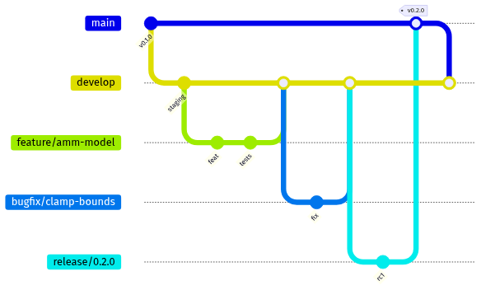
Figure 2
The CI workflows enforce this topology: tests and docs run on every push to main and develop and on every pull request targeting main, and the PyPI publish workflow only fires on a published GitHub Release (see Automated testing & CI/CD).

2. Semantic versioning
sparsehydro adopts Semantic Versioning 2.0.0 (MAJOR.MINOR.PATCH) with a formal pre-release progression. The current published version is 0.1.0 and the package is classified as Development Status :: 3 - Alpha in pyproject.toml.
Segment | Increment when…
MAJOR | Backwards-incompatible API changes (e.g. IModel contract changes).
MINOR | Backwards-compatible features (new model, solver, or objective).
PATCH | Backwards-compatible bug fixes only.

Pre-release channels
Releases mature through a defined sequence of pre-release identifiers before a final release:
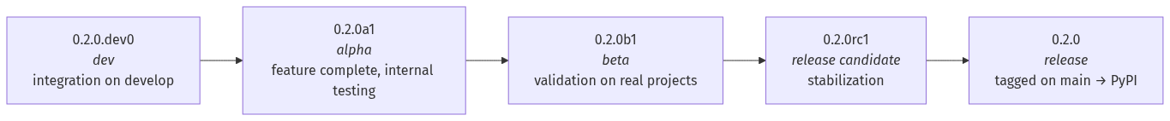
Figure 3
Stage | Identifier (PEP 440) | Meaning
dev | X.Y.Z.devN | Active integration on develop; API may change daily.
alpha | X.Y.ZaN | Feature-complete; internal testing; API mostly stable.
beta | X.Y.ZbN | Validated against real project data; only fixes expected.
rc | X.Y.ZrcN | Release candidate; documentation and changelog finalized.
release | X.Y.Z | Tagged on main; published to PyPI; entered in CHANGELOG.
The package version is declared in two synchronized locations — pyproject.toml ([project].version) and sparsehydro/__init__.py (__version__) — and every release is recorded in CHANGELOG.md following the Keep a Changelog convention. The Python version identifiers above conform to PEP 440.

3. Documented formulations & code structure
Every model formulation and architectural decision is documented in version-controlled Markdown/reStructuredText, rendered to HTML via Sphinx, and published to GitHub Pages. Documentation is treated as a build artifact: the docs job compiles with sphinx-build -W --keep-going, so any warning (a broken cross-reference, an undocumented symbol, a malformed directive) fails the build.

Documentation set
Document | Scope
DESIGN.md | Package design: lifecycle, parameter system, IModel ABC.
docs/rdii_design.md | Physics-based RDII / Initial-Abstraction formulation.
docs/combined_model.md | Configurable composite IA + unit-hydrograph model.
docs/unithydrograph_strategy.md | Unit-hydrograph subpackage architecture.
docs/getting_started.rst | End-to-end calibration walkthrough.
docs/api.rst | Autodoc API reference with literature citations.

Formulations are mathematically specified
Model equations are written out in LaTeX so reviewers can check the implementation against the math. For example, the RDII Initial-Abstraction recovery and depletion ODEs are documented in docs/rdii_design.md:
$$IA_{avail}(t+Δt)=IA_{max}−\left(IA_{max}−IA_{avail}(t)\right) e^{−k_{rec}(T) Δt}$$

Architecture is documented with diagrams
The README and Sphinx docs include Mermaid class, flow, and sequence diagrams that are kept in sync with the code. The core abstractions and their relationships:
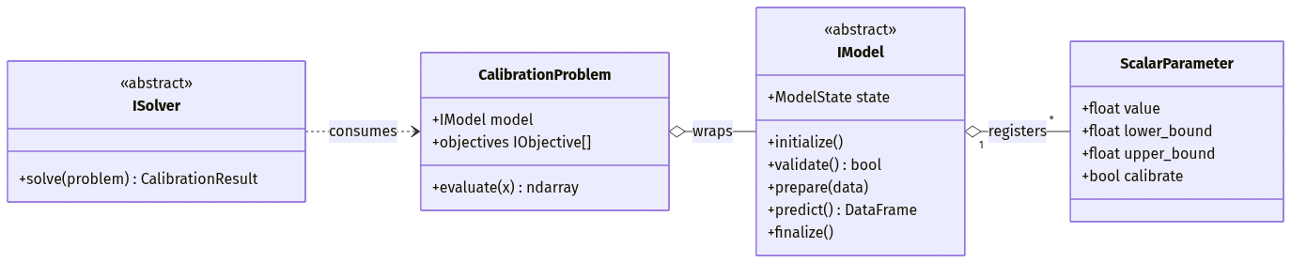
Figure 4

Implementations cite their sources
Documented formulations reference the peer-reviewed literature they implement so that the modeling assumptions are traceable. Key references:
- Edgren, J., Czachorski, R., & Gonwa, W. (2024). Antecedent Moisture Model. Journal of Water Management Modeling, 32, C525. https://doi.org/10.14796/JWMM.C525 — implemented by sparsehydro.models.amm.AMMModel.
- Nash, J. E., & Sutcliffe, J. V. (1970). River flow forecasting through conceptual models part I. Journal of Hydrology, 10(3), 282–290 — NashSutcliffe objective.
- Gupta, H. V., Kling, H., Yilmaz, K. K., & Martinez, G. F. (2009). Decomposition of the mean squared error and NSE performance criteria. Journal of Hydrology, 377 — KGE objective.
- Deb, K., Pratap, A., Agarwal, S., & Meyarivan, T. (2002). A fast and elitist multiobjective genetic algorithm: NSGA-II. IEEE Trans. Evol. Comput., 6(2) — NSGAIISolver (via pymoo).

4. Automated testing & CI/CD
All correctness checks are automated with GitHub Actions and run on every push to main/develop and on every pull request into main. No change reaches a protected branch without a green test suite.

Test suite scope
Metric | Value
Test functions | 646 across 18 test modules
Frameworks | pytest, pytest-cov
Operating systems | Ubuntu, Windows, macOS
Python versions | 3.10, 3.11, 3.12
Matrix combinations | 9 (3 OS × 3 Python)
Coverage reporting | --cov-report=term-missing + coverage.xml → Codecov
The suite combines unit tests (parameters, enums, registry, interfaces, objectives) with regression tests that pin numerical behavior of the scientific models — e.g. test_amm_model.py verifies model outputs against worked examples from the source paper, and test_rdii_model.py (93 tests) and test_calibration_comprehensive.py (105 tests) lock down the calibration math. Because these regression tests assert against known-good values, any unintended change to a formulation is caught automatically.
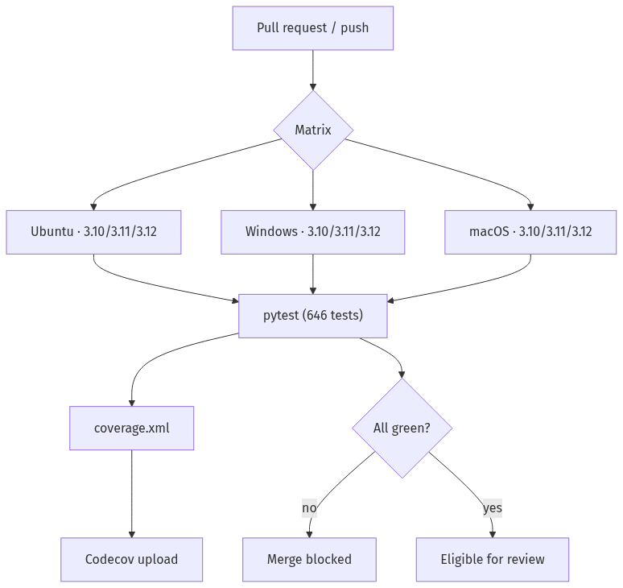
Figure 5

Workflows
Workflow | Trigger | Purpose
tests.yml | push main/dev, PR → main | Run the full matrix test suite; upload coverage.
docs.yml | push main/dev, PR → main | Build Sphinx docs with warnings-as-errors; deploy.
publish.yml | GitHub Release published | Build sdist+wheel and publish to PyPI (OIDC).
The publish workflow uses PyPI trusted publishing (OpenID Connect, id-token: write), so no long-lived API tokens are stored — releases are cryptographically attributed to the workflow run, reducing supply-chain risk.

Coverage policy
Coverage is configured in pyproject.toml (--cov=sparsehydro --cov-report=term-missing --cov-report=xml) and uploaded to Codecov from the canonical job (Ubuntu / Python 3.12). Coverage is tracked over time and reviewers are expected to ensure new code ships with corresponding tests so that overall coverage trends upward and core scientific modules stay well covered.

5. Pull-request review & merge gate
Code review by a senior engineer is a required, non-bypassable gate. Branch protection on main and develop requires:
- ✅ All CI status checks passing (test matrix + docs build).
- ✅ At least one approving review from a designated senior engineer (enforced via a CODEOWNERS reviewer assignment).
- ✅ The branch up to date with its base before merge.
- ✅ Conversations resolved.
- 🚫 No direct pushes to protected branches — changes land only via PR.
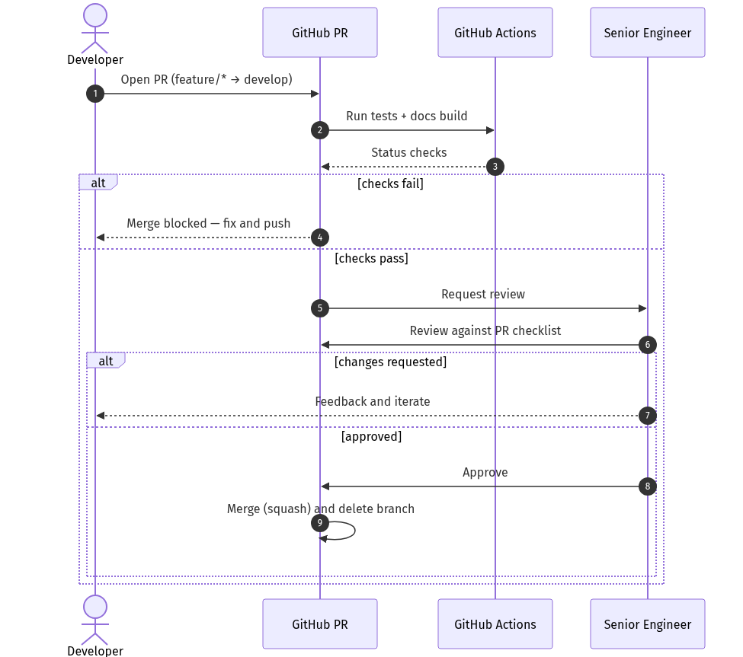
Figure 6

Pull-request checklist (template)
Every PR must complete the following checklist before it is eligible for merge. This is maintained as a repository PR template (.github/PULL_REQUEST_TEMPLATE.md) so it is pre-populated on every new PR:
## Summary
<!-- What does this change do and why? -->
## Related issues
<!-- Closes #… -->
## Type of change
- [ ] Bug fix (non-breaking)
- [ ] New feature (non-breaking)
- [ ] Breaking change (MAJOR version bump)
- [ ] Documentation only
## QA/QC checklist
- [ ] Branch follows naming convention (`feature/*`, `bugfix/*`, `hotfix/*`).
- [ ] Targets the correct base branch (`develop` for features/bugfixes).
- [ ] New/changed behavior is covered by unit and/or regression tests.
- [ ] Full test suite passes locally (`pytest`) and in CI (all matrix legs).
- [ ] Coverage does not regress; new code is exercised by tests.
- [ ] Public API changes are reflected in docstrings and `docs/`.
- [ ] Sphinx docs build cleanly (`sphinx-build -W`).
- [ ] Formulation changes cite the relevant literature.
- [ ] Version bumped appropriately (SemVer) and `CHANGELOG.md` updated.
- [ ] No secrets, credentials, or large data files committed.
## Reviewer (senior engineer)
- [ ] Math/implementation reviewed against documented formulation.
- [ ] Test design reviewed for adequacy and correctness.

6. Independent validation across projects
Beyond automated tests, the package and its formulations are independently exercised and validated on real engineering projects, providing a second, domain-level verification layer outside the unit-test harness:
- SERWS Big Sandy Model — calibration experiments and Pareto analyses (calibration.ipynb, chilacothe_calibration.ipynb, sheridan.ipynb).
- Southeast Ohio Regional Water Study — regression and calibration notebooks (Zanesville, Chillicothe, Rio Grande) that apply the same models and solvers to independent datasets.
- UnitHydrograph — companion package exercising the unit-hydrograph formulations against multiple monitored sewershed datasets.
- Example notebooks shipped with the package (sparsehydro/notebooks/) demonstrate and sanity-check end-to-end workflows on representative data.
When a formulation is found to be deficient on a real project, the finding is captured as an issue, fixed on a bugfix/* branch with an accompanying regression test, and flows back through the same review and release pipeline — closing the loop between field validation and the automated test suite.

Summary
Pillar | Control
Branching | Protected main/develop; feature/*, bugfix/*, hotfix/* topics.
Versioning | SemVer 2.0 with dev → alpha → beta → rc → release (PEP 440).
Documentation | Sphinx (warnings-as-errors) + diagrams + literature citations.
Automated testing | 646 tests, 3 OS × 3 Python matrix, coverage to Codecov, on every change.
Review gate | Mandatory senior-engineer approval + standardized PR checklist.
Independent validation | Real-project notebooks and companion packages cross-check formulations.
Together these controls ensure that every change to sparsehydro is tested, reviewed, documented, versioned, and independently validated before it reaches users.

