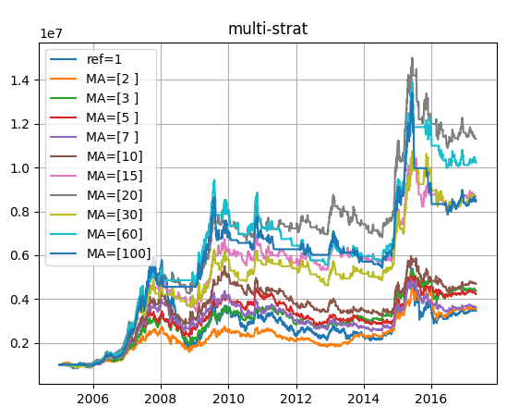

Moving Average - Breakthrough
ref=1 MA=[2 ] MA=[3 ] MA=[5 ] MA=[7 ] MA=[10] MA=[15] \
2005 -0.069597 -0.028507 0.049202 0.033813 -0.041444 0.014165 -0.002622
2006 1.209604 0.542901 0.579432 0.759385 0.749585 0.784503 1.215259
2007 1.615076 0.735603 0.850957 0.765399 1.203521 1.226589 1.105741
2008 -0.659433 -0.298516 -0.290515 -0.176667 -0.255304 -0.221915 -0.221799
2009 0.966866 0.440701 0.672324 0.576043 0.520709 0.639475 0.740334
2010 -0.125112 -0.034603 -0.021137 -0.022944 -0.195052 -0.152557 -0.032940
2011 -0.250106 -0.167427 -0.190690 -0.187013 -0.101287 -0.132327 -0.070857
2012 0.075530 -0.077453 0.013690 -0.018019 -0.014441 0.032120 0.078098
2013 -0.076454 0.189751 0.074674 -0.064983 -0.081506 -0.098160 -0.040789
2014 0.516487 0.428702 0.385746 0.289442 0.339980 0.312463 0.341799
2015 0.055826 0.257422 0.116591 0.157092 0.035074 0.045383 0.115670
2016 -0.112803 -0.162925 -0.096357 -0.073978 -0.037290 -0.038921 -0.009033
2017 0.039169 0.017575 -0.004158 0.005094 -0.010631 0.012295 -0.000563

MA=[20] MA=[30] MA=[60] MA=[100]
2005 0.077086 -0.040174 0.010416 -0.037858
2006 1.183908 1.035196 1.190337 1.071753
2007 1.153710 1.231320 1.275892 1.370137
2008 -0.099927 -0.129571 -0.068421 -0.036067
2009 0.753500 0.532477 0.721515 0.560473
2010 -0.083645 -0.034395 -0.105815 -0.045325
2011 -0.014264 -0.038708 -0.108415 -0.075733
2012 0.101151 -0.036311 -0.029432 0.027487
2013 -0.067581 -0.009729 -0.047597 -0.115122
2014 0.468814 0.497173 0.542552 0.551153
2015 0.101285 0.247640 0.288322 0.013763
2016 -0.033221 -0.124676 -0.144881 -0.065553
2017 -0.024257 0.012376 0.010293 0.010103

ref=1 MA=[2 ] MA=[3 ] MA=[5 ] MA=[7 ] MA=[10] \
rtot 1.242516 1.266758 1.475502 1.439835 1.286607 1.546768
ravg 0.000415 0.000423 0.000493 0.000481 0.000430 0.000517
rnorm 0.110322 0.112592 0.132326 0.128929 0.114453 0.139143
rnorm100 11.032240 11.259173 13.232563 12.892912 11.445328 13.914268

MA=[15] MA=[20] MA=[30] MA=[60] MA=[100]
rtot 2.161113 2.426158 2.143031 2.324388 2.135597
ravg 0.000722 0.000811 0.000716 0.000777 0.000714
rnorm 0.199637 0.226718 0.197811 0.216248 0.197061
rnorm100 19.963681 22.671788 19.781120 21.624788 19.706148

ref=1 MA=[2 ] MA=[3 ] MA=[5 ] MA=[7 ] MA=[10] \
sharperatio 0.377438 0.43254 0.461189 0.454927 0.372399 0.421244

MA=[15] MA=[20] MA=[30] MA=[60] MA=[100]
sharperatio 0.52674 0.580404 0.53291 0.54216 0.507314

ref=1 MA=[2 ] MA=[3 ] MA=[5 ] MA=[7 ] MA=[10] MA=[15] \
vwr 4.04696 4.119581 4.728597 4.62331 4.176158 4.938483 6.826629

MA=[20] MA=[30] MA=[60] MA=[100]
vwr 7.689274 6.769276 7.354061 6.74485

ref=1 MA=[2 ] MA=[3 ] MA=[5 ] MA=[7 ] MA=[10] \
sqn 0 1.363356 1.519474 1.344167 1.093364 1.357911
trades 0 736.000000 517.000000 360.000000 289.000000 236.000000

MA=[15] MA=[20] MA=[30] MA=[60] MA=[100]
sqn 1.767587 1.739591 1.566486 1.271874 1.092261
trades 170.000000 144.000000 104.000000 73.000000 58.000000

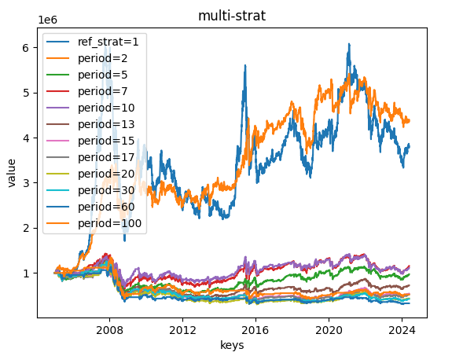

Moving Average – Reversion
ref=1 MA=[2 ] MA=[3 ] MA=[5 ] MA=[7 ] MA=[10] MA=[15] \
2005 -0.069597 -0.033199 -0.105481 -0.104086 -0.033552 -0.065843 -0.071966
2006 1.209604 0.431976 0.398728 0.255726 0.262939 0.238066 -0.002514
2007 1.615076 0.505551 0.411782 0.480314 0.186230 0.173893 0.241423
2008 -0.659433 -0.513834 -0.519558 -0.585991 -0.542263 -0.561842 -0.561842
2009 0.966866 0.364813 0.175513 0.248014 0.292644 0.200380 0.130672
2010 -0.125112 -0.093766 -0.105876 -0.104350 0.087190 0.032359 -0.095338
2011 -0.250106 -0.099193 -0.073424 -0.077592 -0.165318 -0.135461 -0.192389
2012 0.075530 0.165791 0.060891 0.095093 0.091082 0.041977 -0.002098
2013 -0.076454 -0.223562 -0.140402 -0.012454 0.005256 0.023965 -0.037047
2014 0.516487 0.061066 0.094123 0.175738 0.131622 0.155249 0.129842
2015 0.055826 -0.159853 -0.054553 -0.087454 0.021018 0.010071 -0.052195
2016 -0.112803 0.059835 -0.017693 -0.042226 -0.078785 -0.076309 -0.103524
2017 0.039169 0.021105 0.043448 0.033827 0.050210 0.026480 0.039639

MA=[20] MA=[30] MA=[60] MA=[100]
2005 -0.103132 -0.079593 -0.071879 0.051723
2006 0.011636 0.085773 0.008887 0.066183
2007 0.214010 0.171531 0.148620 0.102745
2008 -0.621075 -0.608365 -0.634412 -0.645934
2009 0.121399 0.282794 0.141920 0.259535
2010 -0.044709 -0.093525 -0.021953 -0.083702
2011 -0.238866 -0.219427 -0.158473 -0.187782
2012 -0.023378 0.115999 0.108088 0.046326
2013 -0.009753 -0.067435 -0.029957 0.043506
2014 0.032192 0.013086 -0.016915 -0.022382
2015 -0.040653 -0.153068 -0.178819 0.042300
2016 -0.082395 0.013484 0.037187 -0.050244
2017 0.064539 0.026392 0.028448 0.028702

ref=1 MA=[2 ] MA=[3 ] MA=[5 ] MA=[7 ] MA=[10] \
rtot 1.242516 -0.014202 -0.224212 -0.202421 -0.047993 -0.284588
ravg 0.000415 -0.000005 -0.000075 -0.000068 -0.000016 -0.000095
rnorm 0.110322 -0.001195 -0.018707 -0.016904 -0.004034 -0.023684
rnorm100 11.032240 -0.119548 -1.870700 -1.690430 -0.403400 -2.368431

MA=[15] MA=[20] MA=[30] MA=[60] MA=[100]
rtot -0.918969 -1.144595 -0.950395 -1.072744 -0.807199
ravg -0.000307 -0.000383 -0.000318 -0.000359 -0.000270
rnorm -0.074480 -0.091902 -0.076927 -0.086390 -0.065726
rnorm100 -7.448024 -9.190208 -7.692669 -8.638993 -6.572649

ref=1 MA=[2 ] MA=[3 ] MA=[5 ] MA=[7 ] MA=[10] \
sharperatio 0.377438 0.101425 0.0125 0.045584 0.066848 -0.026306

MA=[15] MA=[20] MA=[30] MA=[60] MA=[100]
sharperatio -0.292473 -0.336689 -0.235483 -0.304434 -0.180002

ref=1 MA=[2 ] MA=[3 ] MA=[5 ] MA=[7 ] MA=[10] MA=[15] \
vwr 4.04696 -0.075599 -0.903346 -0.834688 -0.243063 -1.077094 -1.963949

MA=[20] MA=[30] MA=[60] MA=[100]
vwr -1.936588 -1.970404 -1.963391 -1.914797

ref=1 MA=[2 ] MA=[3 ] MA=[5 ] MA=[7 ] MA=[10] \
sqn 0 -0.016549 -0.270243 -0.262696 -0.050319 -0.356928
trades 0 736.000000 517.000000 359.000000 288.000000 236.000000

MA=[15] MA=[20] MA=[30] MA=[60] MA=[100]
sqn -1.255685 -1.6167 -1.30797 -0.953736 -0.712531
trades 169.000000 144.0000 103.00000 73.000000 59.000000
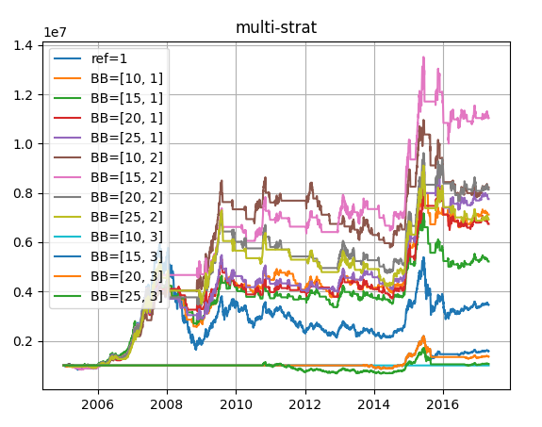

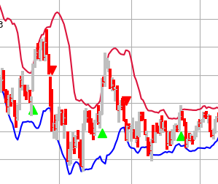
Bollinger-Band – Breakthrough
ref=1 BB=[10, 1] BB=[15, 1] BB=[20, 1] BB=[25, 1] BB=[10, 2] \
2005 -0.069597 -0.044996 0.019990 -0.068648 -0.024729 -0.081666
2006 1.209604 1.138282 1.171343 1.043110 0.993118 1.109704
2007 1.615076 0.945878 0.981571 1.236347 1.137766 1.166140
2008 -0.659433 -0.307941 -0.343867 -0.228235 -0.299299 -0.027471
2009 0.966866 0.582990 0.456852 0.292173 0.588001 0.796758
2010 -0.125112 0.027031 -0.112371 -0.063675 -0.067420 0.038036
2011 -0.250106 -0.087748 -0.006912 0.001281 -0.061341 0.009450
2012 0.075530 0.063527 0.040016 0.068048 0.105899 -0.122673
2013 -0.076454 -0.043006 -0.025967 -0.036587 0.022279 -0.066680
2014 0.516487 0.465214 0.437039 0.390762 0.381919 0.381090
2015 0.055826 0.170151 0.045563 0.345121 0.258200 0.044294
2016 -0.112803 -0.003372 -0.062277 -0.113068 -0.033354 -0.134296
2017 0.039169 0.003886 -0.012036 -0.008075 0.007440 0.046113

BB=[15, 2] BB=[20, 2] BB=[25, 2] BB=[10, 3] BB=[15, 3] BB=[20, 3] \
2005 -0.092699 -0.003491 -0.036992 0.0 0.000000 0.000000
2006 1.227550 1.007516 0.896175 0.0 0.000000 0.000000
2007 1.309883 1.112083 1.480936 0.0 0.000000 0.000000
2008 0.006933 -0.185347 -0.227229 0.0 0.000000 0.000000
2009 0.407965 0.748118 0.615770 0.0 0.000000 0.000000
2010 0.043692 -0.035291 0.007590 0.0 0.000000 0.000000
2011 -0.040233 -0.066164 -0.071906 0.0 0.000000 0.000000
2012 0.085950 0.014873 -0.031084 0.0 0.000000 0.000000
2013 0.019968 -0.042373 -0.042374 0.0 -0.045228 -0.045228
2014 0.341776 0.331499 0.353581 0.0 0.515626 0.515626
2015 0.182946 0.285178 0.201835 0.0 0.006582 -0.072969
2016 -0.053102 -0.103615 -0.139012 0.0 0.044281 -0.024540
2017 0.001012 0.007693 0.007691 0.0 0.039129 0.039142

BB=[25, 3]
2005 0.000000
2006 0.000000
2007 0.000000
2008 0.000000
2009 0.000000
2010 -0.001478
2011 -0.249993
2012 0.075484
2013 -0.076411
2014 0.516173
2015 -0.073020
2016 -0.024552
2017 0.039162

ref=1 BB=[10, 1] BB=[15, 1] BB=[20, 1] BB=[25, 1] \
rtot 1.242516 1.963007 1.651433 1.907737 2.047458
ravg 0.000415 0.000656 0.000552 0.000638 0.000684
rnorm 0.110322 0.179787 0.149229 0.174307 0.188208
rnorm100 11.032240 17.978651 14.922904 17.430728 18.820805

BB=[10, 2] BB=[15, 2] BB=[20, 2] BB=[25, 2] BB=[10, 3] \
rtot 2.106367 2.402248 2.097188 1.935474 0.0
ravg 0.000704 0.000803 0.000701 0.000647 0.0
rnorm 0.194118 0.224250 0.193195 0.177054 0.0
rnorm100 19.411810 22.424999 19.319526 17.705382 0.0

BB=[15, 3] BB=[20, 3] BB=[25, 3]
rtot 0.457817 0.307326 0.058053
ravg 0.000153 0.000103 0.000019
rnorm 0.039312 0.026222 0.004901
rnorm100 3.931249 2.622233 0.490146

ref=1 BB=[10, 1] BB=[15, 1] BB=[20, 1] BB=[25, 1] \
sharperatio 0.377438 0.51567 0.443998 0.485974 0.531732

BB=[10, 2] BB=[15, 2] BB=[20, 2] BB=[25, 2] BB=[10, 3] \
sharperatio 0.515602 0.564112 0.534293 0.468063 None

BB=[15, 3] BB=[20, 3] BB=[25, 3]
sharperatio 0.240039 0.152726 0.035603

ref=1 BB=[10, 1] BB=[15, 1] BB=[20, 1] BB=[25, 1] BB=[10, 2] \
vwr 4.04696 6.202279 5.250332 6.030734 6.466681 6.652702

BB=[15, 2] BB=[20, 2] BB=[25, 2] BB=[10, 3] BB=[15, 3] BB=[20, 3] \
vwr 7.611137 6.623255 6.116157 0.0 1.747113 1.257242

BB=[25, 3]
vwr 0.297407

ref=1 BB=[10, 1] BB=[15, 1] BB=[20, 1] BB=[25, 1] BB=[10, 2] \
sqn 0 1.712025 1.317856 1.513908 1.639525 1.431868
trades 0 106.000000 78.000000 61.000000 46.000000 36.000000

BB=[15, 2] BB=[20, 2] BB=[25, 2] BB=[10, 3] BB=[15, 3] \
sqn 2.103166 1.694624 1.363003 0 0
trades 31.000000 27.000000 22.000000 0 1

BB=[20, 3] BB=[25, 3]
sqn 0 0
trades 1 1

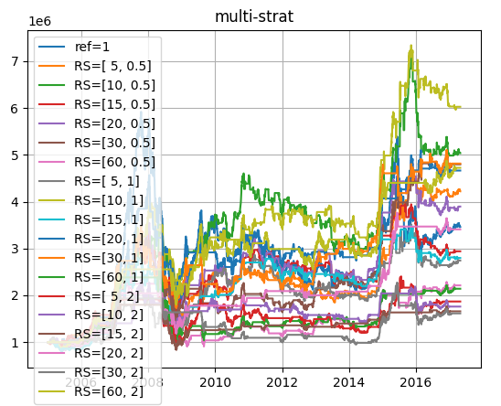

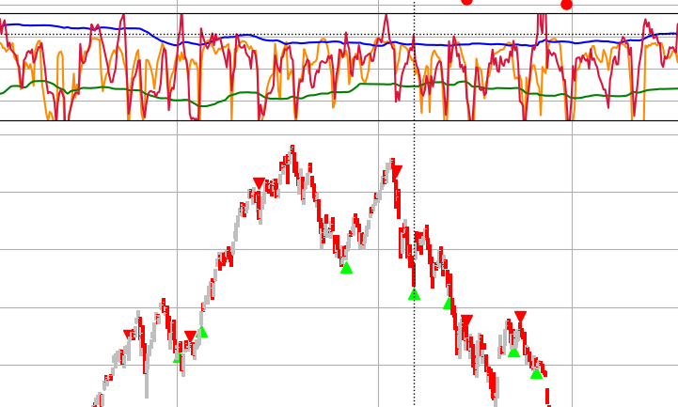

RSRS – Breakthrough (100 day dynamic thd)
ref=1 RS=[ 5, 0.5] RS=[10, 0.5] RS=[15, 0.5] RS=[20, 0.5] \
2005 -0.069597 0.065984 0.033362 -0.083533 -0.044636
2006 1.209604 0.496304 0.880825 0.873487 0.928495
2007 1.615076 0.866628 0.605879 0.796548 0.856329
2008 -0.659433 -0.488989 -0.250982 -0.435085 -0.484340
2009 0.966866 0.699875 0.593841 0.347950 0.497515
2010 -0.125112 -0.012495 0.201484 0.201181 0.084169
2011 -0.250106 -0.123609 -0.153625 -0.097555 -0.124018
2012 0.075530 -0.051364 -0.065583 0.029740 0.081201
2013 -0.076454 -0.038278 -0.094687 -0.061606 -0.102467
2014 0.516487 0.419453 0.390702 0.330908 0.547628
2015 0.055826 0.549286 0.420847 0.075115 0.194485
2016 -0.112803 -0.081102 -0.213084 -0.186738 -0.152868
2017 0.039169 0.022771 0.010464 0.026998 0.022076

RS=[30, 0.5] RS=[60, 0.5] RS=[ 5, 1] RS=[10, 1] RS=[15, 1] \
2005 -0.080400 -0.077119 -0.044450 -0.021792 -0.144130
2006 0.830144 0.831923 0.320413 0.963652 0.904486
2007 0.881189 0.330030 0.562203 0.896801 0.553724
2008 -0.436723 -0.547994 -0.382378 -0.355520 -0.456590
2009 0.028088 0.021343 1.060286 0.348446 0.526634
2010 0.106701 0.278990 0.023294 0.075302 0.286352
2011 -0.168375 -0.133015 -0.179888 0.030782 -0.132282
2012 0.239522 0.212310 0.021193 0.030028 0.047098
2013 0.058194 -0.005273 -0.068344 -0.022487 -0.052663
2014 0.531822 0.477981 0.313738 0.383381 0.373487
2015 0.306103 0.013546 0.218039 0.390922 -0.015636
2016 0.065594 0.018692 -0.183823 -0.112993 -0.121736
2017 0.016419 0.044754 0.048867 -0.000938 0.012929

RS=[20, 1] RS=[30, 1] RS=[60, 1] RS=[ 5, 2] RS=[10, 2] RS=[15, 2] \
2005 0.080199 0.154358 -0.020637 0.091279 0.000000 -0.022520
2006 0.958345 0.807682 0.828488 0.450197 0.403206 0.438159
2007 1.010788 0.427632 0.330681 0.210148 0.508217 0.279133
2008 -0.434652 -0.281422 -0.519427 -0.487191 -0.347533 -0.481756
2009 0.218884 0.046552 0.025540 0.849759 0.361365 0.348366
2010 0.119418 0.107910 0.181322 -0.115371 -0.049504 0.063911
2011 -0.179971 -0.126400 -0.032633 -0.058236 -0.048510 0.016938
2012 0.088552 0.227033 0.073270 -0.012829 -0.070929 -0.022161
2013 -0.038932 0.124852 0.006081 -0.134235 -0.052114 0.052673
2014 0.444951 0.552851 0.414555 0.279035 0.363444 0.148979
2015 0.147597 -0.001302 -0.009683 0.264806 0.031745 0.016736
2016 -0.015058 0.020357 0.013001 -0.106910 -0.164213 0.003188
2017 0.014549 0.016417 0.041190 0.000000 0.000000 0.011345

RS=[20, 2] RS=[30, 2] RS=[60, 2]
2005 0.000447 0.040694 0.045603
2006 0.653689 0.532767 0.783040
2007 0.235781 0.211756 0.370519
2008 -0.354943 -0.152167 -0.212726
2009 0.348563 -0.191524 0.609394
2010 0.093128 -0.174264 -0.074298
2011 0.075339 -0.062999 -0.002464
2012 -0.042393 0.096635 0.022003
2013 0.039103 -0.055648 0.019048
2014 0.195472 0.412459 0.387212
2015 0.394859 0.194010 0.019115
2016 -0.024554 -0.112468 0.027368
2017 0.007374 0.016423 0.044287

ref=1 RS=[ 5, 0.5] RS=[10, 0.5] RS=[15, 0.5] RS=[20, 0.5] \
rtot 1.242516 1.439944 1.616649 1.078551 1.359924
ravg 0.000415 0.000481 0.000540 0.000360 0.000455
rnorm 0.110322 0.128940 0.145867 0.095094 0.121356
rnorm100 11.032240 12.893955 14.586708 9.509432 12.135646

RS=[30, 0.5] RS=[60, 0.5] RS=[ 5, 1] RS=[10, 1] RS=[15, 1] \
rtot 1.567823 0.794381 1.009137 1.796001 1.028878
ravg 0.000524 0.000266 0.000337 0.000600 0.000344
rnorm 0.141165 0.069195 0.088711 0.163308 0.090522
rnorm100 14.116451 6.919542 8.871070 16.330779 9.052241

RS=[20, 1] RS=[30, 1] RS=[60, 1] RS=[ 5, 2] RS=[10, 2] \
rtot 1.539943 1.571448 0.761367 0.625310 0.565475
ravg 0.000515 0.000525 0.000254 0.000209 0.000189
rnorm 0.138488 0.141513 0.066227 0.054078 0.048779
rnorm100 13.848801 14.151299 6.622652 5.407806 4.877933

RS=[15, 2] RS=[20, 2] RS=[30, 2] RS=[60, 2]
rtot 0.505960 1.226322 0.479426 1.552310
ravg 0.000169 0.000410 0.000160 0.000519
rnorm 0.043535 0.108809 0.041206 0.139675
rnorm100 4.353531 10.880905 4.120579 13.967453

ref=1 RS=[ 5, 0.5] RS=[10, 0.5] RS=[15, 0.5] RS=[20, 0.5] \
sharperatio 0.377438 0.451235 0.491269 0.36257 0.418755

RS=[30, 0.5] RS=[60, 0.5] RS=[ 5, 1] RS=[10, 1] RS=[15, 1] \
sharperatio 0.476832 0.32329 0.337245 0.514701 0.357021

RS=[20, 1] RS=[30, 1] RS=[60, 1] RS=[ 5, 2] RS=[10, 2] \
sharperatio 0.446824 0.53724 0.31171 0.268468 0.25325

RS=[15, 2] RS=[20, 2] RS=[30, 2] RS=[60, 2]
sharperatio 0.259276 0.480836 0.221513 0.526851

ref=1 RS=[ 5, 0.5] RS=[10, 0.5] RS=[15, 0.5] RS=[20, 0.5] \
vwr 4.04696 4.624379 5.14664 3.57543 4.389914

RS=[30, 0.5] RS=[60, 0.5] RS=[ 5, 1] RS=[10, 1] RS=[15, 1] \
vwr 5.002529 2.755541 3.376401 5.688212 3.432867

RS=[20, 1] RS=[30, 1] RS=[60, 1] RS=[ 5, 2] RS=[10, 2] RS=[15, 2] \
vwr 4.918498 5.012601 2.659072 2.257048 2.076923 1.895335

RS=[20, 2] RS=[30, 2] RS=[60, 2]
vwr 4.003361 1.812947 4.955959

ref=1 RS=[ 5, 0.5] RS=[10, 0.5] RS=[15, 0.5] RS=[20, 0.5] \
sqn 0 1.668272 1.353621 0.942255 1.265621
trades 0 224.000000 121.000000 87.000000 67.000000

RS=[30, 0.5] RS=[60, 0.5] RS=[ 5, 1] RS=[10, 1] RS=[15, 1] \
sqn 1.971664 0.772068 1.213556 1.975964 1.02339
trades 46.000000 27.000000 124.000000 78.000000 58.00000

RS=[20, 1] RS=[30, 1] RS=[60, 1] RS=[ 5, 2] RS=[10, 2] \
sqn 1.67699 1.559936 0.636699 0.678015 0.799006
trades 43.00000 33.000000 19.000000 28.000000 22.000000

RS=[15, 2] RS=[20, 2] RS=[30, 2] RS=[60, 2]
sqn 0.705712 1.626206 0.473972 1.863017
trades 15.000000 14.000000 11.000000 12.000000

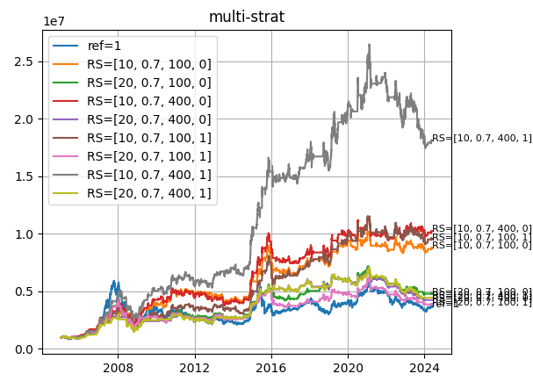

RSRS – Breakthrough (standard score = +-0.7, use adjusted R^2 to filter out poor OLS fitting)
ref=1 RS=[10, 0.7, 100, 0] RS=[20, 0.7, 100, 0] \
2005 -0.069597 0.067935 0.034787
2006 1.209604 0.828211 0.993468
2007 1.615076 0.584310 1.027550
2008 -0.659433 -0.165715 -0.493598
2009 0.966866 0.553414 0.358202
2010 -0.125112 0.206830 0.081383
2011 -0.250106 -0.047522 -0.163014
2012 0.075530 -0.013666 0.137734
2013 -0.076454 -0.050549 -0.086593
2014 0.516487 0.413258 0.505150
2015 0.055826 0.315048 0.273119
2016 -0.112803 -0.185062 -0.172321
2017 0.217719 0.148773 0.172444
2018 -0.253068 -0.035903 0.042771
2019 0.360637 0.277297 0.153914
2020 0.272074 0.030539 0.111494
2021 -0.051981 -0.055203 -0.100976
2022 -0.216306 -0.022704 -0.177400
2023 -0.113768 0.005510 -0.023870
2024 0.053157 -0.009807 -0.019386

RS=[10, 0.7, 400, 0] RS=[20, 0.7, 400, 0] RS=[10, 0.7, 100, 1] \
2005 0.076410 0.006224 -0.018158
2006 0.993728 0.842301 1.006671
2007 0.697720 0.666917 0.727446
2008 -0.376156 -0.425554 -0.412053
2009 0.873017 0.350421 0.561497
2010 0.183659 0.167345 0.123777
2011 -0.104569 -0.124093 -0.041363
2012 -0.043157 0.033984 0.099352
2013 -0.039491 0.049166 -0.055896
2014 0.572628 0.438693 0.409042
2015 0.379134 0.319003 0.469548
2016 -0.172675 0.014124 -0.123566
2017 0.113251 0.137407 0.142395
2018 -0.024199 -0.105276 0.024573
2019 0.246501 0.154143 0.311802
2020 0.060353 0.074106 0.103506
2021 -0.076748 -0.105423 -0.037072
2022 0.020095 -0.194959 -0.055097
2023 0.026168 -0.066932 -0.013872
2024 -0.011557 -0.024494 -0.013112

RS=[20, 0.7, 100, 1] RS=[10, 0.7, 400, 1] RS=[20, 0.7, 400, 1]
2005 0.012273 -0.011650 -0.111183
2006 0.993518 0.981909 0.885538
2007 1.028095 1.353151 0.705940
2008 -0.479916 -0.420293 -0.430470
2009 0.326416 0.881574 0.524866
2010 0.073815 0.191627 0.160886
2011 -0.189195 -0.072166 -0.171297
2012 0.113053 0.108259 0.079193
2013 -0.048738 0.135294 0.053717
2014 0.515009 0.472057 0.447785
2015 0.273123 0.494756 0.291723
2016 -0.266626 -0.035123 0.001057
2017 0.112049 0.113681 0.129457
2018 0.025107 -0.049643 -0.055257
2019 0.152977 0.333956 0.111982
2020 0.182239 0.133297 0.068463
2021 -0.117645 -0.017969 -0.068849
2022 -0.180553 -0.134535 -0.195030
2023 -0.040152 -0.082128 -0.082470
2024 -0.033671 -0.023311 0.000000

ref=1 RS=[10, 0.7, 100, 0] RS=[20, 0.7, 100, 0] \
rtot 1.291793 2.170139 1.560995
ravg 0.000274 0.000461 0.000331
rnorm 0.071528 0.123063 0.087066
rnorm100 7.152802 12.306333 8.706650

RS=[10, 0.7, 400, 0] RS=[20, 0.7, 400, 0] RS=[10, 0.7, 100, 1] \
rtot 2.322999 1.442566 2.252628
ravg 0.000493 0.000306 0.000478
rnorm 0.132282 0.080203 0.128029
rnorm100 13.228201 8.020314 12.802871

RS=[20, 0.7, 100, 1] RS=[10, 0.7, 400, 1] RS=[20, 0.7, 400, 1]
rtot 1.344578 2.896070 1.489232
ravg 0.000285 0.000615 0.000316
rnorm 0.074557 0.167522 0.082902
rnorm100 7.455721 16.752160 8.290238

ref=1 RS=[10, 0.7, 100, 0] RS=[20, 0.7, 100, 0] \
sharperatio 0.303284 0.496674 0.340886

RS=[10, 0.7, 400, 0] RS=[20, 0.7, 400, 0] RS=[10, 0.7, 100, 1] \
sharperatio 0.457023 0.347353 0.466634

RS=[20, 0.7, 100, 1] RS=[10, 0.7, 400, 1] RS=[20, 0.7, 400, 1]
sharperatio 0.308238 0.495428 0.34658

ref=1 RS=[10, 0.7, 100, 0] RS=[20, 0.7, 100, 0] \
vwr 2.607713 4.207068 3.086654

RS=[10, 0.7, 400, 0] RS=[20, 0.7, 400, 0] RS=[10, 0.7, 100, 1] \
vwr 4.499317 2.87566 4.364524

RS=[20, 0.7, 100, 1] RS=[10, 0.7, 400, 1] RS=[20, 0.7, 400, 1]
vwr 2.701703 5.640862 2.958837

ref=1 RS=[10, 0.7, 100, 0] RS=[20, 0.7, 100, 0] \
sqn 0 1.877104 1.247111
trades 0 155.000000 86.000000

RS=[10, 0.7, 400, 0] RS=[20, 0.7, 400, 0] RS=[10, 0.7, 100, 1] \
sqn 2.029167 1.233404 2.03678
trades 139.000000 73.000000 107.00000

RS=[20, 0.7, 100, 1] RS=[10, 0.7, 400, 1] RS=[20, 0.7, 400, 1]
sqn 0.934469 2.192829 1.338027
trades 82.000000 87.000000 66.000000

