Checking for images. There’s an image because I was testing if the installation had any problems.

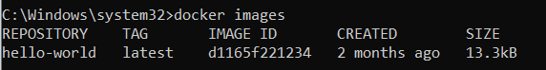

Running docker pull ubuntu:16.04

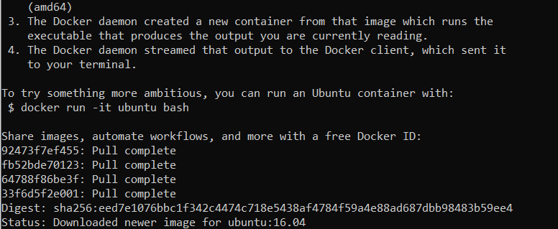

Running docker pull ubuntu:16.10

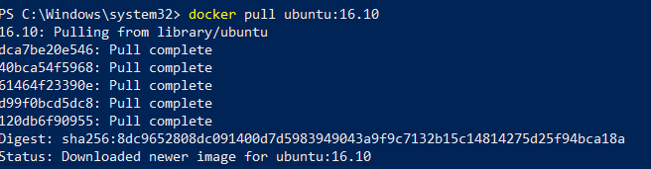

Note\* I changed to powershell

New images now!

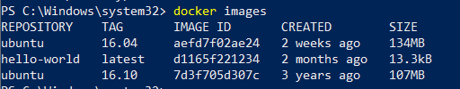

After removing the unwanted images



Hello World



Checking for containers



Interactive running



Bash session

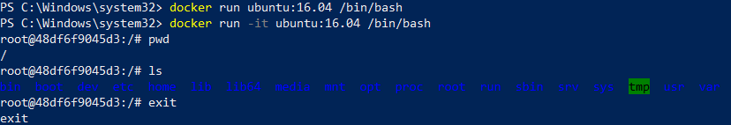

Running inside already running container

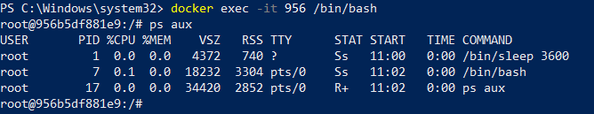

Using docker stop

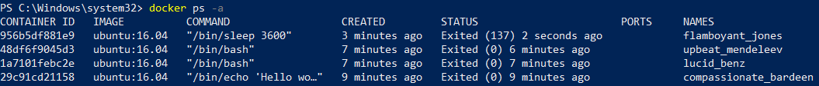

Removing containers

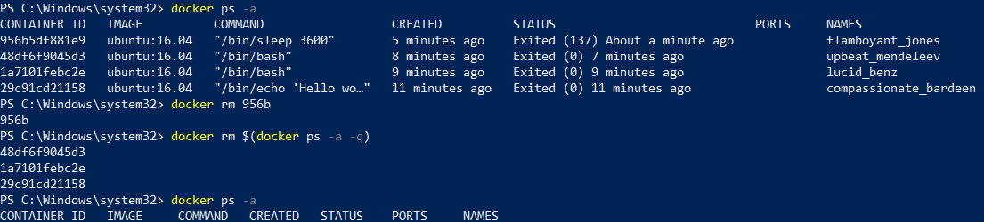

Removing container automatically after exit

