Mariella G. Dela Cruz

201503203

ME8 Activity 01

Running and Managing Docker Containers and Images

For all Activities, I basically followed the instructions on the provided GitHub tutorial. Screenshots are shown below. The captions describe each image.

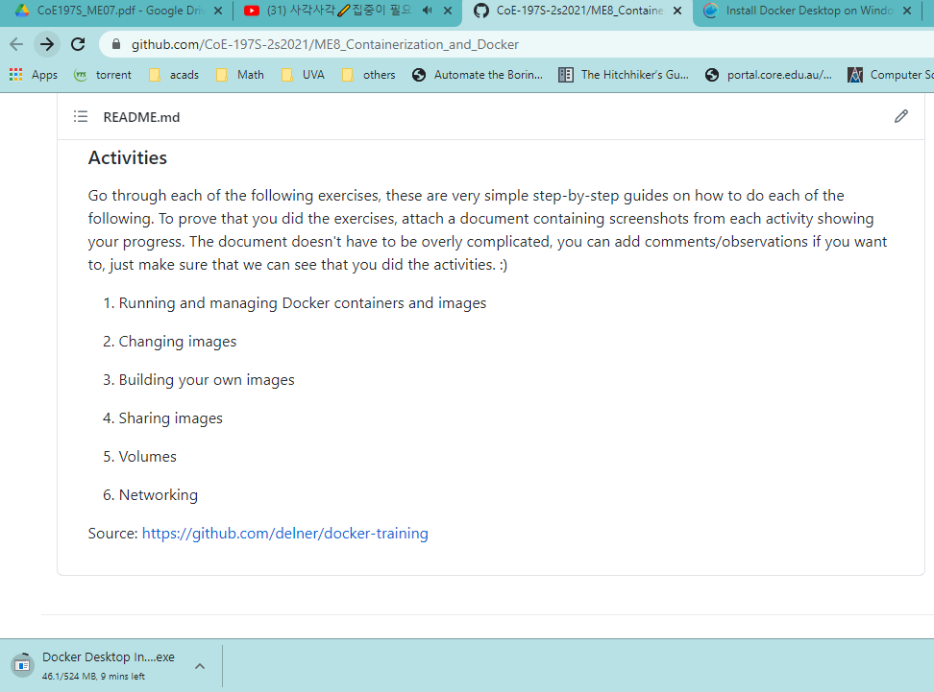

Figure 1. Download of Docker Desktop

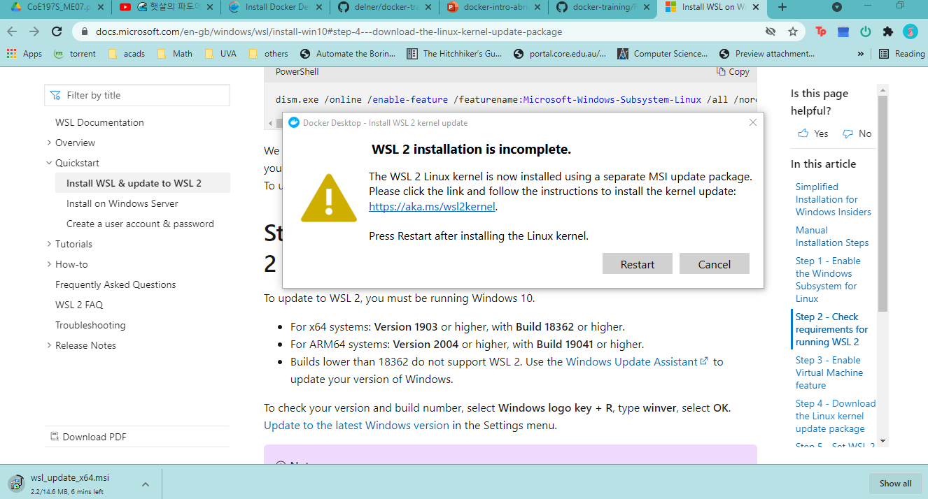

Figure 2. WSL2 Installation (For Docker Compatibility on Windows)

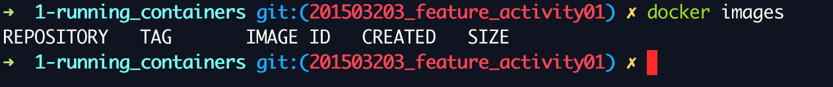

Figure 3. Initial run of Docker

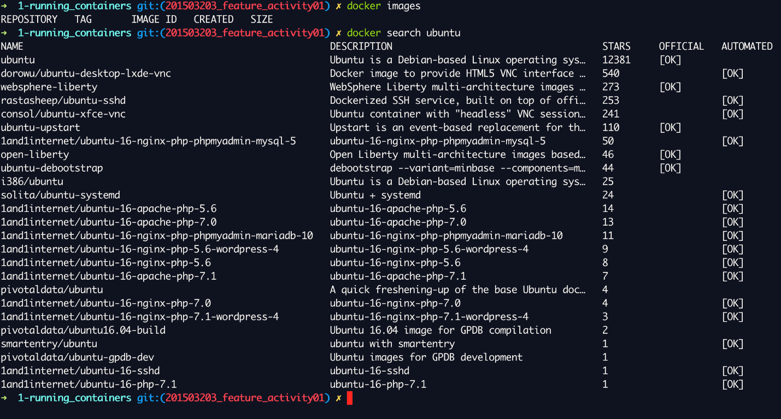

Figure 4. Searching for an Ubuntu distribution image for Docker

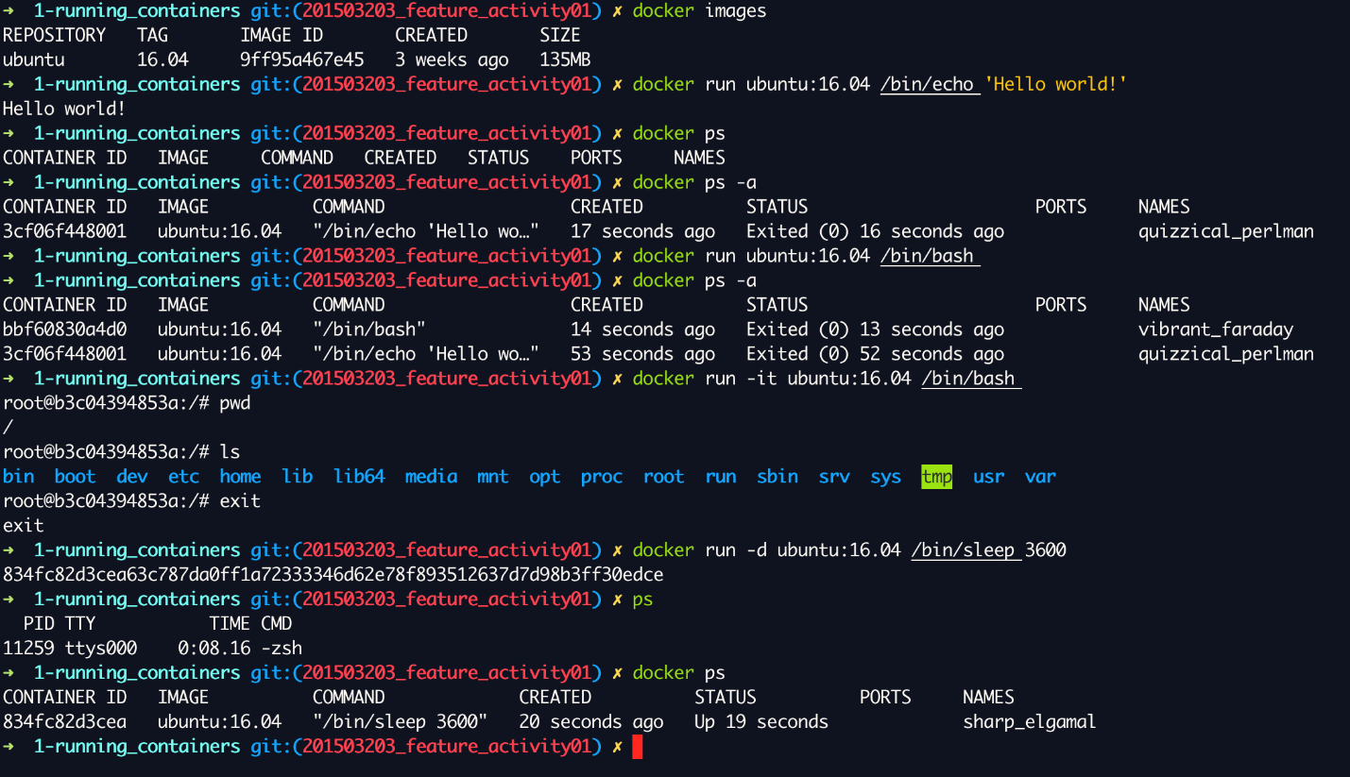

Figure 5. Pilot testing Docker with Ubuntu 16.04 images

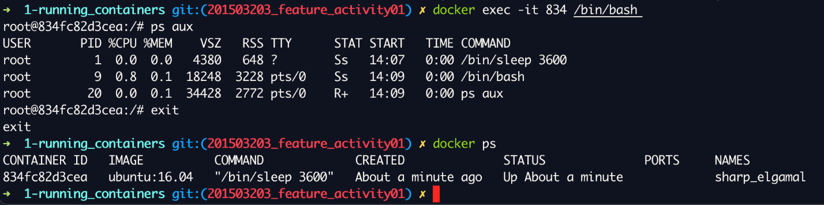

Figure 6. Using exec under Docker

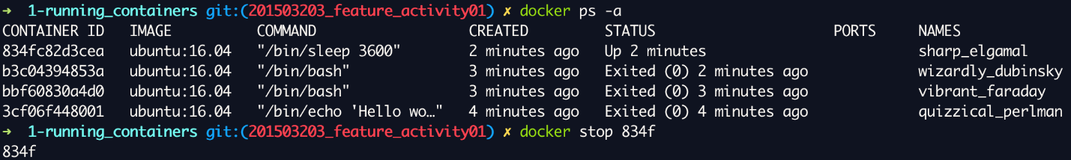

Figure 7. Stopping a Docker container’s execution

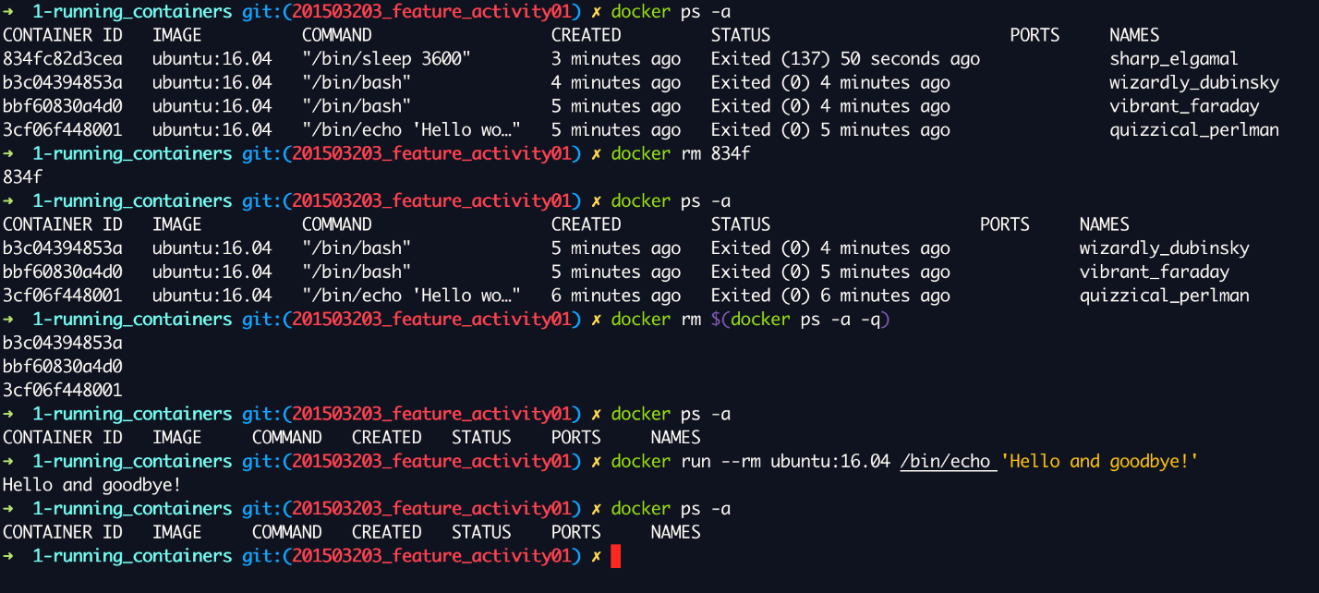

Figure 8. Finishing Activity 1