Ping command attempt

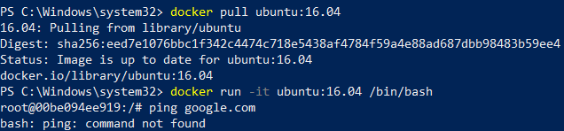

Getting updates and installing ping

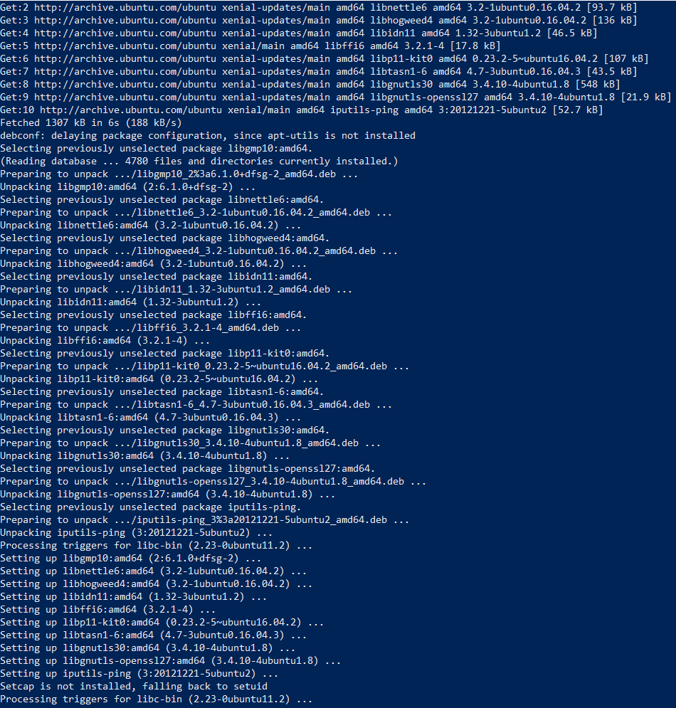

Committing a new image

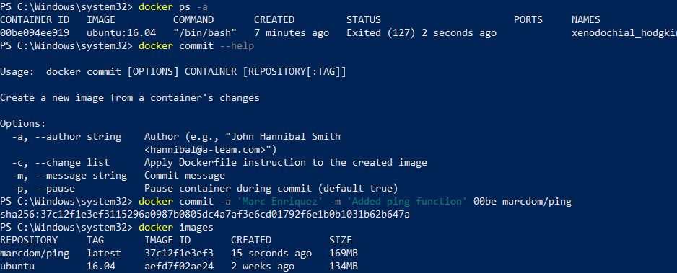

Testing new image

