Mariella G. Dela Cruz

201503203

ME8 Activity 02

Running and Managing Docker Containers and Images

For all Activities, I basically followed the instructions on the provided GitHub tutorial. Screenshots are shown below. The captions describe each image.

Figure 1. Updating the package database of the Ubuntu container

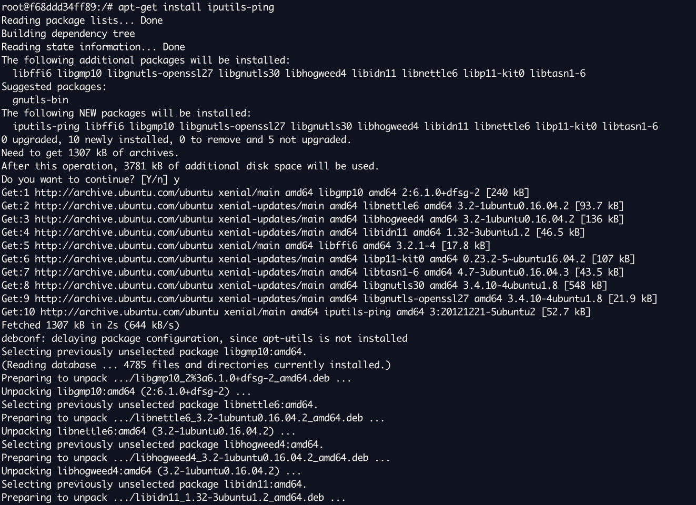

Figure 2. Installing the ping module manually in the container

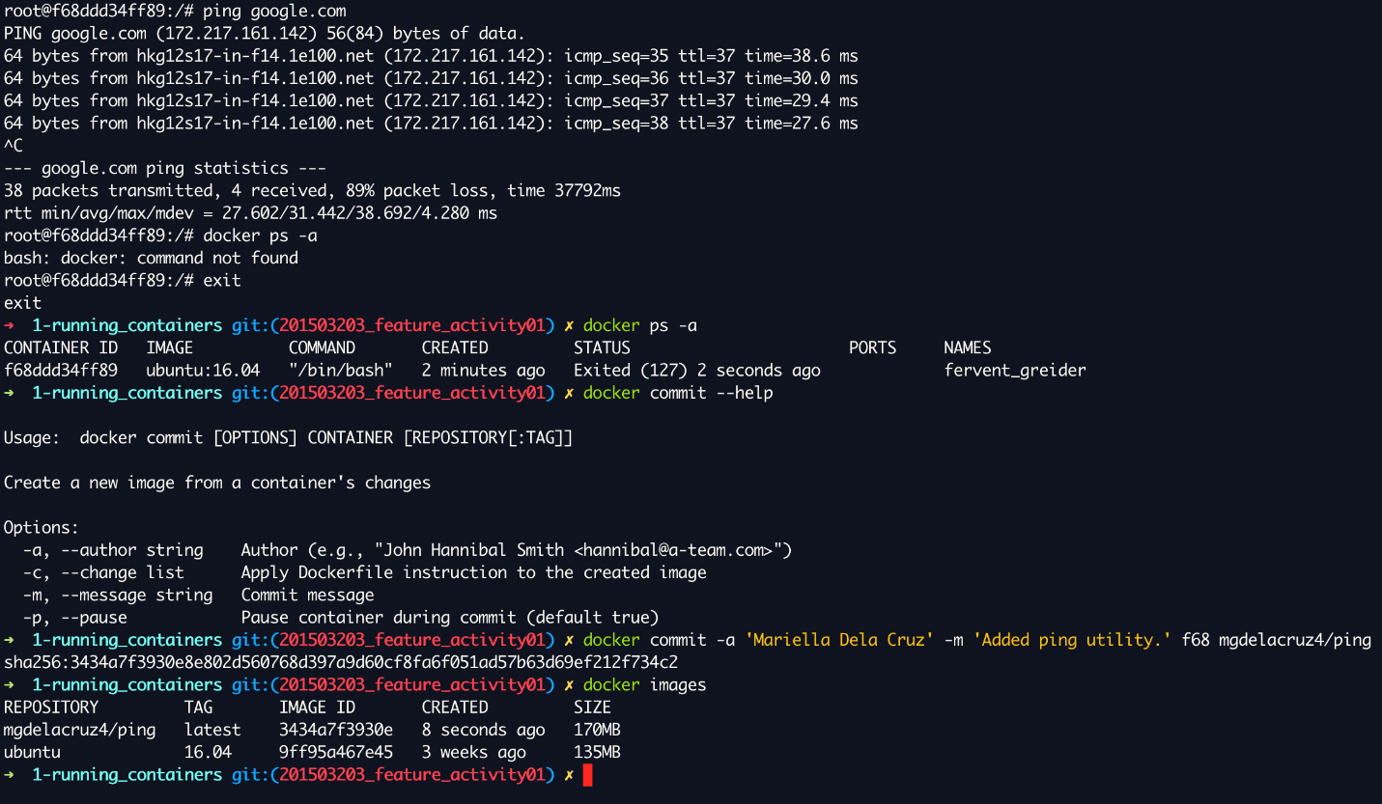

Figure 3. Testing the ping functionality of the container and saving the image in a new container

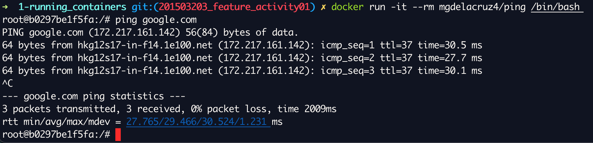

Figure 4. Running the cloned container with the ping utility