Deleting previous ping image

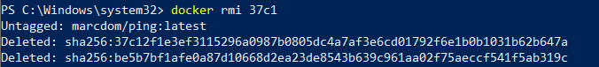

Creating docker image from docker file

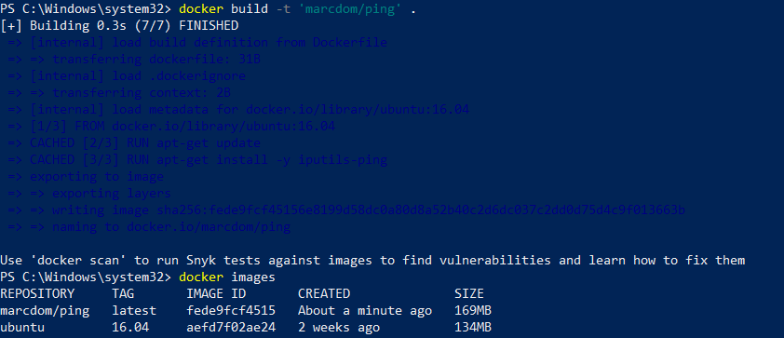

New and improved image

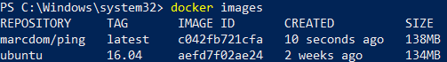

Using new ping image

