Mariella G. Dela Cruz

201503203

ME8 Activity 03

Running and Managing Docker Containers and Images

For all Activities, I basically followed the instructions on the provided GitHub tutorial. Screenshots are shown below. The captions describe each image.

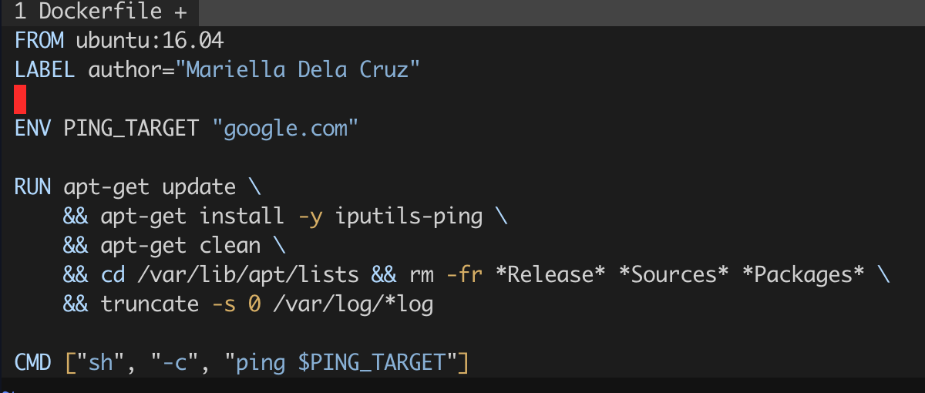

Figure 1. All the requested content of the Dockerfile configuration file. These lines enable automatic execution of the commands inside upon creation of the container. The commands also reduce the size of the new image relative to the original image that did not execute the commands.

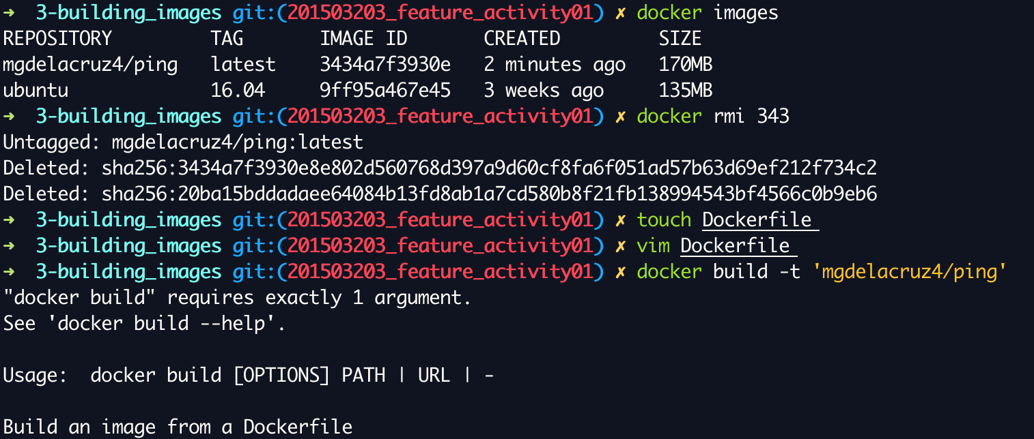

Figure 2. Using docker build

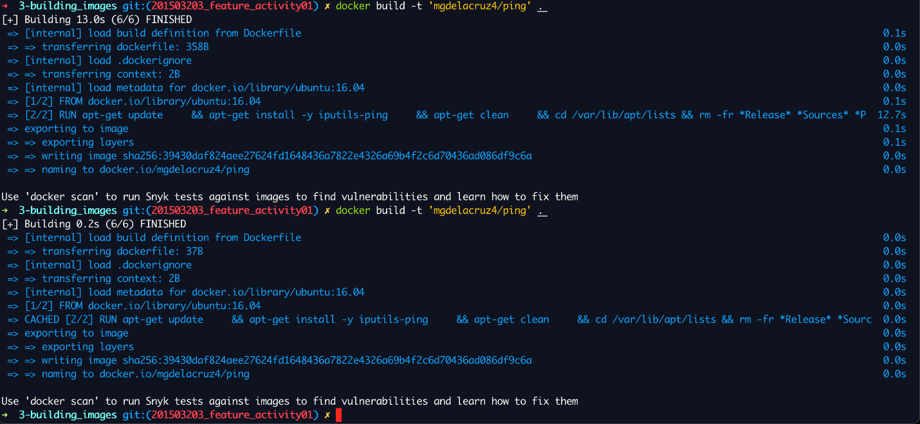

Figure 3. Success of docker build based on the Dockerfile configuration file

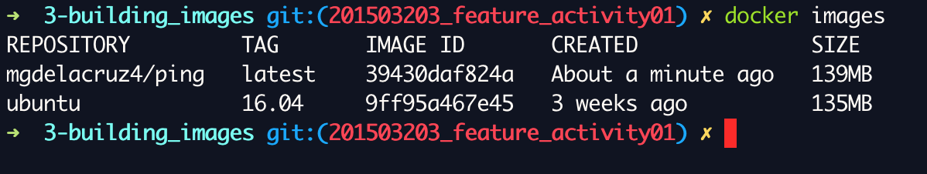

Figure 4. The final product of the image building

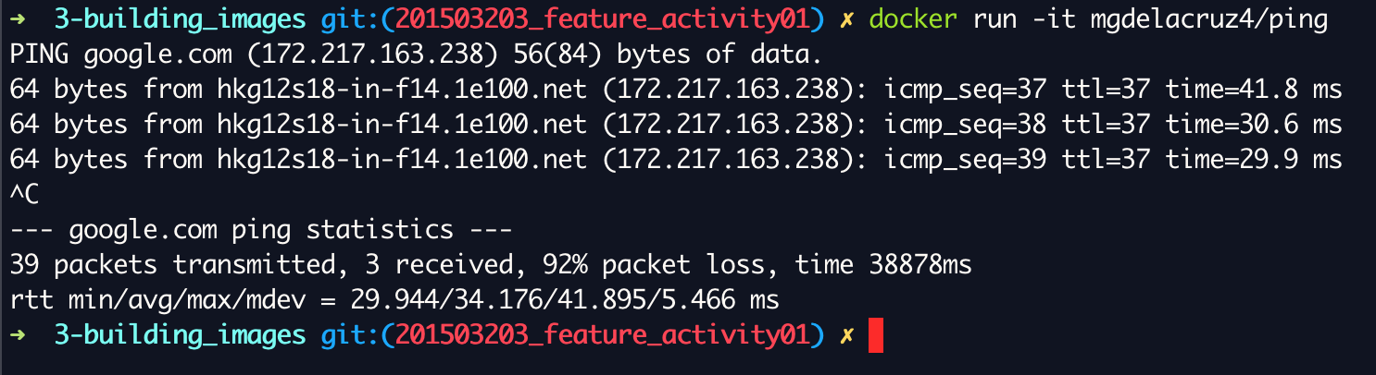

Figure 5. The built image works