**Getting Started**



**Finding images**

**Tagging images**

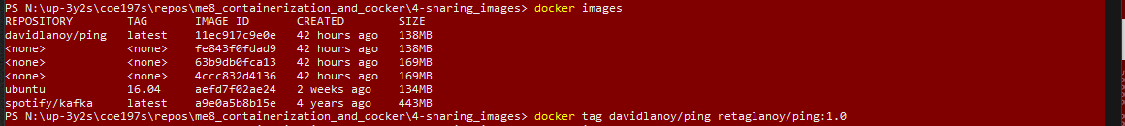

**Pushing images**

*\*re-tagged my image to davidlanoy since that is my username*

