Logging in

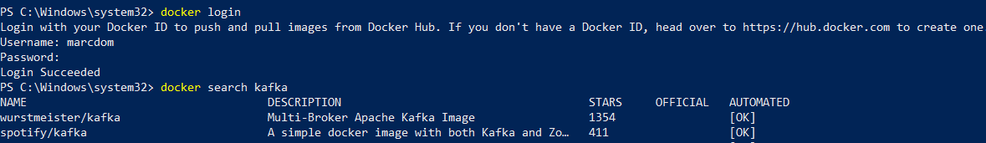

Tagging Image and pushing to new directory

