Mariella G. Dela Cruz

201503203

ME8 Activity 04

Running and Managing Docker Containers and Images

For all Activities, I basically followed the instructions on the provided GitHub tutorial. Screenshots are shown below. The captions describe each image.

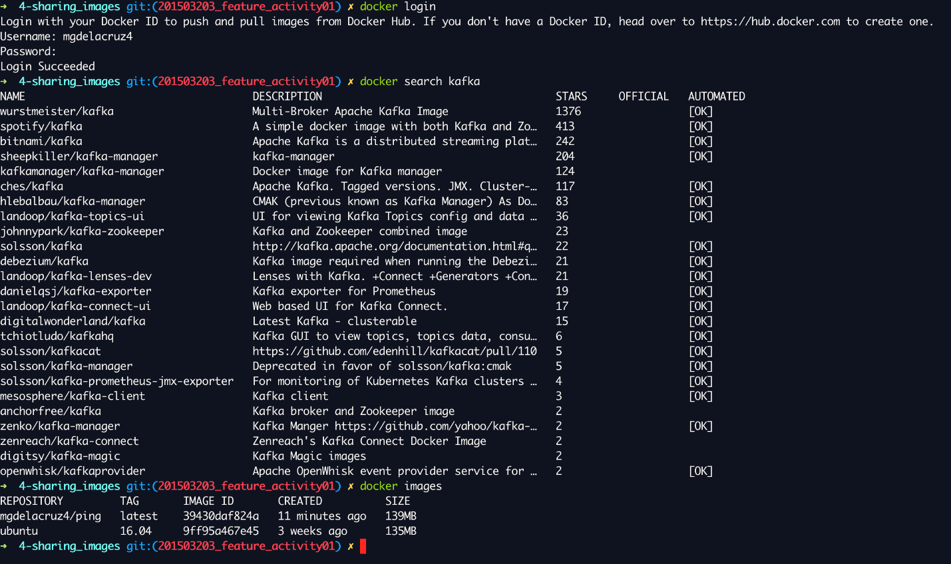

Figure 1. Logging into Dockerhub and checking packages

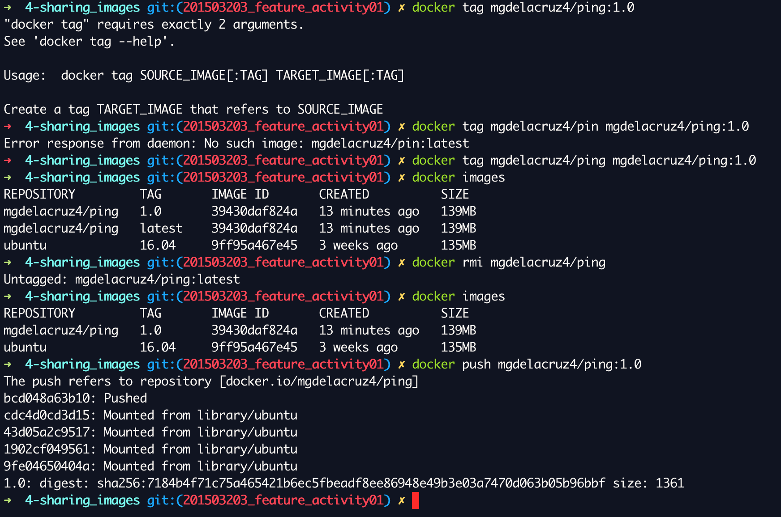

Figure 2. Pushing the created container from Activity 3 to Dockerhub

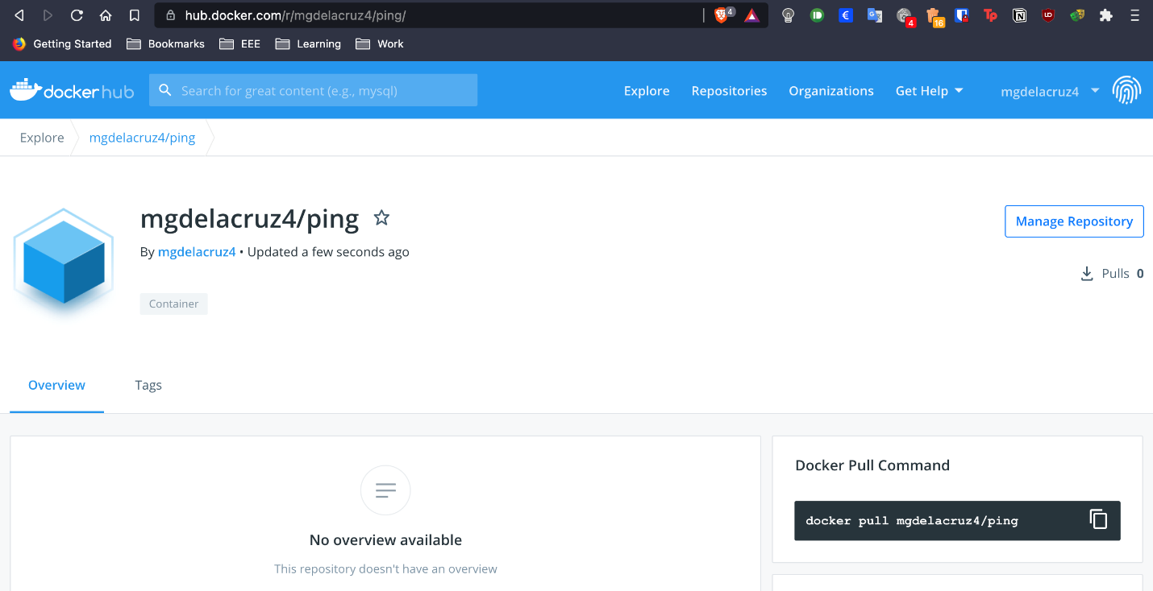

Figure 3. Existence of container in Dockerhub