Running server and html file

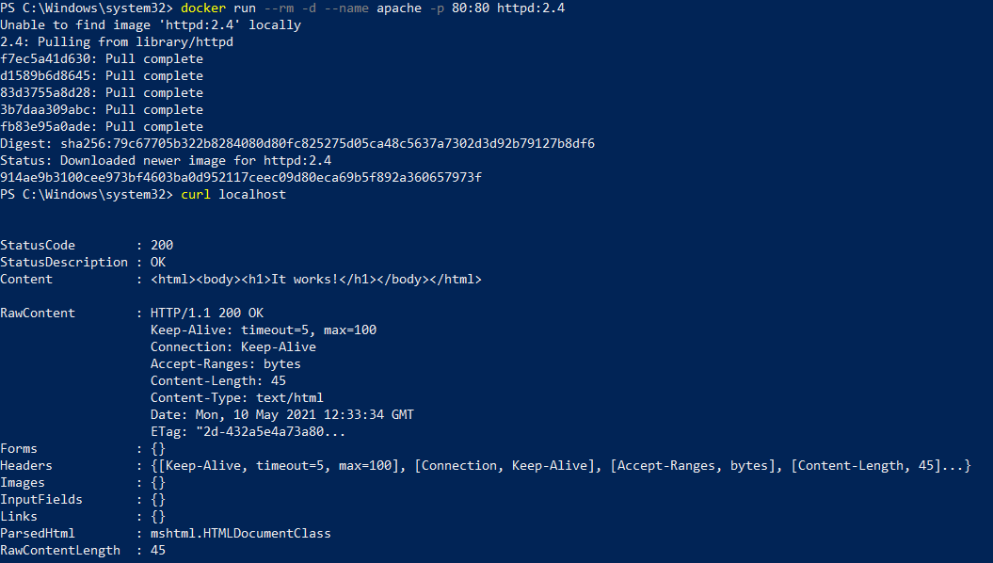

Replacing default html file

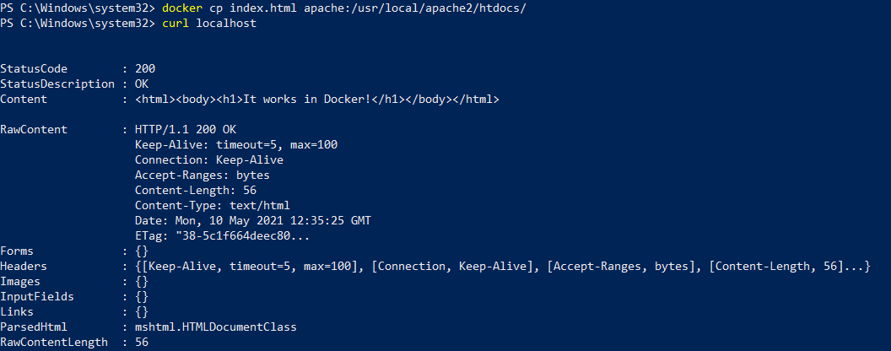

Rerunning and checking the default html file again

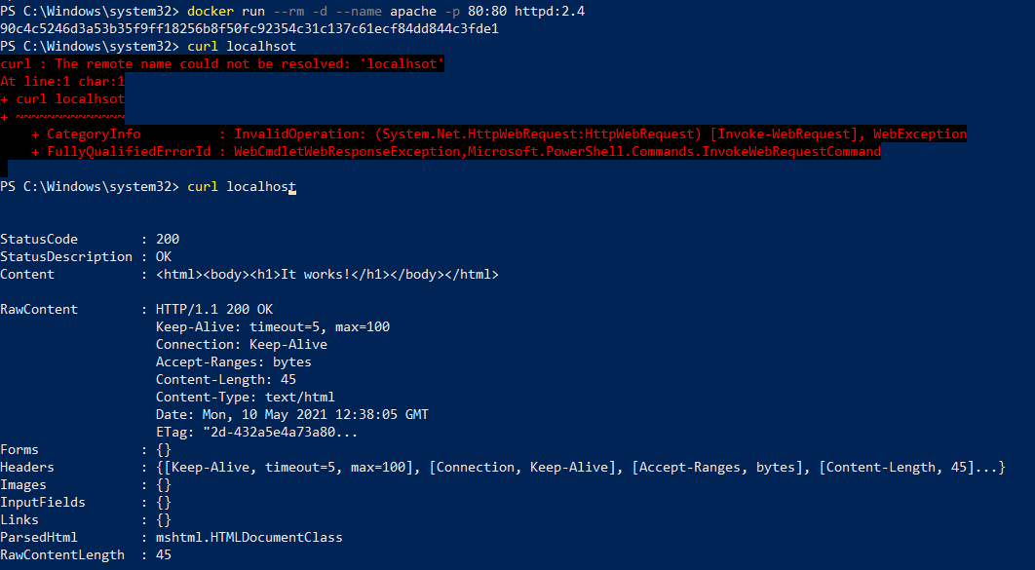

Creating docker volume

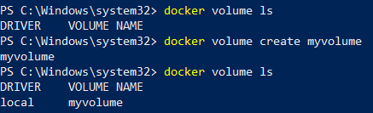

Removing the created docker volume

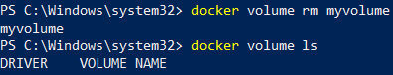

Rerunning apache

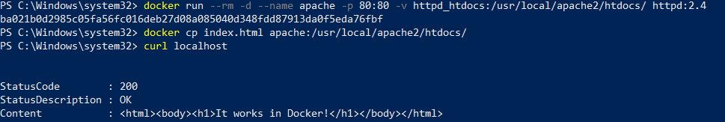

Changes remained!

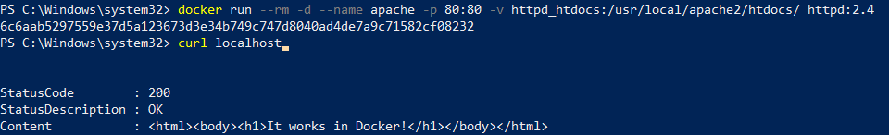

Checking for file changes

