Mariella G. Dela Cruz

201503203

ME8 Activity 05

Running and Managing Docker Containers and Images

For all Activities, I basically followed the instructions on the provided GitHub tutorial. Screenshots are shown below. The captions describe each image.

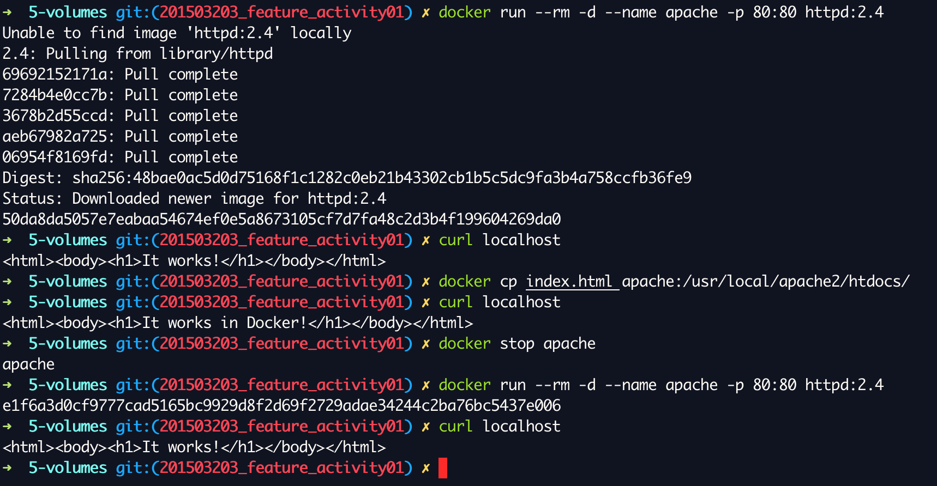

Figure 1. Seeing the need for a virtual volume to store persistent changes

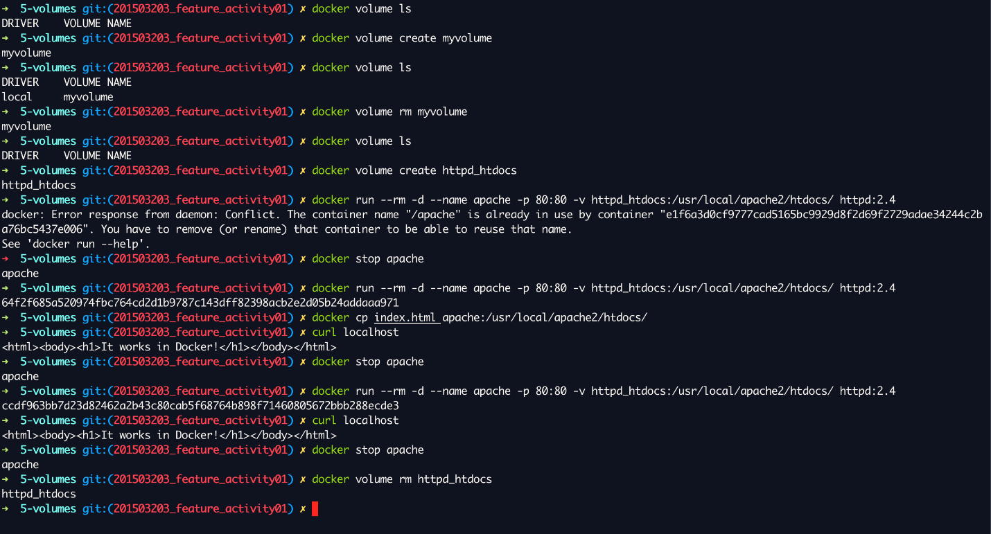

Figure 2. Creating said virtual volume and seeing the desired changes being persistent