**Listing networks**



**The default bridge network**

**Managing custom networks**

**Adding containers to a network**



**Connecting between containers in a network**

*\*container exits automatically due to error below (removed “-rm” tag to view logs of container)*

*\*added -e POSTGRES_PASSWORD=password as temp password for the purpose of activity*

**

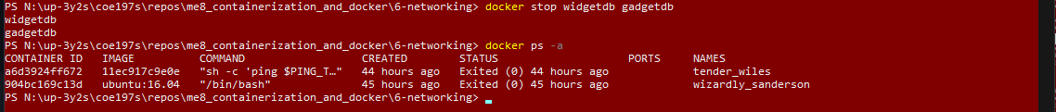

**Building ports to the host**

