Docker network and inspect bridge

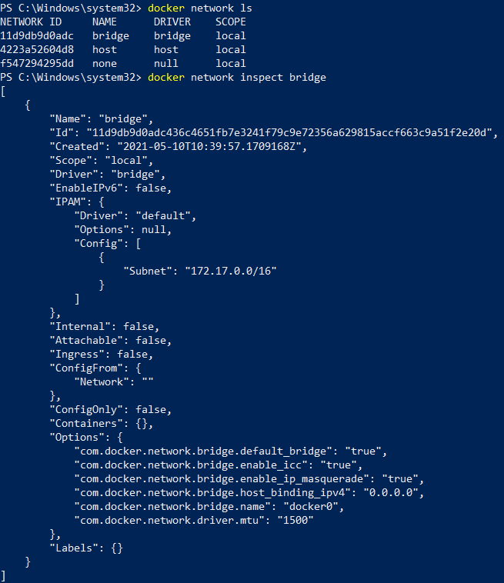

Dummy container on bridge

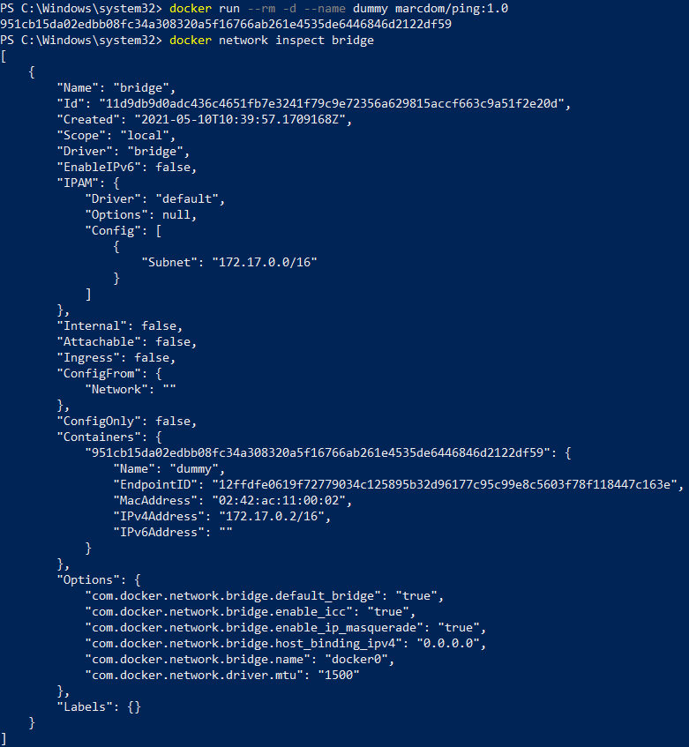

Extra ping container

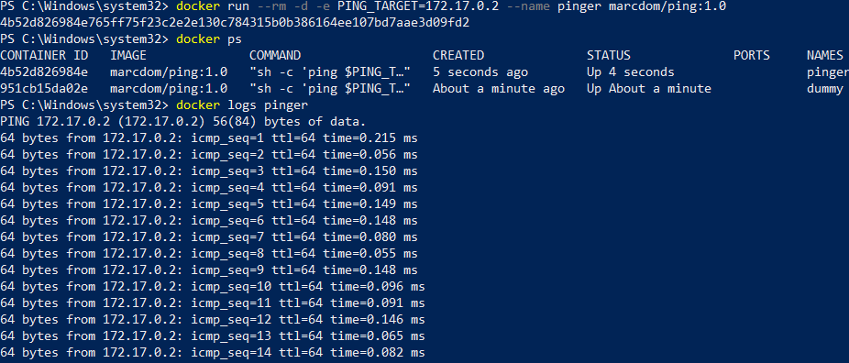

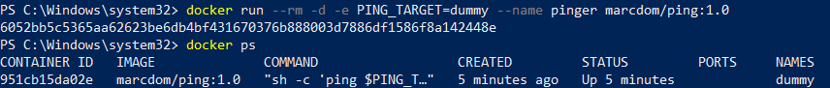

New network Skynet

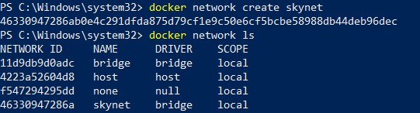

Pinger logs

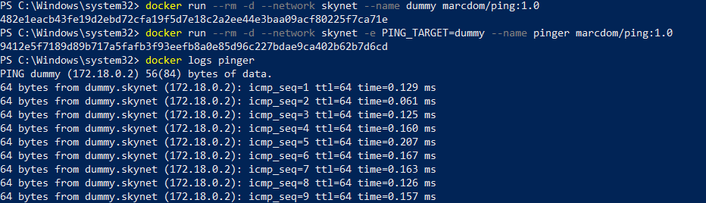



I do not have the psql utility installed unfortunately