**LISTING NETWORKS AND DEFAULT BRIDGE NETWORK**

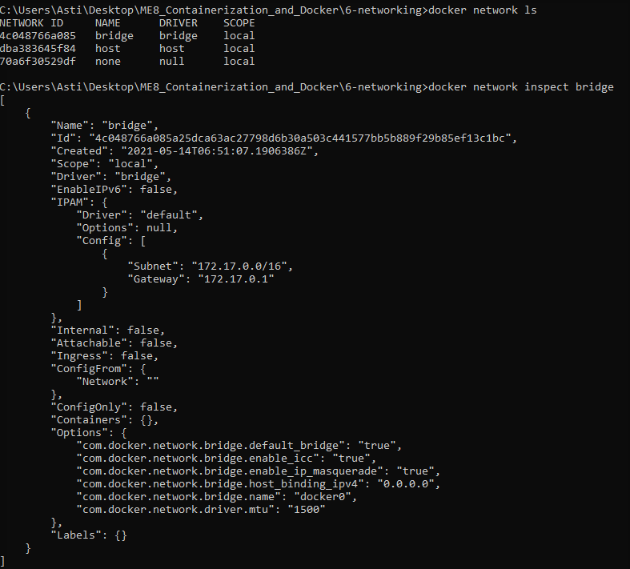

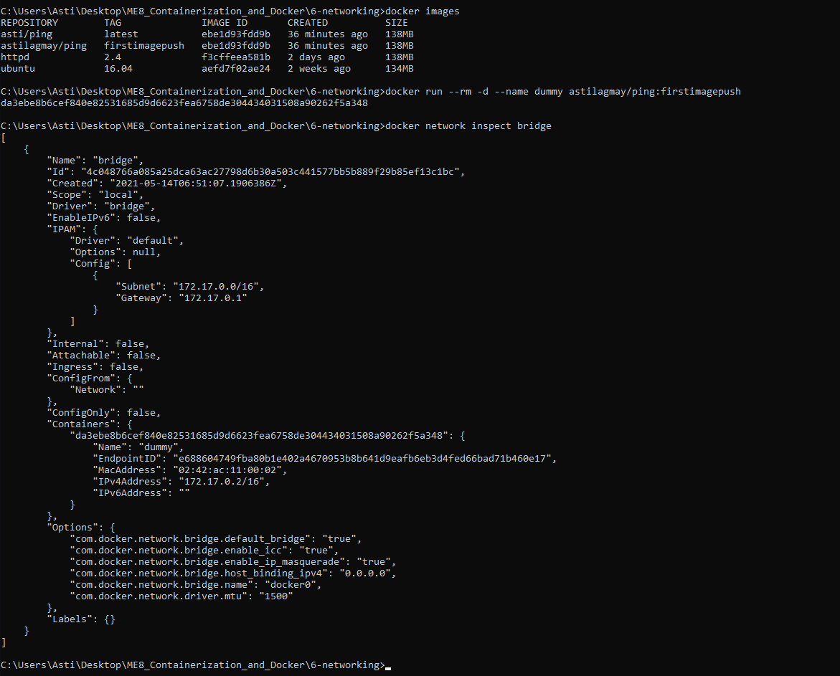

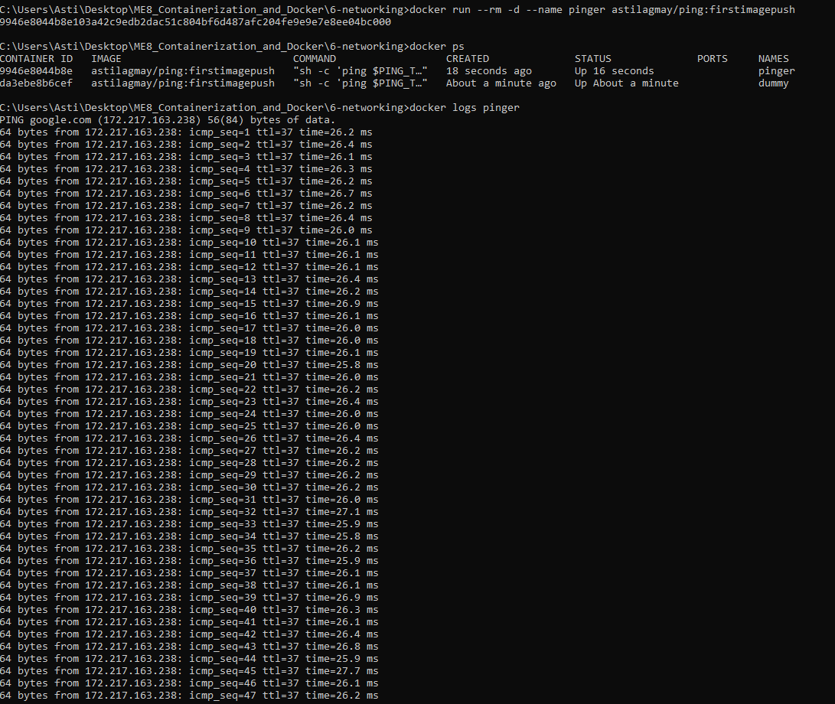

**MANAGING CUSTOM NETWORKS**

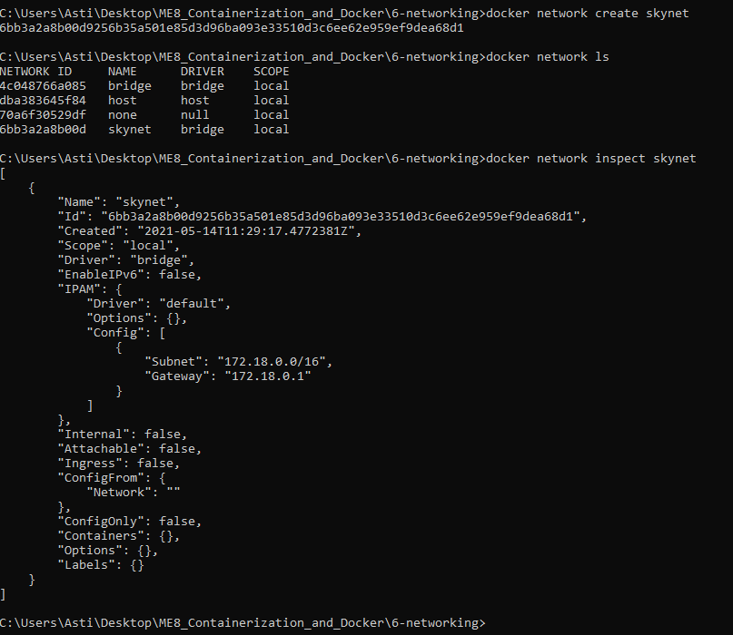

**ADDING CONTAINERS TO A NETWORK**

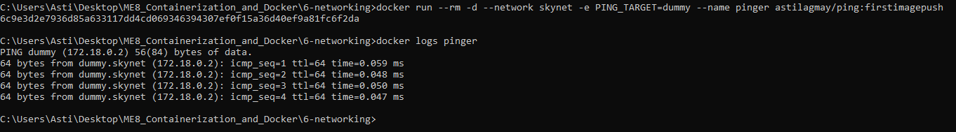

**CONNECTING BETWEEN CONTAINERS IN A NETWORK**

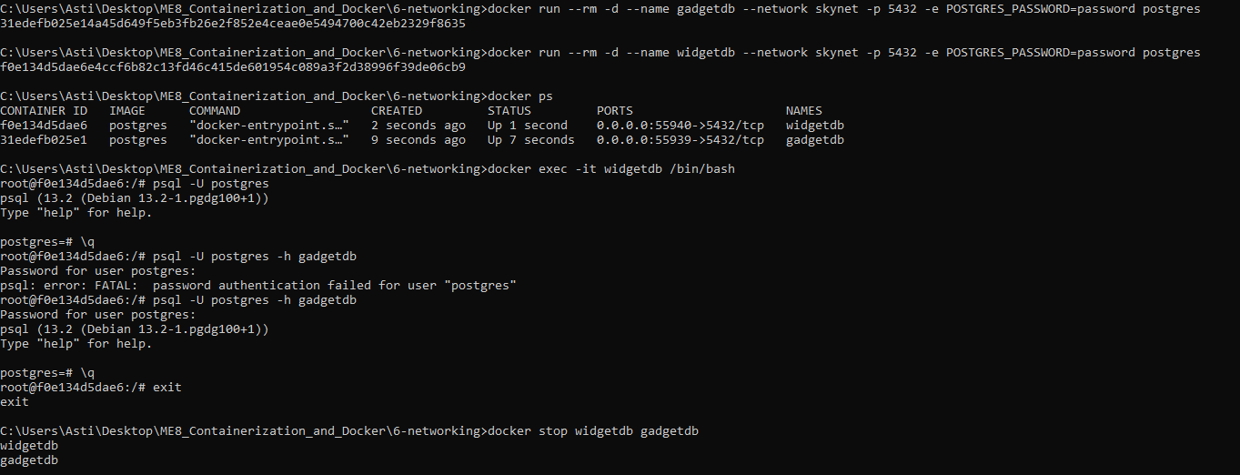

**BINDING PORTS TO THE HOST**

