**Networking**



Not sure why diff container

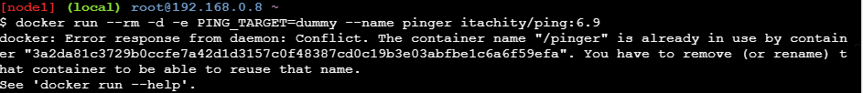

Custom Network

Connecting Containers

