Mariella G. Dela Cruz

201503203

ME8 Activity 06

Running and Managing Docker Containers and Images

For all Activities, I basically followed the instructions on the provided GitHub tutorial. Screenshots are shown below. The captions describe each image.

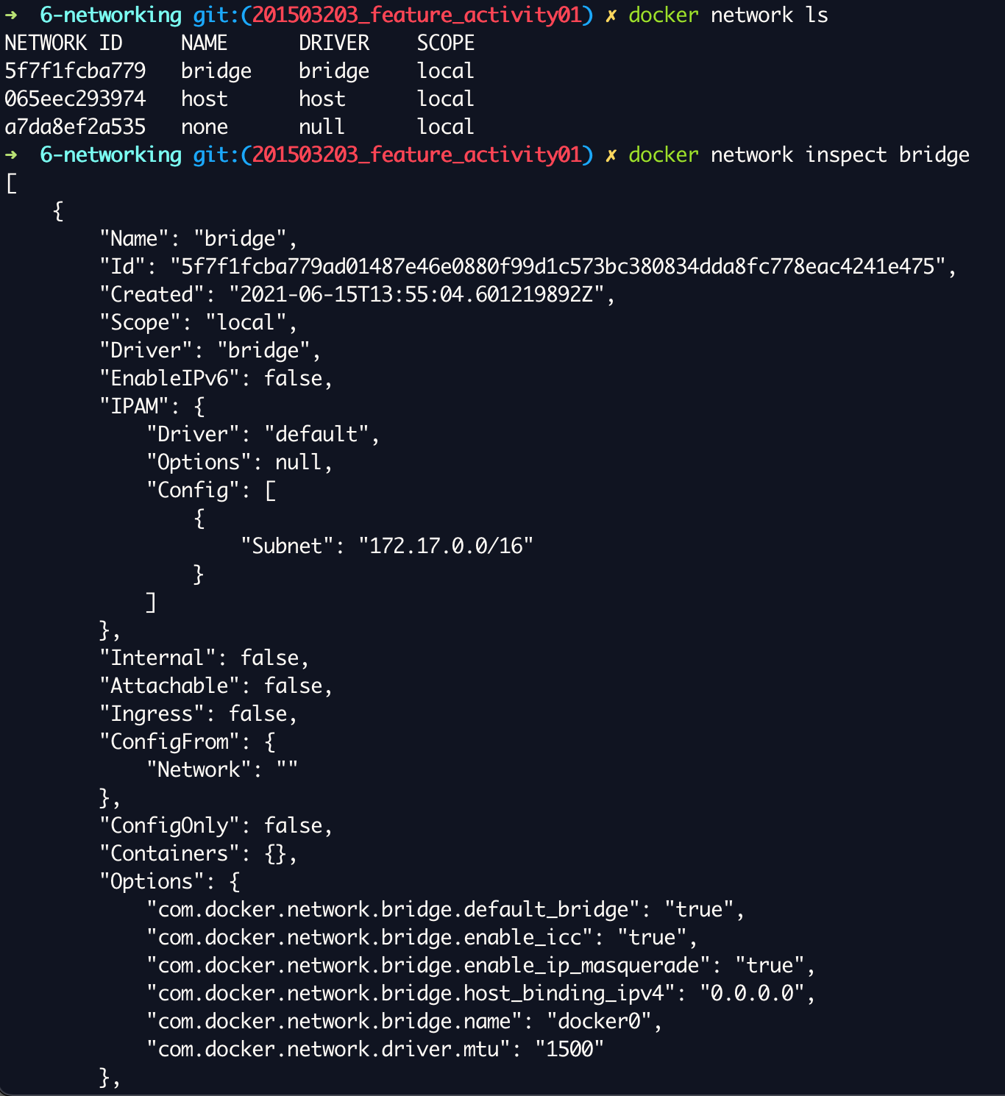

Figure 1. Inspecting the virtual network devices on Docker

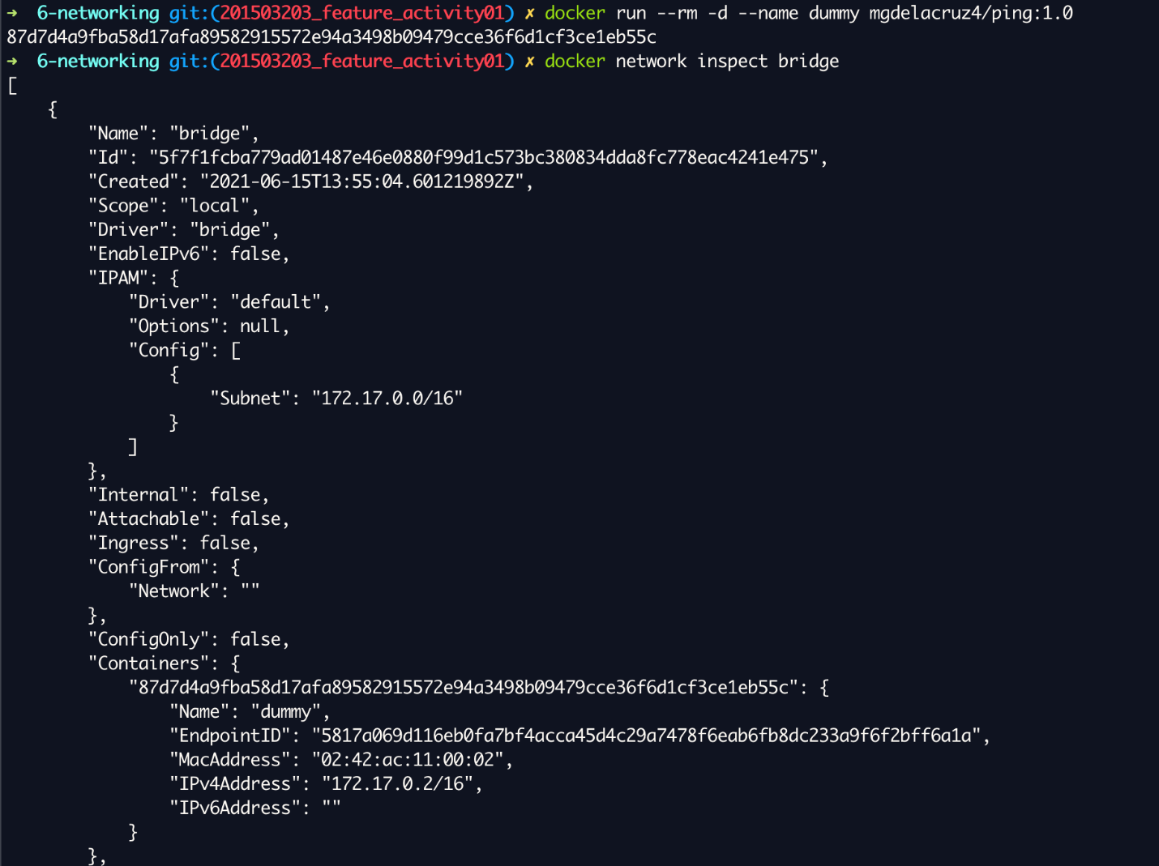

Figure 2. Seeing that the dummy container is using the bridge interface

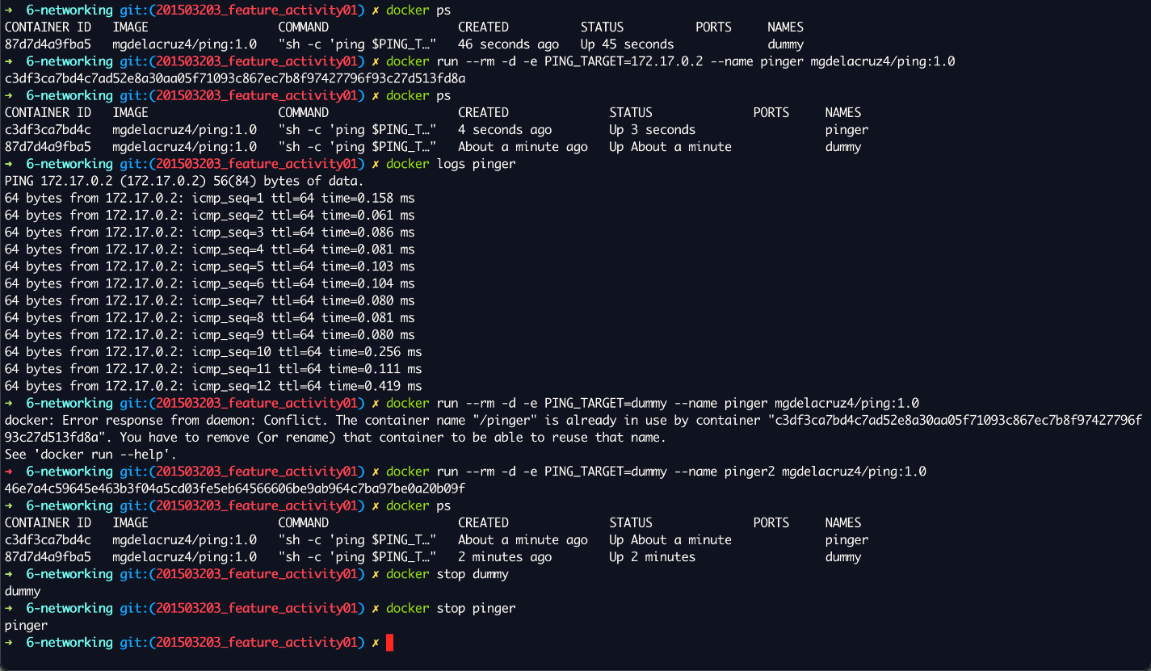

Figure 3. Pinger failing due to restrictions on default network devices

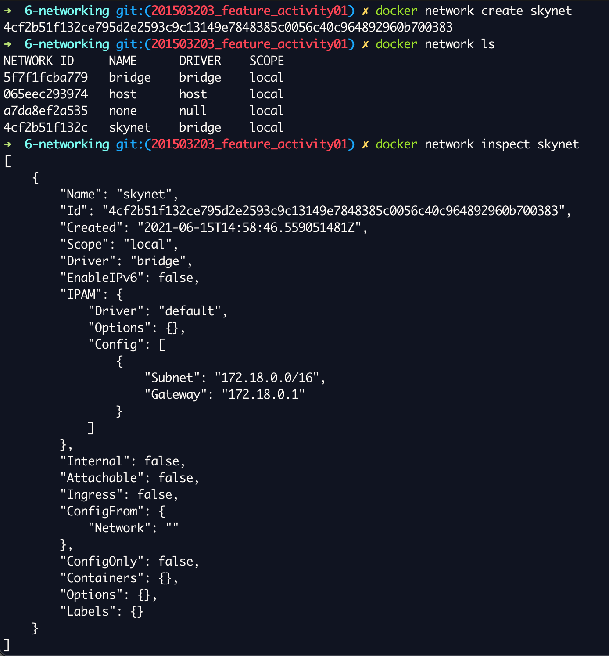

Figure 4. Creating a custom virtual network device/interface

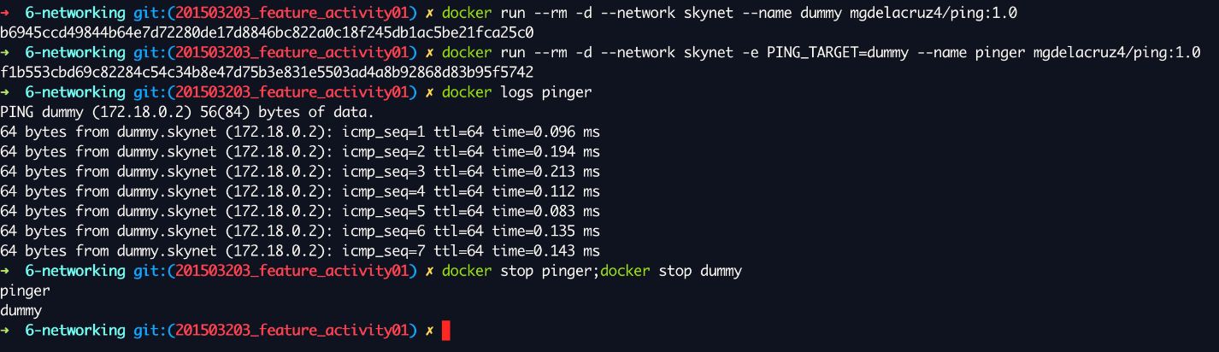

Figure 5. The two containers can now send pings to each other

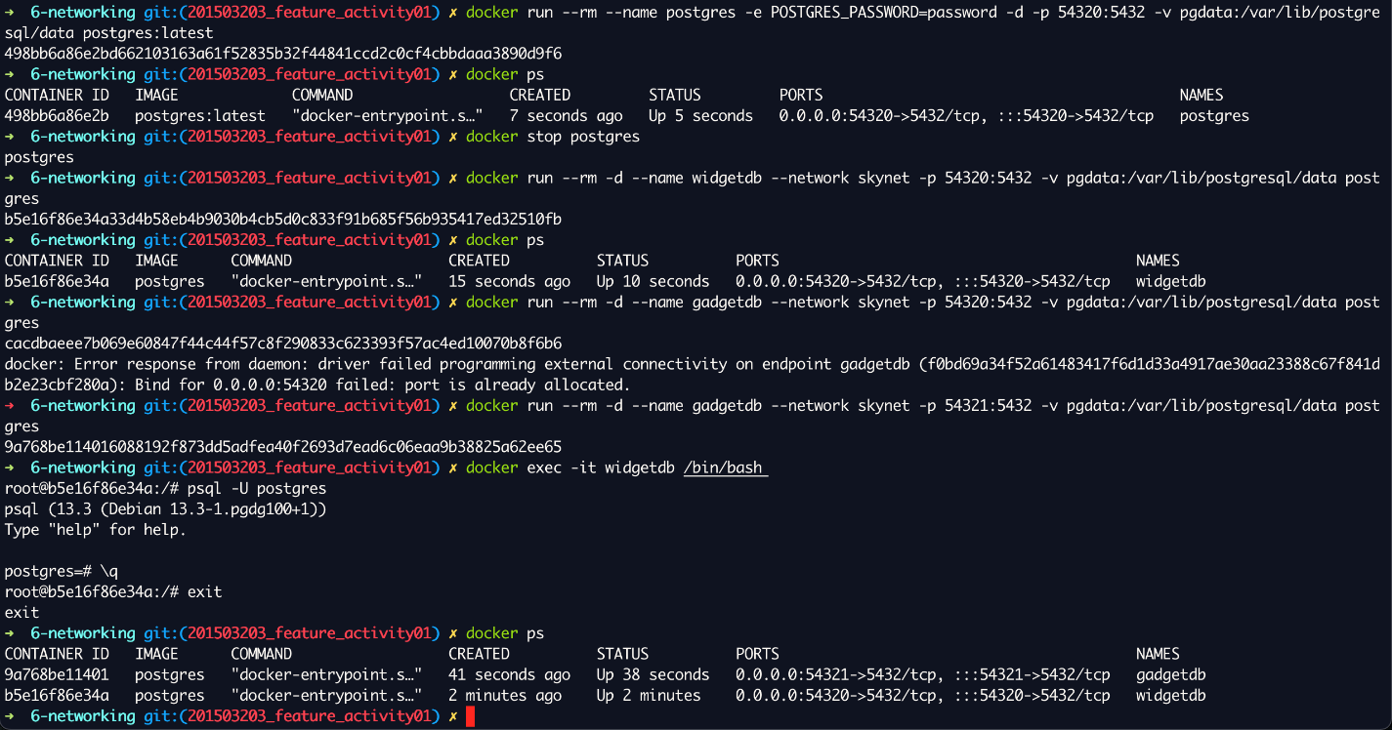

Figure 6. Setting up postgreSQL containers

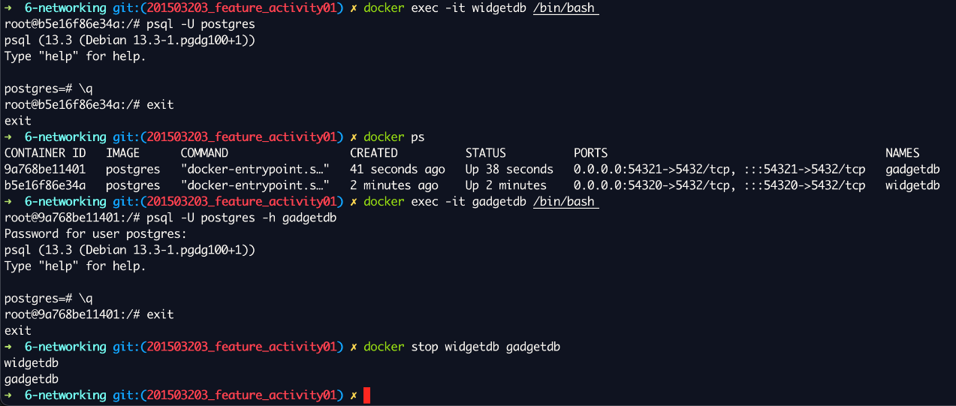

Figure 7. Checking functionality and connectivity of the two postgre containers

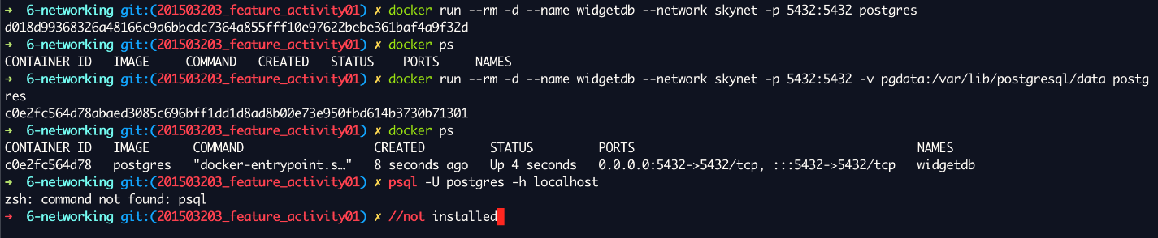

Figure 8. Trying to connect to the outside world. It would work if I have postgreSQL installed