**โค้ดภาษาซี**

#include <avr/io.h>

#include <avr/interrupt.h>

#define *F_CPU* 1000000ul

#include <util/delay.h>

unsigned char ROW, SWITCH_V;

void blink(unsigned char num, unsigned char p );

unsigned char LOOKUPTB[] = {

0x01, 0xFF, 0xFF, 0xFF, 0x04, 0xFF, 0x07, 0x0A, 0xFF,

0x02, 0xFF, 0xFF, 0xFF, 0x05, 0xFF, 0x08, 0x00, 0xFF,

0x03, 0xFF, 0xFF, 0xFF, 0x06, 0xFF, 0x09, 0x0B, 0xFF

};

int main(void)

{

DDRB = 0xF0;

PORTB = 0x0F;

DDRD = 0xFB;

PORTD = 0xFF;

EICRA = (1 << ISC01); // Falling Edge Interrupt

EIMSK = 1 << INT0; // Enable INT0

sei();

while (1)

{

PORTB = 0x0F;

sei();

}

}

ISR(INT0_vect)

{

cli();

for(unsigned char i=0; i<3; i++)

{

PORTB = ~(1 << (6 - i));

ROW = PINB & 0x0F;

ROW = ROW - 7 + (i * 9);

SWITCH_V = LOOKUPTB[ROW];

if(SWITCH_V == 0x00) blink(5, 0);

else if(SWITCH_V != 0xFF) blink(SWITCH_V, 1);

}

}

void blink(unsigned char num, unsigned char p )

{

for(unsigned char i=0; i<num; i++)

{

PORTD ^= (0x01 << p);

*_delay_ms*(300);

PORTD ^= (0x01 << p);

*_delay_ms*(300);

}

}

**ภาพวงจรบน Proteus**

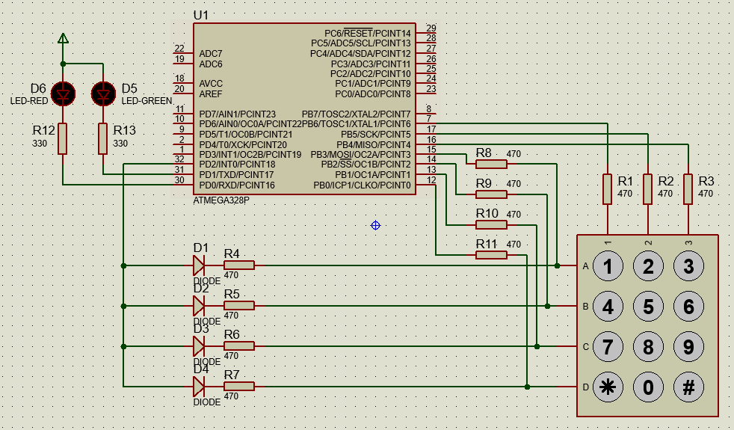

**ภาพการทำงานของวงจรบน Proteus**

