**โค้ดภาษาซี**

#include <avr/io.h>

#include <avr/interrupt.h>

#define *F_CPU* 16000000

#include <util/delay.h>

unsigned char LOOKUPTB[] = {

// DDRC PORTC

0b1111011, 0b0000010, // LED 1

0b1111011, 0b0000001, // LED 2

0b1111110, 0b0000100, // LED 3

0b1111110, 0b0000010, // LED 4

0b1111101, 0b0000100, // LED 5

0b1111101, 0b0000001, // LED 6

0b1111111, 0b0000000 // LED OFF

};

unsigned char SWITCH_V, i, test_bit;

int main(void)

{

DDRB = 0xC0;

PORTB = 0x3F;

SWITCH_V = PINB;

// Set Pin Change Interrupt

PCICR = 0x01;

PCMSK0 = 0x3F;

sei();

while (1)

{

if(SWITCH_V)

{

for(i=0; i<6; i++)

{

test_bit = SWITCH_V & (1 << i);

if(test_bit)

{

DDRC = LOOKUPTB[2*i];

PORTC = LOOKUPTB[2*i + 1];

*_delay_ms*(7);

}

}

}

else

{

DDRC = LOOKUPTB[12];

PORTC = LOOKUPTB[13];

}

}

}

ISR(PCINT0_vect)

{

SWITCH_V = PINB;

}

**ภาพวงจรบน Proteus**

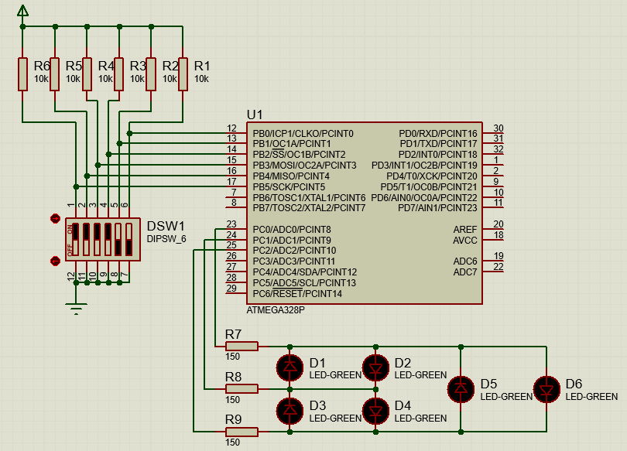

**ภาพการทำงานของวงจรบน Proteus**

