**โค้ดภาษาซี**

#include <avr/io.h>

#include <avr/interrupt.h>

#define *F_CPU* 16000000

#include <util/delay.h>

unsigned char COUNT, TIMER;

unsigned char LOOKUPTB[] = {

0b00111111, 0b00000110, // 0, 1

0b01011011, 0b01001111, // 2, 3

0b01100110, 0b01101101, // 4, 5

0b01111101, 0b00000111, // 6, 7

0b01111111, 0b01101111, // 8, 9

0b01110111, 0b01111100, // A, b

0b00111001, 0b01011110, // c, d

0b01111001, 0b01110001 // E, F

};

int main(void)

{

DDRB = 0xFF;

DDRD = 0xFB;

PORTD = 0x04;

COUNT = 0;

EICRA = 0x02; // Falling Edge Interrupt

EIMSK = 0x01; // Enable INT0

sei(); // Enable Interrupt

while (1)

{

PORTB = LOOKUPTB[COUNT];

}

}

ISR(INT0_vect)

{

TIMER = 0;

while( ! (PIND & 0x04) && TIMER < 187)

{

*_delay_ms*(1);

PORTB ^= 0x80; // Check 3 Sec

TIMER++;

}

if(TIMER==187)

{

COUNT = 0;

}

else

{

COUNT++;

if(COUNT==16)

COUNT = 0;

}

}

**ภาพวงจรบน Proteus**

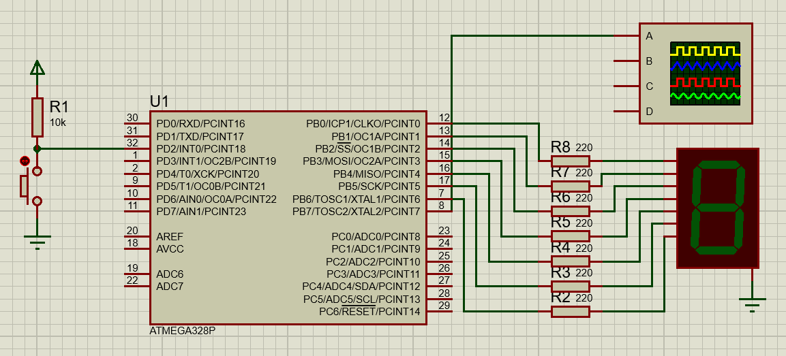

**ภาพการทำงานของวงจรบน Proteus**

