TraceLab Documentation

(GTK# Version)

Table of Content

Installation Instructions

Windows

Installing Mono

Installing TraceLab

Running the Batch File

Linux

Running the Install Script

Compiling Instructions

Linux

## 

## 

## Installation Instructions

### Windows

#### Installing Mono

To install and run TraceLab on window first install the latest version of Mono. Mono can be downloaded from this url: <http://www.mono-project.com/download/#download-win>

#### Installing TraceLab

Run the TraceLab setup and follow the installation wizard.

#### Running the Batch File

Run the batch file. Make sure that the *tracelabkey.txt* file is in the same directory as the batch file.

### Linux

#### Running the Install Script

Place the *tracelabkey.txt* and *tracelab.tar.gz* files in the same directory as *Install*. Open a terminal and navigate to the folder where all three files are. Run the command to initiate the install process for TraceLab at the end of the process Tracelab will automatically start.

|  |
| --- |
| ./install |

## Compiling Instructions

### Linux

Run the following commands in the terminal to add the required repositories and install the required dependencies.

|  |
| --- |
| sudo apt-key adv --keyserver hkp://keyserver.ubuntu.com:80 --recv-keys 3FA7E0328081BFF6A14DA29AA6A19B38D3D831EF |

|  |
| --- |
| echo "deb http://download.mono-project.com/repo/debian wheezy main" | sudo tee /etc/apt/sources.list.d/mono-xamarin.list |

|  |
| --- |
| sudo apt-get update |

Depending on the Linux distro run the following commands:

Ubuntu 13.10 and later:

|  |
| --- |
| echo "deb http://download.mono-project.com/repo/debian wheezy-apache24-compat main" | sudo tee -a /etc/apt/sources.list.d/mono-xamarin.list |

Older Ubuntu releases

|  |
| --- |
| echo "deb http://download.mono-project.com/repo/debian wheezy-libtiff-compat main" | sudo tee -a /etc/apt/sources.list.d/mono-xamarin.list |

Debian 8.0 and later:

|  |
| --- |
| echo "deb http://download.mono-project.com/repo/debian wheezy-apache24-compat main" | sudo tee -a /etc/apt/sources.list.d/mono-xamarin.list |

|  |
| --- |
| echo "deb http://download.mono-project.com/repo/debian wheezy-libjpeg62-compat main" | sudo tee -a /etc/apt/sources.list.d/mono-xamarin.list |

CentOS, Fedora, and derivatives (**run in a root shell**):

|  |
| --- |
| rpm --import "http://keyserver.ubuntu.com/pks/lookup?op=get&search=0x3FA7E0328081BFF6A14DA29AA6A19B38D3D831EF" yum-config-manager --add-repo http://download.mono-project.com/repo/centos/ |

Finally install the required packages to install MonoDevelop on your system:

(**Note**: The following commands assume you’re working on Debian or a derivative, change the command based on the package-management tool in your distro to install the packages).

|  |
| --- |
| sudo apt-get install mono-devel |

|  |
| --- |
| sudo apt-get install mono-complete |

|  |
| --- |
| sudo apt-get install referenceassemblies-pcl |

|  |
| --- |
| sudo apt-get install ca-certificates-mono |

|  |
| --- |
| sudo apt-get install monodevelop |

Once all commands are run, open **monodevelop** from your distro **gui** or type the command *monodevelop* in the **terminal** to start the monodevelop IDE. Create a test project to make sure GTK compiles correctly.

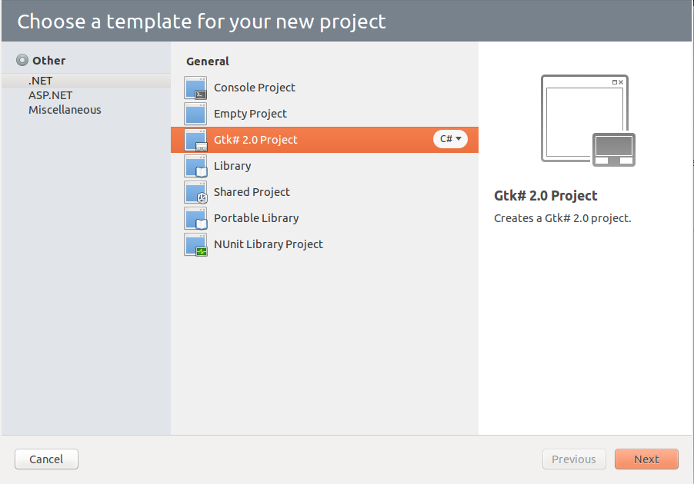

Go to **File→ New→ Solution** and when the the template window pops up select **GTK# 2.0 project** and press **next**. In the next page name the project and select the desired directory.

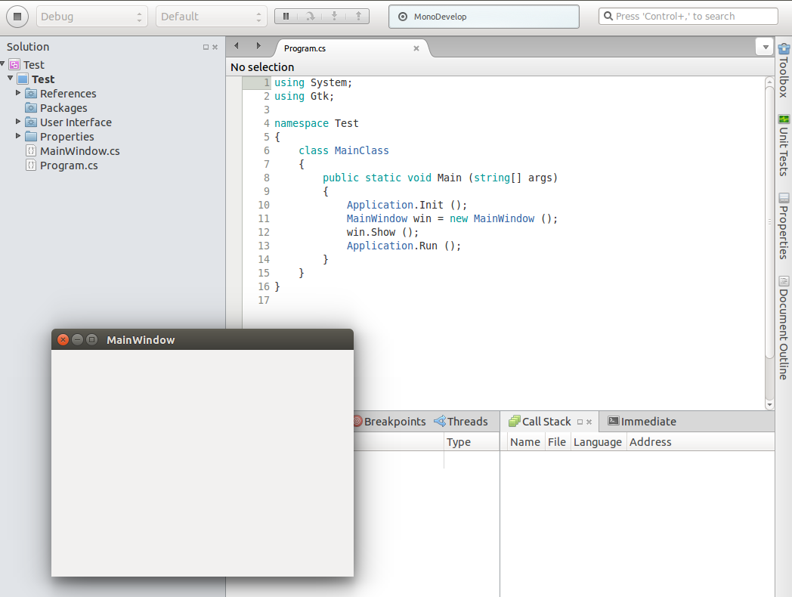

Once the new Solution is created press the **Start** button in the top left corner and an empty window called **MainWindow** should appear. Congratulations GTK# works correctly on your system.

To run **Tracelab** you’ll have to acquire the latest version currently on **Github**. To do so you’ll need to Install **Git** on your system first. Open up a **terminal** and run the following commands:

|  |
| --- |
| sudo apt-get install git |

Once **Git** is installed run the following commands:

|  |
| --- |
| cd ~ |

|  |
| --- |
| mkdir devel |

|  |
| --- |
| git clone <https://github.com/CoEST/TraceLab> devel |

The **Git Repository** will be cloned to the **devel** folder in your home directory. Navigate to that folder using your file explorer or Monodevelop and open the **Tracelab.Gtk.sln** file to load the solution in **MonoDevelop**. You can also run the following command from the **terminal**.

|  |
| --- |
| monodevelop devel/Tracelab/Main/Tracelab/Tracelab.Gtk.sln |

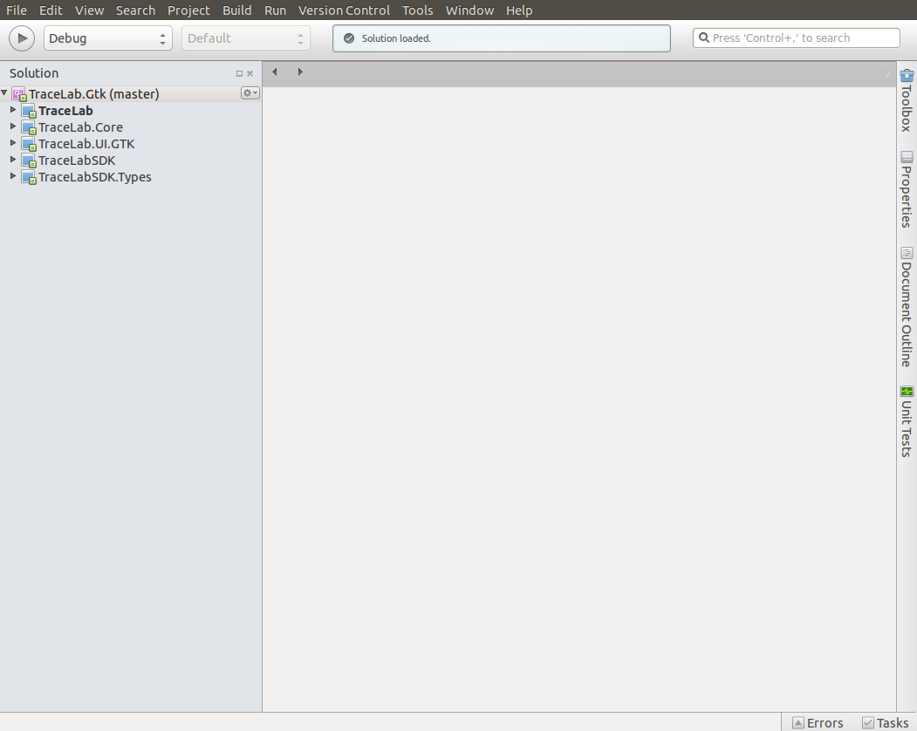

Once the solution is loaded the following **projects** should appear in **MonoDevelop**: