**Running TraceLab on Windows with Mono**

1. Download and install **Mono version 2.10.x** (version 3.2.x is not supported) <http://www.go-mono.com/mono-downloads/download.html>
2. Install TraceLab with the provided setup file **TraceLab-setup.exe**
3. Set Mono and TraceLab environmental variables in Windows:

* Right click on to Computer\Properties

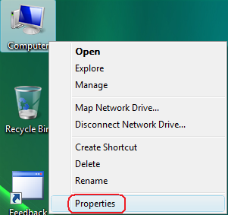

* Click on "Advanced system settings"

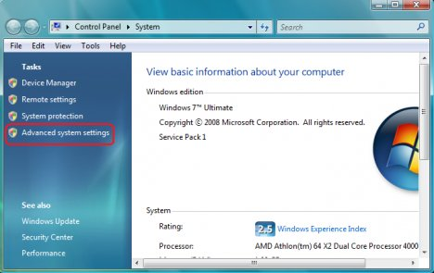

* Go to "Advanced" tab then click on "Environment variables"

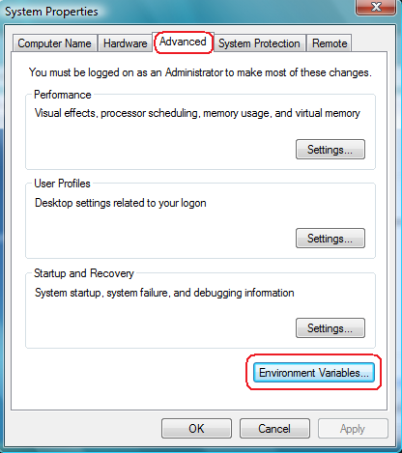

* click "New" in "User Variables"

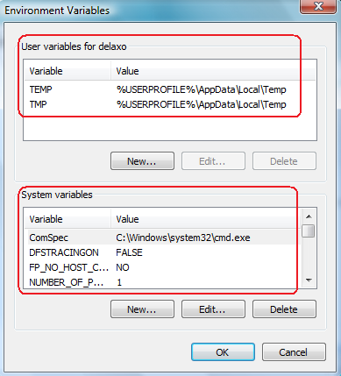

* Add a new variable named "***MONO_HOME***". The Mono installation folder will be the variable value. For example, if Mono is installed in "*C:\Program Files (x86)\Mono-2.10.9*"then:

|  |  |
| --- | --- |
| Varable Name | MONO_HOME |
| Variable Value | C:\Program Files (x86)\Mono-2.10.9\bin |

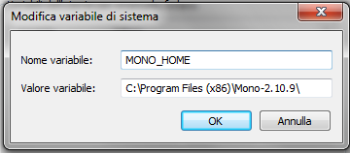

* Modify the "***Path****"* variable adding **%MONO_HOME%\bin** (remember to separate such a string with a ";" ):

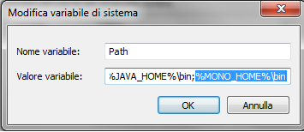

* Add a new variable "***TraceLab_Home***" (Variable Value will be the TraceLab installation folder, usually C:\Program files(x86)\TraceLab):

|  |  |
| --- | --- |
| Varable Name | TraceLab_Home |
| Variable Value | <<*Your TraceLab installation folder*>> |

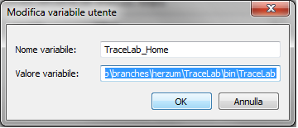

1. Copy the file **tracelabkey.txt** into the TraceLab installation folder
2. You can now run the application double clicking on the shortcut installed on the Desktop, on the file **StartTraceLab.bat** in the TraceLab installation folder or you can open an experiment double clicking on it.  
   You can also unpack a package (.*tpkg*) file double clicking on it.