**Overview**

The project work is done in groups. Please find your team in the Moodle page.

**Objective:**

The objective of the project work is to apply skills that you have learnt in the Website User Interface and Web Programming courses to build a website that is user friendly and has features that use databases. You may build features on top of the pages that you have created in the previous course or make a complete new one. The project is carried out using the SCRUM method. Your team can decide what features/service/element you want to implement.

1. A proper layout with Bootstrap
2. Multiple pages
3. Implementation of CRUD base system
4. Relevant Form(s) with JavaScript validation
5. JavaScript event handlers for HTML element

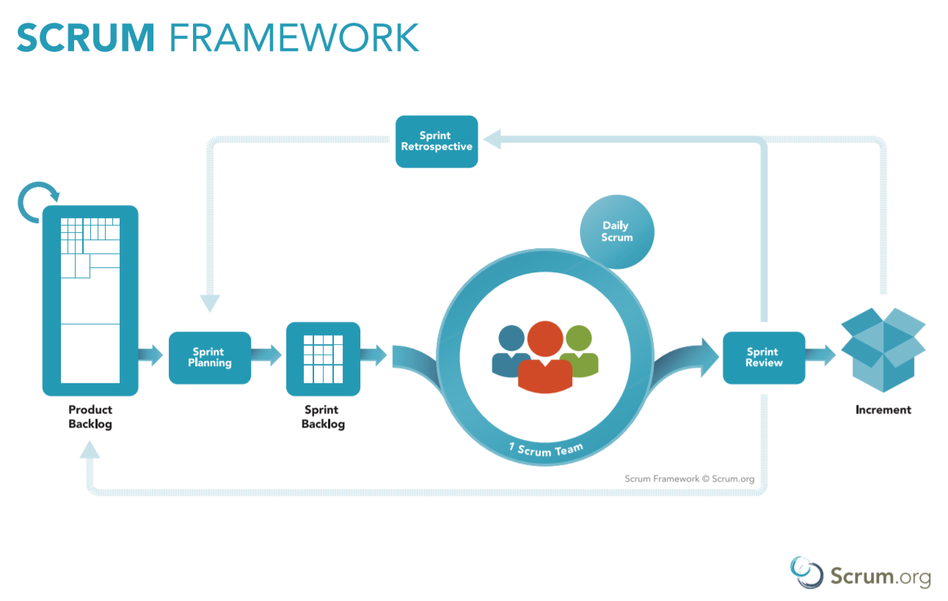

You will fill up the **project plan template**. You are required to build a product backlog and then split them into 3 sprints. The project plan template is available at this link:

<https://drive.google.com/file/d/1dLAf-4Sqp0kBm9aFTIVWmOx7x4O07d1-/view?usp=sharing>

Your team is required to have the following **Scrum Events**:

1. Sprint Planning (In the beginning of every week, please fill the excel file above)
2. You may have daily scrum and sprint review (not compulsory).

Your team is required to have the following Scrum Artifacts:

1. Product Backlog (fill in the project plan template)
2. Sprint Backlog (fill in the project plan template)

**Return**

All your code should be in a GitHub repo. It can be a private repository will other members added as collaborators.

During the project review, you will download all files and database from your repo as a zipped file and upload it to the submission folder in Moodle.

Project work is reviewed in teams. Group-specific review times will be informed shortly.

**Criteria for assessment**

G1: The student can make a website simply by using PHP.

G2: The student can make a dynamic web site with PHP, the content of which comes from a database. The system at least reads and prints data on a web page - at best, edits and deletes data.

G3: In addition to the above, the student can validate, and filter information provided by a user from a web page using PHP/JavaScript.

G4: In addition to the above, the student will be able to implement an element that utilizes JavaScript on the site.

G5: Overall, the design and implementation of the site is impressive, the user interface is excellent with responsive design and the website serves some real purpose.

***In order to get grade 2, you need to complete at least G1 & G2. You won’t get 1 for the project part, it will be either 0, 2, 3 4 or 5.***

***If you do not participate in the evaluation discussion your grade will be reduced by 1.***

***If you don not submit the required zipped file, the team’s grade is subtracted by 1.***