**© CoLiTec**: Collection Light Technology

(<http://neoastrosoft.com>)

**CoLiTecVS (Variable Stars)**

**1.8.3.1**

1. Introduction 2

2. Setting for Windows\Linux 2

2.1.Windows configuration 2

2.2.Linux configuration 2

2.2.1.Verify Java version 2

2.2.2.Compiler C & C++ update 2

2.2.3.Set the permissions for all CoLiTec modules 3

3. Start software 3

4. How to adjust the frame calibration 4

5. Setting the parameters of processing frames 6

6. Setting the settings for generate a light curve 8

7. Creating the task-file «LCP» 10

8. Processing in the «DAY»mode 10

9. Processing in the «OLDAS» mode 14

9.1. Frame header requirements 14

9.2. Setting parameters and start processing 14

9.3. OnLine viewing the light curve 17

10. Manual mode for forming the light curve 19

11. Sending a light curve to a virtual observatory site 19

## Introduction

**CoLiTecVS (Variable Stars)** – cross-platform software for the automated creation of light curves of the investigated stars. The software has two main processing modes – "DAY" and "OLDAS".

«DAY» mode – processing of frames from the given folder / folders under the following conditions:

– frames of the same folder belong to the same telescope / filter / sky area;

– the number of frames cannot be changed during processing and is determined at the moment of selecting the processing folder.

"OLDAS (Online data analysis system)" mode is deprived of both of the above limitations. In the "OLDAS", online processing of frames is performed as they arrive. Including, online frames processing, as they are formed by telescopes.

Thus, OLDAS is:

– online processing of the frames;

– distribution of frames by subfolders in accordance with the signs "object \ filter \ RA, DE";

– display and the ability to view in real time the dynamically change graphs of the light curves of each subfolder (of each telescope, filter).

It is possible to control the processing of each series of astronomical frames.

Below is a sequence of observer actions for processing of frames and creation the light curve.

## Setting for Windows/Linux

# Windows configuration

For using **CoLiTecVS** recommend the latest version of Java 8 ([32-bit](http://www.neoastrosoft.com/download/3631/), [64-bit](http://www.neoastrosoft.com/download/3633/)). Also, add all executable modules from the directory of **3C** to the Windows Firewall exceptions.

# Linux configuration

# *Verify Java version*

Recommend using the latest version of Java 8. Verify Java version. Perform in the terminal the following:

***java –version***

If Java version is less than 8, install Java 8. Perform in the terminal the following:

***sudo add-apt-repository ppa:webupd8team/java***

***sudo apt-get update***

***sudo apt-get install oracle-java8-installer***

# *Compiler C & C++ update*

Verify compiler C version. Perform in the terminal the following:

***gcc –v***

If compiler C version is less than 4.8, install gcc 4.8 or higher. Perform in the terminal the following:

***sudo add-apt-repository ppa:ubuntu-toolchain-r/test***

***sudo apt-get update***

***sudo apt-get install gcc-4.8***

***sudo update-alternatives --remove-all gcc***

***sudo update-alternatives --install /usr/bin/gcc gcc /usr/bin/gcc-4.8 20***

***sudo update-alternatives --config gcc***

Verify compiler C++ version. Perform in the terminal the following:

***g++ -v***

If compiler C++ version is less than 4.8, install g++ 4.8 or higher. Perform in the terminal the following:

***sudo add-apt-repository ppa:ubuntu-toolchain-r/test***

***sudo apt-get update***

***sudo apt-get install g++-4.8***

***sudo update-alternatives --remove-all g++***

***sudo update-alternatives --install /usr/bin/g++ g++ /usr/bin/g++-4.8 20***

***sudo update-alternatives --config g++***

# *Set the permissions for all CoLiTec modules*

Set read & write permissions for the directory with all CoLiTec modules. Perform in the terminal the following:

***chmod -R 700 Path_to_CoLiTecVS***

## Start software

Launch CLTLogger.exe (Windows) or CLTLogger.jar (Linux). Appearance is shown in Fig. 1.

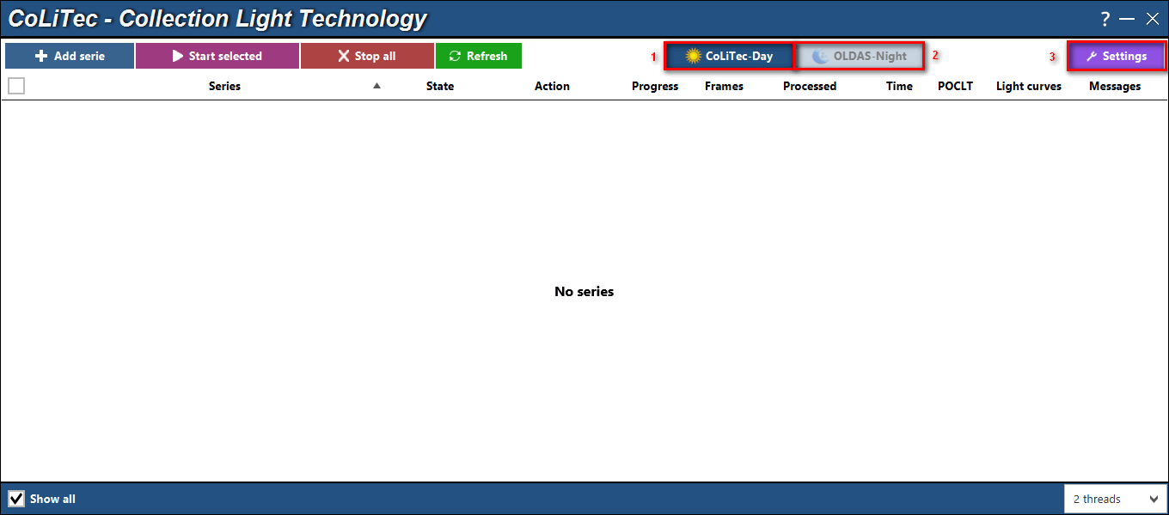

*Fig. 1. Appearance of the software "CLTLogger": 1 ­ processing in the "Day" mode, 2 ­ processing in the "OLDAS" mode, 3 ­ Click the settings menu of the software "CLTLogger"*

## How to adjust the frame calibration

* 1. Click the Settings menu in the CLTLogger window.

In the resulting settings window (Figure 2), launch up the settings editor.

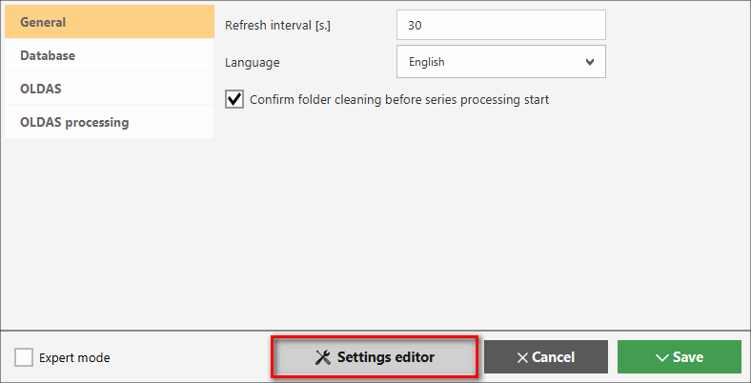

*Fig. 2. Settings window*

* 1. In the settings editor, in the "Brightness Equalization" section, set the required parameters (Figure 3).

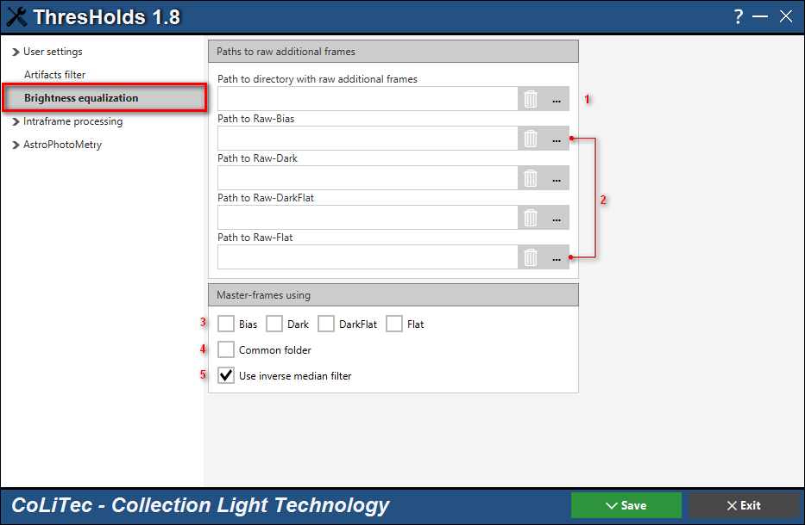

*Fig. 3. "Brightness Equalization" window*

**«1»** – The path to the folder with the original service frames. Service frames for light-frame calibration CoLiTecVS can determine by itself.

The observer can collect service frames of different types and different telescopes in the investigated folder.

From the service frames of the specified folder, the software generates the master frames of the corresponding types and uses them to calibrate the light frames. To enable this mode, you need to specify the path to the folder with the service frames and include the pointer «4» ­ the shared folder, as well include the pointer «3» of types of frames to be used.

Тable 1 – Requirements for headers of service frames

|  |  |  |  |  |  |
| --- | --- | --- | --- | --- | --- |
| Name | The ID in the frame header | Value \ identity of the parameter | | | |
| Light |  |  | Light |
| Frame size | NAXIS1, NAXIS2 | + | + | + | + |
| Frame type | IMAGETYP |  | bias | dark | flat |
| Telescope name | TELESCOP | + | + | + | + |
| Temperature | SET-TEMP  CCD-TEMP  TEMPERAT | + |  | + |  |
| Exposition | EXPOSURE  EXP-TIME  EXPTIME | + |  | + |  |
| Filter | FILTR  FILTER | + |  |  | + |

When using automatic determination of the original service frames, it is necessary to comply with the requirements for their headers, indicated in Table 1. In this mode, service frames should be formed earlier than light frames, otherwise – service frames are not used. Also, of all the service frames of the specified folder, only frames formed in the night nearest to light-frames are used. This condition is associated with the possibility of finding in the specified folder the original service frames received within a few days (for example, today, yesterday, the day before yesterday).

As an alternative to automatic determination of original service frames, it is possible to manually specify the list of source service frames – see «2»**.**

Requirements for dark-frames for flat-frames (dark-flat frames) are similar to the requirements for dark frames with respect to light-frames

«2» – Alternatively, you can explicitly specify the original service frames for creating master frames. When manually specifying the original service frames, all the requirements of Table 1 are ignored, except the frame sizes (NAXIS1, NAXIS2). The use of service frames types also will be done according to the indicators «3» .

«5» – The software implements a mathematical filter for brightness alignment of frames. The filter can be used in conjunction with the service frames and without them. This filter can be especially useful when the flat-frames do not completely correspond to the light-frames or are absent.

## Setting the parameters of processing frames

The most frequently used parameters are.

* 1. Creation individual user settings for each telescope. In this case, the name of the setting file must contain the field "TELESCOPE" from the header of light frames, an example in Fig. 4.

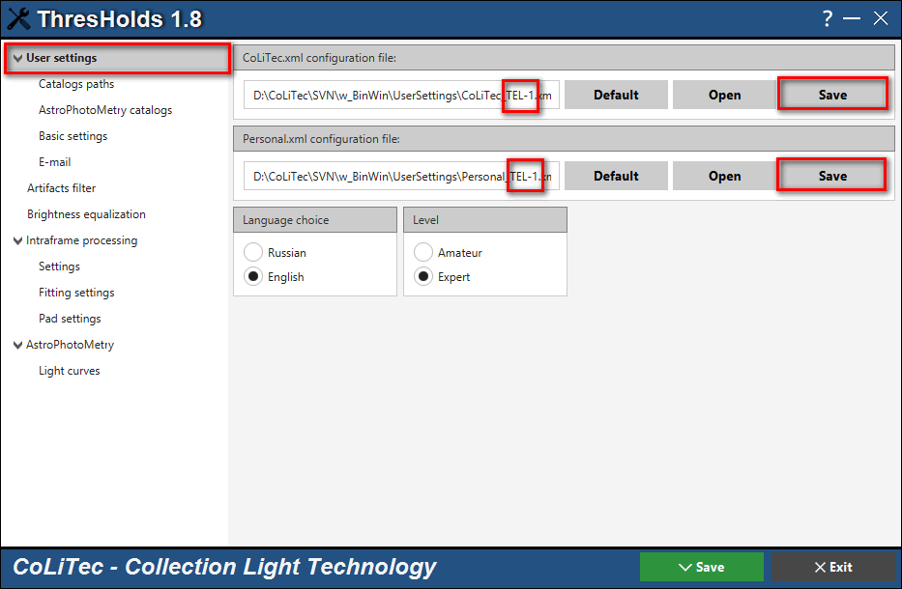

*Fig. 4. "Saving individual user settings" window*

* 1. The choice of an astrometric catalog. You can use the UCAC4 catalog for a wide field of view. It is better to install the NOMAD1 catalog for a field view of 10-15 angular minutes. The example in Fig. 5.

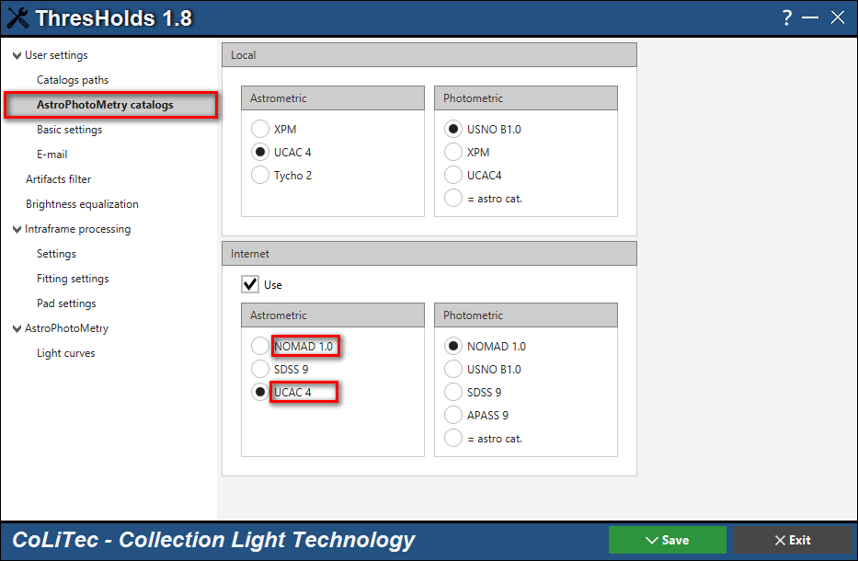

*Fig. 5. "Astrometric Catalog" window*

* 1. The focal length and pixel size should be specified in the frame headers. Instead, the WCS parameters can be specified. If all the specified parameters are missing, you must manually specify the focal length and / or pixel size. Also, if there is no field value in the header of the TELESCOP, you must fill it in the appropriate window field. The example in Fig. 6.

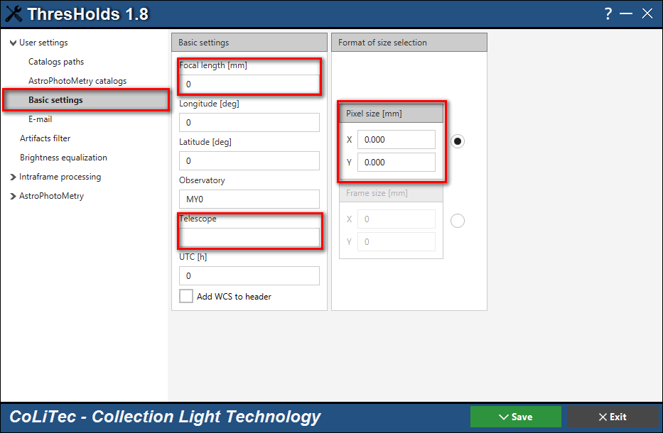

*Fig. 6. "Setting the focal length and / or pixel size" window*

## Setting the parameters for the light curve creation

The settings for the formation and sending of the light curve are shown in Fig. 7.

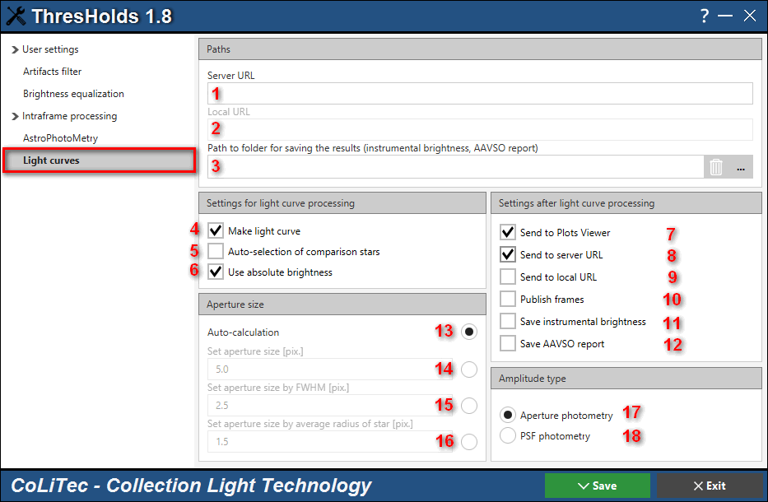

*Fig. 7. "The settings for the formation and sending of the light curve" window*

«1»Field for entering the Internet URL (fill if you want to use the virtual observatory).

«2» Field for entering the local URL (fill if you want to use the local virtual observatory).

«3» Field for entering the path to the folder for saving files with instrumental brightness of the investigated star and comparison stars. If there is no need to save files with instrumental brightness , this folder can be not specified. The name of the file with instrumental brightness has the following format: "date" ­ "star name" _ "filter" _ "telescope", for example, "2017-11-23-RZ Cas_V_MYTELESCOP.txt".

«4» Automatically generate a light curve. In DAY mode, the light curve will be formed after the last frame is processed. In OLDAS mode, the light curve will be formed when processing every 5 frames. The light curve will be formed if there is a task-file, see the section "Task-file creation "LCP".

«5» Setting the option "automatic assignment of comparison stars". With the comparison stars automatic option enabled, the software uses the brightness value of the main comparison star from the catalog. For this, use the folder that is specified in the settings (see section 5.2, block in the screenshot "Photometric"). In this case, the brightness of the star from the catalog is taking in the filter, which is specified in the field of the frame header filter. For example, if "FILTR = B_Johnson" is recorded in the header of the frame, the software does not "understand" that it is necessary to use the brightness value of the star from the folder in the "B" filter.

«6» Setting the option for using the absolute (standardized) measurements in the light curve.

«7» Setting the sending a file with a light curve to the Viewer of light curve.

«8» Setting the sending of data to the Internet version of the virtual observatory (fill if you want to use the virtual observatory).

«9» Setting the sending of data to the local version of the virtual observatory (fill if you want to use the virtual observatory).

«10» Setting the option for sending frames along with the light curve (fill if you want to use the virtual observatory).

«11» Setting the option for saving file with the instrumental brightness of the investigated and comparison stars.

«12» Setting the option for saving reports in AAVSO format.

«13» Setting the automatic calculation of the radius of the aperture (when using aperture photometry).

«14» Setting the aperture radius "explicitly" (when using aperture photometry).

«15» Setting the aperture radius of the aperture through specifying a multiplier when estimating the half-width of stars in frames (when using aperture photometry).

«16» Setting the aperture radius through specifying a multiplier when estimating the radius of images of stars in frames (using aperture photometry).

«17» Setting of the gloss determination of the investigated star and comparison stars through aperture photometry.

«18» Setting of the brightness of the investigated star and comparison stars through PSF photometry.

NOTE. If necessary, the barycentric correction to the Julian date can be calculated. For this, enable mode «SETBARYTIME = true» in the file «…\Bin\MyDevelopSettings.xml». This mode is under testing, so high accuracy and stability are not guaranteed.

## Creating the task-file «LCP»

Task-file for creating the light curve contains with the equatorial coordinates of the investigated star, the main and other comparison stars, as well as other parameters. The main in the task-file creating is selecting the comparison stars. The observer creates a task file for the star-telescope pair only once during the first observation, which saves time.

Task-file can contain the absolute values of the brightness of the main comparison star in different filters. The name of the task-file should contain the name of the telescope (field "TELESCOPE"). By its name the software will determine which task-file to use when building the light curve.

Task-file can be created in the LookSky software. To do this, it is necessary to use the processed frame (frame with an astrometric solution). The processed frame has a prefix "Step_".

A detailed description of the format and creating a task-file is found in the file "LookSky-Creating_task-file_for_light_curve_creation_en.pdf".

Example: task-file for a light curve creation.

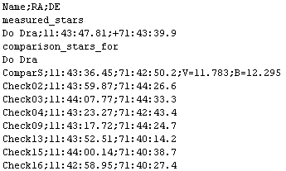

NOTE. If there is a brightness of the main comparison star in task-file, then the light curve of the investigated star contains "absolute" values. If in task-file there is not a brightness of the main comparison star, then the light curve of the investigated star contains "differences" values. This approach allows the observer to determine the brightness of the main comparison star after plotting the curve.

## Processing in the «DAY»mode

Loading frames for processing. In the CLTLogger software window, select the folder with frames - a series of frames (Figure 8.). This folder can contain subfolder with a series of frames. In such subfolder there should be frames of only one section of the sky, which are formed with the same parameters of the telescope and of the CCD camera). The number of frames in a series must be at least three.

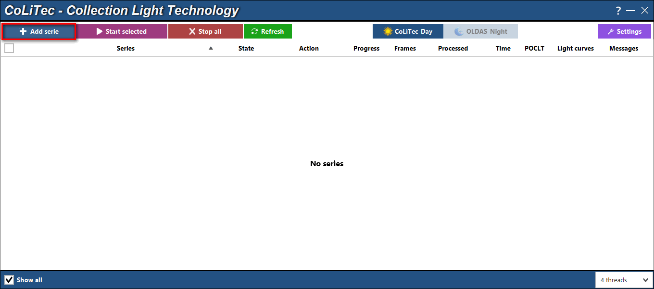

*Fig. 8.1. « Menu selection of series with frames» window*

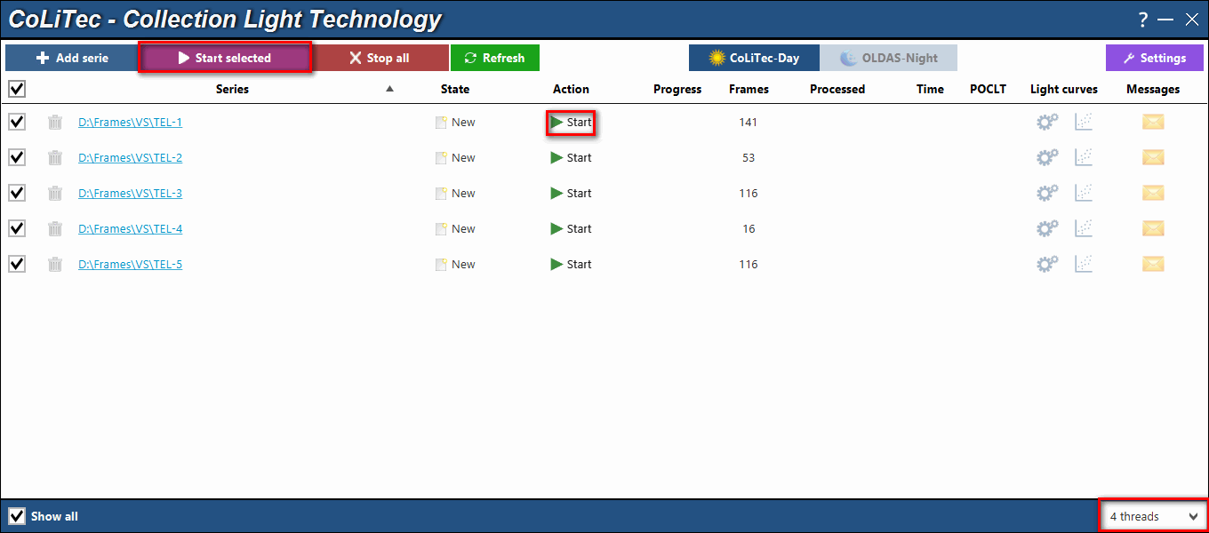

*Fig. 8.2. Appearance of "CLTLogger" window with 5 loaded series of frames for processing*

Start processing - by clicking the "Start" or "Start selected" button.

The number of simultaneously processed series is specified by the number of processor cores available for the software.

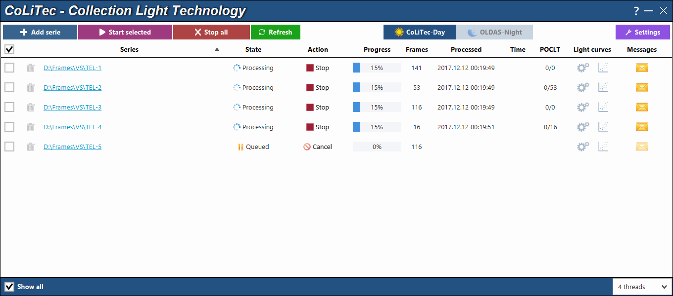

*Fig. 8.3. Appearance of "CLTLogger" window during processing*

When out of 4 processed series at least one is processed, the queue will go to the 5th series.

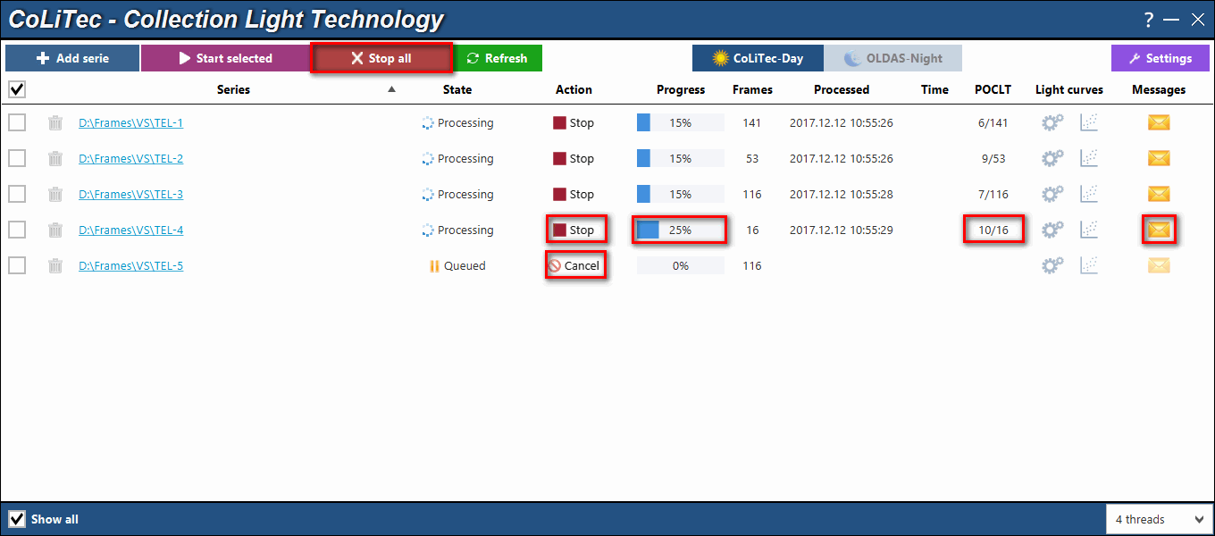

*Fig. 8.4. Appearance of the "CLTLogger" window during processing*

The processing of any series can be stopped / canceled. An example of the progress display is shown in Fig. 8.4. The log of messages about the processing progress can be viewed by clicking on the envelope icon.

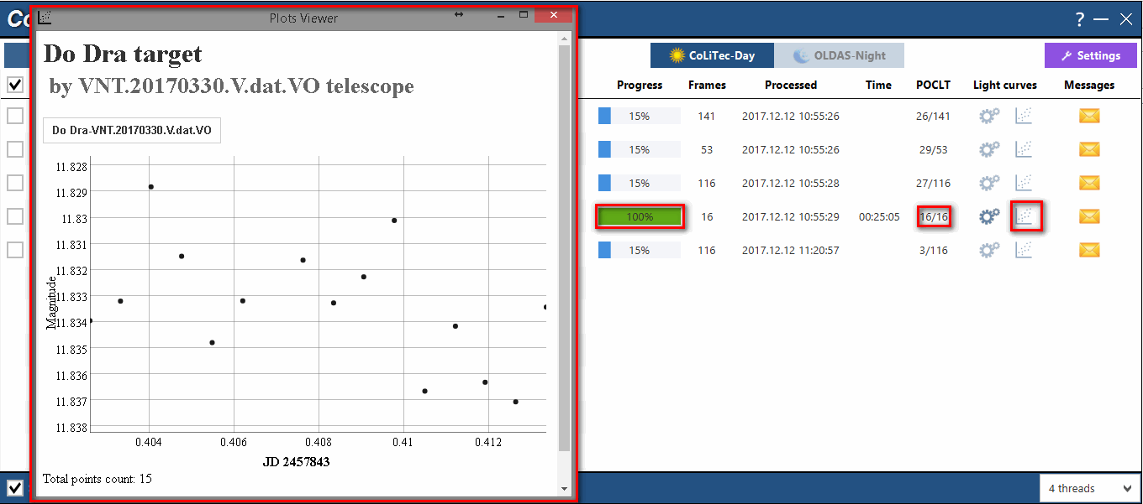

*Fig. 8.5. One of the series was processed. When you click on the light curve icon, Plots Viewer will start and a light curve for this series of frames will be displayed.*

You can separately run the software of the light curves viewer "...\Bin\Plot\plot-viewer". In this case, all light curves that are in the folder "...\Bin\Plot\Data\" will be displayed. An example is shown in Fig. 8.6.

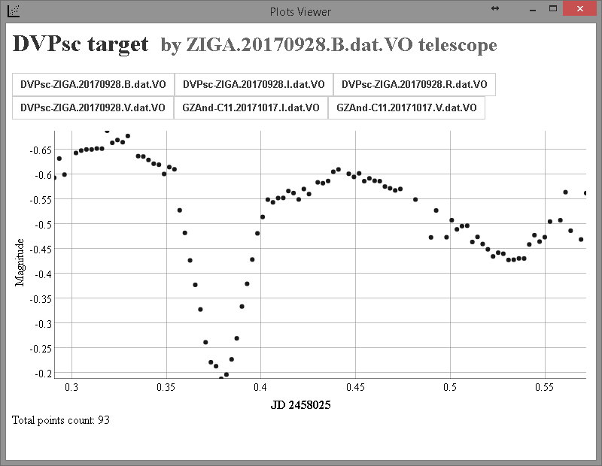

*Fig. 8.6. Run a plot-viewer from the program directory with the ability*

*to view all available light curves*

The file with the light curve, after processing, will be in a folder with a series of frames:

"\TEL-4\**LightCurves**\'telescope' _ 'name'.LCP \' name '-' telescope'.'Date'.'Filter'.dat.VO"

## Processing in the «OLDAS» mode

### Frame header requirements

In addition to the general requirements for frame headers, according to the FITS standard, for right processing in the OLDAS mode, the following fields should be filled in the headings of light frames:

Object

Filter

Ra \ De (if present in the header)

These fields are necessary for the formation of subfolders names in the full path to the folder with processed frames. If the specified fields are not filled, the corresponding subfolders are called "None \" form.

### Setting parameters and start processing

Launch CLTLogger software, enable OLDAS mode (1), set the number of processor cores available to the software (3) and open the software settings (2) (Fig. 9.1).

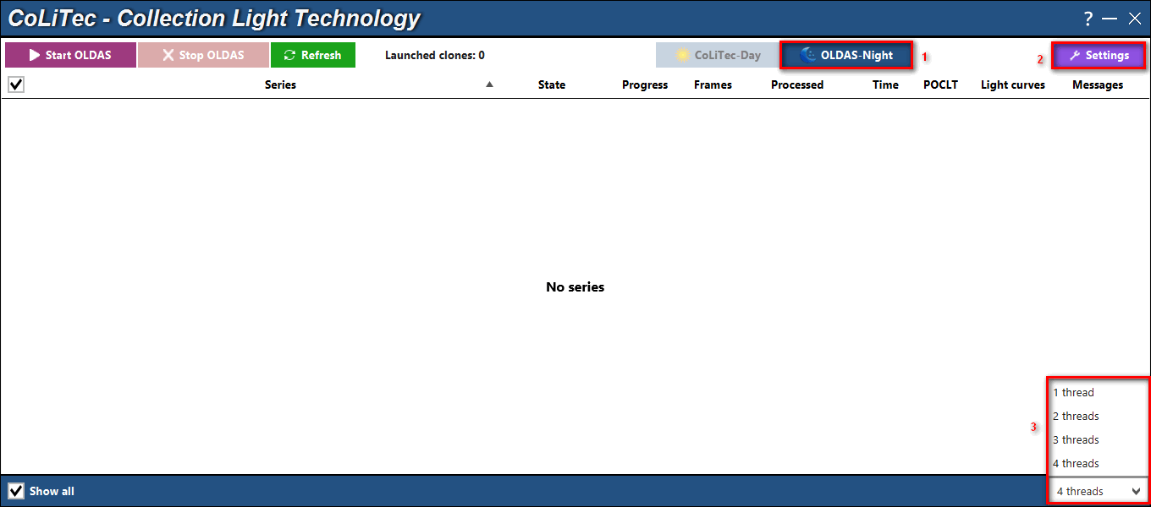

*Fig. 9.1. Window in OLDAS mode*

In the settings window that appears, select the OLDAS tab (Figure 9.2).

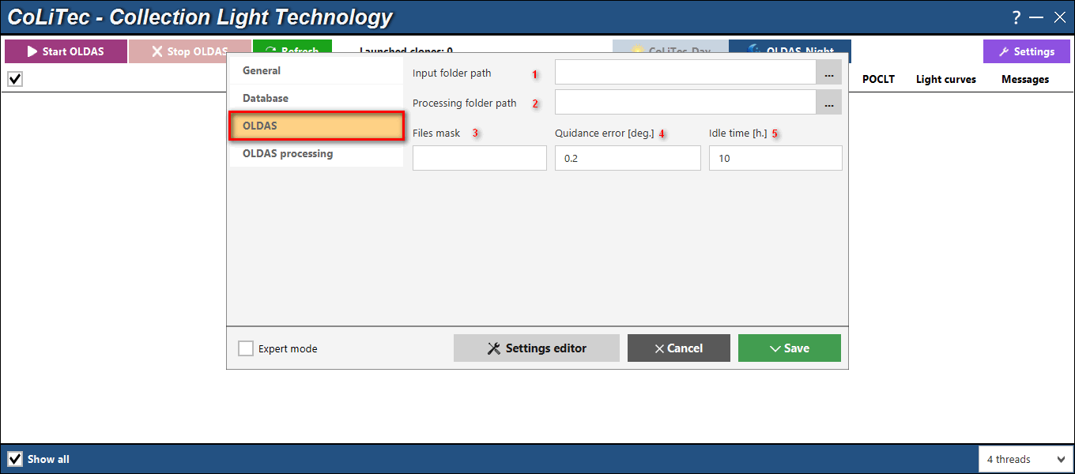

*Fig. 9.2. OLDAS settings window*

«1» Define the input folders, the folders in which the frames for processing are located. The input folders may be several.

«2» Definition of the output folder, in which subfolders (object \ filter \ RADE) would be created, into which the processed frames will be formed.

«3» Name mask of the frames for searching the frames in the input folders. If the mask is not specified, then all fit frames (fit \ fts \ fts) will use.

«4» Guidance error - the permissible deviation of the next frame from those processed earlier (it is calculated in the center of the frame Ra0 \ De0).

«5» Idle time of the software - the maximum number of hours of waiting in the absence of new frames in the input folders. If the time is exceeded, the software will stop searching for new frames and will finish its work.

Select the OLDAS processing tab (Figure 9.3).

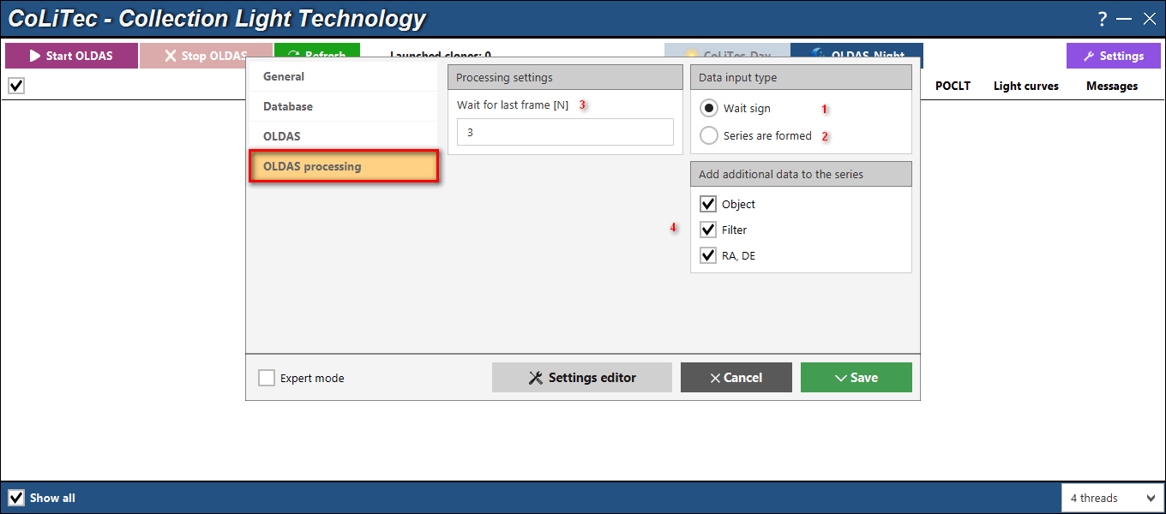

*Fig. 9.3. “Settings OLDAS processing”*

Setting waiting mode for new frames.

When processing frames in the conditions of their constant formation (at night) it is necessary to set the mode "Wait sign" "1". In the "Wait sign" mode, the "Waiting for last frame" "3" field becomes available. "N" field determines how many times the waiting time of the "last frame of the series" exceeds the maximum difference between the formation times of adjacent frames of the series.

For example. 10 frames of series were processed. The maximum difference between the formation times of adjacent frames of the series is 4 minutes. The software will wait for the 11th frame no more than N * 4 minutes and will close the series for addition at the end of this time. The created light curve will be sent to the virtual observatory site if there is an appropriate setting.

In the "Series are formed" mode "2" when processing all frames (all frames of the input folder), the series is closed for addition and the light curve will be sent to the virtual observatory site if there is an appropriate setting.

Settings block "4" ­ the configuration data order the creation of various subfolders (Object \ Filter \ RaDe \) of the processed frames with different values of the header fields Object, Filter, RaDe.

For example, for the folder of frames "D:\frames\" with the three settings used, the path to the folder of the processed frames can be "D:\frames\Object\Filter\RaDe\".

**Start OLDAS**

After setting the parameters in the "OLDAS" and "OLDAS processing" tabs in the window CLTLogger, click the "Start OLDAS" button (Fig. 9.4).

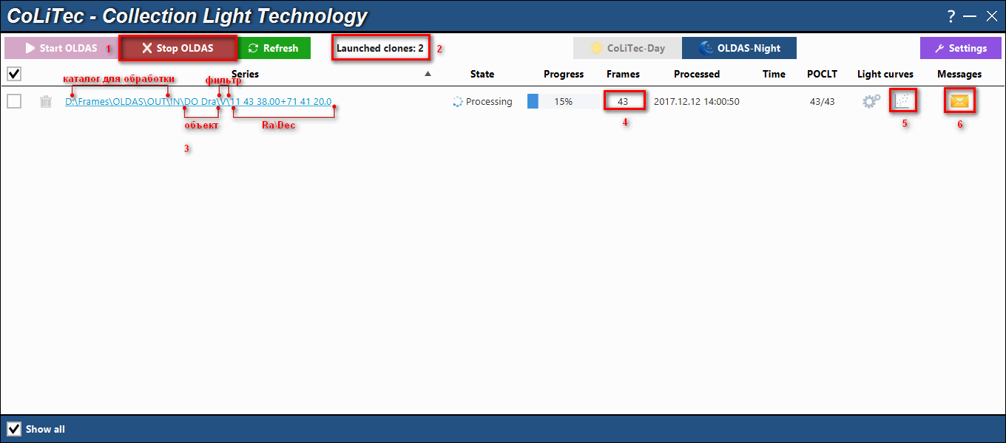

*Fig. 9.4. Window "CLTLogger" while OLDAS running*

«1» Stop processing in OLDAS mode.

«2» Number of running " software instances" (determined by the number of allowed kernels).

«3» Path to the folder with processed frames and a light curve.

«4» Number of processed frames in the series.

«5» Start button for the light curve viewer (Bin \ Plot \ plot-viewer).

«6» Start button for the message monitor. The log of the processing series of frames is displayed in the message monitor.

The file of the light curve, after the end of the series processing, will be in the folder:"...\Serie\**LightCurves**\'telescope'_'star name'.LCP\".

### OnLine viewing the light curve

When CoLiTecVS operates in OLDAS mode, the observer can online monitor the brightness change of the investigated star. In this case, the light curve mapping module is launched every 5 frames. For this the updated light curve is transmitted to the plot-viewer software. An example of the screenshots group in Fig. 9.5.

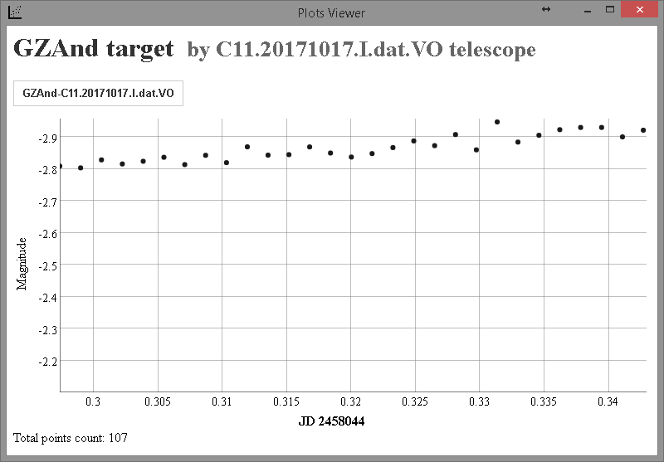 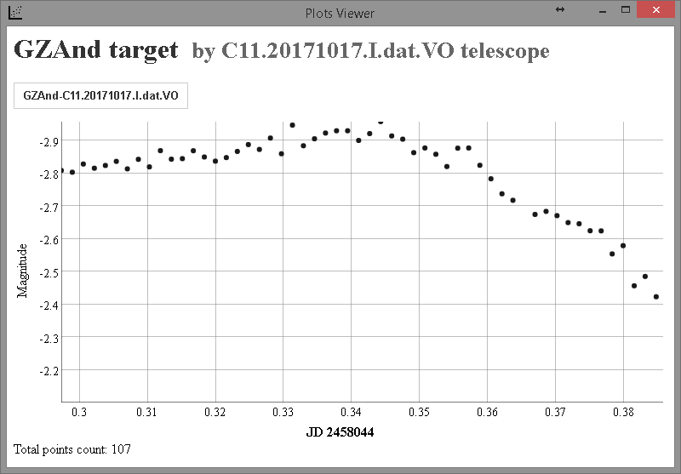 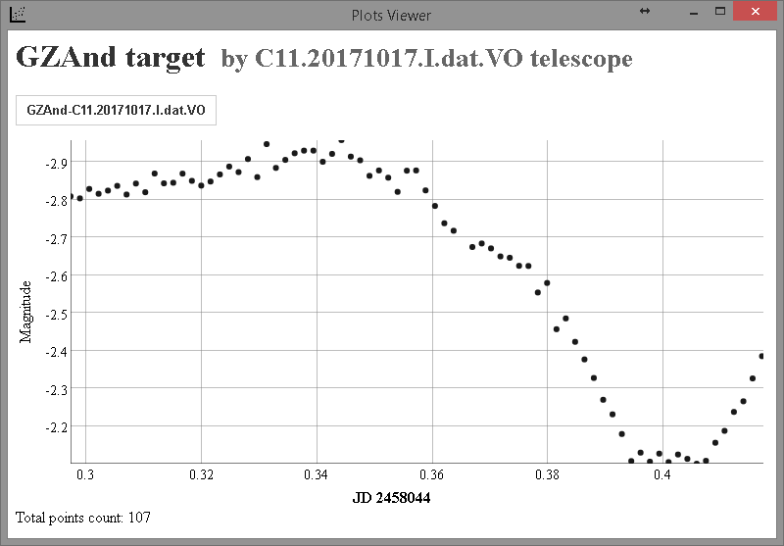 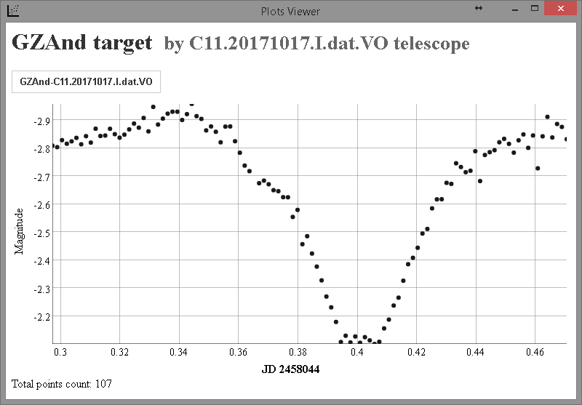

*Fig. 9.5. Display of the dynamics of processing the light curve in OLDAS mode*

## Processing method and representation of the light curve

Ensemble-photometry method was taken as a basis for the light curve formation.

**Representation of the light curve**

The light curve will be represented as the absolute (standardized) measurements if the brightness from catalog of the main comparison star was set in the task-file.

Also, the light curve can be represented in standardized view if the main comparison star is presented in selected photometry catalog and a filter from the frames header is equal to a filter from the catalog.

For this enable the option «Use absolute brightness» in the "Manual formation and sending a light curve" window (fig. 10), or in the settings editor **ThresHolds** before processing (fig. 7 «6»).

Otherwise, the light curve will be represented as the differential (relative) measurements.

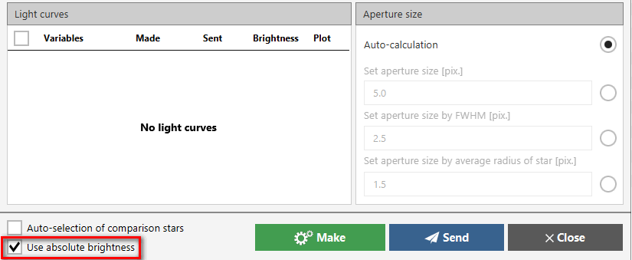

*Fig. 10. Enable "Use absolute brightness" option in*

*"Manual formation and sending a light curve" window*

## Manual mode for forming the light curve

What to do if the task-file was not created before processing? When at least one frame of the series has already been processed, you need to launch the LookSky viewer. With LookSky create a task-file for calculation a light curve (see "Creating an LCP task-file" in this document or see document "LookSky-Creating_task-file_for_light_curve_creation_en.pdf").

Click on the icon "gears" for recreation the light curve with the new processing settings, if necessary. A list of investigated stars available for processing will appear (according to the found list of task-file of this series of frames).

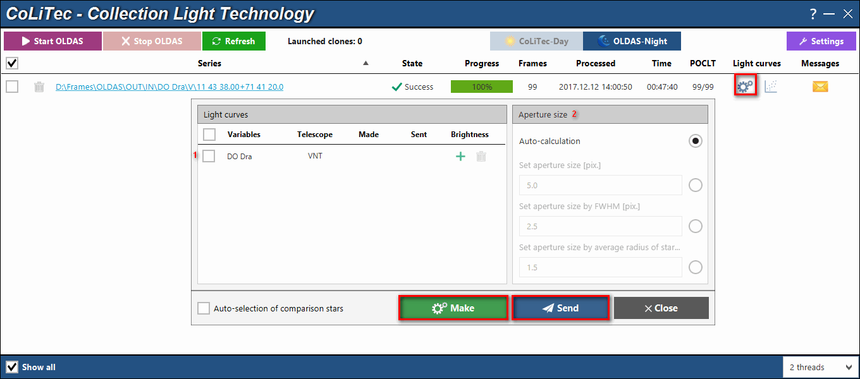

*Fig. 11. "Manual formation and sending a light curve" window*

«1» Field of the list of available investigated stars.

«2» Blok of the method choice for calculating the radius of the aperture (described in the section "Setting the parameters for the light curve creation").

«Make» – start processing.

«Send» – send a light curve, frames, meta-data to the site of a virtual observatory.

## Sending a light curve to a virtual observatory site

A possibility to send a light curve, frames, meta-data to a virtual observatory site is provided in the presence of a virtual observatory (xViO) installed by the CoLiTec Team. The sending mode, the data sending addresses are described in the section "Setting the parameters for the light curve creation".