**[](http://neoastrosoft.com)**

<http://neoastrosoft.com>



User guide

Version **1.8.6.1**

2018

**Contents:**

1. License agreement 4

2. Common information 8

3. Minimal system requirements 8

4. Supported files formats 8

5. Windows configuration 9

6. Linux configuration 9

6.1. Verify Java version 9

6.2. Set required permissions 9

6.3. C & C++ compilers update 9

6.4. Database libraries update 10

6.5. Install libraries for reports (e-mail) sending in LookSky 11

7. CoLiTec Control Center launch 11

8. Graphical user interface 11

8.1. Main window 11

8.2. Control buttons 12

8.3. Processing modes 13

8.4. Working area 14

8.5. Window with processing messages 15

8.6. Settings window 16

8.6.1. "General" section 16

8.6.2. "Database" section 17

8.6.3. "OLDAS" section 18

8.6.4. "OLDAS processing" 19

8.6.5. "Paths to modules"section 21

9. Initial setup of processing parameters 21

9.1. Custom settings for each telescope 22

9.2. Astrometry and photometry catalogs selection 22

9.3. Basic settings 23

9.4. Settings for frames calibration 23

9.5. Settings for reports 26

10. Light curves creation 26

10.1. Task-file «LCP» preparation 27

10.2. Settings for light curves creation 29

10.3. Settings for aperture 31

11. Processing in «CoLiTec-Day» mode 32

12. Processing in «OLDAS-Night» mode 33

13. Analysis of formed light curves 35

14. Manual mode of light curve creation 38

15. Light curve sending to virtual observatory 39

16. Appendix A 41

# License agreement

**«COLITECVS» LICENSE AGREEMENT**

**1. GRANT OF LICENSE**

This End User License is a legal agreement between you (either an individual or an entity) and developers group from *Collection Light Technology* *(CoLiTec)* project. CoLiTec project provides you the License Agreement ("License") for using CoLiTecVS software ("Software"), and you accept, a limited, nonexclusive license to use the Software on the terms defined in this Agreement. For the purposes of this License Agreement, Software includes any updates, enhancements, modifications, revisions, plugins or additions to the software developed by CoLiTec project, available to users through a web site (<http://neoastrosoft.com>). Notwithstanding the foregoing, the developers are under no obligation to provide any updates, enhancements, modifications, revisions, plugins or additions to the software.

**1.1. CoLiTecVS installation and using**

By accepting this License, you may install a copy of the program to no more than one computer.

**1.2. Copies and modifications**

Prohibited the reverse engineering, decompiling, disassembling or any translations of the Software. Prohibited in any way modification or adaptation of the Software. Prohibited from providing or distributing the Software among others. CoLiTecVS distribution is only possible through the web site (<http://neoastrosoft.com>).

**1.3. License grant for remote access to CoLiTecVS**

1.3.1. To access your licensed copies of the software and its use, you can use remote access technologies (for example, Remote Desktop, Radmin, Team Viewer), provided, however, that using remote access software accesses and uses only the primary user of the device, to which remote access occurs. These rights do not allow remote access at the same time you use the software on a device that created the remote session.

1.3.2. CoLiTec developers are entitled to access to the remote user's machine for maintenance, troubleshooting and debugging the Software, while using remote access technologies (for example, Remote Desktop, Radmin, Team Viewer). Remote access can be provided by the user permanently or on developer's request.

1.3.3. People with the full "service" license for the Software may ask developers to assist them using remote access technologies (for example, Remote Desktop, Radmin, Team Viewer).

**1.4. License grant for documentation**

Documentation accompanying software is licensed for internal, non-commercial use.

**2. DESCRIPTION OF OTHER RIGHTS AND LIMITATIONS**

2.1. User undertakes to issue by request the implementation act of the Software and processed data (measured, discovered objects).

2.2. CoLiTec developers have the rights to write articles about the program, it's using and undertake to include in these articles researchers as CoLiTecVS users.

2.3. During publication of the research results that received with help of Software, it is necessary to use link to the official web site (<http://neoastrosoft.com>) and/or citation to publication, which was written by CoLiTec developers.

**3. INTELLECTUAL PROPERTY AND CONFIDENTIALITY**

**3.1. Reports using, License violations and remedies**

CoLiTec developers reserve the rights to obtain information of the Software using, including user names, IP-addresses, and other proprietary information related to this issue. Any unauthorized Software using will be considered by developers as a breach of this License by the user.

**3.2. Property rights on the Software**

You acknowledge that the Software is the property of CoLiTec developers, and that the Software is protected by law "on copyright and related rights." You also acknowledge and agree that developers own all rights and interests in the Software, including associated intellectual property rights in accordance with the laws "on copyright and related rights", "on trade secrets" and "trademark". This License does not grant you any ownership interest in the Software, but only the limited rights of the Software using that can be withdrawn by CoLiTec developers in accordance with the terms of this License.

**4. TERM AND TERMINATION**

This License shall enter into force after your acceptance of the terms of it, or after you downloading, accessing and using the Software, even if you have not explicitly agreed to the terms of the License. This License shall remain in effect until terminated. Without prejudice to any other rights, this License will be terminated automatically if you breach any of the following restrictions or requirements. You may terminate this License at any time by sending e-mail notification about your decision to terminate the License and removing Software to <colitec@neoastrosoft.com>. If you breach any of the terms of License, the developers have the rights to terminate this License. Upon termination of the License by the developers you agree to remove the Software.

**5. LIMITATION OF LICENSE**

**5.1. Software warranty**

CoLiTecVS software is provided «as is». CoLiTec developers clearly state that they do not provide assurance that the Software will meet your requirements, as well as that the Software will be uninterrupted during processing. You are responsible for the selection of software that allows you achieving the intended results, as well as responsibility for the results to be achieved by the Software using. You must bear all risks associated with the quality and performance of the Software.

**5.2. Application of losses**

In any cases, developers are not liable to you or any other related to you party for any incidental, indirect, special, exemplary or punitive damages or loss of profits, even if the developers were aware of the possibility of such damages.

**5.3. Software improvements**

Software user has the rights to make suggestions to refine and improve the Software. All of them will be considered and possibly eventually accounted for.

**6. CHANGES IN TERMS OF LICENSE**

This License may be changed unilaterally by the developers. User notification about changes in the terms of this License will be published on the web site (<http://neoastrosoft.com>). These changes in the terms of the License will enter into force on the date of their publication, unless otherwise specified in the relevant publication.

**7. SOFTWARE «NOT FOR SALE»**

CoLiTecVS software «Not for Resale» («NFR») cannot be sold or transferred for a fee, it can be used for demonstration purposes only, testing or evaluation.

**8. COMPONENTS SEPARATION**

CoLiTecVS software licensed as a single product. Its components should not be separated for using on the multiple devices.

**9. BAN ON TRANSFERRING TO TEMPORARY AND COMMERCIAL USING**

Prohibited the providing CoLiTecVS software for rent, leasing, lending and using as network service to third parties on a commercial basis.

**10. CONSENT TO USE OF DATA**

By user's request the CoLiTec developers can collect and use technical information gathered during providing the support services in relation to the Software. CoLiTec developers may use this information solely to improve its products or to provide customized services or technologies, and will not disclose this information in a form that personally identifies you.

**11. FULLNESS OF LICENSE**

If you have questions concerning to the License, or, if necessary, contact the CoLiTec developers for some reason – use the address information supplied with the CoLiTecVS software (<colitec@neoastrosoft.com>), or visit the web site (<http://neoastrosoft.com>).

# Common information

**CoLiTecVS (Variable Stars)** is the cross-platform software for automated creation of the light curves of investigated variable stars.

Management and processing control of the different types of astronomical data are performed by **CoLiTec Control Center (3C).**

**3С** is a cross-platform module of the **CoLiTecVS** software, which allows user launching of the different processing stages by using corresponding modules.

# Minimal system requirements

* **Windows** system from 7 (32, 64-bit) version, **UNIX** system (32, 64-bit);
* **CPU** frequency no less 1 GHz;
* **RАМ** no less 1 GB;
* **Free space** on the hard drive no less 200 Mb;
* Installed [**Java SE Runtime Environment**](https://java.com/en) no less than 1.8.0.77 version;
* Minimal **screen resolution** no less than 1360 x 600;
* Internet access (without proxy using).

**IMPORTANT**! If the minimal system requirements do not match, the software may not work correctly. Also without internet access the following features can’t be used: processing with on-line astrometric and photometric catalogs, identification of the found objects with [MPC](https://www.minorplanetcenter.net/cgi-bin/checkmp.cgi) data, report sending to the predetermined e-mail.

# Supported files formats

**CoLiTec Control Center** supports all *fits* files of different bits depth (*\*.fit, *.FIT, *.fits, *.FITS, *.fts, *.FTS*). The body, structure and headers of *fits* files should be filled according to the [NASA*fits* standards](https://fits.gsfc.nasa.gov/fits_standard.html), considering to the [commonly used keywords](https://heasarc.gsfc.nasa.gov/docs/fcg/common_dict.html). Description of the mandatory and recommended keywords in the frame header for the correct and fastest processing by **CoLiTecVS** is provided in the Appendix A. Also the possible messages during the input control of parameters and frames are provided there.

# Windows configuration

Using of the latest version of [Java 8](https://java.com/ru/download) according to the **Windows** platform is recommended. Also, *if needed* add to the Windows Firewall exceptions the executable modules from the **CoLiTecVS** directory that asked for the network access.

# Linux configuration

## Verify Java version

Using of the latest version of [Java 8](https://java.com/ru/download) is recommended.

Verify installed Java version. Perform in terminal the following:

***java -version***

If Java version is less than 8, install [Java 8](https://java.com/ru/download). Perform in terminal the following:

***sudo add-apt-repository ppa:webupd8team/java***

***sudo apt-get update***

***sudo apt-get install oracle-java8-installer***

## Set required permissions

It is necessary to set read & write permissions for the **CoLiTecVS** directory. Perform in terminal the following:

***chmod -R 700 Path_to_CoLiTecVS***

## C & C++ compilers update

6.2.1 ***C compiler***

Verify compiler C version. Perform in terminal the following:

***gcc -v***

If C compiler version is less than 4.8, install gcc 4.8 or higher. Perform in terminal the following:

***sudo add-apt-repository ppa:ubuntu-toolchain-r/test***

***sudo apt-get update***

***sudo apt-get install gcc-4.8***

***sudo update-alternatives --remove-all gcc***

***sudo update-alternatives --install /usr/bin/gcc gcc /usr/bin/gcc-4.8 20***

***sudo update-alternatives --config gcc***

6.2.2 ***C++ compiler***

Verify compiler C version. Perform in terminal the following:

***g++ -v***

If C++ compiler version is less than 4.8, install g++ 4.8 or higher. Perform in terminal the following:

***sudo add-apt-repository ppa:ubuntu-toolchain-r/test***

***sudo apt-get update***

***sudo apt-get install g++-4.8***

***sudo update-alternatives --remove-all g++***

***sudo update-alternatives --install /usr/bin/g++ g++ /usr/bin/g++-4.8 20***

***sudo update-alternatives --config g++***

## Database libraries update

If necessary, update database libraries. Perform in terminal the following:

***sudo apt-get install libpam0g:i386***

***sudo apt-get update***

***sudo apt-get upgrade -y***

***sudo apt-get dist-upgrade***

## Install libraries for reports (e-mail) sending in LookSky

Reports (e-mail) sending in LookSky is performed by using the SMTP protocol. For example, [gmail](https://support.google.com/a/answer/176600?hl=en) (usermail@gmail.com, smtp.gmail.com, port 465). Before using gmail, make sure that «Allow less secure apps» option is set in «Sign-in & security» section. In addition, the reports will be also saved to «Sent Mail». This is exclusive policy of Google, another mail services don’t have this.

For the implementation the following are used: free [Synapse](http://synapse.ararat.cz/doku.php) library and open source [X-Mailer](https://github.com/silvioprog/xmailer) plugin.

If necessary, install libraries for e-mail sending. Perform in terminal the following:

***sudo apt-get install libssl-dev***

# CoLiTec Control Center launch

**CoLiTecVS** directory should have read & write permissions or shared access.

To launch **CoLiTec Control Center (3С)** run "***CLTLogger.exe***" file in Windows and "***CLTLogger.jar***" using Java 8 in Linux. Also **3С** can be launched from terminal using the following:

***java -jar CoLiTecVS\CLTLogger.jar***

During the first launch of **3С** the network access can be required for the following modules: ***Dolli*** (processing with the online astrometric and photometric catalogs) and ***PostgreSQL*** (local database for logging and processing monitoring). So, it is necessary to provide the appropriate network access for these processes and add them to Firewall exceptions.

# Graphical user interface

## Main window

Access to capabilities of **CoLiTec Control Center (3C)** is carried out through the interface of main window ().

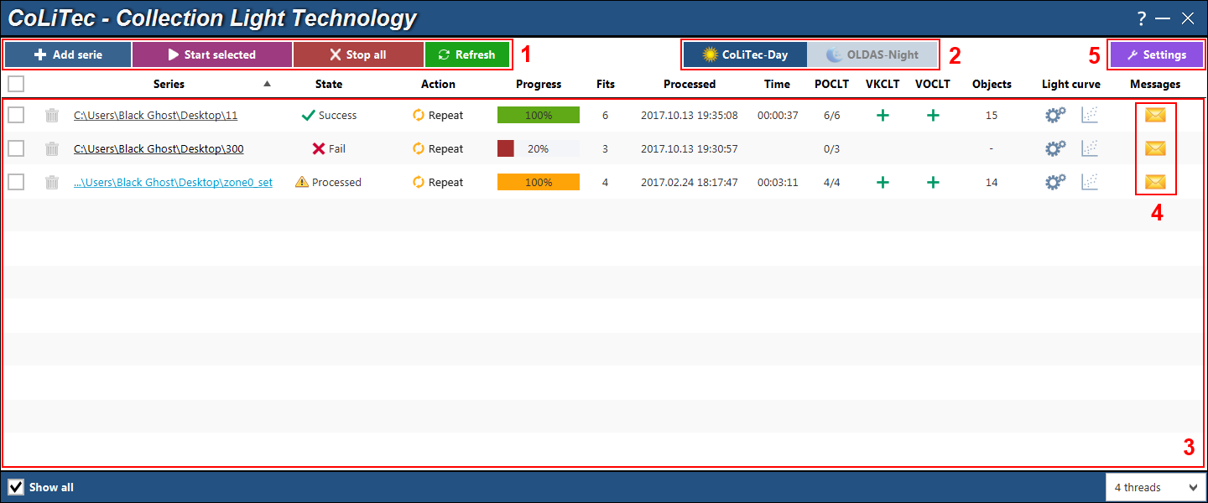

**Figure 1.** **CoLiTec Control Center**main window

1 – Control buttons;

2 – Processing modes;

3 – Working area;

4 – Messages during the processing;

5 – Program settings.

According to the processing mode (2) **CoLiTec Control Center** interface contains the different sets of controls buttons and processing elements.

## Control buttons

Series processing is performed using the following control buttons:



– allows user to add the new folder with a series. The program allows also selecting the parent folder, which contains some folders with series – all child folders will be added recursively to the working area;



– allows user to start processing of selected series. Series can be selected using the checkboxes opposite each series from the series list in the working area;

 – allows user to stop all running threads of the series processing. The confirmation message will appear for this action. Interrupted threads of the series processing do not guarantee the integrity of the processed data;



– allows user to refresh the status of all series from the list in the working area. Refreshing also occurs automatically according to the refresh interval in seconds, which is specified in the program settings;



– allows user to start processing in OLDAS mode. All necessary paths and parameters should be specified in the program settings;



– allows user to stop processing in OLDAS mode. Stopping also occurs automatically according to the idle time in hours, which is specified in the program settings;



 – shows the number of launched clones during processing in OLDAS mode. The number of launched clones can be set before processing start using the drop down on the main window () – .

## Processing modes

**CoLiTec Control Center** supports 2 processing modes: **CoLiTec-Day** and **OLDAS-Night** (On-line Data Analysis System).



**CoLiTec-Day** – mode, which allows you the frames processing from already prepared series. The processing types and pipeline will be determined in accordance with the configuration in the settings editor **ThresHolds**.

To process frames from already prepared series in **CoLiTec-Day** mode the following conditions must be met:

– frames belong to the same telescope/filter/field of view;

– number of frames is determined during series selection and can't be changed during the processing.

**OLDAS-Night** – mode, which allows you the frames processing in real time. This means that during the operation of the telescope, frames are saved in a folder that **CoLiTecVS** has access to. The paths to this folder, as well as to the folder where the processing and saving of results will occur, are specified in the program settings (Section 8.6.3).

Also, this mode allows you to distribute frames to subfolders according to the attributes «*Object\Filter\RADE\Camera*» (Section 8.6.4), view in real time the plots with the light curves of each subfolder (each telescope, filter) that dynamically change.

For **OLDAS-Night** mode it is necessary to set the number of threads for processing, as well as the number of frames from which the observational series will consist (Section 8.6.4).

## Working area

Working area in **CoLiTec Control Center** contains the list of all available series with the following information about each of them:

"**Series**" – full path to the folder with frames of the current series. If the path is too long its first part will be replaced with "...". This path is represented as a hyperlink, by clicking on which the folder with frames of the selected series will be opened;

"**State**" – processing state of the current series: success, error, processing, in queue;

"**Action**" – action buttons that are available on the different processing stages: start, stop, repeat, cancel (remove from the processing queue);

"**Progress**" – processing progress of the current series, which is depend of the processing stages;

"**Frames**" – number of frames in the current series;

"**Processed**" – date and time of the last processing of the current series;

"**Time**" – processing time of the current series;

"**POCLT**" – status of the intraframe processing stage, number of the formed subseries that were processed;

"**Light curves**" – control buttons of the light curves: – create and send light curves in manual mode (Section 15) and – open light curve in **Plots Viewer** (Section 14);

"**Messages**" – button to open a window with processing messages (Section 8.5) during all processing stages of the current series.

In the working area you can sort the list of series by different columns. Also you can use "**Show all**" checkbox to show the list with all available in database series. Otherwise, you can see the list with all only active series, i.e. data from the old series will not be displayed.

## Window with processing messages

Using button in the working area of **CoLiTec Control Center** you can open the window with processing messages ().

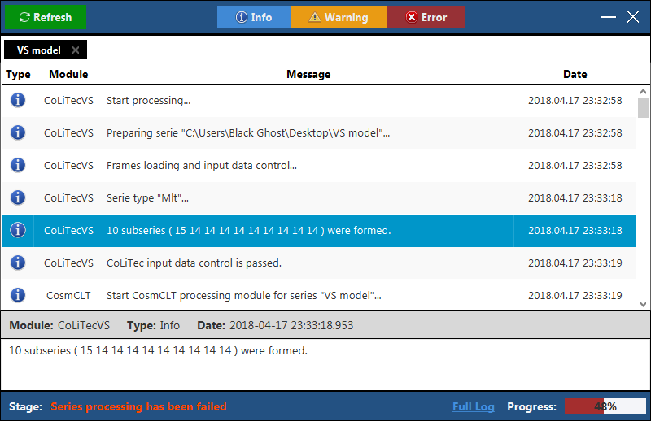

**Figure 2.** Window with processing messages

The window with processing messages contains all messages from the different modules during any types of processing of different astronomical data.

The following message types are supported in this window: **info**, **warning** and **error**. Enabling/disabling of these message types is performed by the following control buttons:



In the window with processing messages you can sort messages by "**Module**" and "**Date**" columns. When selecting a message the detailed information about this message appears at the bottom of the window.

## Settings window

Using button in **CoLiTec Control Center (3C)** you can open window with program settings. In this window you can change all necessary parameters to manage any types of processing of different astronomical data.

### *"General" section*

"**General**" section of settings window in **CoLiTec Control Center** contains the following parameters ():

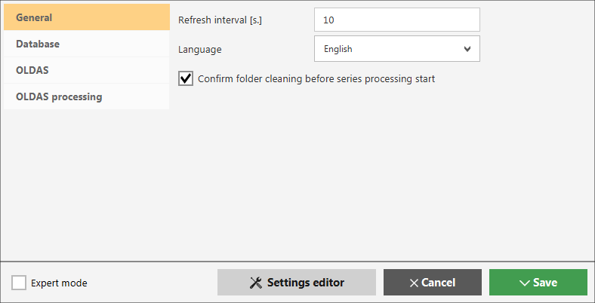

**Figure 3.** Settings window, "General" section

"**Refresh interval [s.]**" – time interval in seconds for the refresh of information about series processing in the working area of **3С**;

"**Language**" – selection of the interface language of **3С**, Russian and English languages are available;

 "**Confirm folder cleaning before series processing start**" – checkbox to permit/prohibit the automatic cleaning of the folder with series before processing start;

– open settings editor **ThresHolds**.

### *"Database" section*

"**Database**" section of settings window in **CoLiTec Control Center** contains the following parameters ():

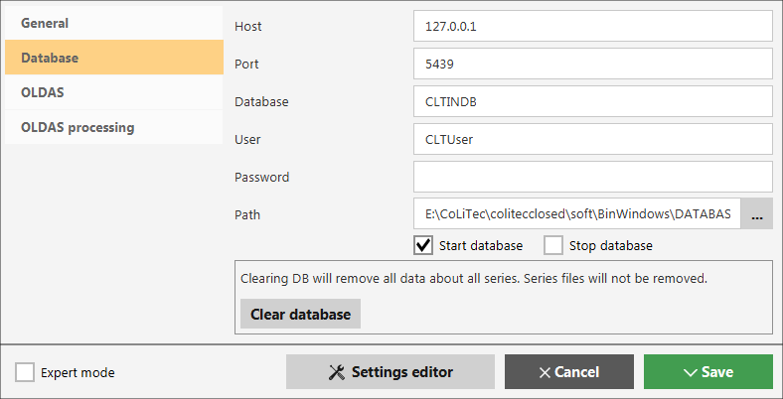

**Figure 4.** Settings window, "Database" section

"**Host**" – IP-address of database, by default is "127.0.0.1" – local database means that the server with database is located on the same PC as **3С**;

"**Port**" – port for access to database;

"**Database**" – database name;

"**User**" – user name for access to database;

"**Password**" – user password for access to database;

"**Path**" – path to the local database;

"**Start database**" – checkbox to permit/prohibit the automatic start of the local server with database during **3С** launching;

"**Stop database**" – checkbox to permit/prohibit the automatic stop of the local server with database during **3С** closing;

– allows user to clear all content of the database (information about all series). The physical data of the series will not be affected.

### *"OLDAS" section*

"**OLDAS**" section of settings window in **CoLiTec Control Center** contains the following parameters ():

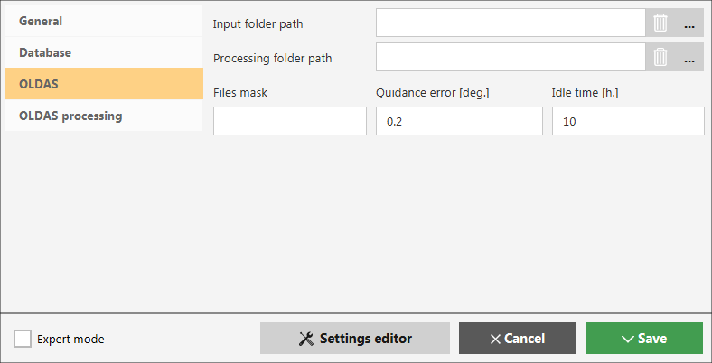

**Figure 5.** Settings window, "OLDAS" section

"**Input folder path**" – path to the folder with frames that are stored during telescope observation. To set several input folders use separator ";";

"**Processing folder path**" – path to the folder where series are formed (subfolders creation for the frames distribution according to the attributes «*Object\Filter\RADE\Camera*») and the processing results are saved;

"**Files mask**" – mask of files name that are used for the subseries/series creation from the input folder. If the files mask is not set all supported *fits* files (Section 4) are used from the input folder;

"**Quidance error [deg.]**" – telescope guidance error in degrees, the deviation of the center (RA0/DE0) of the next frame from the center of the previous one;

"**Idle time [h.]**" – maximum amount of hours for waiting in the absence of processing tasks or new frames in the input folder. After this time the search for new frames in the input folder will be stopped and work of all clones will be automatically completed.

### *"OLDAS processing"*

"**OLDAS processing**" section of settings window in **CoLiTec Control Center** contains the following parameters ():

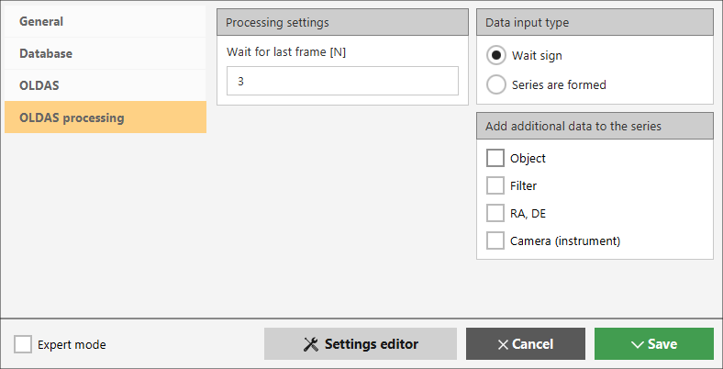

**Figure 6.** Settings window, "OLDAS processing" section

"**Processing settings**":

"**Wait for last frame [N]**" – time of waiting for the last frame of series in times, namely, how many times the waiting time exceeds the maximum difference between the formation times of neighboring frames in series.

After the waiting time has expired, **OLDAS** mode is stopped and the series is closed for processing. In this case, the formed light curve is sent to virtual observatory only if there is an appropriate setting.

"**Wait for last frame [N]**" field is available only when "**Wait sign**" option is set.

For example, after processing of 10 frames in series with a maximum difference between the formation times of neighboring frames in series equal to 4 minutes, the program will wait for the 11th frame no more than N*4 minutes.

"**Data input type**":

* "**Wait sign**" – interframe processing is started only after the indication about completion of the series formation. This mode should be enabled for the frames processing in the conditions when they are permanent formed (at night);
* **"Series are formed**" – all processing stages are distributed between clones (threads) and interframe processing will be immediately started after the completion of intraframe processing of the last subserie. Then the series is closed for processing, light curve is formed and sent to virtual observatory only if there is an appropriate setting.

"**Add additional data to the series**":

"**Object**", "**Filter**", "**RA, DE**" and "**Camera**" checkboxes allow managing the subfolders creation for the frames distribution in the processing folder according to the attributes «*Object\Filter\RADE\Camera*». The data for names of these subfolders is taken from the corresponding fields of the frame's header. That's why for **OLDAS-Night** mode it is important that "**Object**", "**Filter**", "**RA, DE**" and "**Camera**" fields are presented and correctly filled.

If some checkboxes are not set the sequence of subfolders «*Object\Filter\RADE\Camera*» will still be met, excluding subfolders corresponding to these checkboxes.

For example, for processing folder «*D:\Frames*» and various checkboxes, the full path to formed series will have the following appearance:

|  |  |  |  |  |
| --- | --- | --- | --- | --- |
| **Object** | **Filter** | **RA, DE** | **Camera** | **Full path to series** |
| **-** | **-** | **-** | **-** | *D:\Frames* |
| **-** | **-** | **-** | **+** | *D:\Frames\****FLI*** |
| **-** | **-** | **+** | **-** | *D:\Frames\****11 43 38.00+71 41 20.0*** |
| **-** | **+** | **-** | **-** | *D:\Frames\****V*** |
| **+** | **-** | **-** |  | *D:\Frames\****Do Dra*** |
| **+** | **+** | **+** | **+** | *D:\Frames\****Do Dra\V\11 43 38.00+71 41 20.0\FLI*** |

### *"Paths to modules" section*

During enabling the expert mode using **"Expert mode"** checkbox the additional section "**Paths to modules**" will appear.

"**Paths to modules**" section of settings window in **CoLiTec Control Center** contains the following parameters ():

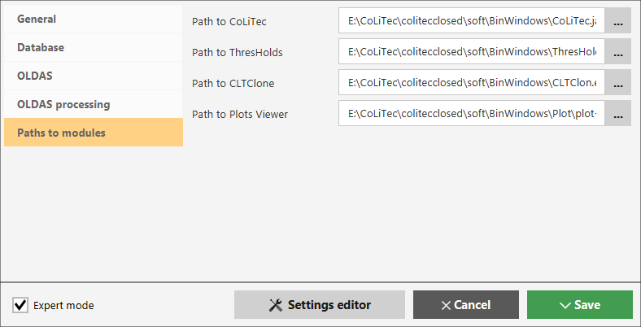

**Figure 7.** Settings window, "Paths to modules" section

"**Path to CoLiTec**" – path to the processing program "**CoLiTec.jar**";

"**Path to ThresHolds**" – path to the settings editor "**ThresHolds.jar**";

"**Path to CLTClone**" – path to the cloning program "**CLTClon.exe**";

"**Path to Plots Viewer**" – path to the program "**plot-viewer.exe**" for displaying the light curves.

# Initial setup of processing parameters

For the first start of processing for automated light curve creation of the investigated variable star using **CoLiTec Control Center (3C)** perform initial setup of processing parameters.

These settings can be set using the settings editor **ThresHolds**, which is available from the settings window of **3С** using button (Section 8.6.1)**.**

*Detailed description of each parameter is provided in the document «****ThresHolds – Parameters description****».*

## Custom settings for each telescope

If during the processing it is supposed using of the astronomical data from different telescopes, it is necessary to create custom settings for each telescope in settings editor **ThresHolds**. This is especially important for **OLDAS-Night** mode. Also the custom settings can take into account the individual characteristics of each telescope.

It is recommended for each telescope to save configuration files with the following names: "**CoLiTec_TEL.xml**" and "**Personal_TEL.xml**", where "**TEL**" is a name of telescope, which is contained in «**TELESCOPE**» field in headers of calibration frames.

## Astrometry and photometry catalogs selection

According to the telescope's field of view it is necessary to select appropriate astrometry and photometry catalogs in section "**User settings – AstroPhotoMetry catalogs**" of settings editor **ThresHolds** ().

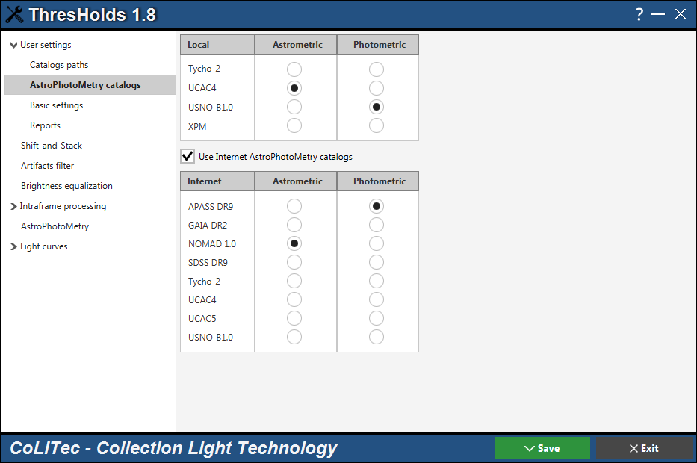

**Figure 8.** Settings editor, "AstroPhotoMetry catalogs" section

With a fairly wide telescope's field of view, it is recommended to use the online astrometric catalog UCAC5. If the telescope's field of view is in the range from 10 to 15 arc minutes, it is recommended to use the online catalog GAIA DR2 as astrometric catalog.

**IMPORTANT**! If no Internet connection, perform the following actions in the settings editor **ThresHolds**:

* set paths to the local astrometric and photometric catalogs in "**User settings – Catalogs paths**" section;
* select the local astrometric and photometric catalogs using the appropriate options and remove **"Use Internet AstroPhotoMetry catalogs**" checkbox in "**User settings – AstroPhotoMetry catalogs**" section.

## Basic settings

If the focal length, pixel size and WCS data are not specified in the frame's header, it is necessary to specify them in section «**User settings – Basic settings**» as well as observatory, latitude, longitude, altitude, UTC time zone and ability for adding this data to frame's header during processing ().

If there are no values of «TELESCOP» and/or «FILTER» fields in the frame's header, it is necessary to specify them in the appropriate fields (). This data will be used during processing and light curves creation.

## Settings for frames calibration

**CoLiTecVS** provides a possibility for the calibration of raw (light) frames using calibration frames (bias, dark, flat, dark-flat), and brightness equalization using the mathematical inverse median filter.

This filter can be used in conjunction with the calibration frames using and without them. It will be useful when flat-frames are not fully corresponded to the light-frames or even missing.

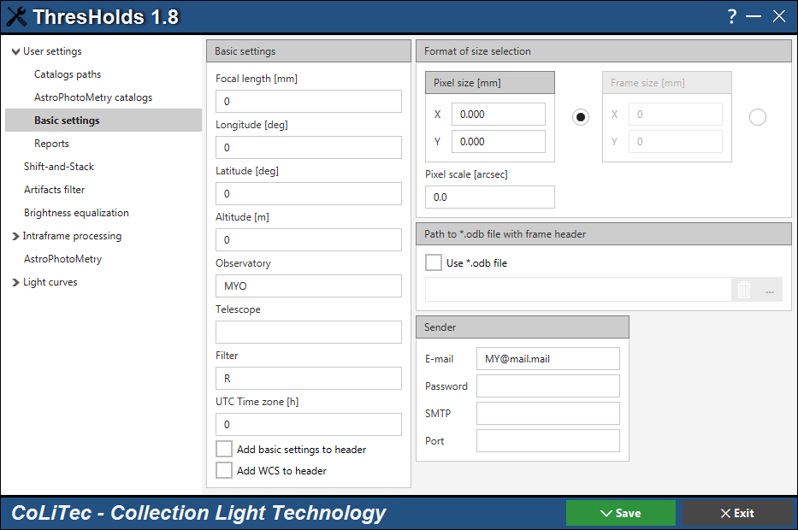

**Figure 9.** Settings editor, "User settings – Basic settings" section

Settings for the frames calibration (paths to calibration frames, filter settings) are available in section «**Brightness equalization**» of settings editor **ThresHolds** ().

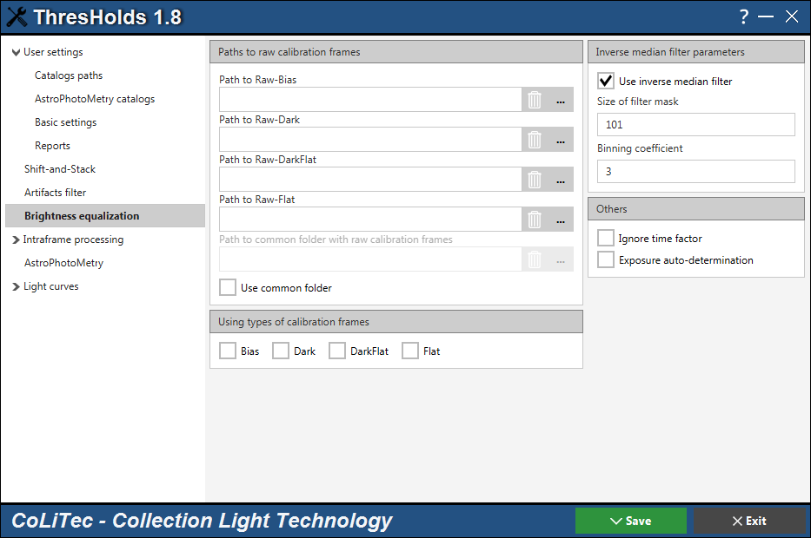

**Figure 10.** Settings editor, "Brightness equalization" section

**CoLiTecVS** can determine the calibration frames to improve the light-frames. The observer can collect the calibration frames of different types and different telescopes in the specified folder. **CoLiTecVS** creates the appropriate master-frames from calibration frames in the folder specified by the observer. These master-frames are used for the calibration of light-frames.

To enable this mode you need to specify "**Path to common folder with raw calibration frames**" and set "**Use common folder**" checkbox. It is also necessary to select the frames types that should be used by the corresponded checkboxes.

When using the automatic determination of raw calibration frames, the last should be formed earlier than the light-frames, otherwise the calibration frames are not used. Also the frames headers should meet the following requirements:

|  |  |  |  |  |  |
| --- | --- | --- | --- | --- | --- |
| **Parameter** | **Keyword in**  **frame header** | **Value / identity of parameter** | | | |
| **Light** | **Bias** | **Dark** | **Flat** |
| Frame size | NAXIS1, NAXIS2 | + | + | + | + |
| Frame type | IMAGETYP |  | bias | dark | flat |
| Telescope name | TELESCOP | + | + | + | + |
| Temperature | SET-TEMP  CCD-TEMP  TEMPERAT | + |  | + |  |
| Exposure | EXPOSURE  EXP-TIME  EXPTIME | + |  | + |  |
| Filter | FILTR  FILTER | + |  |  | + |

Of all calibration frames from the specified folder, only frames formed at the night nearest to the light-frames are used. This condition is associated with the possibility of finding in the specified folder the original calibration frames that were received within a few days. To ignore this condition set "**Ignore time factor**" checkbox.

Settings "**Exposure auto-determination**" checkbox allows selecting only dark-frames with exposure, which is closest to the exposure of light-frame.

The list of raw calibration frames can also be specified manually as an alternative for the automatic determination of raw calibration frames.Requirements for dark-frames of flat-frames (dark-flat frames) are similar to requirements for dark-frames relatively to light-frames. All requirements for the frames headers except the frame sizes (*NAXIS1, NAXIS2*) are ignored when raw calibration frames are specified manually.

## Settings for reports

To send reports the sender's details (E-mail and mail client settings) must be filled out in section «**User settings – Basic settings**» ().

Also it is necessary to fill in the information for the report formation to the recipient (AAVSO service) in section «**User settings – Reports**».

For example, AVVSO code ().

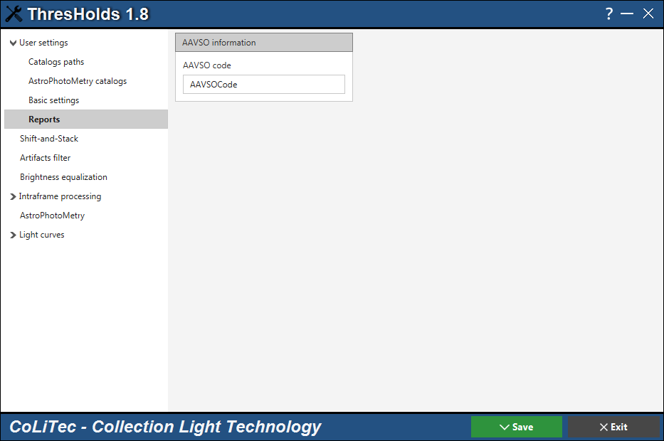

**Figure 11**. Settings editor, "User settings – Reports" section

# Light curves creation

**CoLiTecVS** provides a possibility for the light curves creation in automated and manual modes, which is based on ensemble-photometry method.

The light curve can be created only in the presence of task-file «LCP», which is prepared in **LookSky** (details in section 10.1).

In **CoLiTec-Day** mode the light curve is created after processing of the last frame. In **OLDAS-Night** mode the light curve is created/updated after processing of every 5 frames.

* 1. ***Task-file «LCP» preparation***

«LCP» task-file is necessary for the light curve creation. This is a file with equatorial coordinates of the investigated star, the main and other comparison stars, as well as other parameters. The main in the task-file preparing is a selecting of the comparison stars. The observer creates a task-file for the «star-telescope» pair only once during the first observation, which saves time.

Task-file can contain the absolute values of brightness of the main comparison star in different filters. The name of task-file should contain the name of telescope («*TELESCOPE*» field). By its name the software determines which task-file to use during the light curve creation. For example, *«$Telescope$_$Star$.LCP*». Task-file for the investigated star can be prepared in the frames viewer **LookSky**.

To launch **LookSky** run "***LookSky.exe***" file in Windows or "***LookSky***" in Linux. Task-file «LCP» is saved to «*List_LCP*» folder by default.

The task-file can be prepared only if at least one frame of the series has already been processed, that is, a frame with an astrometric solution. The processed frame has in the name a prefix «*STEP-*».

To create task-file perform the following actions.

1. Activate «*Service*»  «*Hand Measurer*» menu item and select «*Variable Stars – Light Curves*» class ().

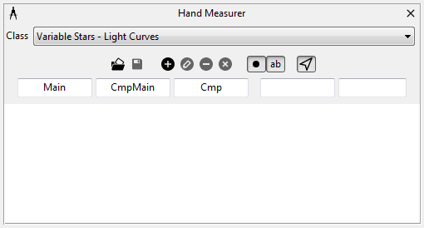

***Figure 12.*** *"Hand Measurer" window, «Variable Stars – Light Curves» class*

2. Load a series of frames with the investigated variable star.

In «*Image view*» window use a mouse to mark the investigated star, main comparison star and other comparison stars ():

– CTRL + Left Mouse Button – add new or shift the mark;

– CTRL + Right Mouse Button – remove the mark.

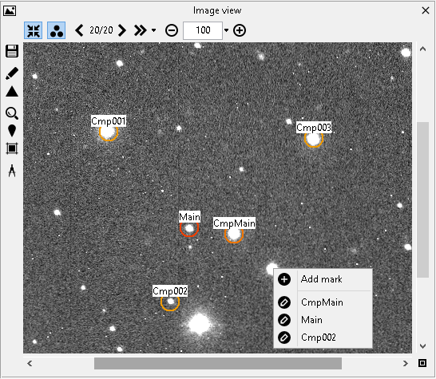 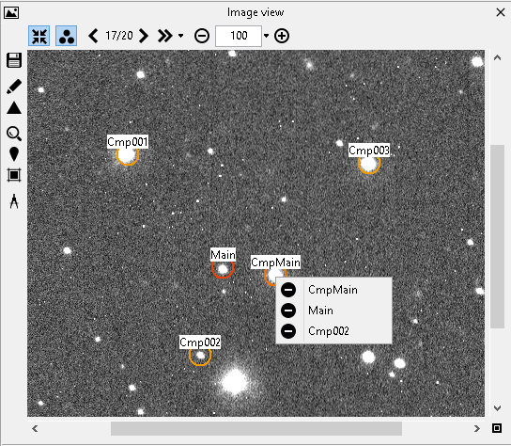

***Figure 13.*** *"Image view" window. Add new, shift or remove the mark*

3. Using «*Save marks to task-file for the light curve creation*» button ObjSave in «*Hand Measurer*» window save the task-file to «*List_LCP*» folder with the following name: *«$Telescope$_$Star$.LCP*».

Additional elements of «*Variable Stars – Light Curves*» class in «*Hand Measurer*» window provide the following abilities:

– to change the masks for names of marks:



– to add the name of source with photometric data of the main comparison star (if such data is entered) in "**Source"** field;

– to add the user comment in "**Comment"** field:



– to add, edit and remove marks manually ():

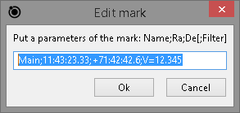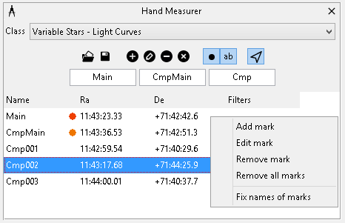

***Figure 14.*** *"Hand Measurer" window, context menu for the mark*

If the brightness of main comparison star is not presented in the task-file «LCP», the light curve of the investigated star contains "absolute" values. Otherwise, the light curve of the investigated star contains values as "differences". This approach allows the observer to determine the brightness of the main comparison star after plotting the curve.

The example of a file-task for creation of the light curve of investigated star is presented in .

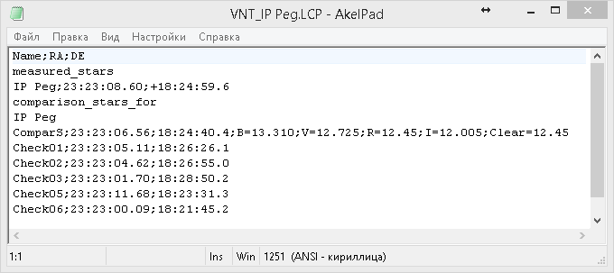

***Figure 15.*** *The example of a file-task for the light curve creation*

* 1. ***Settings for light curves creation***

All settings for the light curves creation are available in «**Light curves**» section of settings editor **ThresHolds** ().

The created light curve is represented in the form of absolute (standardized) values only if the brightness of main comparison star from catalog was given in the task-file «LCP» (Section 10.1). Also the light curve can be obtained in standardized form when the main comparison star is in the specified photometric catalog and a filter from the frame's header is the same as filter from catalog.

For this set "**Use absolute brightness**" checkbox. Otherwise the light curve is represented in the form of differential (relative) values.

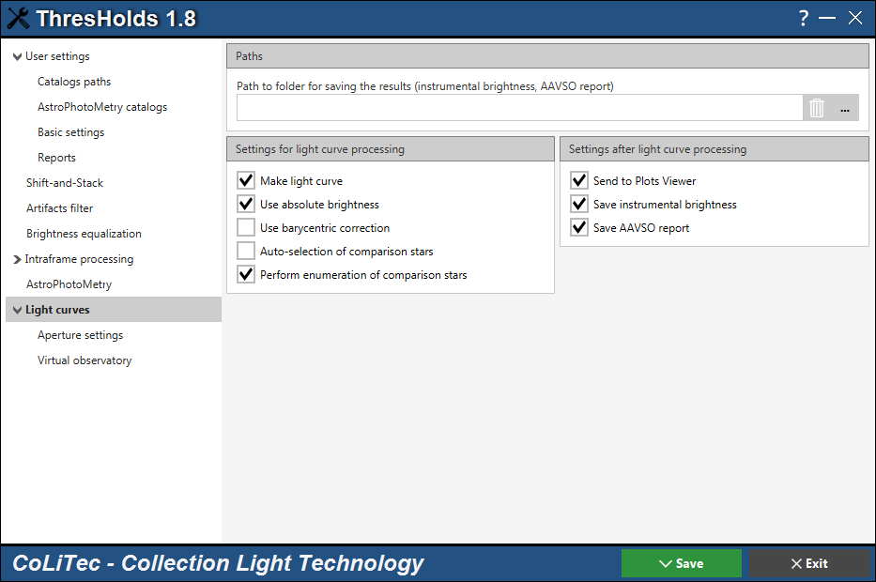

**Figure 16.** Settings editor, "Light curves" section

If "**Auto-selection of comparison stars**" checkbox is set the program specifies brightness of the main comparison star from the photo catalog, which is specified in "**User settings – AstroPhotoCatalogs**" section (). In this case, the brightness of the star is taken from the catalog in the filter, which is explicitly specified in the filter field of frame header. Detailed description about supported filter keywords are in the Appendix A.

"**Path to folder for saving the results**" field should be specified if the file with instrumental brightness or/and AAVSO report are saving. The name of file with instrumental brightness has the following format:

*«$Date$-$Star$_$Filter$_$Telescope$.txt»*,

«*2017-11-23-RZ Cas_V_MYTELESCOPE.txt*».

* 1. ***Settings for aperture***

All settings related to the shape and size of the aperture are available in «**Light curves – Aperture settings**» section of settings editor **ThresHolds** ().

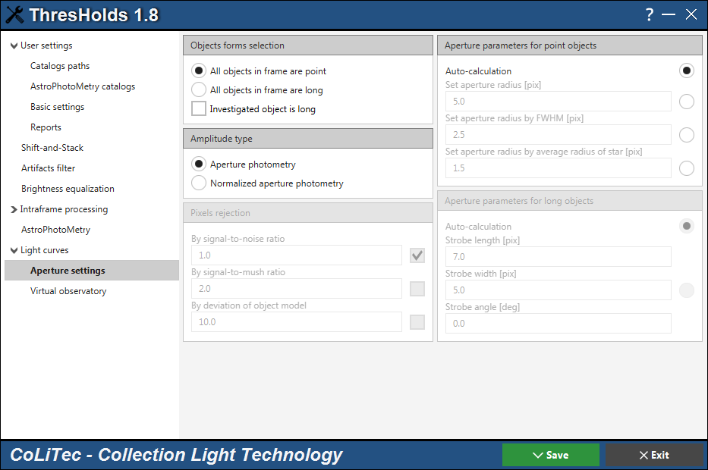

***Figure 17.*** *Settings editor, "Light curves – Aperture settings" section*

The form of aperture can be point and long. For this use appropriate checkboxes: "**All objects in frame are point**" or " **All objects in frame are long**".

Set "**Investigated object is long**" checkbox if all comparison stars in frame are the point objects but the investigated star is a long object.

Set "**Aperture photometry**" checkbox to calculate the object's brightness inside the area of specified aperture.

Set "**Normalized aperture photometry**" checkbox to normalize aperture by parameters of the model's form that were estimated by the PSF function. In this case, the access to rejection parameters of «bad» pixels (slightly conditioned with the estimated parameters of the image model) is activated. This mode is not available when the investigated object or all objects in the frame are long.

Parameters of the aperture radius for the point objects are available in "**Aperture parameters for point objects**" section:

* "**Auto-calculation**" – enumeration of the aperture radii and selection one with the lowest error value;
* "**Set aperture radius**" – aperture radius for calculation the image brightness;
* "**Set aperture radius by FWHM**" – aperture radius as the multiplication of the specified coefficient by the average value of half-width of the stars images in frames;
* "**Set aperture radius by average radius of star**" – aperture radius as the multiplication of the specified coefficient by the average radius of investigated star in all frames.

Parameters of the aperture radius for the long objects are available in "**Aperture parameters for long objects**" section:

* "**Auto-calculation**" – values of the length, width and angle of the strobe will be determined from the segmentation procedure;
* "**Strobe length**", "**Strobe width**", "**Strobe angle**" – fields to set the length, width and angle of the strobe.

# Processing in «CoLiTec-Day» mode

To start processing in **CoLiTec-Day** mode select the folder with frames of serie using "**Add serie**" button in **CoLiTec Control Center (3С)** () and standard dialog window, which supports all necessary extensions of *fits* files.

The folder can also contain subfolders with another series of frames. These frames should belong to only one survey (part of the sky) and be formed with the same parameters of the telescope and CCD-camera.

Then press "**Start**" button in "**Action**" column. Also you can select the series using checkboxes in the working area and press "**Start selected**" button.

The number of series for the simultaneously processing is specified by the number of available processor cores ().

The queue system is implemented in **3С**. For example, for 4 available threads (processor cores) if processing of at least 1 from 4 series is finished, the processing is started with the 5th series from the queue ().

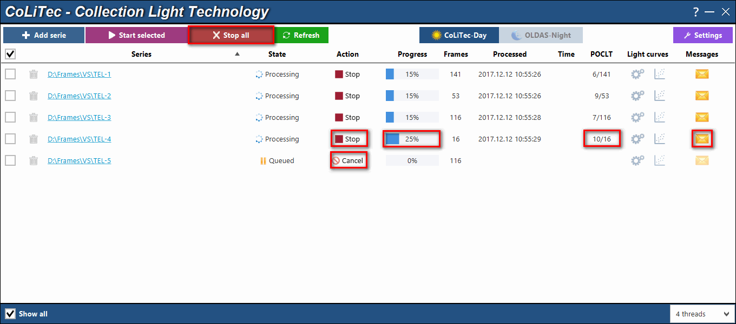

**Figure 18.** **CoLiTec Control Center** during processing in **«CoLiTec-Day»** mode

The processing of any series can be stopped/processed again/canceled (removed from the queue). The processing messages of any series can be opened in the window with processing messages () using button in the **3C** working area for the appropriate series.

# Processing in «OLDAS-Night» mode

To start processing in **OLDAS-Night** mode the processing parameters should be set in following sections: "**OLDAS**" (Section 8.6.3) and "**OLDAS processing**" (Section 8.6.4) of settings window in **CoLiTec Control Center (3С)**.

For the correct series processing in **OLDAS-Night** mode the frames headers should contain correct values in the fields: «*Object», «Filter», «RADE»* and *«Camera*».

The presence of data in these fields allows **3C** to create subfolders in the full path to the folder with processed frames according to the appropriate selected options in the settings: «*Object\Filter\RADE\Camera*» (Section 8.6.4).

If the specified fields are not filled, the blank «*None*» is used as name for the corresponding subfolders.

After setting the parameters select **OLDAS-Night** mode in the main window of **3С** and set the number of threads (available processor cores for using) ().

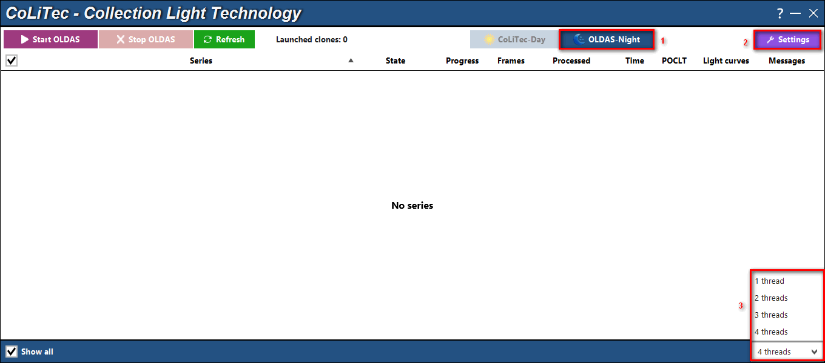

**Figure 19.** **CoLiTec Control Center** during processing in **«OLDAS-Night»** mode

The processing in **OLDAS-Night** mode can be stopped/resumed. There are two ways to stop processing:

* **Soft (recommended)** – termination of all clones after each of them completes the current stage of processing;
* **Hard** – immediate termination of all clones, which can lead to loss of processing data, but will not affect the initial data (raw frames).

The processing messages of all formed series are also available in the window with processing messages ().

# Analysis of formed light curves

After processing in **CoLiTec-Day** or **OLDAS-Night** modes the folder with the same name as task-file «LCP» will appeared: *«…\colitec\lightcurves\$Telescope$_$Star$.LCP*».

The following files will be created in this folder:

|  |  |
| --- | --- |
| **№** | **File name** |
| **1** | *$Star$-$Telescope$.$StartDate$-$EndDate$.$Filter$.****VO*** |
| **2** | *$Star$-$Telescope$.$StartDate$-$EndDate$.$Filter$.****note*** |
| **3** | *$Star$-$Telescope$.$StartDate$-$EndDate$.$Filter$.****aavso*** |

1. Light curve file of the investigated star (*\*.****VO***):

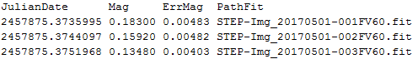

1. Report file in [AAVSO Extended](https://www.aavso.org/aavso-extended-file-format) format (*\*.****aavso***):

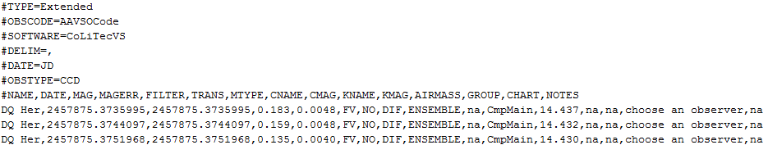

1. Note file with detailed information about the light curve (*\*.****note***);

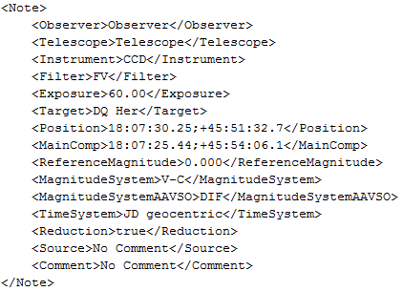

Analysis of the formed light curves is carried out by using the light curve viewer **Plots Viewer**. It is available by button for each processed series in the working area of **CoLiTec Control Center** (). In **CoLiTec-Day** mode the button is available only after finishing of series processing.

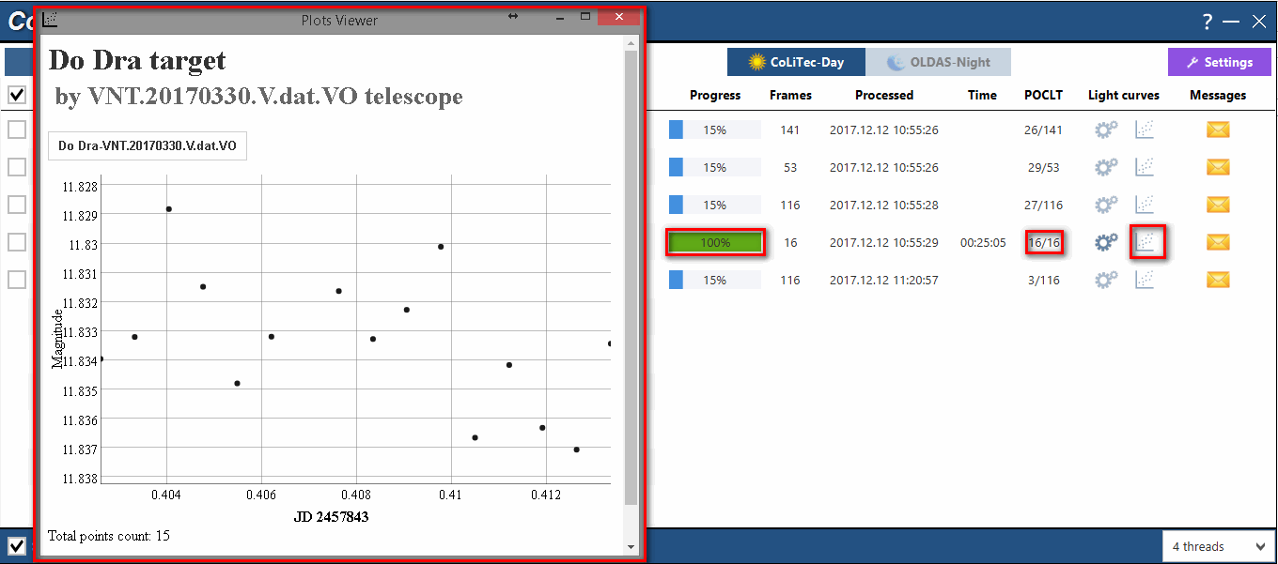

**Figure 20. Plots Viewer** with opened light curveof processed series

In **OLDAS-Night** mode the observer can monitor the brightness changes of investigated star during the light curve creation. In this mode the light curve is created/updated after processing of every 5 frames.

To monitor and analyze the light curve of investigated star in **OLDAS-Night** mode open **Plots Viewer** using button in the working area of **CoLiTec Control Center** for selected series, processing of which was completed or in progress.

The on-line dynamics of light curve creation in **Plots Viewer** is presented in .

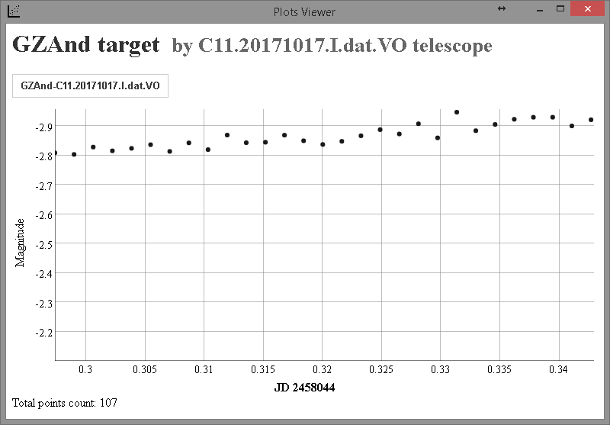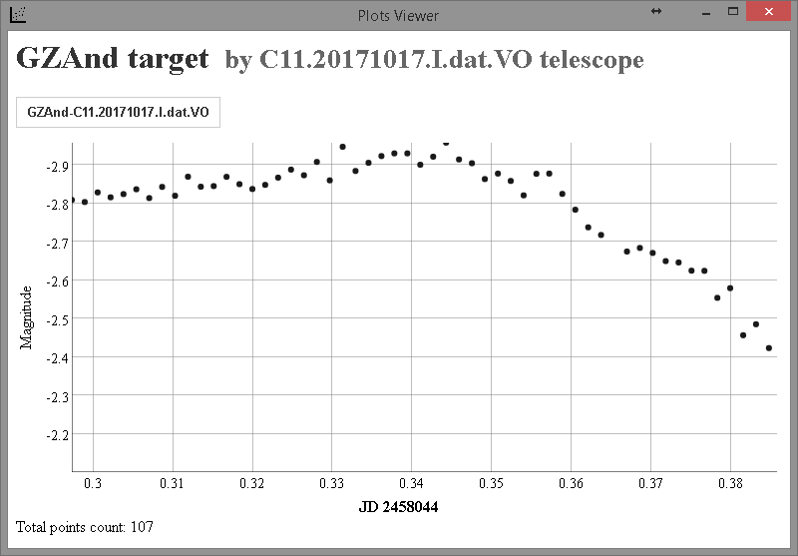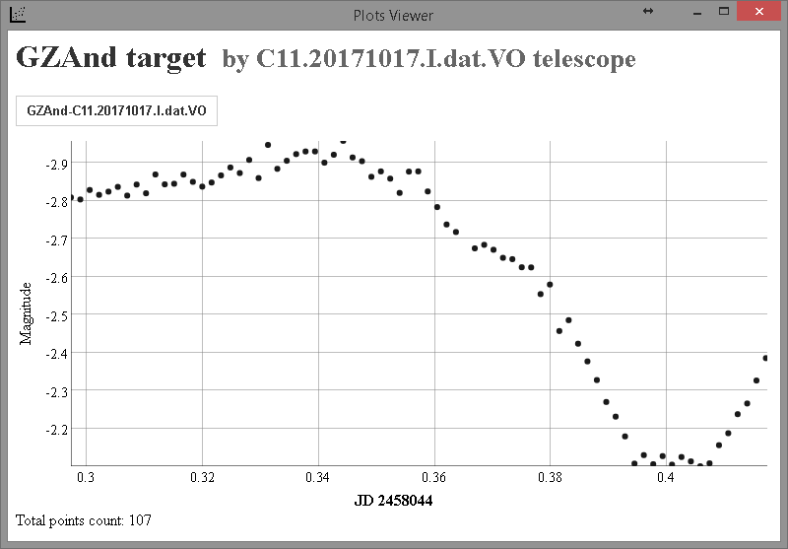 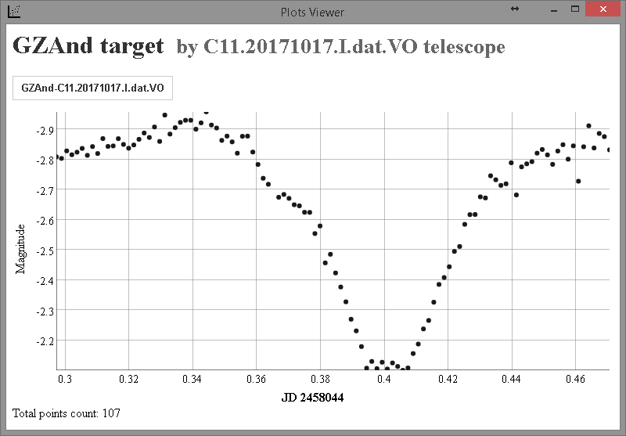

**Figure 21.** On-line dynamics of light curve creation in **Plots Viewer**

Also **Plots Viewer** allows editing (removing) of the obtained brightness measurements of the investigated star. For this open light curve in **Plots Viewer** for analysis, select"bad" measurement, press left mouse button. The context menu will appear with the following information:

* magnitude of the investigated star;
* "**Delete**" menu item to remove the brightness measurement from light curve;
* "**Cancel**" menu item to exit from the context menu ().

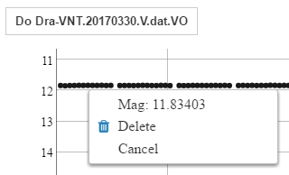

**Figure 22.** Context menu for measurement of the light curve in **Plots Viewer**

**IMPORTANT!** Editing (removing) of brightness measurements of the investigated star is possible only after the series processing is completed in any processing mode (**CoLiTec-Day** or **OLDAS-Night**).

To launch **Plots Viewer** separatelyrun "***plot-viewer.exe***" file in Windows or "***plot-viewer***" in Linux from the folder «*...\CoLiTecVS\Plot*». In this case all available light curves from the folder «*...\CoLiTecVS\Plot\Data*» are displayed (). The light curve file of the investigated star (*\*.****VO***) is saved to this folder when processing in **CoLiTec-Day** is finished, or after processing every 5 frames in **OLDAS-Night** mode.

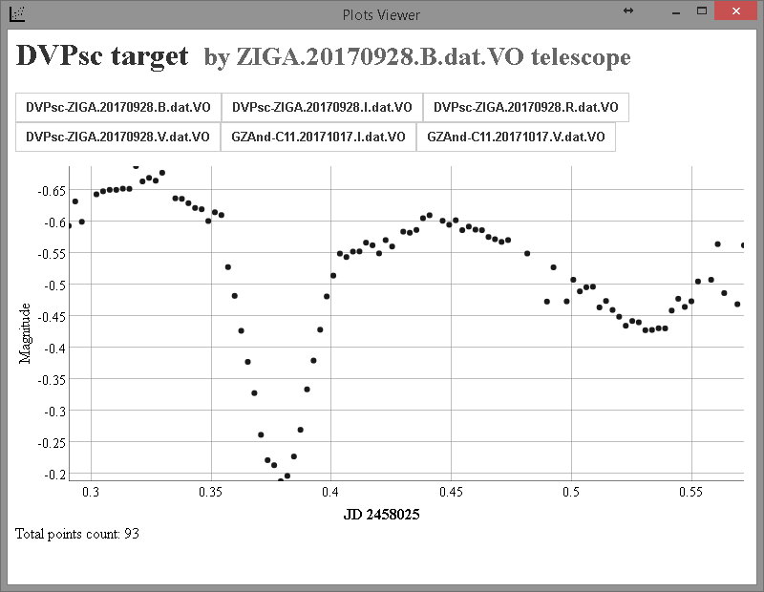

**Figure 23.** All available light curves are displayed in **Plots Viewer**

The saving of light curve files to the folder «*...\CoLiTecVS\Plot\Data*» is managed by "**Send to Plots Viewer**" checkbox in «**Light curves**» section of settings editor **ThresHolds** ().

# Manual mode of light curve creation

**CoLiTecVS** allows light curve creation in manual mode. It is necessary when task-file «LCP» (detailed in section 10.1) was not created before start processing of frames with investigated star.

For this launch frames viewer **LookSky** when at least one frame of the series has already been processed, i.e. the file with «*STEP-*» prefix in title was appeared in the series folder. Then open «*STEP-*» file in **LookSky** and prepare the task-file «LCP» for light curve creation of the investigated star (Section 10.1).

If necessary, for re-creating the light curve with new processing parameters, press button for selected series. The window for manual mode of light curve creation and sending will appeared ().

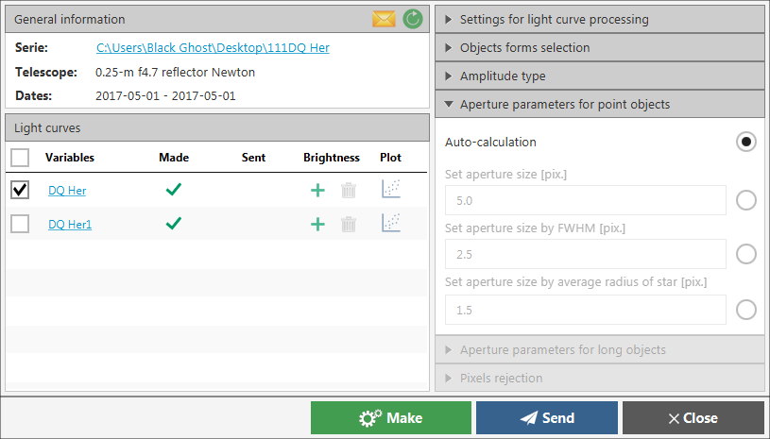

**Figure 24.** Window for manual mode of light curve creation and sending

This mode is very useful when researcher wants to investigate the photometry of star by adjusting various parameters of the light curve creation. Because it is not necessary to repeatedly perform intraframe processing (series processing from the beginning) for the photometry. It is enough to create the light curve with the updated processing parameters.

The window for manual mode of light curve creation and sending () contains the following:

1 – general information about series (path to serie with ability to open a folder, telescope name, start and end dates of observation);

2 – list of available for processing investigated stars (according to the list of task-files for this serie) with the current status of creation and sending;

3 – quick access of main parameters for light curve creation that are also available in «**Light curves – Aperture settings**» section of settings editor **ThresHolds** ().

D:\YandexDisk\CLTLogger\Resources\Images\RefreshVS.pngThe formed light curve for each investigated star in the list can be opened in **Plots Viewer**. Also the file with instrumental brightness can be added for the future using during light curve creation.

The list of available for processing investigated stars can be refreshed using button. This is useful when the new task-files are created in **LookSky** in parallel.

To create light curves for the selected available investigated stars from the list by checkboxes press button.

To send the light curves, processed frames and metadata of investigated stars to the Virtual Observatory (**xViO**) press button. (detailed in section 15).

The processing messages during light curves creation and sending of the investigated stars can be opened in the window with processing messages () using button.

# Light curve sending to virtual observatory

**CoLiTecVS** allows sending the light curves, processed frames and metadata of investigated stars to the Virtual Observatory (**xViO**).

The data sending can be performed only if the **xViO** is installed by **CoLiTec** team.

There are two modes of data sending:

* automated – sending immediately after the series processing and light curves creation;
* manual – sending from the window for manual mode of light curve creation and sending ().

All settings related to the light curve sending are available in «**Light curves – Virtual observatory**» section of settings editor **ThresHolds** ().

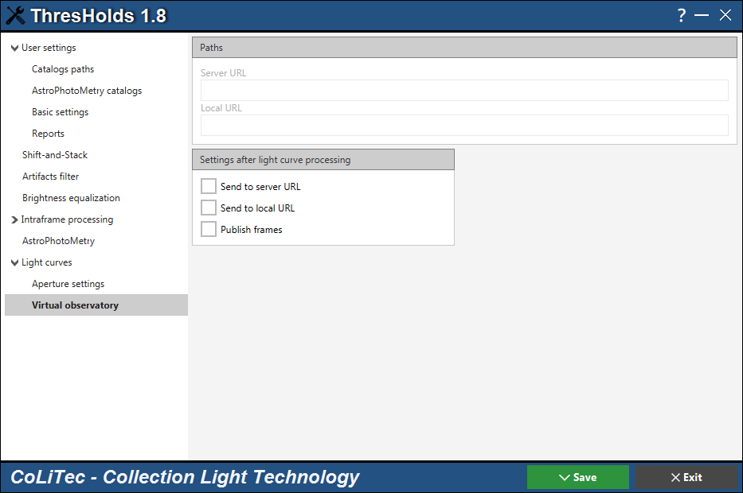

***Figure 25.*** *Settings editor, "Light curves – Virtual observatory" section*

**CoLiTec** team provides the test **xViO** at <http://vo.neoastrosoft.com>.

To work with a test or another installed **xViO** by **CoLiTec** team, perform the following actions.

1. Register at the **xViO** address, for example <http://vo.neoastrosoft.com>.

2. Set the following parameters for the light curve sending in «**Light curves – Virtual observatory**» section of settings editor **ThresHolds** ():

* "**Server** **URL**" – **xViO** address, for example <http://vo.neoastrosoft.com>;
* set "**Send to server URL**" checkbox and if needed "**Publish frames**" checkbox (frames sending to the server so that they are available on the **xViO** and attached to the corresponding light curve).

3. Fill "**E-mail**" field in «**User settings – Basic settings**» section of settings editor **ThresHolds** () using the same E-mail as during registration at the **xViO** (point 1).

4. Save all settings and start series processing in any mode – **CoLiTec-Day** (Section 12) or **OLDAS-Night** (Section 13).

5. The results of data sending are available at the **xViO** address, for example <http://vo.neoastrosoft.com/light-curves>.

# Appendix A

The control of input parameters for processing is performed in both **CoLiTec Control Center** and settings editor **ThresHolds**. All parameters are checked for compliance with the data type and the valid range of values, that are described in document «**ThresHolds – Parameters description**».

The following messages can be appeared during the control of input parameters:

* *Invalid parameter "ХХХ" = "УУУ". Processing is impossible.*
* *Invalid path for local catalog "ХХХ" = "PATH TO CATALOG".*
* *File "УУУ" is not found. Processing is impossible.*
* *Invalid E-mail "УУУ". Processing is possible.*
* *Invalid sender password. MPC report sending is impossible.*
* *Path to "УУУ" is not found. Processing is impossible.*

During processing **CoLiTec Control Center** performs checking the input frames and their headers. Priority of the parameters usage: frame header – personal settings – WCS from the frame header. The examples of messages for the input control are below.

* Checking the correctness of the frame structure:

*Structure of frame "УУУ" is not correct. Perhaps, frame is corrupted or partly downloaded.*

* Checking the presence of the following mandatory fields in frame header: NAXIS, pixel bit, frame width and height, exposure, observation date and time:

*Frame header does not contain parameter "УУУ".*

* Checking the values of mandatory fields in frame header:

*Invalid value of parameter "NAXIS" = "УУУ". Available values = [2].*

*Invalid value of parameter "BITPIX" = "УУУ". Available values = [-64, -32, -16, -8, 8, 16, 32, 64].*

*Invalid value of parameter "ХХХ" = "УУУ".*

*Check camera settings.*

*Header of frame "УУУ" is not filled correctly. Frame processing is impossible.*

* Checking the presence of the following recommended fields (equatorial coordinates RA, DE, focal length, pixel width and height) in frame header:

*Frame header does not contain parameter "УУУ".*

* Checking the values of recommended fields in frame header:

*Invalid value of parameter "ХХХ" = "УУУ".*

*Check camera settings.*

*Header of frame "УУУ" is filled with warnings. Frame processing is possible, but can be longer.*

**IMPORTANT!** In absence of the values of equatorial coordinates RA, DE, focal length and pixel size (width and height) in the frame header, the identification with the sky will be performed using [**Astrometry.net**](http://nova.astrometry.net) service. However, when using this service the processing time is increased. Therefore it is recommended to fill at least approximate values of equatorial coordinates RA, DE in the frame header.

* Checking the correspondence of width and height of all frames with base frame:

*Frame "УУУ" was excluded from processing due to mismatch of sizes:*

*1000 х 2000 "УУУ"*

*1500 х 2000 "УУУB"*

* Checking the correspondence of center RA/DE in all frames with base frame (when relevant data is available):

*Frame "УУУ" was excluded from processing due to mismatch of center RA/DE:*

*10h 45m 32s +13d 41m 12s "УУУ"*

*11h 45m 32s +13d 41m 12s "УУУB"*

* Checking the correspondence of telescope field of view in all frames with base frame (when relevant data is available):

*Frame "УУУ" was excluded from processing due to mismatch of fields of view:*

*00d 45m "УУУ"*

*00d 25m "УУУB"*

* Checking the minimal number of frames in series:

*Number of subseries (frames) is less than 3. Serie "УУУ" processing is impossible.*

* Checking the free space in series folder (*4 * Nframes * Sizeframe*):

*Not enough free space on storage. Required: 1024 Mb. Available: 999 Mb. Serie "УУУ" processing is impossible.*

The list of supported keywords in the frame header with corresponding verification fields is provided in the .

Mandatory fields are marked as *, recommended – **.

**Table A.1.** List of the supported keywords in frame header

|  |  |
| --- | --- |
| **Name** | **Keywords** |
| NAXIS * | NAXIS |
| Pixel bit * | BITPIX |
| Frame width * | NAXIS1; WIDTH |
| Frame height * | NAXIS2; HEIGHT |
| Exposure * | EXPOSURE; EXP-TIME; EXPTIME; EXP |
| Observation date * | DATE-OBS; DATE; TIME-OBS |
| Observation time * | DATE-OBS; TIME-OBS; TIME |
| Telescope * | TELESCOP |
| Filter * | FILTER; FILTR; CLRBAND |
| RA ** | CRVAL1; RA; RA2000; OBJRA; OBJCTRA; SSA-RA; SSA_RA; RA-TEL |
| DE ** | CRVAL2; DE; DEC; DEC2000; OBJDEC; OBJCTDEC; SSA-DEC; SSA_DEC; DEC-TEL |
| Focal length ** | FOCALLEN; FOC-LEN; FOC_LEN; FLENGTH; TELFOCUS; FOCUS |
| Pixel width ** | PIXWIDTH; XPIXSZ; XPIXSIZ; XPIXELSZ; PIXSIZE1 |
| Pixel height ** | PIXHEIGHT; PIXHEIGH; YPIXSZ; YPIXSIZ; YPIXELSZ; PIXSIZE2 |
| BZERO | BZERO |
| BSCALE | BSCALE |
| Temperature | SET-TEMP; CCD-TEMP; TEMPERAT; TEMP(C); TEMP |
| WCS | CRPIX1; CRPIX2; CD1_1; CD1_2; CD2_1; CD2_2 |
| Image type | IMAGETYP; IMGETYPE; IMGTYPE |
| Observer | OBSERVER; OBSERV; OBS |
| Instrument | INSTRUME; INSTRUM; INSTR ; CAMERA |
| Aperture | APERTURE; APTDIA; APER |
| Observatory latitude | LATITUDE; LAT-OBS; SITELAT; LAT |
| Observatory longitude | LONGOBS; LONG-OBS; LONG; SITELONG; LONGNUM |
| Observatory altitude | ALTOBS; ALT-OBS; ALT |

The list of supported keywords in frame header from the is editable. The keywords in the list can be added, changed according to the personal settings of the frame header during frames saving.

All supported keywords are stored in the following text file: «*...\CoLiTecVS\****HeaderKeys.xml***». An example of the structure of supported keywords for «RA» field is presented below:

*<****RA****>*

*<string>****CRVAL1****</string>*

*<string>****RA****</string>*

*<string>****RA2000****</string>*

*<string>****OBJRA****</string>*

*<string>****OBJCTRA****</string>*

*<string>****SSA-RA****</string>*

*<string>****SSA_RA****</string>*

*</****RA****>*

The list of supported formats of the observation date and time is provided in the .

**Table A.2.** List of the supported formats of observation date and time

|  |  |
| --- | --- |
| **Name** | **Format** |
| Observation time | HH:mm:ss  HH:mm:ss.S  HH:mm:ss.SS  HH:mm:ss.SSS |
| Observation date | dd.MM.yyyy  dd/MM/yyyy  dd-MM-yyyy  yyyy.MM.dd  yyyy/MM/dd  yyyy-MM-dd |

Also formats of the observation date and time as combination of formats from the with different separators " ", "**:**", "**Т**" are supported.

For example, "*dd.MM.yyyy HH:mm:ss.SSS*", "*yyyy/MM/dd****:****HH:mm:ss.SSS*", "*yyyy-MM-dd****T****HH:mm:ss.SSS*".

Also user can extend the list of values for «FILTER» field in the frame header that correspond to the supported filter keywords. All supported keywords corresponding to the common filter values can be added, changed and are stored in the following text file: «*...\CoLiTecVS\****FilterKeys.xml***».

An example of the structure with supported keywords and their correspondence to the common filter value «R» is presented below:

*<****R****>*

*<header>Red</header>*

*<header>RED</header>*

*<header>1/4_R_Johnson</header>*

*<header>R_Johnson</header>*

*<header>FR</header>*

*<header>RF</header>*

*</****R****>*