***© CoLiTec****: Collection Light Technology*

(<http://neoastrosoft.com>)

**CoLiTec Control Center**

User guide

Version 1.7.10.1

2017

**Contents:**

1. License agreement 3

2. Common information 7

3. Minimal system requirements: 7

4. Supported file formats 7

5. Windows configuration 7

6. Linux configuration 8

6.1. Verify Java version 8

6.2. Compiler C & C++ update 8

6.3. Set the permissions for all CoLiTec modules 9

7. CoLiTec Control Center launch 9

8. Main window CoLiTec Control Center 10

8.1. Control buttons 10

8.2. Processing modes 11

8.3. Working area 12

9. Window with processing messages 13

10. Settings window 14

10.1. "General" section 14

10.2. "Database" section 15

10.3. "OLDAS"section 16

10.4. "OLDAS processing" section 17

10.5. "Paths to modules" section 18

# License agreement

**COLITEC CONTROL CENTER LICENSE AGREEMENT**

**1. GRANT OF LICENSE.**

This End User License is a legal agreement between you (either an individual or an entity) and a group of developers Collection Light Technology (CoLiTec) to use the CoLiTec Control Center. Software developers provide you CoLiTec Control Center License Agreement ("License") to use the CoLiTec Control Center version, and you accept, a limited, nonexclusive license to use the Software on the terms defined in this Agreement. For the purposes of this License Agreement, "Software" includes any updates, enhancements, modifications, revisions, or additions to the software developed by developers, available to users through a web site (<http://neoastrosoft.com>). Notwithstanding the foregoing, the developers are under no obligation to provide any updates, enhancements, modifications, revisions, or additions to the software.

**1.1. Installation and use of the CoLiTec Control Center.**

By accepting this license agreement, you may install a copy of the program to no more than one computer.

**1.2. Copy and modify.**

Prohibited reverse engineer, de-compile, disassemble or otherwise translate the CoLiTec Control Center. Prohibited in any way modify or adapt the CoLiTec Control Center. Prohibited from providing or distribute CoLiTec Control Center among others. CoLiTec Control Center distribution is only possible through the web site (<http://neoastrosoft.com>).

**1.3. License Grant for Remote Access Software.**

1.3.1. To access your licensed copies of the software and its use, you can use remote access technologies (for example, Remote Desktop, Radmin, Team Viewer), provided, however, that using remote access software accesses and uses only the primary user of the device, to which remote access occurs. These rights do not allow remote access at the same time you use the software on a device that created the remote session.

1.3.2. CoLiTec developers are entitled to access to the remote user's machine for maintenance, troubleshooting and debugging using CoLiTec Control Center, while using remote access technologies (for example, Remote Desktop, Radmin, Team Viewer). Remote access can be provided by the user permanently or on request of the developer.

1.3.3. People with the full "service" in the full CoLiTec package may appeal to developers to assist them using remote access technologies (for example, Remote Desktop, Radmin, Team Viewer).

**1.4. License Grant for documentation.**

Documentation accompanying software is licensed for internal, non-commercial use.

**2. DESCRIPTION OF OTHER RIGHTS AND LIMITATIONS.**

2.1. CoLiTec user undertakes to issue by request the act of implementing the processing (measured, discovered objects) using the program.

2.2. CoLiTec developers have the right to write articles about the program and using it and commit themselves in these articles include performers of user-specified FrameSmooth software.

2.3. During publication results of research that received with help of CoLiTec Control Center, it is necessary to use in citation the link to the official web site (<http://neoastrosoft.com>) and/or publication, which was written by CoLiTec developers.

**3. INTELLECTUAL PROPERTY AND CONFIDENTIALITY.**

**3.1. Use Reporting, License Violations and Remedies.**

CoLiTec developers reserve the right to obtain information on the use of the Software, including user names, IP-addresses, and other proprietary information related to this issue. Any unauthorized use of the software developers will be considered as a breach of this EULA by the user.

**3.2. Property rights in the Software.**

You acknowledge that the Software is the property of developers, and that the Software is protected by law "on copyright and related rights." You also acknowledge and agree that, as between you and developers, developers own all rights and interests in and to the Software, including associated intellectual property rights in accordance with the laws "on copyright and related rights", "on trade secrets" and "trademark". This Agreement does not grant you any ownership interest in the Software, but only a limited right of use that can be withdrawn by CoLiTec developers in accordance with the terms of this Agreement.

**4. TERM AND TERMINATION.**

This Agreement shall enter into force after your acceptance of the terms of this Agreement, or after you downloading, accessing and using the Software, even if you have not explicitly agreed to the terms of the Agreement. This Agreement shall remain in effect until terminated. Without prejudice to any other rights, this Agreement will terminate automatically if you breach any of the following restrictions or requirements. You may terminate this License Agreement at any time by sending e-mail notification about your decision to terminate the Agreement and removing CoLiTec Control Center. If you breach any of the terms of the Agreement, the developers have the right to terminate this License Agreement. Upon termination of the Agreement by the developers to agree to remove the CoLiTec Control Center.

**5. LIMITATION OF LICENSE.**

**5.1. Software Warranty.**

CoLiTec Control Center is provided "as is". Software developers clearly state that they do not provide assurance that the software will meet your requirements, as well as that in the process of the software will be uninterrupted or errors interrupt. You are responsible for the selection of software that allows you to achieve the intended results, as well as responsibility for the results to be achieved through the use of software. You must bear all risks associated with the quality and performance of the software.

**5.2. Application of losses.**

In any cases, developers are not liable to you or any other related to you for any party related, incidental, indirect, special, exemplary or punitive damages or loss of profits, even if the developers were aware of the possibility of such damages.

**5.3. Improvements software.**

CoLiTec Control Center user has the right to make suggestions to refine and improve the software. All of them will be considered and possibly eventually accounted for.

**6. CHANGES IN TERMS OF THE LICENSE AGREEMENT.**

This License Agreement may be changed unilaterally by the developers. User notification about changes in the terms of this License shall be published on the web site (<http://neoastrosoft.com>). These changes in the terms of the License Agreement shall enter into force on the date of their publication, unless otherwise specified in the relevant publication.

**7. SOFTWARE "NOT FOR SALE".**

Software "Not for sale" cannot be sold or otherwise transferred for a fee, it can be used for demonstration purposes only, testing or evaluation.

**8. SEPARATION COMPONENTS.**

This CoLiTec Control Center licensed as a single product. Its component parts may not be separated for use on multiple devices.

**9. BAN ON TRANSFERRING TEMPORARY USE AND COMMERCIAL USE.**

You may not provide CoLiTec Control Center rent, lease, lend and use the program to provide network services to third parties on a commercial basis.

**10. CONSENT TO USE OF DATA.**

By will user, of CoLiTec developers group can collect and use technical information gathered in the course of providing it support services for the product in relation to software. CoLiTec development team may use this information solely to improve its products or to provide customized services or technologies, and will not disclose this information in a form that personally identifies you.

**11. THE FULLNESS OF THE LICENSE AGREEMENT.**

If you have questions concerning the User License Agreement, or, if necessary, contact the group of CoLiTec developers for some reason **–** use the address information supplied with the CoLiTec Control Center, or visit the web site (<http://neoastrosoft.com>).

# Common information

**CoLiTec Control Center** **(3C)** – cross-platform software for managing of the processing of the different types of astronomical data. 3C allows launching of the different stages of the processing by using corresponding modules.

It is possible to track the processing of the each series of astronomical data.

# Minimal system requirements:

* **Windows** system from 7 (32, 64-bit) version or **UNIX** system (32, 64-bit);
* **CPU** frequency no less 1 GHz;
* **RАМ** no less 1 GB;
* **Free space** on the hard drive no less 20 Mb;
* Installed **JRE (Java Runtime Environment)** 8 version no less 1.8.0.XXX;
* Minimal resolution no less 1440 x 900.

**IMPORTANT!** If the minimum system requirements do not match, the program may not work correctly.

# Supported file formats

**CoLiTec Control Center** supports all***fits***files of different bits depth (*.fit, *.FIT, *.fits, *.FITS, *.fts, *.FTS).

**IMPORTANT!** The file names and paths to them should not contain cyrillic characters.

# Windows configuration

For using **CoLiTec Control Center** recommend the latest version of Java 8 ([32-bit](http://www.neoastrosoft.com/download/3631/), [64-bit](http://www.neoastrosoft.com/download/3633/)). Also, add all executable modules from the directory of **3C** to the Windows Firewall exceptions.

# Linux configuration

## Verify Java version

Recommend using the latest version of Java 8.

Verify Java version. Perform in the terminal the following:

***java –version***

If Java version is less than 8, install Java 8. Perform in the terminal the following:

***sudo add-apt-repository ppa:webupd8team/java***

***sudo apt-get update***

***sudo apt-get install oracle-java8-installer***

## Compiler C & C++ update

***6.2.1 Compiler C***

Verify compiler C version. Perform in the terminal the following:

***gcc –v***

If compiler C version is less than 4.8, install gcc 4.8 or higher. Perform in the terminal the following:

***sudo add-apt-repository ppa:ubuntu-toolchain-r/test***

***sudo apt-get update***

***sudo apt-get install gcc-4.8***

***sudo update-alternatives --remove-all gcc***

***sudo update-alternatives --install /usr/bin/gcc gcc /usr/bin/gcc-4.8 20***

***sudo update-alternatives --config gcc***

***6.2.2 Compiler C++***

Verify compiler C++ version. Perform in the terminal the following:

***g++ -v***

If compiler C++ version is less than 4.8, install g++ 4.8 or higher. Perform in the terminal the following:

***sudo add-apt-repository ppa:ubuntu-toolchain-r/test***

***sudo apt-get update***

***sudo apt-get install g++-4.8***

***sudo update-alternatives --remove-all g++***

***sudo update-alternatives --install /usr/bin/g++ g++ /usr/bin/g++-4.8 20***

***sudo update-alternatives --config g++***

## Set the permissions for all CoLiTec modules

Set read & write permissions for the directory with all CoLiTec modules. Perform in the terminal the following:

***chmod -R 700 Path_to_CoLiTec_Control_Center***

# CoLiTec Control Center launch

To launch **CoLiTec Control Center** run "***CLTLogger.jar***" file using Java 8.

In Linux, also possible to launch CoLiTec Control Center via terminal:

***java -jar Path_to_CLTLogger.jar***

Network access can be required for the following modules: ***Dolli*** (processing with the online catalogs) and ***PostgreSQL*** (local database for logging and processing monitoring) during the first launching. So, the necessary network access should be granted for these modules. Also add to Firewall exceptions the processes that require access.

To launch processing select the folder with frames of series using "**Add serie**" button and standard dialog window, which supports all necessary extensions of *fits* files. Press **"Start"** button in **"Action"** column. Also you can select the series using checkboxes in the working area and press "**Start selected**" button.

**IMPORTANT**! If no Internet connection, perform the following actions in the settings editor **ThresHolds**:

* set paths to the local astrometric and photometric catalogs in "**User settings – Catalogs paths**" section;
* set necessary local astrometric and photometric catalogs using the appropriate checkboxes and remove **"Internet – Use**" checkbox in **"AstroPhotoMetry catalogs"** section.

# Main window CoLiTec Control Center

The processing in **CoLiTec Control Center (3C)** is performed in the main window (fig. 1).

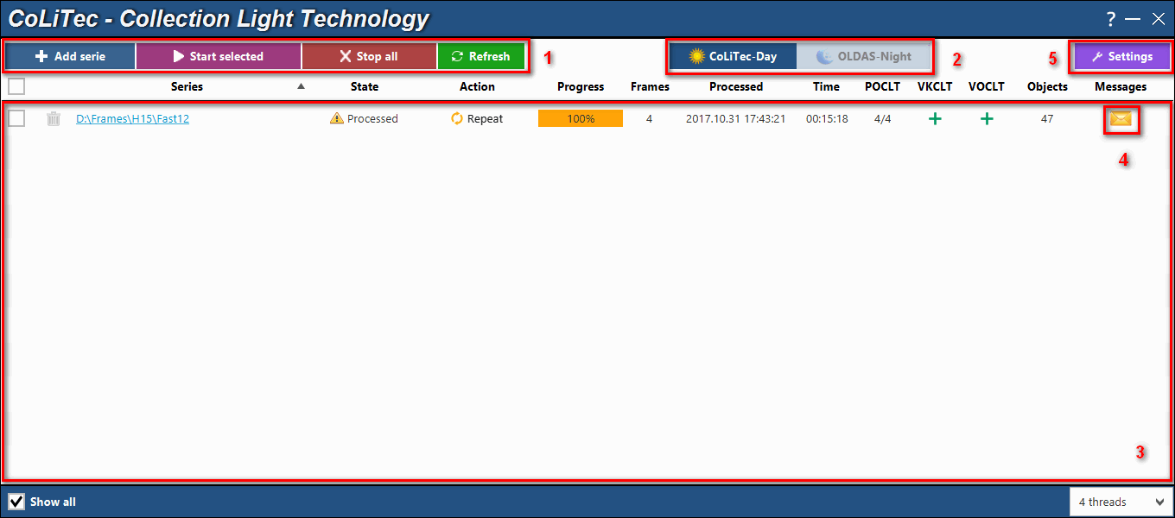

*Fig. 1. Main window*

1 – Control buttons;

2 – Processing modes;

3 – Working area;

4 – Messages during the processing;

5 – Program settings.

8. 1. ***Control buttons***

Series processing is performed using the following control buttons:



– allows the user to add the new folder with a series. The program allows also to select parent folder, which contains some folders with series – all child folders will be added recursively to the working area;



– allows the user to start processing of selected series. Series can be selected using the checkboxes opposite each series from the series list in the working area;



– allows the user to stop all running processes of the series processing. The message will be appear to confirm this action. Interrupted processes of the series processing do not guarantee the integrity of the processed data;



– allows the user to refresh the status of all series from the list in the working area. Refreshing also occurs automatically according to the **"Refresh interval [s.]"** specified in the program settings;



– allows the user to start processing in OLDAS mode. All necessary paths and parameters should be specified in the program settings;



– allows the user to stop processing in OLDAS mode. Stopping also occurs automatically according to the **"Idle time [h.]"** specified in the program settings;



 – shows the number of launched clones during processing in OLDAS mode. The number of launched clones can be set before processing start using the combo box on the main window (fig. 1) – .

* 1. ***Processing modes***

CoLiTec Control Center supports 2 processing modes: CoLiTec-Day and OLDAS-Night (On-line Data Analysis System).



**CoLiTec-Day** – mode, which allows you to process frames from already prepared series. The processing types and pipeline will be determined in accordance with the configuration in the settings editor **ThresHolds**.

**OLDAS-Night** – mode, which allows you to process frames in real time. This means that during the operation of the telescope, frames are saved in a folder that CoLiTec has access to. The paths to this folder, as well as to the folder where the processing and saving of results will occur, are specified in the program settings (section 10.3).

To use **OLDAS-Night** mode you should specify the number of allowed processor cores, as well as the number of frames from which the observational series will consist (section 10.4). Thus, this mode allows you to quickly process data and assign confirmation of the most interesting detected objects on the night of their preliminary discovery.

* 1. ***Working area***

Working area in **CoLiTec Control Center** contains the list of all available series with the following information about each of them:

"**Series**" – full path to the folder with frames of the current series. If the path is long its first part will be replaced with "...";

"**State**" – processing state of the current series: success, error, processing;

"**Action**" – action buttons that are available on the different processing stages: start, stop, repeat;

"**Progress**" – processing progress of the current series, which is depend of the processing stages;

"**Frames**" – number of frames in the current series;

"**Processed**" – date and time of the last processing of the current series;

"**Time**" – processing time of the current series;

"**POCLT**" – status of the intraframe processing stage;

"**VKCLT**" – status of the identification and internal catalog creation stages;

"**VOCLT**" – status of the interframe processing stage;

"**Objects**" – number of the detected moving objects;

"**Light curve**" – control buttons of the light curve: (create light curve) and (open light curve in Plot Viewer);

"**Messages**" – button to open a window with processing messages during all processing stages of the current series.

In the working area you can sort the list of series by different columns. Also you can use "**Show all**" checkbox to show the list with all available in database series. Otherwise, you can see the list with all only active series, i.e. data from the old series will not be displayed.

1. **Window with processing messages**

Using button in the working area of **CoLiTec Control Center** you can get access to the window with processing messages (fig. 2).

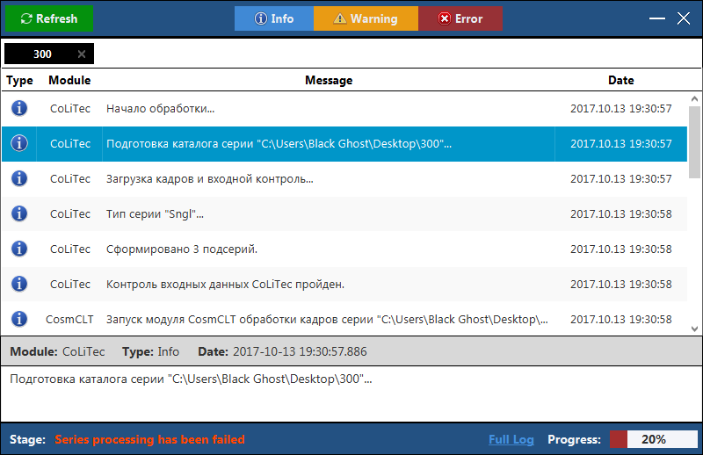

*Fig. 2. Window with processing messages*

The window with processing messages contains all messages from the different modules during any types of processing of different astronomical data.

The following message types are supported in this window: **info**, **warning** and **error**. Enabling / disabling of these message types is performed by the following control buttons:



In the window with processing messages you can sort messages by "**Module**" and "**Date**" columns. When you select a message, you will see detailed information about this message at the bottom of the window.

1. **Settings window**



Using button in **CoLiTec Control Center (3C)** you can open window with program settings (fig. 3 – 7). In this window you can change all necessary parameters to manage any types of processing of different astronomical data.

* 1. ***"General" section***

"**General**" section of settings window in **CoLiTec Control Center** contains the following parameters (fig. 3):

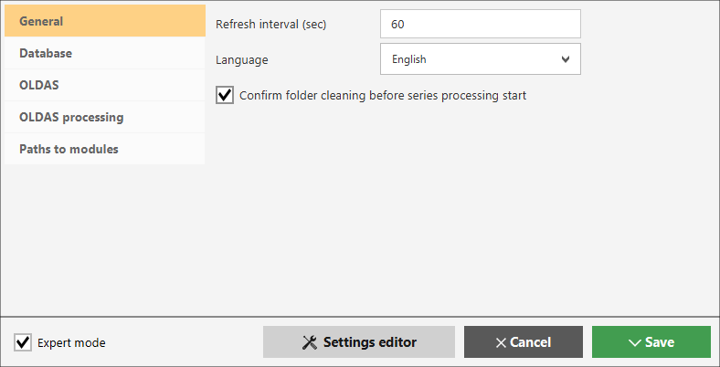

*Fig. 3. Settings window, "General" section*

"**Refresh interval [s.]**" – time interval in seconds for the refresh of information about series processing in the working area of **3С**;

"**Language**" – selection of the interface language of **3С**, Russian and English languages are available;

 "**Confirm folder cleaning before series processing start**" – checkbox for permitting / prohibiting of automatic cleaning of the folder with series before processing start;

– open settings editor **ThresHolds**.

* 1. ***"Database" section***

"**Database**" section of settings window in **CoLiTec Control Center** contains the following parameters (fig. 4):

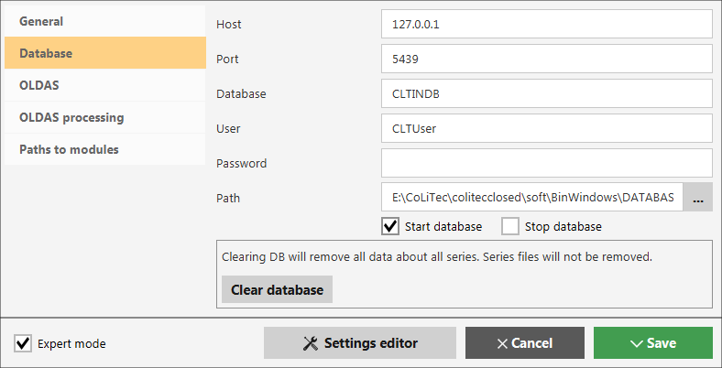

*Fig. 4. Settings window, "Database" section*

"**Host**" – IP-address of database, by default is "127.0.0.1" – local database means that server with database is located on the same PC as **3C**;

"**Port**" – port for access to database;

"**Database**" – database name;

"**User**" – user name for access to database;

"**Password**" – password for access to database;

"**Path**" – path to the local database;

"**Start database**" – checkbox for permitting / prohibiting of automatic start of local server with database during **3С** launching;

"**Stop database**" – checkbox for permitting / prohibiting of automatic stop of local server with database during **3С** closing;

– allows user to clear all content of the database (information about all series). The physical data of the series will not be affected.

* 1. ***"OLDAS"section***

"**OLDAS**" section of settings window in **CoLiTec Control Center** contains the following parameters (fig. 5):

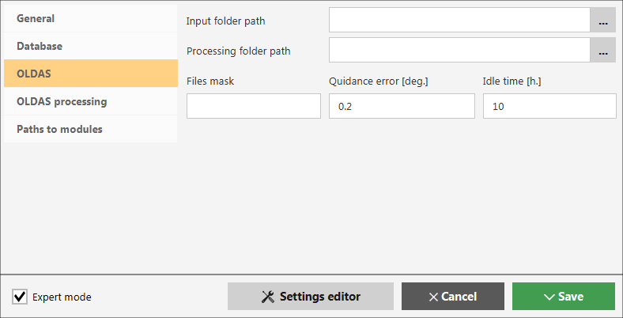

*Fig. 5. Settings window, "OLDAS" section*

"**Input folder path**" – path to the folder with frames that are stored during telescope observation;

"**Processing folder path**" – path to the folder where the processing results will be saved;

"**Files mask**" – mask of files name that will be used for the subseries / series creation;

"**Quidance error [deg.]**" – telescope guidance errors in degrees;

"**Idle time [h.]**" – time of clones inactivity, i.e. no new frames or tasks for the processing. After this time, the work of all clones will be automatically completed.

* 1. ***"OLDAS processing" section***

"**OLDAS processing**" section of settings window in **CoLiTec Control Center** contains the following parameters (fig. 6):

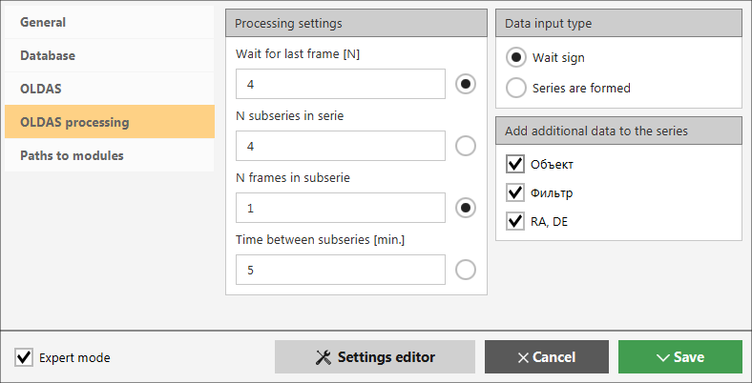

*Fig. 6. Settings window, "OLDAS processing" section*

"**Processing settings**":

* "**Wait for last frame [N]**" – waiting time for the last frame of subserie in minutes, after which the OLDAS mode will be stopped;
* "**N subseries in serie**" – number of subseries, which is expected in the observation script;
* "**N frames in subserie**" – number of frames in subserie, which is expected in the observation script;
* "**Time between subseries [min.]**" – time between subseries in serie in minutes, which is expected in the observation script.

"**Data input type**":

* "**Wait sign**" – interframe processing will be started only after the indication about completion of the series formation;
* "**Series are formed**" – all processing stages will be distributed between clones and interframe processing will be immediately started after completion of intraframe processing of the last subserie.

"**Add additional data to the series**":

* "**Object**" – save additional data about the object to the folder with serie;
* "**Filter**" – save additional data about the filter to the folder with serie;
* "**RA, DE**" – save additional data about the angular coordinates RA and DE to the folder with serie.
  1. ***"Paths to modules" section***

When you turn on expert mode using **"Expert mode"** checkbox the additional section "**Paths to modules**" will appear.

"**Paths to modules**" section of settings window in **CoLiTec Control Center** contains the following parameters (fig. 7):

"**Path to CoLiTec**" – path to the processing program "**CoLiTec.jar**";

"**Path to ThresHolds**" – path to the settings editor "**ThresHolds.jar**";

"**Path to CLTClone**" – path to the cloning program "**CLTClon.exe**";

"**Path to Plot Viewer**" – path to the program "**plot-viewer.exe**" for displaying the light curves.

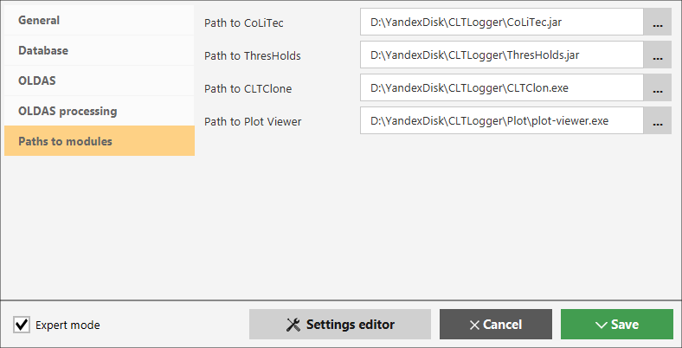

*Fig. 7. Settings window, "Paths to modules" section*