***© CoLiTec****: Collection Light Technology*

(<http://neoastrosoft.com>)

**FrameSmooth**

User guide

Version 2.0

2017

Contents:

[1. License agreement 3](#_Toc473833324)

[2. Common information 7](#_Toc473833325)

[3. Minimal system requirements: 7](#_Toc473833326)

[4. Supported file formats 7](#_Toc473833327)

[5. Windows configuration 7](#_Toc473833328)

[6. Linux configuration 8](#_Toc473833329)

[6.1. Verify Java version 8](#_Toc473833330)

[6.2. Compiler C & C++ update 8](#_Toc473833331)

[6.3. Set the permissions for all FrameSmooth modules 9](#_Toc473833332)

[6.4. Installing libraries for graphical formats support 9](#_Toc473833333)

[6.5. Installing ImageMagick library 10](#_Toc473833334)

[7. FrameSmooth software launch. 10](#_Toc473833335)

[8. Main window 11](#_Toc473833336)

[9. Brightness equalization 12](#_Toc473833337)

[10. Image transformation to FIT format 16](#_Toc473833338)

[11. Master-Frames creation and using 17](#_Toc473833339)

[11.1. Master -frames creation 17](#_Toc473833340)

[11.2. Master-Frames using 19](#_Toc473833341)

[11.3. Master-Frames settings 20](#_Toc473833342)

[12. OLDAS (on-line data analysis system) mode 21](#_Toc473833343)

[13. SCRIPT mode 24](#_Toc473833344)

[14. Settings for OLDAS or SCRIPT modes 26](#_Toc473833345)

# License agreement

**FRAMESMOOTH SOFTWARE LICENSE AGREEMENT**

**1. GRANT OF LICENSE.**

This End User License is a legal agreement between you (either an individual or an entity) and a group of developers Collection Light Technology (CoLiTec) to use the FrameSmooth software. Software developers provide you FrameSmooth License Agreement ("License") to use the FrameSmooth software version, and you accept, a limited, nonexclusive license to use the Software on the terms defined in this Agreement. For the purposes of this License Agreement, "Software" includes any updates, enhancements, modifications, revisions, or additions to the software developed by developers, available to users through a web site (<http://neoastrosoft.com>). Notwithstanding the foregoing, the developers are under no obligation to provide any updates, enhancements, modifications, revisions, or additions to the software.

**1.1. Installation and use of the FrameSmooth software.**

By accepting this license agreement, you may install a copy of the program to no more than one computer.

**1.2. Copy and modify.**

Prohibited reverse engineer, de-compile, disassemble or otherwise translate the FrameSmooth software. Prohibited in any way modify or adapt the FrameSmooth software. Prohibited from providing or distribute FrameSmooth software among others. FrameSmooth software distribution is only possible through the web site (<http://neoastrosoft.com>).

**1.3. License Grant for Remote Access Software.**

1.3.1. To access your licensed copies of the software and its use, you can use remote access technologies (for example, Remote Desktop, Radmin, Team Viewer), provided, however, that using remote access software accesses and uses only the primary user of the device, to which remote access occurs. These rights do not allow remote access at the same time you use the software on a device that created the remote session.

1.3.2. FrameSmooth developers are entitled to access to the remote user's machine for maintenance, troubleshooting and debugging using FrameSmooth software, while using remote access technologies (for example, Remote Desktop, Radmin, Team Viewer). Remote access can be provided by the user permanently or on request of the developer.

1.3.3. People with the full "service" in the full FrameSmooth software package, may appeal to developers to assist them using remote access technologies (for example, Remote Desktop, Radmin, Team Viewer).

**1.4. License Grant for documentation.**

Documentation accompanying software is licensed for internal, non-commercial use.

**2. DESCRIPTION OF OTHER RIGHTS AND LIMITATIONS.**

2.1. FrameSmooth user undertakes to issue by request the act of implementing the processing (measured, discovered objects) using the program.

2.2. FrameSmooth developers has the right to write articles about the program and using it and commit themselves in these articles include performers of user-specified FrameSmooth software.

2.3. During publication results of research that received with help of FrameSmooth software, it is necessary to use in citation the link to the official web site (<http://neoastrosoft.com>) and/or publication, which was written by FrameSmooth developers.

**3. INTELLECTUAL PROPERTY AND CONFIDENTIALITY.**

**3.1. Use Reporting, License Violations and Remedies.**

FrameSmooth software developers reserve the right to obtain information on the use of the Software, including user names, IP-addresses, and other proprietary information related to this issue. Any unauthorized use of the software developers will be considered as a breach of this EULA by the user.

**3.2. Property rights in the Software.**

You acknowledge that the Software is the property of developers, and that the Software is protected by law "on copyright and related rights." You also acknowledge and agree that, as between you and developers, developers own all rights and interests in and to the Software, including associated intellectual property rights in accordance with the laws "on copyright and related rights", "on trade secrets" and "trademark". This Agreement does not grant you any ownership interest in the Software, but only a limited right of use that can be withdrawn by FrameSmooth software developers in accordance with the terms of this Agreement.

**4. TERM AND TERMINATION.**

This Agreement shall enter into force after your acceptance of the terms of this Agreement, or after you downloading, accessing and using the Software, even if you have not explicitly agreed to the terms of the Agreement. This Agreement shall remain in effect until terminated. Without prejudice to any other rights, this Agreement will terminate automatically if you breach any of the following restrictions or requirements. You may terminate this License Agreement at any time by sending e-mail notification about your decision to terminate the Agreement and removing FrameSmooth software. If you breach any of the terms of the Agreement, the developers have the right to terminate this License Agreement. Upon termination of the Agreement by the developers to agree to remove the FrameSmooth software.

**5. LIMITATION OF LICENSE.**

**5.1. Software Warranty.**

FrameSmooth software is provided "as is". Software developers clearly state that they do not provide assurance that the software will meet your requirements, as well as that in the process of the software will be uninterrupted or error interrupt. You are responsible for the selection of software that allow you to achieve the intended results, as well as responsibility for the results to be achieved through the use of software. You must bear all risks associated with the quality and performance of the software.

**5.2. Application of losses.**

In any cases, developers are not liable to you or any other related to you for any party related, incidental, indirect, special, exemplary or punitive damages or loss of profits, even if the developers were aware of the possibility of such damages.

**5.3. Improvements software.**

FrameSmooth software user has the right to make suggestions to refine and improve the software. All of them will be considered and possibly eventually accounted for.

**6. CHANGES IN TERMS OF THE LICENSE AGREEMENT.**

This License Agreement may be changed unilaterally by the developers. User notification about changes in the terms of this License shall be published on the web site (<http://neoastrosoft.com>). These changes in the terms of the License Agreement shall enter into force on the date of their publication, unless otherwise specified in the relevant publication.

**7. SOFTWARE "NOT FOR SALE".**

Software "Not for sale" cannot be sold or otherwise transferred for a fee, it can be used for demonstration purposes only, testing or evaluation.

**8. SEPARATION COMPONENTS.**

This FrameSmooth software licensed as a single product. Its component parts may not be separated for use on multiple devices.

**9. BAN ON TRANSFERRING TEMPORARY USE AND COMMERCIAL USE.**

You may not provide FrameSmooth software rent, lease, lend and use the program to provide network services to third parties on a commercial basis.

**10. CONSENT TO USE OF DATA.**

By will user, of FrameSmooth developers group can collect and use technical information gathered in the course of providing it support services for the product in relation to software. FrameSmooth development team may use this information solely to improve its products or to provide customized services or technologies, and will not disclose this information in a form that personally identifies you.

**11. THE FULLNESS OF THE LICENSE AGREEMENT.**

If you have questions concerning the User License Agreement, or, if necessary, contact the group of FrameSmooth software developers for some reason **–** use the address information supplied with the FrameSmooth software, or visit the web site (<http://neoastrosoft.com>).

# Common information

FrameSmooth software – cross-platform module for brightness equalization. It allows processing images with any formats. Module is based on using of inverse median filter for brightness equalization. Also it supports using of additional astronomical master-frames (Bias, Dark, DarkFlat and Flat).

Also the feature for converting images in fits format was added.

# Minimal system requirements:

- **Windows** system from 7 (32, 64-bit) version or **UNIX** system (32, 64-bit);

- **Processor** frequency no less 1 Hz;

- **RАМ** no less 2GB;

- Free space on the hard drive (taking into account the space for temporary files) no less 6GB.

# Supported file formats

FrameSmooth in filter mode supports the following file types – *jpg, png, tiff, bmp,* and *gif* of 8 and 16 bits depth and *fits* files of different bits depth.

**IMPORTANT!** The file names and paths to them should not contain cyrillic characters.

# Windows configuration

Recommended using the latest version of Java 8 ([32-bit](http://www.neoastrosoft.com/download/3631/), [64-bit](http://www.neoastrosoft.com/download/3633/)).

# Linux configuration

## Verify Java version

Recommended using the latest version of Java 8.

Verify Java version. Perform in the terminal the following:

***java –version***

If Java version is less than 8, install Java 8. Perform in the terminal the following:

***sudo add-apt-repository ppa:webupd8team/java***

***sudo apt-get update***

***sudo apt-get install oracle-java8-installer***

## Compiler C & C++ update

***5.2.1 Compiler C***

Verify compiler C version. Perform in the terminal the following:

***gcc –v***

If compiler C version is less than 4.8, install gcc 4.8 or higher. Perform in the terminal the following:

***sudo add-apt-repository ppa:ubuntu-toolchain-r/test***

***sudo apt-get update***

***sudo apt-get install gcc-4.8***

***sudo update-alternatives --remove-all gcc***

***sudo update-alternatives --install /usr/bin/gcc gcc /usr/bin/gcc-4.8 20***

***sudo update-alternatives --config gcc***

***5.2.2 Compiler C++***

Verify compiler C++ version. Perform in the terminal the following:

***g++ -v***

If compiler C++ version is less than 4.8, install g++ 4.8 or higher. Perform in the terminal the following:

***sudo add-apt-repository ppa:ubuntu-toolchain-r/test***

***sudo apt-get update***

***sudo apt-get install g++-4.8***

***sudo update-alternatives --remove-all g++***

***sudo update-alternatives --install /usr/bin/g++ g++ /usr/bin/g++-4.8 20***

***sudo update-alternatives --config g++***

## Set the permissions for all FrameSmooth modules

Set the required permissions (read/write) for the directory with all installed FrameSmooth modules. Perform in the terminal the following:

***chmod -R 700 Path\_to\_FrameSmooth.jar***

## Installing libraries for graphical formats support

Libraries for graphical formats (*tiff, jpg, png, gif, bmp*) support are necessary for transformation graphical files to FITS format and for “*Brightness Equalization*” with files different graphical formats. For processing only FITS files by FrameSmooth software these libraries are **not necessary**.

Libraries for graphical formats support are available by the following links: [tiff](http://www.imagemagick.org/download/delegates/tiff-4.0.4.tar.gz), [jpg](http://www.imagemagick.org/download/delegates/jpegsrc.v9a.tar.gz), [png](http://www.imagemagick.org/download/delegates/libpng-1.6.28.tar.gz), [gif](http://downloads.sourceforge.net/giflib/giflib-5.1.4.tar.bz2) и [bmp](https://storage.googleapis.com/google-code-archive-downloads/v2/code.google.com/libbmp/libbmp-0.1.3.tar.bz2). Full list of libraries for graphical formats support is available [here](http://www.imagemagick.org/download/delegates/).

To install libraries for graphical formats support download archive for required graphical format. Example for *tiff* format: extract downloaded archive ***tiff-4.0.4.tar.gz***, navigate to extracted folder ***tiff-4.0.4*** and perform in the terminal the following:

***./configure***

***make***

***sudo make install***

## Installing ImageMagick library

[ImageMagick-6.9.3-10](http://www.imagemagick.org/download/releases/ImageMagick-6.9.3-10.tar.xz) library is necessary for FrameSmooth software to process different graphical formats (*tiff, jpg, png, gif, bmp*).

To [install](http://www.imagemagick.org/script/install-source.php) ImageMagick library extract downloaded archive ***ImageMagick-6.9.3-10.tar.xz***, navigate to extracted folder ***ImageMagick-6.9.3-10*** and perform in the terminal the following:

***./configure***

***make***

***sudo make install***

***sudo ldconfig /usr/local/lib***

# FrameSmooth software launch.

To launch FrameSmooth software you need to run ***FrameSmooth.jar*** file with help of Java 8.

In Linux, also possible to run FrameSmooth software via terminal:

***java -jar Path\_to\_FrameSmooth.jar***

# Main window

Access to the program features can be provided through the main window of GUI (fig. 1).

|  |
| --- |
|  |
| *Fig. 1. Main window.* |

1 – Navigate to home page from processing mode;

2 – FrameSmooth software description with ability to visit official web site of CoLiTec project (<http://neoastrosoft.com>);

3 – Select brightness equalization mode (section 8);

4 – Select image transformation mode (section 9);

5 – Select mode for creation and using of master frames (section 10);

6 – Select OLDAS mode for the frames processing in real-time (section 11);

7 – Select SCRIPT mode for the frames processing with selected sequence of operations (section 12);

8 – Expanded configuration pane;

9 – Path to the active configuration file;

10 – Reset all settings to default;

11 – Save configuration file with new name;

12 – Load configuration file;

13 – Select interface language;

14 – Select threads count for processing.

# Brightness equalization

Astronomical digital images may be divided into coarse-grained and fine-grained components. Each of these components has its own physical nature.

Coarse-grained components correspond to the illumination of the image during astronomical observations at full moon or at sunrise/sunset and cover large part of frame (Fig. 2а). Fine-grained components correspond to the images of stars, asteroids and comets. The size of fine-grained components usually takes 5 ÷ 10 pixels and no more than 50 ÷ 60 pixels.

Using of service frames for calibration of obtained images does not al-ways lead to desired result, for example, in case of parasitic illumination. Therefore it is necessary to consider ways of brightness equalization of image background.

Coarse-grained and fine-grained components of the digital image correspond to different harmonics in image spectrum (Fig. 2). Coarse-grained components of the image (Fig. 2b) correspond to low-frequency harmonics image spectrum (Fig. 2c), and fine-grained components (Fig. 2d) correspond to high-frequency harmonics.

Difference in spectrum of images of interest (stars, asteroids, comets) and image background (coarse-grained components of astronomical images) makes it possible to use image frequency filtering for increasing the signal-to-noise ratio or decreasing the dynamic range of the image background.

To remove coarse-grained components from the image it is advisable to use a high-pass filter that both attenuates low-frequency harmonics of the image spectrum and passes high-frequency harmonics. It is known that median filter with a certain window size may also perform functions of low pass filter. In this case high-pass filtering can be obtained by simple subtraction of the result of median filtering of the frame from initial frame.

In other words, difference in sizes of images of objects of interest (stars, asteroids, comets) and background (coarse-grained components of astronomical images) allows using image median filtering for coarse-grained components extraction. In this regard, described method has been called “inverse median filtering”.

|  |  |
| --- | --- |
| Cherniy | Sin |
| a) | b) |
| Cherniy_LFCint32 | Slf |
| c) | d) |
| Cherniy_51 | Shf |
| f) | g) |
| Fig. 1. a) Astronomical image. b) Spectrum absolute value of astronomical image. c) Coarse-grained component of astronomical image. d) Spectrum absolute value of coarse-grained component f) Fine-grained component of astronomical image. g) Spectrum absolute value of fine-grained component | |

|  |
| --- |
|  |
| *Fig. 3* |

1. In “***Paths***” pane following paths can be set:

- “*Path to input file(s)*” – path to the raw files.

- “*Path to output folder*” – path to the output folder of processed files.

2. In “***Options***” pane set modes:

- “*Process frames by RGB channels*” allows processing a color image by channels. It is not affect for filtering of gray images and fits-files;

- “*Size of filter mask*” width and height of a square median filter mask;

*The recommended value of the inverse median filter mask size is determined by the expression:*

*,*

*where – radius of the image of the brightest object by level of background;*

*– RMS evaluation of the background brightness.*

- “*Binning coefficient*” sets the binning coefficient. When using binning the median filtering is performed with binning image. The result of median filtering is de-binning and subtracted from the original image. The binning operation allows reducing memory usage and processing time of large images.

- “*Output mask” –* mask for file names of the processed images.

Filtering the color image

with *“Process frames by RGB channels”* option:

|  |  |  |  |
| --- | --- | --- | --- |
|  |  |  |  |
|  |  |
|  |  |
| Original color image | Three channels of the original image | Three channels of the processed image | Processed color image |

Filtering color images

without *“Process frames by RGB channels”* option:

|  |  |  |
| --- | --- | --- |
|  |  |  |
| Original color image | The gray image obtained from the original image | Processed gray image |

# Image transformation to FIT format

|  |
| --- |
|  |
| *Fig. 4* |

1. In “***Paths***” pane following paths can be set:

- “*Path to input file(s)*” – path to the raw files.

- “*Path to output folder*” – path to the output folder of processed files.

2. In "***Options***" pane set transformation parameters:

- “*Do image inversion*” – activates the image inversion function during transformation.

- “*Make crop*” – activates the crop creation function. It defines by the coordinates of the upper left vertex, the width and height.

- Crop parameters can be set in “*X*”, “*Y*”, “*Width*” and “*Height*” fields.

# Master-Frames creation and using

Functionality section for “manual (individual)” creation and using of the additional master-frames.

## Master -frames creation

To create additional master-frames use the following tab:

**“*MF creation*”**

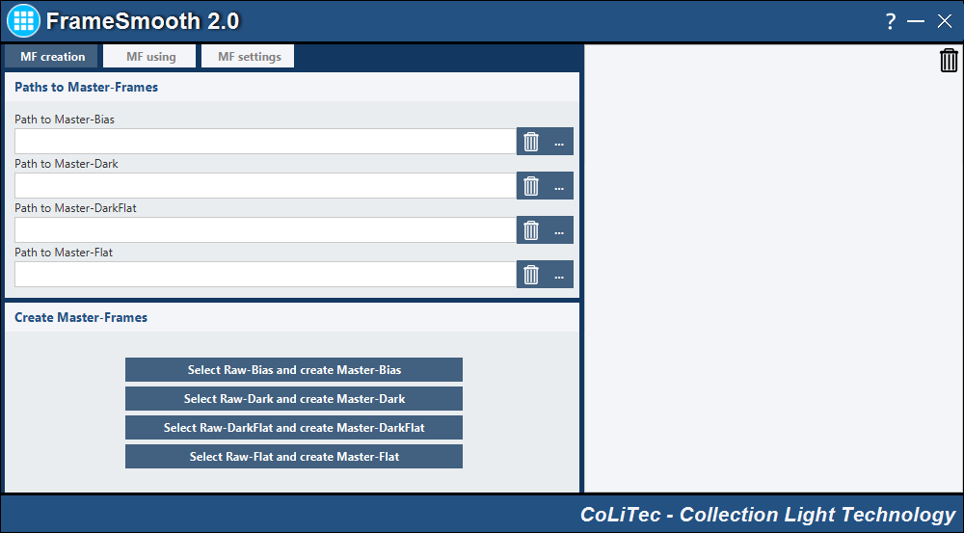

*Fig. 5*

1. For creation the master-frame perform the following:
   1. Master-Bias – press “*Select Raw-Bias and create Master-Bias*” button.
   2. Master-Dark – press “*Select Raw-Bias and create Master-Dark*” button.
   3. Master-DarkFlat – press “*Select Raw-Bias and create Master-DarkFlat*” button.
   4. Master-Flat – press “*Select Raw-Bias and create Master-Flat*” button.
2. Paths of the created master-frames will be inserted to the appropriated fields:
   1. For Bias – “*Path to Master-Bias*”.
   2. For Dark – “*Path to Master-Dark*”.
   3. For DarkFlat – “*Path to Master-DarkFlat*”.
   4. For Flat – “*Path to Master-Flat*”.
3. If Master-Bias and Master-DarkFlat master-frames were created, they will be used for creation Master-Dark and Master-Flat master-frames. If necessary, you can select another Master-Bias and Master-DarkFlat.
4. If you want to create a Master-Dark and Master-Flat frames without Master-Bias and Master-DarkFlat frames, you should clean “*Path to Master-Bias*” and “*Path to Master-DarkFlat*” fields.
5. The mask for created master-frame can be set in “***MF settings***” section.

## Master-Frames using

To use additional master-frames select the following tab:

**“*MF using*”**

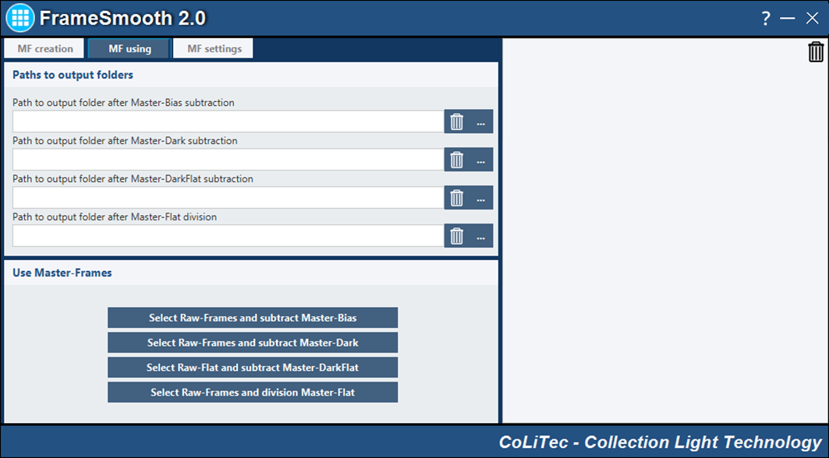

*Fig. 6*

1. For calibration raw (Light) frames the appropriate paths to the master-frames should be set in “***MF creation***” tab.
2. You should specify the output directory where will be saved Light-frames after using the appropriate master-frames.
3. In “*Use Master-Frames*” field to set type of the Light-frames processing: Subtract Master-Bias, Subtract Master-Dark, Subtract Master-DarkFlat or division on Master-Flat.
4. Rejection and division masks for the new names of Light-frames after the appropriate master-frame using can be set in the “***MF settings***” section.

## Master-Frames settings

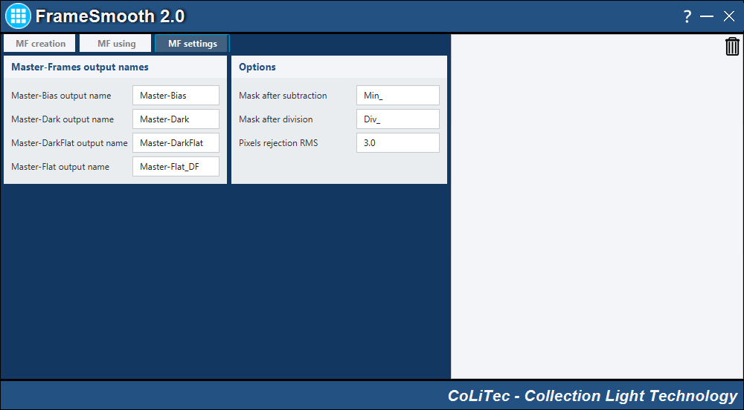

*Fig. 7*

Parameters description:

1. **“*Master-Frames output names*”** pane allows you to specify the names of the master-frames for “***MF creation*”** mode.
2. **“Options”** pane:

“*Mask after subtraction*” – a prefix to the name of the target (Light) frames after subtraction operation;

“*Mask after division*” – a prefix to the name of the target (Light) frames after division operation;

“*Pixels rejection RMS*” – coefficient of the pixels rejection in an operation of master-frames creation.

# OLDAS (on-line data analysis system) mode

Functionality section is designed for automatic on-line processing of any number of frames that can be formed by different telescopes.

**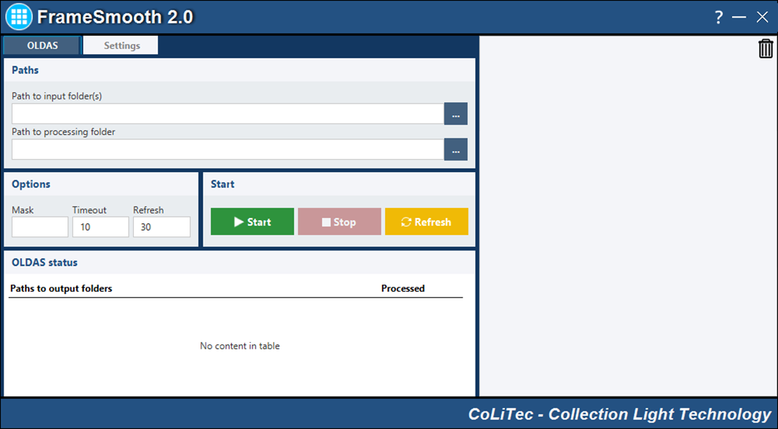**

*Fig. 8*

OLDAS mode performs the following functions:

1. On-line search for frames in the specified input directory;
2. Copy the frames found in the directory for processing;
3. Search for the appropriate master-frames (bias, dark, darkflat, flat), if not set by the user;
4. Master-frames creation and using;
5. Inverse median filter using.

To start OLDAS perform the following steps:

1. Set the number of cores (main window, configuration) that will be available for the program (we recommend to leave at least one core for the needs of other processes). This parameter determines the number of running CLTClone programs that will be look for the task (frame alignment).
2. It is necessary to specify the “*Path to input folder(s)*” with frames that are already located in it or will be created (i.e. by telescope during observation). The structure of output folders will be the same as the structure of the input folders.
3. It is necessary to specify the “*Path to processing folder*”, where frames processing (alignment) will be performed. Processing folder should be different with the input folder.
4. “Mask” parameter – mask of the frame's name that will be selected from “*input folder(s)*”. By default the mask is empty that means looking for all frames.
5. “Timeout” parameter – idle time of the program, in hours. After this time all running CLTClone programs will be terminated.
6. “Refresh” parameter – frequency of updating the processing information in “*OLDAS status*” window.
7. Set required parameters in “*Settings*” tab (see section 14).
8. “Start/Stop” buttons – start/stop OLDAS processing.
9. “Refresh button” – update the information about number of processed frames.

***Note 1*** *- location of the processed frames.*

*For example, two user-selected input folders (\IN\_1\ and \IN\_2\) and processing folder is set as (\OUT\). The processed frames will be saved in the processing folder with the same structure of folders. Moreover, additional folders «\Object» and «\Filter» will be created according to the same fields of frames header. Example in Table 1.*

Table 1

|  |  |  |  |
| --- | --- | --- | --- |
| Catalog search frames | Frames location | Directory for processing | Aligned frames |
| **\TestFS\IN\_1\** | **\TestFS\IN\_1\**KIC 2835289\ | \TestFS\OUT\ | \TestFS\OUT\**IN\_1\Object\Filter\**KIC 2835289.fit \ |
| **\TestFS\IN\_2\** | **\TestFS\IN\_2\**RXJ1803\ | \TestFS\OUT\ | \TestFS\OUT\**IN\_2\Object\Filter\**RXJ1803.fit\ |

***Note 2*** *- individual processing parameters for each telescope.*

*If you want to set "own" parameters for each telescope, such as window size for inverse median filter, using/not using some types of master-frames, do the following: save configuration file (see section 8.11) with the name, which includes the number (name) of telescope, the same as in the fit-frame header. For example, “MYSCOPE.xml”. Such individual settings should be saved for EACH telescope.*

***Note 3 -*** *processing folder from* “*Path to processing folder” should not be the same with any input folders from “Path to input folder(s)”.*

***Note 4 -*** *input folders from “Path to input folder(s)” should not be inside of the processing folder from* “*Path to processing folder”. In this case, the frames will not be processed because the program excludes from processing the frames that present in the processing folder from* “*Path to processing folder”.*

# SCRIPT mode

SCRIPT mode is designed for brightness equalization with specified sequence of operations.

SCRIPT mode allows performing the following:

1. Specify list of frames for brightness equalization “*Path to input file(s)*”;
2. Search for the appropriate master-frames (bias, dark, darkflat, flat), if not set by the user;
3. Master-frames creation and using;
4. Inverse median filter using;
5. Detection and blanking of the bad pixels.

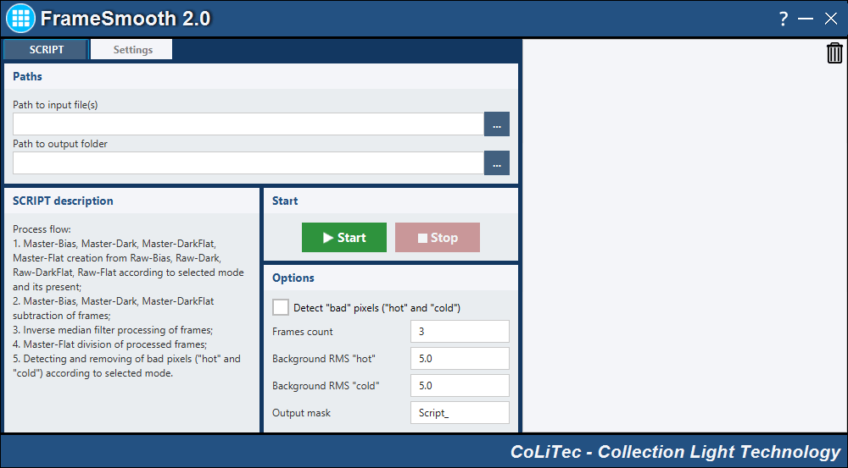

*Fig. 9*

To run SCRIPT perform the following steps:

1. Select frames for brightness equalization “*Path to input file(s)*”.
2. Specify processing folder “*Path to output folder*” – the folder for processed frames (if specified).
3. Set required parameters in “*Settings*” tab (see section 14).
4. Set parameters for bad pixels detection:

“*Frames count*” – the minimum number of frames on which bad pixel should be detected;

“*Background RMS "hot"*”, “*Background RMS "cold"*” – value of "hot"/"cold" bad pixels detection.

1. Set mask “*Output mask*” for the name of processed frame.
2. Run/Stop mode – “*Start/Stop*” buttons.

# Settings for OLDAS or SCRIPT modes

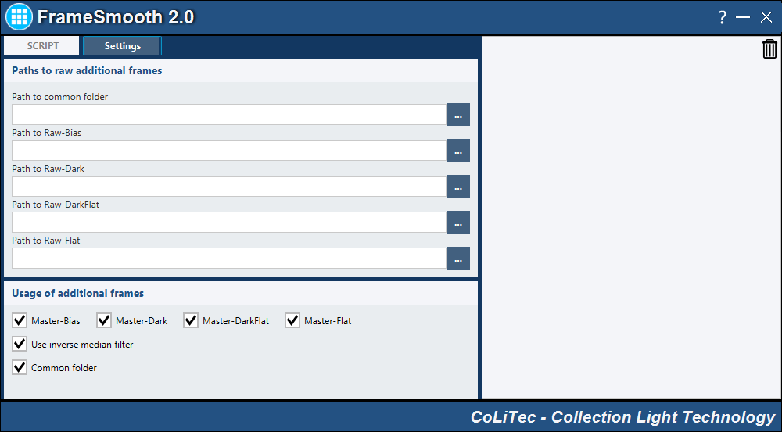

*Fig. 11*

Parameters description:

1. Automatic search for additional frames. You should specify the directory “*Path to common folder*”, and set “*Common folder*” checkbox. This directory can contain additional frames of different types and telescopes. Criteria for selection additional frames from “*Path to common folder*” directory for master-frames creation are described below:
   1. For Bias – frame size, frame type ('IMAGETYP' field should contain a combination of “bias” characters), title of 'TELESCOP' telescope;
   2. For Dark – frame size, temperature ( 'SET-TEMP'), exposure ( 'EXPOSURE', 'EXP-TIME', 'EXPTIME'), frame type ('IMAGETYP' field should contain a combination of “dark” characters), title of 'TELESCOP' telescope;
   3. For DarkFlat – the same as for the Dark, but relative to Flat frames;
   4. For Flat – frame size, filter type ('FILTR', 'FILTER'), frame type ('IMAGETYP' field should contain a combination of “flat” characters), title of 'TELESCOP' telescope;
   5. Time criterion. The group of frames with the time near or early then time of the target frame will be used in processing. For example, the target frame is received on 15/10/2016, there are 20 Dark-frames from 13/10/2016 and 20 Dark-frames from 12/10/2016 in the common folder. So, 20 Dark-frames from 13/10/2016 will be taken for creation of Master-Dark frame.
2. Manual setting of the list of the additional frames. In the fields “*Path to Raw-Bias*”, “*Path to Raw-Dark*”, “*Path to Raw-DarkFlat*”, “*Path to Raw-Flat*” specify lists of raw additional frames, from which master-frames will be created.
3. Set modes:
   1. “*Common folder*” - use/not use the "common folder" for search of the additional frames;
   2. “Master-Bias” – use/not use Master-Bias;
   3. “Master-Dark” – use/not use Master-Dark;
   4. “Master-DarkFlat” – use/not use Master-DarkFlat;
   5. “Master-Flat” – use/not use Master-Flat;
   6. “Use inverse median filter” – use/not use inverse median filter.