Frames and series of frames requirements for CoLiTec software processing
1*. Each series of frames must be located in a separate catalog.
2*. No less than 3 frames in a series.
3*. Time between frames (groups, frames’ subseries) in a series during asteroids’ observation – no less than 20-30 min. (see Recommendations MPEC 2011-E67 (http://www.minorplanetcenter.org/mpec/K11/K11E67.html)).
4. The size of a tool’s field of view may vary from 20 angular minute to 10 degrees (the present software hasn’t been tasted within fields of view beyond specified limits).
5. Frame’s size: from pixels.
6. Presence of the following information about survey conditions is required.

6.1. Approximate equatorial coordinates of image center. Display variants:
- equatorial coordinates (RA, DE) of frame center, indicated in the frame’s headline (recommended)
fields “RA”, “DEC” (see fig. 1);
- name of a known observing asteroid or comet in МРС format, indicated in the frame’s headline,
field “OBJECT” (see fig. 1);

6.2. Telescope focal length and CCD-camera pixel’s size (in millimeters) Display variants:
- focal length and CCD-camera pixel’s size are indicated in the frame’s headline and in software settings (recommended)
field “FOCALLEN” (see fig. 1);
- focal length and pixel size are indicated in software settings.

6.3. Image capacity and its parameters (must be indicated in the frame’s headline)
fields “BITPIX”, “BSCALE”, “BZERO” (see fig. 1).
6.4. Frame size in pixels (must be indicated in the image’s headline)
fields “NAXIS1” and “NAXIS2” (see fig. 1).

6.5. Date, time and duration of the display (must be indicated in the frame’s headline)
fields “DATE-OBS” and “EXPOSURE” (see fig. 1).

Additional guidelines.
The following parameters may be also indicated in the frame’s headline:
1. Type of the light filter used during the survey. The frames are received in a visible band (V) (default setting).
field “CLRBAND” (see fig. 1)
2. Geographical coordinates of telescope location point (latitude, longitude, altitude above sea level).
fields “LAT-OBS”, “LONG-OBS”, “ALT-OBS” (see fig. 1)
3. Air temperature during the survey.
4. Information about observer, telescope (aperture, optical scheme), used CCD-camera.
fields “OBSERVER”, “INSTRUM”, “APTAREA” (see fig. 1)

* – Paragraph contains requirements for series of frames and does not contain any requirements for their headlines. Necessarily to perform with automatic processing for series of asteroid surveys frames.

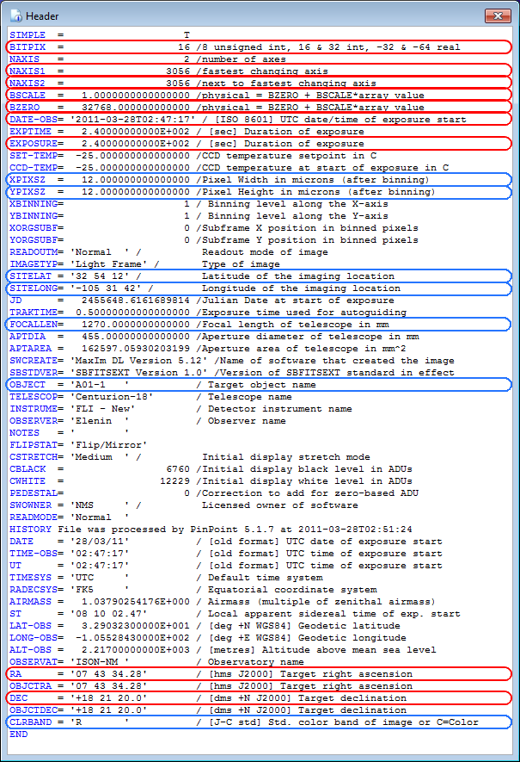
Fig.1 FITS-frame’s headline with highlighted red – required parameters; blue – recommended parameters.

