LookSky – Quick start

Contents:

1. General information 2
2. Quick start 2
2.1. Initial user settings 2
2.2. Series loading 2
2.3. Visual analysis of the moving objects 5
2.4. Hand measuring of the not detected objects 6
2.5. Saving the results of work 8
2.6. Reports sending 9

1. General information
LookSky – is a new cross-platform version of the frames viewer of the CoLiTec software for automated asteroids and comets discoveries in a series of CCD-frames.

The main features of LookSky for the quick start are the following:
- visual analysis of the moving objects (asteroids, comets) detected in automation mode by CoLiTec software;
- deleting the false objects (it is necessary to pay attention to the previously unknown objects);
- hand measuring of the objects (asteroids, comets) that were not detected in automation mode;
- saving the results of work;
- creation and sending the reports.

2. Quick start
After the successful processing of a series of frames by CoLiTec software perform quick start of LookSky. To do this, launch the executable file accordingly to the operating system: «LookSky.exe» (Windows) or «LookSky» (Linux).

2.1. Initial user settings
During the first launching of LookSky (figure 1) perform the initial user settings. For this open LookSky settings by menu «File → Profile LookSky».
The following settings are available: localization settings, saving of the parameters and windows position, automated objects searching and loading from the active series.

2.2. Series loading
After initial user settings load the series of frames processed by CoLiTec software using menu «File → Open zones…». In the appeared dialog window find and select the folder with the processed series of frames. The loading process may take several seconds.
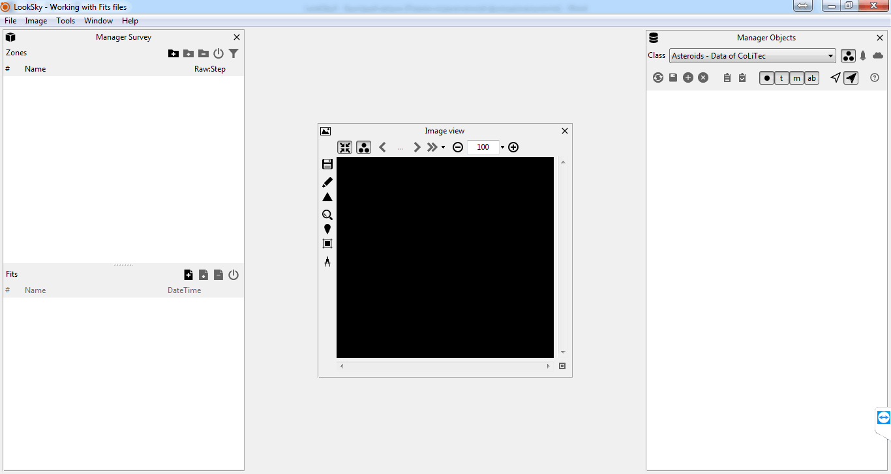
Figure 1. LookSky during the first launching

After loading the series of frames the activation window will appear (figure 2).

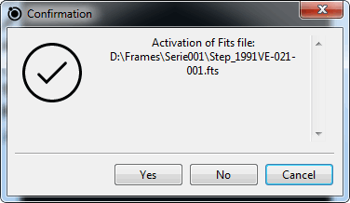
Figure 2. Activation window

Select «Yes» button for the frame activation from loaded series. After this the frame will appear in the «Image view» window (figure 3).

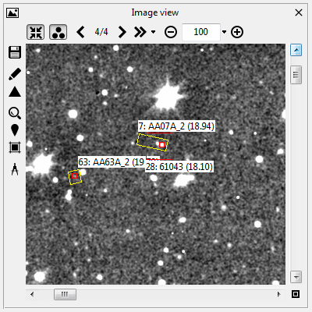
Figure 3. Image view window
You can set position and size of all windows in the program according to the used monitor to increase usability (figure 4).

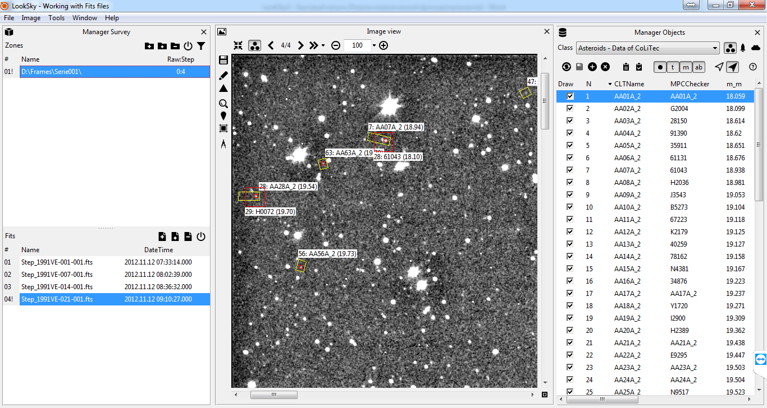
Figure 4. Windows location after series loading

Also set the mode for the frames centering by stars for the convenient blinking of frames in series (figure 5).

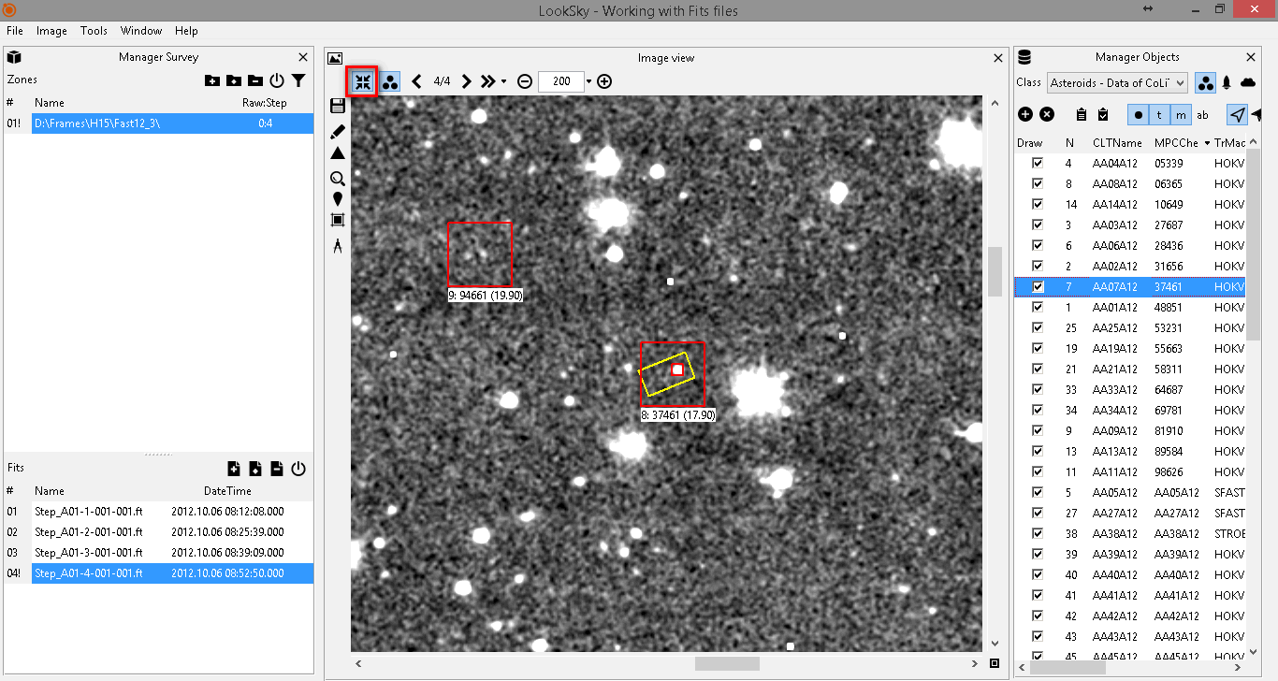
Figure 5. Setting the mode for the frames centering by stars

For the visual analysis of the moving objects (asteroids, comets) detected in automation mode by CoLiTec software, «Manager Objects» window should be opened (figure 6).
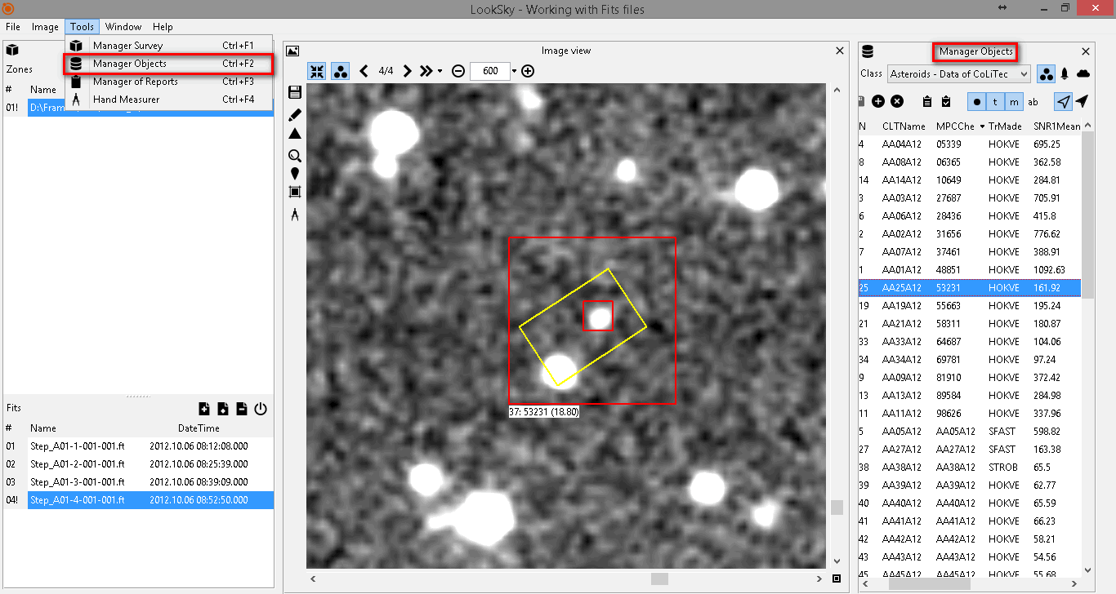
Figure 6. Manager objects window

After successful series loading and activation the list of detected moving objects (asteroids, comets) will appear in «Manager Objects» window.

2.3. Visual analysis of the moving objects
Blinking mode should be started for the visual analysis of the moving objects detected in automation mode by CoLiTec software (figure 7).

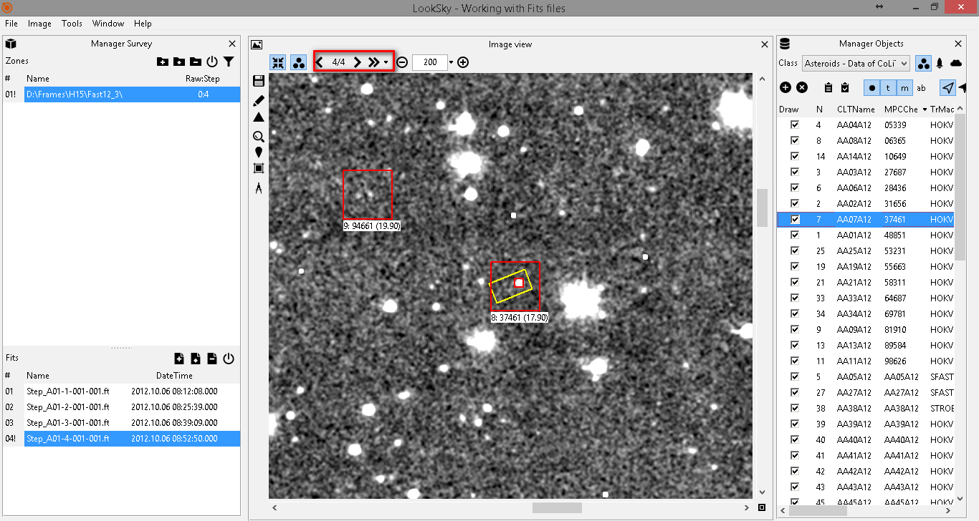
Figure 7. Blinking mode for visual analysis of the detected moving objects

During the frames blinking analyze all objects from «Asteroids - Data of CoLiTec» list. For this, select every object in «Manager Objects» window using mouse or cursors control buttons and analyze object's image in the «Image view» window.
Next, make a decision – is this object real or it is the false detection? Uncheck appropriate checkboxes in the «Draw» column for all false objects to prevent including them to the report.
Use the frame navigation modes for a quick navigation to the moving objects (asteroids/comets) detected on a series of frames. (figure 8).

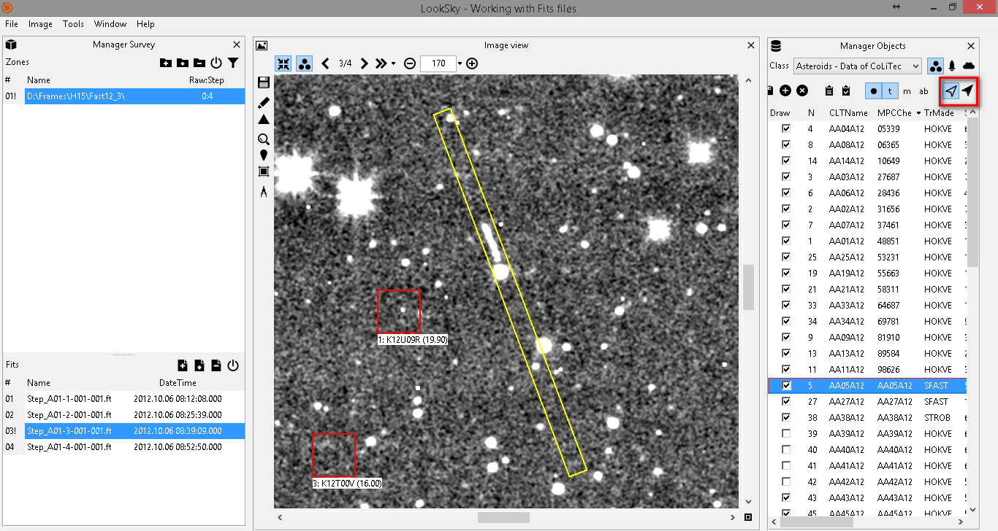
Figure 8. Frame navigation modes

2.4. Hand measuring of the not detected objects
For the quality control of the automated moving objects detection by CoLiTec software you can also use the data from the Minor Planet Center (MPC) catalog.
This information is available in «Asteroids of Minor Planet Center» list of «Manager Objects» window (figure 9). It contains the data about known asteroids/comets that were verified.
Verify that all available asteroids/comets from this list were detected by CoLiTec software.
If the object has two selection: red (MPC) and yellow (CoLiTec), it is the known asteroid or comet and was successfully detected and measured by CoLiTec software.
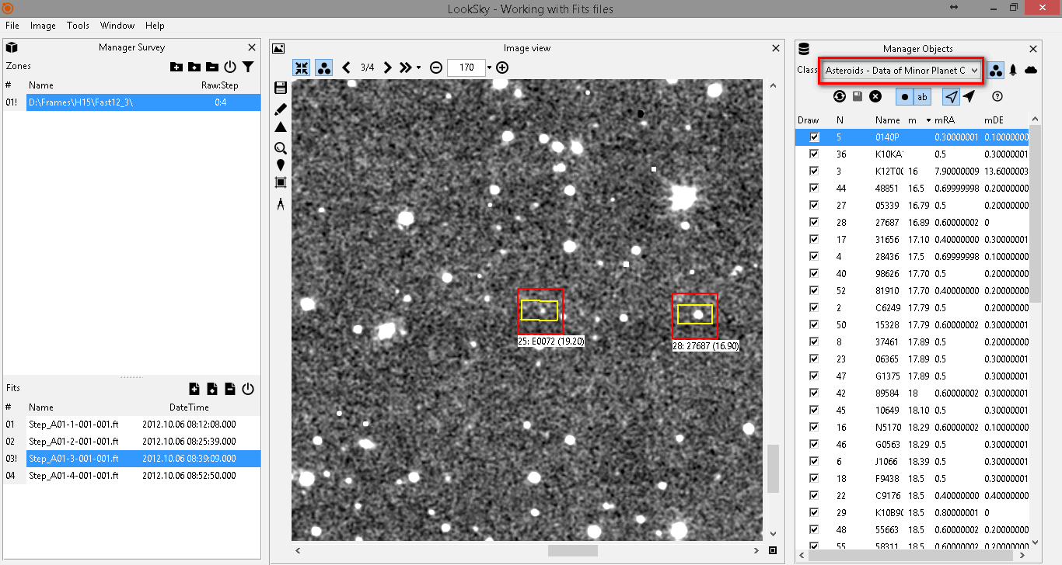
Figure 9. Data from the Minor Planet Center (MPC) catalog

In case if some objects (asteroids/comets) were not detected by CoLiTec software and there is only one red (MPC) selection of these objects you should perform the hand measuring of all not detected objects.
Use «Tools → Hand Measurer» menu for this (figure 10).

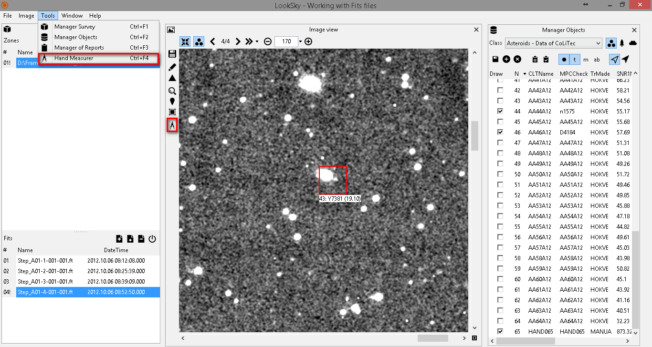
Figure 10. Hand measurer opening

The measuring of the object's image in the current frame can be perfomed by clicking on Ctrl+LMB. Perfrom measuring of this object for all frames of series. Then press «Make object» button and this new object will be added to «Asteroids - Data of CoLiTec» list (figure 11).
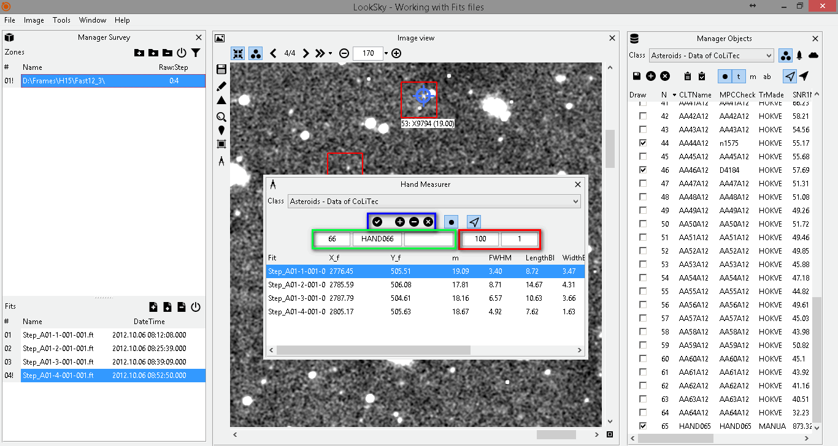
Figure 11. Hand measuring of the not detected object

2.5. Saving the results of work
Save the results of work after analysis of all moving objects (asteroid / not asteroid), known objects from the Minor Planet Center (MPC) catalog in «Manager Objects» window and hand measuring of all not detected objects, i. e. current status of all checked and unchecked objects from «Asteroids - Data of CoLiTec» and «Asteroids of Minor Planet Center» lists (figure 12).

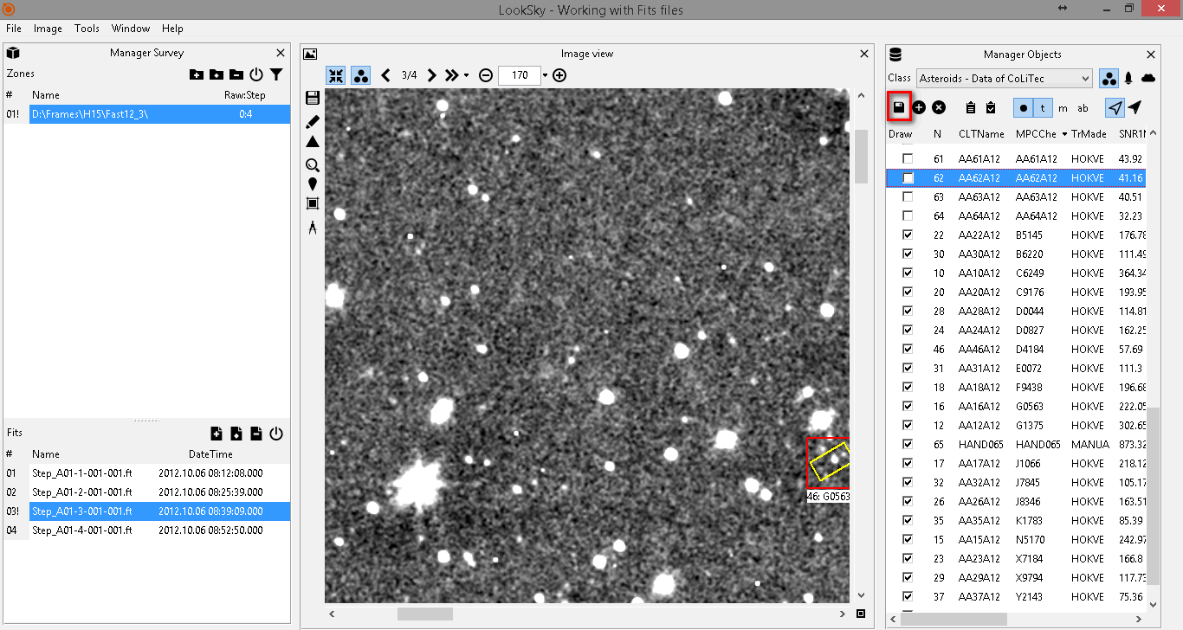
Figure 12. Saving the results of work

2.6. Reports sending
Create report after saving the results of work (figure 13).

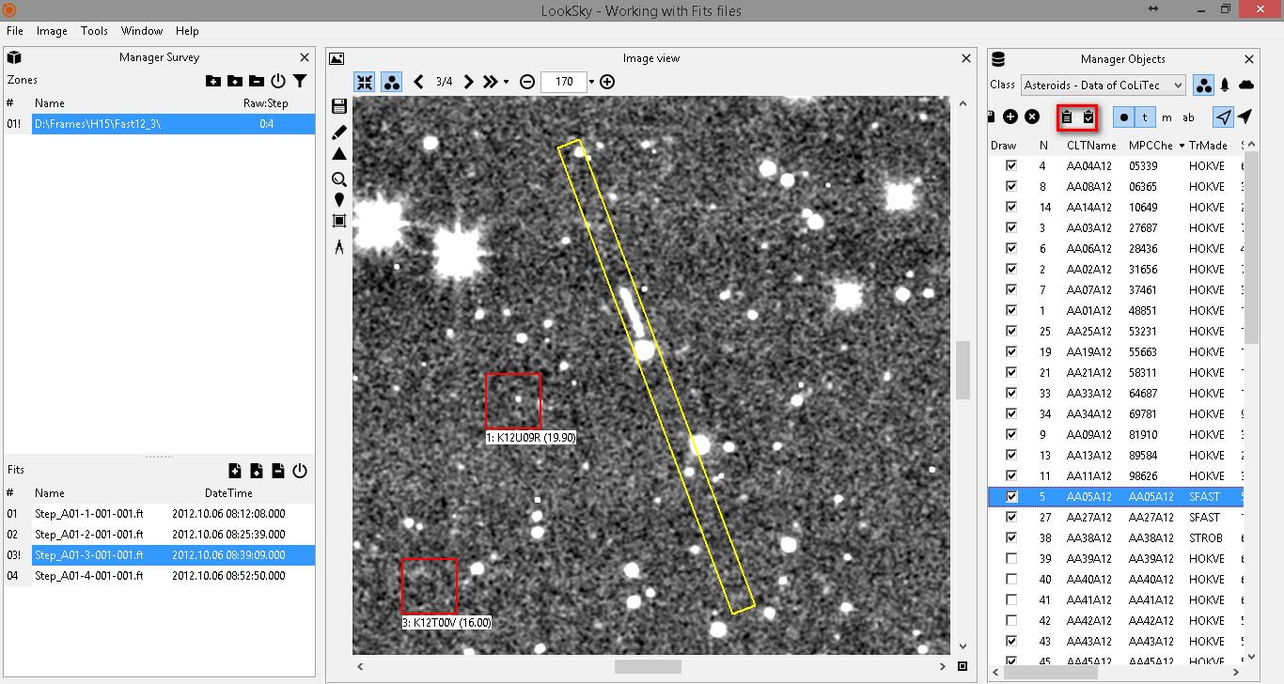
Figure 13. Report window opening

IMPORTANT! To send reports from LookSky set E-mail settings in «User settings → E-mail → Sender» section and check fields in «MPC recipient» section in the settings editor ThresHolds. Report also can be saved as text file and sent manually from the preferred mail service.
If several series were downloaded, LookSky provides the opportunity to generate a consolidated report for several series (figure 14).

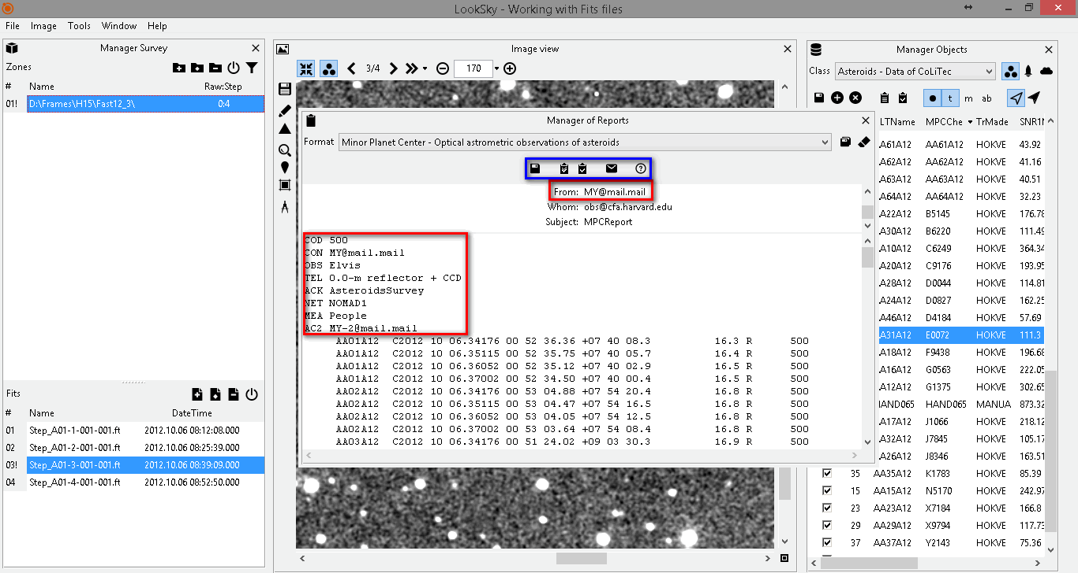
Figure 14. Report creation for sending

