ThresHolds - Brief settings creating

Contents:

1. Introduce. 2
2. Initial configuration. 2
2.1. User settings. 2
2.2. Astro-, photocatalogs choosing 2
2.3. Dolli service. 4
2.4. Basic settings. 4
2.5. Head Report MPC. 4
2.6. E-mail (sending). 5

1. Introduce
ThresHolds – is a new cross-platform version of the settings editor of the CoLiTec software for automated asteroids and comets discoveries in a series of CCD-frames, designed for the accurate adjustment of all parameters that are used by different CoLiTec modules.
After CoLiTec software installing you should to set initial configuration in the ThresHolds settings editor.

2. Initial configuration
Before CoLiTec software first-time start you should set some required parameters in ThresHolds settings editor. For this action please launch «ThresHolds.jar».
Full description of all parameters presented in «ThresHolds - Variables list with descriptions» document

2.1. User settings
In the «User settings» section the following values should be set: language choice and expert level. Also select the appropriate task for processing (figure 1).
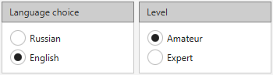
Figure 1. «User settings» section

2.2. Astro-, photocatalogs choosing
Connection to star catalogues can be organized locally (Local) or via the Internet (Internet).
Local: Catalogs have to be located in any directory with local or network access. In the «User settings/Catalogs paths» section of the settings editor ThresHolds you should specify paths to all local catalogs that can be used via the form of directory choice (figure 2).
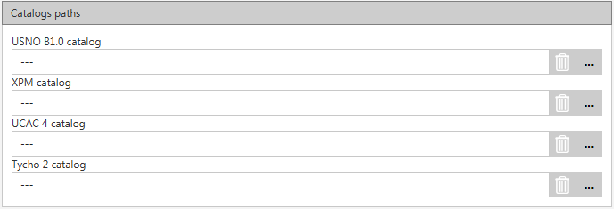
Figure 2. «User settings/Catalogs paths» section
Astrometry and photometry catalogs are chosen in the «AstroPhotoMetry catalogs/Local» section of settings editor ThresHolds via «Astrometric» and «Photometric» forms (figure 3).
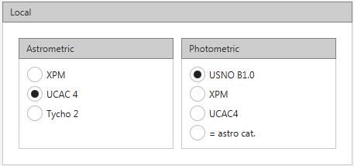
Figure 3. «AstroPhotoMetry catalogs/Local» section
If you choose the «=astro cat.» item in the «Photometry» form, the photometry catalog will be the same as astrometry catalog. For example, if the «UCAC4» catalog is chosen in the astrometry, and «=astro cat. » is chosen in photometry, then «UCAC4» catalog will be used for the photometry also.
Local catalogs «UCAC4» and «USNO B1.0» are available for download from ftp://91.212.253.48 via any FTP-client. To do this, create a new FTP-connection, type in the address field value «91.212.253.48». When prompted for a password for the connection, you need to enter any E-mail address. After successful connection folder which contains astro catalogs on the server is displayed. Navigate to this folder and copy astro catalogs to yours local drive.
Note: Be sure to specify the new location of your local astro catalogs in the settings editor ThresHolds in the «User settings/Catalogs paths» section (figure 2).
Internet: If you choose connection to catalogs via the Internet they are uploaded by the VizieR service (http://vizier.u-strasbg.fr). In this case Dolli service creates corresponding requests and receives.
To activate the option of uploading catalogues via the Internet, set «Use» checkmark in the «AstroPhotoMetry catalogs/Internet» section.
Astrometry and photometry catalogs are chosen in the «AstroPhotoMetry catalogs/Internet» section of settings editor ThresHolds via «Astrometric» and «Photometric» forms (figure 4).
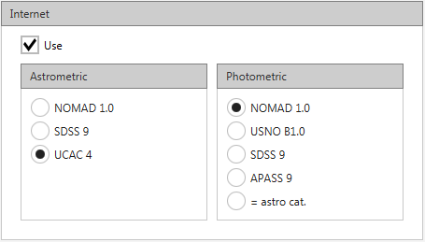
Figure 4. «AstroPhotoMetry catalogs/Internet» section
Note: If the data are not received, the program attempts to take the data from the local catalogs specified in settings will be made. If there are no local catalogs specified, the error message will appear, and the program will be terminated.
Important: Recommended to fill in all fields with catalogs paths following symbol: «3 dashes» (---) in the « User settings/Catalogs paths» section, if you want to use only Internet catalogs. This action allows you to avoid all verifies with local star catalogs (presence and correctness).

2.3. Dolli service
Dolli is the server of applications for access to Internet resources (web services). This is exe-file that run queries of CoLiTec process (programs).
Processes themselves “communicate” with Dolli via sockets.
CoLiTec processes can be run inside local network. After establishing the connection with Dolli, the process sends a query in determined format to receive information from some internet resource. Dolli identifies the received query, and query ID is sent to the initiating process. Dolly calls the required plug-in (dll) that: process POST/GET query, «parses» the result and write it to a file. This file is saved in the Dolli directory as «ID.dol».
CoLiTec process can receive the saved result via ID (both synchronous and asynchronous modes are possible).
Such three-tiered architecture is used, first of all, for the queries synchronization on the side of CoLiTec processes.
Generally, each internet resource has a tool to control the number of active connections of the given IP. The scheme described above allows CoLiTec process to run queries independently.
Synchronization mechanism is implemented both in Dolli and in its plug-ins.

2.4. Basic settings
In the «User settings/Basic settings» section the following values should be set: focus length, longitude, latitude, observatory, UT and format of size selection (figure 5).
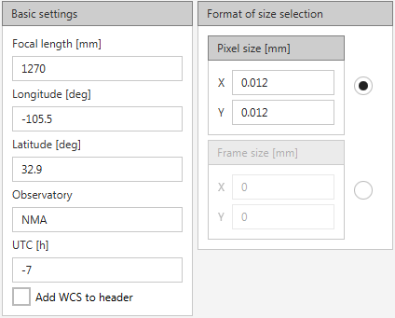
Figure 5. «User settings/Basic settings» section

2.5. Head Report MPC
In the «iNet databases» section the values of the head of MPC report should be set (figure 6).
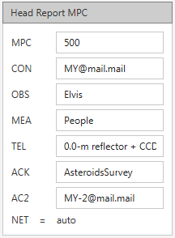
Figure 6. «iNet databases» section

2.6. E-mail (sending)
In the «E-mail» section the following values should be set (figure 7).
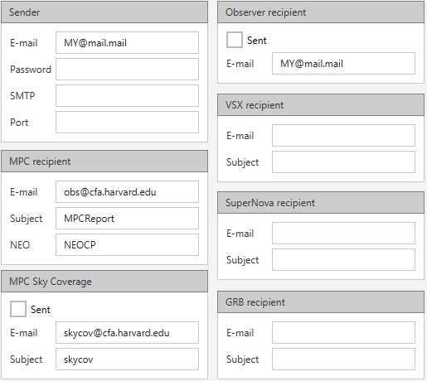
Figure 7. «E-mail» section
Important! Recommend to save settings with your profile. For this action please press «Save» button in the settings editor ThresHolds and choose name for every your own configuration files (figure 8).
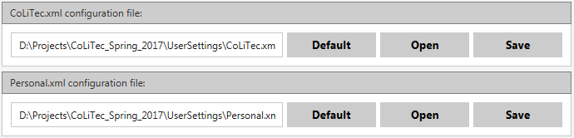
Figure 8. Configuration files saving

