SETTINGS EDITOR THRESHOLDS

User guide

Version 1.7

Contents:

1. About the program: general information 2
2. Installation and system requirements 2
3.General view 2
3.1. Tree menu sections 2
3.2. Workspace 3
3.3. Task panel 5
3.4. Control panel 5

1. About the program: general information

ThresHolds – is a new cross-platform version of the settings editor of the CoLiTec software for automated asteroids and comets discoveries in a series of CCD-frames, designed for the accurate adjustment of all parameters that are used by different CoLiTec modules.
The main features of ThresHolds are the following:
• loading and saving the configuration file with parameters;
• ability for using previously set configuration file or customized set of parameters;
• ability for configuring the profile according to selected task and expert level;
• ability for restoring all default parameters;
• validation of input values ​​and data.
Program settings are stored in the configuration file «CoLiTec.xml», personal settings are stored in the configuration file «Personal.xml» that by default are located in the root directory «/Bin/UserSettings/».

2. Installation and system requirements

For the correct using of all CoLiTec software modules the executable file «ThresHolds.jar» should be located in the root directory «/Bin/».
For the storing «CoLiTec.xml» and «Personal.xml» configuration files with any custom name the folder «/Bin/UserSettings/» will be created in the root directory during first launching.
Minimal system requirements:
• Windows system from 2000 version or UNIX system;
• CPU frequency no less 1 GHz;
• RАМ no less 256 Mb;
• Free space on the hard drive no less 5 Mb;
• Installed JRE (Java Runtime Environment) 8 version no less 1.8.0.XXX.

3. General view

General view of the user interface of ThresHolds is presented on figure 1. Settings editor consists of tree menu sections (1), workspace (2), which contains parameters of each section, task panel (3) and control panel (4).
Descriptions for each of these units are shown below.

3.1. Tree menu sections

Settings editor includes editing of the parameters in the different sections. Their names are given in the window 1 on figure 1.
Detailed descriptions of parameters of each section are provided in the "ThresHolds - Variables list with descriptions".
IMPORTANT! Each parameter of all sections is included to the configuration files «CoLiTec.xml» and «Personal.xml» and also has its unique identifier, using which it can be called by other CoLiTec modules.

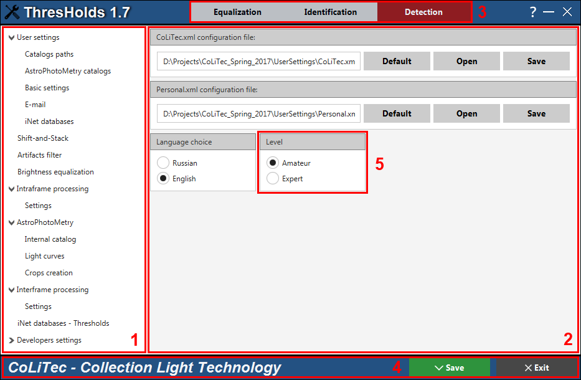
Figure 1. General view of settings editor Thresholds

3.2. Workspace

Workspace (window 2 on figure 1) of settings editor ThresHolds contains the following elements:
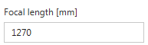– input field that can contain both character values ​​and numbers. For each parameter the input field has a data validation that will help the user to enter only correct values.
, – radio button, which can take only two values: true and false. This item allows you to choose certain modes that can be used only in strict dependence on each other.
– check box, which can also take only two values​​: true and false. However, selection items can be used independently of any other parameters.
– button for cleaning the corresponding non-editable input field.
– button for opening the dialog windows to select a directory (1) and file (2) with filters (3) that are presented on figure 2.
Settings editor has several filters for files:
«*.dat» – for MPC catalog selecting;
«*.odb» – for selecting the file with data of the frame’s header;
«*.exe, *.jar» – for executable modules selecting;
«*.cfg» – for selecting the URL-paths for SPD service;
«*.fit», «*.fts», «*.fits» – for calibration frames selecting;
«*.xml» – for configuration file selecting.

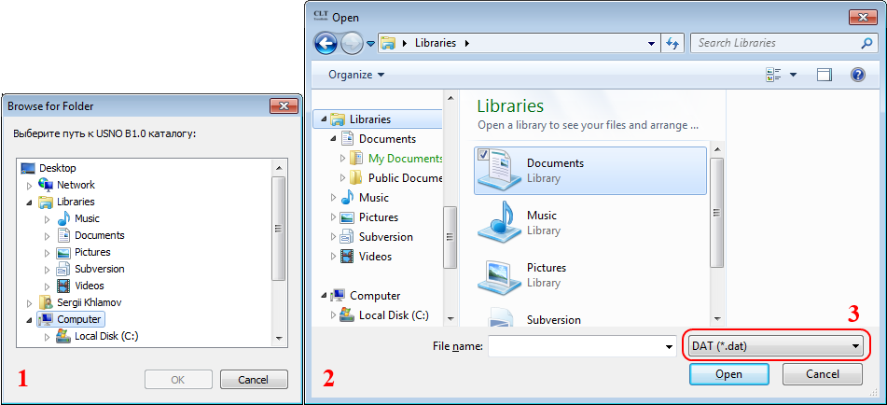
Figure 2. Dialog windows to select a directory (1) and file (2) with filter (3)
The information about the current configuration files «CoLiTec.xml» and «Personal.xml» is available in the workspace of «User settings» section. The processing (saving, loading) will be performed only with these current configuration files.
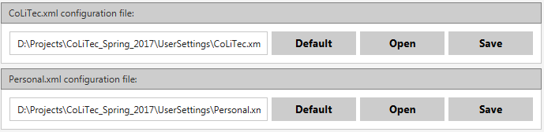
Also the following actions can be performed with the configuration files:
– button to reset of all parameters to default values in the settings editor for the corresponding configuration file. A dialog window to confirm the operation:
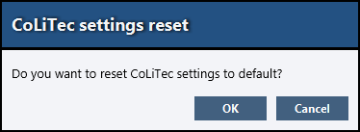

When you select «OK» all parameters for the corresponding configuration file in the settings editor will be reset to their default values.
«Cancel» selection will close the dialog window and the program will continue its work;
– button for selecting the corresponding configuration file with an individual set of parameters and loading them into the settings editor. The selection is made using a standard file open dialog with «*.xml» filter. After loading this file will be copied to the system directory: «/Bin/UserSettings/». All processing (saving, loading) will be performed only with it;
– button for selecting the corresponding configuration file to save individual set of parameters of the settings editor. The selection is made using a standard file selection dialog with «*.xml» filter.

3.3. Task panel
The task panel (window 3 on figure 1) in settings editor ThresHolds allows selecting appropriate processing task. According to the selected processing task user can perform accurate adjustment of all parameters that are available in the tree menu (window 1 on figure 1).
The following processing tasks are available for user: equalization, identification and detection.
For «Equalization» processing task the following sections will be available: User settings, Artifacts filter and Brightness equalization.
For «Identification» processing task the following sections will be available: User settings, Artifacts filter, Brightness equalization, Intraframe processing and AstroPhotoMetry.
For «Detection» processing task all sections will be available.
Also the following expert levels are available for user: amateur, expert (window 5 on figure 1). According to the selected level some additional sections / fields will be available for the more accurate and professional adjustment of parameters for processing.

3.4. Control panel
Control panel (window 4 on figure 1) consists of the following controls:
– button for saving all parameters of the settings editor to the configuration files «CoLiTec.xml» and «Personal.xml»;
– button for exiting the program. Before you exit you’ll see the following dialog window:
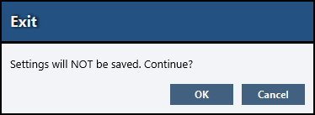
When you select «OK» all changes in the settings editor will not be saved and the program will exit.
«Cancel» selection will close the dialog window and the program will continue its work.

