CoLiTec-Light - Brief manual for start

Contents:

1. Introduce. 2
2. General CoLiTec software functions: 2
• Intraframe processing: 2
• Frame’s identification: 2
• Astrometric and photometric frames’ reduction: 2
• Interframe processing: 2
• Detection of objects with tiny visible movement. 3
• Processing pipeline managed by OLDAS (OnLine Data Analysis System). 3
• Results viewer (LookSky) with graphical user interface. 3
• Mobile viewer of CoLiTec results. 3
• Storage and access to all obtained images software. 3
3. Initial configuration in ThresHolds settings editor. 3
4. Step-by-step instruction for asteroid survey processing. 3
4.2. Series selecting. 3
4.2. Series processing. 5

1. Introduce.

CoLiTec software package designed for automated processing of asteroid surveys.
The survey is the input data. Survey is a group of zones which are located in the same folder on your hard disk. Zone is folder on the hard disk, which contains the group of frames belonging to one part of the sky. All frames within a single review should have common parameters, such as exposure, size, etc.
The main output result of the CoLiTec software is a list of detected moving objects. Viewing and editing detected objects is performed by the LookSky program.
After CoLiTec software installing you should to set initial configuration in the ThresHolds settings editor (see 3rd section), and first-time start of asteroid survey processing with help of CoLiTec (see 4th section).

2. General CoLiTec software functions:

Intraframe processing:
– luminance alignment frames of any size (median filter and Fourier analysis);
– auto calibration and cosmetic correction (automatic removal of broken and hot pixels);
– frames’ addition with accumulation of signals from moving object (FAMO) – a type of frames’ addition used to increase signal/noise ratio (SNR) of signals from objects with unknown velocity of apparent motion (experimental feature for the full version OLDAS);
– adaptive formation thresholds of forming blobs on the frames;
– evaluation of celestial objects’ coordinates (fitting).

Frame’s identification:
– forming of inner catalog of objects that are motionless on the series of observation;
– automatic identification of a sum of frames’ blobs and inner catalog of motionless objects from series of observation with a stellar catalog;
– automatic identification of asteroids’ detected by the present software and known by MPC.

Astrometric and photometric frames’ reduction:
– fully automatic robust algorithm of astrometric reduction;
– working with very wide field of view (up to 10 degrees);
– access to electronic stellar catalogs (USNO B1.0, UCAC 4 or XPM);
– automatic rejection of objects with worst observations.

Interframe processing:
– exclusion of inner catalog of objects’ with zero apparent motion’s blobs from interframe processing;
– asteroid detection based on method which allows to collect signals from objects along trajectories with unknown parameters motion by use of a multi-valued transformation. Computational cost of this method are stabilized at an acceptable level through the implementation of a hierarchical implementation. (Automatic detection of faint moving objects (SNR>2.5));
– manual rejection automatically detected asteroids;
– formation of MPC report, sending via E-mail.

Detection of objects with tiny visible movement.
So was discovered ISON Comet, which was held for 4 frames only 3 pixels with the size of its image 5 pixels.

Processing pipeline managed by OLDAS (OnLine Data Analysis System).
OLDAS allows for near real-time data processing and assigns confirmation of the most interesting objects at the night of their preliminary discovery.
OLDAS:
– multi-threaded support for multi-cores systems and local network;
– obtaining results in 30 minutes after end of astronomical twilight;
– working with online catalogues via VizieR;
– inspection detected objects via web‐interface.

Results viewer (LookSky) with graphical user interface.
CoLiTec software equipped with the modern viewer of obtained results with a user-friendly GUI. The viewer runs independently of the main program and it can be used for independent review of CoLiTec operation results when the main program is processing data. Mapping on the frames objects that interest astronomer (NEA, comets, variables, new and supernova stars, galaxies) using the data from appropriate sites.

Mobile viewer of CoLiTec results.
CoLiTec operation results can be monitored from anywhere in the world. All that is required is any modern smartphones, a tablet or laptops running on any OS platform. After connecting to our web-interface, you can perform different operations; for example, send a report to MPC, including quick report to NEOCP.

Storage and access to all obtained images software.
– Management of archive, including searching for data by parameters (coordinates);
– External access via our web-interface and Aladin software (Generic SIA query);
– Retrieve additional data via VizieR (SDSS v8 and 2MASS);
– Software used SIA protocol and VOTable format.

ISON-NM uses it for storage about 40 000 frames made since 2010. This data is in open access in the framework of UkrVO in the RI NASU.

3. Initial configuration in ThresHolds settings editor.

Before CoLiTec software first-time start you should to set some required parameters in ThresHolds settings editor. For this action please launch «ThresHolds.ехе».
Full description of initial configuration in ThresHolds settings editor is presented in the «ThresHolds - Brief settings creating» document.

4. Step-by-step instruction for asteroid survey processing.

4.2. Series selecting.
For series selecting you should launch CoLiTec.exe (Figure 4.1) and select «Series processing/Select series» menu item.
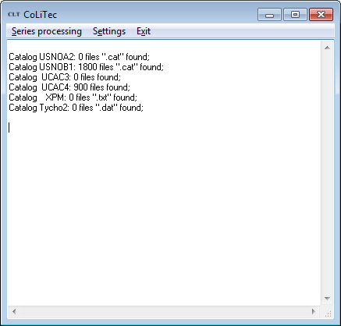

Figure 4.1. General view of CoLiTec.exe

In the appeared «Multiloading» settings window (Figure 4.2) you should to set FIT-file filename mask, which will be performed by frames selection.

Note: if the directory includes only frames for processing you can set null mask.

Set number of involved processors.

Note: number of involved processors is set available maximum by default.
If you want to use only 1 processor core uncheck «Allow the ability to start copies of the application in multiprocessor system» item.

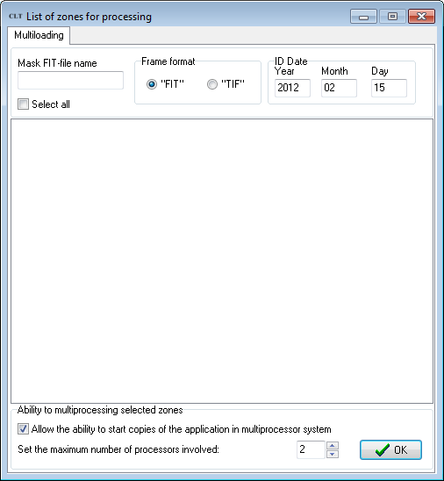
Figure 4.2. General view of «Multiloading» settings window

Press «ОК» button. In the appeared dialog window for directory choosing (Figure 4.3) please select survey that you want.
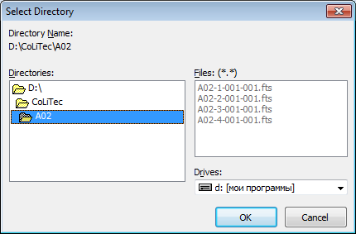
Figure 4.3. Dialog window for directory choosing

Important! The path to the directory with survey, that you want, should not include «_» symbol.
Note: you should not provide survey that was already processed. If you want to re-process this survey please delete all files without of frames or set new directory for survey.

The «Multiloading» settings window appears again (Figure 4.4), which displays a list of zones and frames. Optionally, you can exclude some zones from the list by removing the appropriate checkboxes.

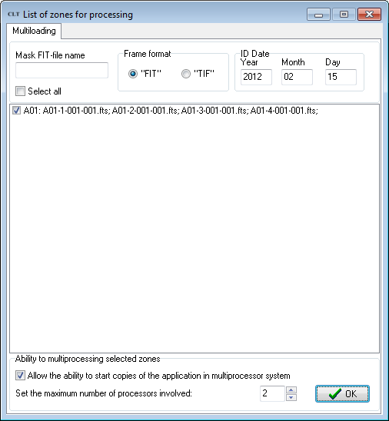
Figure 4.4. General view of «Multiloading» settings window with selected series

4.2. Series processing.

After series selecting press on «Series processing/Start series processing» menu item for start asteroid survey processing. The result window will be displayed when the processing of the selected zones will be ended (Figure 4.5).
Approximate processing time of one zone consisting of 4 frames (3056 x 3056) by a single CPU core is 20-40 min.

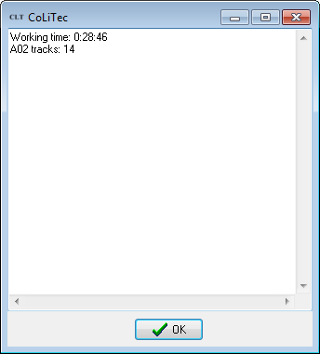

Figure 4.5. General view of result window

