LookSky

User manual
Task-file preparation for the light curve creation

Abbreviations
mark | – star on the frame
task-file | – task-file for the light curve creation

The ability to prepare the task-file for light curve creation is available in LookSky software v. 3.5.2.
CoLiTec software uses the task-file for light curve creation of the investigated star.

Task-file path – Folder «List_LCP».
Task-file name – «%TelescopeName%_%StarName%.LCP».

To prepare task-file do the following:
1. Activate «Service» – «Hand Measurer» menu item and choose «Variable Stars –Light Curves» class (Fig. 1).

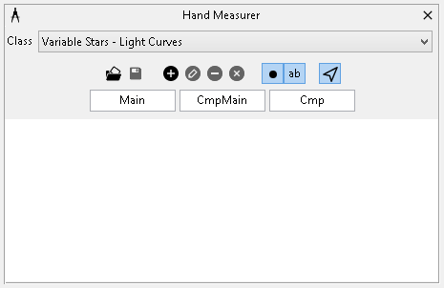
Figure 1 – «Hand Measurer» window, «Variable Stars- Light Curves» class

2. Load a series of frames with the investigated variable star. In the «Image view» window use the mouse to mark the investigated star, main comparison star and other comparison stars. (Fig. 2):
– CTRL + Left Mouse Button – add new mark or shift existed one;
– CTRL + Right Mouse Button – remove mark;

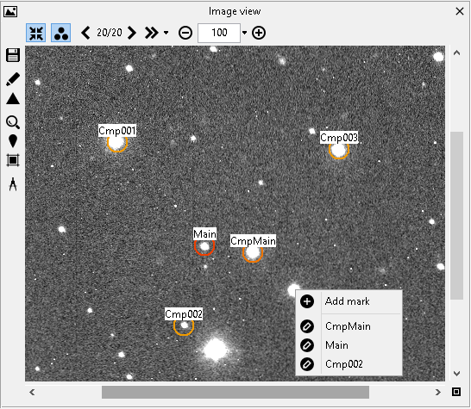

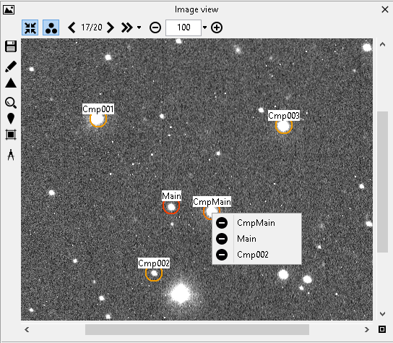
Figure 2 – «Image view» window. Add new, shift mark

3. Using «Save marks to task-file for the light curve creation» button in «Hand Measurer» window save the task-file to «List_LCP» folder with the following name: «%TelescopeName%_%StarName%.LCP».
Additional elements of «Variable stars – Light Curves» class in «Hand measurer» window provide the following abilities:

– to change the masks for names of marks (Figure 3):

Figure 3 – «Image view» window, masks for names

– to add, edit and remove marks manually (Fig. 4, 5):

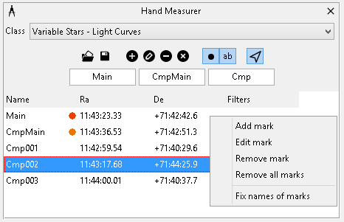
Figure 4 – «Hand Measurer» window, context menu for the mark

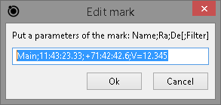
Figure 5 – «Edit mark» window

