ThresHolds – Variables list with descriptions

This document is designed to provide the parameters for the settings editor ThresHolds.exe that are used in the CoLiTec software.
The document contains the following information about each parameter:
- Index number;
- Identifier in the settings editor ThresHolds;
- Parameter name in the settings editor ThresHolds;
- Parameter full name;
- Comments;
- Parameter location in the settings editor ThresHolds (Section / Form);
- Variable type in the program (4 standard Delphi data types are used: boolean – boolean type [true; false], string – string type [“string”], int – integer type (32-bit) [from -2³¹ to 2³¹], double – real type [from 2.23 * 10⁻³⁰⁸ to 1.79 * 10³⁰⁸]);
- Adjustment range (Contains a range of parameter values and its unit of measurement);
- CoLiTec software module, which uses this parameter.

Content:

ThresHolds – Variables list with descriptions 1
Content: 2
1. User settings 3
1.1 Catalogs paths 6
1.2. AstroPhotoMetry catalogs 8
1.3 Basic settings 10
1.4. E-mail 12
1.5. iNet databases, Dolli, SPD 14
1.5.1. MPC 16
1.5.2. SuperNova. Manual mode 19
1.5.3. VSX 21
1.6. Frame calibration 23
2. Intraframe processing 25
2.1. Intraframe processing settings 27
2.2. Fitting settings 30
3. Interframe processing 32
3.1. Interframe processing settings 36
4. AstroPhotoMetry 40
5. "Shift-and-stack" 43
6. iNet databases - Thresholds 45
7. Artifacts filters 48
8. High-pass filter 50
9. Dongle 52

1. User settings
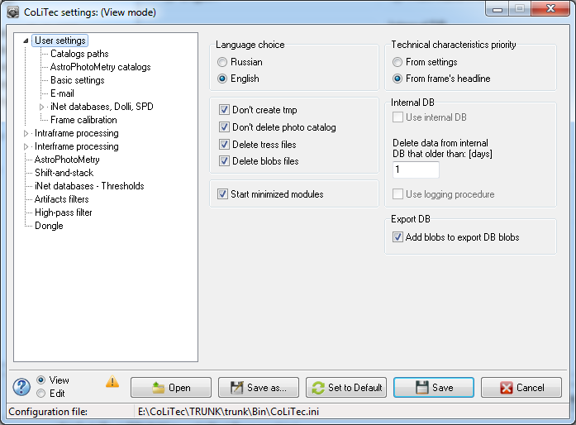
Figure 1. «User settings» section view

Table 1. Variables list in «User settings» section
№ | Identifier | Parameter name | Full name | Comments | Location | Type | Adjustment range | Module, which uses
1 | 2 | 3 | 4 | 5 | 6 | 7 | 8 | 9
1 | RadioButton7 | From settings | Sets the use of technical characteristic values of the equipment from the setting file. | Technical characteristics of equipment include focal length, pixel size, etc.  These settings are located in corresponding settings editor and can be used when information about technical characteristics of the equipment, taken from the frame headline, is not enough. | Technical characteristics priority | bool | [true; false] | POCLT
2 | RadioButton13 | From frame's headline | Sets the use of technical characteristics values of the equipment from the frame headline. |  | Technical characteristics priority | bool | [true; false] | POCLT
3 | RadioButton17 | Russian | Sets Russian / English language for settings. | Sets Russian / English language for titles in settings of all CoLiTec software modules. | Language choice | bool | [true; false] | CoLiTec, POCLT,  VKCLT, VOCLT,  OLDAS, CLTClon,  CosmCLT,  TressHolds
4 | RadioButton18 | English | Sets Russian / English language for settings. |  | Language choice | bool | [true; false] | CoLiTec, POCLT,  VKCLT, VOCLT,  OLDAS, CLTClon,  CosmCLT,  TressHolds
5 | CheckBox3 | Don't create tmp | Enables / disables the temporary files creation. | Intermediate data files are used by the developer to test the program and to identify problem areas in its work. | - | bool | [true; false] | CoLiTec, POCLT,  VKCLT, VOCLT,  OLDAS, CLTClon,  CosmCLT
6 | CheckBox35 | Delete tress files | Enables / disables the thresholds files deletion. | - | - | bool | [true; false] | POCLT, VKCLT,  VOCLT, CLTClon,  CosmCLT
7 | CheckBox36 | Delete blobs files | Enables / disables the blobs files deletion. | The blobs files allow you to view a blobs formed by the program. | - | bool | [true; false] | CoLiTec, POCLT,  VKCLT, VOCLT
8 | CheckBox7 | Start minimized modules | Enables / disables minimized mode for CoLiTec modules. | Some modules (CosmCLT, VKCLT) are launched by CoLiTec software during processing.  For Windows: recommend to enable this option for user usability;  For Linux with Wine emulator: recommend to disable this option to properly launch the console modules. | - | bool | [true; false] | CoLiTec, VKCLT, OLDAS, CLTClon,  CosmCLT
9 | CheckBox38 | Add blobs to DB blobs | Enables / disables the blobs adding to the blobs database. | - | Export DB | bool | [true; false] | CoLiTec, POCLT,  VKCLT, VOCLT
10 | LabeledEdit2 | Delete data from the internal DB that older than: [days] | The number of days for deleting data from the internal database that older than the specified parameter. | - | Intenal DB | int | 0-99999, days | CoLiTec, RunDB.exe
11 | CheckBox16 | Use internal DB | Enables / disables usage of internal database. | In the enabled mode all temporary data (marks etc.) will be created as files in the zone directory.  For Windows: recommend to enable this option for user usability and modules acceleration;  For Linux with Wine emulator: recommend to disable this option to properly launch the console modules. The usual text files will be created instead of the internal DB.  No data will be missed! | Intenal DB | bool | [true; false] | CoLiTec, POCLT,  VKCLT, VOCLT,  OLDAS, CLTClon,  CosmCLT,  TressHolds
12 | CheckBox8 | Use logging  procedure | Enables / disables logging procedure. | Logging procedure will write status messages in the internal DB due to the processing. Messages will be read by the monitor system. | Intenal DB | bool | [true; false] | CoLiTec, POCLT,  VKCLT, VOCLT,  OLDAS, ThresHolds
13 | CheckBox9 | Don’t delete photo catalog | Enables / disables deletion mode for the photo catalog files. | Photo catalog files are created during CoLiTec software processing. For using hand measuring function in the LookSky viewer recommended to enable this mode. | - | bool | [true; false] | CoLiTec, LookSky

1.1 Catalogs paths
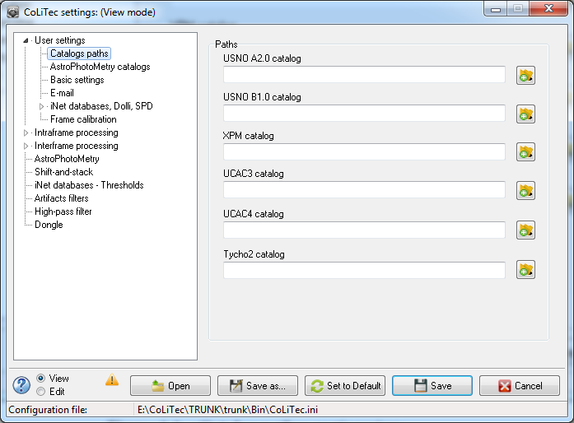
Figure 1.1. «Catalog paths» section view

Table 1.1. Variables list in «Catalogs paths» section
№ | Identifier | Parameter name | Full name | Comments | Location | Type | Adjustment range | Module, which uses
1 | 2 | 3 | 4 | 5 | 6 | 7 | 8 | 9
1 | LabeledEdit109 | USNO A2.0 catalog | Contains path to the USNO A2.0 catalog. | Is used more often for photometry than for astrometry. | Paths | string | Catalog  path | POCLT,  VKCLT
2 | LabeledEdit110 | USNO B1.0 catalog | Contains path to the USNO B1.0 catalog. | Is used more often for photometry than for astrometry. | Paths | string | Catalog  path | POCLT,  VKCLT
3 | LabeledEdit18 | XPM catalog | Contains path to the XPM catalog. | Is used more often for photometry than for astrometry. | Paths | string | Catalog  path | POCLT,  VKCLT
4 | LabeledEdit19 | UCAC3 catalog | Contains path to the UCAC3 catalog. | Is used more often for astrometry, catalog is limited of brightness to 17^{m}. | Paths | string | Catalog  path | POCLT,  VKCLT
5 | LabeledEdit29 | UCAC4 catalog | Contains path to the UCAC4 catalog. | Is used more often for astrometry, catalog is limited of brightness to 16^{m}. | Paths | string | Catalog  path | POCLT,  VKCLT
6 | LabeledEdit12 | Tycho2 catalog | Contains path to the Tycho2 catalog. | Is used more often for astrometry, catalog is limited of brightness to 15^{m}. | Paths | string | Catalog  path | POCLT,  VKCLT
7 | LabeledEdit112 | MPC catalog  (MPCORB.DAT) | Contains path to the MPC catalog (MPCORB.DAT). | Function is not available. | Paths | string | Catalog  path | VKCLT,  VOCLT

1.2. AstroPhotoMetry catalogs
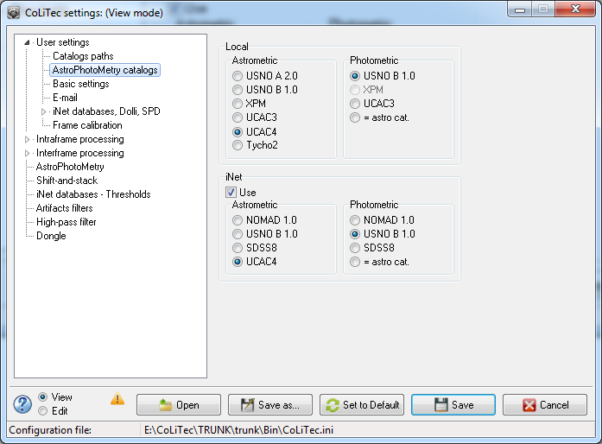
Figure 4.2. «AstroPhotoMetry catalogs» section view

Table 4.2. Variables list in «AstroPhotoMetry catalogues» section
№ | Identifier | Parameter name | Full name | Comments | Location | Type | Adjustment range | Module, which uses
1 | 2 | 3 | 4 | 5 | 6 | 7 | 8 | 9
1 | RadioButton21 | USNO A2.0 | Sets USNO A2.0 catalog for astrometry. | - | Catalogs /  Local/ Astrometric | bool | [true; false] | VKCLT
2 | RadioButton22 | USNO B1.0 | Sets USNO B1.0 catalog for astrometry. | - | Catalogs /  Local/ Astrometric | bool | [true; false] | VKCLT
3 | RadioButton3 | XPM | Sets XPM catalog for astrometry. | - | Catalogs /  Local/ Astrometric | bool | [true; false] | VKCLT
4 | RadioButton4 | UCAC3 | Sets UCAC3 catalog for astrometry. | - | Catalogs /  Local/ Astrometric | bool | [true; false] | VKCLT
5 | RadioButton56 | UCAC4 | Sets UCAC4 catalog for astrometry. | - | Catalogs /  Local/ Astrometric | bool | [true; false] | VKCLT
6 | RadioButton27 | Tycho2 | Sets Tycho2 catalog for astrometry. | - | Catalogs /  Local/ Astrometric | bool | [true; false] | VKCLT
7 | RadioButton5 | USNO B1.0 | Sets USNO B1.0 catalog for photometry. | - | Catalogs /  Local / Photometric | bool | [true; false] | VKCLT
8 | RadioButton6 | XPM | Sets XPM catalog for photometry.  (is not available for selection). | - | Catalogs /  Local / Photometric | bool | [true; false] | VKCLT
9 | RadioButton2 | UCAC3 | Sets UCAC3 catalog for photometry. | - | Catalogs /  Local / Photometric | bool | [true; false] | VKCLT
10 | RadioButton1 | = astro cat. | Photo Catalog is the same as Astro Catalog. | - | Catalogs /  Local / Photometric | bool | [true; false] | VKCLT
11 | CheckBox32 | Use | Enables / disables iNet catalogs. | - | Catalogs / Inet | bool | [true; false] | VKCLT
12 | RadioButton46 | NOMAD 1.0 | Sets NOMAD 1.0 catalog for astrometry. | - | Catalogs / Inet / Astrometric | bool | [true; false] | VKCLT
13 | RadioButton47 | USNO B1.0 | Sets USNO B1.0 catalog for astrometry. | - | Catalogs / Inet / Astrometric | bool | [true; false] | VKCLT
14 | RadioButton48 | SDSS8 | Sets SDSS8 catalog for astrometry. | - | Catalogs / Inet / Astrometric | bool | [true; false] | VKCLT
15 | RadioButton49 | UCAC4 | Sets UCAC4 catalog for astrometry. | - | Catalogs / Inet / Astrometric | bool | [true; false] | VKCLT
16 | RadioButton51 | NOMAD 1.0 | Sets NOMAD 1.0 catalog for photometry. | - | Catalogs / Inet /  Photometric | bool | [true; false] | VKCLT
17 | RadioButton52 | USNO B1.0 | Sets USNO B1.0 catalog for photometry. | - | Catalogs / Inet /  Photometric | bool | [true; false] | VKCLT
18 | RadioButton54 | SDSS8 | Sets SDSS8 catalog for photometry. | - | Catalogs / Inet /  Photometric | bool | [true; false] | VKCLT
19 | RadioButton53 | = astro cat. | Photo Catalog is the same as Astro Catalog. | - | Catalogs / Inet /  Photometric | bool | [true; false] | VKCLT

1.3 Basic settings
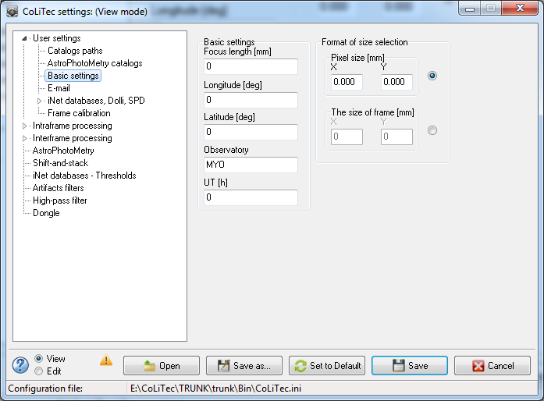
Figure 1.3. «Basic settings» section view

Table 1.3. Variables list in «Basic settings» section
№ | Identifier | Parameter name | Full name | Comments | Location | Type | Adjustment range | Module, which uses
1 | 2 | 3 | 4 | 5 | 6 | 7 | 8 | 9
1 | LabeledEdit8 | Focus length [mm] | Focus length value in millimeters. | From the optical instrument description. | Basic settings | double | From instrument description,  millimeters | POCLT,  VKCLT
2 | LabeledEdit5 | Longitude [deg] | Longitude value in degrees. | Telescope location. | Basic settings | double | 0.000-359.999, degrees | VKCLT,  VOCLT
3 | LabeledEdit6 | Latitude [deg] | Latitude value in degrees. | Telescope location. | Basic settings | double | -90.000-90.000, degrees | VKCLT,  VOCLT
4 | LabeledEdit4 | Observatory | Observatory name. | - | Basic settings | string | From instrument description | VKCLT,  VOCLT
5 | LabeledEdit106 | UT [h] | UT value in hours. | Is used to determine a date of the working night on UTC. | Basic settings | int | -12…12, hours | POCLT
6 | LabeledEdit9 | X | Pixel size value by X. | - | Basic settings /  Size selection format /  Pixel size [mm] | double | From instrument description,  millimeters | POCLT,  VKCLT,  VOCLT
7 | LabeledEdit10 | Y | Pixel size value by Y. | - | Basic settings /  Size selection format /  Pixel size [mm] | double | From instrument description,  millimeters | POCLT,  VKCLT,  VOCLT
8 | LabeledEdit70 | X | Frame size value by X. | - | Basic settings /  Size selection format /  Frame size [mm] | int | From instrument description,  millimeters | POCLT,  VKCLT,  VOCLT
9 | LabeledEdit72 | Y | Frame size value by Y. | - | Basic settings /  Size selection format /  Frame size [mm] | int | From instrument description,  millimeters | POCLT,  VKCLT,  VOCLT
10 | RadioButton42 | Pixel size [mm] | Sets size selection format in pixels. | - | Basic settings /  Size selection format | bool | [true; false] | VKCLT
11 | RadioButton43 | Frame size [mm] | Sets size selection format in frames. | - | Basic settings /  Size selection format | bool | [true; false] | POCLT,  VKCLT,  VOCLT

1.4. E-mail
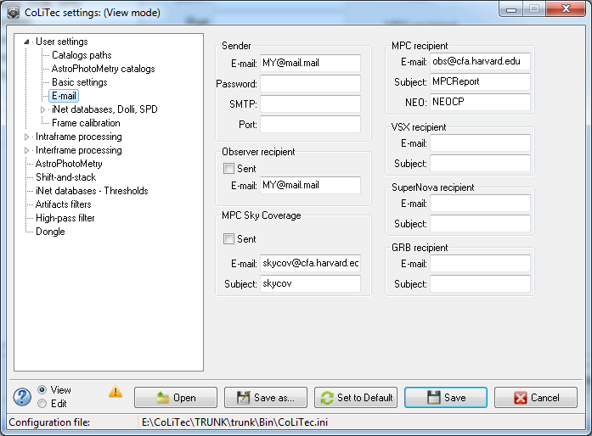
Figure 1.4. «E-mail» section view

Table 1.4. Variables list in «E-mail» section
№ | Identifier | Parameter name | Full name | Comments | Location | Type | Adjustment range | Module, which uses
1 | 2 | 3 | 4 | 5 | 6 | 7 | 8 | 9
1 | LabeledEdit93 | E-mail | Sender E-mail address. | - | E-mail /  Sender | string | - | VOCLT
2 | LabeledEdit101 | Password | Password field (hidden  input #). | - | E-mail /  Sender | string | - | VOCLT
3 | LabeledEdit90 | SMTP | SMTP value (mail server). | Sender SMTP value (widely used network protocol for sending e-mail through networks TCP / IP). | E-mail /  Sender | string | - | VOCLT
4 | LabeledEdit91 | Port | Port number. | Port number which will be used for E-mail sending to each recipient. | E-mail /  Sender | int | - | VOCLT
5 | LabeledEdit102 | E-mail | MPC recipient E-mail address. | - | E-mail /  MPC recipient | string | - | VOCLT
6 | LabeledEdit103 | Subject | E-mail subject. | - | E-mail /  MPC recipient | string | - | VOCLT
7 | LabeledEdit151 | NEO | Minimum acceptable value of NEO-rating, in which the program recommends sending a message to NEOCP. | The minimum value of NEO-rating, in which viewer will highlight object by marker. | E-mail /  MPC recipient | string | - | VOCLT
8 | LabeledEdit108 | E-mail | VSX recipient E-mail address. | - | E-mail /  VSX recipient | string | - | VOCLT
9 | LabeledEdit111 | Subject | E-mail subject. | - | E-mail /  VSX recipient | string | - | VOCLT
10 | LabeledEdit114 | E-mail | SuperNova recipient E-mail  address. |  | E-mail /  SuperNova recipient | string | - | VOCLT
11 | LabeledEdit115 | Subject | E-mail subject. | - | E-mail /  SuperNova recipient | string | - | VOCLT
12 | LabeledEdit113 | E-mail | GRB recipient E-mail  address. | - | E-mail /  GRB recipient | string | -
13 | LabeledEdit116 | Subject | E-mail subject. | - | E-mail /  GRB recipient | string | - | VOCLT
14 | LabeledEdit134 | E-mail | MPC Sky Coverage recipient E-mail address. | - | E-mail / MPC Sky Coverage | string | - | VOCLT
15 | LabeledEdit139 | Subject | E-mail subject. | - | E-mail / MPC Sky Coverage | string | - | VOCLT
16 | CheckBox30 | Sent | Turns on / off sending to MPC Sky Coverage. | - | E-mail / MPC Sky Coverage | bool | [true; false] | VOCLT
17 | LabeledEdit85 | E-mail | Observer recipient E-mail address. | - | E-mail /  Recipient Observer | string | - | VOCLT
18 | CheckBox31 | Sent | Turns on / off sending to Observer recipient. | - | E-mail /  Recipient Observer | bool | [true; false] | VOCLT

1.5. iNet databases, Dolli, SPD
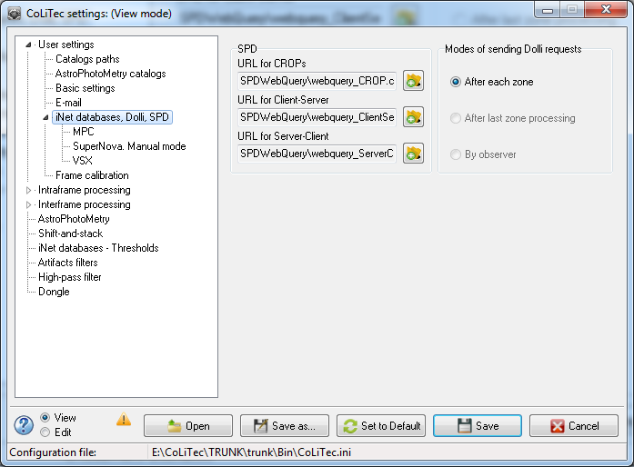
Figure 1.5. «iNet databases, Dolli, SPD» section view

Table 1.5. Variables list in «iNet databases, Dolli, SPD» section
№ | Identifier | Parameter name | Full name | Comments | Location | Type | Adjustment range | Module, which uses
1 | 2 | 3 | 4 | 5 | 6 | 7 | 8 | 9
1 | RadioButton29 | After each zone | Sets “After each zone” mode of sending Dolli requests. | - | Modes of  sending Dolli  requests | bool | [true; false] | VOCLT, LookSky
2 | RadioButton30 | After last zone processing | Sets “After last zone processing” mode of sending Dolli requests.  (is not available for selection) | - | Modes of  sending Dolli  requests | bool | [true; false] | VOCLT, LookSky
3 | RadioButton31 | By operator | Sets “By operator” mode of sending Dolli requests.  (is not available for selection) | - | Modes of  sending Dolli  requests | bool | [true; false] | VOCLT, LookSky
4 | LabeledEdit145 | URL for CROPs | Access path (URL) for CROPs (*.cfg file). | - | SPD | string | - | VOCLT, LookSky
5 | LabeledEdit146 | URL for Client-Server | Access path (URL) for Client-Server (*.cfg file). | - | SPD | string | - | VOCLT, LookSky
6 | LabeledEdit147 | URL for Server-Client | Access path (URL) for Server-Client (*.cfg file). | - | SPD | string | - | VOCLT, LookSky

1.5.1. MPC
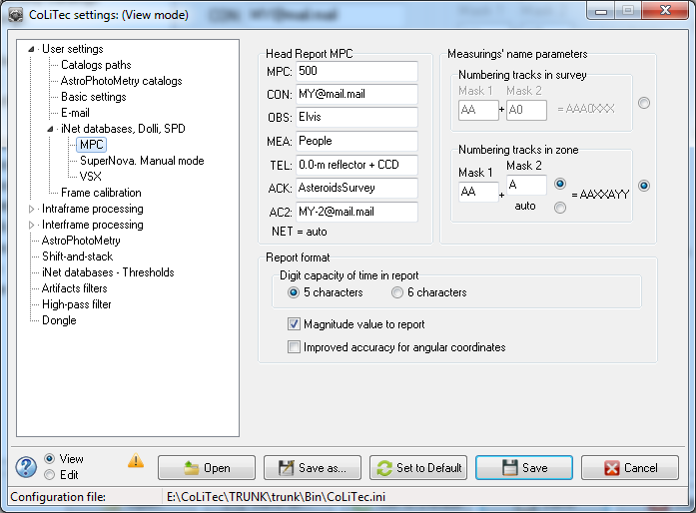
Figure 1.5.1. «MPC» section view

Table 1.5.1. Variables list in «MPC» section
№ | Identifier | Parameter name | Full name | Comments | Location | Type | Adjustment range | Module, which uses
1 | 2 | 3 | 4 | 5 | 6 | 7 | 8 | 9
1 | LabeledEdit15 | MPC | MPC value – observatory code. | Full description is available on official MPC web-site http://www.minorplanetcenter.net/iau/info/ObsDetails.html | MPC /  Head Report MPC | string | - | VOCLT, LookSky
2 | LabeledEdit16 | CON | Observer E-mail. | - | MPC /  Head Report MPC | string | - | VOCLT, LookSky
3 | LabeledEdit38 | OBS | Observer name. | - | MPC /  Head Report MPC | string | - | VOCLT, LookSky
4 | LabeledEdit141 | MEA | So-observer name. | - | MPC /  Head Report MPC | string | - | VOCLT, LookSky
5 | LabeledEdit17 | TEL | Telescope name. | - | MPC /  Head Report MPC | string | - | VOCLT, LookSky
6 | LabeledEdit122 | ACK | Survey name. | - | MPC /  Head Report MPC | string | - | VOCLT, LookSky
7 | LabeledEdit54 | AC2 | Observer E-mail. | - | MPC /  Head Report MPC | string | - | VOCLT, LookSky
8 | LabeledEdit32 | Mask 1 | Mask 1 value in the numbering tracks in survey. | - | MPC / Measurings' name parameters /  Numbering tracks in survey | string | 2 symbols | VOCLT
9 | LabeledEdit33 | Mask 2 | Mask 2 value in the numbering tracks in survey. | - |  | string | 2 symbols | VOCLT
10 | RadioButton35 | Numbering tracks in survey | Sets numbering tracks in survey mode. | - | MPC / Measurings' name parameters | bool | [true; false] | VOCLT
11 | RadioButton36 | Numbering tracks in zone | Sets numbering tracks in zone mode. | - | MPC / Measurings' name parameters | bool | [true; false] | VOCLT
12 | LabeledEdit34 | Mask 1 | Mask 1 value in the numbering tracks in zone. | - | MPC / Measurings' name parameters / Numbering tracks in zone | string | 2 symbols | VOCLT
13 | LabeledEdit35 | Mask 2 | Mask 2 value in the numbering tracks in zone. | - | MPC / Measurings' name parameters / Numbering tracks in zone | string | 1 symbol | VOCLT
14 | RadioButton28 | Manual | Sets manual mode for input Mask 2 value in the numbering tracks in zone. | - | MPC / Measurings' name parameters / Numbering tracks in zone | bool | [true; false] | VOCLT
15 | RadioButton38 | Auto | Sets auto incremented mode for input Mask 2 value in the numbering tracks in zone. | - | MPC / Measurings' name parameters / Numbering tracks in zone | bool | [true; false] | VOCLT
16 | RadioButton8 | 5 characters | Sets the value of time with 5 characters after comma. | - | Report format / Digit  capacity of time in report | bool | [true; false] | VOCLT
17 | RadioButton9 | 6 characters | Sets the value of time with 6 characters after comma. | - | Report format / Digit  capacity of time in report | bool | [true; false] | VOCLT
18 | CheckBox19 | Magnitude value to report | Magnitude value will be added to MPC report. | - | Report format | bool | [true; false] | VOCLT
19 | CheckBox20 | Improved accuracy for angular coordinates | Sets improved accuracy for angular coordinates RA and DE in MPC report. | If "true" angular coordinate RA will be added to MPC report with 3 characters after comma and for DE - with 4 characters after comma. | Report format | bool | [true; false] | VOCLT

1.5.2. SuperNova. Manual mode
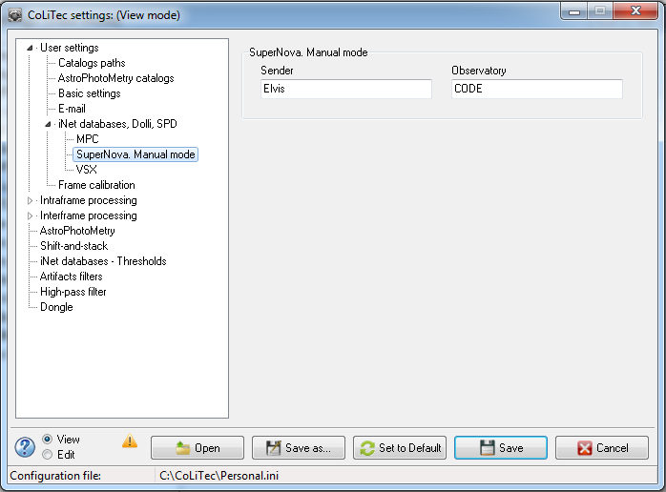
Figure 1.5.2. «SuperNova. Manual mode» section view

Table 1.5.2. Variables list in «SuperNova. Manual mode» section
№ | Identifier | Parameter name | Full name | Comments | Location | Type | Adjustment range | Module, which uses
1 | 2 | 3 | 4 | 5 | 6 | 7 | 8 | 9
1 | LabeledEdit82 | Sender | Observer name. | - | SuperNova.  Manual mode | string | - | VOCLT
2 | LabeledEdit84 | Observatory | Observatory name. | - | SuperNova.  Manual mode | string | - | VOCLT

1.5.3. VSX
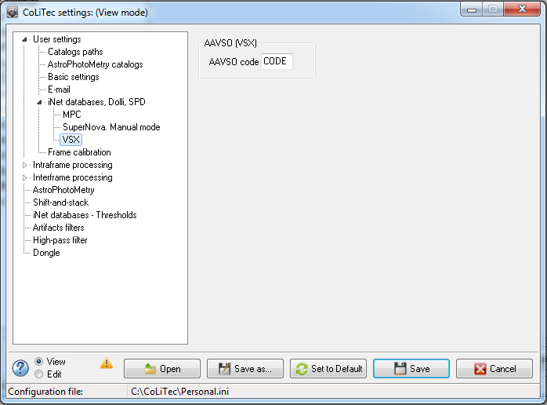
Figure 1.5.3. «VSX» section view

Table 1.5.3. Variables list in «VSX» section
№ | Identifier | Parameter name | Full name | Comments | Location | Type | Adjustment range | Module, which uses
1 | 2 | 3 | 4 | 5 | 6 | 7 | 8 | 9
1 | LabeledEdit50 | AAVSO code | AAVSO code. | - | AAVSO (VSX) | string | - | VOCLT

1.6. Frame calibration
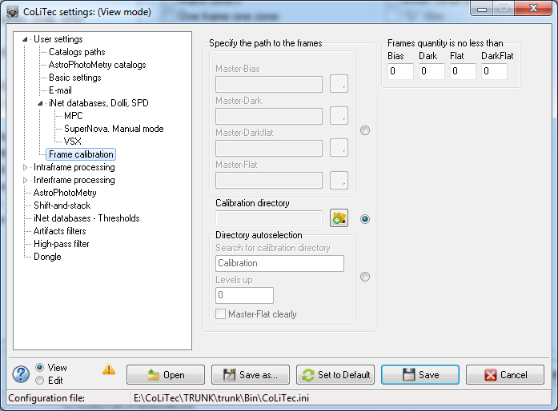
Figure 1.6. «Frame calibration» section view

Table 1.6. Variables list in «Frame calibration» section
№ | Identifier | Parameter name | Full name | Comments | Location | Type | Adjustment range | Module, which uses
1 | 2 | 3 | 4 | 5 | 6 | 7 | 8 | 9
1 | LabeledEdit51 | Bias | Number of frames type Bias, Dark, DarkFlat, Flat, which should not be less than for the formation master frame. | Utilities frames used to form the master - Bias, Dark, DarkFlat, Flat, must be located in the folder "Calibration directory" or should be placed in the folder specified in the "Search for calibration directory". | Calibration frames'  parameters /  Frames quantity is no less than | int | 0-50, pcs. | CosmCLT
2 | LabeledEdit53 | Dark |  |  |  | int | 0-50, pcs. | CosmCLT
3 | LabeledEdit56 | DarkFlat |  |  |  | int | 0-50, pcs. | CosmCLT
4 | LabeledEdit55 | Flat |  |  |  | int | 0-50, pcs. | CosmCLT
5 | LabeledEdit57 | Master-Bias | Path to Master-Bias frame. | - | Calibration frames'  parameters / Specify the path to the frames | string | - | CosmCLT
6 | LabeledEdit59 | Master-Dark | Path to Master-Dark frame. | - |  | string | - | CosmCLT
7 | LabeledEdit60 | Master-DarkFlat | Path to Master-DarkFlat frame. | - |  | string | - | CosmCLT
8 | LabeledEdit61 | Master-Flat | Path to Master -Flat frame. | - |  | string | - | CosmCLT
9 | RadioButton39 | Manual | Sets manual mode to specify the path to frames. | - |  | bool | [true; false] | CosmCLT
10 | RadioButton40 | Calibration  directory | Sets mode to specify the path to frames from calibration directory. | - |  | bool | [true; false] | CosmCLT
11 | RadioButton41 | Directory autoselection | Sets directory autoselection mode to specify the path to frames. | - |  | bool | [true; false] | CosmCLT
12 | LabeledEdit62 | Calibration  directory | Path to calibration directory that contains the "raw" calibration frames from which the master (super-) frames are formed | Calibration directory - the directory that contains the calibration frames types Bias, Dark, DarkFlat, Flat, from which you need to generate the corresponding master (super) frames. Frames shall have an appropriate identifier (e.g., Flat) in a file name or a header field FRAMETYP. | Calibration frames' parameters | string | - | CosmCLT
13 | LabeledEdit63 | Search for  calibration  directory | Calibration directory name for search. | - | Calibration frames'  parameters / Specify the path to the frames /  Directory  autoselection | string | - | CosmCLT
14 | LabeledEdit64 | Levels up | Number of upper levels of nested file system, within which the search of calibration directory is done. | - |  | int | 0…, pcs. | CosmCLT
15 | CheckBox1 | Master-Flat clearly | Turns on / off Master-Flat mode clearly | Often, super-Flat, or data for it, are not created every night, and Bias and / or Dark are created. Additionally, you should identify and process the latter and super-Flat «take" from a pre-specified "place". |  | bool | [true; false] | CosmCLT

2. Intraframe processing
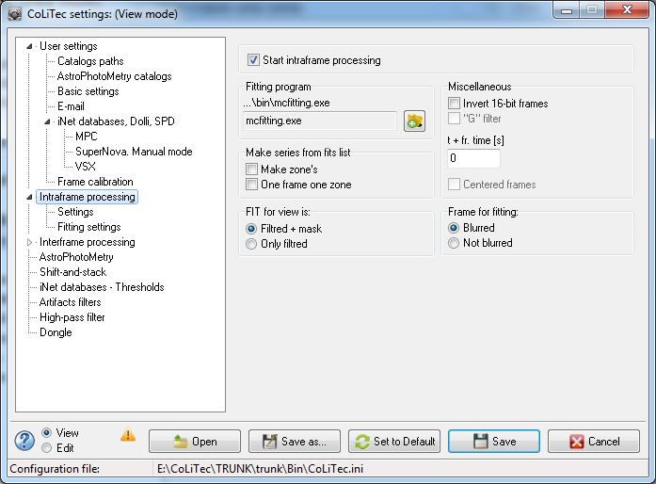
Figure 2. «Intraframe processing» section view

Table 2. Variables list in «Intraframe processing» section
№ | Identifier | Parameter name | Full name | Comments | Location | Type | Adjustment range | Module, which uses
1 | 2 | 3 | 4 | 5 | 6 | 7 | 8 | 9
1 | CheckBox34 | Start intraframe processing | Enables / disables the launch of intraframe processing. | When deactivated, the alignment will be carried out only by image brightness. | - | bool | [true; false] | POCLT
2 | LabeledEdit20 | Fitting  program | Contains the name of the executable fitting file *.exe. | - | Fitting program | string | Path to the  fitting  program | POCLT
3 | CheckBox11 | Make zone's | Forms zones according to the angular coordinates from headlines. | Only used in light-version. All frames can be supplied to the program in the same folder. The program sorts frames, placing frames of different zones into separate folders. In other words, frames with same angular coordinates of the center will be in the same folder. | Make series from fits list | bool | [true; false] | POCLT
4 | CheckBox6 | One frame one zone | Forms zones as “one frame - one zone”. | 1 folder (zone) – 1 frame. It is often used when refusing to use interframe processing. | Make series from fits list | bool | [true; false] | POCLT
5 | RadioButton11 | Filtred + mask | Frame to display will be aligned and processed by filter. | It is the matter of taste and convenience for each user individually. | FIT for view is: | bool | [true; false] | POCLT
6 | RadioButton12 | Only filtred | Frame to display will be only aligned. |  | FIT for view is: | bool | [true; false] | POCLT
7 | CheckBox15 | Centered frames | Enables / disables frame centering. | - | Miscellaneous | bool | [true; false] | VKCLT
8 | LabeledEdit89 | t + fr. time(s) | Value of extra time to frame time. | Sometimes time in the frame headline is written with a constant error - parameter is introduced to compensate it. | Miscellaneous | double | от 0.000,  seconds | POCLT
9 | CheckBox17 | Invert 16-bit frames | Enables / disables inversion mode for 16-bit frames. | Mode is more related to processing of astro-negatives. Frame brightness inversion is performed before the initial processing. | Miscellaneous | bool | [true; false] | POCLT
10 | CheckBox26 | "G" filter | Enables / disables filter «G (Spirit)»  (temporary is not available). | Experimental mode to smooth frame section, which contain post-glow from bright stars that were in this "place" in the previous frame. | Miscellaneous | bool | [true; false] | POCLT
11 | RadioButton10 | Blurred | Choose the blurred type of frame for fitting | - | Frame for fitting | bool | [true; false] | mcfitting
12 | RadioButton14 | Not blurred | Choose the not blurred type of frame for fitting | - | Frame for fitting | bool | [true; false] | mcfitting

2.1. Intraframe processing settings
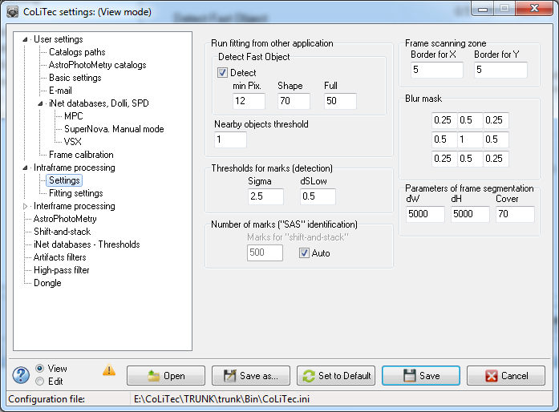
Figure 2.1. «Intraframe processing settings» section view

Table 2.1. Variables list in «Intraframe processing settings» section
№ | Identifier | Parameter name | Full name | Comments | Location | Type | Adjustment range | Module, which uses
1 | 2 | 3 | 4 | 5 | 6 | 7 | 8 | 9
1 | LabeledEdit11 | Border for X | Indents from the edges of frame to X. | Parameters specify the size of the frame edge, which is not processed with intraframe processing. | Frame scanning zone | int | from 5,  pixels | POCLT
2 | LabeledEdit13 | Border for Y | Indents from the edges of frame to Y. |  | Frame scanning zone | int | from 5,  pixels | POCLT
3 | LabeledEdit65 | dW | Value dW (delta W) – frame partition by axis X. | When processing frames of size 5000 x 5000 pixels, it is recommended to undertake segment processing, to avoid errors with the memory.  This increases stability of the computational process and increases the counting time. | Parameters of frame  segmentation | int | from 1000,  pixels | POCLT
4 | LabeledEdit66 | dH | Value dH (delta H) – frame partition by axis Y. |  | Parameters of frame  segmentation | int | from 1000,  pixels | POCLT
5 | LabeledEdit67 | Cover | Value of overlap between frame segments. | It is recommended to choose the overlap between close segments from the frame size of the largest objects. For object detection it is necessary that at least one segment of the frame object was complete. | Parameters of frame  segmentation | int | 50-200,  pixels | POCLT
6 | LabeledEdit128 | Sigma | Threshold value of object detection. Set in standard deviation of correlation responses from neighborhoods noise peaks.  Standard deviation evaluation is calculated by the program automatically. | Main parameter of the intraframe processing.  Selection threshold of frames peaks, close to which fitting (assessment of location and objects shine) will be held.  Correlation feedback values from close noise peaks are located in the left side of the range and have a Gaussian shape. Program automatically finds its standard deviation (sigma). Correlation feedback values from the surrounding area of the peaks of the objects are located in the right part of the range as a long tail.  For further processing those peaks are selected, the value of correlation response of which is more than a standard deviation (specified in parameter number of times). | Thresholds for marks (detection) | double | 1.0-10.0,  pixels | POCLT
7 | LabeledEdit40 | dSlow | The value, which lowers the threshold of markers formation (Sigma) while processing composite series for the initial frames. | Discrepancy with respect to the threshold of forming a mark on the initial frame.  When processing composite series, a marks formation threshold on the super-frame corresponds to the "Sigma", and on the threshold of initial frames is equal to the «Sigma- dSlow». | Thresholds for marks (detection) | double | 0.0-1.0,  pixels | POCLT
8 | LabeledEdit121 | Marks for "shift-and-stack" | Value of marks number on the initial frame, which should be used for the identification of frames to create a master-frame. | This number of the brightest frame marks will be used by the program when combining initial frames to form one master-frame. | Number of marks ("SAS"  identification) | int | 300-1000, pcs. | POCLT
9 | CheckBox34 | Auto | Enables / disables the marks auto counting mode. | If enabled - the number of used marks from frame is determined automatically, otherwise - according to the parameter «Marks for "shift-and-stack"». | Number of marks ("SAS"  identification) | bool | [true; false] | POCLT
10 | LabeledEdit49 | Nearby objects threshold | Threshold value for the objects adding to the group of nearby objects. | Additional value in pixels that is added to the sum of the radius of two objects. If the distance between the peaks of objects smaller than the sum of their radiuses + additional value, they are considered to be nearby. | Run fitting from other application | int | 0-100,  pixels | POCLT  mcfitting
11 | CheckBox37 | Detect | Enables / disables detection fast objects mode. | - | Run fitting from other application/  Detect Fast Object | bool | [true; false] | POCLT
12 | LabeledEdit3 | min Pix. | Minimum pixel value in an enlarged object. | - | Run fitting from other application/  Detect Fast Object | int | 5-20,  pixels | POCLT
13 | LabeledEdit14 | Shape | Value of the object elongation (100 – circle, 0 – ellipse). | - | Run fitting from other application/  Detect Fast Object | int | 1-100,  pixels | POCLT
14 | LabeledEdit31 | Full | The coefficient of pixel filling for contour of an elongated object. | - | Run fitting from other application/  Detect Fast Object | int | 0-100,  pixels | POCLT
15 | Edit9-Edit17 | 1-9 textbox | The blur mask on all sides according to the central pixel. | - | Blur mask | double | 0.0-1.0,  pixels | POCLT

2.2. Fitting settings
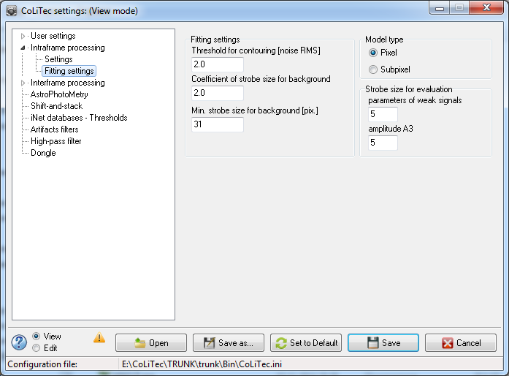
Figure 2.2. «Fitting settings» section view

Table 2.2. Variables list in «Fitting settings» section
№ | Identifier | Parameter name | Full name | Comments | Location | Type | Adjustment range | Module, which uses
1 | 2 | 3 | 4 | 5 | 6 | 7 | 8 | 9
1 | LabeledEdit58 | parameters of weak signals | Minimum strobe size for evaluation parameters of weak signals. | - | Strobe size for evaluation | int | 3-99  (odd),  pixels | mcfitting
2 | LabeledEdit69 | amplitude А3 | Strobe size for the amplitude А3 evaluation. | Amplitude is a sum of pixels in the strobe. | Strobe size for evaluation | int | 3-99  (odd),  pixels | mcfitting
3 | RadioButton34 | Pixel | Sets pixel type of mathematical model for processing. | - | Model type | bool | [true; false] | mcfitting
4 | RadioButton44 | Subpixel | Sets subpixel type of mathematical model for processing. | - | Model type | bool | [true; false] | mcfitting
5 | LabeledEdit107 | Threshold for contouring [noise RMS] | Threshold for contouring of measurements. | - | Fitting settings | double | 1.00-99.9,  noise SKO | mcfitting
6 | LabeledEdit124 | Coefficient of strobe size for background | Coefficient of strobe size for the frame background. | - | Fitting settings | double | 1.00-99.9, n/d | mcfitting
7 | LabeledEdit127 | Min. strobe size for background [pix.] | Minimal strobe size for the frame background. | - | Fitting settings | int | 5-99,  pixels | mcfitting

3. Interframe processing
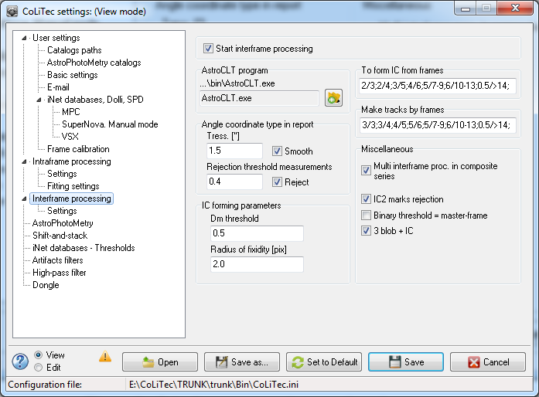
Figure 3. «Interframe processing» section view

Table 3. Variables list in «Interframe processing» section
№ | Identifier | Parameter name | Full name | Comments | Location | Type | Adjustment range | Module, which uses
1 | 2 | 3 | 4 | 5 | 6 | 7 | 8 | 9
1 | CheckBox18 | Start interframe processing | Enables / disables the start of interframe processing. | Interframe processing – forming of objects’ trajectories with zero apparent motion. If disabled, identification with astro-, photocatalogs (astro-, photoreduction) will be undertaken, IC (internal catalog of stationary objects) will be formed. | - | bool | [true; false] | CoLiTec, OLDAS
2 | CheckBox12 | Multi interframe proc. in composite series | Enables / disables multi interframe processing in composite series. | When processing composite series (i.e., master-frames and initial frames) the detection of trajectories both on master-frames and on initial frames will be undertaken. The same trajectories will be merged. Parameters of the trajectories on the initial frames will be converted to trajectories parameters of master-frames. | Miscellaneous | bool | [true; false] | VOCLT
3 | CheckBox14 | IC2 marks rejection | Enables / disables rejection of marks IC2 (Internal catalog). | Rejection of marks located near bright objects (stars). | Miscellaneous | bool | [true; false] | VOCLT
4 | CheckBox29 | Binary threshold = master-frame | Enables / disables the binary threshold, which is equal to master-frame (number of marks in trajectory must not be less than the number of frames). | - | Miscellaneous | bool | [true; false] | VOCLT
5 | CheckBox13 | 3 blob + IC | Enables / disables the detection of objects in three marks on 4 frames, provided that the mark will belong to one object of internal catalog. | Can detect objects SSO even if one of the frames series SSO merged frame of the object with the frame of the star. | Miscellaneous | bool | [true; false] | VOCLT
6 | CheckBox4 | Smooth | Enables / disables issuance of smoothed angular coordinates in the report. | Used for wide field telescopes with poor measurement accuracy for passing MPC input control, is recommended for use only in case of urgency. | Angle  coordinate  type in report | bool | [true; false] | VOCLT
7 | LabeledEdit42 | Tress [“] | The limit value for smoothing coordinate marks in trajectory in seconds. | Smoothing of marks coordinates in trajectory up to the value set in the «Tress [“]» field. Thus, the sum of the thresholds for markers formation for each coordinate value will not exceed the threshold. | Angle  coordinate  type in report | double | 0.1-5.0,  seconds | VOCLT
8 | CheckBox5 | Reject | Enables / disables rejection mode of anomalous measurement in trajectory. | - | Angle  coordinate  type in report | bool | [true; false] | VOCLT
9 | LabeledEdit36 | Rejection threshold measurements | The limit value, exceeding which the measurement will be rejected. | - | Angle  coordinate  type in report | double | 0.1-5.0,  pixels | VOCLT
10 | Edit1 | To form IC from frames | Rules for making decision about a stationary object on a series of frames (rule for forming objects IC of stationary objects).  There may be several rules, they are split by the separator ";". | Rules for making decision about a stationary object (object IC) is determined by the number of frames, for example, using rule 2/3. A stationary object is formed if there are 2 marks in a series of 3 frames.  In other words, different rules are used for a different number of frames. Rules are split by the separator «;».  Number before "/" symbol in every rule is the minimum number of marks on the amount of frames (or for a given amount of frames of the range), which is determined after the "/" symbol.  If there is a fractional number in a rule, the minimum amount of marks in the rule is determined by multiplying this amount by a fractional number of frames in the processed series.  The amount of frames, for which the rule is used, may be stated as a range. For example:  5/7-9; - threshold is equal to five marks with the amount of frames from seven to nine;  0.5/>14; - threshold (the minimum amount of marks required to make a decision about the presence of the object) is equal to half of the frames in the series, which consists of 14 or more frames. | To form IC from frames | string | 2/3;2/4;3/5;4/6;5/7-9;6/10-13;0.5/>14; | VKCLT
11 | LabeledEdit76 | Make tracks by frames | Rules for making decision about finding SSO (asteroids, comets). | Decision threshold of the SSO detection (asteroids, comets) is set into the executable file, and is not accessible for user. | Make tracks by frames | string | 3/3;3/4;4/5;5/6;5/7-9;6/10-13;0.5/>14; | VOCLT
12 | LabeledEdit25 | Radius of fixidity [pix] | Radius of fixidity value in pixels. | Marks (no more than one of each frame) are recognized as belonging to one object, if they are separated from each other by no more than the radius of fixidity.  When forming groups of related fixed objects, the object is included in the group if its distance to one of the objects in a group, smaller than the radius of indifference. | IC forming parameters | double | 0.5-2.5,  pixels | VKCLT
13 | LabeledEdit52 | Dm threshold | The maximum value for the residual variance of brightness estimates of IC object. | When the residual variance exceeds estimates of IC brightness to the maximum value, the object and the corresponding group of markers (no more than one on each frame) are considered "suspicious." Mark with the greatest shine of "suspicious" IC object is used to search for objects with nonzero apparent motion. | IC forming parameters | double | 0.1-1.0,  pixels | VKCLT
14 | LabeledEdit92 | AstroCLT program | Contains executable file name AstroCLT.exe. | - | AstroCLT program | string | Path to  AstroCLT program | VKCLT

3.1. Interframe processing settings
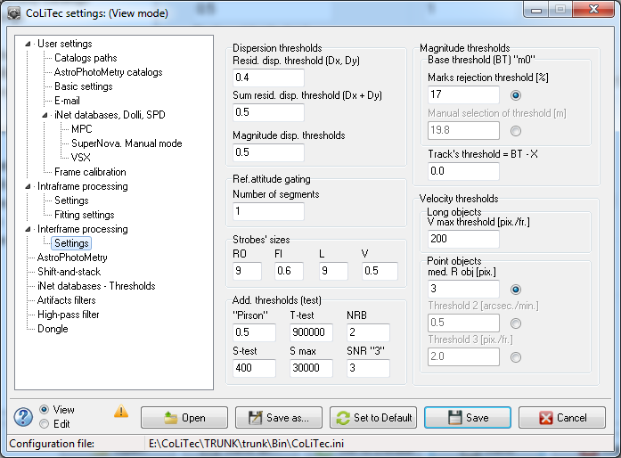
Figure 3.1. «Interframe processing settings» section view

Table 3.1. Variables list in «Interframe processing settings» section
№ | Identifier | Parameter name | Full name | Comments | Location | Type | Adjustment range | Module, which uses
1 | 2 | 3 | 4 | 5 | 6 | 7 | 8 | 9
1 | LabeledEdit95 | RO | Strobes' sizes to traverse range. | Full range of traverse range is evenly divided into areas / gates with the same size, which is specified in this field. | Strobes' sizes | int | 5-20,  pixels | VOCLT
2 | LabeledEdit96 | FI | Step by the traverse angle. | Value of a busting step at the traverse angle.  The smaller the pitch, the longer the program works. There is full coverage by areas / strobes. For a given value of object positioning errors for any possible trajectory of the apparent motion of the object there is at least one area / strobe that will get all marks of this trajectory, if they are formed [Hough article]. | Strobes' sizes | double | 0.1-1.0,  pixels | VOCLT
3 | LabeledEdit97 | L | Strobe size over the initial position. | Similar to 3rd paragraph of this table. | Strobes' sizes | int | 5-20,  pixels | VOCLT
4 | LabeledEdit98 | V | Speed step. | Similar to 4th paragraph of this table. | Strobes' sizes | double | 0.1-1.0,  pixels | VOCLT
5 | LabeledEdit105 | Number of segments | Number of segments into which each line of the frame is divided, as possible trajectory of the object apparent motion. | Data accumulation along possible trajectories of the object apparent motion is not along the whole line, but along its segment. This is advantageous if the apparent speed is low.  If this parameter is equal to 1, the dividing is not performed. At the moment of the dividing mode does not work. | Ref. attitude gating | int | 1-10, pcs. | VOCLT
6 | LabeledEdit27 | Marks rejection threshold [%] | Minimum percentage of identification of ID objects used by the program with photometric catalog. The program automatically assigns the value of the input threshold of detection procedure SSO according to assessment of mark (object) shine. | Only those markers are served to the SSO detection procedure that have not been put in the ID and shine evaluation which is not less than a preassigned threshold. The value of the threshold magnitudes is chosen adaptively. It corresponds to a given percentage of the input field IC objects identification with photometric catalog that is used by the program. The minimum shine of the last shine range is chosen for threshold value with percentage of not less than the specified identification. All IC objects are pre-divided into 50 bands on shine with the same amount of marks in each. | Magnitude  thresholds / Base  threshold  (BT) "m0" | int | 15-50, % | VOCLT
7 | RadioButton19 | Marks rejection threshold [%] | Sets the determination mode for input of SSO threshold detection procedure according to assessment of mark (object) shine as a function of the minimum percentage of identifying objects with IC with photometric catalog. | - | Magnitude  thresholds / Base  threshold  (BT) "m0" | bool | [true; false] | VOCLT
8 | LabeledEdit117 | Manual selection of threshold [m] | The value of input threshold detection procedure SSO according to mark (object) shine assessment, selected manually. | - | Magnitude  thresholds / Base  threshold  (BT) "m0" | double | 15.0-20.0,  pixels | VOCLT
9 | RadioButton20 | Manual selection of threshold [m] | Sets the manual mode for defining the input threshold detection procedure SSO according to mark (object) shine assessment. | - | Magnitude  thresholds / Base  threshold  (BT) "m0" | bool | [true; false] | VOCLT
10 | LabeledEdit87 | Track's threshold =  BT - X | The threshold value for the trajectory, which is equal to the difference between the basic threshold and value entered. | Brightness evaluation in one of the marks on the SSO can sag significantly. However, the average marks from the SSO have a greater brightness evaluation than noise marks, which appeared along SSO possible trajectory accidentally. The program uses, but recently it is recommended to use "0.0". | Magnitude thresholds | double | 0.0-1.0,  magnitude | VOCLT
11 | LabeledEdit126 | V max threshold [pix/fr] | The maximum velocity of the object investigation. | - | Velocity thresholds / Long  objects | int | 50-200,  pixels / frame | VOCLT
12 | RadioButton26 | mid. R obj | Sets type of velocity thresholds for point objects as value of the average (typical) radius of the object frame in pixels. | - | Velocity thresholds / Point  objects | bool | [true; false] | VOCLT
13 | LabeledEdit45 | mid. R obj [pix] | Value of the average (typical) radius of the object frame. | The parameter is set based on the size of the pixel. Parameter affects the threshold calculation for the maximum velocity of circular objects. | Velocity thresholds / Point  objects | int | 1-5, pixels | VOCLT
14 | RadioButton15 | Threshold 2 | Sets type of velocity thresholds for point objects as Threshold 2 in arcsec./min. | - | Velocity thresholds / Point  objects | bool | [true; false] | VOCLT
15 | LabeledEdit94 | Threshold 2 [arcsec./min.] | Thresholds for point objects in arcsec./min. | - | Velocity thresholds / Point  objects | double | 0.0-999.9,  arcsec./min. | VOCLT
16 | RadioButton16 | Threshold 3 | Sets type of velocity thresholds for point objects as Threshold 2 in pixels/frame. | - | Velocity thresholds / Point  objects | bool | [true; false] | VOCLT
17 | LabeledEdit104 | Threshold 3 [pix./fr.] | Thresholds for point objects in pixels/frame. | - | Velocity thresholds / Point  objects | double | 0.0-999.9,  pixels/frame | VOCLT
18 | LabeledEdit99 | Resid. disp. threshold (Dx,Dy) | The limit value for the residual dispersion | After the OLS evaluation of motion parameters (the apparent motion of the object is considered to be visible movement in a straight line at a constant speed), the residual dispersion are compared with the maximum permissible value. When it exceeds, the object is not considered to be detected. | Dispersion thresholds | double | 0.3-0.7,  pixels | VOCLT
19 | LabeledEdit30 | Sum resid. disp. threshold (Dx + Dy) | Maximum permissible value of the total residual dispersion in two coordinates. | After the OLS evaluation of motion parameters, the total residual dispersion is compared with the maximum permissible value. When it exceeds the object is not considered to be detected. | Dispersion thresholds | double | 0.5-0.8,  pixels | VOCLT
20 | LabeledEdit24 | Magnitude disp. thresholds | The limit dispersion value for brightness of the object. | The limit value for the dispersion of magnitude marks of the assumed object (the brightness of the object on a series of observations is assumed constant). | Dispersion thresholds | double | 0.4-0.8,  magnitude | VOCLT
21 | LabeledEdit44 | "Pirson" | Maximum permissible value of the Pearson criteria. | - | Add. thresholds (test) | double | 0.5-0.9, n/d | VOCLT
22 | LabeledEdit37 | t-test | The limit value for the t-criteria. | - | Add. thresholds (test) | int | 900000, n/d | VOCLT
23 | LabeledEdit39 | NRB | Maximum permissible value of the amount of marks (not less) on the initial frames. | The limit value corresponds to master-mark (mark formed on the master-frame). | Add. thresholds (test) | int | 2-10, n/d | VOCLT
24 | LabeledEdit41 | S-test | The limit value for S-criteria. |  | Add. thresholds (test) | int | 300-500, n/d | VOCLT
25 | LabeledEdit130 | S max | The critical value of S-criterion. | When exceeding the critical value of S-criteria, the object is considered to be detected in any of its indicators. | Add. thresholds (test) | int | 30000, n/d | VOCLT
26 | LabeledEdit75 | SNR "3" | Threshold of Signal-to-noise ratio for marks in the trajectory. | SNR "3" calculated as the ratio of the peak brightness of marks (without frame noise value) to the standard deviation of frame noise.  0 - threshold is disable;  99 - almost nothing will be found. | Add. thresholds (test) | int | 0-99, n/d | VOCLT

4. AstroPhotoMetry
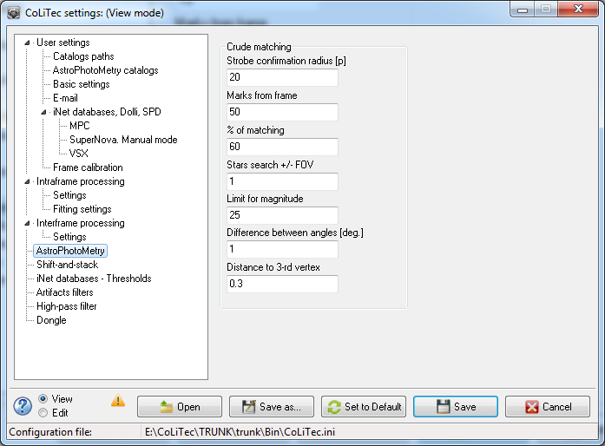
Figure 4. «AstroPhotoMetry» section view

Table 4. Variables list in «AstroPhotoMetry» section
№ | Identifier | Parameter name | Full name | Comments | Location | Type | Adjustment range | Module, which uses
1 | 2 | 3 | 4 | 5 | 6 | 7 | 8 | 9
1 | LabeledEdit7 | Strobe confirmation radius [p] | Strobe confirmation radius for selected frame objects by catalog objects. | - | Crude matching | int | 10-30, pixels | VKCLT
2 | LabeledEdit71 | Marks from frame | Amount of marks from the frame, selected by the program to confirm them by Astro Catalog objects within a preliminary hypothesis about the parameters of the frame shear. | During the preliminary identification of shear assessment prepared within the hypotheses about par marks (one on the frame and a catalog of the same object). | Crude matching | int | 30-100, pcs. | VKCLT
3 | LabeledEdit23 | % of matching | Minimum allowable percentage of confirmations. | Amount of confirmations is used as the weight of the hypotheses. A circular area (gate) with a given radius (§ 2) is placed around each mark of the first frame introduced. Amount of evidence is the number of markers of the second frame, which were introduced in the area (gates). If the number of confirmations is above the minimum, then the frame is considered to be identified with Astro Catalog. | Crude matching | int | 60-80, % | VKCLT
4 | LabeledEdit43 | Stars search +/- FOV | Choosing stars within a given catalog for emergency identification. | When there is a large error in the eyepiece (more than a third part of the field of view) sections of the star catalog , which attempts to identify the frame will be enumerated (if the parameter is greater than 0). If the parameter is 0, enumerating will not be implemented. | Crude matching | double | 0.0-1.0,  angular  frame size | VKCLT
5 | LabeledEdit28 | Limit for magnitude | Limit value for objects shine of Photo Catalog used for identification. | Stars of Photo Catalog whose shine is above a predetermined limit are not loaded in memory. | Crude matching | double | 15.0-25.0, magnitude | VKCLT
6 | LabeledEdit86 | Difference between angles [deg.] | Difference between angles of triangle in degrees. | - | Crude matching | int | 1-180,  degrees | VKCLT
7 | LabeledEdit88 | Distance to 3-rd vertex | Distance to 3-rd reference star for triangle forming. | - | Crude matching | double | 0.0-9.9 | VKCLT
8 | RadioButton23 | Linear | Sets linear model mode for astroreduction. | - | Model | bool | [true; false] | VKCLT
9 | RadioButton24 | Quadratic | Sets quadratic model mode for astroreduction. | - | Model | bool | [true; false] | VKCLT
10 | RadioButton25 | Qubic | Sets qubic model mode for astroreduction. | - | Model | bool | [true; false] | VKCLT

5. "Shift-and-stack"
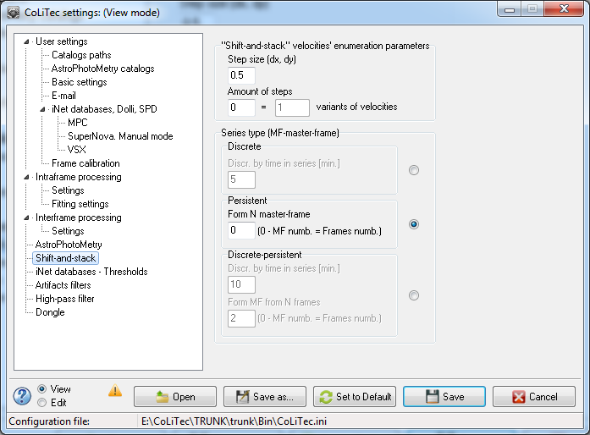
Figure 5. «"Shift-and-stack"» section view

Table 5. Variables list in «"Shift-and-stack"» section
№ | Identifier | Parameter name | Full name | Comments | Location | Type | Adjustment range | Module, which uses
1 | 2 | 3 | 4 | 5 | 6 | 7 | 8 | 9
1 | LabeledEdit83 | Step size (dx, dy) | Step size value by X and Y. | Shift value between frames of one subseries, provided that the frames are already centered on a star. | "Shift-and-stack" velocities' enumeration parameters | int | 0-100, pixels | POCLT
2 | LabeledEdit68 | Amount of steps | Amount of steps for “SAS”. | Amount of such shifts. | "Shift-and-stack" velocities' enumeration parameters | int | 0-100, pcs. | POCLT
3 | Edit3 | variants of velocities | Variants of velocities for “SAS” (Read only). | Just a calculator. 1 step = 9 variants. Calculation formula:  ( (2 * amount of steps) + 1)². | "Shift-and-stack" velocities' enumeration parameters | int | - | POCLT
4 | LabeledEdit77 | Discr. by time in series [min.] | The minimum value of the time "gap" between subseries of frames in minutes. | Adding frames (“SAS”) is only carried out in subseries. Series is divided into subseries by time dividing. | Series type  (MF-master-frame) / Discrete | double | 0.01-…,  minutes | POCLT
5 | RadioButton32 | Discrete | Sets “Discrete” mode for type of “SAS” series. | - | Series type  (MF-master-frame) / Discrete | bool | [true; false] | POCLT
6 | LabeledEdit138 | Form N master-frame | Value of the number of master -frames N (the number of sub-series), which will be formed. | Specifies the number of master-frames (i.e. sub-series) ("0" - the number of super frames is equal to the number of frames). | Series type  (MF-master-frame) /  Persistent | int | 3-…, pcs. | POCLT
7 | RadioButton33 | Persistent | Sets “Persistent” mode for type of “SAS” series. | - | Series type  (MF-master-frame) /  Persistent | bool | [true; false] | POCLT
8 | LabeledEdit47 | Discr. by time in series [min.] | The minimum value of the time "gap" between subseries of frames in minutes. | Forms sub-series by the time of interruption. | Series type  (MF-master-frame) /  Discrete-persistent | double | 0.01-…,  minutes | POCLT
9 | LabeledEdit48 | Form MF from N frames | Value of the number of master-frames N (the number of sub-series), which will be formed. | Discontinuously continuous series - first series divides into a series of sub-time by finding the "gaps", and then splits into sub-sub-series with fewer frames. ("0" - the number of superframes equals to the number of frames). | Series type  (MF-master-frame) /  Discrete-persistent | int | 3-…, pcs. | POCLT
10 | RadioButton37 | Discrete-persistent | Sets “Discrete-persistent” mode for type of “SAS” series. | - | Series type  (MF-master-frame) /  Discrete-persistent | bool | [true; false] | POCLT

6. iNet databases - Thresholds
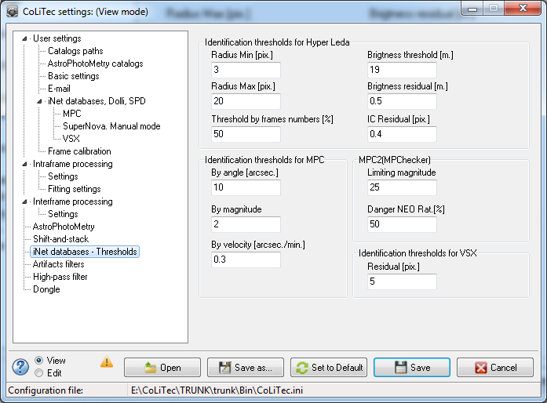
Figure 6. «iNet databases - Thresholds» section view

Table 6. Variables list in «iNet databases - Thresholds» section
№ | Identifier | Parameter name | Full name | Comments | Location | Type | Adjustment range | Module, which uses
1 | 2 | 3 | 4 | 5 | 6 | 7 | 8 | 9
1 | LabeledEdit125 | Limiting magnitude | Limiting magnitude value for loaded objects from MPC catalog. | Limiting magnitude value to download objects from the MPC (via Dolly). | MPC/ MPC2 (MPChecker) | double | 10.0-25.0,  magnitude | VOCLT
2 | LabeledEdit140 | Danger NEO Rat.[%] | Danger NEO-rating in percents. | Limiting NEO-rating value for identifying this rating as dangerous. | MPC/ MPC2 (MPChecker) | int | 0-100, % | VOCLT
3 | LabeledEdit131 | By angle [arcsec.] | Sets the threshold of angle for identification of objects with a MPC catalog. | Residual value of the position for identification of detected CoLiTec objects with objects from MPC. | Identification thresholds for MPC | int | 1-20,  arcseconds | VOCLT
4 | LabeledEdit132 | By magnitude | The limi value of brightness for identifying objects with a MPC catalog. | Residual value of brightness for identification of detected CoLiTec objects with objects from MPC. | Identification thresholds for MPC | double | 0.1-2.0,  magnitude | VOCLT
5 | LabeledEdit133 | By velocity [arcsec./min.] | Threshold speed value in arcseconds / minutes for identifying trajectories. | Residual value of speed for identification of detected CoLiTec objects with objects from MPC. | Identification thresholds for MPC | double | 0.1-10.0,  arcseconds/  minutes | VOCLT
6 | LabeledEdit73 | Radius Min [pix.] | Value of the minimum radius from the center of the galaxy to the candidates for a supernova in their preliminary detection. | The program prepares candidates for supernova close to galaxies from the SuperNova catalog. Candidates are selected from the internal catalog of stationary objects (IС). Candidates must be located from the galaxy center on not less than a predetermined distance. | Identification thresholds for  Hyper Leda | double | 3.0-5.0,  pixels | VOCLT
7 | LabeledEdit74 | Radius Max [pix.] | Value of the maximum radius from the center of the galaxy to the candidates for a supernova in their preliminary detection. | See previous paragraph. Candidates must be located from the galaxy center on not more than a predetermined distance. | Identification thresholds for  Hyper Leda | double | 15.0-30.0,  pixels | VOCLT
8 | LabeledEdit79 | Brigtness threshold [m.] | Minimum allowable brightness of the candidate for supernova. | In order for IC object to become a candidate for a supernova its brightness should exceed a predetermined distance. | Identification thresholds for  Hyper Leda | int | 15-20, magnitude | VOCLT
9 | LabeledEdit81 | Threshold by frames numbers [%] | Minimum allowable percentage (the number of frames in series) of evidences of the IC object by marks. | In order for IC object to become a candidate for a supernova, it must be confirmed by a large number of markers, not less than a specified percentage of confirmations of the total number of frames. | Identification thresholds for  Hyper Leda | int | 50-100, % | VOCLT
10 | LabeledEdit80 | Brigtness residual [m.] | Minimum allowable residual on estimated brightness of the IC and photo catalog for the candidate if it is IC object, identified with photo catalogs. | It is better if the IC object (as a candidate for the supernova) was not identified with the object from photo catalog. And if it is identified, then the IC object brigtness value must differ from such of identified object of the catalog by not less than a predetermined amount. | Identification thresholds for  Hyper Leda | double | 0.1-1.0,  magnitude | VOCLT
11 | LabeledEdit120 | IC Residual [pix.] | The minimum allowable value of the IC residual for each coordinate for identified IC object. | See previous paragraph. If the candidate for a supernova is identified with photo catalog object, then the IC object's coordinates should be different from coordinates of identified IC object of not less than a predetermined amount. | Identification thresholds for  Hyper Leda | double | 0.1-2.0,  pixels | VOCLT
12 | LabeledEdit78 | Residual [pix.] | Residual value in pixels. | IC object will be identified with the VSX object, if the residual value of the position will be less than specified. | Identification thresholds for VSX | double | 3.0-7.0,  pixels | VOCLT

7. Artifacts filters
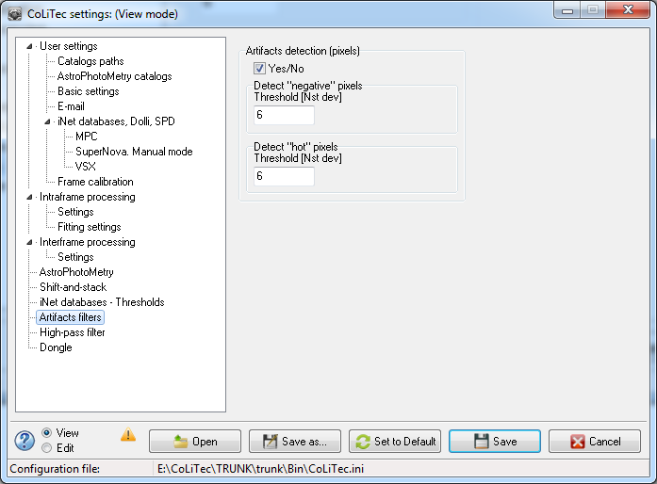
Figure 7. «Artifacts filters» section view

Table 7. Variables list in «Artifacts filters» section
№ | Identifier | Parameter name | Full name | Comments | Location | Type | Adjustment range | Module, which uses
1 | 2 | 3 | 4 | 5 | 6 | 7 | 8 | 9
1 | CheckBox25 | Yes/No | Turns on / off artifacts detection (pixels). | - | Artifacts detection (pixels) | bool | [true; false] | CoLiTec
2 | LabeledEdit1 | Threshold [Nst dev] | Limit, exceeding which "negative / broken» pixels will be detected. | Detection threshold of "negative / broken" pixel is:  medium_frame_ background –  (N * stdev_frame_background). | Artifacts detection (pixels) | double | 2.0-10.0, n/d | CosmCLT
3 | LabeledEdit100 | Threshold [Nst dev] | Limit, exceeding which "hot / broken» pixels will be detected. | Detection threshold of "hot / broken" pixel is:  medium_frame_ background +  (N * stdev_frame_background). | Artifacts detection (pixels) | double | 2.0-10.0, n/d | CosmCLT

8. High-pass filter
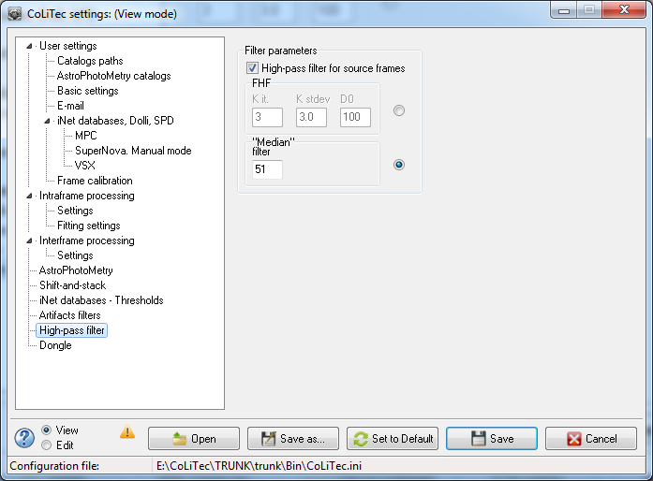
Figure 8. «High-pass filter» section view

Table 8. Variables list in «High-pass filter» section
№ | Identifier | Parameter name | Full name | Comments | Location | Type | Adjustment range | Module, which uses
1 | 2 | 3 | 4 | 5 | 6 | 7 | 8 | 9
1 | CheckBox2 | High-pass filter for source frames | Turns on / off high-pass filter for source frames. | Alignment of the low frequency frame component. | Filter parameters | bool | [true; false] | CoLiTec, OLDAS
2 | LabeledEdit21 | K it. | The iterations coefficient for the “Fourier” filter. | Amount of iterations of the filter - reduces drawdown of bright objects in the frame. | Filter parameters / FHF | int | 2-4 | CoLiTec, OLDAS
3 | LabeledEdit22 | K stdev | The coefficient of the standard deviation for the “Fourier” filter. | Cutoff threshold of objects in the frame is:  medium_frame_ background +  (К_{stdev} * stdev _frame_ background). | Filter parameters / FHF | double | 1.0-5.0 | CoLiTec, OLDAS
4 | LabeledEdit26 | D0 | Window size value for the “Fourier” filter. | Radius of the filter impulse characteristic. | Filter parameters / FHF | int | 50-200,  pixels | CoLiTec, OLDAS
5 | RadioButton50 | FHF | Sets “Fourier” filter. | - | Filter parameters / FHF | bool | [true; false] | CoLiTec, OLDAS
6 | LabeledEdit148 | «Median» filter | Window size value for the “Median” filter. | - | Filter parameters /  «Median» filter | int | 50-200,  pixels | CoLiTec, OLDAS
7 | RadioButton55 | «Median» filter | Sets “Median” filter. | - | Filter parameters /  «Median» filter | bool | [true; false] | CoLiTec, OLDAS

9. Dongle
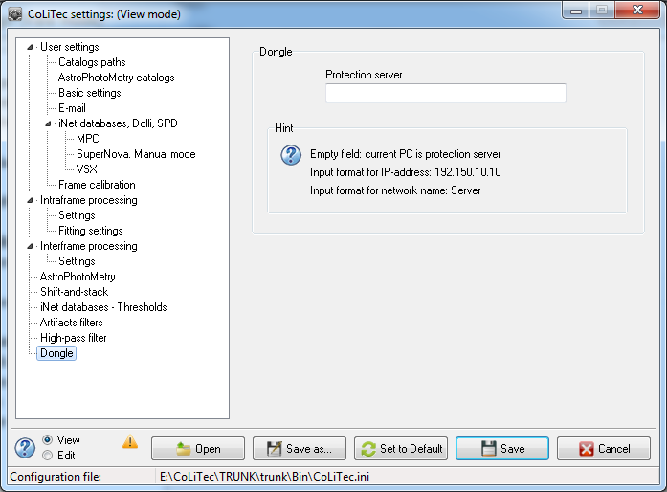
Figure 9. «Dongle» section view

Table 9. Variables list in «Dongle» section
№ | Identifier | Parameter name | Full name | Comments | Location | Type | Adjustment range | Module, which uses
1 | 2 | 3 | 4 | 5 | 6 | 7 | 8 | 9
1 | LabeledEdit46 | Protection server | Protection server input value. | There are two types of protection server input value: IP-address and PC network name.  It is necessary to type in the field if the dongle is present in the remote PC. | Dongle | string | - | OLDAS.exe

