Konstantin Kustov - Android Software Engineer
Address: Russiyanova 12, 11, Minsk, Belarus, 220141 Phone: +375333584449
LinkedIn: www.linkedin.com/in/KanstantsinKustau WhatsApp: +375333584449
GitHub: www.github.com/CoOstOFF E-mail: coostof@gmail.com
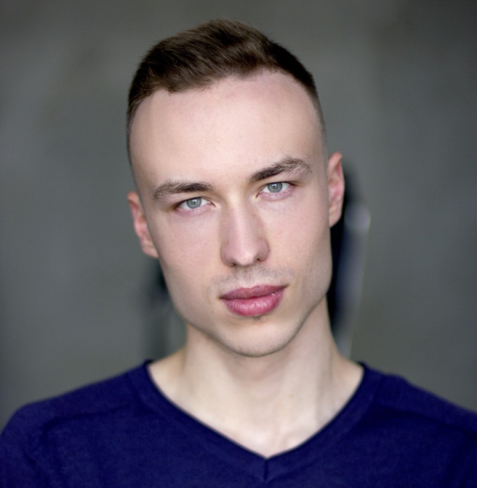
Date of Birth: 31/08/94 Skype: live:coostof

Strong Software Engineer who has been working in IT area since June 2015. Has experience in projects development, features development, architecture design, mentoring developers, code review, tasks estimation, working along Scrum / Kanban, business trips and communication with English speaking customers from all over the world. Experienced to work independently or as a part of a team. Excellent soft skills, responsibility and discipline.
 |   Main skills: Java, Kotlin, Android SDK, Multithreading, Architectural and Design Patterns, Automated Testing, Android Jetpack, Android Architecture Components, 3Rd party Android Libraries, Databases, Teamwork, Collaboration.  Work History
  Freelance, self-employed / Software Engineer / Jan 2020 - Feb 2020 / Minsk.
  I was self-employed and worked remotely. I greatly improved my technical and leadership skills here. Working remotely, I improved my time management skills. I established good networking, estimated tasks, code review, mentored developers. Main technologies that I used: Java, Kotlin, Android SDK, Clean Architecture, Android Jetpack, Rx, Coroutines, Retrofit 2, Dagger 2, JUnit, Mockito, Cucumber. I took part in projects:
  Shelfy. Israel. I worked with several mobile business applications for large retailers around the world. This project had about 10 million clients. I communicated daily with all development departments and with management. Working as a team, I have successfully created new stories for users. Moreover, I fixed vulnerabilities in legacy code, which greatly improved the reliability of the code.
  Potto Sales. Belarus. It was a startup. It’s an international aggregator of discounts from various major online stores. I built scalable and testable architecture for whole project (android, iOS, backend). I designed UX and developed android app from scratch. Team consisted of six person including me. The team jointly made a market analysis, android and iOS apps, website, backend, excellent design for brand and entire project. It was a great and interesting experience in a startup.
  Jaguar InControl Remote / Land Rover InControl Remote. UK. I was a certified specialist of the Jaguar Land Rover UK Company in a position Lead Software Engineer. The team was distributed both in Belarus and UK. Remotely participated in daily scrum, sprint planning and retrospective meetings. I was defining weak points in the app and was creating tasks for the team. Also I solved a lot of technical tasks and reduced technical debt of the app.
  ScienceSoft / Software Engineer / Jun 2018 - Sep 2019 / Minsk, Abu Dhabi.
  It’s outsourcing company. I was working on Agile in large teams and was establishing effective teamwork. My technical and soft skills have improved tremendously in this company. Also I have made public speeches in this company about new technologies. Main technologies that I used: Java, Kotlin, Android SDK, Clean Architecture, Android Architecture Components, Rx, Retrofit 2, Dagger 2, Glide. Projects in which I took part:
  Project is protected by NDA. UAE. I was doing native mobile messenger for one of the most secure Mobile Phones in the world. I was the first member in new UX/UI team, helped new members to understand project and reviewed their code. I made estimation for the team six months ahead. I had two-month business trip to Abu Dhabi to connect their team with Minsk team. I completed many tech tasks successfully and established effective work of the team.
  LatticePro. USA. Medical App. I did this app from scratch using modular clean architecture and after full development cycle and interaction with team I published this in the Google Play.
  Lixar. Canada. App for the medical area. I implemented graphs that were tracking changes of health indicators in real time and now these charts help thousands of medical workers to treat people.
  SINAM. Belarus. Banking App. I had experience the Multi-Module Clean Architecture. I found weak points in architecture and refactored it. After that team began to work more efficiently.
  VironIT / Software Engineer / Jun 2017 – Jun 2018 / Minsk.
  I worked in an outsourcing company. I worked in large Agile teams. I acquired excellent skills in working in international teams and mentoring other developers in this company. Also I did estimations to large projects for various customers. Main technologies that I used: Java, Android SDK, Retrofit 2, Dagger 2, Rx, EventBus, Moxy, Espresso, Picasso, quickblox, Glide, Realm, Room, Firebase. I took part in the following projects:
  Yota. Russia. This is mobile operator app for popular mobile device called Yota Phone. This is a very large project with 10M+ downloads in Google Store. I implemented new UX and UI of android app and now 10M+ people are enjoying the results of my work.
  Pluggd. Canada. It was a startup for interaction between contractors and customers. I designed architecture from scratch. And communicating with team of testers, designers, developers. I made a reliable android app from scratch and published it in Google Play.
  Workchat. USA. This is a chat for communication customers and mechanics from the auto workshop. I created several new features for this project and refactored vulnerable places to support easily in future.
  Golden Software / Software Engineer / Oct 2015 – Jun 2017 / Minsk.
  I worked with android apps in product company that develops ERP systems. My team and I completed 3 high quality and reliable apps. I acquired excellent communication skills.
  Freelance / Software Engineer / Jun 2015 – Oct 2015 / Minsk.
  I began to gain experience in developing android apps and solving problems for my customers. I completed 4 small projects from scratch and got great feedback from customers.

Education:
BSUIR / Higher education / Sep 2011 – Jun 2016 / Minsk
Degree Name: Bachelor. Information Technology Engineer.


Languages: Russian, Belarusian, English.

