 Rivers of Colorado Water Watch – Data Report 
Purpose
The purpose of these mini-reports is to turn the data generated by River Watch volunteers into information and provide feedback on the health of Colorado Rivers. The only data used in these reports are data collected by River Watch Volunteers. Each report will be archived on the River Watch website, http://wildlife.state.co.us/landwater/riverwatch/, and updated on a rotating basis about every three years.
Program
The River Watch Program started in 1989 with 5 schools on the Yampa River. It has grown to serve up to 140 groups annually, monitoring over 500 stations on 200 rivers each year. Currently, our database holds information on more than 1000 stations and 600 rivers. In any given River Watch year, approximately 70% of our volunteer organizations are school groups and the remaining 30% are a diverse mix of individuals and adult groups. To become a volunteer with River Watch, a group representative must attend a four day intensive training, and commit to one year of monthly sampling for most indicators. They must also comply with our methods and protocols for collection and sign an annual memorandum. Our program is heavy on quality assurance and control measures. All supplies are provided except travel to sites and shipping of samples. Unused equipment is reclaimed.
The main goal of River Watch is to collect long term high quality data on the health of Colorado Rivers while providing a hands-on experience for volunteers to understand the value and function of river ecosystems. The primary targeted decision makers for the data are the Water Quality Control Division (WQCD), the Colorado Water Quality Control Commission, and Colorado Parks & Wildlife (CPW) Biologists. The targeted decision processes involve Commission implementation of the Clean Water Act (CWA), assessment of water quality standards across the state, and the alignment of the goals of individual volunteers with River Watch data objectives. Thus, all field and laboratory methods match or compliment WQCD methods for CWA assessment processes, standard development, and protection and restoration efforts.
Each group must commit to the following baseline sampling; some may deviate in frequency or indicator for a variety of reasons. The parameters include field collection, metal collection, nutrient collection and macroinvertebrate collection. (Both total and dissolved metals are collected.)
Indicator | Frequency | Method | Reporting Limit
pH | monthly | Meter, probe for fresh water | 0.1 S.U.
Temperature | monthly | Celcius thermometer | 1.0 unit
Dissolved Oxygen | monthly | SM 421.B | 0.5 mg/l
Phenol/Total Alkalinity | monthly | EPA 310.1 | 2 mg/l
Total Hardness | monthly | SM 314 B | 2 mg/l
Aluminum | monthly | EPA 200.7 (ICP) | 15 ug/l
Arsenic | monthly | EPA 200.7 (ICP) | 15 ug/l
Calcium | monthly | EPA 200.7 (ICP) | 100 ug/l
Cadmium | monthly | EPA 200.7 (ICP) | 0.15 ug/l
Copper | monthly | EPA 200.7 (ICP) | 1.0 ug/l
Iron | monthly | EPA 200.7 (ICP) | 10 ug/l
Magnesium | monthly | EPA 200.7 (ICP) | 100 ug/l
Manganese | monthly | EPA 200.7 (ICP) | 5 ug/l
Lead | monthly | EPA 200.7 (ICP) | 5 ug/l
Potassium | monthly | EPA 200.7 (ICP) | 100 ug/l
Selenium | monthly | EPA 200.7 (ICP) | 5 ug/l
Sodium | monthly | EPA 200.7 (ICP) | 100 ug/l
Zinc | monthly | EPA 200.7 (ICP) | 3 ug/l
Ammonia | High/Low Flow | EPA 350.1 | .01 mg/l
Nitrate-Nitrite | High/Low Flow | EPA 353.2 | .02 mg/l
Total Phosphorus | High/Low Flow | EPA 365.1 and .3 | .005 mg/l
Chloride | High/Low Flow | EPA 325.1 | 1.0 mg/l
Sulfate | High/Low Flow | EPA 375.4 | 0.5 mg/l
Total Suspended Solids | High/Low Flow | Standard Methods | 4 mg/l
Macroinvertebrates | Annually/Fall | See RW Sample Plan – bugs ID’d by taxonomist, Dnet, 4, 60 sec kicks, sandy/rocky methods | NA
Physical habitat | Annually/Fall | Micro for bug kick, macro both banks assessed | NA
Field quality assurance samples | Two unknowns/yr | NA | 80-120% recovery  pH 96-104%
Metals quality assurance samples | 10% | NA | Function(test)

Volunteer monitoring is cost effective but not free, and the biggest trade off is time. River Watch sets a goal for analysis and posting turnaround time for each indicator family, and barring events outside of their control, generally meets those times. River Watch has collected field and metal data since inception. Therefore, the majority of posted results contain field and most metal data. Nutrient data is relatively new and has only been collected for the last ten years. Not all stations have collected nutrient data consistently. These reports use all data available when they are produced. The amount of data available may vary due either the study design or the duration of the volunteer commitment.
Initially, not all stations collected filtered metals, only those with known elevated metals. From 1989 to 1999, metals were analyzed by atomic absorption. In 1999, we switched to inductively coupled plasma atomic emission spectrophotometer (ICP) analyses and added parameters for the metals Al, Ar, Ca, Mg, Na and K. In 2010, we upgraded to a new ICP machine. Due to the differing capacities of the various machines, reporting limits for some metals have been adjusted over the years to compensate. Results used in these reports may not follow these actual dates as the analyses date may overlap one of these dates. A blank/empty results means no sample was collected or results were removed for quality assurance and control purposes. River Watch handles below detection limits by reporting zero. Nutrient collections were added in 2001. Initially, field and metal sampling occurred 24 times per year; that was dropped to 12 times per year in 2002 when we began collecting macroinvertebrates and conducting a physical habitat assessment annually. The macroinvertebrate component of the program is very important, but is not fully funded and therefore not every station has macroinvertebrate data.
Data management is a large component of the program. There are numerous validation steps, some built into data entry and manipulation, some completed by volunteers, lab technicians and biologists. CPW finalizes all data. Minimum meta-data is required for each organization, station and event. River Watch has an operations manual and quality assurance plan is available upon request (large document). Quality Assurance/ Quality Control (QAQC) is performed on 20% of samples both in the field and laboratory. Raw data dumps can be downloaded on the River Watch website or by contacting Barb Horn (barb.horn@state.co.us). CPW provides the WQCD with all River Watch data during their annual data calls or by request. The WQCD combines River Watch data with other data sources to formally conduct analyses and make informed decisions about Colorado’s Rivers.
CPW implements River Watch through a partnership with Colorado Watershed Assembly in order to provide professional support, diversity in fundraising and expansion into areas outside of CPW mission.
To learn more about the River Watch program please visit our website:
http://wildlife.state.co.us/landwater/riverwatch/

Colorado Clean Water Act (CWA)
This section may assist you in understanding various aspects of this report. The Clean Water Act states the nations waters will be “fishable and swimmable”. It is implemented by funds from United States Environmental Protection Agency (USEPA) given to states and tribes who determine beneficial uses that protect our waters. Colorado has four beneficial uses:
Agriculture
Quality of water is safe enough to grow crops and raise animals.
Drinking Water
Quality of water is safe enough for humans to drink or consume.
Recreation
Quality of water is safe enough to recreate in without getting sick. The type of activity in the specific water dictates the recreation classification, ranging from zero activity (area fenced off, too cold, access not allowed, etc.) to full emersion (activities like swimming). Standards for ecoli, the recreation pollutant indicator, will be lower for waters with no recreational activity.
Aquatic Life
Cold or warm water class one: quality of water and/or physical habitat is high enough to support a diverse number of species and individuals.
Cold or warm water class two: quality of water and/or physical habitat is such that it does not support a diverse number of species or individuals.

Limits for potential pollutants are developed based on scientific studies focused on one specific use. A toxic amount of zinc for humans is different than for cows and trout for example. Often aquatic life is the most sensitive use of the four uses categories. When a segment has more than one use occurring in it, the standard for the most sensitive use will be the enforced standard. This report will focus primarily on aquatic life use. When appropriate other uses will be discussed.
Watershed Report Organizing Unit
Through a public process, the WQCD assigns each body of water their beneficial or designated use or uses. Uses along a river from the headwaters to the mouth likely change and very time they do, the river is segmented then. Each segment has a set of uses that is used to implement discharge permits and other CWA sections to protect those uses. A river like the South Platte has 20 some segments from the headwaters to the state line.
Some segments of a river will have all four uses, some only one. These “use” segments, called Water Body ID’s (WBIDs), become the administrative unit for which the CWA is implemented. Each WBID is made up of six letters and a number. The first two letters are CO for Colorado; the next two are the major basin such as South Platte, Colorado, Rio Grande, Arkansas, etc. The next two letters are for a smaller watershed within the major one such as the Big Thompson, North Fork of Gunnison or Roaring Fork. The number is the segment starting at 01 for the headwaters and moving downstream. COUCRF04 is Colorado, Upper Colorado, Roaring Fork, segment 4. The WBID is the organizing unit for each of these reports. We chose this format because this is the unit used to determine the river’s health based on the CWA. One can combine several WBID Watershed Reports to comprise an entire river basin.
CPW also has an administrative unit for which we can quantify how we manage the fishery in a particular water body or river, thus creating another administrative unit and segment system. This is called “watercode” and is included in these reports. Sometimes the watercode is longer than the WBID and sometimes it is not.

Standards
Beneficial uses for each segment in a WBID and associated standards are provided for each report. For some pollutants, the standard is a number. For example, 50 mg/l may be a standard for which concentrations cannot exceed in some manner. For others there is an equation because the toxicity of the pollutant is dependent upon other indicators. For example, ammonia toxicity is a function of temperature and pH. Many metals toxicity is a function of hardness, for example Cadmium (Cd) chronic standard is the equation = (1.101672-(ln(hardness)*0.041838))*(e((0.7998*(ln(hardness)))-4.4451)), where you plug in a hardness value. For these you will see the letters “TVS”, which refers to table value standards. TVS standards are basically the default standards applied for all four uses statewide, unless another process has determined another standard. Temperature standards are dictated by the fishery and lumped into river/stream versus lake classifications and then into tiers within those water body types. To see these tables visit the WQCC’s website for regulation 31, http://www.cdphe.state.co.us/regulations/wqccregs/. The tables are in the first part of this document. To find the regulations for your entire basin, visit the same site, look for your major basin and download the tables.
The WQCC reviews the uses, segmentation and standards for every basin every three years, with the fourth year being a review of all the TVS. You can find your next review on the WQCC website. The CWA is a risk assessment. In general, standards are developed from scientific studies for which the numbers are combined from the most sensitive species. The theory is that if pollutants are kept below that level, ALL species are protected all the time, but that cannot be true. Just because a standard is exceeded does not mean toxicity or impact occurred to an organism. The magnitude, duration and frequency of that exposure is important but harder to measure. It is similar to catching a cold or not, if all your family has a cold and you are around them 24-7 you will likely get a cold. But if you pass someone on the street with a cold, you likely will not. The analysis tries to get a characterizing exposure, but it is difficult to have a perfect data set.
Some segments may have what is called temporary modifications. These act as temporary standards that must be met as work (restoration, research, sampling, etc.) to achieve a lower standard.
Each body of water in Colorado is also review for what is called antidegradation designation. This part of the CWA helps keep our rivers from degrading beyond what is necessary, or said another way, by having a criteria for say zinc, allows discharges to pollute a river up to that standard. But what if the natural zinc in a river is well below the zinc standard? Shouldn’t that space between what is there and what is allowed be protected? That space is called assimilative capacity or the rivers ability to “assimilate” say zinc up to the standard. This assimilative capacity is what the antidegradation designation is designed to protect.
There are three antidegradation designations, outstanding waters (OW), use protected (UP) and reviewable (blank). Outstanding Waters designation has to be proven with data and specific protocols but in essence states that a body of water is of significant quality below the standards for the uses in the water. In other words the space between what is in the water and the standards is LARGE and should be protected at the highest quality, not allowing all that space to be filled with pollutants. This might mean lots of treatment for existing or potential dischargers and maybe even mean no discharges allowed in that segment, thus this designation has a high bar to meet and is not often assigned. Most Outstanding Waters Designations in Colorado are high in the watershed in wilderness areas, national parks and such.
The other end of the spectrum is “use protected” designation. This in essence is saying that the quality in the water body is equal to standards right now and maybe even on the edge of not obtaining them sometimes, in other words the space between exiting water quality and standards in zero. Thus, the exiting uses on that river and associated discharges are protected from having to clean up the quality anymore than standards. Their “uses” are “protected”, hence the name. Indicators and thresholds on these segments are different that the default if you will. Data has to be provided to obtain this designation as well. Often these segments are lower in a watershed at mouths of tributaries and in urban, developed areas.
Most of Colorado’s waters fall into reviewable designation, if not outstanding or use protected, the segment is reviewable. All that means is that when a new discharge permit is evalutated or existing permit is being renewed, the space between existing water quality and standards is reviewed to see how much of it is available for the relevant pollutants in the discharges. Is there room, is there not and that is weighed in on what that discharger is allowed to discharge in their permit. You will see the antidegradation designation on the each of the WBID’s standards table.
Analyses
This report employs, where possible, the same assessment methods that the WQCD does to develop their impaired stream segment list. Impairment defined as a specific pollutant is exceeding a standard for a specific use in a specific WBID. Chronic and acute standards are set for relevant pollutants. Biologically, chronic toxicity usually means exposure at low concentrations for a long duration many times that results in any ailment that may or may not lead to death (cancer is an example). Acute toxicity usually means exposure at high concentration for a short time, maybe once or twice and results in death (high radiation is an example). To measure chronic and acute in regulatory setting you will have two thresholds or standards, one for each exposure condition. Both acute and chronic standards cannot be exceeded more than once in three years.
When there is enough data, a high enough n (n = how many number of samples in the analysis), the 85 percentile of the data will be used to compare against the standard for most pollutants. Some use the 50th percentile. For ecoli, the geometric mean would be used. When there is not enough data, what is available will be compared to the standard. Chronic temperature standards are meant to be compared to a maximum weekly average temperature (MWAT) and cannot be exceeded more than once in a three year period. Acute temperature standards are meant to be compared to a daily maximum (DM) temperature and cannot be exceeded more than once in a three year period. River Watch study design does not collect continuous temperature data to calculate MWAT’s and DM’s. Comparison will be with available data.

COUCNP03.doc – January 24, 2013, Meta Report by Bill Schwan and Data Analyses by Emily Roth
\\dowdenfs01\rss\RiverWatch\Watershed Reports\WSR Webpage Archive\Colorado33&37\North Platte\COUCNP03 \Archive\Colorado33&37\COUCNP05B.doc

Colorado River, Upper Colorado, North Platte, Segment 3 (COUCNP03)
Colorado Parks and Wildlife Water Code: 10904, 11089, 11786
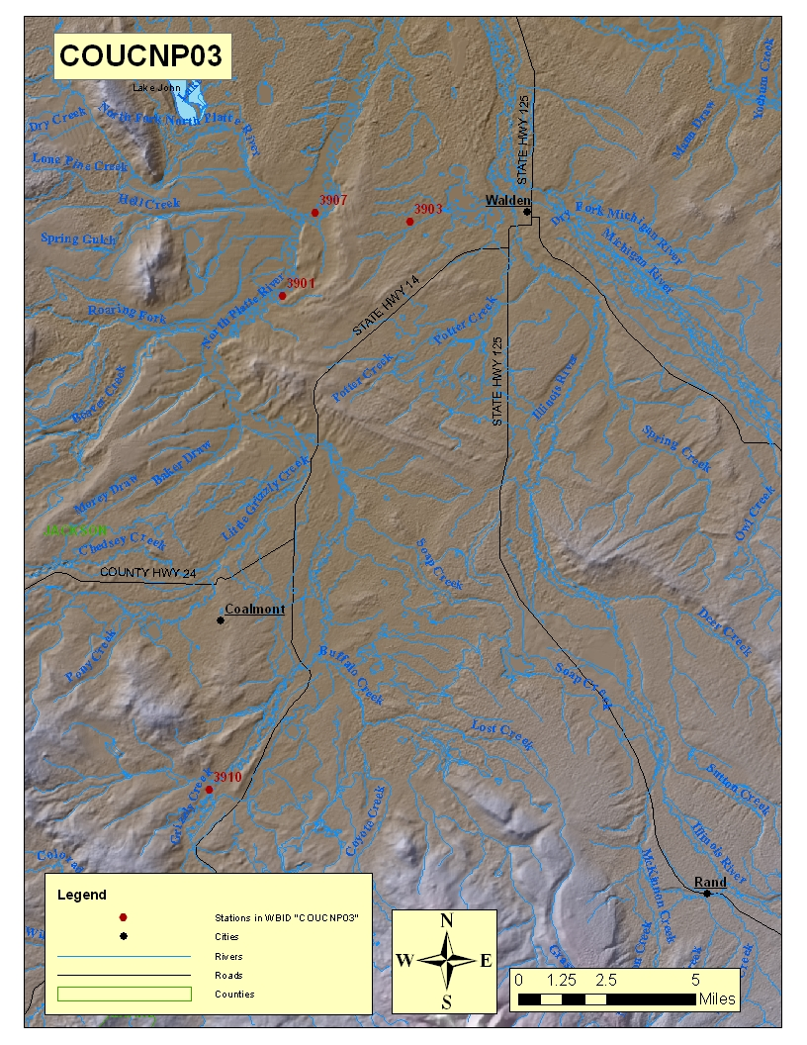

Stations
Station | Name | Hydro Unit | River | Latitude | Longitude | Period of Record
3901 | Double R Ranch | 10180001 | N Platte | 40.69598 | -106.415 | 6/10/2009
3907 | CR 7 Br | 10180001 | N Platte | 40.73019 | -106.398 | 8/14/2009
3903 | Stateline | 10180001 | N Platte | 40.72701 | -106.347 | 7/9/2009
3910 | At Spicer Ranch | 10180001 | Grizzly Cr | 40.49341 | -106.45 | 9/16/2009

WQCD Water Body ID - Description: Mainstem of the North Platte River from the confluence of Grizzly Creek and Little Grizzly Creek to the Colorado/Wyoming border.

Water Code – Description: 10904 - NORTH PLATTE R #B2
11089 - GRIZZLY CREEK
11786 - NORTH PLATTE R #1

WBID Assigned Uses: Aq Life Cold 1, Recreation E, Water Supply, Agriculture

WBID Antidegradation
Designation: Reviewable

Collection Volunteers: Colorado Natural Heritage Program (318)

Standards for WBID (Effective Date: 1/1/2012)
Desig | Classifications | NUMERIC STANDARDS |  |  |  |  |  | TEMPORARY MODIFICATIONS and QUALIFIERS
 |  | PHYSICAL and BIOLOGICAL | INORGANIC mg/l |  | METALS ug/l |  |  | TEMPORARY MODIFICATIONS and QUALIFIERS
 | Aq Life Cold 1  Recreation E  Water Supply  Agriculture | T=TVS(CS-II)oC  D.O.=6.0 mg/l  D.O.(sp)=7.0 mg/l  pH=6.5-9.0  E.Coli=126/100ml | NH3(ac/ch)=TVS  Cl2(ac)=0.019  Cl2(ch)=0.011  CN=0.005 | S=0.002  B=0.75  NO2=0.05  NO3=10  Cl=250  SO4=WS | As(ac)=340  As(ch)=0.02(Trec)  Cd(ac)=TVS(tr)  Cd(ch)=TVS  CrIII(ac)=50(Trec)  CrVI(ac/ch)=TVS  Cu(ac/ch)=TVS | Fe(ch)=WS(dis)  Fe(ch)=1000(Trec)  Pb(ac/ch)=TVS  Mn(ch)=WS  Mn(ac/ch)=TVS  Hg(ch)=0.01(tot) | Ni(ac/ch)=TVS  Se(ac/ch)=TVS  Ag(ac)=TVS  Ag(ch)=TVS(tr)  Zn(ac/ch)=TVS

Field Results (mg/l)
Event# | Org Name | Date | Time | PH | &deg;C | Phen Alk | Tot Alk | Tot Hard | DO
3901.001 | CO Natural Heritage Pgm | 6/10/2009 | 10:09:00 | 7.86 |  | 0 | 110 | 102 | 7.3
3907.001 | CO Natural Heritage Program | 8/14/2009 | 11:30:00 |  | 15 | 4 | 76 | 88 | 6.7
3903.001 | CO Natural Heritage Program | 7/9/2009 | 14:50:00 | 8.43 |  | 8 | 123 | 122 | 8.4
3910.001 | CO Natural Heritage Program | 9/16/2009 | 17:40:00 | 8.14 | 13.7 | 0 | 54 | 150

Metal Results (ug/l)
Event# | AL Dis | AL Tot | AS Dis | AS Tot | CA Dis | CA Tot | CD Dis | CD Tot | CU Dis | CU Tot
3901.001 | 0 | 376 | 0 | 0 | 24836 | 24725 | 0 | 0 | 1.7 | 2.1
3907.001 | 0 | 160 | 0 | 0 | 23219 | 23769 | 0 | 0 | 0 | 0
3903.001 | 0 | 211 | 0 | 0 | 30164 | 30404 | 0 | 0 | 0 | 0
3910.001 | 27 | 201 | 0 | 0 | 12347 | 12723 | 0 | 0 | 1.1 | 1.4

Event# | FE Dis | FE Tot | PB Dis | PB Tot | MG Dis | MG Tot | MN Dis | MN Tot | SE Dis | SE Tot | ZN Dis | ZN Tot
3901.001 | 208 | 729 | 5.1 | 5.9 | 6829 | 6817 | 43.5 | 68 | 0 | 0 | 4.5 | 10.7
3907.001 | 173 | 487 | 7.2 | 7.8 | 5785 | 5876 | 28.2 | 43 | 0 | 0 | 4.2 | 6.4
3903.001 | 206 | 702 | 4.6 | 5.5 | 8678 | 8735 | 35.3 | 77.6 | 0 | 0 | 5.8 | 33.5
3910.001 | 503 | 1130 | 15.1 | 15.1 | 3248 | 3349 | 25 | 39 | 0 | 0 | 22 | 18.4

Nutrient Results (mg/l)
Event# | Ammonia | Chloride | Nitrate Nitrite | Sulfate | Tot N* | Tot P | TSS
3901.001 | 0 | 1.62 | 0.012 | 18.9 | 0.012 | 0.0672 | 11.6
3907.001 | 0 | 1.12 | 0 | 15.2 | 0 | 0.021 | 4.5
3903.001 | 0 | 1.65 | 0 | 18.2 | 0 | 0.0341 | 7.3
3910.001 | 0 | 1.09 | 0 | 7.13 | 0 | 0.164 | 7.6
*TN is addition of ammonia and nitrate/nitrite

COUCNP03.doc – January 24, 2013, Meta Report by Bill Schwan and Data Analyses by Emily Roth
\\dowdenfs01\rss\RiverWatch\Watershed Reports\WSR Webpage Archive\Colorado33&37\North Platte\COUCNP03 \Archive\Colorado33&37\COUCNP05B.doc

Analyses Biological Standards
Alkalinity and Hardness
Alkalinity reflects a rivers buffering capacity (higher especially if pH’s are greater than 8.3), hardness is the amount of calcium and magnesium in the water. Grizzly Creek showed the lowest in alkalinity and greatest in hardness. Usually alkalinity and hardness increase in a downstream fashion, hardness at a higher magnitude than alkalinity, and also change seasonally- being at their highest in the winter months and then lower in spring summer and fall after being diluted by runoff. For the samples collected on the N Platte, hardness and alkalinity are shown to first slightly decrease and then slightly increase in a downstream fashion.

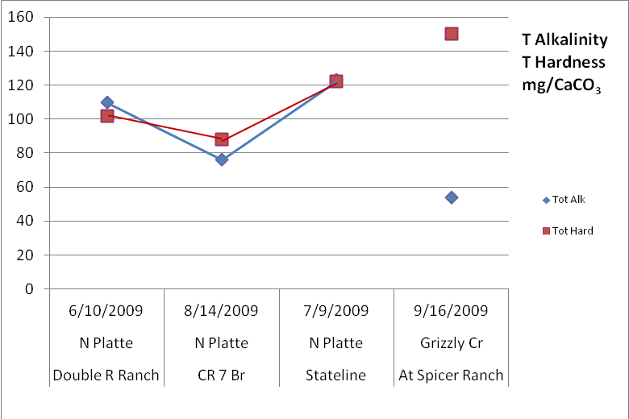

pH
pH results fell within the standards. Stateline on the N Platte has a high relative buffering capacity (pH>8.3). No data was available for CR 7 Br.

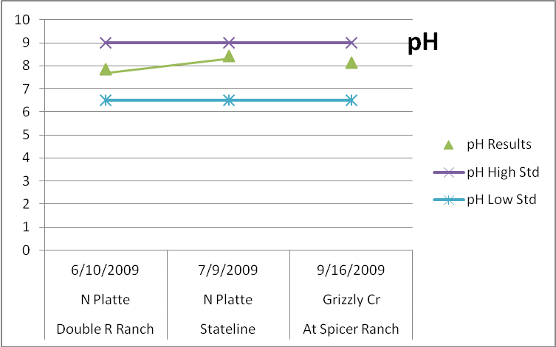

Dissolved Oxygen
All stations had a DO level above the Standard on their sample date. No data was available for At Spicer Ranch, which Grizzly Cr flows into, so it is not represented in the graph below.

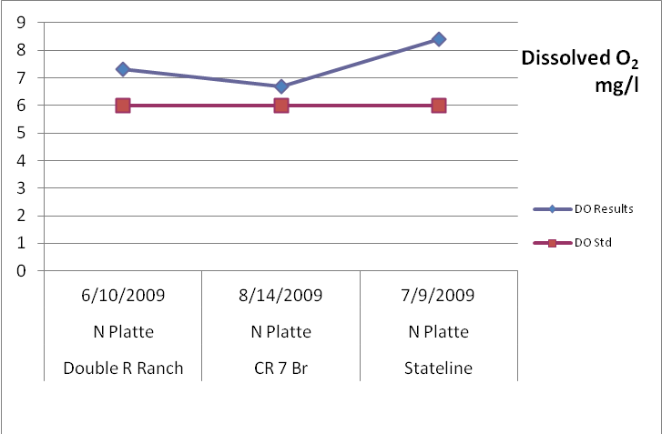

Temperature
Temperature standards classify fish into tiers that protect ranges of temperatures for groupings of species. Different species have different temperature thresholds. For cold water there are essentially two tiers, Tier Iª for where cutthroat and brook trout are expected to occur and Tier II^{b} where cold water fish reside, excluding cutthroat and brook trout. Then smaller cold water lakes and reservoirs have thresholds different than large lakes and reservoirs.

All cold and warm water tiers have chronic and acute thresholds that apply seasonally, for example Tierª has chronic and acute standards between June and September, then different thresholds between October and May. Seasons are different for each tier.

The temperature metric used to compare chronic thresholds too is a mean weekly average temperature (MWAT). That means temperature data needs to be collected continuously over a period, so every 15 minutes, every day for 10 consecutive days. Acute thresholds are compared to a Daily Maximums (DM) and also require frequent measurements over days and weeks to calculate. River Watch does not collect continuous temperature data. For discussion purposes we will treat single point or summarized temperature data as an MWAT and DM. This is not a representative analysis but is useful for illustration and educational purposes.

There was no temperature data for Double R Ranch or Stateline so they are not represented below. Temperatures for both the CR 7 Br site and At Spicer Ranch were taken in August and September respectively, and do not exceed the chronic standard of 18.3°C or the acute standard of 23.9°C.
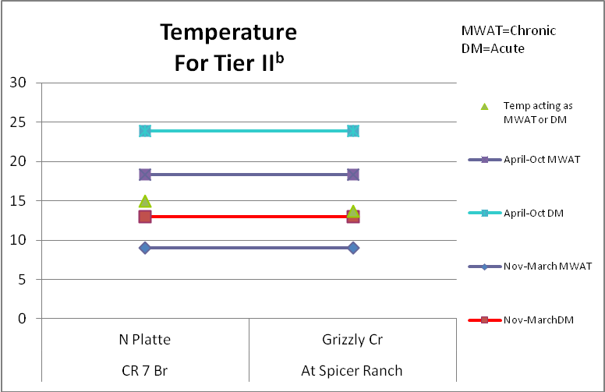

Analyses Inorganic Standards
Ammonia
All ammonia results were below reporting limits indicating the absence of ammonia in these creeks on those specific sampling dates.

Nitrate-Nitrite
Total nitrogen is all three forms of nitrogen, ammonia, nitrate and nitrite. The current TN interim proposal for cold water streams is a standard of 1.25 mg/l, which is a 5 year median, never to be exceeded. There is a limit on N0₂ of 0.05 mg/l and N0₃ of 10 mg/l for protecting aquatic. Neither site came close to approaching the N0₂, N0₃ limits or the interim Total N standard.

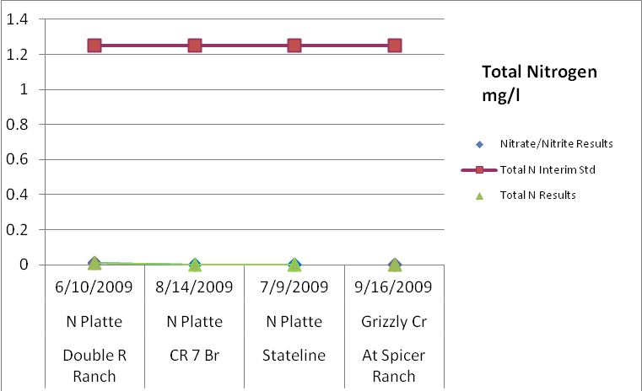

Total Phosphorus
The interim TP standard for cold water is 0.11 mg/l TP, 5 year median not to be exceeded. All N Platte data samples fell below this standard, Grizzly Cr at Spicer Ranch exceeded the interim standard by 0.054 mg/l, at a level of 0.164 mg/l for this sample date.
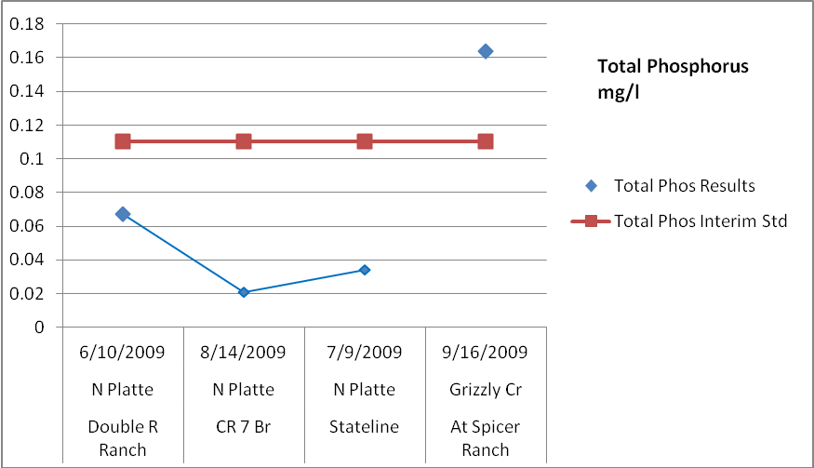

Chloride
All chloride results are well below the Drinking Water standard of 250 mg/l.
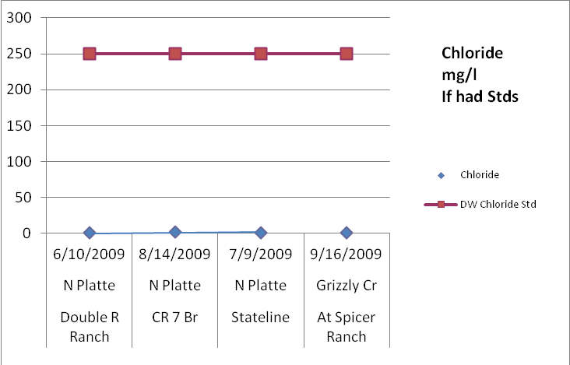

Sulfate
There is not an aquatic life standard for sulfate. All results are well below the Drinking Water Sulfate Std of 250 mg/l.
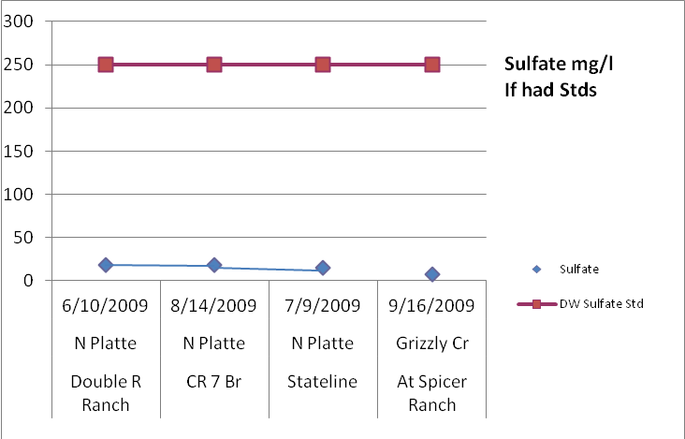

Total Suspended Solids
There is not a TSS standard for any beneficial use. TSS is an indicator of suspended material, turbidity and clarity; it does not tell you the composition of the suspended material. These waters all had very little suspended particles on their sample dates.

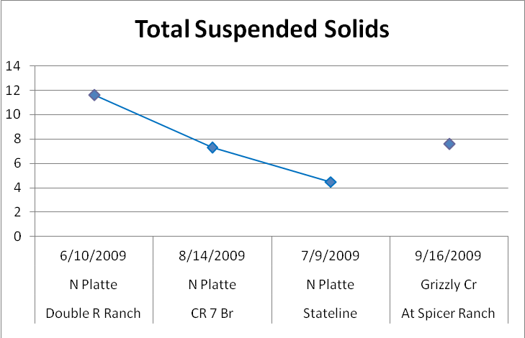

Analyses Metals Standards
Aluminum
Aluminum is not an indicator to protect uses on this segment. If it were, we would use the standard that aligns with pH values greater than 7. Total aluminum was detected at all sites, Double R Ranch the highest. Dissolved aluminum was detected only at Spicer Ranch at a level of 27 ug/l. All results fell below both the acute and chronic standards.
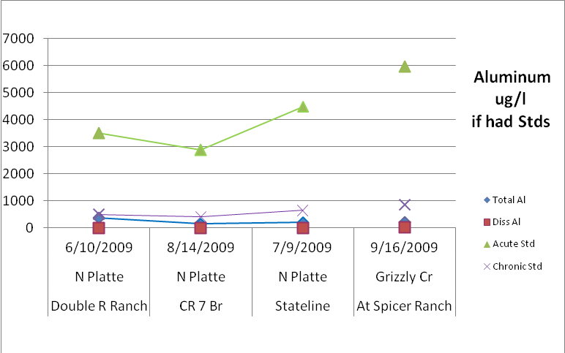

Arsenic
No arsenic was detected at any station and thus remained clear of the arsenic acute standard of 340 ug/l.

Cadmium
No Cadmium was detected at either site, and therefore does not approach the acute or chronic table value standards.
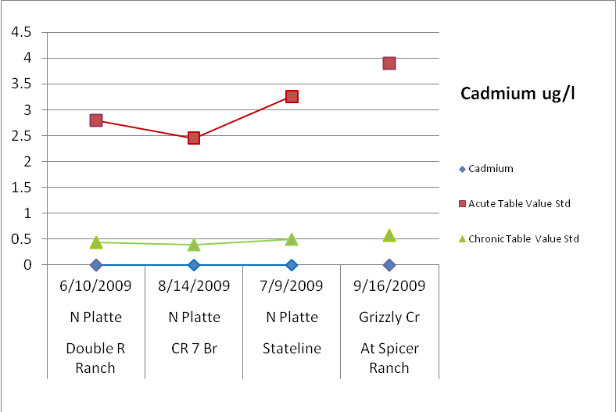

Copper
All sites were well below the chronic and acute copper standards.
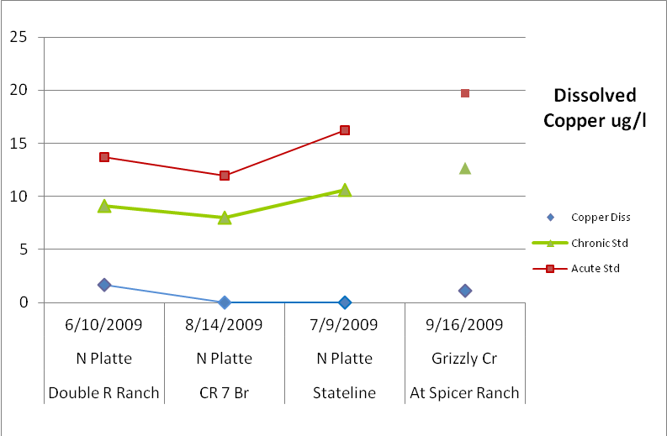

Iron
The table value total iron standard is 1000 ug/l. All N Platte samples are below this standard. At Spicer Ranch on Grizzly Creek exceeds this standard by 130 ug/l.
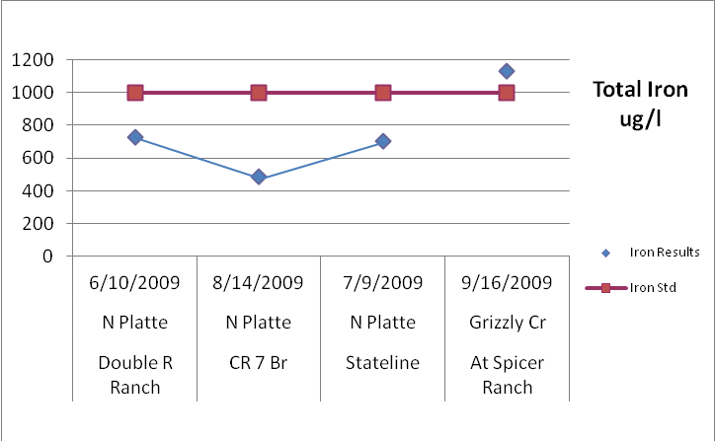

Lead
Lead Diss exceeded the chronic standards at all four sites, Grizzly Cr being the greatest, with an exceedance of 11.2 ug/l.

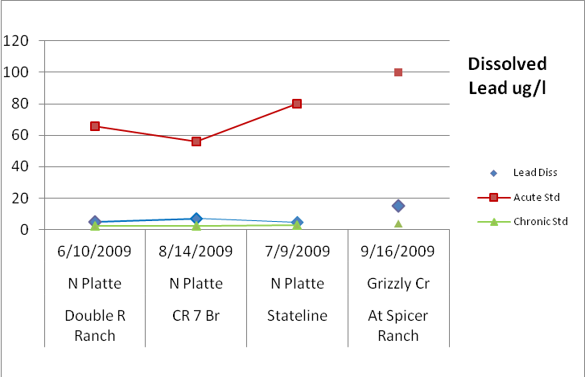

Manganese
Dissolved Manganese levels at all sites are below 44 ug/l, far from approaching both acute and chronic standards.

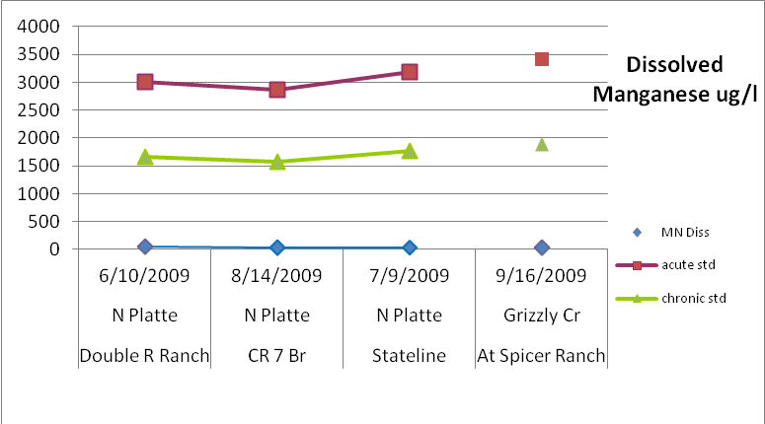

Selenium
The acute Selenium standard is 18.4; the chronic Selenium standard is 4.6. No selenium was detected at any site.

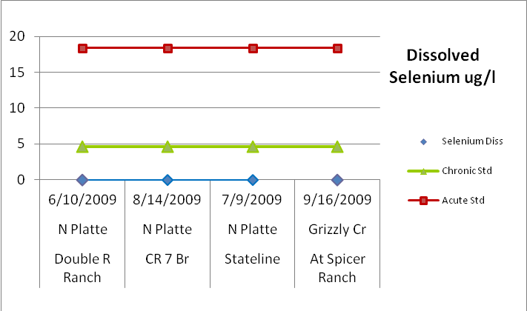

Zinc
All data points are well below both the chronic and acute standards.

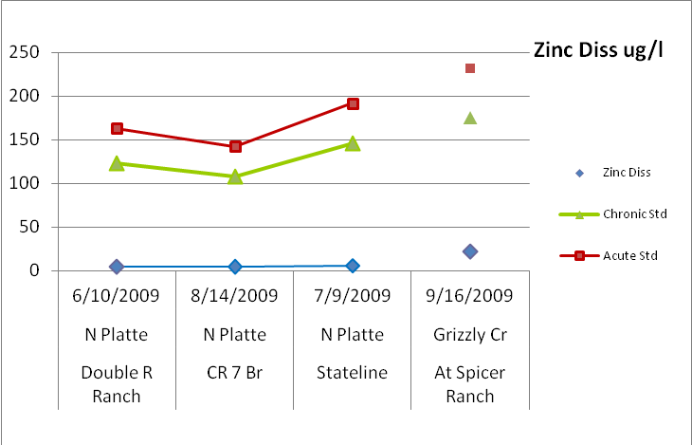

Data Availability Summary
This data set represents the mainstem of the North Platte River from the confluence of Grizzly Creek and Little Grizzly Creek to the Colorado/Wyoming border. It is important to note that there is only one data point for each station, which provides a snap shot of water quality and may or may not represent ongoing or current conditions.

Summary Parameters of Concern

Parameter | Reason
Total Phosphorus | At Spicer Ranch on Grizzly Creek exceeded the interim TP standard by 0.054 mg/l for this particular sample date. More data would be needed to gain a better knowledge of magnitude, duration, and frequency of this exceedance to determine if TP is indeed an issue at this site and will subsequently impair uses.
Iron | At Spicer Ranch on Grizzly Creek also saw an exceedance in iron for this particular sample date. Again, more data would be required to understand if iron is a habitual issue at this site, since this data only represents one data point.
Lead | All four sites saw lead diss levels slightly above their chronic standards, the greatest being At Spicer Ranch on Grizzly Creek. More data would be required to supplement this result to determine if lead is an issue at these sites.

COUCNP03.doc – January 24, 2013, Meta Report by Bill Schwan and Data Analyses by Emily Roth
\\dowdenfs01\rss\RiverWatch\Watershed Reports\WSR Webpage Archive\Colorado33&37\North Platte\COUCNP03 \Archive\Colorado33&37\COUCNP05B.doc

