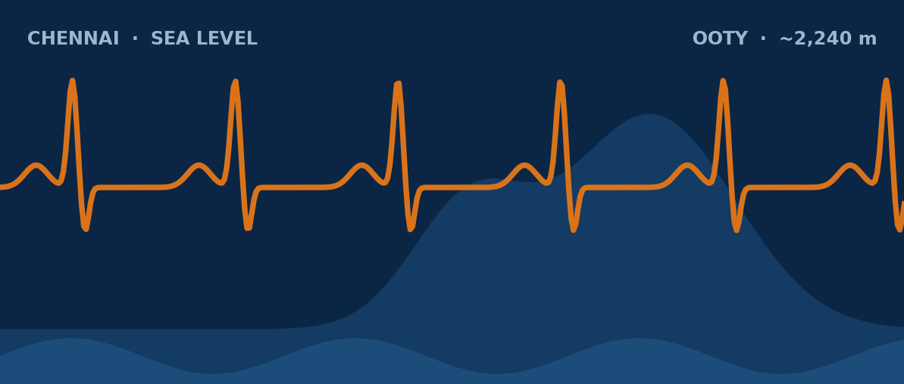
AKURA
WORLD ATHLETE RESEARCH BOOK
The AKURA Endurance Index™ (AEI)
From Myth to Measurement
MEASURE THE ATHLETE • UNDERSTAND THE BODY • BUILD THE PERFORMANCE
Complete English Edition • Indian Sports Context
KURA
AKURA Endurance Research System
Prototype Edition 0.1 • 2026

AKURA World Athlete Research Book — The AKURA Endurance Index™ (AEI): From Myth to Measurement
Complete English Edition. Prototype Edition 0.1, 2026.
© 2026 Kura / AKURA Endurance Research System. All rights reserved. No part of this publication may be reproduced without the prior written permission of the author, except for brief quotations in reviews and academic work with attribution.
AKURA, AKURA Endurance Index™, AEI and AISRi are names used by the AKURA Endurance Research System. VDOT is associated with Jack Daniels and V.O2; it is referenced for educational comparison only. Garmin and Strava are trademarks of their respective owners.
Important notice. This book is an educational and research document. It is not medical advice. The AKURA Endurance Index is a proposed research framework that has not yet been validated; its equations and categories must not be used for high-stakes selection, medical or safety decisions. Blood testing, cardiac screening, hypoxic exposure and heat-acclimation interventions should be conducted only with appropriate medical oversight and, for research, with informed consent and ethics committee approval.
Chennai, Tamil Nadu, India.
Contents

Author's Note
This book began with a practical question: when endurance athletes perform at a world-class level, which parts of that performance are inherited, which are trained, which are environment-dependent, and which can be measured and developed in an Indian athlete? It is a simple question to ask on a track at six in the morning. It is a much harder question to answer honestly.
For years I have watched runners in Chennai finish a humid long run soaked to the skin, heart rate climbing while the pace slowly falls, and then ask me what they are missing. Some have been told they need altitude. Some have been told their lungs are weak, or that they were simply not born in the right place. Some have been sold a supplement, a watch metric or a training plan that promised a shortcut. Very few have been given the one thing that actually helps: a clear way to measure what is happening in their own body, and a method for turning that measurement into a better training decision.
The purpose of this book is not to copy another country. Kenya and Ethiopia have given the world extraordinary distance runners, and there is much to learn from how those athletes live, train and progress. But learning is not copying. An Indian athlete cannot import a Rift Valley childhood, and should not have to. What an Indian athlete can do is understand the human endurance system well enough to build an evidence-led pathway for training in our own climate, on our own roads, tracks and hills, and in our own cities.
We don't have to copy their mountain. We have to understand the science behind their success.
— Kura
That sentence is the spirit of the whole project. The mountain is not the magic. The mechanisms are what matter: how oxygen is delivered and used, how heat and hypoxia challenge the body, how an athlete absorbs training load, and how performance holds up in the last ten kilometres of a marathon. Mechanisms can be studied anywhere. Many of them can be measured with tools already in a coach's hands, and others with the help of a sports-science laboratory or a sports-medicine team.
The AKURA Endurance Index (AEI) is my attempt to organise that measurement into a single, transparent research framework. I want to be clear from the first page about what it is and what it is not. It is a structured way of collecting and interpreting an athlete's performance, physiology, environment and recovery. It is not yet a validated score. It is not a replacement for established tools such as VDOT, laboratory testing or medical assessment. It is a Prototype Edition, numbered 0.1, because I expect it to be tested, corrected and improved by the athletes and coaches who use it.
I have tried to write with humility. Where the evidence is strong, I say so. Where a mechanism is plausible but unproven, I say that too. Where I am sharing coaching experience, or proposing an AKURA hypothesis, the text is labelled accordingly. If some of those hypotheses turn out to be wrong, the book will have done its job, because a wrong hypothesis that is tested properly still moves the field forward.
This book is dedicated to every Indian runner who has been told what they cannot become, and to every coach who would rather measure than guess.

How to Use This Book
This book is deliberately written in layers, so that different readers can enter at the level that suits them and then go deeper when they are ready.
The first layer explains physiology in plain language. Parts I to VI describe the question behind the book, the human endurance engine, heat, altitude, and the marathon as a systems test. You do not need a degree in physiology to follow these chapters, although sports-science students will find the concepts consistent with their textbooks.
The second layer converts physiology into measurable variables. Throughout the book, and especially in the Testing Lab and Environment sections, each idea is translated into something that can be recorded: a pace at a fixed heart rate, a haemoglobin-mass value, a sweat-loss estimate, a durability measure from a long run.
The third layer proposes the AEI research framework itself: its domains, its separation of Fitness from Readiness, its approach to normalisation, missing data and confidence, and its validation plan.
The fourth layer connects AEI to day-to-day readiness and training decisions: how a coach might use the profile to modify a session, plan a heat or altitude block, or interpret a disappointing race.
A research prototype is not presented as a proven clinical or sporting standard. Its equations and domains must be validated against athlete data before being used as a high-stakes decision system, such as team selection, return-to-play decisions or medical judgements.

Boxes you will meet
Five types of box appear throughout the chapters. Each has a specific job.
Box | Purpose
Key idea | The central point of a section in one to three sentences
Coach's corner | How to apply the idea in real training
Field protocol | A concrete, step-by-step test or session you can run
Myth vs evidence | A common belief set beside what the evidence supports
Checkpoint | Reflection questions to close each chapter

The Checkpoint questions are not a test. They are designed to be discussed between coach and athlete, or used in a classroom or team meeting.

Who this book is for
- Coaches, from school and college coaches to club and elite endurance coaches, who want to move from rules of thumb to repeatable, measured decisions.
- Athletes, especially club runners and aspiring competitive runners, who want to understand why their training works or fails and what their data is really saying.
- Sports-science students, who need a bridge between laboratory physiology and the messy reality of training in Indian heat, humidity and traffic.
- Sports-medicine staff, including physicians, physiotherapists and dietitians, who work alongside coaches and need a shared vocabulary for testing, monitoring and safety.
You can read the book from start to finish, or begin with the part most relevant to your current problem. If you are a coach preparing a Chennai marathon group, Part III on heat may be your starting point. If you are planning a camp in Ooty or Kodaikanal, begin with Part IV. Wherever you begin, return to Part I, because it explains the attitude the rest of the book depends on.

Important Scientific Boundary
Elite East African endurance performance is multifactorial. This book does not claim that nationality, ethnicity, altitude or genetics alone explains marathon success. No serious body of research supports such a single-cause explanation, and repeating it harms athletes on every side of the argument: it reduces East African champions to their birthplace and ignores the years of work behind their performances, and it tells athletes elsewhere that their ceiling has been set before they begin.
This book also does not claim that heat training is a universal substitute for altitude training. Heat and altitude are different environmental stimuli. They can overlap in some cardiovascular and performance outcomes, but their primary mechanisms differ. Where later chapters compare them, the comparison is made carefully and with explicit uncertainty.
The purpose throughout is to separate four kinds of statement that are often mixed together in coaching conversations: evidence, plausible mechanisms, coach experience and hypotheses. A statement can be useful without being proven, and a mechanism can be plausible without being the explanation for a given athlete. Keeping these categories apart is the single most important habit this book hopes to build.
Nothing in this book is medical advice. Blood tests, cardiac screening, hypoxic exposure and heat exposure all carry risks and require appropriate supervision. Any abnormal finding, symptom or concern should be referred to a qualified clinician. A coach or an algorithm should never diagnose from a watch reading, an ECG screenshot or a single blood value.
Finally, the AKURA Endurance Index is presented as an original research framework in its prototype form. It must be validated prospectively and independently before being used to make high-stakes decisions about any athlete.

Evidence Levels Used in This Book
To keep the boundary described above visible, claims in this book are written with one of five levels of confidence in mind. When the language says "research shows", it refers to the first two levels. When it says "may", "could" or "AKURA proposes", it refers to the later levels.
Level | Meaning | Example
Established evidence | Consistent findings across many studies and reviews | Heat acclimation lowers heart rate at a fixed workload
Emerging evidence | Supported by some studies; results vary or are still developing | Heat blocks improving sea-level performance in cool conditions
Plausible mechanism | Physiologically reasonable but not confirmed as the cause | Plasma expansion supporting stroke volume late in a marathon
Coach experience | Repeated practical observation, not formally tested | Runners in humid Chennai summers adapting over four to six weeks
AKURA hypothesis | A proposal of this book, awaiting validation | AEI domains improving training decisions beyond VDOT alone

Readers should expect statements to move between these levels as new research appears. That movement is a sign of a healthy science, not a weakness.

PART I — THE QUESTION
Every serious research programme begins with a well-framed question. Part I asks why some athletes reach world-class endurance, what we can honestly say about East African success, how birthplace, biology and genetics fit together, and whether Indian athletes can build comparable endurance in their own environments. It rejects both easy answers: that champions are simply born, and that a few weeks in the heat or the hills can reproduce their physiology. Instead, it sets out the AKURA method of turning coaching beliefs into measurable hypotheses, testing them in individual athletes, and accepting the result even when it disagrees with our expectations.
IN THIS PART
1 Why This Book Exists
2 The East African Marathon Question
3 Birthplace Versus Biology
4 Genetics: A Contribution, Not a Shortcut
5 Can Indian Athletes Build World-Class Endurance?
6 From Belief to Measurement
CHAPTER 1

1. Why This Book Exists
PART I — THE QUESTION
Endurance coaching is full of numbers: pace, heart rate, VO₂max, lactate, kilometres, elevation, sleep score and training load. A club runner in Bengaluru can finish a Sunday long run and receive, within a minute, a dozen metrics from a watch and an app. Yet athletes often receive a single conclusion from a complex body: "you need altitude," "your lungs are weak," "your haemoglobin is high," or "your VDOT is low." Real physiology is rarely that simple. This chapter explains why AKURA exists, and why it asks a different kind of question.
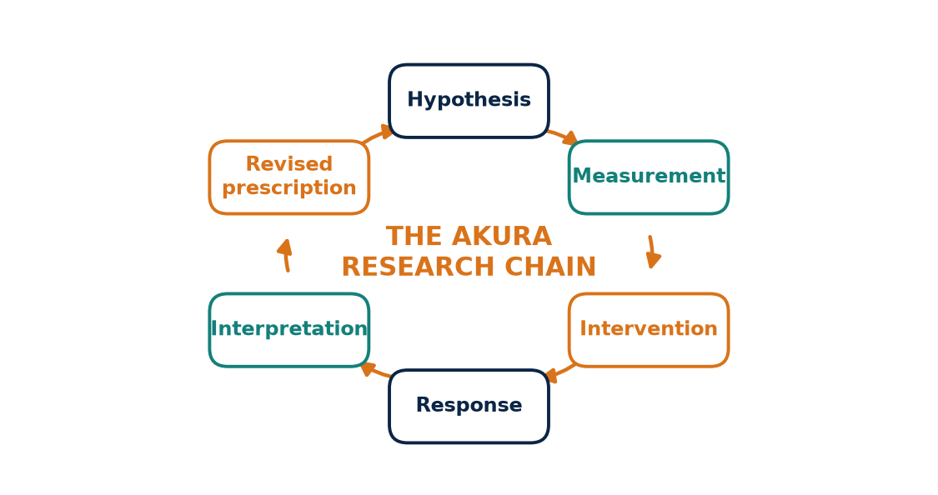
Figure 1. The AKURA research chain. Every coaching belief becomes a testable hypothesis; the loop repeats for the athlete's entire career.

Too many numbers, too few answers
The problem is not a shortage of data. Modern athletes are surrounded by it. The problem is that the data is rarely organised around a clear question, rarely collected under consistent conditions, and rarely interpreted with its limitations in view. A heart-rate value from a humid evening run in Chennai is compared directly with one from a cool morning in Ooty. A single blood test is treated as a verdict. A watch estimate of VO₂max is quoted as if it were a laboratory result.
When numbers are used this way, they do not replace the old coaching myths. They simply dress them up. "Your lungs are weak" becomes "your VO₂max is low," and the athlete is still left with a single explanation for a performance that almost certainly has several causes.
Physiologists have long described endurance performance as the product of several interacting determinants. Joyner and Coyle's 2008 review of the physiology of endurance champions, for example, framed performance around maximal oxygen uptake, the fraction of that capacity an athlete can sustain, and running economy, each shaped by further underlying factors. No single number in that model tells the whole story, and this book takes the same view.
KEY IDEA
A single number rarely explains an endurance performance. AKURA's purpose is to organise many measurements around clear questions, so that each number is interpreted in context rather than treated as a verdict.

The central AKURA question
The central AKURA question is therefore not whether one environment is magical. It is not "Is altitude better than heat?" or "Are some people simply born to run?" It is a set of four practical questions:
- Which performance determinants can be measured?
- Which of those determinants can be trained?
- How large is the individual response to training or environmental exposure?
- How should that information change the athlete's training?
These questions turn coaching from a collection of beliefs into a repeatable research process. They also protect athletes. A college runner who is told "you need altitude" may spend money and weeks away from home on a camp that does not address the actual limitation. A runner whose real problem is late-race durability or fuelling will not be helped by chasing a higher haemoglobin value.
MYTH VS EVIDENCE
Myth: My watch says my VO₂max is low, so that is why my marathon is slow.
Evidence: A watch estimate is an indirect calculation, and even a laboratory VO₂max is only one determinant. Marathon performance also depends on economy, sustainable intensity, fuelling, heat and durability.

The AKURA research chain
The book uses a simple chain that appears again and again in later chapters:
hypothesis → measurement → intervention → response → interpretation → revised prescription
A good coach may start with intuition. Experienced coaches often see patterns long before they can explain them, and that intuition is valuable. But intuition is where the process starts, not where it ends. A good research system must finish with data. The coach's hunch becomes a hypothesis; the hypothesis is tested with a defined measurement; an intervention is applied; the athlete's response is recorded; the result is interpreted honestly; and the training prescription is revised.
Step | Question it answers | Example
Hypothesis | What do we think is happening? | Heat is limiting this runner's long runs
Measurement | What will we record? | Pace, HR, body-mass loss, WBGT
Intervention | What will we change? | A 10–14 day heat block
Response | What happened? | HR at fixed pace fell by a measurable amount
Interpretation | What does it mean? | A heat response, not proof of elite status
Revised prescription | What do we do next? | Adjust summer long-run pacing

The chain is repeated for the athlete's entire career. Each cycle makes the athlete more understandable to themselves and their coach, which is ultimately what the AKURA Endurance Index is for.
COACH'S CORNER
Before you give an athlete an explanation, write it down as a hypothesis and name one measurement that could prove it wrong. If you cannot name such a measurement, you are holding a belief, not a coaching conclusion. Share the hypothesis with the athlete so they understand why they are being tested.

Why an Indian research system
Most of the physiology behind endurance performance was first described in laboratories in Europe and North America, and later refined through studies of East African runners. Those findings are valuable, but Indian athletes train in conditions that are rarely studied: monsoon humidity, coastal heat, dense urban traffic, school and college schedules, and hill stations that offer moderate rather than high altitude. A research system built in India can collect local, longitudinal data rather than assuming that findings from elsewhere will transfer unchanged.
That is why this book exists: not to announce a new truth, but to provide a structured way of finding out what is true for each athlete.
CHECKPOINT
Think of the last explanation you gave, or were given, for a poor race. Was it a single cause? What measurement could have tested it, and what else might have contributed?

CHAPTER 2

2. The East African Marathon Question
PART I — THE QUESTION
Kenyan and Ethiopian runners have produced a remarkable body of elite distance-running performances, from Olympic medals on the track to world records on the roads. It is tempting to explain that success with one sentence: "they are born for running." That sentence is too small for the problem. This chapter explains why, and how AKURA uses the East African example as a source of questions rather than a stereotype.
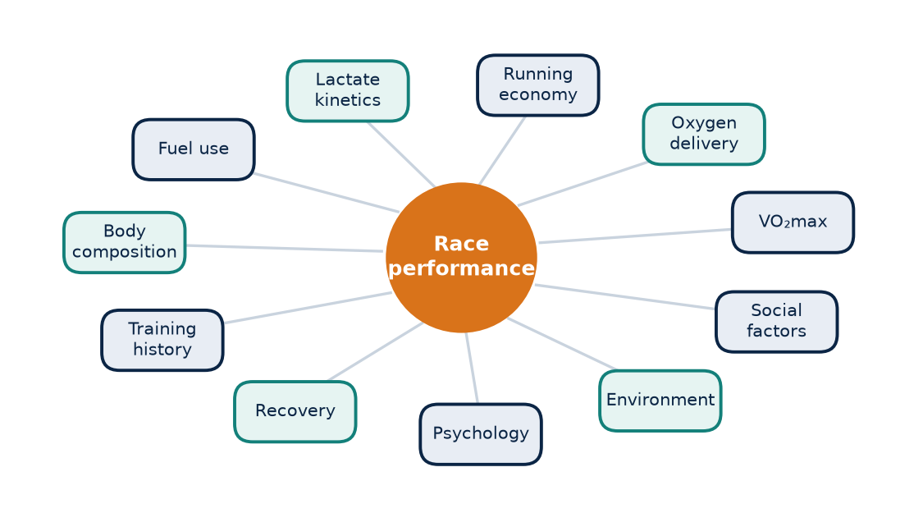
Figure 2. Elite endurance performance emerges from many interacting systems. No single factor, including birthplace or genetics, explains it alone.

A performance built from many systems
Performance is the result of interacting systems: maximal oxygen uptake, oxygen delivery, running economy, lactate kinetics, substrate use, body composition, training history, recovery, psychology, environment and social factors. Any explanation that picks one of these and ignores the rest will be incomplete.
Researchers have studied this question for decades. Saltin and colleagues' studies of Kenyan and Scandinavian runners in the 1990s compared aerobic capacity and muscle characteristics and did not find that a single variable such as maximal oxygen uptake explained the performance gap. Later reviews, including Wilber and Pitsiladis's 2012 paper on why Kenyan and Ethiopian runners are so successful, concluded that the answer is multifactorial, involving physiological and biomechanical traits, the training environment, a culture of running, and strong socio-economic motivation, with no convincing evidence that a specific genetic profile explains the dominance.
KEY IDEA
East African distance-running success is best understood as the interaction of many physiological, environmental, training and social factors. No single cause, including birthplace, altitude or genetics, is sufficient to explain it.

Altitude is part of the story, not the whole story
Many successful East African runners live and train at moderate altitude, and altitude exposure may contribute for some athletes. But living at altitude is not the same thing as possessing a permanent physiological advantage. Adaptations to altitude, such as changes in haemoglobin mass, depend on the dose of exposure, iron availability and the individual, and some of them fade after return to lower elevation.
It is also worth noting what altitude comes bundled with. Training camps in the Kenyan and Ethiopian highlands often combine high training volume, group training with other strong runners, soft trails, simple routines and a strong focus on running as a career. Separating the effect of the altitude from the effect of everything else is extremely difficult.
Factor | What it may contribute | How confident are we?
Training volume and history | Aerobic development over many years | Established as important
Running economy | Lower oxygen cost at race pace | Emerging, varies by study
Altitude exposure | Possible oxygen-transport adaptations | Plausible, individual
Group and camp culture | Consistency, motivation, pacing partners | Coach experience
Socio-economic motivation | Commitment and depth of talent pool | Discussed in reviews
Specific genes | Uncertain contribution | Not demonstrated as decisive

MYTH VS EVIDENCE
Myth: East Africans win because they are born at altitude.
Evidence: Altitude may help some athletes, but many runners born at altitude elsewhere in the world do not become elite, and the evidence points to a combination of training, environment, economy, culture and individual biology.

A source of questions, not a stereotype
AKURA treats the East African model as a source of questions, not a stereotype. Instead of asking "What are they?", it asks "What do they do, and what might it change?" For example:
- How much easy running do successful East African athletes accumulate over years, and at what intensity?
- How does running on soft, hilly terrain influence economy and resilience?
- How do group training and simple daily routines support consistency and recovery?
- What changes in oxygen transport, if any, occur with the altitude doses they experience?
Each of these can become an AKURA research question for Indian athletes. If an adaptation can be measured, it should be measured. If it cannot yet be separated from confounding factors, the correct scientific answer is uncertainty. That answer may feel unsatisfying, but it is more honest, and more useful, than a confident myth.
COACH'S CORNER
When an athlete brings up the "born to run" idea, redirect the conversation to what can be copied: consistent easy volume, group training, patient progression and good recovery. These are available in Chennai, Bengaluru or a small-town college ground, and they are among the most transferable lessons from successful endurance cultures.

CHECKPOINT
List three habits from successful endurance cultures that your athletes could adopt this season. Which of them could you measure, and which would you have to observe more informally?

CHAPTER 3

3. Birthplace Versus Biology
PART I — THE QUESTION
A birthplace can influence an athlete's developmental environment without being a biological destiny. Where a child grows up shapes how much they move, what they eat, how far they walk or run to school, what sport they see around them and what opportunities they receive. These are real influences. But they are not the same as a fixed biological ceiling, and confusing the two leads to poor coaching decisions.

Environment during development
A person raised at altitude may experience repeated hypoxic exposure over many years, alongside whatever physical activity their daily life involves. Another person may develop exceptional endurance through years of running, an active childhood, good nutrition, sound coaching and selection into strong training groups. Both routes can produce a highly capable endurance athlete. Only one of them depends on geography.
It is also important to remember selection. Every elite athlete who emerges from any region is the survivor of a large pool of young people who tried the sport. When we look only at the winners, it is easy to credit the place rather than the process that filtered and developed them.
KEY IDEA
Birthplace shapes the developmental environment, but it is not a biological destiny. Most of the factors that build endurance, such as training history, active childhood, nutrition and coaching, can be developed in many places.

What this means in India
This distinction matters in India. Athletes in Chennai, Bengaluru, Delhi or coastal towns should not be told that world-class endurance is impossible because they were not born in a mountain region. That message is both scientifically weak and practically damaging, because it discourages young athletes before they have had a chance to develop.
Conversely, they should not be promised that a few weeks of heat or altitude will reproduce the complete physiology of an elite East African athlete. A two-week hill camp in Kodaikanal, or a summer of humid running in Chennai, may produce useful and measurable adaptations. It will not recreate years of development, and it should not be sold as if it could.
Statement | Why it is a problem | A better framing
You were not born at altitude, so forget the marathon | Treats birthplace as a ceiling | Let us measure what you can develop
Two weeks in Ooty will make you like a Kenyan | Overpromises a short exposure | Let us test your response to a defined dose
Chennai heat is the same as altitude | Confuses different stimuli | Heat and altitude produce different adaptations
Your background decides your potential | Ignores training history | Your trend over time will tell us more

MYTH VS EVIDENCE
Myth: Athletes from the plains cannot reach high endurance levels.
Evidence: Endurance is built through years of training, nutrition, recovery and coaching. Geography can shape opportunities, but it does not set a fixed biological limit for any individual.

A narrower, more useful objective
The research objective is narrower and more useful: identify modifiable determinants, quantify them, and build the training environment around the individual response. Modifiable determinants include aerobic fitness, running economy, threshold, durability, heat tolerance, iron status (under clinical supervision), body composition, strength and recovery habits. Each can be measured to some degree, and each can respond to training or environmental change.
FIELD PROTOCOL
1. Development history interview for a new athlete
2. Record where the athlete grew up and the approximate elevation
3. Ask how active their childhood was, including walking or cycling to school and other sports
4. Record years of structured running and typical weekly volume in each year
5. Note current training environment, temperature and humidity range
6. Store these answers in the athlete's baseline file as context, not as a score

COACH'S CORNER
Use background information to understand the athlete, never to label them. A school runner from a coastal town with little childhood sport simply has a shorter training history, which usually means more room for development, not less potential.

CHECKPOINT
What assumptions have you made about an athlete based on where they come from? Which modifiable determinants could you measure instead?

CHAPTER 4

4. Genetics: A Contribution, Not a Shortcut
PART I — THE QUESTION
Genetics can influence endurance-related traits. Differences between people in heart size, muscle-fibre composition, trainability and many other characteristics have some inherited component. But a simple national or ethnic genetic explanation is not a sufficient model of elite performance. This chapter explains why genetic arguments are harder than they appear, and why AEI deliberately leaves genetics out of the score.

Why genetic explanations are difficult
Genetic studies of endurance performance face four major problems.
- Performance is polygenic. Endurance depends on many traits, each influenced by many genes with small individual effects. There is no single "endurance gene".
- Populations are heterogeneous. A country or broad ethnic group contains enormous genetic diversity, often more within the group than between groups.
- Environmental exposure is entangled with ancestry. People who share ancestry often share environments, diets, activities and cultures, which makes it very difficult to separate genetic effects from environmental ones.
- Elite selection is strong. Elite athletes are an extremely filtered group, so comparisons between champions and the general population can exaggerate or distort genetic signals.
Family and training studies show that genetics matters in a more individual way. The HERITAGE Family Study led by Bouchard and colleagues found that people given the same standardised endurance-training programme showed very different improvements in VO₂max, and that the size of the response clustered within families. In other words, inherited factors may influence how much an individual responds to training, but the only way to know an individual's response is to train and measure them.
KEY IDEA
Genetics contributes to endurance traits and to how strongly individuals respond to training, but it cannot be read from nationality or ethnicity. An athlete's ceiling must be observed through testing, not assumed from background.

The practical coaching rule
For coaching, the practical rule is straightforward: do not infer an athlete's physiological ceiling from nationality. Test the athlete. Measure performance and physiology longitudinally, over months and seasons rather than a single test day.
When a trait is strongly inherited or poorly trainable, that is still useful information. For example, if repeated testing over two years shows that an athlete's VO₂max has changed very little while their economy and threshold have improved considerably, the coach can shift attention towards the qualities that are still moving. But this conclusion must be demonstrated, not assumed. It comes from the athlete's own data, not from a stereotype about a group.
MYTH VS EVIDENCE
Myth: A genetic test can tell you whether you should be a marathon runner.
Evidence: Current consumer genetic tests cannot reliably predict endurance performance or talent. Performance depends on many genes and on years of training and environment; longitudinal testing of the athlete is far more informative.

COACH'S CORNER
If an athlete asks whether they have the right genes, answer honestly: nobody can tell from a spit test or a surname. Then show them their trend data, such as easy pace at a fixed heart rate over the last six months. Trainability is revealed by training, and the trend is the athlete's own evidence.

Why AEI excludes genetics from the score
AEI therefore treats genetic explanations as background context rather than a score component. A score should reward what can be observed, measured and validated. Including a genetic or ancestry component would introduce three problems: it would reward something the athlete cannot change, it would rest on weak predictive evidence, and it could reinforce the very stereotypes this book rejects.
Type of information | Role in AEI | Reason
Race performance | Primary anchor | Directly observed and meaningful
Physiological tests | Supporting domains | Measurable and repeatable
Training response over time | Trend and confidence | Shows trainability in the individual
Family or ancestry information | Not scored | Weak prediction, risk of stereotyping
Consumer genetic tests | Not scored | Not validated for performance prediction

This does not mean genetics is unimportant for science. Research into how genes influence training response is valuable and will continue. It means that for coaching an individual athlete, measured response is more useful than inferred potential.
CHECKPOINT
Which of your athletes has improved most over the last year? Would you have predicted that from their background? What does their trend tell you that a prediction could not?

CHAPTER 5

5. Can Indian Athletes Build World-Class Endurance?
PART I — THE QUESTION
Yes, athletes can develop very high endurance performance in India, but the route is individual. There is no single Indian formula, just as there is no single East African one. What India offers, perhaps more than most countries, is variety: a wide range of climates and elevations within reach of most athletes. This chapter describes that variety and reframes the national question as an individual one.

India as a natural laboratory
India contains hot and humid coastal environments, warm inland climates, cool highlands and substantial altitude zones. This creates a natural research laboratory. An athlete can, within a day's travel, move from sea-level humidity to a cooler hill station, or from a dry inland city to a coastal one.
Chennai can provide repeated heat and humidity exposure for much of the year. Bengaluru, at roughly 900 metres above sea level, provides a different climate and elevation profile, with generally milder temperatures. Ooty and Kodaikanal in the Western Ghats sit at roughly 2,000 metres or more and provide access to higher elevation and cooler conditions. The Himalayan regions offer considerably higher altitude, with correspondingly greater physiological and safety demands.
Environment | Typical stimulus | Research use | Main caution
Chennai (coastal) | Heat and high humidity | Heat and humidity adaptation | Heat illness, dehydration
Bengaluru (plateau) | Milder climate, modest elevation | Quality training, comparison | Not a strong hypoxic dose
Ooty / Kodaikanal (hills) | Moderate altitude, cooler air | Altitude response studies | Dose depends on sleep altitude
Himalayan regions | High altitude | Specialist hypoxia research | Requires medical oversight

KEY IDEA
India's range of climates and elevations is a genuine research asset. But these environments are not interchangeable, and each produces a different stimulus that must be defined and measured.

Environments are not interchangeable
These environments are not interchangeable, and the useful stimulus depends on the athlete, the season, the dose and recovery. A Chennai summer and a Chennai December are very different heat exposures. A week in Kodaikanal during the monsoon brings rain and cool temperatures along with the elevation. An athlete who travels overnight by bus to a hill station starts the camp with poor sleep, which can blunt the benefit of the first days.
The dose also matters. Spending a weekend in Ooty is not the same as sleeping there for three weeks. Running one humid long run is not the same as a structured, progressive heat-acclimation block. Later chapters on heat and altitude describe how to record the dose properly, but the principle begins here: name the stimulus, measure the dose, and record the response.
FIELD PROTOCOL
1. Environment log for any training block
2. Record location and approximate elevation of sleeping and training sites
3. Log temperature and relative humidity for key sessions, or WBGT if available
4. Note total days and nights spent in the environment
5. Record sleep duration and quality daily
6. Note travel, illness and any change in diet or routine

MYTH VS EVIDENCE
Myth: Training in Chennai heat is the same as training at altitude.
Evidence: Heat and altitude challenge the body in different ways. Heat mainly stresses thermoregulation and fluid balance; altitude reduces the pressure of inspired oxygen. Some outcomes may overlap, but the primary adaptations differ.

From a national question to an individual one
The research question is therefore not "Can India produce elite runners?" It is "Which combination of training, environment, recovery and athlete characteristics produces the best response for this athlete?"
This framing matters because national questions invite national answers, and national answers invite stereotypes. Individual questions invite measurement. A college athlete in Coimbatore, a club runner in Bengaluru and a school runner in a coastal town will each respond differently to the same plan. The goal of AEI is to learn those differences and use them.
COACH'S CORNER
Before planning a hill camp or a summer heat block, write down the specific adaptation you want, the measurement you will use before and after, and how you will control for travel, sleep and training load. If you cannot write those three things, the camp is a holiday with running, not an intervention.

CHECKPOINT
What environments can your athletes realistically access within a season? For each one, what adaptation would you target, and how would you know if it happened?

CHAPTER 6

6. From Belief to Measurement
PART I — THE QUESTION
Every coach holds beliefs about training. Many of them are valuable, built from years of watching athletes succeed and fail. But a belief only becomes useful knowledge when it can be tested. This chapter explains how a coaching belief becomes a research hypothesis, what every AKURA intervention must define, and why accepting an unwelcome result is the most important discipline in the whole system.

Turning a belief into a hypothesis
A coach's belief becomes a research hypothesis when it is stated in measurable terms. "Heat makes you stronger" is vague. It does not say what "stronger" means, how much heat, for how long, or how the change would be detected. "A 10–14 day controlled heat-acclimation block increases plasma volume and lowers heart rate at a fixed submaximal workload" is testable. It names the dose, the expected adaptations and the measurements that could confirm or refute them. It is also consistent with the heat-acclimation literature, which, as reviewed by Périard, Racinais and Sawka in 2015, describes lower exercise heart rate and plasma-volume expansion among the adaptations to repeated heat exposure, while noting that the size of response varies.
Vague belief | Testable hypothesis
Heat makes you stronger | A 10–14 day heat block lowers HR at a fixed pace by a measurable amount
Hill camps build lungs | Two weeks sleeping in Ooty changes Hb mass, measured before and after
Long runs build endurance | Eight weeks of progressive long runs reduce late-run pace decline
Strength work makes you faster | Twice-weekly strength training improves economy at marathon pace

KEY IDEA
A belief becomes useful when it is written as a testable hypothesis: a defined intervention, a named measurement and an expected direction of change.

What every AKURA intervention must define
Every AKURA intervention should define six elements before it begins:
- Baseline: the athlete's current performance and relevant physiology, measured under recorded conditions.
- Exposure dose: what the intervention is, how long it lasts, and how intense it is, such as temperature, humidity, altitude and hours of exposure.
- Performance test: a standardised test that will be repeated, such as a fixed-pace run or a time trial.
- Physiological markers: the variables expected to change, such as heart rate at a fixed pace, body-mass loss or haemoglobin mass.
- Timing of the post-test: when the repeat test will occur, since some adaptations appear quickly and others take weeks.
- Possible confounders: other factors that could explain any change.
Confounders are where many coaching conclusions quietly fail. If the athlete sleeps less, loses weight, changes caffeine intake or suddenly adds mileage during the intervention, the interpretation becomes weaker. A runner who improves after a hill camp may have improved because of the altitude, or because they slept ten hours a night away from college exams, or because the camp included more total running. Recording these factors does not remove them, but it keeps the interpretation honest.
Measurement error must also be respected. Every test has some natural variation from day to day. Hopkins's widely used work on reliability in sports science emphasised that a change smaller than a test's typical error should not be interpreted as a real adaptation. A two-beat drop in heart rate on a single humid morning may be noise.
FIELD PROTOCOL
1. Standard fixed-pace heart-rate test
2. Choose a flat, measured route or track and a pace the athlete finds comfortable
3. Test at the same time of day, after a similar previous day and similar breakfast
4. Warm up for 10 minutes, then run 20 minutes at the fixed pace
5. Record average HR for the final 10 minutes, plus temperature, humidity and body mass before and after
6. Repeat on two separate days at baseline to see normal variation before comparing with post-intervention results

Accepting results that disagree with you
The most important discipline is to accept a result that disagrees with the coach's expectation. It is natural to want the heat block to work, the hill camp to pay off or the new plan to succeed. But if the heart rate at a fixed pace does not change, or haemoglobin mass stays the same, that is information. It may mean the dose was too small, the measurement too noisy, or the athlete not a strong responder to that particular stimulus. Each of those is worth knowing.
Data that proves a hypothesis wrong is still valuable data. It saves the athlete from repeating an intervention that does not help them, and it pushes the coach towards a better question. Over time, a record of honest results, positive and negative, becomes the athlete's most valuable coaching asset.
MYTH VS EVIDENCE
Myth: If the test did not show improvement, the test was wrong.
Evidence: Sometimes a test is poorly controlled, which is why protocols matter. But often a null result is real. Accepting it, and asking why, is how coaching knowledge improves.

COACH'S CORNER
Keep a simple intervention log for each athlete: the hypothesis, the dose, the before-and-after results and your honest interpretation. Review it at the end of each season with the athlete. You will quickly see which interventions consistently help that individual and which were based on hope.

CHECKPOINT
Choose one belief you hold about training. Rewrite it as a testable hypothesis with a dose, a measurement and possible confounders. What result would convince you that you were wrong?

PART I AT A GLANCE
The key idea from each chapter, for quick revision.
1 | Why This Book Exists  A single number rarely explains an endurance performance. AKURA's purpose is to organise many measurements around clear questions, so that each number is interpreted in context rather than treated as a verdict.
2 | The East African Marathon Question  East African distance-running success is best understood as the interaction of many physiological, environmental, training and social factors. No single cause, including birthplace, altitude or genetics, is sufficient to explain it.
3 | Birthplace Versus Biology  Birthplace shapes the developmental environment, but it is not a biological destiny. Most of the factors that build endurance, such as training history, active childhood, nutrition and coaching, can be developed in many places.
4 | Genetics: A Contribution, Not a Shortcut  Genetics contributes to endurance traits and to how strongly individuals respond to training, but it cannot be read from nationality or ethnicity. An athlete's ceiling must be observed through testing, not assumed from background.
5 | Can Indian Athletes Build World-Class Endurance?  India's range of climates and elevations is a genuine research asset. But these environments are not interchangeable, and each produces a different stimulus that must be defined and measured.
6 | From Belief to Measurement  A belief becomes useful when it is written as a testable hypothesis: a defined intervention, a named measurement and an expected direction of change.

PART II — THE HUMAN ENDURANCE ENGINE
Before we can measure an endurance athlete, we have to understand what we are measuring. Part II opens the engine. It follows oxygen from the air of a Chennai beach road or an Ooty hillside into the lungs, across into blood, around the body on haemoglobin, through the heart and into the working muscle, where mitochondria turn fuel into movement. Each chapter takes one link of that chain, explains its physiology in plain language, separates evidence from myth, and shows how it becomes a variable inside the AKURA Endurance Index. The lesson throughout is the same: no single number is the athlete.
IN THIS PART
7 The Endurance System as a Chain
8 The Heart: Pump, Not Just Heart Rate
9 The Lungs and the Oxygen Myth
10 Haemoglobin Mass
11 Plasma Volume
12 Red Blood Cells and Erythropoiesis
13 VO₂max
14 Running Economy
15 Mitochondria and Muscle Oxygen Use
16 Lactate Is a Messenger
17 Lactate Threshold
18 Fuel, Glycogen and Fat Oxidation
CHAPTER 7

7. The Endurance System as a Chain
PART II — THE HUMAN ENDURANCE ENGINE
Distance running is, at its core, an oxygen-and-energy delivery problem expressed through movement. A marathon runner leaving the Marina at dawn is solving that problem thousands of times a minute. Air must reach the lungs; oxygen must cross into the blood; haemoglobin must carry it; the heart must circulate that blood; the working muscle must receive the oxygen; mitochondria must use it, together with carbohydrate and fat, to generate ATP; and finally the athlete must convert that chemical energy into forward motion with as little waste as possible. Every one of those steps is a link. Performance is what happens when all the links work together under the stress of pace, distance, heat and fatigue.
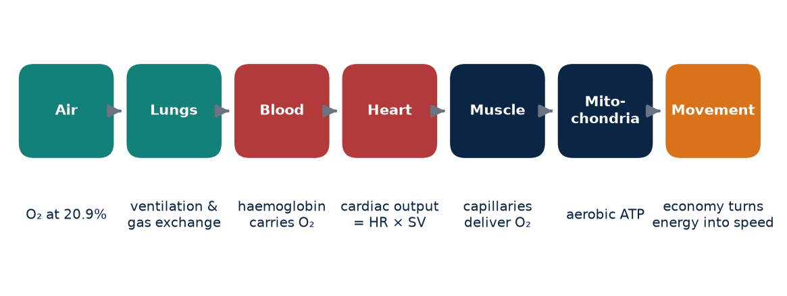
Figure 3. The endurance chain. A limitation at any link can affect performance, but improving one link does not guarantee a faster race.

Following the oxygen
It helps to picture the chain in order, because each link has its own physiology, its own measurement and its own way of failing.
Link | What it does | Typical measure | Common confounder
Ventilation and lungs | Moves air and exchanges gas | Ventilation, SpO₂, spirometry | Altitude, airway conditions
Blood | Carries oxygen on haemoglobin | Hb mass, [Hb], ferritin | Plasma volume, hydration
Heart | Pumps blood to tissues | HR, stroke volume, cardiac output | Heat, dehydration, fatigue
Muscle and mitochondria | Extracts and uses oxygen | Lactate, muscle oxygenation, biopsy | Glycogen, training state
Mechanics | Turns energy into speed | Running economy, cadence, GCT | Footwear, surface, fatigue

The table is a simplification. In the living athlete these links interact continuously: a change in plasma volume alters the heart's filling, which alters stroke volume, which alters oxygen delivery, which alters how hard the muscle must work at a given pace. That interdependence is exactly why the chain metaphor is useful. It reminds us that the body does not have a single "fitness" dial.

Weak links and false promises
A limitation at any link can influence performance. An athlete with low iron stores may struggle to build haemoglobin; an athlete with poor mechanics may waste oxygen on vertical bounce; an athlete who has not practised race fuelling may run out of carbohydrate at 32 km regardless of how strong the heart is. In each case the weak link sets the ceiling on the day.
The opposite is also true, and it is where many coaching myths begin. Improving one link does not guarantee an improvement in race time. Plasma expansion after a block of heat training may increase stroke volume, yet the athlete still needs economical mechanics and sustainable metabolic control to turn that extra blood flow into faster kilometres. A higher VO₂max measured in a laboratory is encouraging, but if the athlete's economy has worsened because of a new shoe or an injury compensation, the race result may not move. The chain is only as useful as its weakest working link at the moment of competition.
KEY IDEA
Endurance performance is a chain of linked systems, from air to ATP to forward motion. Strengthening one link helps only if it is, or becomes, the link that limits the athlete.

MYTH VS EVIDENCE
Myth: One magic variable, such as VO₂max or haemoglobin, explains why some runners are faster.
Evidence: Performance emerges from several interacting systems; similar values in one link can coexist with very different race results because other links differ.

Why AEI is a profile, not a single dial
This is the reason the AKURA Endurance Index avoids a single-variable model. AEI is designed as a multidimensional profile with a performance anchor. The profile records the state of several links, such as cardiovascular response, blood markers where available, economy, threshold and fuelling behaviour. The anchor is real performance: a time trial, a race or a standardised field test. The profile helps explain the anchor; the anchor keeps the profile honest. If the physiology improves but performance does not, AEI should flag the mismatch rather than hide it.
For Indian coaches this matters practically. Many squads will have access to heart-rate monitors and GPS watches but not to carbon-monoxide rebreathing or laboratory gas analysis. A chain model lets the coach be explicit about which links are measured, which are estimated and which are unknown, instead of pretending that a watch's single "fitness score" captures the whole athlete.
The chain also has a time dimension. Some links adapt within days, such as plasma volume at the start of a training block or after the first week of heat exposure. Others, such as mitochondrial content and capillary density, build over weeks and months. Red-cell mass responds over weeks and depends on iron and the stimulus. Mechanics and economy may take years of consistent running and strength work. A coach who expects every link to respond on the same schedule will misread the data. AEI therefore records not only what was measured, but when, so that fast and slow adaptations can be separated and a short-term change is not mistaken for a long-term one.
COACH'S CORNER
When an athlete stalls, walk the chain before changing the plan. Ask which link is most likely limiting now: sleep and recovery, iron and blood, heat load, mechanics, threshold or fuelling. Change one major variable at a time so you can see what actually moved.

CHECKPOINT
For one athlete you coach, list the five links in the table above. Which ones do you currently measure, which do you estimate from feel, and which are completely unknown?

CHAPTER 8

8. The Heart: Pump, Not Just Heart Rate
PART II — THE HUMAN ENDURANCE ENGINE
Heart rate is the most familiar number in endurance sport. It sits on every wrist, it is cheap to record and it responds quickly to effort, heat and stress. It is a genuinely useful field signal. But it is not the heart's entire story. The heart is a pump, and what matters for oxygen delivery is how much blood it moves each minute, not simply how often it beats.
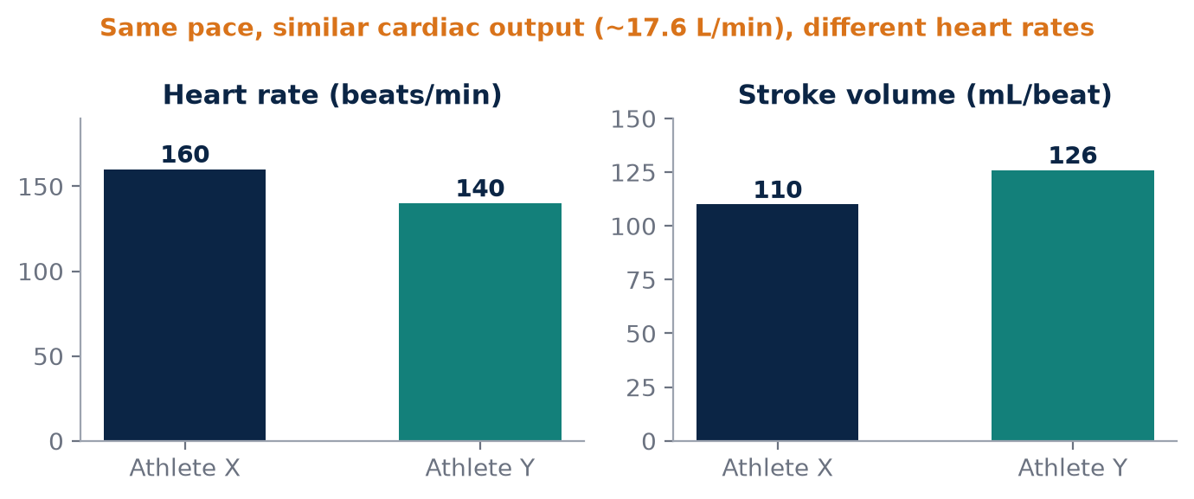
Figure 4. Illustrative example: cardiac output = heart rate × stroke volume. A larger stroke volume lets Athlete Y deliver similar blood flow at a lower heart rate.

Cardiac output and the Fick principle
Cardiac output is the volume of blood the heart pumps per minute. It equals heart rate multiplied by stroke volume, the volume ejected with each beat. The oxygen the body consumes is then described by the Fick principle: oxygen uptake equals cardiac output multiplied by the difference in oxygen content between arterial and mixed venous blood. In words, the body's oxygen use depends on how much blood is delivered and how much oxygen the tissues take out of each litre.
Quantity | Formula or meaning | Illustrative range (varies widely)
Cardiac output (CO) | HR × stroke volume | About 5 L/min at rest; can exceed 30 L/min in elite endurance athletes at maximum
Stroke volume (SV) | Blood ejected per beat | Often 60–100 mL at rest; larger in trained hearts
a–vO₂ difference | Arterial minus venous O₂ content | Rises from about 50 mL/L at rest to well over 100 mL/L in hard exercise
VO₂ (Fick) | CO × a–vO₂ difference | Whole-body oxygen uptake

These values are illustrative only; they differ with body size, sex, training status, posture and measurement method. The principle, however, is robust. Two athletes can share the same heart rate at the same pace while delivering very different amounts of oxygen, because one has a larger stroke volume or extracts more oxygen at the muscle.
KEY IDEA
Cardiac output = heart rate × stroke volume, and oxygen uptake = cardiac output × oxygen extraction. Heart rate is only one of the terms.

Why the same pace feels different
This explains a common coaching observation. During endurance training an athlete may improve performance while running at a similar heart rate, because more blood is pumped per beat or because the muscles extract oxygen more effectively. Conversely, the same pace can feel very different on a cool Bengaluru morning and a humid Chennai evening.
Heat can reduce effective stroke volume in two ways. First, blood is shifted toward the skin to release heat, so a larger share of cardiac output is diverted away from working muscle and less blood returns to fill the heart. Second, sweating reduces plasma volume, which again lowers filling. To maintain cardiac output with a smaller stroke volume, heart rate rises. Physiologists describe the gradual upward drift of heart rate during prolonged exercise as cardiovascular drift, and heat and dehydration make it larger. Endurance training and heat acclimation can improve plasma volume and cardiac function, helping to maintain circulation under the same conditions.
MYTH VS EVIDENCE
Myth: A lower heart rate at the same pace always means the athlete is fitter.
Evidence: It often does, but it can also reflect cooler weather, better hydration, a different course or even a sensor error. Context is required before interpreting the change.

Recording heart rate properly in AEI
Because heart rate responds to so many inputs, AEI should store HR together with pace, temperature, humidity when available, body mass change and perceived effort, rather than treating HR as a standalone score. A 150 bpm run at 5:00 per km in 24 °C is not the same physiological event as a 150 bpm run at the same pace in 32 °C with high humidity. Stored with context, the two sessions become comparable; stored alone, they mislead.
Wrist-based optical sensors are convenient but can be inaccurate during intervals, in heavy sweat or with loose straps. Chest straps are usually more reliable for training analysis. Where exact stroke volume or cardiac output measurement is needed, that is laboratory or clinical work and should be done by qualified staff. Any unusual symptom such as chest pain, fainting or palpitations during exercise is a medical matter for a doctor, not a coaching variable.
FIELD PROTOCOL
1. Standardised submaximal HR check
2. choose a flat, familiar 2–3 km loop
3. warm up 10 minutes easy
4. run 3 × 1 km at a fixed pace (for example marathon pace) with 1 minute standing rest
5. record average HR of the last 30 seconds of each rep, air temperature, humidity, time of day and RPE
6. weigh the athlete before and after in minimal clothing
7. repeat every 2–4 weeks under similar conditions.

COACH'S CORNER
Do not change training zones on the basis of a single hot-day heart-rate reading. Look for trends in HR at fixed pace across several comparable sessions, and always note the weather and the athlete's sleep and hydration beside the number.

CHECKPOINT
On your athlete's last three easy runs, was the heart rate different because the athlete changed, or because the conditions changed? What data would let you tell the difference?

CHAPTER 9

9. The Lungs and the Oxygen Myth
PART II — THE HUMAN ENDURANCE ENGINE
Few ideas in endurance sport are repeated as confidently, or as inaccurately, as "there is less oxygen at altitude" and "hill running builds bigger lungs". Both contain a grain of truth wrapped in a misunderstanding. Getting the physics and physiology right matters, because a coach who misunderstands the stimulus will misjudge the dose.

Percentage versus pressure
The percentage of oxygen in normal atmospheric air is approximately 20.9% at sea level and remains approximately the same at altitude. The air in Ooty or Kodaikanal contains the same proportion of oxygen as the air in Chennai. What changes substantially with altitude is barometric pressure. Because the total pressure is lower, the partial pressure of oxygen falls, and it is partial pressure that drives oxygen from the lungs into the blood. A lower driving pressure reduces how readily oxygen loads onto haemoglobin, particularly during hard exercise when blood moves quickly through the lung capillaries.
At moderate altitudes of around 2,000–2,500 m, inspired oxygen pressure is roughly a quarter lower than at sea level. The body responds within minutes by breathing more, and over days to weeks with further adaptations. Performance in longer events is usually reduced at altitude, particularly on arrival.
MYTH VS EVIDENCE
Myth: There is less oxygen in the air at altitude.
Evidence: The fraction of oxygen stays about 20.9%. The barometric pressure falls, so the partial pressure of oxygen, and therefore the pressure pushing oxygen into the blood, is lower.

KEY IDEA
Altitude is a pressure stimulus, not a percentage stimulus. The same 20.9% oxygen at lower pressure means a lower partial pressure of oxygen and less driving force for gas exchange.

What hill running really trains
Hill running can make breathing harder because ventilation rises with workload, and it rises further at altitude. Repeated training can strengthen the respiratory muscles and improve tolerance to high ventilation. Hills also load the calves, quadriceps and hip extensors, and they can be a valuable tool for strength and economy. But ordinary hill running should not be described as automatically increasing lung size. In healthy adults, lung dimensions are largely set by body size and development, and training does not reliably enlarge them. What training changes more readily is how the athlete uses the lungs: breathing pattern, respiratory muscle endurance and the sensation of breathlessness at a given work rate.
In healthy, well-trained sea-level runners the lungs are often not the primary limiter of oxygen transport, although some highly trained athletes do show a fall in arterial oxygen saturation during very intense exercise. That phenomenon is individual and should be measured, not assumed.

Four things that are often confused
The useful distinction is between lung structure, ventilation, gas exchange and systemic oxygen transport. These are related, but they are not the same measurement.
Concept | Meaning | How it may be assessed
Lung structure | Size and mechanics of the lungs | Spirometry, lung volumes (clinical)
Ventilation | Volume of air moved per minute | Gas analysis during exercise
Gas exchange | Oxygen moving from alveoli into blood | Arterial saturation (SpO₂ as a rough field proxy)
Systemic O₂ transport | Oxygen delivered to tissues | Hb mass, cardiac output, VO₂

A pulse oximeter reading at rest in Kodaikanal tells you something about gas exchange under those conditions. It does not tell you lung size, and it does not tell you how much oxygen is being delivered to the calf muscle at race pace. Keeping these categories separate prevents a common error: using one measurement to make claims about another.
For Indian athletes, air quality in some cities during certain seasons is also a relevant respiratory stressor. Coaches may reasonably move sessions to cleaner times or locations, but any persistent breathing symptom, wheeze or exercise-induced cough should be assessed by a clinician rather than trained through.
The body's early response to altitude is itself informative. Resting ventilation rises, resting heart rate is often higher for the first days, sleep can be disturbed and plasma volume may fall, which temporarily raises haemoglobin concentration without any new red cells being made. These early changes are responses to reduced oxygen pressure, not evidence that the lungs have grown or that the blood has already adapted. Distinguishing the first-week response from genuine longer-term adaptation is one of the reasons AKURA insists on repeated, standardised measurement at altitude rather than a single reading taken on the second morning of a camp.
COACH'S CORNER
Use hills for strength, economy and controlled intensity, and describe them honestly. If you take a squad to Ooty or Kodaikanal, expect paces to feel harder at first, reduce intensity for the first days, and record SpO₂, resting HR, sleep and RPE rather than assuming lungs are "growing".

CHECKPOINT
Can you explain to an athlete, in two sentences, why the air at altitude has the same percentage of oxygen but still makes running harder?

CHAPTER 10

10. Haemoglobin Mass
PART II — THE HUMAN ENDURANCE ENGINE
Haemoglobin is the iron-containing protein inside red blood cells that binds oxygen. Each gram of fully saturated haemoglobin can carry roughly 1.34 mL of oxygen, so the total amount of haemoglobin in the body sets a large part of the blood's oxygen-carrying capacity. When the research question is oxygen-carrying capacity, haemoglobin mass, the total grams of haemoglobin circulating in the body, is more informative than haemoglobin concentration alone.
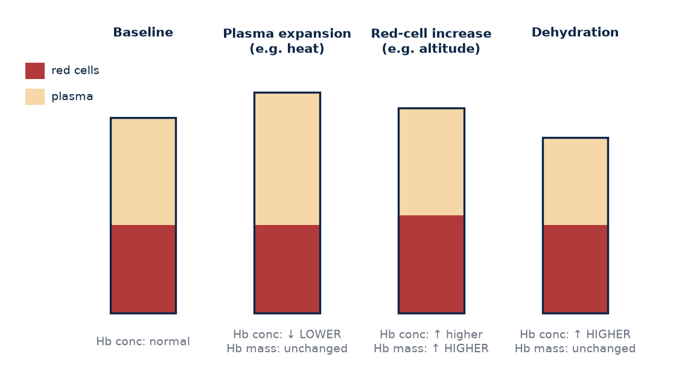
Figure 5. Schematic only: why haemoglobin concentration and haemoglobin mass can move in different directions. Concentration depends on plasma volume as well as red-cell mass.

Concentration is a ratio, mass is an amount
A routine blood test reports haemoglobin concentration, usually in grams per decilitre. That number is a ratio: haemoglobin divided by the volume of blood it is dissolved in. Concentration can rise because red-cell mass increases, because plasma volume falls, or both. It can fall because red-cell mass decreases, because plasma volume expands, or both. A single concentration value cannot tell which of these happened.
Scenario | Hb mass | Plasma volume | Hb concentration
Red-cell production after altitude | Up | Unchanged | Up
Dehydration after a hot long run | Unchanged | Down | Up (apparent)
Heat acclimation | Unchanged | Up | Down (apparent)
Altitude plus heat block | Up | Up | Could be unchanged
Iron deficiency, blood loss | Down | Variable | Usually down

The third and fourth rows are especially important for AKURA's heat-based research. An athlete returning from a Chennai summer training block may show a lower haemoglobin concentration, not because oxygen-carrying capacity has worsened but because plasma volume has expanded. Without a measure of mass or volume, a coach could misread a positive adaptation as a problem.
KEY IDEA
Haemoglobin concentration is a ratio that changes with plasma volume. Haemoglobin mass is the total amount, and is the better marker of oxygen-carrying capacity.

MYTH VS EVIDENCE
Myth: A higher haemoglobin value on a blood report always means better endurance capacity.
Evidence: A higher concentration can simply reflect dehydration or reduced plasma volume. Total haemoglobin mass, interpreted with performance, is the more meaningful variable.

How haemoglobin mass is measured
In research and elite sport, haemoglobin mass is commonly measured with the optimised carbon-monoxide rebreathing method, in which the athlete breathes a small, controlled dose of carbon monoxide and the change in carboxyhaemoglobin is used to calculate total haemoglobin. The method, developed and refined by Schmidt and Prommer and others, has good reliability in experienced hands. It must be performed by trained staff using established safety procedures; it is not a do-it-yourself field test.
Typical haemoglobin mass is higher in endurance-trained athletes than in untrained people when expressed per kilogram of body mass, and it differs between men and women and among individuals. Values should be interpreted relative to the athlete's own baseline rather than a single universal norm.

Altitude and the 1% rule
Altitude exposure can stimulate erythropoietin (EPO) and, over weeks, erythropoiesis, the production of new red blood cells. A meta-analysis by Gore and colleagues, published in the British Journal of Sports Medicine in 2013, pooled altitude studies that used carbon-monoxide rebreathing and estimated an average haemoglobin-mass increase of about 1.1% per 100 hours of exposure. The same analysis also showed substantial individual variability, and the authors estimated a wide prediction interval for any individual athlete's response.
Therefore "1% per 100 hours" should be treated as a research estimate from particular protocols, typically natural or simulated altitude of moderate elevation with sufficient daily hours and adequate iron, not as an athlete guarantee. Some athletes gain more, some gain little or nothing, and measurement error around a single test is not trivial. For an Indian squad considering a camp in Ooty or Kodaikanal, the practical translation is to calculate the expected hours of exposure, check iron status beforehand under medical supervision, and measure rather than assume the response.
FIELD PROTOCOL
1. Planning an altitude Hb-mass study
2. record baseline performance test and, if available, Hb mass by CO rebreathing
3. obtain clinician-supervised iron studies 4–6 weeks before
4. log daily hours at altitude, sleep altitude and training load
5. retest Hb mass within a few days of descent
6. repeat the performance test under standardised conditions
7. interpret change against the method's known measurement error.

It is worth adding a simple calculation to show why mass matters. If an athlete has 900 g of haemoglobin and each gram, fully saturated, binds about 1.34 mL of oxygen, the blood can carry roughly 1.2 litres of oxygen at any moment. A 3% increase in haemoglobin mass would add roughly 36 mL of carrying capacity, regardless of whether the concentration on a lab report moved. These figures are illustrative, not targets, but they explain why researchers prefer to measure the total amount directly when they want to understand oxygen transport, and why concentration alone can hide or exaggerate genuine change.
COACH'S CORNER
Treat any Hb-mass gain as a potential that must still be converted into performance. Pair every blood measurement with a standard performance test, and resist announcing a camp as "successful" until both have been checked.

CHECKPOINT
If your athlete's haemoglobin concentration dropped after a heat block, what additional information would you need before deciding whether this was good, bad or neutral?

CHAPTER 11

11. Plasma Volume
PART II — THE HUMAN ENDURANCE ENGINE
Blood is not only red cells. Roughly half or more of it, depending on the individual, is plasma, the liquid portion of blood made mostly of water, together with proteins, electrolytes and other solutes. Plasma is easy to overlook because it does not carry much oxygen itself, yet it plays a central role in endurance performance and, for athletes training in India's heat, may be one of the most responsive parts of the whole system.

What plasma does for the endurance athlete
Expansion of plasma volume increases total blood volume. A larger blood volume can improve venous return, the flow of blood back to the heart, which helps fill the ventricles more completely before each beat. Better filling supports stroke volume, and a better-maintained stroke volume supports cardiovascular stability during long efforts. Plasma volume also contributes to thermoregulation: there is more fluid available both to send blood to the skin for cooling and to sustain sweating, without starving the working muscles or the heart.
Heat acclimation is particularly relevant because sweating and repeated thermal stress stimulate fluid-regulatory adaptations. Repeated exposure to exercise in the heat promotes retention of sodium and water and an increase in plasma proteins that help hold fluid within the circulation. Endurance training in cooler conditions also expands plasma volume, typically within days of starting a new training block, which is one reason heart rate at a fixed pace can fall quickly early in a training cycle.
KEY IDEA
Plasma volume supports venous return, stroke volume, cardiovascular stability and cooling. Heat acclimation and endurance training can both expand it, but by different amounts in different people.

Evidence, and its limits
Systematic reviews show that heat acclimation can change plasma volume and cardiovascular responses, but the size and speed of adaptation vary across protocols and individuals. Reviews such as that by Périard, Racinais and Sawka describe plasma expansion as one of the earlier heat adaptations, often apparent within the first week of a structured protocol, while also noting that some of it may be transient if heat exposure stops. Protocol details such as daily duration, core temperature achieved, hydration practice and training status strongly influence what is observed.
This matters for how AKURA frames its heat hypotheses. It is reasonable, on current evidence, to hypothesise that a controlled heat-acclimation block may expand plasma volume in many athletes. It is not reasonable to promise a specific percentage to any individual, or to assume that plasma expansion automatically produces a faster race in cool conditions. That is a separate research question that needs its own performance test.
MYTH VS EVIDENCE
Myth: A drop in haemoglobin concentration after heat training means the athlete has become anaemic.
Evidence: It may partly reflect plasma expansion diluting the red cells. Anaemia is a clinical diagnosis that requires proper medical assessment, including measures of red-cell mass or iron status where appropriate.

Measuring concentration and volume separately
This creates a central AKURA principle: measure concentration and volume separately whenever the research question requires it. A lower haemoglobin concentration after heat adaptation does not automatically mean worse oxygen-carrying capacity; it may partly reflect plasma expansion.
Approach | What it gives | Practical note
CO rebreathing with Hb and Hct | Hb mass, blood and plasma volume | Specialist equipment and trained staff
Change in Hb and Hct (Dill–Costill method) | Estimated percentage change in plasma volume | Needs standardised posture and timing
Body mass and urine colour or specific gravity | Hydration context only | Does not measure plasma volume
HR at fixed pace and conditions | Functional response | Indirect, many confounders

The Dill and Costill approach estimates the relative change in plasma volume from paired haemoglobin and haematocrit values. It is a practical research tool but is sensitive to posture, time of day and recent exercise, so blood samples must be taken under identical conditions. In a typical Indian club setting without laboratory access, the coach can still collect the functional evidence carefully: standardised heart rate at fixed pace, body mass, sweat observations and perceived effort, all logged with temperature and humidity.
There is also a practical interpretation problem in the days after a race or hard session. Prolonged exercise, especially in heat, can shift fluid out of the circulation and reduce plasma volume acutely, while recovery and training over subsequent days can expand it. Blood sampled on a Monday after a Sunday long run is not directly comparable with blood sampled after two easy days. For AKURA studies, the timing of the last hard session, fluid intake and even the posture in which the athlete waited before sampling should be recorded, because each of these can move plasma volume enough to change the apparent result.
COACH'S CORNER
If you run a heat block, schedule the post-test within a few days of finishing, because some plasma adaptations can fade without continued exposure. Keep hydration, caffeine and posture before blood tests the same at baseline and follow-up.

CHECKPOINT
For your next heat-training block, which marker will you use for concentration, which for volume, and which for performance?

CHAPTER 12

12. Red Blood Cells and Erythropoiesis
PART II — THE HUMAN ENDURANCE ENGINE
Red blood cells are the delivery vehicles of the endurance system. They contain haemoglobin and transport oxygen from the lungs to the tissues, and help carry carbon dioxide back. They are produced in the bone marrow through erythropoiesis and, in healthy adults, circulate for roughly four months before being removed and recycled. That slow turnover is the first thing a coach must understand: changing the red-cell population takes weeks, not days.

How the body decides to make more
At altitude, reduced oxygen availability can increase erythropoietin signalling. Specialised cells in the kidney sense reduced oxygen delivery and increase production of the hormone erythropoietin, often within hours of arrival. EPO then stimulates the bone marrow to produce more red-cell precursors. Young red cells, called reticulocytes, appear in the blood over the following days, and a measurable increase in total red-cell and haemoglobin mass generally requires weeks of adequate exposure.
The response is not instantaneous and is affected by exposure dose, iron status, sleep, individual biology and the exact altitude protocol. Exposure dose includes both the altitude itself and the number of hours per day spent there, which is why the "live high, train low" model studied by Levine and Stray-Gundersen and others emphasises where the athlete sleeps as well as where the athlete trains. Illness, inflammation, inadequate energy intake and heavy training stress can all blunt the response.
KEY IDEA
Erythropoiesis is a slow, dose-dependent process. A rise in EPO is only the first step; building new red cells needs time, iron, energy, sleep and a sufficient hypoxic stimulus.

Iron: the raw material
Every new haemoglobin molecule needs iron. An athlete with insufficient iron stores may not respond as expected to an altitude intervention, and may simply become more fatigued. This is one reason ferritin and broader blood assessment may be relevant in a supervised sports-medicine programme. Endurance athletes, particularly female athletes, athletes with low energy availability and those following predominantly vegetarian diets, may be at greater risk of low iron status, although risk is individual and should be assessed rather than presumed.
Iron supplementation is not a harmless default. Excess iron can cause harm, and supplementation decisions, dose and duration belong with a qualified doctor or sports physician, based on proper blood tests. Ferritin in particular can rise with inflammation or recent hard exercise, so timing of blood draws and clinical interpretation matter.
MYTH VS EVIDENCE
Myth: Taking iron tablets before a camp will guarantee more red blood cells.
Evidence: Iron only helps if stores are actually insufficient, and the decision to supplement should be made by a clinician after testing. Iron is a necessary raw material, not a performance booster on its own.

Blood data is not a performance score
The coaching mistake is to treat a blood marker as a performance score. A higher red-cell count, haemoglobin or haematocrit is not the same as a faster 10 km. Blood markers fluctuate with hydration, posture, recent training and laboratory method. The correct approach is to connect blood data with performance and with longitudinal change in the same athlete.
Marker | What it may indicate | Interpret with caution because
Haemoglobin concentration | Oxygen-carrying ratio | Changes with plasma volume
Haematocrit | Proportion of blood that is cells | Changes with hydration and posture
Reticulocytes | Recent red-cell production | Short-lived, method-dependent
Ferritin | Iron stores (approximate) | Rises with inflammation
Hb mass | Total oxygen-carrying capacity | Needs specialist method

It is also worth stating plainly: artificially raising red-cell mass through EPO injection, blood transfusion or similar methods is prohibited in sport and carries serious health risks. AKURA's interest in erythropoiesis is entirely about understanding legitimate, natural adaptation to training and environment.
FIELD PROTOCOL
1. Supervised blood-monitoring routine
2. schedule tests at the same time of day after a rest or easy day
3. keep the athlete seated for a standardised period before sampling
4. record hydration, menstrual phase where relevant, recent illness and training
5. request ferritin, full blood count and any tests advised by the clinician
6. store results beside the nearest standardised performance test
7. review trends with the medical team, not in isolation.

Individual variation deserves emphasis. Two athletes on the same altitude camp, sleeping at the same elevation and following the same programme, may show very different red-cell responses. Some of this reflects measurement error, some reflects iron status, illness or training stress, and some appears to be genuine biological difference. This is why the phrase 'responder' or 'non-responder' should be used carefully. An athlete who does not respond on one camp may respond on another when iron, sleep and load are better managed. AEI records each exposure as an individual experiment rather than labelling the athlete permanently.
COACH'S CORNER
Build a relationship with a sports physician before planning altitude or heavy training blocks. Your job is to provide training context and performance data; the clinician's job is to interpret blood results and decide on any treatment.

CHECKPOINT
Does your athlete have a baseline ferritin and full blood count taken under standardised conditions, and do you know what the result was compared with their own previous values?

CHAPTER 13

13. VO₂max
PART II — THE HUMAN ENDURANCE ENGINE
VO₂max is probably the most famous number in endurance physiology. It describes the maximum rate at which the body can take up and use oxygen during severe exercise, usually expressed in millilitres of oxygen per kilogram of body mass per minute. It is important: elite endurance athletes almost always have high values, and a low VO₂max limits what an athlete can achieve at race pace. But it is not a complete description of running ability, and treating it as the master number leads to poor coaching decisions.

What VO₂max actually represents
Using the Fick principle from Chapter 8, VO₂max is the product of maximal cardiac output and maximal oxygen extraction. In trained athletes at sea level, much of the evidence suggests that oxygen delivery, especially maximal cardiac output and haemoglobin mass, is a major determinant of VO₂max, while muscle oxidative capacity also contributes. Reviews by Bassett and Howley, and by Joyner and Coyle in the Journal of Physiology in 2008, describe VO₂max as one of three key pillars of endurance performance, alongside the lactate or threshold characteristics and running economy.
VO₂max is measured in a laboratory with gas analysis during an incremental test to exhaustion. Values vary with protocol, equipment, motivation and whether the test is run on a treadmill or another ergometer. Values reported by watches are estimates derived from heart rate and pace; they can be useful for tracking trends in one person but should not be treated as laboratory measurements.
KEY IDEA
VO₂max sets the size of the aerobic ceiling. It does not tell you how close to that ceiling the athlete can race, or how much oxygen each kilometre costs.

Same engine, different results
Two athletes can have similar VO₂max values and different race performances because of running economy, threshold characteristics, body mass, fuel use, biomechanics and pacing. Consider a simplified illustration.
Variable | Athlete A | Athlete B
VO₂max (mL/kg/min) | 70 | 70
Threshold as % of VO₂max | 75% | 85%
Oxygen cost at 16 km/h (mL/kg/min) | 56 | 50
Likely marathon outcome | Slower | Faster

The numbers are hypothetical, chosen to show the logic. Athlete B can sustain a higher fraction of the same ceiling and needs less oxygen for the same speed, so Athlete B's sustainable race pace is higher despite an identical VO₂max. This is the same reasoning used in the Joyner and Coyle model, in which performance velocity reflects VO₂max, the fraction of it that can be sustained, and economy together.
Coaching software can add to the confusion. Jack Daniels' VDOT, for example, is a performance-based index derived from race times; its documentation explicitly distinguishes VDOT from laboratory VO₂max and notes that runners with similar VO₂max can produce different race results. VDOT is useful precisely because it folds economy and other factors into a single performance-derived value, but it should be labelled for what it is.
MYTH VS EVIDENCE
Myth: The athlete with the highest VO₂max will win the race.
Evidence: Among well-trained athletes of similar level, VO₂max alone predicts race results poorly. Economy, sustainable fraction of VO₂max, fuelling and pacing often separate them.

How AEI uses VO₂max
AEI therefore treats VO₂max as one physiological variable, not the master number. Where a valid laboratory test exists, AEI records the value together with the protocol, date, body mass and testing conditions. Where only a field or wearable estimate exists, AEI labels it as an estimate. In both cases, the value sits in the profile beside economy, threshold and the performance anchor, so that a change in VO₂max can be checked against a change in real running.
VO₂max is trainable, especially in less-trained athletes, through a combination of consistent aerobic volume and intervals near maximal aerobic speed. It also has a substantial inherited component, and responses to the same training vary between individuals. For Indian athletes the practical message is not to fixate on a number that may be difficult to measure, but to build the aerobic system through progressive training and to measure it well when the opportunity exists.
There is also the question of how VO₂max is expressed. Relative values, per kilogram of body mass, are most relevant to running because runners carry their own weight. Absolute values, in litres per minute, better reflect the size of the cardiovascular engine. An athlete who loses body mass may see relative VO₂max rise without any change in the heart or blood, while an athlete who gains muscle may see it fall slightly despite becoming stronger and more robust. Neither change should be interpreted without body mass, performance and health in view, and deliberately chasing a higher relative number through weight loss is not a safe coaching strategy.
COACH'S CORNER
If your athlete's VO₂max estimate on a watch changes, check whether pace at a fixed heart rate or a time trial has also changed. If it has not, treat the watch number as noise until real performance confirms it.

CHECKPOINT
Do you know whether the VO₂max values you hear about for your athletes are laboratory measurements, field estimates or watch algorithms?

CHAPTER 14

14. Running Economy
PART II — THE HUMAN ENDURANCE ENGINE
Running economy is the oxygen cost of running at a given submaximal speed. If two athletes run at the same pace but one uses less oxygen, the more economical runner has more physiological reserve: more room below the ceiling, less heat produced for the same speed and potentially slower use of carbohydrate. The marathon is not only about how much oxygen you can take in. It is also about how little oxygen you need for the speed you want.
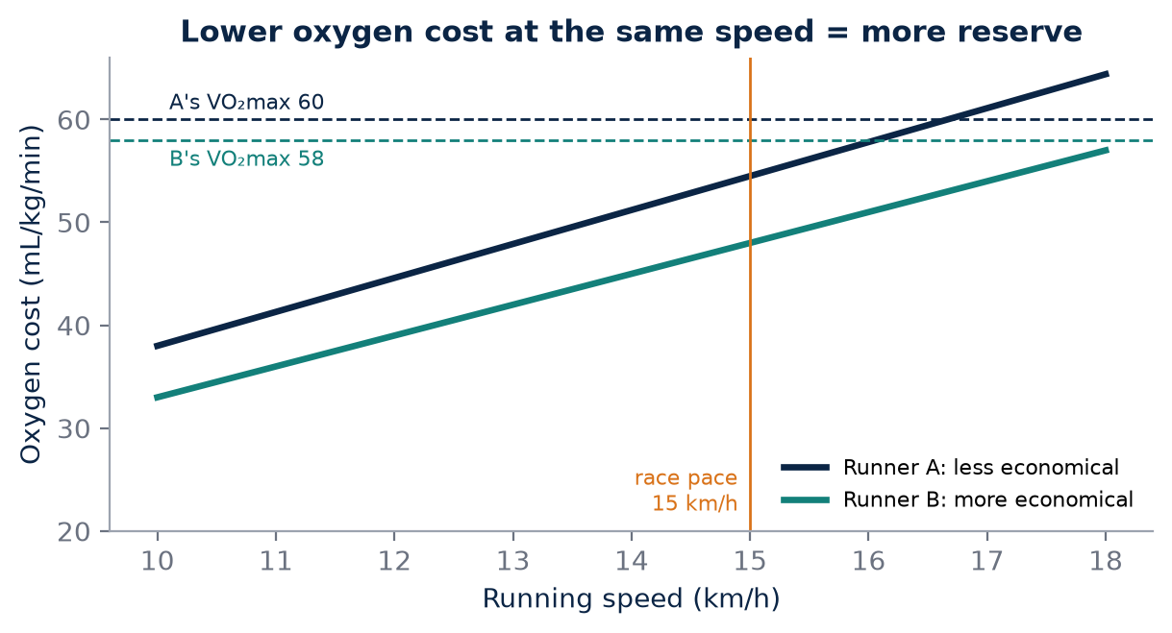
Figure 6. Illustrative values. Runner B has the lower VO₂max but uses less oxygen at race pace, so runs at a smaller fraction of maximum and may race faster.

Measuring economy
In the laboratory, economy is measured by recording steady-state oxygen uptake while the athlete runs at one or more fixed submaximal speeds, usually below the lactate threshold so that aerobic metabolism dominates. It can be expressed as oxygen uptake per kilogram per minute at a given speed, or as oxygen cost per kilogram per kilometre, which allows comparison across speeds. Some researchers also express it as energy cost, taking into account the mix of fuels being used.
Expression | Units | Why used
VO₂ at fixed speed | mL/kg/min at, say, 14 or 16 km/h | Simple, protocol-specific
Oxygen cost of transport | mL/kg/km | Compares across speeds
Energy cost | kcal or kJ/kg/km | Accounts for fuel mix

Economy varies considerably even among athletes of similar ability, and small differences of a few percent can matter over 42.2 km. Measurement also has error: day-to-day variation, treadmill versus overground differences and footwear all influence results, so repeated tests should be standardised carefully.
KEY IDEA
Economy is how much oxygen the athlete spends to buy a given speed. A more economical runner has more reserve at race pace, even with the same VO₂max.

What shapes economy
Economy is influenced by biomechanics, body mass, stiffness and elastic return, neuromuscular coordination, footwear, fatigue and training history. Reviews such as that by Saunders and colleagues in Sports Medicine in 2004 describe many of these factors. Tendons and muscles that store and return elastic energy efficiently reduce the metabolic work the muscle must do. Coordinated recruitment reduces wasted co-contraction. Lighter shoes with compliant, resilient midsoles can lower oxygen cost for many runners, although responses differ individually. Body mass matters, but chasing weight loss carries serious health risks, including low energy availability, and is not a safe economy strategy.
Economy is one reason a runner can outperform another athlete despite having a similar or lower VO₂max. It is also a quality that can deteriorate late in a race: as fatigue accumulates, mechanics change, oxygen cost at the same speed may rise and the athlete moves closer to the ceiling without speeding up.
MYTH VS EVIDENCE
Myth: Economy is fixed by body type and cannot be trained.
Evidence: Economy reflects many trainable qualities. Years of running, strength and plyometric work, and technique refinement may improve it, although the size of change varies and some influences such as limb proportions are not trainable.

Building economy in an Indian context
Many Indian runners train on mixed surfaces: roads, dirt tracks, temple streets, synthetic tracks where available and hills. That variety can be an advantage, developing robust feet and adaptable mechanics. Economy development usually includes consistent volume over years, short relaxed strides and hill sprints, heavy and explosive strength training performed with good technique, and exposure to race-pace running so that the athlete becomes efficient at the speed that matters.
Heat is also relevant. Running in heat increases total physiological strain at the same speed, and some studies show a small rise in oxygen cost in the heat, although the effect is not consistent. A more economical runner produces less metabolic heat for the same pace, which may help in hot races, but that link needs individual testing.
FIELD PROTOCOL
1. Field economy proxy
2. on a flat, calm route or track, warm up 15 minutes
3. run 2 × 6 minutes at a fixed, well-below-threshold pace with 2 minutes easy between
4. record HR over the last 2 minutes of each, cadence and RPE
5. note temperature, humidity, shoes and body mass
6. repeat monthly with identical pace and shoes
7. a falling HR at the same pace and conditions may reflect better economy, plasma volume or fitness, so label it as a proxy.

Economy also interacts with pacing. Because oxygen cost rises with speed, an athlete who runs an uneven marathon, surging on inclines or chasing groups early, spends more oxygen and more carbohydrate than one who runs the same average pace evenly. In crowded Indian city marathons, with congested starts, sharp turns and flyovers, good pacing discipline can protect some of an athlete's economy advantage. AEI therefore treats pacing data from races, including split variation and response to gradients, as useful context when interpreting economy tests, not as a separate matter.
COACH'S CORNER
Protect economy late in races by building strength and by practising race pace when partially fatigued, for example the last kilometres of a long run. Film the athlete fresh and tired; changes in posture and ground contact often reveal where economy is lost.

CHECKPOINT
How many of your athlete's weekly sessions develop economy directly, through strength, strides, hills or race-pace running, rather than only aerobic volume?

CHAPTER 15

15. Mitochondria and Muscle Oxygen Use
PART II — THE HUMAN ENDURANCE ENGINE
The heart, lungs and blood deliver oxygen, but oxygen only creates energy when a muscle cell uses it. That happens inside mitochondria, the cellular machinery that supports aerobic ATP production. Mitochondria oxidise fatty acids and the products of carbohydrate breakdown, including pyruvate and lactate, to generate most of the ATP needed for sustained running. If delivery is the supply chain, mitochondria are the factory floor.

What endurance training does to muscle
Endurance training stimulates mitochondrial adaptations and improves the muscle's ability to use oxygen and oxidise substrates. The classic work of John Holloszy in the 1960s showed that endurance training increases mitochondrial enzyme activity and oxidative capacity in skeletal muscle. Since then, research has described increases in mitochondrial content and function, in capillary density around muscle fibres, and in the enzymes and transporters that handle fat and carbohydrate.
These adaptations increase the muscle's ability to extract oxygen from blood, widening the arteriovenous oxygen difference in the Fick equation. They also mean that, at a given submaximal pace, the trained muscle can meet its energy needs with less disturbance to its internal environment, relying relatively more on fat and producing less lactate accumulation in the blood.
Adaptation | Effect | Typical stimulus
Mitochondrial content and function | More aerobic ATP capacity | Aerobic volume, threshold and interval work
Capillary density | Shorter diffusion distance, longer transit time | Consistent aerobic training
Fat-oxidation enzymes | Greater fat use at submaximal pace | Aerobic volume, long runs
Lactate and glucose transporters | Better lactate exchange and use | Varied intensity training

KEY IDEA
A high-level endurance athlete is not a large oxygen tank but a coordinated system that delivers oxygen and uses it efficiently. Mitochondria and capillaries determine how well the muscle uses what the heart delivers.

Many roads to the same factory
This distinction helps explain why easy volume, threshold work, long runs and strength training can all contribute through different pathways. Easy volume accumulates time with aerobic signalling in many fibres and supports capillary growth. Threshold work challenges the muscle to sustain a high oxidative rate. Long runs deplete glycogen in working fibres and may amplify some metabolic signals, while also training durability. Strength training contributes mainly through economy, force production and injury resilience rather than through large mitochondrial gains, but it keeps the whole chain working.
The research literature continues to debate which combinations of volume and intensity best stimulate mitochondrial adaptation, and the answer likely depends on training history. For practical coaching, the consistent message is that repeated, well-recovered aerobic work over months and years builds the muscle's aerobic machinery, and that no single session type is sufficient.
MYTH VS EVIDENCE
Myth: Only high-intensity intervals build mitochondria, so easy running is wasted time.
Evidence: High-intensity work is a strong stimulus, but aerobic volume also drives mitochondrial and capillary adaptation, and it can be sustained over far longer periods with less risk. Most successful endurance programmes combine both.

Avoid chasing one number
The practical implication is to avoid chasing one physiological number at the expense of the system. A programme built entirely around raising VO₂max may neglect muscle endurance and economy; one built entirely around easy volume may leave the threshold under-developed. Mitochondrial adaptations are also not directly visible to most coaches. They are inferred from outcomes such as lower heart rate and lactate at a given pace, improved fat use and better late-race durability.
Near-infrared spectroscopy devices that estimate muscle oxygen saturation are increasingly available, but their readings depend on placement, skin and fat thickness and device algorithms. They may be useful for research within the same athlete under standardised conditions, and should not be treated as a direct measure of mitochondrial content.
Recovery is part of the mitochondrial story. The training session provides the signal, but the adaptation is built during the hours and days that follow, supported by adequate energy, carbohydrate and protein intake, and sleep. Athletes with low energy availability, chronic sleep restriction or frequent illness may accumulate training without the expected muscle adaptations. For Indian athletes balancing work or study, long commutes and early morning sessions to avoid heat, protecting sleep and nutrition may be as important for the muscle as adding another session. AEI should record these recovery inputs alongside training load, so that a lack of adaptation can be interpreted fairly.
COACH'S CORNER
Judge muscle adaptation by what the athlete can sustain, not by a single test. Track how pace, heart rate and perceived effort behave in the final third of long runs; better durability there is often the most practical sign that the muscle's aerobic machinery is improving.

CHECKPOINT
Over the last eight weeks, has your athlete's training included enough consistent aerobic volume and enough sustained threshold work to stimulate the muscle, or has it relied on one type of session?

CHAPTER 16

16. Lactate Is a Messenger
PART II — THE HUMAN ENDURANCE ENGINE
For much of the twentieth century, lactate was cast as the villain of endurance sport: a toxic waste product that made legs burn and caused fatigue. That picture is now considered outdated. Lactate is a normal metabolic intermediate, not simply a toxic waste product. It can be produced in active muscle, transported between tissues and used as a fuel. Understanding this changes how a coach thinks about threshold training, lactate testing and the language used with athletes.

From waste to shuttle
When glucose or glycogen is broken down through glycolysis, the end product pyruvate can either enter the mitochondria for oxidation or be converted to lactate. Lactate is produced continuously, even at rest, and production rises as exercise intensity and glycolytic rate increase. Crucially, lactate does not simply sit in the muscle. It moves out of cells through monocarboxylate transporters and can be taken up by neighbouring oxidative muscle fibres, the heart, the brain and the liver. Oxidative fibres and the heart can use it as a fuel; the liver can convert it back to glucose.
George Brooks and colleagues developed and extended this framework as the lactate shuttle concept, describing lactate as a link between glycolytic and oxidative metabolism and as a signalling molecule that may influence gene expression and adaptation. The details continue to be researched, but the broad idea that lactate is a useful fuel and messenger, not merely waste, is well supported.
KEY IDEA
Lactate is produced, moved and used throughout the body. Blood lactate concentration reflects the balance between production and clearance, not simply how much "waste" has been made.

MYTH VS EVIDENCE
Myth: Lactate causes muscle soreness the next day and must be flushed out after hard sessions.
Evidence: Blood lactate returns towards resting levels within roughly an hour after exercise, even without special cooling-down methods. Delayed soreness has other causes, mainly related to unfamiliar or eccentric loading.

What rising blood lactate means
During increasing exercise intensity, blood lactate concentration rises as production and clearance dynamics change. At low intensities, production and removal are closely matched, so blood lactate stays near resting values. As intensity rises, glycolytic flux increases, more fast-twitch fibres are recruited and clearance may fail to keep pace, so blood lactate begins to accumulate. At higher intensities it rises steeply.
Fatigue during hard exercise is associated with a complex mix of metabolic changes, including accumulation of hydrogen ions and inorganic phosphate, and changes in ion balance within the muscle. The older idea that lactate itself is the direct cause of the burning sensation and fatigue is now regarded as too simple. Blood lactate remains a useful marker of metabolic strain, precisely because it tracks the balance of these processes, but it should be seen as a signal rather than a poison.
Threshold training is therefore not about "removing all lactate". It is about improving the athlete's ability to sustain a high metabolic rate while controlling the accumulation and use of lactate and associated metabolites. Training may improve this through greater mitochondrial capacity, better lactate transport and oxidation, and changes in muscle fibre recruitment and fuel use.

Testing lactate responsibly
This is why lactate testing can be valuable when standardised, but a single lactate number should not be interpreted without workload, timing and protocol. A reading of 3 mmol/L means little unless you know the pace, the gradient, how long the athlete had been running, when the sample was taken, the analyser used and the athlete's recent diet and training.
Factor | Why it changes the reading
Stage duration | Short stages may not reach steady state
Sample timing | Lactate changes quickly after stopping
Glycogen status | Low glycogen can lower lactate at a given pace
Heat and hydration | Can raise physiological strain at fixed pace
Analyser and site | Devices and finger versus earlobe differ

Portable lactate meters are now affordable for some Indian academies and clubs. They are powerful tools when used carefully, and misleading tools when used casually. Hygiene is essential: sweat contamination, especially in humid conditions, can falsely raise readings, so the sampling site must be cleaned and dried, and sharps must be disposed of safely.
FIELD PROTOCOL
1. Standardised lactate step test
2. after a consistent diet and an easy day, warm up 10–15 minutes
3. run 5–7 stages of 4–5 minutes, increasing pace by a fixed step each stage
4. take a clean, dry earlobe or fingertip sample within about 30 seconds after each stage
5. record pace, HR, RPE, temperature and humidity
6. stop when RPE is very hard or lactate rises steeply
7. repeat on the same route or treadmill with the same analyser.

COACH'S CORNER
Stop describing lactate as poison to athletes. Explain it as a fuel and a messenger that the trained body learns to handle better. It changes how athletes relate to hard sessions and reduces fear of discomfort at threshold.

CHECKPOINT
If your athlete produced a lactate reading of 4 mmol/L today, what six pieces of information would you need to interpret it properly?

CHAPTER 17

17. Lactate Threshold
PART II — THE HUMAN ENDURANCE ENGINE
Few words in coaching are used as loosely as "threshold". Athletes talk about "threshold runs", laboratories report "thresholds" and watches estimate "threshold pace", yet these often refer to different things. The term "threshold" can describe several related concepts, including fixed blood-lactate definitions and individual physiological breakpoints, and different laboratories may use different protocols and terminology.
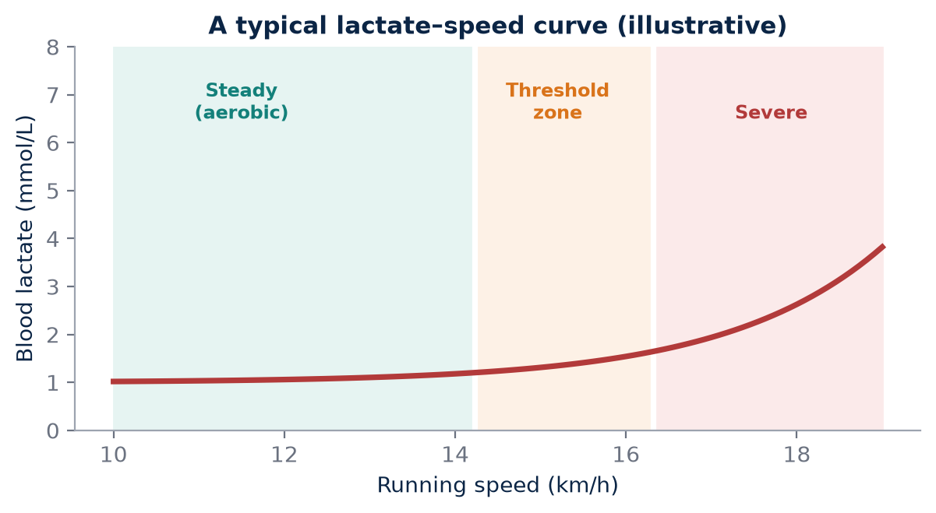
Figure 7. As speed rises, blood lactate stays low, then accumulates increasingly quickly. Threshold is best treated as a zone, and its definition depends on the test protocol.

Many thresholds, one idea
Broadly, two important transitions are commonly described as intensity rises. The first is the intensity at which blood lactate first rises meaningfully above resting or baseline values, sometimes called the first lactate threshold or aerobic threshold. The second is a higher intensity above which lactate can no longer be stabilised and keeps rising over time during constant-pace running, often associated with the maximal lactate steady state, the second threshold, or related concepts such as critical speed.
Term | Common definition | Caution
LT1 or aerobic threshold | First sustained rise above baseline lactate | Detection method varies
Fixed 2 mmol/L | Pace at a set concentration | Not individualised
Fixed 4 mmol/L (OBLA) | Pace at a set concentration | Individual MLSS may be higher or lower
MLSS | Highest pace with stable lactate over about 30 minutes | Time-consuming to determine
Critical speed | Boundary derived from time trials at several distances | Model and protocol dependent

Faude, Kindermann and Meyer, in a 2009 review in Sports Medicine, described the large number of lactate threshold concepts in use and cautioned that they are not interchangeable. Fixed concentrations such as 4 mmol/L are convenient but ignore the fact that individual maximal lactate steady state values differ considerably between athletes. A threshold number is therefore meaningful only alongside the method that produced it.
KEY IDEA
"Threshold" is a family of concepts, not one universal number. Every threshold value must be stored with the protocol and method used to find it.

Threshold as a training domain
For coaching, threshold is best treated as a training intensity domain rather than a magical pace. It should feel controlled-hard rather than maximal. Athletes often describe it as comfortably hard: breathing is deep and rhythmic, speaking is limited to short phrases, and the effort could be held for a sustained period in a race. It supports the ability to sustain a high fraction of aerobic capacity, which, as Chapter 13 showed, is one of the three pillars of endurance performance.
Because the domain has boundaries rather than a single point, sessions such as continuous tempo runs, cruise intervals and longer intervals with short recoveries can all target it. Heat, hills, fatigue and fuelling state all shift the pace at which the domain occurs, so on a humid Chennai evening the correct threshold effort may be noticeably slower than on a cool morning. Coaches who hold athletes to a fixed pace regardless of conditions risk turning a threshold session into a much harder one.
MYTH VS EVIDENCE
Myth: Threshold pace is a fixed number you can use all season.
Evidence: Threshold shifts with training, fatigue, fuel and environment. It is better treated as an effort domain checked by heart rate, RPE and, where available, lactate, and retested regularly.

Recording threshold in AEI
AEI should record the test protocol alongside the threshold result. A number without the protocol is incomplete data. For each threshold entry, AEI stores the method (lactate step test, fixed concentration, MLSS, critical-speed model or field time trial), the stage duration and step size, the surface or treadmill gradient, the environmental conditions and the analyser or device. Field estimates, such as the pace sustained in a 30-minute time trial, are useful and practical but should be labelled as such, and they are strongly influenced by motivation and pacing skill.
Changes over time are often more valuable than absolute values. A rightward shift of the lactate curve, where the same lactate appears at a faster pace, or a lower heart rate at the same threshold pace, is a meaningful sign of adaptation if the protocol has been kept the same.
FIELD PROTOCOL
1. Field threshold check
2. on a flat track or measured loop, warm up 15 minutes with strides
3. run a 30-minute evenly paced effort as hard as can be sustained
4. record average pace and HR for the final 20 minutes, RPE, temperature and humidity
5. cool down 10 minutes
6. repeat every 6–8 weeks in similar conditions
7. store as "field threshold estimate" with the protocol.

The relationship between threshold and heat deserves particular attention in India. Heat increases cardiovascular strain and, for many athletes, carbohydrate use at a given pace, so blood lactate and heart rate at a fixed speed may be higher on a hot day. A threshold test performed in a cool December morning in Chennai will not give the same result as one performed in May. Where possible, testing should be scheduled at a consistent time of day and season, or the conditions should be recorded carefully enough that the difference can be accounted for when results are compared.
COACH'S CORNER
Prescribe threshold by a combination of pace range, heart-rate range and perceived effort, and let conditions decide which one leads on the day. In heat, let effort and heart rate lead and allow the pace to slow.

CHECKPOINT
Which threshold definition have you been using for your athletes, and would another coach or laboratory reproduce the same number from your notes?

CHAPTER 18

18. Fuel, Glycogen and Fat Oxidation
PART II — THE HUMAN ENDURANCE ENGINE
The marathon is where physiology meets the kitchen. Marathon performance depends heavily on substrate management: which fuels the athlete uses, how much is stored and how well it is replaced during the race. Carbohydrate supports high-intensity work efficiently, while fat oxidation contributes increasingly as intensity and duration change. Training can influence substrate use, but race-day fuelling remains essential.
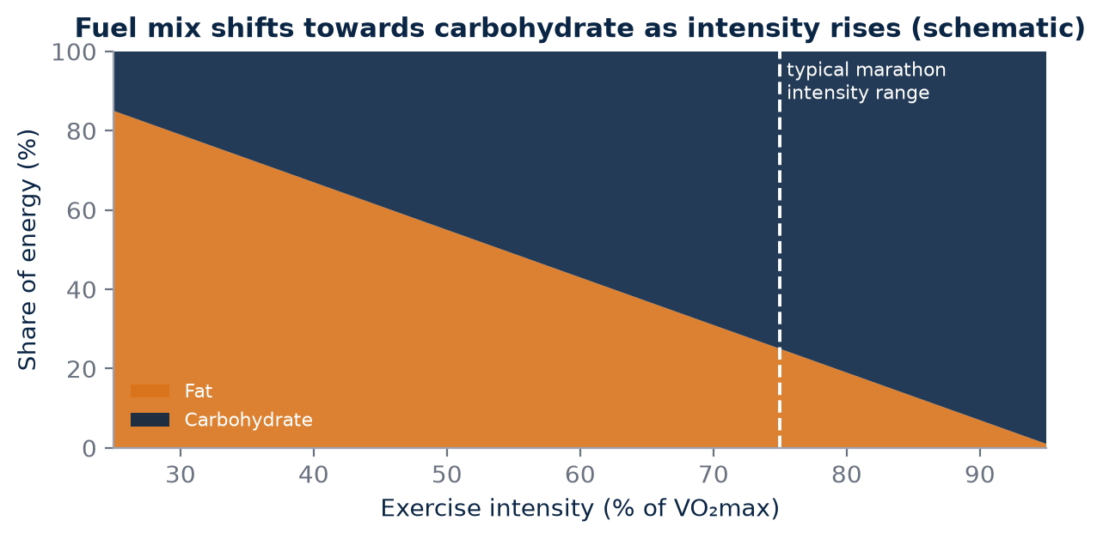
Figure 8. Schematic of the general pattern. Individual fuel use varies with training, diet, sex and duration, which is why marathon fuelling must be practised.

Two fuel tanks
The body stores carbohydrate as glycogen in muscle and liver, and as a small amount of glucose in the blood. Glycogen stores are limited, on the order of a few hundred grams in muscle and around a hundred grams in the liver in a well-fed adult, although they vary with body size, training and diet. Fat stores, by contrast, are large even in lean athletes. Carbohydrate yields more ATP per litre of oxygen than fat, so it is the preferred fuel as intensity rises. Fat is abundant but oxidised more slowly and is the dominant fuel mainly at lower intensities.
Feature | Carbohydrate | Fat
Storage size | Limited (muscle and liver glycogen) | Large
Energy per litre of O₂ | Higher | Lower
Use at marathon pace | Major contributor for most runners | Contributes, varies by athlete
Main risk | Depletion late in race | Too slow to sustain high pace alone

As a marathon progresses, muscle glycogen in the working fibres falls. If carbohydrate availability becomes insufficient, the athlete may be unable to hold pace, a phenomenon runners call "hitting the wall". Training can increase the capacity to oxidise fat at a given pace and increase glycogen storage, sparing carbohydrate, but for most runners racing a marathon at a competitive pace, carbohydrate remains central.
KEY IDEA
Carbohydrate is the high-performance fuel for racing, but its stores are limited. Fitness improves fat use and glycogen storage; race-day fuelling protects what remains.

Fitness and fuel need each other
The athlete who starts a marathon with excellent aerobic fitness but poor carbohydrate availability can still fail late. Conversely, high carbohydrate intake cannot rescue inadequate fitness. Current sports nutrition guidance, summarised in reviews by Burke, Hawley, Jeukendrup and colleagues, describes several practical tools: increasing carbohydrate intake for one to two days before a marathon to maximise glycogen stores, a carbohydrate-containing pre-race meal, and carbohydrate intake during the race, commonly in the range of about 30–60 g per hour and up to around 90 g per hour for longer events when using mixtures of glucose and fructose that the gut has been trained to tolerate. Exact amounts should be individualised, ideally with a qualified sports dietitian.
Gut tolerance is trainable. Athletes who try new gels or drinks on race day risk gastrointestinal distress, which is more likely in heat. In the Indian context, familiar carbohydrate foods such as rice, idli, bananas or other locally available options may form part of pre-race meals, provided they have been practised in training and suit the athlete's gut.
MYTH VS EVIDENCE
Myth: Fat-adapted runners do not need carbohydrate during a marathon.
Evidence: Low-carbohydrate adaptation can raise fat oxidation, but studies have shown it may impair the ability to use carbohydrate efficiently at high intensity. For most competitive marathoners, carbohydrate availability remains critical at race pace.

Fuel meets heat, pacing and hydration
The research model should therefore connect metabolic fitness with practical fuelling, hydration, pacing and environmental stress. Heat increases reliance on carbohydrate at a given pace in many individuals and makes the gut less tolerant, while dehydration reduces performance and increases strain. An aggressive early pace burns glycogen faster and may leave the athlete short in the final 10 km. These factors interact; a fuelling plan that works in a cool Bengaluru long run may fail in a humid Mumbai race.
Athletes should also avoid both extremes of drinking: significant dehydration impairs performance in heat, while drinking large amounts beyond sweat losses in long events can cause dangerous low blood sodium. Individual sweat-rate testing helps set sensible targets, and any athlete with symptoms such as confusion, severe headache or vomiting during or after a race needs urgent medical attention.
FIELD PROTOCOL
1. Race-fuel rehearsal long run
2. eat the planned pre-race meal 3–4 hours before
3. weigh the athlete nude or in minimal clothing before and after
4. run 25–32 km with the final 8–12 km at goal marathon pace
5. take the planned carbohydrate every 20–30 minutes at the planned hourly amount
6. record fluid intake, gut comfort, RPE, HR and pace drift
7. note temperature and humidity
8. adjust the plan in small steps.

COACH'S CORNER
Treat fuelling as a trained skill. Rehearse the race-day meal, gel or drink type, timing and quantity in at least three long runs, including one in conditions similar to the race, and record what happened in the athlete's log.

CHECKPOINT
Has your athlete practised the exact race-day fuelling plan, in similar heat, at goal marathon pace, and does AEI hold a record of how their pace and heart rate behaved late in that run?

PART II AT A GLANCE
The key idea from each chapter, for quick revision.
7 | The Endurance System as a Chain  Endurance performance is a chain of linked systems, from air to ATP to forward motion. Strengthening one link helps only if it is, or becomes, the link that limits the athlete.
8 | The Heart: Pump, Not Just Heart Rate  Cardiac output = heart rate × stroke volume, and oxygen uptake = cardiac output × oxygen extraction. Heart rate is only one of the terms.
9 | The Lungs and the Oxygen Myth  Altitude is a pressure stimulus, not a percentage stimulus. The same 20.9% oxygen at lower pressure means a lower partial pressure of oxygen and less driving force for gas exchange.
10 | Haemoglobin Mass  Haemoglobin concentration is a ratio that changes with plasma volume. Haemoglobin mass is the total amount, and is the better marker of oxygen-carrying capacity.
11 | Plasma Volume  Plasma volume supports venous return, stroke volume, cardiovascular stability and cooling. Heat acclimation and endurance training can both expand it, but by different amounts in different people.
12 | Red Blood Cells and Erythropoiesis  Erythropoiesis is a slow, dose-dependent process. A rise in EPO is only the first step; building new red cells needs time, iron, energy, sleep and a sufficient hypoxic stimulus.
13 | VO₂max  VO₂max sets the size of the aerobic ceiling. It does not tell you how close to that ceiling the athlete can race, or how much oxygen each kilometre costs.
14 | Running Economy  Economy is how much oxygen the athlete spends to buy a given speed. A more economical runner has more reserve at race pace, even with the same VO₂max.
15 | Mitochondria and Muscle Oxygen Use  A high-level endurance athlete is not a large oxygen tank but a coordinated system that delivers oxygen and uses it efficiently. Mitochondria and capillaries determine how well the muscle uses what the heart delivers.
16 | Lactate Is a Messenger  Lactate is produced, moved and used throughout the body. Blood lactate concentration reflects the balance between production and clearance, not simply how much "waste" has been made.
17 | Lactate Threshold  "Threshold" is a family of concepts, not one universal number. Every threshold value must be stored with the protocol and method used to find it.
18 | Fuel, Glycogen and Fat Oxidation  Carbohydrate is the high-performance fuel for racing, but its stores are limited. Fitness improves fat use and glycogen storage; race-day fuelling protects what remains.

PART III — HEAT
India is, for much of the year, a hot country, and for many coastal athletes heat is not an occasional problem but the daily condition of training. Part III treats heat as a measurable physiological stimulus rather than a test of character. It explains what heat does to the heart, blood and skin, how controlled heat acclimation works, why plasma expansion matters, how sweating and humidity interact, and how a city such as Chennai can become a genuine training laboratory. Throughout, safety comes first: heat can build adaptation, but uncontrolled heat can also cause serious illness. The aim is dose, data and judgement, not bravado.
IN THIS PART
19 What Heat Actually Does
20 Heat Acclimation
21 Plasma Expansion and Stroke Volume
22 Sweating and Thermoregulation
23 Chennai as a Training Laboratory
CHAPTER 19

19. What Heat Actually Does
PART III — HEAT
Every runner in Chennai, Kochi, Mumbai or Visakhapatnam knows the feeling: a pace that feels comfortable on a cool January morning becomes laboured on a humid May evening. The legs have not changed overnight, and fitness has not vanished. What has changed is the job the body must do. Heat increases cardiovascular and thermoregulatory demand. Skin blood flow rises, sweating increases, core temperature is challenged and plasma volume can adapt with repeated exposure. At the same running pace, heart rate may be higher in the heat. Understanding why is the first step towards using heat intelligently rather than simply enduring it.
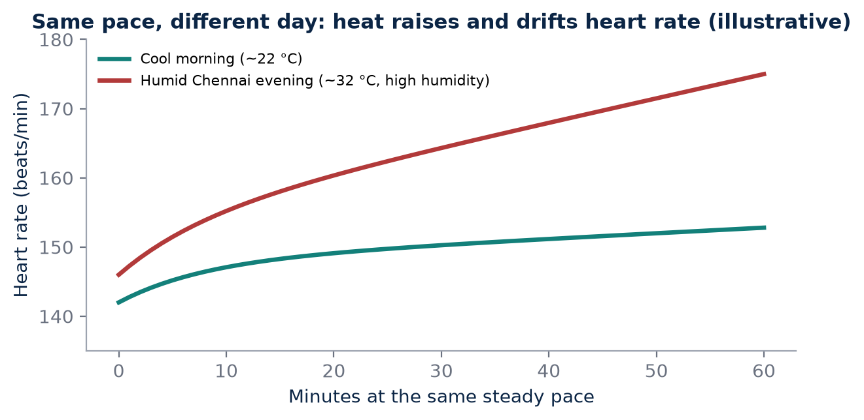
Figure 9. Illustrative example of cardiovascular drift. In the heat, blood is shared between muscle and skin and fluid is lost, so heart rate rises at the same pace.

Two jobs for one circulation
During running, the heart must supply oxygen to working muscles. In the heat it must also carry heat from the body's core to the skin, where it can be lost to the environment. Both demands draw on the same finite blood volume and the same cardiac output. As skin blood flow increases, a larger share of blood sits in the expanded vessels of the skin, and sweating gradually reduces circulating fluid. Less blood returns to the heart with each beat, stroke volume tends to fall, and heart rate rises to compensate. This progressive rise in heart rate at a constant pace is often called cardiovascular drift, and it is usually more pronounced in hot and humid conditions.
The result is that the same external workload, for example 5:00 per kilometre, represents a greater internal load in the heat. Perceived effort climbs, the sustainable pace falls and, if the exposure is long enough, core temperature may rise to levels that impair performance and eventually threaten health.

Adaptation, not toughness
The body is not simply becoming "tougher" when it trains in heat. It is adapting to manage thermal strain. With repeated, controlled exposure, several changes can occur: plasma volume may expand, sweating may begin earlier and become more effective, resting and exercising core temperature may fall slightly, and heart rate at a given pace may decrease. These changes are specific responses to a specific stress. They are useful when the dose is controlled and recovery is sufficient, and they fade when exposure stops.
This matters for coaching language. Telling an athlete that suffering in the midday sun "builds character" confuses discomfort with adaptation. A well-designed heat session may feel uncomfortable, but its value comes from the physiological signal, the recovery that follows and the repetition over days, not from how much the athlete can tolerate on a single afternoon.
KEY IDEA
Heat stress is a training stimulus, not a badge of toughness. The same pace costs more in the heat because the circulation must serve both the muscles and the skin.

Heat illness: the non-negotiable boundary
Because heat is a real physiological stress, it carries real risk. Exertional heat illness ranges from heat cramps and heat exhaustion to exertional heat stroke, a medical emergency in which core temperature rises to dangerous levels and the brain is affected. Warning signs that should stop a session immediately include confusion, disorientation, irrational or unusual behaviour, stumbling or loss of coordination, collapse, severe headache, vomiting, dizziness, and chills or goosebumps while running in the heat. An athlete who is still sweating can still be developing heat stroke; sweating alone is not reassurance.
AKURA does not provide medical diagnosis. The coaching rule is simpler: when in doubt, stop, move the athlete to shade, begin cooling and seek medical help. International consensus guidance on exercise in the heat emphasises rapid whole-body cooling, ideally cold-water immersion, for suspected heat stroke, and any organised heat programme should have a medical plan agreed in advance with qualified professionals.
Warning sign | What the coach does
Confusion or odd behaviour | Stop at once, cool, call medical help
Stumbling or collapse | Emergency: cool immediately, call for help
Severe headache, nausea, vomiting | Stop the session; shade, cooling, medical review
Chills or goosebumps in heat | Stop; treat as a red flag
Unusual heart rate at easy pace | End the session; review next day

COACH'S CORNER
Before any hot-weather session, agree three things with the athlete: a stop rule (for example, any warning sign ends the session with no debate), a cooling plan (shade, cold water, ice towels or a tub available) and a contact plan (who calls for medical help and where the nearest facility is). Heat training without these is not a protocol; it is a gamble.

MYTH VS EVIDENCE
Myth: Drinking a lot of water guarantees protection from heat stroke.
Evidence: Hydration matters, but heat stroke is driven mainly by heat production and inadequate heat loss. A well-hydrated athlete running hard in humid heat can still overheat, and excessive drinking carries its own risks.

CHECKPOINT
When your athlete runs the same pace in cool and hot conditions, do you record the heart-rate difference? Do you have a written stop rule and cooling plan for every hot session?

CHAPTER 20

20. Heat Acclimation
PART III — HEAT
If heat is a stimulus, then heat acclimation is the training block built around it. Heat acclimation generally involves repeated exposure to elevated environmental or body temperature during exercise, so that the body gradually becomes better at managing thermal strain. Strictly, "acclimation" refers to adaptation achieved in artificial or deliberately controlled conditions, while "acclimatisation" refers to adaptation in the natural environment. For an athlete living in Chennai, some acclimatisation happens simply through daily life; a structured acclimation block adds deliberate dose, measurement and progression.
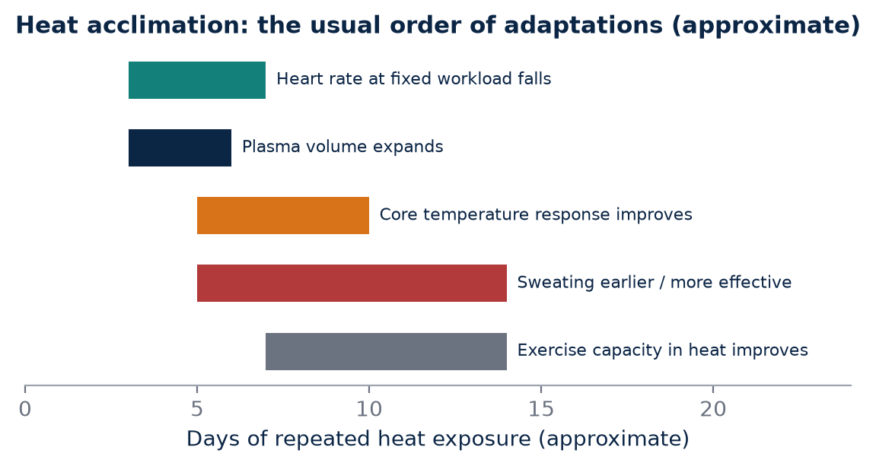
Figure 10. Approximate time course summarised from heat-acclimation reviews. Timing varies with protocol, humidity, fitness and individual response.

What the evidence suggests
Protocols differ in duration, intensity, humidity and whether exposure is active or passive. Some use running or cycling in a climate chamber; others use training in naturally hot conditions, sauna or hot-water immersion after exercise, or wearing extra clothing to raise body temperature. Evidence supports improvements in thermoregulatory and cardiovascular responses, with systematic reviews reporting changes in heart rate, core temperature, plasma volume and exercise performance depending on protocol.
Reviews such as that by Périard, Racinais and Sawka (2015) describe a broad pattern: many adaptations begin within the first several days of exposure, and a substantial portion is typically present after about one to two weeks of regular sessions. Heart rate at a given workload often falls relatively early, plasma volume can expand within the first week, and sweating responses and thermal comfort continue to improve with further exposure. Adaptations decay when exposure stops, although re-acclimation is generally quicker than initial acclimation. These are population tendencies, not promises for any individual.
KEY IDEA
Heat acclimation is a dose-response intervention. Its effects depend on how hot, how humid, how long, how hard and how often, and they fade without continued exposure.

Measuring the heat dose
A block cannot be evaluated if the dose is unknown. AKURA should record heat dose: temperature, relative humidity, session duration, workload, pre/post body mass, fluids, HR and perceived effort. Where available, wet-bulb globe temperature (WBGT) is preferable to air temperature alone because it incorporates humidity, radiant heat and wind. Core temperature measurement, for example with an ingestible sensor, is valuable in research settings but is not essential for a well-run field block; consistent recording of the variables above already gives a coach far more information than "it was hot".
Variable | How to record | Why it matters
Air temperature and humidity | Local sensor or nearby station, at start | Defines environmental load
WBGT (if available) | Handheld WBGT meter | Combines heat, humidity, sun, wind
Duration and workload | Minutes, pace or power | Separates dose from fitness
Body mass pre/post | Nude or minimal clothing, towel-dried | Estimates sweat loss
Fluid intake | Millilitres consumed | Corrects sweat-loss estimate
HR and RPE | Average and end-of-session | Internal response to the dose

FIELD PROTOCOL
1. Safe 10–14 day heat-acclimation block (healthy, medically cleared athletes only)
2. Days 1–3: 45–60 min easy running in warm conditions, heart rate capped at easy zone, full stop rule in place
3. Days 4–7: 60 min, same pace or slightly longer duration, still easy intensity, record HR drift and body mass change
4. Days 8–14: 60–90 min at easy to steady effort, with one or two short controlled strides only if the athlete is tolerating well
5. Schedule at least one lighter or rest day each week
6. Keep hard interval sessions in the cooler part of the day so training quality is protected
7. Weigh before and after each session and rehydrate to replace losses gradually
8. Stop immediately for any warning sign and have cooling and medical contact ready
9. Repeat a standard pace-HR test before and after the block

Active, passive and hybrid approaches
Not every heat dose must come from running in the midday sun. Some athletes combine normal training with post-exercise hot-water immersion or sauna, which raises body temperature without adding running load. Others use extra clothing layers during easy runs in mild conditions. Each method has advantages and risks, and none should be introduced without considering the athlete's health, recovery and overall stress. For a junior athlete, a recreational masters runner or anyone with a medical condition, professional medical clearance should come before any deliberate heat exposure.
COACH'S CORNER
Treat the first days of a heat block as a reduced-intensity phase. Lower the pace, cap the heart rate and let the environment provide the stress. If your athlete finishes a heat session unable to train normally the next day, the dose was too high.

MYTH VS EVIDENCE
Myth: The hotter and harder the session, the faster the adaptation.
Evidence: Adaptation depends on a sufficient, repeated rise in body temperature combined with recovery. Excessive single doses increase the risk of heat illness and can damage the rest of the training week.

Finally, remember that acclimation is not permanent. If an athlete completes a block in April and then trains mostly in air-conditioned gyms or cool early mornings, much of the adaptation may fade over the following weeks. For a target race in hot conditions, the timing of the block relative to race day matters, and brief top-up exposures in the final weeks may help maintain adaptation. The AEI should therefore store not only whether a block was completed, but when it finished and what exposure followed.
CHECKPOINT
For your last hot training week, could you state the temperature, humidity, duration, workload and body-mass change for each session? If not, what would you need to start recording?

CHAPTER 21

21. Plasma Expansion and Stroke Volume
PART III — HEAT
One of the most discussed effects of heat acclimation is an increase in plasma volume, the liquid portion of the blood. For a coach, the idea is intuitive: more fluid in the circulation should make it easier for the heart to fill and pump. The physiology broadly supports this, but it also carries important caveats. Plasma expansion can increase circulating volume. More effective venous return can support ventricular filling and stroke volume, although the complete response depends on vascular control, hydration, cardiac function and the exercise environment.

From blood volume to stroke volume
Stroke volume is the amount of blood the heart ejects with each beat. It depends partly on how much blood returns to the heart and fills the ventricle before contraction. In the heat, blood is redirected towards the skin and fluid is lost as sweat, so venous return can fall. A larger plasma volume offers a buffer: the circulation can supply the skin for cooling while still returning enough blood to the heart. The practical consequence, often seen after acclimation, is a lower heart rate at the same pace and a smaller rise in heart rate during prolonged exercise in the heat.
The mechanisms behind plasma expansion include changes in fluid- and sodium-regulating hormones and an increase in circulating protein that helps retain fluid within the vessels. Lorenzo and colleagues (2010), in a well-known study published in the Journal of Applied Physiology, reported that a 10-day heat-acclimation programme increased plasma volume and improved performance not only in hot conditions but also in cool conditions in trained cyclists. That finding generated wide interest in heat as a potential performance tool for athletes who do not compete in the heat, although later studies have not always reproduced the cool-condition benefit to the same degree.
KEY IDEA
Plasma expansion can support stroke volume and lower heart rate at a given pace, but it increases the volume of blood, not the number of red cells.

Why a sea-level athlete should care
This is one reason heat acclimation is interesting for sea-level athletes. It may improve cardiovascular stability without requiring a mountain camp. For an athlete in Chennai who cannot easily spend four weeks in Ooty, a carefully designed heat block is accessible, cheap and measurable. But plasma expansion is not equivalent to an increase in red-cell mass. More plasma without more red cells means each litre of blood carries slightly less haemoglobin, even though total circulating volume is larger.
This leads directly to a measurement trap. A blood test taken after a heat block may show a lower haemoglobin concentration. That result does not automatically mean the athlete is anaemic or has lost oxygen-carrying capacity; it may partly reflect dilution by expanded plasma. Concentration and total mass answer different questions. Haemoglobin concentration tells you how much haemoglobin is in each unit of blood; haemoglobin mass tells you how much haemoglobin the body contains in total. Only specialised methods, such as carbon-monoxide rebreathing, estimate total mass directly.
Measure | What it tells you | Effect of plasma expansion
Haemoglobin concentration | Hb per unit of blood | May fall (dilution)
Haematocrit | Share of blood that is red cells | May fall (dilution)
Plasma volume | Liquid part of the blood | Rises
Haemoglobin mass | Total Hb in the body | Not directly changed by plasma alone

COACH'S CORNER
Never interpret a single blood test in isolation after a heat block. Note the timing relative to training and heat exposure, and discuss unexpected results with a qualified sports-medicine professional rather than making dietary or supplement decisions on your own.

Separating the pathways
The research comparison should therefore separate plasma-related adaptation from erythropoietic adaptation. In AKURA terms, a heat block is expected to act mainly on fluid regulation, thermoregulation and cardiovascular stability. An altitude block is expected to act, at least in part, on red-cell production. Both might lower heart rate at a given pace or improve a time trial, but for different reasons. If the AEI records only the performance outcome, it cannot tell which pathway was responsible.
FIELD PROTOCOL
1. Plasma-sensitive pace-HR check
2. Choose a flat, familiar route or a treadmill
3. After an easy day, run 20 minutes at a fixed easy pace in similar conditions each time
4. Record average HR for minutes 10–20, the temperature and humidity, and body mass before and after
5. Repeat before a heat block, at its end and one to two weeks later
6. A lower HR at the same pace in similar conditions is consistent with improved cardiovascular stability, but interpret alongside sleep, illness and training load

MYTH VS EVIDENCE
Myth: If haemoglobin concentration drops after heat training, the athlete's blood has become weaker.
Evidence: A lower concentration can reflect a larger plasma volume diluting the same number of red cells. Total haemoglobin mass and clinical context are needed before drawing conclusions.

CHECKPOINT
If your athlete's heart rate at easy pace falls after a heat block, which explanations can you rule in or out with the data you currently collect?

CHAPTER 22

22. Sweating and Thermoregulation
PART III — HEAT
Sweating is the body's most powerful cooling tool during running in warm conditions, but it only cools when sweat evaporates. That simple fact explains much of what Indian coastal runners experience. Repeated heat exposure can improve the timing and distribution of sweating and reduce the thermal strain associated with a given workload. The goal is not simply to sweat more; it is to regulate body temperature effectively while maintaining cardiovascular function.

How the body loses heat
A running body produces a large amount of heat as a by-product of muscular work. That heat can be lost through several routes: radiation, convection to moving air, conduction and, most importantly during hard exercise in warm weather, evaporation of sweat from the skin. When air temperature approaches or exceeds skin temperature, radiation and convection contribute little or may even add heat, and evaporation becomes the main route of heat loss.
With acclimation, sweating often begins at a lower core temperature, the sweat rate at a given workload may increase, and sweat may become more dilute as the body conserves sodium. Sweat can also be distributed more effectively across the skin. Together, these changes help the athlete lose heat earlier and more efficiently, which can lower core and skin temperature for the same pace and reduce the strain on the circulation.
KEY IDEA
Sweat cools only when it evaporates. Acclimation improves the timing and efficiency of sweating, but humidity limits how much of that sweat can do its job.

The humidity problem
Humidity complicates this because sweat evaporation becomes less efficient. When the air already holds a lot of water vapour, the gradient that drives evaporation from the skin is smaller. Sweat drips instead of evaporating, soaking clothing without providing proportional cooling. A runner in Chennai may experience a large thermal burden even when air temperature is not extreme. A 30 °C morning with very high humidity can be more stressful than a hotter but drier afternoon inland.
This is also why acclimation to humid heat and dry heat may not be identical in every respect, and why a coach should be cautious when transferring a protocol designed in a dry climate chamber to the streets of a coastal Indian city. Dripping sweat also means greater fluid loss for less cooling, so body-mass change can be substantial in long humid sessions.

Measuring the environment properly
This is why WBGT and local environmental measurement are more informative than temperature alone when designing heat research. Wet-bulb globe temperature combines air temperature, humidity (through the wet-bulb reading), radiant heat from sun and surfaces (through the globe reading) and, indirectly, air movement. It is the basis of many sports-medicine guidelines for modifying or cancelling activity in the heat. A weather application reporting "32 °C" says nothing about the humidity at the athlete's route, the sun on the tarmac or the lack of breeze between buildings.
Condition | Air temperature | Humidity | Likely evaporative cooling
Cool dry morning | Lower | Low | Good
Hot dry afternoon | High | Low | Good if well hydrated
Warm humid morning | Moderate | High | Limited
Hot humid evening | High | High | Poor; highest caution

COACH'S CORNER
Record where and when conditions were measured. A sensor on the balcony at 5:30 a.m. does not describe a sunlit beach road at 7:30 a.m. When you cannot measure WBGT, at least record temperature, relative humidity, cloud cover, wind and time of day, and adjust pace by heart rate and effort rather than by the watch.

Sweat, fluids and body mass
Sweat rates vary widely between athletes and with conditions. Weighing an athlete before and after a session, and correcting for fluid consumed and urine passed, gives a practical estimate of sweat loss. This helps individualise drinking plans without resorting to blanket rules. Large losses repeated day after day may compromise recovery, while drinking far beyond losses can also be harmful. Sodium needs, particularly for heavy salty sweaters in long events, are an individual matter best discussed with a qualified sports dietitian or physician.
FIELD PROTOCOL
1. Simple sweat-rate estimate
2. Athlete empties bladder and records body mass in minimal clothing
3. Run a normal 45–60 minute session and record all fluid consumed
4. Towel dry and weigh again in the same clothing
5. Sweat loss (litres) is approximately pre-mass minus post-mass plus fluid consumed (kg), minus any urine passed
6. Divide by hours to estimate hourly sweat rate
7. Record temperature, humidity and pace with the result and repeat in different conditions

MYTH VS EVIDENCE
Myth: A runner who sweats heavily is poorly conditioned.
Evidence: Well-trained and heat-acclimated athletes often sweat earlier and more. The key question is whether they regulate core temperature and maintain circulation, not how much they sweat.

There is one more practical lesson. Clothing, hair, sunscreen and even the colour and fabric of a vest affect how easily sweat can evaporate and how much radiant heat is absorbed. Light, loose, breathable clothing and running in shade where possible are simple, evidence-consistent choices. None of these replaces acclimation or sensible pacing, but together they reduce the thermal burden an athlete must manage on a humid Chennai morning.
CHECKPOINT
For your athletes, do you know their typical sweat rate in both humid and less humid conditions? Does your heat monitoring use WBGT, or temperature alone?

CHAPTER 23

23. Chennai as a Training Laboratory
PART III — HEAT
Every environment offers some stimuli and withholds others. Chennai provides a distinctive endurance environment: warm temperatures, high humidity for substantial portions of the year, dense urban running routes and relatively little natural elevation. That combination makes it unsuitable for copying a mountain camp, but potentially useful for studying heat and humidity adaptation. Rather than lamenting what the city lacks, the AKURA approach asks what the city can teach.

The Chennai environment
Chennai sits close to sea level on the Coromandel Coast. Its climate is hot for much of the year, with the peak heat typically in the pre-monsoon months, and it receives much of its rainfall during the north-east monsoon towards the end of the year. Humidity is often high, especially near the coast and in the early morning, precisely when most runners train. Heat stored in roads and buildings, limited shade on some routes, traffic and air quality add further variables that a laboratory chamber would not reproduce.
For a coach, this means that the environmental dose varies by season, by time of day and by route. A beach-road run at dawn in January and the same route at dusk in May are, physiologically, different sessions. The city therefore offers a natural gradient of heat stress across the year, which can be used for research if it is recorded carefully.
KEY IDEA
Chennai cannot provide hypoxia, but it can provide repeated, measurable heat and humidity. Its value depends on turning daily exposure into controlled data.

Turning a challenge into controlled data
The scientific opportunity is to turn a challenge into controlled data. Compare the same athlete's pace-HR relationship in cool and hot conditions; record body mass change; standardise hydration; track sleep and recovery; and repeat after an acclimation block. None of these steps needs expensive equipment. A heart-rate monitor, a reliable scale, a basic temperature and humidity sensor, and a disciplined logbook are enough to generate useful individual data.
FIELD PROTOCOL
1. Chennai pace-HR heat test
2. Choose a flat, measured route of 3–5 km with some shade, or a track
3. Perform the test on a consistent day of the week after an easy or rest day
4. Record body mass, time, temperature, humidity and, if available, WBGT at the start
5. Warm up 10 minutes, then run 20–30 minutes at a fixed easy pace agreed in advance
6. Record average HR for the final 10 minutes, the HR drift (last 5 minutes minus minutes 5–10) and RPE
7. Weigh again after towel-drying and record fluid intake
8. Repeat in a cooler window (for example December–January dawn) and a hotter window, and again after a 10–14 day acclimation block
9. Stop immediately for any heat-illness warning sign

This test does not require the athlete to run hard, which keeps the risk low and the data comparable. Over months, a pattern emerges: how much the athlete's heart rate rises per degree of WBGT, how quickly drift appears, and whether an acclimation block reduces those responses. That pattern is exactly the kind of individual evidence the AEI is designed to store.

Protecting quality and safety
Training in Chennai also raises practical coaching questions. Hard interval sessions in severe heat may force the athlete to slow down so much that the intended stimulus is lost. Many coaches therefore schedule quality sessions in the coolest available window and use easy runs, when appropriate, as the controlled heat dose. Recovery may be affected by warm nights and poor sleep, so sleep duration and perceived sleep quality should be logged. Pollution, traffic safety and access to water and shade are part of the risk assessment.
Season (approximate) | Typical challenge | Research use
Cooler months | Milder mornings, lower heat load | Baseline pace-HR testing
Pre-monsoon hot months | Highest heat and heat illness risk | Cautious, closely monitored acclimation
Monsoon periods | Rain, humidity, disrupted routes | Humidity-focused observation

COACH'S CORNER
Build a local calendar. Mark the months when baseline testing is most reliable, the months when heat blocks are feasible with low risk, and the periods when heat is so severe that the priority is simply safe, reduced training. Revisit the calendar each year using your own data.

MYTH VS EVIDENCE
Myth: Athletes who grow up in hot cities are automatically heat-adapted and need no precautions.
Evidence: Living in a hot climate provides some acclimatisation, but many people spend much of the day indoors, and adaptation depends on exercise-related heat exposure. Every athlete still needs stop rules, hydration planning and medical support.

The goal is not to glorify heat. It is to understand the dose-response relationship. A Chennai athlete who knows exactly how their body responds to a WBGT of 22 °C versus 28 °C has a genuine advantage in pacing, preparation and safety, not because heat is magical, but because knowledge replaces guesswork.
CHECKPOINT
Which two months of the year would you choose for baseline testing of your Chennai athletes, and which for a monitored heat block? What data would convince you that the block worked?

PART III AT A GLANCE
The key idea from each chapter, for quick revision.
19 | What Heat Actually Does  Heat stress is a training stimulus, not a badge of toughness. The same pace costs more in the heat because the circulation must serve both the muscles and the skin.
20 | Heat Acclimation  Heat acclimation is a dose-response intervention. Its effects depend on how hot, how humid, how long, how hard and how often, and they fade without continued exposure.
21 | Plasma Expansion and Stroke Volume  Plasma expansion can support stroke volume and lower heart rate at a given pace, but it increases the volume of blood, not the number of red cells.
22 | Sweating and Thermoregulation  Sweat cools only when it evaporates. Acclimation improves the timing and efficiency of sweating, but humidity limits how much of that sweat can do its job.
23 | Chennai as a Training Laboratory  Chennai cannot provide hypoxia, but it can provide repeated, measurable heat and humidity. Its value depends on turning daily exposure into controlled data.

PART IV — ALTITUDE
Altitude is one of the most romanticised ideas in endurance sport. It is often described as a place with "less oxygen" that magically builds champions. Part IV replaces that story with physiology. It explains what actually changes as you climb, why the oxygen fraction of air stays close to 20.9 per cent, how hypoxia can stimulate EPO and red-cell production, what live-high, train-low strategies attempt, how Indian hill stations such as Ooty and Kodaikanal can serve as research sites, and why athletes respond so differently. Altitude is treated here as a dose of hypoxia to be specified, monitored and measured.
IN THIS PART
24 What Changes at Altitude?
25 The 20.9% Oxygen Truth
26 EPO and Red-Cell Adaptation
27 Living High, Training Low
28 Ooty and Kodaikanal as Indian Research Sites
29 Altitude Responders and Non-Responders
CHAPTER 24

24. What Changes at Altitude?
PART IV — ALTITUDE
Ask a group of runners what happens at altitude and most will say, "There is less oxygen." The intuition is understandable, but it hides the real mechanism. At altitude, barometric pressure falls. The fraction of oxygen in air remains approximately 20.9%, but the partial pressure of oxygen is lower. This reduces the oxygen pressure gradient and creates hypoxic stress. Everything an athlete experiences at altitude, from breathlessness on the first run to changes in blood over several weeks, flows from this reduced driving pressure.
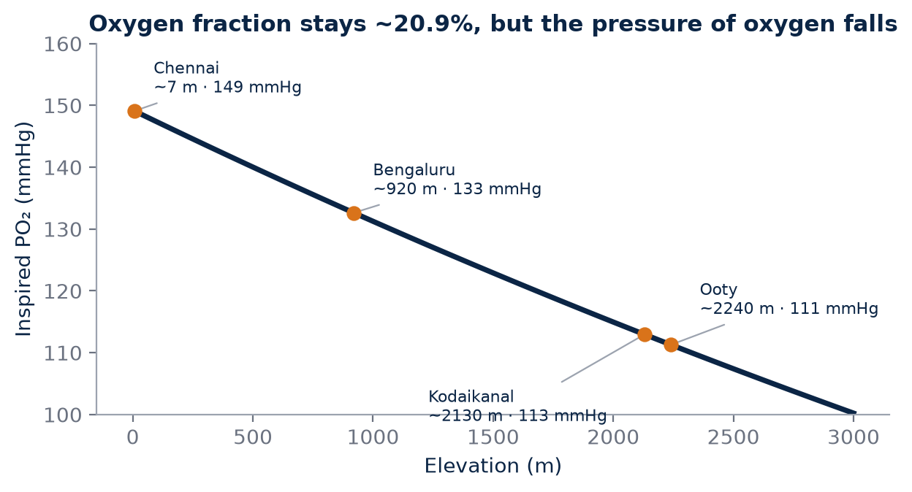
Figure 11. Approximate inspired oxygen pressure by elevation, calculated from the standard-atmosphere model (weather changes actual values). The Indian hill stations offer a moderate hypoxic stimulus.

The pressure gradient
Oxygen moves from the air in the lungs into the blood, and from the blood into the muscles, because of differences in partial pressure. Oxygen diffuses from higher to lower pressure. When the atmospheric pressure is lower, the partial pressure of oxygen in inspired air is lower, the pressure in the alveoli is lower, and the gradient driving oxygen into the blood is smaller. Arterial oxygen saturation may fall, particularly during hard exercise, and each litre of blood leaving the lungs may carry somewhat less oxygen than at sea level.
The magnitude of the change increases with altitude. The table below gives approximate values based on a standard atmosphere model. Real values vary with weather, season and latitude (tropical locations tend to have slightly higher pressure at a given altitude than the standard model), so these numbers illustrate the trend rather than exact local conditions.
Location (approx. elevation) | Barometric pressure (approx.) | Inspired PO₂ (approx.)
Sea level, e.g. Chennai | 760 mmHg | about 150 mmHg
~900 m, e.g. Bengaluru | about 680 mmHg | about 133 mmHg
~2,000 m | about 595 mmHg | about 115 mmHg
~2,200 m, e.g. Ooty | about 580 mmHg | about 112 mmHg
~2,400 m | about 565 mmHg | about 109 mmHg

Inspired PO₂ here refers to air warmed and saturated with water vapour in the airways, which is why it is lower than a simple 20.9 per cent of barometric pressure. The key message is the direction and scale: at around 2,000–2,400 m, the oxygen pressure available to the lungs is roughly a quarter lower than at sea level.
KEY IDEA
Altitude is a hypoxic stimulus created by lower barometric pressure, not a mysterious source of "more oxygen" or a place where air contains a different percentage of oxygen.

Acute responses: the first days
Acute responses include increased ventilation and heart rate. Within minutes to hours of arrival, breathing increases to compensate for the lower oxygen pressure, and heart rate at rest and during submaximal exercise is often higher. Maximal aerobic capacity is typically reduced, and the reduction becomes more noticeable as altitude increases. As a result, a pace that was comfortable at sea level may feel harder, and interval sessions at sea-level target paces may be unattainable or excessively stressful.
Sleep can be disturbed in the first nights, and some people experience headache, poor appetite or unusual fatigue. At the moderate altitudes of Indian hill stations, serious altitude illness is uncommon in healthy athletes, but symptoms should not be ignored. Persistent or worsening headache, breathlessness at rest, confusion or unsteadiness warrant stopping training and seeking medical assessment.

Longer exposure: days to weeks
Over longer exposure, the body can alter fluid balance and stimulate erythropoietic pathways. In the first days, plasma volume often decreases, which raises haemoglobin concentration even before any new red cells are produced. Over subsequent weeks, erythropoietin signalling may increase red-cell production. Ventilatory acclimatisation continues, and many athletes find that training feels progressively more normal. The magnitude depends on altitude, duration, individual response and iron availability.
Time frame | Typical response | Coaching implication
First hours to days | Higher ventilation and HR; reduced VO₂max | Reduce intensity; prioritise easy running and sleep
First days | Plasma volume may fall; Hb concentration rises | Do not mistake concentration rise for new red cells
Weeks | Possible increase in red-cell production | Needs sufficient time, dose and iron availability
After return | Adaptations decline over weeks | Plan competition timing and retesting

COACH'S CORNER
Plan the first three to five days of any altitude camp as an adjustment phase. Reduce volume and intensity, monitor morning heart rate, sleep and wellbeing, and delay hard sessions until the athlete's responses stabilise.

MYTH VS EVIDENCE
Myth: Arriving at altitude gives an athlete an immediate boost.
Evidence: The immediate effect is usually a reduction in aerobic capacity and a higher heart rate at a given pace. Any benefit depends on sufficient exposure, recovery and adaptation over weeks.

For a coach in India, these principles translate directly into the design of a hill-station camp. The athlete's first runs in Ooty or Kodaikanal are not a fair test of fitness; they are a measure of acute hypoxic stress. Only after the adjustment phase does training at altitude begin to resemble normal training, and even then pace targets may need to be revised downwards for sustained efforts. Recording heart rate, pace and perceived effort from the first day allows the coach to see the adjustment curve rather than guessing it, and to compare it with future camps.
CHECKPOINT
If your athlete's heart rate is 10 beats higher at the same easy pace on day two of a camp, how will you adjust the plan, and what would you record?

CHAPTER 25

25. The 20.9% Oxygen Truth
PART IV — ALTITUDE
Few phrases are repeated more often in endurance sport than "there is less oxygen at altitude". It sounds harmless, and in everyday conversation it communicates something real: breathing is harder up there. But the way it is usually understood, as a lower percentage of oxygen in the air, is wrong. The statement "there is less oxygen percentage at altitude" is a common shorthand, but scientifically it is inaccurate for normal atmospheric air. The oxygen fraction remains close to 20.9%.
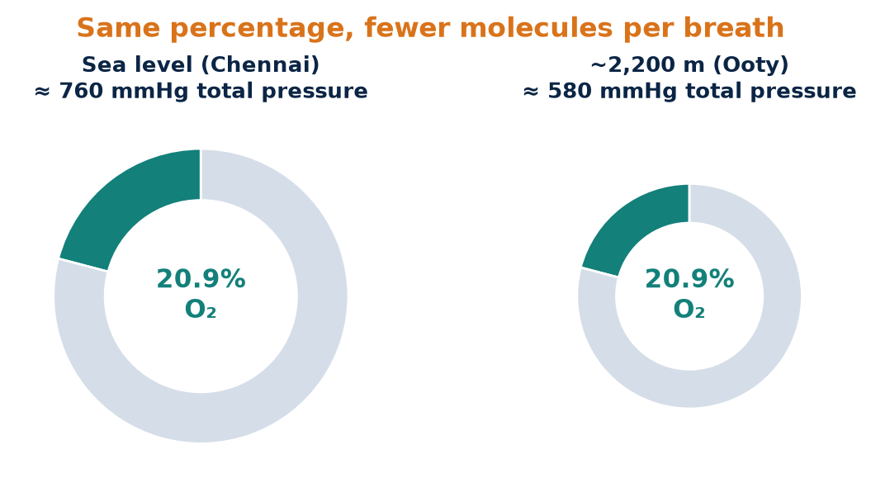
Figure 12. The ring size represents total air pressure. The oxygen fraction is unchanged at altitude; what falls is barometric pressure, and with it the partial pressure of oxygen.

Fraction versus pressure
The atmosphere is a well-mixed gas up to altitudes far higher than any runner will ever train. On a beach in Chennai, on the Ooty racecourse or on a Himalayan pass, roughly 20.9 per cent of the molecules in dry air are oxygen. What falls is atmospheric pressure. Because partial pressure is related to gas fraction multiplied by total pressure, the partial pressure of oxygen declines. Each breath therefore contains fewer oxygen molecules per unit volume than at sea level.
A simple calculation makes the point. At sea level, with a barometric pressure of about 760 mmHg, the partial pressure of oxygen in dry air is roughly 0.209 × 760, or about 159 mmHg. At around 2,200 m, with a barometric pressure of about 580 mmHg, it is roughly 0.209 × 580, or about 121 mmHg. The percentage has not changed; the pressure, and therefore the number of oxygen molecules in each breath of a given volume, has.
KEY IDEA
The oxygen percentage of air stays near 20.9% at altitude. What falls is barometric pressure, and with it the partial pressure of oxygen that drives oxygen into the blood.

Why the distinction matters
This distinction is fundamental to understanding altitude physiology. It explains why the body responds by breathing more (to move a greater volume of thinner air), why blood oxygen saturation can fall during hard efforts, and why the stimulus to the kidneys that release erythropoietin is related to oxygen availability in the tissues rather than to a change in the composition of air.
It also clarifies how simulated altitude works. Hypoxic tents and rooms usually reduce the oxygen fraction of the air at normal pressure, creating "normobaric hypoxia", whereas real altitude is "hypobaric hypoxia", with a normal fraction at reduced pressure. Both lower the inspired partial pressure of oxygen, which is the main driver of the physiological response, although researchers continue to debate whether the two conditions are fully equivalent in every respect. For AKURA, this means that simulated and natural altitude should be recorded as different interventions, with the method, the equivalent altitude and the hours of exposure specified.
Situation | Oxygen fraction | Total pressure | Inspired PO₂
Sea level, normal air | About 20.9% | Normal | Normal
Natural altitude (hypobaric) | About 20.9% | Reduced | Reduced
Hypoxic tent (normobaric) | Reduced | Normal | Reduced
Hill running at sea level | About 20.9% | Normal | Normal

Hills are not altitude
The same reasoning separates hill training from altitude training. A steep climb near sea level makes breathing hard because the workload is high, not because the air is thinner. Hill running can build strength, running economy on gradients and tolerance for high ventilation, but it does not create hypoxia. Ordinary hill running should not be described as automatically increasing lung size or producing altitude-type blood adaptations.
COACH'S CORNER
Teach athletes the correct language. Instead of "there's less oxygen up there", say "the air pressure is lower, so each breath delivers less oxygen". Correct language prevents incorrect training decisions, such as believing that a hilly loop in Chennai is a substitute for living in Kodaikanal.

MYTH VS EVIDENCE
Myth: Air at altitude contains a lower percentage of oxygen.
Evidence: The oxygen fraction of normal atmospheric air remains about 20.9% at altitude. The partial pressure of oxygen falls because total atmospheric pressure falls.

FIELD PROTOCOL
1. Explaining partial pressure to athletes
2. Show the formula: partial pressure ≈ oxygen fraction × barometric pressure
3. Calculate sea level: 0.209 × 760 ≈ 159 mmHg
4. Calculate Ooty: 0.209 × about 580 ≈ 121 mmHg
5. Ask athletes what changed, the fraction or the pressure
6. Link the answer to why easy pace feels harder on the first days of a camp

There is also a practical temperature point that often confuses athletes. Air at hill stations is usually cooler, and cool air is denser than warm air at the same pressure. This does not offset the effect of lower barometric pressure in any meaningful way for an athlete; the inspired partial pressure of oxygen is still lower in Ooty than in Chennai. Cooler air may make training feel more comfortable, but it does not cancel the hypoxic stimulus, which is precisely why altitude-plus-cool camps must be interpreted carefully.
CHECKPOINT
Can each of your athletes explain, in one sentence, why breathing is harder at altitude without saying "less oxygen percentage"? How will you record simulated versus natural altitude exposure?

CHAPTER 26

26. EPO and Red-Cell Adaptation
PART IV — ALTITUDE
The most famous proposed benefit of altitude training is an increase in red cells. The logic is appealing: more red cells means more haemoglobin, more haemoglobin means more oxygen-carrying capacity, and more oxygen delivery should support faster running. Each link in that chain is plausible, but each is also conditional. Hypoxia can stimulate erythropoietin signalling. EPO acts on the bone marrow to increase red-cell production over time. Increased red-cell mass can increase the blood's oxygen-carrying capacity.

The EPO pathway
Erythropoietin is a hormone produced mainly by the kidneys in response to reduced oxygen availability. Within hours of arriving at altitude, EPO levels in the blood can rise. EPO then stimulates the bone marrow to produce more red cells. Because red cells take time to mature and the circulating red-cell population turns over slowly, measurable increases in total haemoglobin mass require weeks rather than days. Interestingly, EPO concentration often peaks early and then falls back towards baseline even while the athlete remains at altitude, so a single EPO measurement is a poor guide to eventual adaptation.
The most useful outcome measure for this pathway is total haemoglobin mass, which can be estimated with carbon-monoxide rebreathing methods in specialised laboratories. A meta-analysis by Gore and colleagues, published in the British Journal of Sports Medicine in 2013, pooled studies using this method and estimated an average increase in haemoglobin mass of roughly 1 per cent per 100 hours of altitude exposure, with considerable individual variability. That figure implies that a three-week camp with most of each day spent at altitude might, on average, produce a modest increase of a few per cent, and that short or partial exposures produce correspondingly less.
KEY IDEA
Hypoxia can increase EPO and, over weeks, red-cell mass. The average effect is modest, dose-dependent and highly variable between individuals.

Conditions for a response
But an athlete does not automatically become faster simply because EPO rises. The response needs sufficient exposure, adequate iron availability and enough time. The training programme must also maintain quality. Several factors influence whether an increase in red-cell production actually occurs and whether it translates into performance.
Factor | Why it matters
Hours of exposure | Hb-mass response is related to cumulative hypoxic time
Altitude level | Too low may give little stimulus; too high may impair sleep and training
Iron availability | Red-cell production requires iron
Illness and inflammation | Can blunt the response
Sleep and energy intake | Recovery and energy availability support adaptation
Training quality | Performance gains need maintained training stimulus

Iron deserves special mention. An athlete with insufficient iron stores may not respond as expected to an altitude intervention. Ferritin and broader blood assessment before a camp can be relevant in a supervised sports-medicine programme. Iron supplementation should be decided by a qualified clinician based on test results, not by a coach or athlete guessing, because excessive iron carries its own risks.
COACH'S CORNER
Four to six weeks before a planned altitude block, arrange for the athlete to discuss blood testing, including iron status, with a qualified doctor. Record the results in the AEI profile so that any later haemoglobin changes can be interpreted in context.

Asking the right question
It is tempting to ask, "Does altitude work?" The history of research on this question is full of apparently contradictory findings, partly because studies differed in altitude, duration, hours per day, training, athlete level and measurement methods. The correct research question is not "Does altitude work?" but "For which athlete, at what dose, under what protocol, and with what measurable response?"
FIELD PROTOCOL
1. Red-cell adaptation monitoring plan
2. Baseline: blood assessment including iron status as advised by a doctor, and Hb mass if laboratory access exists
3. Record daily hours at altitude, sleeping elevation and training elevation
4. Retest Hb concentration only with the same laboratory, time of day and posture, noting that early rises may reflect plasma loss
5. Retest Hb mass, where available, near the end of the block and after return
6. Pair blood measures with a standard performance or pace-HR test

MYTH VS EVIDENCE
Myth: A higher haemoglobin concentration after one week at altitude proves new red cells have been made.
Evidence: Early rises in concentration often reflect a fall in plasma volume. New red-cell mass takes weeks and is best assessed by total haemoglobin mass.

Finally, red-cell adaptation is not permanent. After returning to sea level, the stimulus to produce extra red cells disappears, and haemoglobin mass is generally expected to return towards baseline over the following weeks as red cells reach the end of their natural lifespan. The timing of competition after a camp is therefore a practical question with no universal answer; coaches often balance the potential benefit of higher red-cell mass against the fatigue of travel and the need to re-establish sea-level race pace.
CHECKPOINT
For your next altitude plan, how many total hours of exposure will the athlete accumulate, and how will you know whether iron availability was adequate?

CHAPTER 27

27. Living High, Training Low
PART IV — ALTITUDE
One of the central problems of altitude training is that the environment which may stimulate red-cell production also makes hard training more difficult. At altitude, the athlete cannot usually run intervals at sea-level speeds. Over weeks, a lower training intensity might offset some of the benefit of any blood adaptation. Live-high, train-low strategies attempt to combine the physiological stimulus of hypoxia with the ability to perform high-quality running at a lower altitude. The rationale is to obtain erythropoietic adaptation without sacrificing training intensity.
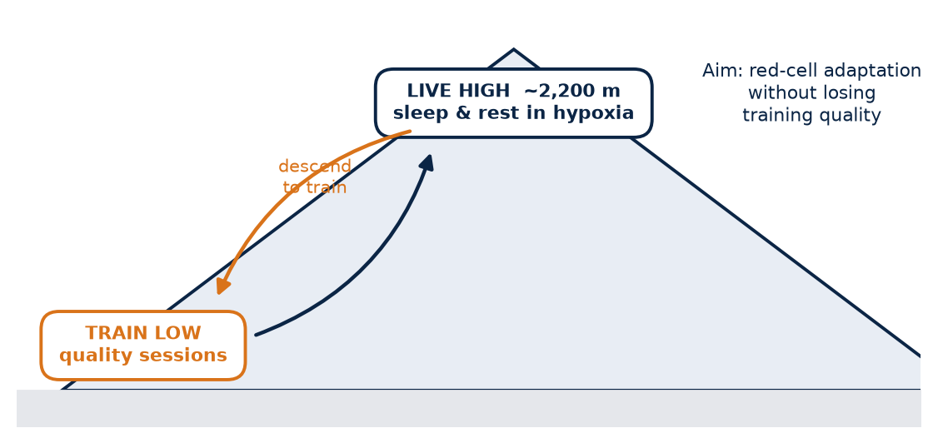
Figure 13. Live high, train low: the athlete sleeps at altitude for the hypoxic stimulus and descends for high-quality training. Responses vary between athletes.

The classic study
The best-known study of this approach was published by Benjamin Levine and James Stray-Gundersen in the Journal of Applied Physiology in 1997. Trained runners were divided into groups that lived and trained near sea level, lived and trained at moderate altitude, or lived at moderate altitude (about 2,500 m) while travelling down to train at a lower altitude (about 1,250 m). After four weeks, the live-high, train-low group improved 5,000 m race performance compared with the sea-level control group. The researchers attributed the benefit to a combination of increased red-cell mass and preserved training quality.
That study became the foundation of many national altitude programmes and later variants: living in hypoxic tents or rooms, training high for easy runs and low for key sessions, or using supplemental oxygen during hard sessions at altitude. Subsequent research from the same group and others also highlighted considerable individual variation in response.
KEY IDEA
Live-high, train-low aims to separate the hypoxic stimulus (sleeping and living high) from training quality (running hard sessions low). It is a rationale to test, not a guarantee.

Variable results
Results vary across protocols and athletes. The literature contains both positive and null findings, and response variability is important. Some well-controlled studies, including placebo-controlled designs in which athletes did not know whether their tents were hypoxic, have reported little or no performance benefit. Others report meaningful gains. Differences in hours per day, altitude, duration, athlete level, iron status and the precision of performance measurement all contribute. A change of one or two per cent in performance is important for elite athletes but is also close to the day-to-day variability of many tests, which makes detection difficult.
Variant | How it works | Main practical challenge
Classic LHTL | Live high, travel down to train | Requires two suitable sites close together
Live high, train high and low | Easy runs high, key sessions low | Travel logistics; tracking where each session occurs
Simulated LHTL | Hypoxic tent or room at home | Cost; sleep disruption; dose verification
Live and train high | All sessions at altitude | Intensity may need to fall

An Indian perspective
The Nilgiri and Palani hills offer interesting possibilities. An athlete could, in principle, live in Ooty or Kodaikanal and descend for key sessions, but the road descents are long and winding, so travel time and fatigue must be considered honestly. In practice, many Indian coaches may find it more realistic to reduce intensity at altitude and schedule the most important sessions before or after the camp, or to modify pace targets using heart rate and effort. Each of these is a different intervention and should be recorded as such.
AKURA should therefore avoid treating "live high, train low" as a guaranteed recipe. It is one intervention to be tested against the athlete's baseline and control condition. The athlete's own history, the logistics of the location and the goals of the season all determine whether it is sensible.
COACH'S CORNER
Before promising an athlete a live-high, train-low benefit, write down the sleeping elevation, training elevations, hours per day, number of days, planned key sessions and the tests you will use before and after. If you cannot specify these, you are not yet ready to run the intervention.

FIELD PROTOCOL
1. Altitude camp logging protocol
2. Daily: sleeping location and elevation, hours spent above target altitude, waking HR, sleep duration and quality, body mass, wellbeing score
3. Per session: training elevation, duration, distance, pace, average HR, RPE, temperature and humidity
4. Weekly: summary of total hypoxic hours and training load
5. Before and after: standard performance test and pace-HR test at the same location and conditions, blood tests as advised by a doctor
6. Note illnesses, travel days and missed sessions

MYTH VS EVIDENCE
Myth: Live high, train low always improves sea-level performance.
Evidence: Some studies show benefits and others show little or none. The outcome depends on dose, protocol, logistics and the individual athlete.

A further practical point concerns the return to lower altitude. Some athletes report feeling flat for several days after coming down from the hills, while others feel strong almost immediately. The reasons are not fully understood and likely include travel fatigue, changes in training load and individual physiology. Rather than relying on popular rules about the perfect number of days before a race, the AKURA approach is to log how each athlete performs in the days and weeks after returning, building an individual timing profile over several camps.
CHECKPOINT
If your athlete lived in Ooty for three weeks, where would the key sessions take place, and how would you know whether training quality was preserved?

CHAPTER 28

28. Ooty and Kodaikanal as Indian Research Sites
PART IV — ALTITUDE
India does not need to borrow mountains. The Western Ghats contain hill stations at elevations comparable with some well-known international altitude training sites, and many Indian coaches already take athletes there. Indian hill stations such as Ooty and Kodaikanal can provide useful altitude environments, but the exact physiological stimulus depends on elevation, sleeping altitude, time spent there and training load. A coach should never label a location "altitude training" without specifying the actual exposure.

The sites
Ooty (Udhagamandalam), in the Nilgiri Hills of Tamil Nadu, lies at roughly 2,200–2,240 m for the main town. Kodaikanal, in the Palani Hills, lies at roughly 2,100–2,130 m. Both fall within the moderate-altitude range often discussed for altitude training, typically described as roughly 1,800–2,500 m or a little higher, although the exact optimal altitude remains debated. For comparison, Bengaluru, at about 900–920 m, is too low to be considered a conventional altitude site but is not at sea level either; its milder climate may matter as much as its elevation.
Location | Approx. elevation | Environmental character
Chennai | Near sea level | Hot, often humid, coastal
Bengaluru | About 900–920 m | Milder, moderate elevation
Kodaikanal | About 2,100–2,130 m | Cool, hilly, moderate altitude
Ooty (Udhagamandalam) | About 2,200–2,240 m | Cool, hilly, moderate altitude

These figures describe the town centres. Accommodation, training routes and tracks within and around each town can lie hundreds of metres higher or lower, and routes often include steep gradients. A camp that sleeps at 2,000 m and trains on roads between 1,800 and 2,300 m provides a different stimulus from one that sleeps at 2,250 m and trains mainly on flat ground at the same height.
KEY IDEA
"Ooty" or "Kodaikanal" is not a dose. The dose is the sleeping elevation, the hours spent there, the training elevations and the duration of the stay.

Confounding factors
Travel itself can affect sleep, hydration and training. The journey up from the plains involves long road travel, and the first days may be disrupted by fatigue, new food and unfamiliar sleeping arrangements. Temperature can also change with elevation, creating a mixed altitude-plus-cooler-environment intervention. An athlete from Chennai who spends three weeks in Kodaikanal may improve partly because of hypoxia, partly because cooler conditions allow higher-quality training and better sleep, partly because of a dedicated camp environment with fewer distractions, and partly because of increased training volume on hilly terrain.
This is not a weakness of Indian hill stations; it is simply the reality of field research. It does, however, mean that performance improvements after a camp cannot automatically be attributed to altitude. A comparison group, or a comparison period at a cool, low-altitude location, would help separate these effects, though such designs are often difficult in practice.
Possible reason for improvement | How to check
Hypoxic adaptation | Hb mass change, where available; hours of exposure
Cooler training conditions | Compare session quality and HR with home training
Better sleep and fewer distractions | Sleep log; wellbeing scores
Increased hill training | Record elevation gain and terrain
Increased training load | Weekly load before and during camp

Recording the camp properly
A rigorous study records location, elevation, sleeping hours, training altitude and environmental conditions rather than simply writing "hill camp." A phone GPS or barometric watch can give a reasonable estimate of elevation, but readings should be checked against known reference points, because barometric altimeters drift with weather changes.
COACH'S CORNER
Keep a camp sheet for every athlete. At minimum it should show where they slept, for how long, at what elevation, where each session took place, and what the weather was. Two athletes at the same camp can receive very different doses if one spends afternoons in the town below or sleeps poorly.

FIELD PROTOCOL
1. Indian hill-station camp protocol
2. Two to four weeks before: baseline pace-HR test and performance test at home, and medical and blood assessment as advised
3. Travel day: easy or no training, focus on fluids and sleep
4. Days 1–4: easy running only, monitor waking HR, sleep and symptoms
5. Days 5 onwards: introduce quality gradually, adjusting pace targets by HR and effort
6. Log daily sleeping elevation, hours at altitude, training elevation and weather
7. Final days: repeat pace-HR test at altitude for within-camp comparison
8. After return: retest at home in comparable conditions at planned intervals

MYTH VS EVIDENCE
Myth: Any hill station is altitude training.
Evidence: A location becomes an altitude intervention only when elevation, sleeping hours, training altitude and duration are sufficient and recorded. A short weekend trip provides little hypoxic dose.

Hill stations also bring practical considerations that deserve planning. Monsoon rain and mist can make roads slippery and reduce visibility, some routes carry heavy tourist traffic in holiday seasons, and steep descents increase eccentric load on the legs. Accommodation, food quality and access to medical facilities vary. A camp calendar that avoids the heaviest rain and busiest tourist periods, and a clear plan for injury and illness, makes the altitude stimulus easier to deliver safely and consistently.
CHECKPOINT
For your last camp, could you state the sleeping elevation, total hours at altitude and training elevation for each athlete? Which other factors might explain the improvement you observed?

CHAPTER 29

29. Altitude Responders and Non-Responders
PART IV — ALTITUDE
Put twenty athletes through the same altitude camp and they will not return with twenty identical results. Some improve their haemoglobin mass and race times; others show little change; a few may perform worse. Athletes do not respond identically to altitude. Differences may arise from exposure dose, iron status, baseline Hb mass, genetics, sleep, ventilation and individual physiology. The variability is not noise to be ignored; it is one of the most important findings in altitude research.

Sources of variability
Chapman, Stray-Gundersen and Levine (1998), analysing runners in live-high, train-low research, described athletes whose performance improved as "responders" and those whose performance did not as "non-responders", and reported differences between the groups in EPO and red-cell responses. The Gore et al. (2013) meta-analysis also emphasised the wide spread of individual haemoglobin mass responses around the average.
Several factors plausibly contribute. An athlete with low iron stores may lack the raw material for red-cell production. An athlete who already has a high haemoglobin mass may have less room for improvement. Poor sleep at altitude may limit recovery, and differences in the ventilatory response may affect oxygen saturation. Illness during the camp, reduced energy intake or excessive training load can blunt adaptation. Inherited biology may also play a role, but it should be treated as background context rather than a convenient explanation for every disappointing result.
Possible contributor | What could be measured
Insufficient exposure | Hours at altitude, sleeping elevation
Low iron availability | Ferritin and blood assessment via a doctor
High baseline Hb mass | Hb mass, where available
Poor sleep | Sleep duration and quality log
Illness or overload | Symptom log; training load
Measurement error | Repeat tests; known test reliability

KEY IDEA
Response to altitude is individual and variable. A disappointing result is information about that athlete, dose and protocol, not a verdict on the athlete's potential.

Using the label carefully
The concept of a "non-responder" should be used carefully. Failure to improve a single marker may reflect insufficient exposure or measurement error rather than a permanent inability to adapt. Haemoglobin mass measurement has a typical error of a couple of per cent even in good laboratories, which is similar in size to the expected average adaptation from a short camp. Performance tests are also affected by weather, motivation, fatigue and timing. An athlete labelled a non-responder after one camp might respond to a longer exposure, better iron status, or a better-timed retest.
There is also a human risk. Telling an athlete they are "a non-responder" can become a self-fulfilling belief, discouraging effort or leading to the conclusion that their body is fundamentally limited. AKURA avoids fixed labels based on limited evidence.

Response as a trend
AEI should track response as a confidence interval and trend, not as a permanent label. In practice, this means recording each altitude exposure with its dose, the measured changes, and an honest estimate of uncertainty. Over several exposures, a pattern may emerge: perhaps an athlete consistently shows clear improvement after longer camps but not after short ones, or responds well only when iron status is adequate.
COACH'S CORNER
After each camp, describe the athlete's response in three parts: what changed, how confident you are that it was a real change beyond normal test variation, and what might explain it. Avoid the words "responder" or "non-responder" unless you have repeated evidence under well-controlled conditions.

FIELD PROTOCOL
1. Individual response record
2. List the dose: days, sleeping elevation, hours at altitude
3. List the pre and post values for each marker (pace-HR, performance test, Hb measures if available)
4. Note each test's typical error, estimated from repeated baseline tests if possible
5. Classify each change as likely real, unclear or likely noise
6. Note conditions that could explain the result: illness, iron, sleep, load
7. Compare with the athlete's previous camps before drawing conclusions

MYTH VS EVIDENCE
Myth: Some athletes simply cannot benefit from altitude.
Evidence: Single-camp results are affected by dose, iron status, illness and measurement error. Permanent non-response should not be assumed without repeated, well-controlled evidence.

CHECKPOINT
If an athlete showed no improvement after a camp, which three explanations would you investigate before concluding that altitude does not suit them?

PART IV AT A GLANCE
The key idea from each chapter, for quick revision.
24 | What Changes at Altitude?  Altitude is a hypoxic stimulus created by lower barometric pressure, not a mysterious source of "more oxygen" or a place where air contains a different percentage of oxygen.
25 | The 20.9% Oxygen Truth  The oxygen percentage of air stays near 20.9% at altitude. What falls is barometric pressure, and with it the partial pressure of oxygen that drives oxygen into the blood.
26 | EPO and Red-Cell Adaptation  Hypoxia can increase EPO and, over weeks, red-cell mass. The average effect is modest, dose-dependent and highly variable between individuals.
27 | Living High, Training Low  Live-high, train-low aims to separate the hypoxic stimulus (sleeping and living high) from training quality (running hard sessions low). It is a rationale to test, not a guarantee.
28 | Ooty and Kodaikanal as Indian Research Sites  "Ooty" or "Kodaikanal" is not a dose. The dose is the sleeping elevation, the hours spent there, the training elevations and the duration of the stay.
29 | Altitude Responders and Non-Responders  Response to altitude is individual and variable. A disappointing result is information about that athlete, dose and protocol, not a verdict on the athlete's potential.

PART V — HEAT VS ALTITUDE
In Indian running circles, a question keeps returning: if heat can expand plasma volume and lower heart rate, can a Chennai summer do what a mountain camp does? Part V addresses that question directly and without slogans. It contrasts plasma-volume adaptation with red-cell adaptation, asks whether heat can replace altitude, and considers whether the two stresses should ever be combined. The answer is neither "yes" nor "no" but "define the adaptation you want, then measure it". Heat and altitude overlap in some outcomes and differ fundamentally in their mechanisms, and good coaching depends on knowing which is which.
IN THIS PART
30 Plasma Versus Red-Cell Adaptation
31 Can Heat Replace Altitude?
32 Combining Heat and Altitude
CHAPTER 30

30. Plasma Versus Red-Cell Adaptation
PART V — HEAT VS ALTITUDE
Heat and altitude are often discussed together because both are environmental stresses that can change an endurance athlete's blood and cardiovascular responses. Both can make running feel harder at first, both can lower performance acutely, and both may be followed by improved fitness. Heat and altitude can overlap in cardiovascular stress but differ in their primary stimuli. Heat strongly challenges thermoregulation and fluid balance; altitude reduces inspired oxygen pressure.
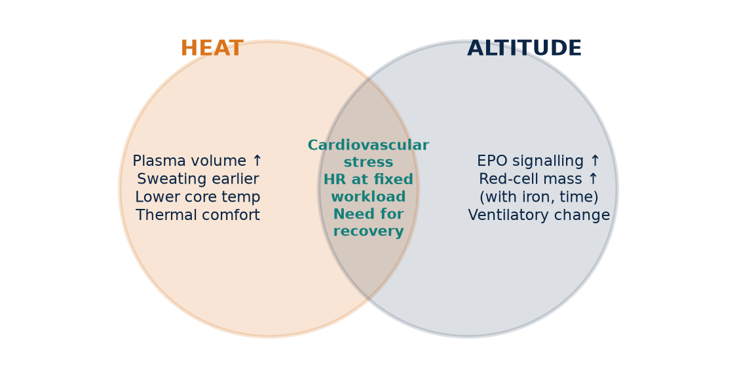
Figure 14. Heat and altitude overlap in cardiovascular stress but have different primary adaptations. Define the target adaptation before choosing the environment.

Two different signals
A useful conceptual contrast is: heat can produce plasma-volume and thermoregulatory adaptation, while sustained hypoxia can stimulate erythropoiesis. Both may affect cardiovascular function, but through different pathways. Heat acclimation asks the body to protect circulation while dumping heat, and the body's response includes expanding plasma, adjusting sweating and reducing cardiovascular strain. Altitude asks the body to deliver oxygen when the pressure driving it into the blood is lower, and the body's response, given sufficient time and dose, includes increased red-cell production.
Blood is made up mainly of plasma and cells, most of which are red cells. Total blood volume can therefore increase in two broad ways: by adding plasma, or by adding red cells (which brings along some additional plasma as well). The two routes have different consequences for oxygen transport.
Feature | Heat acclimation | Altitude exposure
Primary stimulus | Raised body and skin temperature | Lower inspired oxygen pressure
Main blood change | Plasma volume may rise | Red-cell (Hb) mass may rise over weeks
Typical time course | Many changes within 1–2 weeks | Hb mass needs weeks of sufficient exposure
Effect on Hb concentration | May fall (dilution) | Often rises early (plasma loss), then Hb mass may rise
Thermoregulation | Directly improved | Not a primary target
Accessibility in India | Widely available (e.g. Chennai) | Requires travel (e.g. Ooty, Kodaikanal) or simulation

KEY IDEA
Heat mainly targets plasma volume and thermoregulation; altitude mainly targets red-cell production. Both can influence cardiovascular function, but through different pathways.

What each adaptation can and cannot do
More plasma can support stroke volume, cooling and cardiovascular stability, especially in warm conditions. But plasma does not carry much oxygen; oxygen is carried by haemoglobin in red cells. More red cells can increase the blood's total oxygen-carrying capacity, but a thicker blood without adequate plasma might also increase viscosity, and red cells alone do not improve heat dissipation. The two adaptations are therefore complementary rather than interchangeable.
An analogy may help athletes. Plasma expansion is like widening the road and adding more lanes of traffic; red-cell expansion is like adding more delivery lorries carrying oxygen. Both can improve the supply chain, but they solve different problems. The analogy is simplified, and like all analogies it should not be pushed too far, but it captures why "heat equals altitude" misleads.
COACH'S CORNER
When an athlete asks, "Is heat training my altitude?", respond with a question: "What adaptation are we looking for?" If the answer is better tolerance of race-day heat, heat is the direct tool. If the answer is more red-cell mass, altitude or a well-designed simulated altitude programme is the more direct stimulus.

Measuring the difference
This is why "heat equals altitude" is too simple. The scientifically interesting question is where the adaptations overlap and where they do not. To answer that, the AEI must record separate markers: plasma-related measures (changes in pace-HR relationship, heart-rate drift, estimated plasma volume change where laboratory methods allow), thermoregulatory measures (sweat rate, core or skin temperature where available, thermal comfort) and red-cell measures (haemoglobin mass where available, with haemoglobin concentration interpreted cautiously).
FIELD PROTOCOL
1. Separating plasma and red-cell responses
2. Baseline: pace-HR test, sweat-rate estimate and blood assessment as advised by a doctor, with Hb mass if possible
3. After heat block: repeat all tests; expect possible HR and sweat changes and possible Hb concentration fall
4. After altitude block: repeat all tests; interpret early Hb concentration rise cautiously and look for Hb mass change
5. Record each result with the environmental conditions of testing
6. Summarise which pathway changed, not only whether performance changed

MYTH VS EVIDENCE
Myth: Heat training and altitude training produce the same blood adaptation.
Evidence: Heat mainly expands plasma volume and improves thermoregulation; altitude can stimulate red-cell production. Performance effects may overlap, but the mechanisms differ.

The time course also differs. Heat-related adaptations are relatively quick to appear and relatively quick to decay, often over a matter of weeks without exposure. Red-cell adaptations to altitude take longer to build and, once exposure ends, decline as the extra red cells reach the end of their lifespan. These timelines matter for scheduling: a heat block might be placed close to a hot race, while an altitude block requires a longer lead time and careful planning of the return to sea level.
CHECKPOINT
Which markers in your current monitoring could distinguish a plasma-volume adaptation from a red-cell adaptation? Which are missing?

CHAPTER 31

31. Can Heat Replace Altitude?
PART V — HEAT VS ALTITUDE
For a sea-level athlete in India, the question is practical and personal. Altitude camps cost money, time away from work or study, and family support. Heat is available on the doorstep for much of the year. If heat could deliver the same benefits, it would democratise a powerful training tool. Heat acclimation may improve endurance performance and can alter plasma volume and cardiovascular function. Altitude exposure can increase haemoglobin mass in appropriate protocols. These are not the same adaptation.

What the studies suggest
Interest in heat as an "altitude alternative" grew after studies such as Lorenzo et al. (2010) reported performance improvements in cool conditions following heat acclimation. Some studies compare heat and altitude interventions and show overlapping performance outcomes under certain conditions, while the underlying physiology can differ. In some comparisons, both groups improved time-trial performance to a broadly similar extent, yet one group showed plasma expansion while the other showed changes in red-cell measures. Other studies have found little benefit from heat for performance in cool conditions, and results vary with protocol, athlete level and the test used.
The honest interpretation is that heat can improve some aspects of endurance performance for some athletes, particularly performance in the heat, and may help in cooler conditions in certain protocols. It does not reliably reproduce the red-cell response that altitude can provoke, and it should not be sold as a free equivalent of a mountain camp.
KEY IDEA
Heat can be a valuable sea-level tool, but it is not a copy of altitude. Define the target adaptation first, then choose the stimulus.

Start with the target adaptation
Therefore a coach should define the desired adaptation first. If the objective is thermoregulation, heat is directly relevant. If the objective is erythropoietic stimulation, altitude is the more direct environmental stimulus. If the objective is marathon performance, the outcome must be measured rather than assumed.
Coaching objective | More direct tool | Key measurement
Race in hot, humid conditions | Heat acclimation | Pace-HR in heat; sweat rate; thermal comfort
Increase red-cell mass | Altitude (natural or simulated) | Hb mass, where available
Improve cardiovascular stability at sea level | Heat, or consider both | Pace-HR drift; performance test
Improve marathon time | Depends on athlete and race | Race or time-trial performance, in comparable conditions
Limited budget, no travel | Heat, plus well-planned training | Pace-HR, performance trend

For many Indian marathoners, the race environment itself provides the answer. Several major Indian road races are run in warm and often humid conditions, even with early starts. An athlete preparing for such a race has a direct reason to be heat-acclimated. The same athlete preparing for a cool autumn marathon abroad may have more reason to consider altitude or simply high-quality training in the coolest available conditions.
COACH'S CORNER
Write the objective in one sentence before choosing heat or altitude, for example: "Reduce heart-rate drift during a 30 km run in Chennai conditions" or "Increase haemoglobin mass before the spring marathon". The sentence decides the intervention; the measurement decides whether it worked.

The measurement obligation
Whichever tool is chosen, the claim must be tested. A heat block followed by a faster race does not prove that heat caused the improvement; the athlete may also have been fitter, better tapered or racing in kinder weather. The AEI approach is to measure the outcome in comparable conditions, record the intervention dose and repeat interventions over time to build individual evidence.
FIELD PROTOCOL
1. Heat-versus-altitude decision test
2. Step 1: write the target adaptation in one sentence
3. Step 2: identify the most direct stimulus for that adaptation
4. Step 3: check feasibility, cost and safety, including medical clearance
5. Step 4: select one primary and two secondary measurements
6. Step 5: run a baseline test under recorded conditions
7. Step 6: deliver the intervention with full dose logging
8. Step 7: retest under comparable conditions and record the result with its uncertainty

MYTH VS EVIDENCE
Myth: A Chennai summer is a free altitude camp.
Evidence: Heat and humidity can produce valuable adaptations, particularly for racing in the heat, but they do not reliably reproduce the red-cell response to altitude. They are different tools for different targets.

Cost and access are legitimate coaching considerations, not signs of lower ambition. A Chennai athlete who cannot travel to the hills for a month can still build a high-quality aerobic base, improve running economy, develop threshold fitness and prepare for race-day heat with a careful acclimation block. These controllable elements often matter more than any environmental intervention. The mistake is not choosing heat over altitude; the mistake is making promises about either that the data cannot support.
CHECKPOINT
For your athlete's next target race, what is the likely race-day environment, and which adaptation matters most for that race?

CHAPTER 32

32. Combining Heat and Altitude
PART V — HEAT VS ALTITUDE
If heat and altitude each offer something, it is tempting to use both, perhaps simultaneously. Some coaches have experimented with heat sessions at altitude or with alternating blocks. Combining environmental stresses can increase total physiological load. That can be useful, but it can also reduce training quality and recovery if the dose is poorly controlled.

Stress is not automatically stimulus
The first rule is not to stack stress simply because more stress sounds more scientific. The intervention should have a reason, a target adaptation and a monitoring plan. Every stressor draws on the same finite capacity to recover. An athlete doing hard training, adjusting to altitude, sleeping poorly and adding heat sessions may simply accumulate fatigue. At best, the extra stress adds little; at worst, it increases the risk of illness, heat injury or a poor training block.
There is also a physiological interaction to consider. Early in altitude exposure, plasma volume often falls, while heat acclimation tends to expand plasma volume. Some researchers have speculated that the two might complement each other; others worry that combined stress could blunt one response or overwhelm recovery. The evidence on combined heat and hypoxia is limited and mixed, and it does not yet justify confident recommendations for routine practice.
KEY IDEA
Combining heat and altitude increases total load. Use it only with a clear purpose, a target adaptation, careful monitoring and medical support, not because more stress sounds more scientific.

Sequencing rather than stacking
For most athletes, sequencing is safer and easier to interpret than stacking. A practical research sequence is: baseline → heat block → washout/retest → altitude block or control → retest. Each block has a clear target, each is measured, and the washout period allows at least partial return towards baseline before the next intervention.
Phase | Purpose | Example duration
Baseline | Establish pace-HR, performance, blood markers | 1–2 weeks of testing
Heat block | Target thermoregulation and plasma volume | 10–14 days
Washout and retest | Allow partial decay; measure retention | Several weeks
Altitude block or control | Target red-cell response, or compare with no altitude | 3–4 weeks
Retest | Measure combined and separate effects | Within 1–3 weeks after return

Durations are indicative and must be adjusted to the athlete, season and competition calendar. The washout interval in particular is uncertain; heat adaptations decline over weeks, but some benefits may persist longer than others.

Order effects and study design
The order should be randomised where feasible in a formal study, because adaptation from the first block can influence the second. An athlete who completes heat acclimation first may arrive at altitude with an expanded plasma volume and a different fluid balance. An athlete who does altitude first may begin the heat block with altered blood characteristics. In a group study, randomising the order (some athletes heat first, others altitude first) helps separate the effects of each intervention from the effect of sequence and from general improvements in fitness over time.
For an individual athlete, full randomisation may not be possible, but the coach can still learn by recording the order, the dose and the results carefully and comparing across seasons.
COACH'S CORNER
If you do combine or sequence heat and altitude, reduce training load during the first days of each new environmental block, keep your heat-illness stop rules active at every elevation, and check sleep, morning heart rate and wellbeing daily. The environment should add stimulus, not replace recovery.

FIELD PROTOCOL
1. Combined-intervention monitoring
2. Daily: waking HR, sleep, wellbeing, body mass, symptoms
3. Each session: environment (temperature, humidity, elevation), duration, pace, HR, RPE
4. End of each block: standard pace-HR test and performance test
5. Stop rules: any heat-illness warning sign, persistent unusual fatigue, illness or sharply elevated waking HR prompts reduced load and review
6. Medical: agree a plan with a qualified professional before the first block

MYTH VS EVIDENCE
Myth: Doing heat and altitude together doubles the benefit.
Evidence: Combined stresses add to total load and may interfere with recovery or with each other. The evidence is limited and mixed, and sequencing with measurement is usually safer and easier to interpret.

This is where the AKURA philosophy becomes concrete. The environment is a tool, the athlete's response is data, and the goal is understanding rather than spectacle. Whether an athlete trains in the humidity of Chennai, the cool air of Kodaikanal or both, the question remains the same: what did we give the body, how did it respond, and how certain are we?
CHECKPOINT
If you planned both heat and altitude for one athlete this year, what order would you choose, how long would the washout be, and what result would lead you to change the plan next year?

PART V AT A GLANCE
The key idea from each chapter, for quick revision.
30 | Plasma Versus Red-Cell Adaptation  Heat mainly targets plasma volume and thermoregulation; altitude mainly targets red-cell production. Both can influence cardiovascular function, but through different pathways.
31 | Can Heat Replace Altitude?  Heat can be a valuable sea-level tool, but it is not a copy of altitude. Define the target adaptation first, then choose the stimulus.
32 | Combining Heat and Altitude  Combining heat and altitude increases total load. Use it only with a clear purpose, a target adaptation, careful monitoring and medical support, not because more stress sounds more scientific.

PART VI — MARATHON ENGINE
The marathon is where endurance physiology stops being theory and becomes a public examination. Aerobic power, sustainable intensity, fuel, fluid, heat and muscular resilience must all hold together for two to five hours, and the weakest link decides the outcome. This part treats the marathon as a systems test rather than a longer 5K. It explains why marathon pace is a fraction of aerobic capacity, why that fraction differs between athletes, why pace so often collapses late in the race, and why the final 10 km reveals a quality short races cannot: durability. These ideas prepare the ground for AKURA's argument that an athlete needs distance-specific profiles, not one permanent number.
IN THIS PART
33 The Marathon Is a Systems Test
34 Fractional VO₂max and Marathon Pace
35 Why Marathon Pace Fails Late
36 The Last 10K
CHAPTER 33

33. The Marathon Is a Systems Test
PART VI — MARATHON ENGINE
The marathon is not a 42.195 km version of a 5K. A 5K asks how much oxygen an athlete can use and how much discomfort they can tolerate for a quarter of an hour. A marathon asks a different, broader question: can every system that supports running continue to cooperate for hours, while fuel stores fall, body water is lost, heat accumulates and muscle fibres fatigue? It is a long-duration systems test involving aerobic power, sustainable intensity, glycogen management, hydration, thermoregulation, musculoskeletal resilience and pacing. An athlete can be strong in five of these and still have a poor race because the sixth failed.

Seven systems, one finish line
It helps to name the systems explicitly, because each can be measured and each can be trained. Aerobic power sets the ceiling. Sustainable intensity, usually discussed through lactate threshold and fractional utilisation, determines how close to that ceiling the athlete can run for hours. Glycogen management determines whether carbohydrate lasts to the finish. Hydration influences plasma volume and cardiovascular strain. Thermoregulation decides how much blood must be diverted to the skin for cooling. Musculoskeletal resilience governs whether the legs can keep producing the same force with each step. Pacing is the decision-making system that spends all of these resources, wisely or badly.
System | What it contributes | How it fails late
Aerobic power | Upper limit of oxygen use | Rarely the late limiter itself
Sustainable intensity | Fraction of capacity held for hours | Pace set above true sustainable level
Fuel (glycogen) | Carbohydrate for high-intensity running | Depletion, rising effort, slowing
Fluid balance | Plasma volume, sweat capacity | Rising heart rate, heat strain
Thermoregulation | Heat dissipation | Core temperature rises, pace falls
Muscle and tendon | Force production each stride | Mechanics change, cost rises
Pacing | Allocation of all resources | Early overspending

KEY IDEA
A marathon is limited by the weakest system on the day, not by the strongest number on the athlete's test report.

Why the last 10 km tells the truth
The final 10 km exposes weaknesses that may not appear in a short race. Cardiac drift, dehydration, glycogen depletion, heat accumulation and muscular fatigue can all increase the cost of running. The athlete may be holding the same pace on the watch, yet the internal price of that pace is rising: heart rate creeps up, breathing deepens, perceived effort climbs, and stride mechanics become less efficient. When the internal cost exceeds what the athlete can pay, pace falls.
This is why two runners with similar 10K times can finish a marathon ten minutes apart. The shorter race measured mainly their aerobic capacity and threshold; the marathon measured their ability to keep those qualities stable as fatigue accumulated.
MYTH VS EVIDENCE
Myth: A fast 10K runner will automatically run a fast marathon.
Evidence: Short-race speed predicts marathon potential only when long-run conditioning, fuelling, heat tolerance and durability are also developed; the marathon adds systems that a 10K barely tests.

Central physiology and peripheral fatigue
A good marathon model therefore tracks both central physiology and peripheral fatigue. Central measures include heart rate, cardiac drift, breathing and core temperature, reflecting the heart, lungs and circulation. Peripheral measures describe what happens in the working muscles and tendons: local fatigue, glycogen depletion within fibres, and the gradual change in ground contact and stride that increases the oxygen cost of each kilometre.
In the Indian context, the marathon systems test is often run in warm, humid conditions, where fluid and heat systems are stressed earlier than in cool European races. A Mumbai, Chennai or Hyderabad marathon may therefore reward a different balance of qualities than a cool-weather race, and an athlete's profile should be interpreted with the environment recorded.

Measuring the systems test
If the marathon is a systems test, then preparation should include system checks. Not every athlete needs a laboratory. A coach can learn a great deal from simple, repeatable observations: the heart-rate drift during a steady 25 km run, the change in body mass across a long run, the pace of the last 5 km of a marathon-specific session, and the athlete's notes on gut comfort and leg feel. Recorded consistently, these observations show which system is lagging behind the others.
The aim is not to eliminate every weakness before race day; that is rarely possible. It is to know which systems are most likely to fail, so that pacing, fuelling and cooling strategies can be designed around them. An athlete with modest heat tolerance may choose a cooler race, start more conservatively or practise cooling strategies. An athlete with a sensitive gut may rehearse fuelling repeatedly. Knowing the weak link turns anxiety into a plan.
COACH'S CORNER
After each marathon, ask the athlete to review the race system by system rather than simply saying “I hit the wall”. Was the start too fast, was fuel taken as planned, how much body mass was lost, how hot was it, and when did the legs start to feel different? This turns one disappointing race into a map of the next training block.

CHECKPOINT
For your last marathon, which of the seven systems do you believe failed first, and what evidence (splits, heart rate, fuel log, weather, body mass) supports that belief?

CHAPTER 34

34. Fractional VO₂max and Marathon Pace
PART VI — MARATHON ENGINE
Every runner has a maximal aerobic capacity, but nobody races a marathon at it. Marathon pace is typically below maximal aerobic speed, run at a fraction of VO₂max that can be sustained for hours. That fraction is not fixed. It depends on fitness, durability, fuel, environmental conditions and individual physiology. Understanding fractional utilisation helps coaches move beyond the simple idea that a bigger VO₂max always means a faster marathon.

The three-part performance model
A widely cited framework, summarised by Joyner and Coyle in 2008, describes endurance performance as the product of three main factors: VO₂max, the fraction of VO₂max that can be sustained (closely related to lactate threshold), and running economy, which converts oxygen use into speed. The oxygen uptake an athlete can sustain, combined with economy, gives a performance velocity. A runner with a moderate VO₂max can outperform a runner with a higher VO₂max if they sustain a higher fraction or run more economically.
Factor | Question it answers | Typical assessment
VO₂max | How large is the aerobic ceiling? | Graded laboratory test
Fractional utilisation | How much of it can be held for hours? | Threshold testing, race analysis
Running economy | How much oxygen does each speed cost? | Submaximal steady-state test
Durability | Do these values hold as fatigue builds? | Pre- and post-long-run testing

Well-trained marathon runners are often described as racing at a high fraction of their VO₂max, commonly quoted around three-quarters or more for trained athletes and higher in elites, but the exact figure varies widely by individual, conditions and test method. The point for coaches is not to memorise a percentage but to understand that this fraction is trainable and individual.
KEY IDEA
Marathon speed is not VO₂max alone; it is VO₂max multiplied by the fraction you can sustain and translated through economy, and all three can change with training.

Same pace, different internal effort
The same nominal pace can represent different internal effort for different athletes. A 4:15 min/km pace might be a comfortable steady effort for one runner and close to threshold for another. Even for the same athlete, that pace represents a different internal load at 7 a.m. in a cool Ooty morning than at 7 a.m. on a humid Chennai beach road. Heat, humidity, hills, wind, sleep and accumulated training fatigue all shift the fraction of capacity required.
This is why pace prescriptions should be anchored to current fitness and adjusted for conditions. A pace table is a starting point; heart rate, perceived effort and environmental data tell the coach whether the prescription is being expressed as intended.
MYTH VS EVIDENCE
Myth: My marathon pace is a fixed number I should hold regardless of the weather.
Evidence: Marathon pace is an effort level expressed as a speed; in heat and humidity the same effort produces a slower pace, and holding the cool-weather pace raises the internal cost.

Performance-based anchors
VDOT, developed by Jack Daniels and presented in Daniels' Running Formula, is an established example of converting recent race performance into training intensities rather than treating VO₂max alone as the pace engine. Because it starts from what the athlete has actually run, it automatically includes the combined effect of VO₂max, fractional utilisation and economy as expressed in that race. This is a strength that AKURA respects and discusses in Part VII.
What a performance anchor cannot show on its own is which of those factors is responsible for the result. Two runners with the same race time may reach it with very different physiology, and they may need different training to improve. AKURA's interest is in adding that explanatory layer without discarding the clarity of performance-based prescription.
FIELD PROTOCOL
1. Marathon-effort calibration run
2. choose a flat, measured route
3. warm up 15 min easy
4. run 3 × 5 km at goal marathon pace with 2 min easy jog between
5. record pace, average heart rate, RPE, temperature and humidity for each block
6. compare heart rate and RPE drift between blocks
7. repeat in cooler and hotter conditions to see how the internal cost of the same pace changes.

Training the fraction
Fractional utilisation responds to training that develops sustained aerobic work: consistent easy volume, threshold sessions, and marathon-specific runs that hold goal effort for long periods. Improvements in mitochondrial density, capillary supply and the ability to use fat at moderate intensities help an athlete run faster before carbohydrate use and lactate accumulation rise steeply. These adaptations take months and years, which is one reason experienced marathon runners often improve their marathon times long after their 5K times have plateaued.
For coaches, this means marathon potential cannot be judged from a VO₂max test alone. A young athlete with a high laboratory value but little aerobic history may need several years of patient development before that ceiling becomes a fast marathon. An older athlete with a moderate value but deep aerobic conditioning may already be using a large share of their capacity.
COACH'S CORNER
When an athlete's marathon pace feels unexpectedly hard, check conditions before questioning fitness. Record temperature, humidity, sleep and the previous week's load; if these are unfavourable, the solution may be adjusting pace to effort rather than concluding that fitness has declined.

CHECKPOINT
What evidence do you have that your current marathon pace reflects your present fitness and today's conditions, rather than an old race or a hoped-for target?

CHAPTER 35

35. Why Marathon Pace Fails Late
PART VI — MARATHON ENGINE
Many runners describe the marathon as “going well until 32 km”. The collapse feels sudden, but many late-race collapses begin long before the athlete feels the problem. By the time the legs refuse and pace falls by 20 or 30 seconds per kilometre, the causes have usually been accumulating for more than an hour. Understanding these hidden costs changes how athletes pace, fuel and prepare.
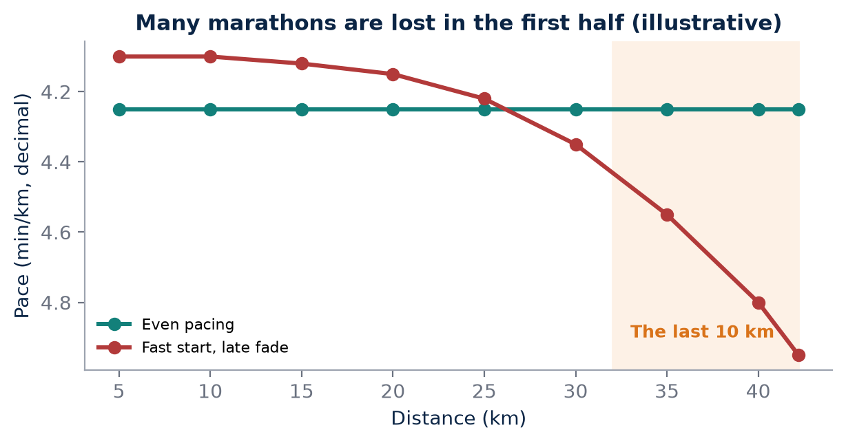
Figure 15. Illustrative split profiles. A fast start raises carbohydrate use and heat load, and the cost appears in the final 10 km.

The hidden costs of the first half
Starting too fast raises carbohydrate use and thermal strain. At higher intensities the body relies more heavily on carbohydrate, so even a modestly aggressive first half draws down glycogen faster than planned. Higher intensity also produces more heat, which must be dissipated through sweating and skin blood flow. Inadequate fuelling reduces available substrate. Dehydration reduces plasma volume and can increase cardiovascular strain, so heart rate climbs for the same pace. Muscular fatigue changes mechanics: ground contact lengthens, the stride becomes less springy, and the oxygen cost of running rises.
None of these changes is dramatic on its own at 15 km. Together they create a debt that is repaid, with interest, in the final 10 km.
KEY IDEA
Marathon pacing is not merely a stopwatch problem. It is a physiological budgeting problem.

The physiological budget
It is useful to think of a marathon as a fixed budget that can be spent in different ways. Every second gained early by running above sustainable pace is purchased with glycogen, fluid, heat tolerance and muscular resilience that will be needed later.
Budget line | What spends it | How to protect it
Pacing | Fast start, surges, hills taken too hard | Even or slightly negative split by effort
Fuel | High intensity, low intake, poor gut tolerance | Planned carbohydrate intake, practised in training
Fluid | Sweat loss, heat, humidity | Individual drinking plan based on sweat testing
Heat | Air temperature, humidity, sun, intensity | Heat acclimation, cooling, pace adjustment
Mechanics | Accumulated muscle damage, downhills | Long runs, strength work, durable footwear choice

Fuel and fluid, practised not improvised
Carbohydrate intake during long events is well supported by sports-nutrition research, and guidance has become more individual. A commonly used summary, associated with work by Asker Jeukendrup, links recommended intake to event duration and the athlete's trained gut tolerance.
Event duration | Commonly recommended carbohydrate | Notes
Under about 1 hour | Little or none needed; mouth rinse may help | Performance rarely fuel-limited
About 1–2 hours | Up to about 30 g per hour | Simple sources are usually sufficient
About 2–2.5 hours | Up to about 60 g per hour | Gut training improves tolerance
Beyond about 2.5 hours | Up to about 90 g per hour | Usually multiple transportable carbohydrates

These are ranges, not targets to be reached on race day for the first time. The gut adapts to regular carbohydrate intake during training, and an athlete who has never taken 60 g per hour in a long run should not attempt it first in a race. Fluid should be individual too: the aim is to limit excessive dehydration without overdrinking, which carries its own risk of hyponatraemia. Sweat rates in Indian summer and humid coastal conditions can be substantial, so pre- and post-run body mass checks are valuable.
MYTH VS EVIDENCE
Myth: Hitting the wall is purely a matter of mental toughness.
Evidence: Late-race slowing usually reflects measurable causes such as early overpacing, carbohydrate depletion, dehydration, heat strain and muscular fatigue; mental skills matter, but they cannot replace an empty fuel tank.

FIELD PROTOCOL
1. Fuel and fluid rehearsal long run
2. weigh the athlete nude or in minimal clothing before the run
3. run 28–32 km including the final 8–10 km at marathon effort
4. take carbohydrate on the race schedule and log grams per hour
5. log all fluid consumed
6. weigh again after towelling dry
7. calculate body-mass change adjusted for fluid intake
8. note gut comfort, heart rate drift and pace in the final 10 km.

Durability as its own quality
The late-race story points to a quality that short-distance speed does not capture: the ability to maintain performance as exercise duration and fatigue increase. Recent sports-science work, including discussion by Maunder and colleagues in 2021 and by Andrew Jones and colleagues in studies of runners at sub-two-hour marathon pace, has highlighted durability or physiological resilience as an important addition to the traditional three-factor model. Research in this area is developing, and measurement protocols are still being standardised.
AEI should eventually estimate an athlete's durability separately from short-distance speed. A runner whose threshold and economy hold steady after two hours is a very different marathon prospect from one whose values degrade quickly, even if both share the same 10K time.
A practical sign of early overspending is a heart rate that rises faster than expected during the first half despite steady pace, or a perceived effort that already feels like threshold at 15 km. Athletes can be taught to recognise these signals and to adjust immediately, because a small correction at 15 km is far cheaper than a forced slowdown at 35 km.
COACH'S CORNER
Use the first 10 km of every marathon as a discipline exercise. Agree a target effort and a ceiling heart rate before the start, and treat any early pace faster than plan as a withdrawal from the final 10 km budget rather than “time in the bank”.

CHECKPOINT
In your last long race, where did you spend your budget: pacing, fuel, fluid, heat or mechanics? Which line would you protect first next time?

CHAPTER 36

36. The Last 10K
PART VI — MARATHON ENGINE
In a well-paced marathon, the last 10 km is where training becomes visible. Up to 30 km, many athletes look similar; after it, their paths separate. The final 10 km is where the interaction of fitness and durability becomes visible, and it provides coaches with some of the most honest information they will ever collect about an athlete.
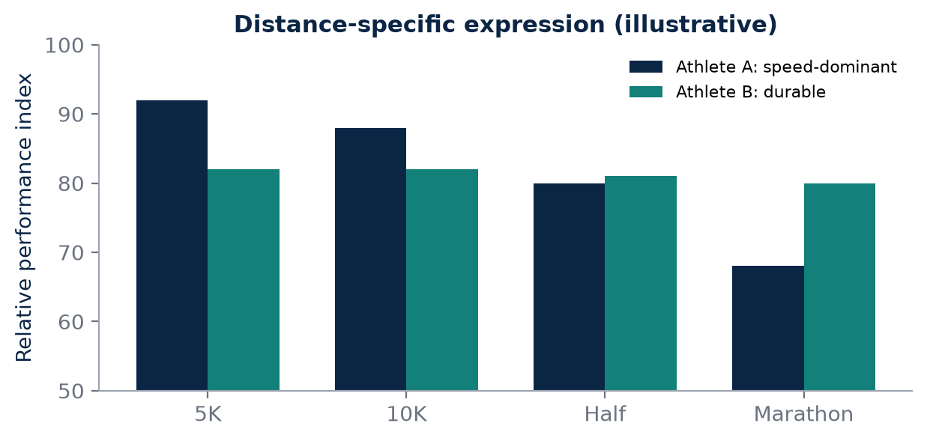
Figure 16. Illustrative only. The gap between short-distance and marathon expression shows where endurance breaks down, which one number would hide.

Speed without durability
An athlete with excellent 5K speed but insufficient long-run conditioning may possess a high short-distance performance index but a weaker marathon profile. Their aerobic capacity and threshold are good, but these qualities are not yet protected against the fatigue of hours of running. By contrast, a runner with a modest 5K time but years of consistent volume may lose very little pace in the final 10 km and finish far higher up the results than their short-distance times would suggest.
Neither athlete is simply “better”. They have different profiles, and they need different training. The first needs long runs, marathon-specific sessions and fuelling practice; the second may benefit from more speed and threshold work to lift the ceiling that their durability protects.
KEY IDEA
The final 10 km separates two qualities that short races blend together: how fast an athlete can run, and how well that speed survives fatigue.

Distance-specific expression
This suggests a useful AEI concept: distance-specific expression. The athlete should not receive one permanent number for all distances. A 5K profile, 10K profile, half-marathon profile and marathon profile can reveal where endurance breaks down. If an athlete's 5K and 10K performances imply a certain level, but the half-marathon and marathon imply progressively lower levels, the gap points towards durability, fuelling or heat tolerance rather than aerobic capacity.
Profile | Mainly tests | What a relative weakness may suggest
5K | Aerobic power, high-intensity tolerance | Limited top-end aerobic capacity
10K | Aerobic power, threshold | Threshold development needed
Half marathon | Threshold, early durability | Sustained-intensity conditioning
Marathon | Fractional utilisation, fuel, heat, durability | Long-run, fuelling or thermal limits

The difference between these profiles is itself useful information. A flat profile across distances suggests balanced development. A profile that falls steeply with distance suggests the athlete has speed to spare but lacks endurance-specific resilience. A profile that is strong at the long end but weaker at 5K suggests a durable athlete who may need to raise the ceiling.
MYTH VS EVIDENCE
Myth: One performance number should describe an athlete across every distance.
Evidence: Race-equivalence models are useful guides, but individual athletes often deviate from them; the pattern of deviation across distances is diagnostic information in its own right.

Reading the final 10 km
Coaches can analyse the last 10 km with simple tools. Compare the average pace of 30–40 km with the average of 10–30 km. Compare heart rate at the same pace in the early and late race. Look at whether the athlete slowed gradually or suddenly; a gradual fade often reflects heat or cumulative fatigue, while a sudden drop may point to glycogen depletion or cramping. Record conditions, fuel taken and any gastrointestinal problems alongside the numbers.
FIELD PROTOCOL
1. Last-10K durability analysis
2. export race splits and heart rate
3. calculate mean pace for 10–30 km and for 30–40 km
4. calculate percentage pace change
5. compare mean heart rate for the same segments
6. annotate temperature, humidity, fuel intake and any stops
7. repeat after every marathon and key long run to build a personal durability trend.

The last 10 km also carries emotional and tactical weight. Athletes who have practised finishing long runs at marathon effort know how that fatigue feels and are less likely to panic when it arrives. Those who have only ever run long runs at easy pace may interpret normal late-race discomfort as disaster and slow more than their physiology requires. Specific preparation therefore trains both body and judgement.
Over a career, the pattern of final-10 km performance becomes one of the most useful records an athlete can keep. It shows whether durability is improving from one marathon cycle to the next, independent of course, weather and finishing time. In AKURA's terms, it is an early, practical estimate of the AEI-D Durability domain.
COACH'S CORNER
Build at least two long runs per block that finish with the final 8–10 km at marathon effort. They rehearse the exact situation that decides races, and the pace and heart-rate change in those final kilometres is an early indicator of marathon readiness long before race day.

CHECKPOINT
If you plotted your 5K, 10K, half-marathon and marathon performances as equivalent levels, where would the line drop, and what would that drop tell you about your next training priority?

PART VI AT A GLANCE
The key idea from each chapter, for quick revision.
33 | The Marathon Is a Systems Test  A marathon is limited by the weakest system on the day, not by the strongest number on the athlete's test report.
34 | Fractional VO₂max and Marathon Pace  Marathon speed is not VO₂max alone; it is VO₂max multiplied by the fraction you can sustain and translated through economy, and all three can change with training.
35 | Why Marathon Pace Fails Late  Marathon pacing is not merely a stopwatch problem. It is a physiological budgeting problem.
36 | The Last 10K  The final 10 km separates two qualities that short races blend together: how fast an athlete can run, and how well that speed survives fatigue.

PART VII — VDOT AND AEI
Good coaching frameworks turn complexity into decisions. Jack Daniels' VDOT is one of the clearest examples in running: it converts a recent performance into a measure of current ability and a set of training intensities. This part begins by describing what VDOT does and why it has earned its place. It then explains why AKURA proposes a different, broader layer, the AKURA Endurance Index, which asks what physiological systems support performance, how the athlete responds to environment and training, and how confident we are in each measurement. AEI is presented as a research prototype that sits beside, not above, established tools, with separate Fitness, Readiness and Trend views.
IN THIS PART
37 What VDOT Does
38 Why AKURA Needs a Different Layer
39 AEI Architecture
40 Proposed AEI Domains
41 AEI-Fitness
42 AEI-Readiness
43 AEI Trend
CHAPTER 37

37. What VDOT Does
PART VII — VDOT AND AEI
Any honest discussion of a new endurance index must start by acknowledging what already works. VDOT, developed by the American coach and exercise physiologist Jack Daniels and set out in Daniels' Running Formula, is an established running-performance framework that represents current running ability and provides training paces from recent or estimated race performance. It has been used by coaches and runners around the world for decades, and its enduring popularity reflects a real achievement: it makes training intensity simple, consistent and actionable.

Performance first
The central idea of VDOT is that a recent race result already contains a great deal of physiological information. A runner's 10K time reflects their aerobic capacity, the fraction of it they can sustain, and their running economy, all expressed together under race conditions. Rather than requiring laboratory testing, VDOT uses that performance to estimate a single value of current running ability. Resources associated with Daniels' methods describe VDOT as a measure of current running ability and distinguish it from laboratory-measured VO₂max. Two runners can have similar VO₂max values yet different VDOT values because economy, threshold and other factors differ.
KEY IDEA
VDOT is a measure of current running ability derived from performance, not a laboratory measurement of VO₂max.

From ability to training intensity
VDOT is valuable because it translates performance into actionable training intensity. From one value, a runner receives guidance for different kinds of training and estimates of equivalent performances at other distances. Daniels organises training into clearly defined categories, each with a distinct purpose.
Category | Broad purpose in Daniels' system
Easy (E) | Aerobic development, recovery, volume
Marathon (M) | Marathon-specific pace and endurance
Threshold (T) | Raise sustainable high intensity
Interval (I) | Stress aerobic power
Repetition (R) | Speed, economy and mechanics

This book deliberately does not reproduce VDOT pace tables. Coaches and athletes who wish to use VDOT should consult Daniels' Running Formula and its official resources directly, where the method and its assumptions are explained by its author.
MYTH VS EVIDENCE
Myth: VDOT is just another name for VO₂max.
Evidence: VDOT is estimated from race performance and reflects current running ability, including the effects of economy and sustainable intensity; laboratory VO₂max measures maximal oxygen uptake only.

What AKURA learns from VDOT
The clarity of VDOT offers several lessons. First, a framework should begin with something athletes and coaches can observe: real performance. Second, it should produce decisions, not just descriptions; a number that does not change the next session has limited coaching value. Third, it should be updated as the athlete changes, rather than fixed for a season. Fourth, it should be simple enough to use daily on the track or road.
AKURA should learn from this clarity rather than copy the same purpose. VDOT already does its job well. There is little value in building a second system that merely produces training paces from race times. AKURA's research question is different, and Chapter 38 explains why.

Using VDOT in the Indian context
Performance-based systems assume that the race used as an anchor was a fair expression of ability. In India, many races are run in heat and humidity, on courses with variable measurement, and sometimes with crowded starts. A coach using VDOT or any similar framework should prefer recent, well-measured, reasonably controlled performances, and should interpret results from very hot races cautiously. This is not a weakness of VDOT; it is a reminder that every input needs context.

The value of simplicity
Part of VDOT's success is that it is easy to explain. A runner with no laboratory access can enter a recent race result and immediately understand how hard their easy runs, threshold sessions and intervals should be. Coaches working with large groups can assign intensities consistently. As the athlete improves and races faster, the value rises and the training intensities progress with it. This self-correcting link between performance and prescription is one of the framework's most practical features.
Like any model, VDOT relies on assumptions. Its race equivalences represent typical relationships between distances, and individual athletes may be relatively stronger at short or long distances. Daniels himself emphasises that training should be adjusted to the individual and to conditions. Recognising these assumptions is not a criticism; it is how every model should be used, with judgement.
COACH'S CORNER
If your athlete already trains with VDOT, keep it. Use AKURA's measurements to explain why their VDOT is moving or not moving, for example whether an improvement came with better economy, better heat tolerance or simply a cooler race day.

CHECKPOINT
Which recent race would you use as your performance anchor today, and was it run in conditions fair enough to represent your current ability?

CHAPTER 38

38. Why AKURA Needs a Different Layer
PART VII — VDOT AND AEI
If VDOT works, why propose anything else? The answer lies in the question each framework is designed to answer. VDOT begins primarily with performance: what can the athlete run now, and how should they train as a result? AKURA's proposed Endurance Index begins with a broader research question: what is the athlete's current performance expression, what physiological systems support it, how is the athlete responding to environment and training, and what is the confidence in each measurement?

Different questions, different tools
A performance-based system is intentionally efficient. It compresses many physiological factors into one ability value and does not need to know which factor produced the result. For daily training prescription, that compression is a strength. For research and long-term athlete development, particularly in an environment as varied as India's, it can hide the very information a coach needs. When an athlete's race times stagnate, the coach wants to know whether the limitation lies in aerobic capacity, economy, threshold, heat tolerance, recovery or durability. A single ability value cannot distinguish between these.
Feature | VDOT (Daniels) | AEI (AKURA prototype)
Primary input | Recent race performance | Performance plus physiology, environment, recovery
Main output | Current ability and training paces | Domain profile, fitness, readiness, trend
Status | Established, widely used | Research prototype, not validated
Environment | Handled through coach judgement | Logged as explicit data
Confidence | Implicit in quality of race used | Attached to each measurement

KEY IDEA
VDOT answers “what can this athlete run and how should they train?”; AEI asks “why can they run it, how are they responding, and how sure are we?”

Beside, not instead of
AEI is therefore not proposed as a replacement for VDOT. It is a research framework that could sit above or beside pace-based systems. An athlete might continue to receive training paces from an established method while AEI tracks whether their economy is improving, whether a heat block changed their cardiovascular response, and whether their durability supports a marathon attempt. In that arrangement the two layers complement each other: one prescribes, the other explains and monitors.
MYTH VS EVIDENCE
Myth: A new index must replace older methods to be useful.
Evidence: Frameworks answering different questions can coexist; AEI is designed to add explanatory and monitoring information, while established pace systems continue to guide daily intensity.

A conservative first version
The first version should be deliberately conservative: fewer validated claims, more transparent data. It is tempting to produce a striking single score, a 0–100 value on a colourful dashboard. But any number that combines measurements with unvalidated weights may look precise while being scientifically fragile. AEI v0.1 therefore prioritises three principles: keep raw measurements visible; report domains separately until a combined model is validated; and attach a confidence level to every value.
For Indian athletes, the additional layer is particularly relevant. Training may alternate between hot plains, humid coasts and hill stations such as Ooty or Kodaikanal. Travel, exams, work shifts and irregular access to laboratory testing all influence the data. A framework that records environment and confidence explicitly is better suited to this reality than one that assumes stable conditions.

What the extra layer must earn
An additional layer adds complexity, and complexity has a cost. Athletes must record more data, coaches must interpret more information, and there are more opportunities for error. AEI must therefore earn its place by improving decisions: identifying the limiting system earlier, showing whether an intervention such as a heat block produced a response, flagging when readiness is too low for a key session, or predicting marathon durability more accurately than short-race times alone.
If, after careful study, a domain does not improve decisions, it should be simplified or removed. This is the discipline that separates a research framework from a marketing score. AKURA's aim is not to build the most elaborate index possible, but the most useful one that the evidence supports.

A practical example
Consider two Indian club runners, each with the same recent 10K time. A performance-based system would give them similar training intensities, and that is a sensible starting point. AEI might then reveal that the first runner's easy pace at a fixed heart rate deteriorates sharply in humid conditions, while the second runner's pace holds steady but their long-run durability is poor. The same pace prescription remains useful for both; what changes is the emphasis of their next training block, heat preparation for one and marathon-specific endurance for the other.
COACH'S CORNER
Before adding any new metric to an athlete's profile, write down the decision it could change. If you cannot name a decision, record the metric for research but do not let it influence training yet.

CHECKPOINT
When your performance stalls, which question would help you more today: “what pace should I train at?” or “which system is limiting me?” Which tool do you currently use to answer each?

CHAPTER 39

39. AEI Architecture
PART VII — VDOT AND AEI
A framework needs structure before it needs numbers. The proposed AEI architecture has two levels, reflecting a distinction that experienced coaches already make intuitively: what an athlete is capable of, and what they can express today. Separating these levels prevents two common errors, over-reacting to a single bad day and ignoring warning signs because the athlete is fit.
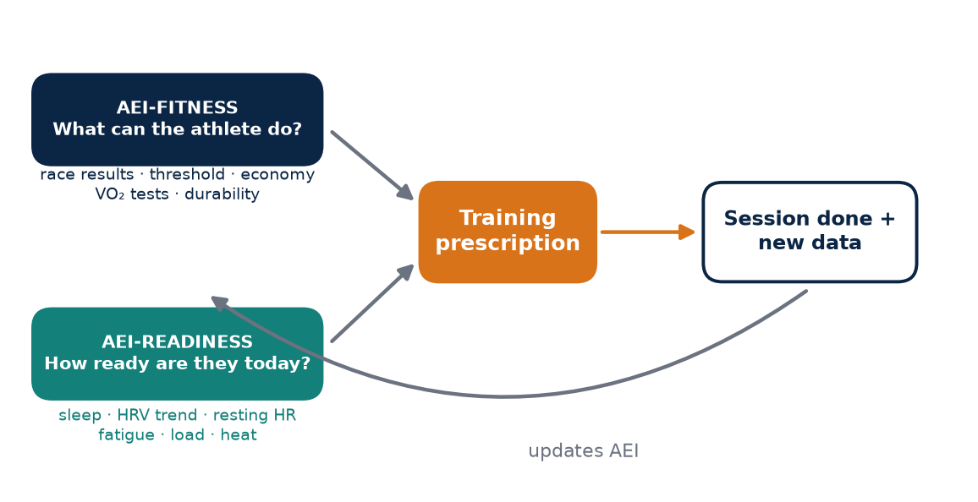
Figure 17. AEI architecture. Stable fitness and daily readiness are separate layers that together inform the prescription; every session feeds new data back.

Level one: AEI-Fitness
AEI-Fitness describes relatively stable performance capacity: recent race performance, aerobic markers, threshold characteristics, economy and endurance durability. These qualities change over weeks and months in response to training, not overnight. Fitness is the athlete's current engine.

Level two: AEI-Readiness
AEI-Readiness describes today's ability to express that fitness: sleep, HRV trend, resting heart rate, fatigue, recent load, soreness, illness flags and environmental stress. These signals can change daily. A fit athlete who has slept badly after an overnight train journey, trained in 38 °C heat for three days and developed a sore throat may be unable to express their fitness in a hard session, even though their engine is unchanged.
Level | Time scale | Main inputs | Coaching question
AEI-Fitness | Weeks to months | Races, threshold, economy, aerobic markers, durability | What can this athlete do?
AEI-Readiness | Days | Sleep, HRV trend, RHR, fatigue, soreness, load, illness, heat | How much can they express today?

KEY IDEA
Fitness is the engine; readiness is whether the engine can be used fully today. AEI keeps them separate so that one does not distort the other.

The closed loop
The conceptual loop is: performance + physiology + environment + recovery → AEI → training prescription → actual session → new data → updated AEI. Each training session is therefore both an intervention and a measurement. The planned session reflects the current AEI; the executed session, with its pace, heart rate, perceived effort, conditions and completion status, becomes new evidence that updates the profile.
- Collect performance, physiological, environmental and recovery data.
- Update domain values and confidence levels in AEI.
- Generate a training prescription, reviewed by the coach.
- Record what the athlete actually did and how it felt.
- Compare planned and actual responses, then update AEI.
This loop is what separates a research system from a static test report. A test tells the coach where the athlete was; a loop shows how the athlete is changing and whether training is working.

No weights before validation
No component should be given a final weight until validated on real athlete data. It would be easy to declare that performance counts for 40%, economy for 15% and recovery for 10%, and to produce a neat total. But such weights would be guesses, and guesses presented as numbers can mislead coaches and athletes. Until longitudinal data show which components genuinely predict performance and injury risk in the populations AKURA serves, each component should be reported separately with its confidence.
MYTH VS EVIDENCE
Myth: A single combined score is always more useful than several separate numbers.
Evidence: A combined score is only as good as its weights; with unvalidated weights, separate domain values with clear confidence levels give coaches more honest and more usable information.

FIELD PROTOCOL
1. Setting up the AEI loop for one athlete
2. record a recent standardised race or time trial as the performance anchor
3. record easy pace at a fixed heart rate on a flat route
4. log daily sleep, morning resting heart rate, HRV if available, fatigue and soreness
5. log temperature and humidity for every session
6. after each key session, record planned versus actual pace, heart rate and RPE
7. review the loop weekly with the coach.

Why two levels matter in practice
In the proposed AKURA ecosystem, the readiness layer also connects to AISRi, the daily training-decision layer, while AEI-Fitness informs longer-term planning. Keeping the interfaces separate makes it clear which information is driving which decision. Many training errors come from mixing the two levels. An athlete who feels flat for three days may conclude they have lost fitness and train harder to compensate, deepening their fatigue. Another athlete may feel excellent one morning after a rest day and attempt a session far beyond their current fitness. By keeping fitness and readiness in separate views, AEI encourages the right response to each: patience with readiness fluctuations, and evidence before revising fitness.
COACH'S CORNER
Keep a simple rule when the two levels disagree. If fitness is high and readiness is low, protect the athlete and modify the day. If readiness is high but fitness is low, do not mistake a good day for a breakthrough; progress the plan as designed.

CHECKPOINT
Can you describe your current fitness and your readiness today as two separate statements? Which one are you more likely to confuse with the other?

CHAPTER 40

40. Proposed AEI Domains
PART VII — VDOT AND AEI
The two-level architecture needs content. A research prototype can store ten domains, each describing one part of the endurance system that earlier chapters of this book explained: performance, aerobic capacity, threshold, economy, oxygen transport, cardiovascular response, recovery, heat adaptation, altitude response and durability. Together they form a map of the athlete rather than a single verdict.
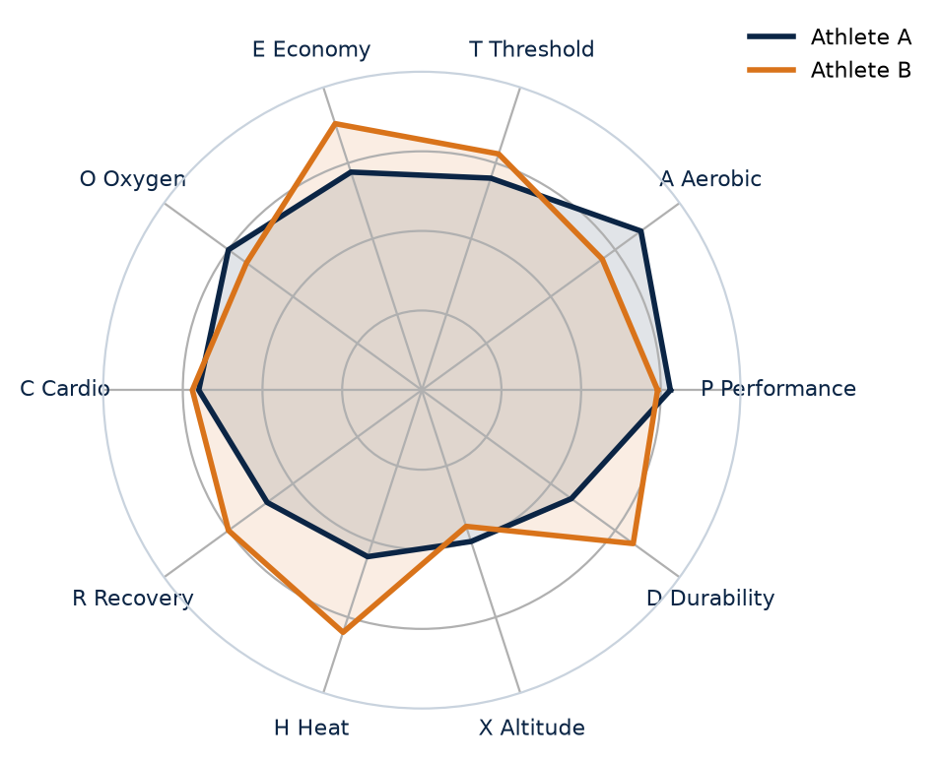
Figure 18. Two illustrative AEI domain profiles. The shape, not a single total, tells the coach where to look. Values are invented and not validated scores.

The ten domains
Domain | Primary examples | Interpretation | Confidence note
AEI-P Performance | 5K, 10K, half-marathon, marathon results | Current race expression | High when recent and standardised
AEI-A Aerobic | VO₂-related tests, submaximal HR–pace | Aerobic capacity | Protocol dependent
AEI-T Threshold | Lactate or threshold pace | Sustainable high intensity | Protocol dependent
AEI-E Economy | O₂ cost at a fixed speed | Movement efficiency | Needs repeatability
AEI-O Oxygen Transport | Hb mass, Hb concentration | O₂ transport context | Hb mass needs specialist testing
AEI-C Cardiovascular | HR, stroke-volume-related measures | Circulatory response | Context dependent
AEI-R Recovery | Sleep, HRV trend, RHR, fatigue | Today's expression capacity | Baseline dependent
AEI-H Heat Adaptation | Heat exposure, thermal response | Heat adaptation | Environment must be logged
AEI-X Altitude Response | Sleeping altitude, Hb mass response | Hypoxic adaptation | Dose dependent
AEI-D Durability | Long-run degradation | Marathon-specific resilience | Needs standardised protocol

KEY IDEA
The ten AEI domains are a structured way to store evidence about an athlete; they are not yet validated scores.

Domains, not scores
These are domains, not yet validated scores. Each should have raw measurements, normalisation rules, confidence and missing-data handling. Raw measurements must remain visible so that a coach can always trace a conclusion back to the test that produced it. Normalisation rules describe how a value is compared, whether against the athlete's own history or, where appropriate, a reference population. Confidence reflects how reliable the measurement is: a laboratory economy test repeated twice under controlled conditions deserves more confidence than a single estimate from a wrist device. Missing-data handling defines what happens when a domain has no recent measurement, so that absence of data is never mistaken for a low value.
Some domains overlap. Aerobic capacity, threshold and economy all contribute to performance, and recovery influences how every other domain is expressed on the day. Oxygen transport and altitude response are related but distinct: one describes the current state of the blood, the other how it changed after hypoxic exposure. Heat adaptation connects to the cardiovascular domain through plasma volume and heart-rate responses. Recording these domains separately allows the research programme to study their relationships rather than assuming them.

Not every athlete needs every domain
A club runner in Coimbatore may have reliable performance, recovery and heat data but no laboratory tests. A national-camp athlete may have regular haemoglobin mass and lactate testing. AEI should work in both cases by reporting what is known, with confidence, and clearly marking what is not. The minimum useful profile is often performance, recovery, a simple submaximal HR–pace marker and durability from long runs; laboratory domains add depth when available.
MYTH VS EVIDENCE
Myth: A polished 0–100 score is more scientific than a table of separate values.
Evidence: A beautiful 0–100 score can be scientifically misleading if its weights are arbitrary; transparent domain values with stated confidence are more honest until a combined model has been validated.

FIELD PROTOCOL
1. Building a first domain profile
2. list the ten domains
3. for each, write the most recent measurement, date and method
4. mark confidence as high, moderate or low
5. mark missing domains clearly as not measured
6. choose the two missing domains that would most change coaching decisions
7. plan how and when to measure them.

Confidence deserves its own display. A domain value measured last week in a laboratory and one estimated six months ago from a single field session should not look identical on a dashboard. Simple labels, such as high, moderate and low confidence, together with the date of the last measurement, allow coaches to weigh each domain appropriately.

How domains link back to the book
Each domain corresponds to physiology explained earlier. AEI-A and AEI-T draw on the chapters on VO₂max, lactate and threshold. AEI-E reflects running economy. AEI-O and AEI-X connect to haemoglobin mass, red-cell adaptation and altitude. AEI-C and AEI-H link to the heart, plasma volume and heat acclimation. AEI-R reflects recovery monitoring, and AEI-D draws on the marathon chapters in Part VI. This mapping keeps AEI grounded in established physiology rather than invented categories, and it makes clear which scientific literature each domain should be validated against.
When a domain changes, the coach should be able to ask which physiological mechanism might explain the change and which intervention preceded it. A domain that cannot be linked to a mechanism, a measurement and a decision is not yet ready to be part of the index.
COACH'S CORNER
Resist the pressure to fill every domain. An honest profile with four well-measured domains is more useful than a complete profile with six guessed values. Ask the athlete to help keep the raw data clean, because they are the source of most daily inputs.

CHECKPOINT
Which AEI domains can you measure reliably today, which require help from a laboratory or clinician, and which missing domain matters most for your next goal race?

CHAPTER 41

41. AEI-Fitness
PART VII — VDOT AND AEI
AEI-Fitness should answer one question: “What can this athlete currently do under standardised conditions?” It is the slow-moving, evidence-heavy layer of the index, the description of the engine that training has built. Getting it right matters because fitness is the foundation for goal-setting, race selection and long-term planning.

The performance anchor
The strongest anchor is recent performance under reasonably controlled conditions. Just as VDOT begins with performance, AEI-Fitness gives recent, well-measured results the greatest influence. A certified-course half marathon on a cool morning, or a carefully run time trial on a measured track, provides a clear expression of current capacity. A hot, crowded race or an estimated course distance provides weaker evidence and should carry lower confidence.

Supporting measures
Supporting measures can include threshold pace, VO₂-related testing, running economy, long-run durability and physiological response. These do not replace performance; they help explain it and fill the gaps between races. An athlete who races only three or four times a year can still show fitness progression through a stable submaximal marker, such as easy pace at a fixed heart rate on the same route in similar conditions, or through a repeated threshold session.
Input | Role in AEI-Fitness | Update frequency
Recent race or time trial | Primary anchor | Every valid race or trial
Threshold session or test | Sustainable intensity marker | Every 4–8 weeks
Submaximal HR–pace | Aerobic trend marker | Weekly, same route and conditions
Running economy test | Efficiency marker | When laboratory access permits
Long-run durability | Marathon-specific resilience | Key long runs

KEY IDEA
AEI-Fitness is anchored in real performance and supported by physiological markers; it describes capacity, not how the athlete feels today.

Slow to change, by design
Fitness should update more slowly than daily readiness. A single bad night's sleep should not erase months of training adaptation. Conversely, a single breakthrough race should not permanently redefine the athlete without confirmation. A new personal best in ideal weather with a strong pacing group may overstate typical capacity; a disappointing race in 34 °C heat may understate it. AEI-Fitness should respond to consistent evidence across several data points, and it should record the conditions of each so that environmental effects are not mistaken for changes in fitness.
Feature | Fitness | Readiness
Question | What can the athlete do? | How much can they express today?
Time scale | Weeks to months | Hours to days
Primary evidence | Races, tests, long-run durability | Sleep, HRV trend, RHR, soreness, load
Typical change | Gradual, training-driven | Rapid, recovery- and life-driven
Main use | Goals, race choice, training phase | Daily session decision

MYTH VS EVIDENCE
Myth: One brilliant race proves a new fitness level.
Evidence: A single result may reflect ideal conditions, pacing or course; fitness should be confirmed by consistent evidence from races, tests and training markers.

FIELD PROTOCOL
1. Standardised fitness check
2. select a flat measured loop or 400 m track
3. record temperature, humidity and time of day
4. warm up 15 min easy
5. run 20 min at a fixed heart rate near the top of the easy zone and record average pace
6. after 5 min recovery, complete a controlled 3 km or 5 km time trial
7. repeat every 4–6 weeks under similar conditions and compare.

Fitness also has a direction. An athlete returning from injury may have a modest current anchor but a steeply rising trend, while a veteran may hold a high anchor that is slowly declining. Both facts matter for planning, which is why AEI-Fitness should always be read alongside the trend view described in Chapter 43.

Fitness is multidimensional
Although AEI-Fitness may one day be summarised in a single figure, it is built from several components. Two athletes with the same performance anchor may have different supporting profiles: one with excellent economy but modest threshold, another with a high aerobic ceiling but poor durability. Keeping these components visible allows training to target the actual limiter. In the prototype stage, AEI-Fitness is best presented as the performance anchor plus a short list of supporting markers, each with its date and confidence.
For Indian athletes who train through long hot seasons, conditions deserve special attention. Fitness markers collected in April and May may look weaker than those collected in December, even when underlying fitness has improved. Recording temperature and humidity with every standardised test allows AKURA to compare like with like and, over time, to model environmental effects directly.
COACH'S CORNER
Update your athlete's fitness picture after patterns, not events. When a surprising result appears, ask whether conditions, pacing or measurement explain it, and look for a second confirming data point before changing training zones or goals.

CHECKPOINT
What is your current performance anchor, how old is it, and what supporting marker would confirm that your fitness has really changed since then?

CHAPTER 42

42. AEI-Readiness
PART VII — VDOT AND AEI
Readiness asks a different question: “How well can the athlete express current fitness today?” The engine may be strong, but on a given morning it may be cold, under-fuelled, overheated or strained. AEI-Readiness is the daily layer that helps the coach decide whether the planned session should go ahead, be modified or be replaced.

Inputs, not verdicts
A readiness layer can use HRV trend, resting heart rate, sleep quantity and quality, subjective fatigue, muscle soreness, recent training load and environmental strain. No single metric should dominate. Heart-rate variability is a useful, context-dependent signal of autonomic state, and research such as that by Plews and colleagues has shown the value of interpreting it as a rolling trend rather than a single morning value. Resting heart rate, sleep and subjective wellbeing add further perspectives. Simple self-reported measures of fatigue and soreness are often as informative as device data and should never be dismissed.
Environmental strain belongs in readiness because it changes the cost of the day's session. A threshold workout planned for 6 a.m. may be appropriate in cool conditions and inappropriate in a humid heatwave, even for a well-recovered athlete.
Signal | What it may reflect | Common confounder
HRV trend | Autonomic balance and recovery | Alcohol, illness, stress, measurement timing
Resting heart rate | Fatigue, illness, heat, dehydration | Caffeine, poor sleep, measurement posture
Sleep | Recovery opportunity | Travel, shift work, exams, family demands
Fatigue and soreness | Perceived recovery | Mood, motivation, life stress
Recent load | Accumulated training stress | Unrecorded activity, heat
Environmental strain | Cost of today's session | Microclimate, time of day

KEY IDEA
Readiness is a confidence-adjusted judgement built from several signals; no single wearable metric is a diagnosis.

From signals to decisions
The practical output is not “train hard” or “rest” from one number. It is a confidence-adjusted recommendation: planned session, modified session, easy session or recovery, with coach review when risk signals conflict. When most signals agree that the athlete is well recovered, the planned session proceeds. When some signals are unfavourable, the session can be modified, for example by reducing volume, moving it to a cooler time or converting intervals to steady running. When several signals are poor, an easy session or recovery day is preferable. When signals conflict, or when an illness flag appears, a human review is required.
- Planned session: signals broadly favourable, no risk flags.
- Modified session: one or two unfavourable signals or high heat strain.
- Easy session: several unfavourable signals, no illness flags.
- Recovery or coach review: illness symptoms, conflicting risk signals or sharp unexplained change.
MYTH VS EVIDENCE
Myth: A high readiness score means the athlete is safe to train hard.
Evidence: Readiness scores cannot detect every problem; symptoms such as chest pain, fever, dizziness or signs of heat illness always override any score and require appropriate medical attention.

FIELD PROTOCOL
1. Morning readiness routine
2. on waking, before caffeine, record resting heart rate and HRV in the same posture
3. record sleep duration and a 1–5 sleep quality rating
4. rate fatigue, soreness and mood 1–5
5. note any illness symptoms
6. check forecast temperature and humidity for the session time
7. compare with the athlete's 7-day and 28-day norms rather than with other athletes.

Recording the decision itself is equally important. When the coach modifies a session, the reason and the outcome should be logged. Over months, these records show whether readiness-based modifications were justified, and they become part of the data that will eventually be used to validate or revise the readiness model.

Readiness in real Indian life
Readiness is shaped by more than training. Long commutes, night shifts, examination seasons, family responsibilities, festival travel and poor sleep in hot, humid bedrooms all influence how an athlete arrives at a session. A readiness system designed for Indian athletes should make it easy to record these factors, because they often explain changes that physiological data alone cannot. The coach's knowledge of the athlete's life remains one of the most important readiness inputs.
Readiness data should also be interpreted against each athlete's own baseline. One athlete's normal resting heart rate may be another's warning sign. For this reason, the first few weeks of monitoring are best treated as a baseline-building period, during which recommendations rely more heavily on coach judgement.
COACH'S CORNER
Teach athletes that modifying a session is a skill, not a failure. A hard session moved by one day or shortened by a third on a poor readiness morning usually costs nothing in fitness, while forcing it can cost a week.

CHECKPOINT
Which readiness signal do you trust most for yourself, and have you ever checked whether it actually predicts your good and bad training days?

CHAPTER 43

43. AEI Trend
PART VII — VDOT AND AEI
A single measurement is a photograph; a trend is a film. A trend is often more informative than a point, because it shows direction, speed of change and response to interventions. Many of the most important coaching questions, whether a heat block worked, whether fitness is still improving, whether fatigue is accumulating, can only be answered by looking across time.
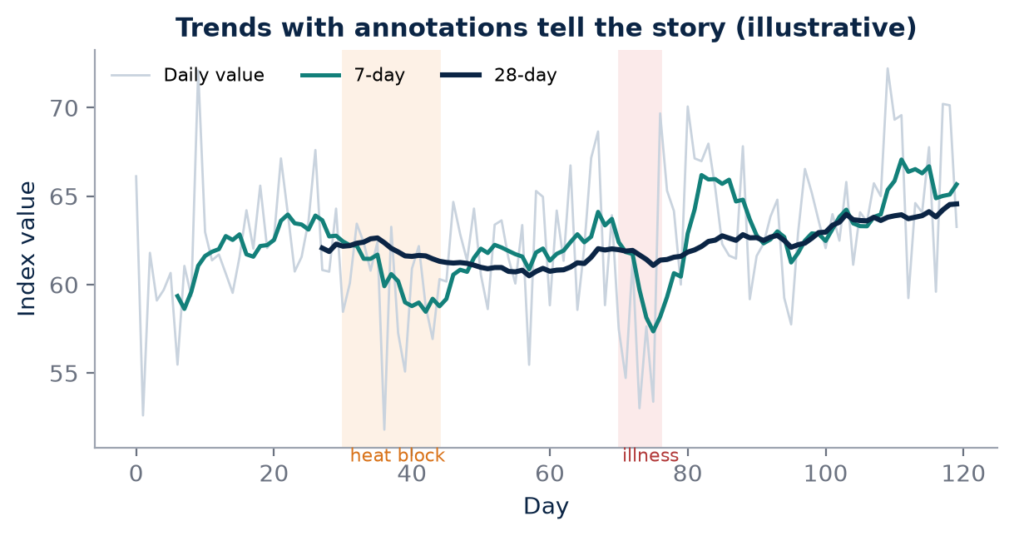
Figure 19. Rolling 7- and 28-day trends with annotations for interventions and illness make cause and effect visible. A single day's number hides this.

When the trend and the race disagree
A runner's pace at a fixed heart rate can improve gradually while race performance remains unchanged because durability or pacing is limiting. Without a trend view, the coach might conclude that training has failed. With it, the coach can see that aerobic fitness is rising and look for the real limiter elsewhere, perhaps in the final 10 km of races, in fuelling, or in pacing discipline. The trend therefore protects good training from being abandoned because of one unrepresentative result.
KEY IDEA
Trends reveal whether an athlete is changing, and in which system, even when race results have not yet caught up.

Rolling windows
AEI Trend should therefore display rolling changes rather than only today's score. Useful views include 7-day, 28-day and 90-day trends, with annotations for races, illness, travel, heat blocks and altitude exposure.
Window | Best for | Typical signals | Caution
7-day | Short-term readiness and fatigue | HRV trend, RHR, sleep, soreness, load | Noisy; sensitive to single events
28-day | Training-block response | Submaximal HR–pace, threshold, load pattern | Affected by heat or travel within block
90-day | Fitness and adaptation | Race anchors, economy, durability, Hb markers | Slow to reveal sudden problems

Annotations are essential. A falling 28-day HR–pace trend might mean improved fitness, or it might mean the weather cooled. A rising resting heart rate might signal fatigue, or it might coincide with a week of travel to a hot city. By marking races, illness, travel, heat blocks, altitude camps, exams, work shifts and equipment changes, the coach can separate cause from coincidence.
MYTH VS EVIDENCE
Myth: A single green number on a dashboard tells you the athlete is on track.
Evidence: A single number hides direction and context; rolling trends with annotations show what is changing, how fast, and what might be causing it.

A dashboard that asks questions
A research dashboard should make cause-and-effect questions visible rather than hiding them behind a single green number. Did easy pace at a fixed heart rate improve after the Chennai heat block? Did resting heart rate settle after the athlete returned from Kodaikanal? Did long-run durability improve over the last 90 days while 5K speed stayed flat? A well-designed trend view invites these questions and allows the coach and athlete to test their hypotheses against the data.
For AKURA, trend data are also the raw material for validation. Only by collecting consistent, annotated measurements over months can the research programme learn which domains truly predict performance, which interventions produce meaningful responses, and how Indian athletes adapt to the specific environments in which they train.
FIELD PROTOCOL
1. Monthly trend review
2. export 90 days of training, readiness and race data
3. plot submaximal HR–pace, resting heart rate, HRV trend and weekly load
4. mark races, illness, travel, heat and altitude exposure on the timeline
5. identify one improving, one stable and one declining signal
6. write a hypothesis explaining each
7. agree one training adjustment and one measurement to test it next month.

Trend windows should also match the question. A coach deciding whether to hold tomorrow's intervals needs the 7-day view. A coach evaluating a four-week heat block needs the 28-day view with the block clearly annotated. A coach planning the next marathon cycle needs the 90-day view and the history of previous cycles. Showing all three windows side by side prevents short-term noise from being mistaken for long-term change, and prevents slow long-term decline from being hidden by a good week.
COACH'S CORNER
Review trends with the athlete, not just for them. When athletes see their own HR–pace line improving through a hard humid summer, they understand their training, and understanding improves adherence far more than any score.

CHECKPOINT
Looking at your last 90 days, which signal has changed most, what annotation might explain it, and what measurement would confirm or reject that explanation?

PART VII AT A GLANCE
The key idea from each chapter, for quick revision.
37 | What VDOT Does  VDOT is a measure of current running ability derived from performance, not a laboratory measurement of VO₂max.
38 | Why AKURA Needs a Different Layer  VDOT answers “what can this athlete run and how should they train?”; AEI asks “why can they run it, how are they responding, and how sure are we?”
39 | AEI Architecture  Fitness is the engine; readiness is whether the engine can be used fully today. AEI keeps them separate so that one does not distort the other.
40 | Proposed AEI Domains  The ten AEI domains are a structured way to store evidence about an athlete; they are not yet validated scores.
41 | AEI-Fitness  AEI-Fitness is anchored in real performance and supported by physiological markers; it describes capacity, not how the athlete feels today.
42 | AEI-Readiness  Readiness is a confidence-adjusted judgement built from several signals; no single wearable metric is a diagnosis.
43 | AEI Trend  Trends reveal whether an athlete is changing, and in which system, even when race results have not yet caught up.

PART VIII — TESTING LAB
Measurement is where the AKURA Endurance Index stops being an idea and becomes a record. This Part moves from the field to the laboratory: the minimum baseline every athlete should have, the blood markers that matter and why they must be read by a clinician, the difference between haemoglobin concentration and total haemoglobin mass, and the practical protocols for VO₂, lactate and running-economy testing. It closes with cardiac screening, where the coach's role is to refer, not to diagnose. Throughout, one principle holds: a test is only as useful as its protocol, its metadata and our understanding of its error.
IN THIS PART
44 The AKURA Athlete Baseline
45 Blood Testing
46 Measuring Haemoglobin Mass
47 VO₂ Testing
48 Lactate Testing
49 Running Economy Testing
50 ECG and Echocardiography
CHAPTER 44

44. The AKURA Athlete Baseline
PART VIII — TESTING LAB
A serious athlete research programme starts with a baseline. Without a clear picture of where an athlete begins, every later number floats free of context: a threshold pace that looks impressive may simply reflect a cool morning, and a heart rate that looks alarming may be that athlete's normal. The AKURA baseline is not a single test but a structured snapshot of the athlete's physiology, training history and daily life, recorded in a way that can be repeated months or years later. It has two layers: a minimum field baseline that any coach in India can collect with a watch, a scale and a notebook, and a laboratory baseline added when it is clinically and logistically appropriate.

The minimum field baseline
The minimum field baseline can include body mass, a recent race result, resting heart rate, the heart-rate variability (HRV) trend, sleep, training history, the easy pace-HR relationship, a threshold session and long-run durability. None of these requires a laboratory, yet together they describe much of what the AEI needs. The race result anchors performance; resting HR and HRV describe the autonomic background; sleep and training history explain what the athlete has been able to absorb; the easy pace-HR relationship describes aerobic efficiency; the threshold session estimates sustainable intensity; and long-run durability shows how well that efficiency holds as fatigue builds.
The laboratory baseline may include blood testing, body composition, ECG, echocardiography, VO₂ testing and lactate testing. These add depth and precision, but they are not a prerequisite for a meaningful AEI. A well-run field battery, repeated consistently, often tells the coach more than a single expensive laboratory visit that is never repeated.
Domain | Field measure | Laboratory measure
Performance | Recent race or time trial | Incremental test to exhaustion
Aerobic efficiency | Easy pace-HR relationship | Submax VO₂ and running economy
Threshold | Threshold session pace and HR | Lactate step test
Durability | Long-run pace-HR decoupling | Prolonged steady-state testing
Health background | Resting HR, HRV, sleep, body mass | Blood markers, ECG, echocardiography
Body composition | Body mass trend | DXA or other validated method

FIELD PROTOCOL
1. AKURA field baseline battery (spread over 7–10 days)
2. Days 1–7: record waking resting HR, HRV (same device, same posture), sleep duration and morning body mass after toilet, before food
3. Day 2: standardised submax run – 10 min easy warm-up, then 20 min at a fixed easy pace on a flat, known route, recording mean HR for minutes 10–20
4. Day 4: threshold session – for example 3 × 10 min at estimated threshold effort with 2 min jog, recording pace, HR and RPE for each rep
5. Day 7: long run of the athlete's usual duration at easy effort on a flat route, recording pace and HR for pace-HR decoupling
6. Log temperature, humidity, time of day, surface and shoes for every session

Metadata: the invisible half of every test
Every test needs a protocol, date, device, operator, environmental conditions and units. Without those fields, longitudinal comparison becomes fragile. A resting heart rate taken lying down on waking is not comparable with one taken seated after tea; a lactate value from a fingertip is not directly comparable with one from an earlobe; a submax run at 6 a.m. in Pune in January is not the same test as the same run at 4 p.m. in Chennai in May. Metadata is what allows AEI to compare like with like, and to flag comparisons that should not be made.
Metadata field | Example entry | Why it matters
Protocol ID | SUBMAX-20-v1 | Ensures the same test is repeated
Date and time | 2026-03-14, 06:10 | Circadian and seasonal effects
Device and firmware | Chest strap, watch model | Device changes alter values
Operator | Coach or lab technician name | Operator technique varies
Environment | Temp, humidity, WBGT, wind | Heat alters HR and lactate
Units | mmol/L, ml/kg/min, min/km | Prevents conversion errors
Athlete state | Sleep, illness, last meal | Explains outliers

KEY IDEA
A baseline is not a single number but a reproducible snapshot. The test and its metadata together form the measurement; a value without its protocol, device, conditions and units cannot safely be compared over time.

Typical error and the smallest worthwhile change
Every measurement contains noise. Hopkins's influential 2000 review in Sports Medicine described how the typical error of a measurement, the within-athlete variation when a test is repeated under stable conditions, determines how confidently we can detect real change. Alongside typical error sits the smallest worthwhile change: the smallest difference that would matter in practice, often estimated from the variation between athletes or from what would change a race result. A change is interesting only when it is clearly larger than the noise and at least as large as the smallest worthwhile change. The practical way to estimate typical error for an individual athlete is simple: repeat the same test two or three times, close together, under controlled conditions, and see how much the results vary when nothing real has changed.
COACH'S CORNER
In the first month, run the standardised submax test twice, a week apart, before any major training change. The difference between those two runs gives you a rough sense of that athlete's day-to-day noise. Later, treat only changes clearly beyond that range as signals worth acting on.

CHECKPOINT
Which items in your athletes' current baseline lack a recorded protocol, device or environment? If you repeated your main field test tomorrow, how much would you expect the result to differ with no real change in fitness?

CHAPTER 45

45. Blood Testing
PART VIII — TESTING LAB
Blood tests are powerful because they reach beneath performance into physiology: oxygen-carrying capacity, iron stores, vitamin status, thyroid and kidney function. They are also easy to misuse. A panel ordered without a question produces numbers without meaning, and a coach who interprets them without clinical training can cause real harm, either by missing something serious or by creating anxiety and inappropriate supplementation. In the AKURA system, blood testing should be clinically supervised and interpreted by qualified professionals. The coach's role is to recognise when a question exists, to help the athlete arrive at the test in a standardised state, and to record the clinician's interpretation alongside the training data.

Markers and why they are measured
Depending on the athlete and research question, relevant markers can include haemoglobin, haematocrit, ferritin, iron indices, B12, folate, vitamin D, thyroid markers, renal function and electrolytes. Each has a purpose, and each has confounders that a clinician must weigh.
Marker | Why it may be measured | Note
Haemoglobin | Oxygen-carrying capacity; anaemia screening | Interpret with clinician
Haematocrit | Proportion of red cells; plasma-volume context | Interpret with clinician
Ferritin | Iron stores; fatigue or altitude planning | Rises with inflammation; clinician
Iron indices (serum iron, transferrin saturation) | Iron availability for red-cell production | Interpret with clinician
Vitamin B12 and folate | Red-cell formation; diet-related deficiency | Interpret with clinician
Vitamin D | Bone health and general status | Interpret with clinician
Thyroid markers | Unexplained fatigue or weight change | Interpret with clinician
Renal function and electrolytes | Kidney health; hydration and heat context | Interpret with clinician

Question first, test second
The list should not become a routine shopping list for every runner. Tests should be linked to a clinical or research question. "Why is this athlete's easy-run heart rate rising while pace falls?" is a question. "Let us check everything" is not. Question-led testing reduces cost, avoids false alarms from the many markers that will fall slightly outside a laboratory's reference range by chance, and makes interpretation sharper because the clinician knows what is being asked.
Standardisation also matters. Many markers vary with hydration, time of day, recent hard exercise, illness and menstrual cycle. Plasma volume can shift after heavy training or heat exposure, altering concentrations without any change in total red-cell mass. A clinician can only interpret a result well when the sampling conditions are known and consistent.
FIELD PROTOCOL
1. Preparing an athlete for a clinically ordered blood test
2. Confirm the clinical or research question with the supervising clinician
3. Schedule a morning draw after an easy day or rest day, not within 24 hours of a hard or very long session
4. Follow the clinician's instructions on fasting and supplements
5. Record sleep, recent illness, menstrual-cycle day where relevant, and recent heat or altitude exposure
6. Use the same laboratory for repeat tests where possible
7. Store the report and clinician interpretation in separate AEI fields from the coach's notes

Iron: the endurance athlete's recurring question
In endurance athletes, iron status is particularly relevant when investigating erythropoietic response, fatigue or unexplained performance change. Iron is needed to build new red cells, so an athlete heading to altitude with depleted stores may not gain the expected haematological benefit. Endurance training itself can increase iron losses and alter absorption, and dietary patterns common in India, including predominantly vegetarian diets, mean iron intake and bioavailability deserve attention. Female athletes face additional menstrual losses. Yet iron supplementation is not harmless and should never be started on guesswork; the decision belongs with a qualified clinician after appropriate testing.
Longitudinal records add a further layer of value. A single ferritin value tells a clinician relatively little; a series of values taken under similar conditions, alongside training load, diet notes and menstrual history, can reveal a slow decline long before it becomes a clinical problem. This is where AKURA's data discipline helps the medical team. The coach does not interpret the numbers, but by keeping clean, dated, well-annotated records, the coach gives the clinician the context needed to interpret them well. In Indian programmes where athletes may use different laboratories in different cities, recording the laboratory name, the method where reported and the reference range printed on each report is especially important, because values and ranges are not always directly comparable between laboratories.
Privacy also matters. Blood results are sensitive health information. They should be stored with the athlete's informed consent, shared only with those who need them, and never posted in group chats or displayed on team noticeboards. For minors, parental or guardian consent and the involvement of a paediatric clinician are essential.
MYTH VS EVIDENCE
Myth: Every tired runner needs an iron tablet.
Evidence: Fatigue has many causes, including under-recovery, poor sleep, low energy availability and illness. Iron should be assessed with appropriate tests and supplementation decided by a qualified clinician, not assumed by a coach.

KEY IDEA
A blood test is only as useful as the question behind it. Markers must be interpreted by a qualified clinician who knows the sampling conditions and the athlete's history.

COACH'S CORNER
When an athlete reports persistent fatigue or an unexplained drop in performance, first check training load, sleep and illness records, then refer to a doctor with a written summary. Do not suggest a diagnosis or a supplement; describe what you have observed and let the clinician decide what to test.

CHECKPOINT
For each blood marker your athletes have had tested in the past year, can you name the question it was meant to answer? Who interpreted it, and is that interpretation stored with the result?

CHAPTER 46

46. Measuring Haemoglobin Mass
PART VIII — TESTING LAB
Altitude training is often justified by its effect on red cells, so it is natural to reach for a blood test to see whether it "worked". The difficulty is that the most common blood value, haemoglobin concentration, answers a different question from the one being asked. This chapter explains why, and why the AKURA research rule is simple: use the measurement that actually answers the question.

Concentration is not mass
Haemoglobin concentration from a standard blood sample is not identical to total haemoglobin mass. Concentration is the amount of haemoglobin per unit volume of blood; total haemoglobin mass is the absolute amount in the whole circulation. Plasma-volume changes can alter concentration without proportional changes in total Hb mass. When an athlete arrives at altitude, plasma volume often falls in the first days, so concentration rises even though no new red cells have been made. Conversely, heat acclimation and heavy endurance training typically expand plasma volume, diluting haemoglobin so that concentration may fall even while total mass is stable or increasing. An endurance athlete can look mildly "anaemic" on concentration while carrying a large, healthy total haemoglobin mass.
Measure | What it describes | Main limitation
Haemoglobin concentration | Hb per unit blood volume | Changes with plasma volume
Haematocrit | Red-cell share of blood volume | Changes with plasma volume
Total haemoglobin mass | Absolute Hb in circulation | Needs specialist method
Ferritin | Iron stores for red-cell production | Inflammation raises it

Direct measurement: optimised CO-rebreathing
When the research objective is altitude response, direct Hb-mass measurement methods such as optimised carbon-monoxide rebreathing can provide a more specific measure. The method most widely used in sport was described by Schmidt and Prommer in 2005. In simple terms, the athlete rebreathes a small, precisely controlled dose of carbon monoxide for a short period; because carbon monoxide binds to haemoglobin, the change in blood carboxyhaemoglobin after a known dose allows total haemoglobin mass to be calculated.
The method requires specialist equipment and safety procedures. Carbon monoxide is toxic, so dosing must be calculated carefully, exhaled and ambient levels monitored, and the procedure run by trained staff under qualified medical supervision. It is not a field test, and it must never be improvised. Even in expert hands it has a measurement error that must be known, which is why duplicate measurements or a well-documented laboratory typical error are important before claiming an altitude effect.
KEY IDEA
Haemoglobin concentration can change simply because plasma volume changes. If the question is whether red-cell mass increased, measure total haemoglobin mass with a validated method under medical supervision.

Designing an altitude Hb-mass study
A useful altitude study measures total haemoglobin mass before the camp, towards the end of it, and after return, with iron status checked beforehand so that low stores do not limit the response. Timing, hydration and the laboratory's own typical error must be documented. The AEI record should store the raw values, the method, the laboratory, and whether the observed change exceeds measurement error, rather than only "Hb up" or "Hb down".
It also helps to understand why the distinction matters for performance. Total haemoglobin mass is closely related to the body's capacity to transport oxygen, and it tends to be higher in endurance-trained athletes. A training or altitude intervention that genuinely increases total mass may support a higher VO₂max, whereas a rise in concentration caused only by plasma-volume loss does not add oxygen-carrying capacity to the circulation as a whole. Confusing the two can lead to wrong conclusions: a coach may believe a camp was successful when it simply dehydrated the athlete, or may abandon a useful camp because concentration fell after plasma volume expanded on return.
For most Indian programmes, direct Hb-mass measurement will be available only through research collaborations or specialist centres. That is acceptable. The AKURA approach is not to demand every measure for every athlete, but to be honest about what each available measure can and cannot show. When total mass cannot be measured, the record should say so, and conclusions about red-cell adaptation should be framed cautiously.
FIELD PROTOCOL
1. Outline for an altitude Hb-mass research block (clinically supervised)
2. 3–4 weeks before the camp: clinician reviews iron status and advises on any action
3. Baseline Hb-mass by optimised CO-rebreathing in an accredited or experienced laboratory, ideally duplicate
4. Log altitude, days at altitude, training load, illness and sleep during the camp
5. Repeat Hb-mass near the end of the camp using the same laboratory and protocol
6. Repeat after return to assess retention
7. Compare changes against the laboratory's typical error before drawing conclusions

COACH'S CORNER
If an athlete shows you a post-camp blood report with a higher haemoglobin concentration, do not celebrate or worry yet. Ask whether plasma volume, hydration or timing could explain it, and whether a total Hb-mass measure is available. Frame the result as a question for the medical team, not a verdict.

CHECKPOINT
In your last altitude or heat block, which measurement did you use to judge the haematological response? Did it answer the question you were actually asking?

CHAPTER 47

47. VO₂ Testing
PART VIII — TESTING LAB
VO₂max is the most famous number in endurance physiology, and for that reason it is also one of the most over-interpreted. A VO₂ test can provide maximal or submaximal oxygen-uptake information, but the value depends heavily on protocol, equipment calibration, athlete effort and whether the athlete reaches a valid maximal criterion. In AKURA, the VO₂ test is treated as a source of raw physiological data, of which the headline VO₂max is just one output.

What makes a maximal value valid
A maximal test typically uses an incremental protocol on a treadmill until volitional exhaustion. The number reported depends on the gas analyser's calibration, the sampling and averaging interval, the treadmill grade and speed increments, the athlete's motivation and familiarity, and the environment. Traditional criteria for confirming a true maximum include a plateau in oxygen uptake despite increasing workload, a high respiratory exchange ratio, near-maximal heart rate and high post-test blood lactate. Midgley and colleagues reviewed these criteria in 2007 and showed that none is perfect, which is why many laboratories add a verification bout at a higher workload. A value obtained without clear criteria should be labelled "peak" rather than "max".
Factor | Effect on the result | What to record
Analyser calibration | Systematic error in all values | Calibration time and gases
Averaging interval | Short intervals give higher peaks | Interval used (e.g. 30 s)
Protocol | Stage length and grade alter peak | Protocol ID and increments
Athlete effort | Early stop underestimates max | Criteria met, RPE, reason for stopping
Environment | Heat raises HR and lowers peak | Temperature and humidity

Submaximal testing: seeing adaptation beneath the ceiling
Submaximal testing can be especially useful for economy and fixed-workload comparisons. If the athlete uses less oxygen at the same speed after training, that can reveal an adaptation even when VO₂max is unchanged. Many well-trained athletes improve for years with little change in VO₂max; the improvement lies in running economy, in the fraction of VO₂max that can be sustained, and in durability. A submaximal test is also less demanding, so it can be repeated more often and with less disruption to training.
FIELD PROTOCOL
1. Combined submax and max treadmill test outline (laboratory, qualified staff)
2. Confirm medical clearance and analyser calibration
3. 10 min warm-up at easy pace, 1% treadmill grade
4. Submax phase: 3–4 stages of 4 min at fixed speeds below threshold, recording steady-state VO₂, HR and RPE in the last minute of each stage
5. Short rest
6. Max phase: incremental stages (e.g. grade or speed increase each minute) to volitional exhaustion
7. Optional verification bout after recovery at a workload above the final stage
8. Record criteria met, averaging interval, environment and the athlete's recent training and sleep

KEY IDEA
VO₂max is one output of a VO₂ test, not the whole test. Submaximal oxygen cost at fixed speeds often reveals adaptations that VO₂max hides.

Field estimates and their limits
Many watches now report an estimated VO₂max from pace and heart-rate data. These estimates can be useful for tracking broad trends in a single athlete using the same device, but they are not measurements of oxygen uptake. They depend on the device's algorithm, the accuracy of heart-rate recording, terrain, heat and the athlete's recorded maximum heart rate. A hot, humid week in Chennai can lower a watch estimate without any change in true aerobic capacity, and a firmware update can shift every value overnight. AKURA therefore stores watch estimates in a separate field from laboratory measurements, labels them clearly as estimates, and never mixes the two in a single trend line. Where a laboratory test and a watch estimate disagree, the laboratory value, collected under a documented protocol, takes priority, while the watch trend can still be used to monitor week-to-week direction.
Safety is part of protocol too. A maximal test is a demanding effort, and athletes should be medically cleared, free from illness and supervised by staff trained in emergency procedures.

Storing raw data
AEI should store raw workload and oxygen data, not only the headline number. The breath-by-breath or averaged export, the speed and grade at each stage, heart rate, respiratory exchange ratio and lactate samples allow later reanalysis, comparison across devices and detection of errors. A single headline VO₂max in a spreadsheet cannot be corrected, reprocessed or compared fairly with a test done on a different system; the raw data can.
Finally, remember that VO₂max is only one of several determinants of endurance performance. The fraction of VO₂max an athlete can sustain, their running economy and their durability over long distances often explain more of the difference between athletes of similar aerobic capacity. AEI treats VO₂ data as one input among these, not as a ranking of talent.
COACH'S CORNER
When an athlete brings a VO₂max number from a gym or clinic, ask for the protocol, the averaging method and the raw export. Use the submaximal stages to set a baseline for future comparisons, and be cautious about comparing numbers from different laboratories or watches.

CHECKPOINT
If your athlete's VO₂max stayed the same over a season but race times improved, what submaximal measures would help explain why?

CHAPTER 48

48. Lactate Testing
PART VIII — TESTING LAB
Blood lactate has a reputation it does not deserve. For decades it was blamed for fatigue and soreness; in reality it is a metabolic intermediate that is produced and cleared continuously, and a useful window into how the body is coping with a given workload. Lactate testing can map the relationship between workload and blood lactate. Used well, it turns lactate from a mysterious number into a performance relationship: a curve showing how much work the athlete can do before the balance between production and clearance tips.

Why protocol consistency is everything
Protocol consistency is essential: stage duration, sample timing, sampling site, analyser, warm-up and nutrition can all influence results. Short stages may not allow lactate to reach a steady state, shifting the curve to the right. A sample taken 30 seconds late after a stage may read differently from one taken immediately. Fingertip and earlobe samples can differ, portable analysers differ from one another, and sweat contamination on the skin can raise a reading. An athlete who has not eaten carbohydrate, or who trained hard the day before, may produce a lower lactate curve that looks like improved fitness but actually reflects depleted glycogen. Faude, Kindermann and Meyer reviewed the many lactate threshold concepts in 2009 and highlighted how different definitions and protocols produce different "thresholds" from the same data, which is exactly why the method must be fixed and documented.
Variable | How it can distort results | Standardise by
Stage duration | Too short: no steady state | Fixed length, e.g. 4–5 min
Sampling site | Finger vs earlobe differ | Same site every test
Analyser | Devices read differently | Same analyser, check calibration
Pre-test nutrition | Low glycogen lowers lactate | Same meal timing and content
Prior training | Fatigue shifts the curve | Easy day before testing
Environment | Heat raises HR and lactate | Record and match conditions

An incremental step test outline
FIELD PROTOCOL
1. Incremental lactate step test (track or treadmill, trained operator, hygienic sampling)
2. Standardise the previous 24 hours: easy training, usual carbohydrate intake, same meal 2–3 h before
3. 10–15 min easy warm-up, then take a resting or post-warm-up baseline sample
4. Run 5–7 stages of 4–5 min each, starting well below marathon pace and increasing by a fixed step (e.g. 0.5–1.0 km/h or 10–15 s/km)
5. At the end of each stage stop briefly (30 s or less), clean and dry the site, discard the first drop, sample, and record HR and RPE
6. Stop when lactate rises steeply or the athlete reaches a pre-agreed limit
7. Record temperature, humidity, surface, shoes, analyser and site
8. Plot lactate and HR against speed

Sampling blood, even from a fingertip, must follow hygiene and sharps-disposal procedures, and should be done by a trained person. On a track, holding a steady pace is harder than on a treadmill, so use pacing lights, a pacer or clear lap splits.

Asking the right question
A useful research design repeats the same test after an intervention. The question is not whether lactate is "high" or "low", but whether the athlete can sustain a higher workload at a comparable physiological response. If, after an eight-week block, the curve shifts to the right, so that the speed at a given lactate concentration or at a fixed rise above baseline is faster, the athlete has improved in a way that matters for racing. If only the peak lactate changed, that may reflect motivation, glycogen or the analyser more than fitness.
Interpretation also depends on context outside the curve. The same athlete may show a different curve in the hot season than in the cool season, because heat increases cardiovascular strain and can raise lactate at a given speed. Carbohydrate availability, recent racing, travel and illness all matter. That is why every lactate test in the AKURA system is stored with its full metadata, and why test-retest comparisons should ideally be made at a similar time of year, time of day and phase of training. When conditions cannot be matched, the difference should be noted and the conclusion softened.
It is also worth resisting the temptation to prescribe training from a single lactate number. Thresholds derived from different methods, such as a fixed concentration, a rise above baseline or a curve-fitting approach, can give quite different speeds from the same data. The value of the test lies less in a precise threshold and more in repeated, comparable curves that show whether the athlete's relationship between workload and lactate is moving in the right direction. For many coaches, the speed and heart rate at a fixed lactate level, tracked over months, are more useful than any single named threshold.
KEY IDEA
Lactate is not good or bad. The useful information lies in the relationship between workload and lactate, compared under identical conditions before and after training.

COACH'S CORNER
Choose one threshold definition and one protocol for your group and never change it mid-season. When comparing tests, look first at the speed and HR at a fixed lactate level, then check whether the change is larger than your test's typical error before adjusting training zones.

CHECKPOINT
If your athlete's lactate curve moved to the right, what other explanations besides improved fitness would you rule out first?

CHAPTER 49

49. Running Economy Testing
PART VIII — TESTING LAB
Two runners with identical VO₂max can race very differently, and running economy is often the reason. Economy describes how much oxygen, or energy, an athlete needs to run at a given speed. Saunders and colleagues' 2004 review in Sports Medicine described how training, physiology, biomechanics, footwear and environment all influence it, and why it is one of the strongest distinguishing features among well-trained distance runners with similar aerobic capacity. For AKURA, economy is a key efficiency component of the AEI, but only if it is measured well.

Standardising the test
Running economy testing requires a standardised speed, grade, footwear condition and steady-state collection period. Economy can be expressed as oxygen cost per unit distance at a given speed, for example millilitres of oxygen per kilogram per kilometre, which makes values at different speeds easier to compare. Some laboratories also express it as energy cost, which accounts for changes in fuel use via the respiratory exchange ratio.
The test must be submaximal: speeds should be comfortably below the lactate threshold so that oxygen uptake reaches a true steady state and anaerobic contribution is small. Shoes matter; a change from a worn trainer to a new carbon-plated racer can alter economy, so footwear must be recorded or held constant. Treadmill familiarisation matters too, because unfamiliar athletes often run less economically on their first visits.
FIELD PROTOCOL
1. Running economy steady-state protocol (laboratory, calibrated gas analysis)
2. Standardise the previous 24 hours, meal timing and caffeine
3. Record body mass in running kit and shoe model and condition
4. Familiarise the athlete with the treadmill if new
5. 10 min warm-up at easy pace
6. Run 3 stages of 5–6 min at fixed submaximal speeds below threshold, with treadmill grade set at 1%
7. Average VO₂ over the final 2 min of each stage, confirming a steady state and RER below 1.0
8. Express economy as ml O₂ per kg per km at each speed
9. Record HR, RPE, room temperature and humidity
10. Repeat the identical protocol for follow-up tests

Change versus noise
Small changes matter, but measurement error must be understood. If the observed change is smaller than the test's typical error, it should not be treated as a real adaptation. Running economy has a typical error of a few per cent in well-controlled laboratories, which is similar in size to the improvements that training or footwear might produce. That makes the logic of Hopkins's work essential: estimate the typical error from repeated tests, identify the smallest worthwhile change, and interpret an observed change in relation to both.
Observed change vs noise | Interpretation | AEI confidence
Smaller than typical error | Cannot distinguish from noise | Low
Similar to typical error | Possible change, needs repeat | Moderate
Clearly larger than typical error and above smallest worthwhile change | Likely real and meaningful | High

KEY IDEA
A 2% improvement in running economy means nothing if the test's typical error is 3%. Every economy result needs a confidence label based on known measurement error.

Beyond the laboratory
Laboratory economy testing is not available to most Indian athletes. Field proxies, such as the heart rate at a fixed easy pace on a standard flat route, can offer a rough window into efficiency, but they mix economy with cardiovascular and thermal factors. A lower heart rate at the same pace may reflect better economy, a larger stroke volume, cooler weather or simply better sleep. AKURA therefore labels such measures as efficiency indicators rather than economy measurements, and interprets them cautiously and only when conditions are matched.
Body mass, footwear and surface also deserve attention in field comparisons. Because economy is often expressed relative to body mass, a change in weight can alter the number without any change in running mechanics. Shoes with different foam or plates, and surfaces from synthetic tracks to uneven roads, can all change the oxygen cost of a given speed. Recording these details is what allows a real improvement to be separated from a change in equipment or ground.

Building measurement confidence into AEI
AEI should therefore include measurement confidence rather than pretending every change is meaningful. Each economy result can carry a confidence flag derived from the laboratory's typical error, the number of repeat trials and whether conditions were matched. A trend supported by several tests carries more weight than a single striking result.
Economy also changes with fatigue. An athlete may be economical in the first minutes of a fresh laboratory test yet lose efficiency late in a marathon. Where resources allow, repeating economy stages after a prolonged run can show how well economy is preserved, linking this chapter to the durability domain of the AEI.
COACH'S CORNER
If a new shoe or strength block seems to improve economy, ask for a repeat test before changing race plans. Report the result to the athlete as "probably improved", "unclear" or "no change", not as a precise percentage that suggests false certainty.

CHECKPOINT
Do you know the typical error of the economy or submax test you use? If not, how could you estimate it with your athletes over the next month?

CHAPTER 50

50. ECG and Echocardiography
PART VIII — TESTING LAB
The endurance athlete's heart adapts to training, and those adaptations can look unusual to anyone unfamiliar with them. A slow resting heart rate, certain ECG patterns and a larger heart can all be normal consequences of training. Rarely, similar-looking findings signal disease that can be dangerous. This chapter sets out the AKURA position clearly: cardiac screening and diagnostic tests belong under qualified medical supervision, and the coach's job is to observe, record and refer.

What the tests show
ECG can identify rhythm and electrical patterns; echocardiography can evaluate structure and function. A resting 12-lead ECG records the heart's electrical activity and can reveal rhythm disturbances and patterns associated with some inherited conditions. Echocardiography uses ultrasound to image the chambers, walls, valves and pumping function. Other investigations, such as exercise testing, ambulatory monitoring or cardiac MRI, are decided by cardiologists when needed.
Test | What it evaluates | Who performs and interprets
12-lead resting ECG | Rhythm and electrical patterns | Trained staff; physician or cardiologist interprets
Echocardiography | Heart structure and function | Sonographer or cardiologist; cardiologist interprets
Exercise ECG | Response to exertion | Under medical supervision
Ambulatory monitoring | Rhythm over 24 h or longer | Ordered and read by physician

Athlete's heart or pathology
Endurance athletes may develop physiological cardiac adaptations, but interpretation must distinguish normal training-related findings from pathology. The international recommendations for electrocardiographic interpretation in athletes, published by Sharma and colleagues in 2017, grouped ECG findings into those considered normal in athletes, borderline findings and abnormal findings that warrant further evaluation. These criteria are tools for physicians trained to use them, and they must be applied with the athlete's age, sex, ethnicity, symptoms and family history in view.
A coach should not diagnose from a watch, ECG screenshot or isolated heart-rate value. Consumer devices can mis-detect rhythm, and a low resting heart rate on its own is common in trained runners. What a coach must never ignore are warning symptoms: chest pain or pressure, fainting or near-fainting especially during or just after exercise, unexplained breathlessness out of proportion to effort, palpitations or a racing irregular heartbeat, and a family history of sudden cardiac death at a young age. These require the athlete to stop training and be assessed by a doctor promptly.
Context is essential in the Indian setting. Many athletes come from regions where formal pre-participation screening is uncommon, and some may never have had an ECG before joining a structured programme. Family history is often under-reported because relatives' deaths may not have been investigated. A careful, respectful conversation at registration, supported by a standard questionnaire, is therefore an important first step. Where screening is offered, it should be organised through qualified clinicians with access to cardiology referral, and the athlete should understand what the tests can and cannot rule out.
It is also important to avoid the opposite error. Over-reading normal athletic adaptations can lead to unnecessary anxiety, repeated tests and lost training. The purpose of expert interpretation is to reassure where reassurance is appropriate and to investigate where it is not. Neither job belongs to a coach, but a coach who understands the difference will refer calmly and support the athlete through the process.
MYTH VS EVIDENCE
Myth: A coach can clear an athlete by looking at their smartwatch ECG.
Evidence: Consumer ECG features are limited and are not a cardiac screening. Only a qualified clinician can interpret cardiac tests and decide on fitness to train or compete.

KEY IDEA
Coaches observe and refer; clinicians interpret and clear. Any exertional chest pain, fainting or unexplained palpitations means stop and see a doctor.

Recording clearance in the AKURA system
The research system should record medical clearance and clinician interpretation as separate fields. The clearance field states whether a qualified clinician has cleared the athlete for training or competition, when and with what restrictions; the interpretation field holds the clinician's written summary. Keeping these apart from coach observations prevents a coach's note such as "HR felt high today" from being mistaken for a medical finding, and makes it clear who is responsible for each judgement. Access to these records should be restricted and handled with the athlete's consent.
FIELD PROTOCOL
1. AKURA cardiac referral pathway for coaches
2. Ask about symptoms and family history at registration using a standard questionnaire
3. If any warning symptom occurs, stop the session and do not resume training that day
4. Refer the athlete to a doctor with a written, factual description of what happened
5. Store the clinician's clearance and interpretation in separate, restricted fields
6. Resume training only after documented clearance, following any restrictions

COACH'S CORNER
Keep a simple emergency plan for every training venue, including the location of the nearest automated external defibrillator and how to call for help. Encourage pre-participation screening organised by qualified clinicians, and never let an athlete talk their way out of a medical review after a fainting episode.

CHECKPOINT
Does your athlete record keep medical clearance separate from coaching notes? Could every coach in your group name the cardiac warning symptoms and the next step?

PART VIII AT A GLANCE
The key idea from each chapter, for quick revision.
44 | The AKURA Athlete Baseline  A baseline is not a single number but a reproducible snapshot. The test and its metadata together form the measurement; a value without its protocol, device, conditions and units cannot safely be compared over time.
45 | Blood Testing  A blood test is only as useful as the question behind it. Markers must be interpreted by a qualified clinician who knows the sampling conditions and the athlete's history.
46 | Measuring Haemoglobin Mass  Haemoglobin concentration can change simply because plasma volume changes. If the question is whether red-cell mass increased, measure total haemoglobin mass with a validated method under medical supervision.
47 | VO₂ Testing  VO₂max is one output of a VO₂ test, not the whole test. Submaximal oxygen cost at fixed speeds often reveals adaptations that VO₂max hides.
48 | Lactate Testing  Lactate is not good or bad. The useful information lies in the relationship between workload and lactate, compared under identical conditions before and after training.
49 | Running Economy Testing  A 2% improvement in running economy means nothing if the test's typical error is 3%. Every economy result needs a confidence label based on known measurement error.
50 | ECG and Echocardiography  Coaches observe and refer; clinicians interpret and clear. Any exertional chest pain, fainting or unexplained palpitations means stop and see a doctor.

PART IX — ENVIRONMENT
India offers almost every endurance environment on one subcontinent: humid coastal cities, dry northern plains in summer, cool hill stations and high Himalayan terrain. The same session can therefore produce very different physiological strain depending on where and when it is run. This Part explains why temperature alone is not enough, how wet-bulb globe temperature captures the combined thermal load, how pace-HR decoupling can signal cardiac drift and heat strain, and why humidity deserves to be treated as a separate variable. The aim is simple: every major AEI session should carry its environmental context, so that fitness is never confused with weather.
IN THIS PART
51 WBGT and Heat Load
52 Pace-HR Decoupling
53 Humidity Is Not Just “More Heat”
CHAPTER 51

51. WBGT and Heat Load
PART IX — ENVIRONMENT
Temperature alone does not describe heat stress. A thermometer reading tells us how warm the air is, but the body gains and loses heat through several routes at once: through the air, through solar and ground radiation, through airflow over the skin and, most importantly for runners, through the evaporation of sweat. Humidity influences evaporative cooling, while radiant heat and wind can alter the total thermal environment. Wet-bulb globe temperature (WBGT) is one commonly used environmental index that tries to capture this combined load in a single number.
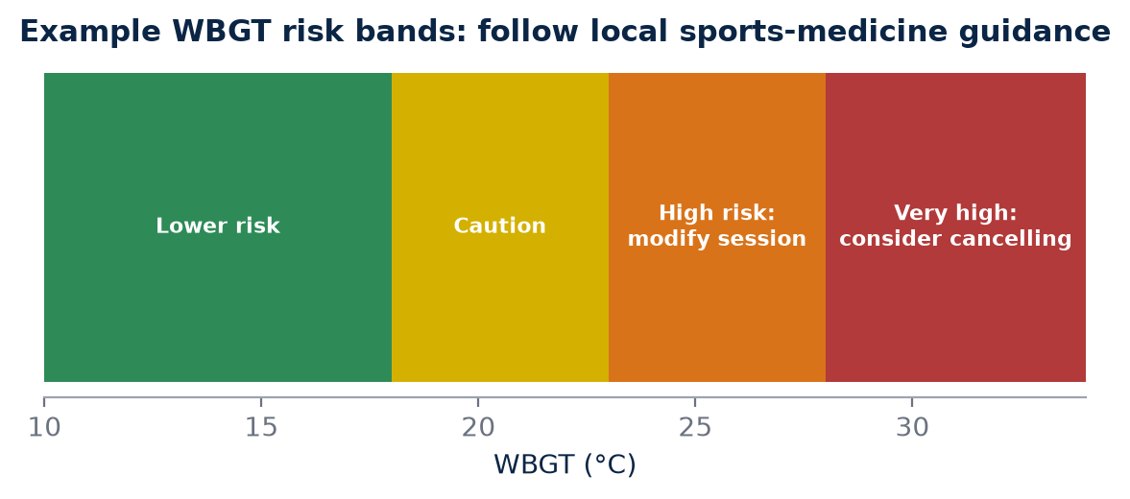
Figure 20. Example categories in the style of widely used athletic heat-safety flag systems. Local federation and medical guidelines take precedence.

What WBGT combines
WBGT was developed for military training in the 1950s and is now widely used in occupational health and sport. Outdoors, it combines three readings: a natural wet-bulb temperature, which reflects the cooling power of evaporation and so responds strongly to humidity and airflow; a black-globe temperature, which reflects radiant heat from sun and surfaces; and ordinary dry-bulb air temperature. The wet-bulb component carries the greatest weight, which is why a humid day can have a high WBGT even when the air temperature does not look extreme.
Component | What it reflects | Why it matters for runners
Natural wet-bulb temperature | Evaporative cooling potential | Humidity limits sweat evaporation
Black-globe temperature | Radiant heat from sun and ground | Direct sun adds heat load
Dry-bulb air temperature | Air temperature | Convective heat exchange

Proper WBGT measurement uses a dedicated instrument placed in the conditions the athletes experience, not a phone app's city estimate. Values can differ markedly between a shaded park at dawn and an exposed road at mid-morning.

Example categories and guidance
Many race-medicine and sports-medicine bodies use flag or category systems based on WBGT. The table below shows example categories in the style of the widely used American College of Sports Medicine flag system for endurance events. They are illustrative only: thresholds differ between organisations, sports, and levels of acclimatisation, and local sports-medicine and federation guidelines always apply.
Example WBGT category | Illustrative risk | General guidance
Below 18°C | Low | Normal training; still hydrate and monitor
18–23°C | Moderate | Monitor closely; adjust pace and hydration
23–28°C | High | Reduce intensity and duration; extra cooling; watch vulnerable athletes
Above 28°C | Very high | Consider postponing or moving hard sessions; follow medical guidance

Individual factors shift risk within any category. Athletes who are not yet heat-acclimatised, who are unwell, sleep-deprived or dehydrated, who are returning from injury, or who are running at high intensity for long durations can be at greater risk even in a moderate category. Young athletes and masters athletes may respond differently, and body size, clothing and fitness also matter. The category is a starting point for decisions, not a permission slip.
In practice, WBGT guidance should shape the whole session plan: when to start, how long to run, how hard to go, where to place fluid and shade, and who will watch for early signs of heat illness such as confusion, unsteady running, collapse or unusual behaviour. Exertional heat stroke is a medical emergency, and every hot-weather programme should have a clear plan for rapid recognition, cooling and medical help, developed with qualified sports-medicine professionals.
KEY IDEA
WBGT combines humidity, radiant heat and air temperature into one heat-load index. Category thresholds are guides that must be adapted to local medical and federation rules and to each athlete's acclimatisation.

Logging environment in Indian training
For Indian endurance training, the environment should be logged whenever possible. A 60-minute run at the same pace can create very different physiological stress at 20°C and at 34°C with high humidity. Heart rate may be many beats higher, sweat loss much greater and perceived effort far harder, even though the watch shows the same pace. If AEI ignored this, it would read a hot-season plateau as lost fitness and a cool-season improvement as a breakthrough.
This is why AEI should carry an environmental context tag for major sessions and races: at minimum air temperature, relative humidity and time of day; ideally WBGT, sun or shade, and wind. With that context, the system can compare sessions run in similar conditions and adjust expectations for sessions that were not.
FIELD PROTOCOL
1. Environmental logging for key sessions
2. Measure at the training site within 15 minutes of the start, at athlete height, in the same sun or shade exposure as the route
3. Record air temperature, relative humidity, WBGT if a meter is available, wind estimate, cloud cover and time
4. Re-measure at the end of sessions longer than 60 minutes
5. Tag the session with its environmental category
6. Compare only sessions within similar categories when judging fitness trends

COACH'S CORNER
Schedule quality sessions in the coolest part of the day during hot months, and treat pace targets as flexible when WBGT is high: run by effort and heart rate instead. Make heat-illness recognition and a cooling plan part of every hot-season training camp.

CHECKPOINT
For your last five key sessions, could you state the temperature, humidity and time? How many of your "bad" sessions coincided with high heat load?

CHAPTER 52

52. Pace-HR Decoupling
PART IX — ENVIRONMENT
On a steady run, pace and heart rate usually travel together. As the run goes on, that partnership can loosen. If heart rate rises while pace remains constant, or pace falls while heart rate remains similar, the relationship may indicate cardiac drift, heat strain, dehydration, fatigue or pacing changes. Pace-HR decoupling measures this loosening, and it is one of the most useful field signals available to AKURA because it needs nothing more than a heart-rate strap and a GPS watch.
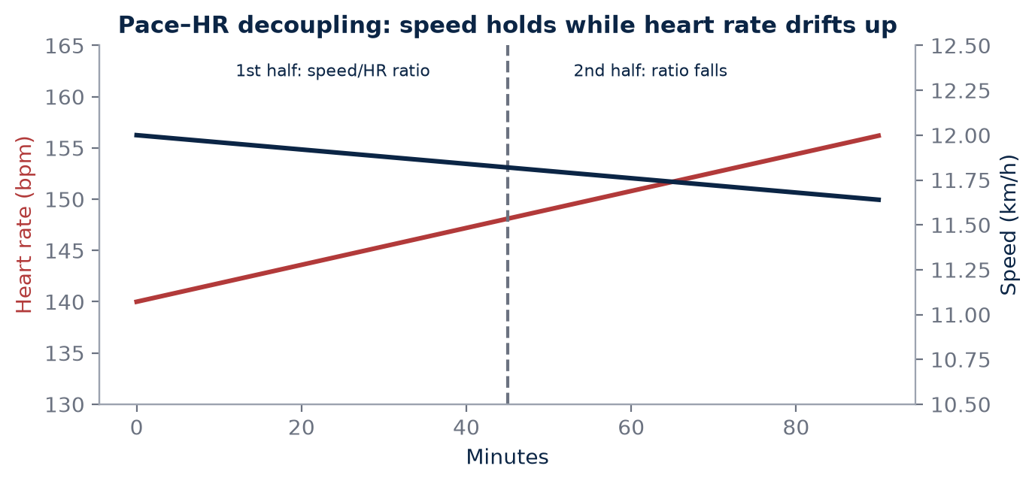
Figure 21. Illustrative long run. Decoupling (%) = (first-half speed:HR − second-half speed:HR) ÷ first-half ratio × 100. It is a signal to interpret, not a diagnosis.

Why the relationship drifts
During prolonged exercise, especially in the heat, heart rate tends to rise gradually even at a constant workload. Coyle and González-Alonso described this cardiovascular drift and linked it to rising body temperature, fluid loss and the increasing demand for skin blood flow, which together reduce stroke volume so that heart rate must climb to maintain output. Fatigue of the running muscles, glycogen depletion and subtle changes in running mechanics can add to the effect. A well-conditioned, well-hydrated athlete in cool weather typically shows little drift; the same athlete in humid heat may show a lot.

Calculating decoupling
The most practical method compares the first half and the second half of a steady run. For each half, calculate an efficiency ratio: average speed divided by average heart rate. Decoupling is the percentage change in this ratio from the first half to the second half. A falling ratio means the athlete is getting less speed for each heartbeat as the run progresses.
FIELD PROTOCOL
1. Pace-HR decoupling calculation
2. Choose a steady run of at least 45–60 min on flat or consistent terrain, after a 10–15 min warm-up that is excluded from analysis
3. Split the analysed portion into two equal halves by time
4. For each half, compute average speed (e.g. metres per minute) and average HR
5. Efficiency ratio = average speed ÷ average HR for each half
6. Decoupling (%) = (first-half ratio − second-half ratio) ÷ first-half ratio × 100
7. Record temperature, humidity, fluid intake, terrain and any pace changes
8. Store the result against the athlete's own history, not a universal cut-off

For example, suppose the first half averages 200 m/min at 140 bpm, giving a ratio of about 1.43, and the second half averages 200 m/min at 150 bpm, giving about 1.33. The decoupling is roughly 7%. Whether that is large depends on the conditions and on what is normal for this athlete.
Half of run | Average speed | Average HR | Efficiency ratio
First half | 200 m/min | 140 bpm | 1.43
Second half | 200 m/min | 150 bpm | 1.33
Decoupling | — | — | About 7%

A signal, not a diagnosis
Decoupling is not a diagnosis. It is a signal. The athlete's hydration, temperature, terrain and effort must be considered. A hilly second half, a headwind, a stop at a traffic signal, a poorly fitting strap or a sunrise that turned a cool start into a hot finish can all create apparent decoupling without any change in fitness. Conversely, a runner who slowed down deliberately may show little decoupling despite significant strain.
Repeated standardised runs can make this signal more useful. Over time, AEI can learn an athlete's normal response instead of using a universal threshold. If an athlete usually shows 2–4% decoupling on a standard 60-minute run in the cool season, a value of 10% under similar conditions deserves attention, while the same 10% on a humid May morning may simply be expected.
A few technical points improve the quality of the signal. Chest straps usually give more reliable heart-rate data than wrist sensors during running, particularly in sweat and heat. Very short runs produce noisy ratios, so the analysed period should be long enough to reveal drift. Runs that include intervals, big hills or long stops are unsuitable. On undulating routes, some coaches use grade-adjusted pace, but even then the most reliable comparisons come from the same route under similar conditions. Finally, decoupling on a treadmill and outdoors are not directly comparable, because airflow, surface and cooling differ.
Decoupling can also help with race preparation. A marathon runner who shows modest decoupling on a long run at goal pace in conditions similar to race day has useful evidence of durability, while one who shows large decoupling may need to reconsider pace targets, fuelling or hydration.
KEY IDEA
Decoupling compares speed per heartbeat in the first and second halves of a steady run. Read it against the athlete's own history and the day's conditions, never as a stand-alone verdict.

COACH'S CORNER
Use one standard route and duration for decoupling checks every few weeks. Falling decoupling on matched days suggests improving aerobic durability; a sudden rise should prompt questions about sleep, illness, hydration and heat before any change to training.

CHECKPOINT
What decoupling does your athlete usually show on a standard steady run in cool conditions? How would you tell whether a higher value reflected fatigue or simply the weather?

CHAPTER 53

53. Humidity Is Not Just “More Heat”
PART IX — ENVIRONMENT
It is tempting to think of humidity as simply making a hot day feel hotter. Physiologically, it does something more specific. Humidity changes how effectively sweat evaporates. Two environments with the same air temperature can create very different thermal strain, because the runner's main cooling mechanism works well in one and poorly in the other.

Evaporation: the runner's radiator
A running body produces a great deal of heat. In warm conditions, most of that heat must be removed by evaporating sweat from the skin. Evaporation depends on the difference between the water vapour pressure at the skin and in the surrounding air. In dry air, sweat evaporates readily and cools effectively. In humid air, the gradient is small, sweat drips rather than evaporates, and much of the fluid lost provides little cooling. The athlete sweats heavily, dehydrates faster and still heats up. Heart rate climbs as blood is diverted to the skin, and perceived effort rises.
Condition | Sweat evaporation | Typical consequence
Hot and dry | Efficient | Cooling works; fluid loss high
Hot and humid | Limited | Core temperature rises faster; HR drift larger
Warm and very humid | Limited | Strain can exceed a hotter dry day
Cool and humid | Adequate at low heat production | Usually manageable

The coastal Indian runner
This matters particularly for coastal India. An athlete who can run comfortably at 32°C in dry conditions may struggle at a lower temperature when humidity is high. Runners in Chennai, Mumbai, Kochi, Visakhapatnam or Kolkata face long stretches of the year when the air is warm and saturated, and early mornings may be the most humid part of the day even though they are the coolest. An athlete who moves from a dry inland city to the coast, or travels to a humid race, can find familiar paces unexpectedly hard.
Heat-index or apparent-temperature numbers reported by weather apps attempt to combine temperature and humidity into a single feels-like value. They can be helpful as a quick warning, but they were not designed for athletes producing large amounts of heat, and they do not include radiant load or wind at the training site. For AKURA, the raw temperature and humidity values, plus WBGT where available, are more useful than a single feels-like figure, because they allow the analysis to separate the contributions of each variable.
Clothing and practical choices also interact with humidity. Light, breathable kit, shaded routes, earlier start times and regular cooling with water or ice can reduce strain, but none of them fully overcomes the physics of limited evaporation. Humid conditions therefore call for honest adjustment of expectations rather than simply trying harder.
MYTH VS EVIDENCE
Myth: If the temperature is lower, the run will be easier.
Evidence: A warm, very humid day can impose more thermal strain than a hotter, drier one, because humidity limits sweat evaporation, the body's main cooling route during running.

Designing heat-acclimation research
Heat-acclimation research should therefore distinguish temperature, humidity and total heat stress rather than treating them as one variable. An acclimation block in dry heat may not fully prepare an athlete for humid heat, and vice versa. Consensus recommendations on training and competing in the heat, such as those led by Racinais and colleagues in 2015, emphasise matching acclimatisation to the expected competition environment where possible. For AKURA, that means recording air temperature, relative humidity and, where available, WBGT separately, so that the analysis can ask whether an athlete's response is driven by heat, by humidity, or by their combination.
FIELD PROTOCOL
1. Humid-heat readiness check
2. Choose a standard 45–60 min easy run performed in both drier and more humid conditions over several weeks
3. Record air temperature, relative humidity, WBGT if available and time of day
4. Weigh the athlete before and after (minimal clothing, towel-dried) to estimate sweat loss, adjusting for fluid taken
5. Calculate pace-HR decoupling for each run
6. Compare decoupling, sweat loss and RPE between drier and more humid days at similar temperatures
7. Use the results to individualise pacing and hydration plans for humid races

Acclimatisation itself is specific and reversible. Adaptations such as an expanded plasma volume, earlier and greater sweating, and a lower heart rate at a given workload develop over roughly one to two weeks of repeated heat exposure and fade if exposure stops. Recording the type of heat an athlete has trained in, and for how long, allows AEI to judge how prepared they are for a particular race environment.
KEY IDEA
Temperature, humidity and total heat stress are different variables. Record them separately so AEI can tell which one is limiting the athlete.

COACH'S CORNER
Before a humid race, rehearse race-pace segments in similar humidity and adjust targets by effort and heart rate. Plan fluid and cooling strategies with a qualified professional where possible, and remind athletes that heavy sweating in humidity is not a sign of efficient cooling.

CHECKPOINT
Does your training log record humidity separately from temperature? Which of your athletes struggle most on humid days, and how would you test whether humidity rather than temperature is the main cause?

PART IX AT A GLANCE
The key idea from each chapter, for quick revision.
51 | WBGT and Heat Load  WBGT combines humidity, radiant heat and air temperature into one heat-load index. Category thresholds are guides that must be adapted to local medical and federation rules and to each athlete's acclimatisation.
52 | Pace-HR Decoupling  Decoupling compares speed per heartbeat in the first and second halves of a steady run. Read it against the athlete's own history and the day's conditions, never as a stand-alone verdict.
53 | Humidity Is Not Just “More Heat”  Temperature, humidity and total heat stress are different variables. Record them separately so AEI can tell which one is limiting the athlete.

PART X — TRAINING DESIGN
Measurement only matters if it changes what happens on Monday morning. Part X turns the AKURA Endurance Index from a profile into a planning tool. It explains how performance, readiness, environmental and recovery information can shape intensity, how six broad intensity domains give coach and athlete a shared language, how the 3–3–1 weekly rhythm can organise load without becoming a rigid formula, how progression can be planned yet reversible, and how strength work can support running economy and resilience without stealing from key sessions. Throughout, the principle is the same: the algorithm informs, the coach decides, and the athlete's response is the final judge.
IN THIS PART
54 From AEI to Training
55 Training Intensity Domains
56 The 3–3–1 Concept
57 Progressive Overload Without Blind Progression
58 Strength and Running Economy
CHAPTER 54

54. From AEI to Training
PART X — TRAINING DESIGN
The purpose of an athlete index is not to create a pretty dashboard. A number that looks impressive on a screen but never alters a session, a pace target or a recovery day is decoration, not science. The AKURA Endurance Index (AEI) earns its place only if it improves decisions: which session to run, how hard to run it, when to hold back and when to push. This chapter describes how the different layers of AEI connect to the training plan, and why the coach remains the final point of responsibility.

Five layers, five kinds of decision
Each layer of AEI answers a different practical question. A performance score describes current capacity and can guide intensity: it tells us what paces or power outputs are realistic for threshold, long-run or interval work. A readiness layer describes today's ability to express that capacity and can modify the session: shorten it, lower the target, or swap it for an easier day. Environmental data—temperature, humidity, altitude, air quality—can alter pace expectations, so that a threshold run in Chennai humidity is judged against the conditions rather than against a cool-morning benchmark. Recovery data such as sleep, resting heart rate and subjective fatigue can reduce unnecessary intensity before it becomes accumulated fatigue. Finally, actual workout execution—what was really run, at what heart rate and with what perceived effort—feeds back into the model and updates the next decision.
AEI layer | Question it answers | Typical training decision
Performance | What can the athlete do? | Set pace or HR targets for each domain
Readiness | Can they express it today? | Keep, modify or replace the session
Environment | How hard are the conditions? | Adjust pace expectations, hydration, timing
Recovery | Is fatigue accumulating? | Reduce intensity or add a reset day
Execution | What actually happened? | Update the model and next week's plan

KEY IDEA
AEI is a decision-support loop, not a scoreboard. Performance sets the targets, readiness and environment adjust them, recovery protects them, and execution data closes the loop.

The feedback loop
A training plan is a hypothesis: "If this athlete does this work, they will adapt in this way." Each session is a small experiment, and execution data is its result. When an athlete completes a planned threshold session at the expected pace with a stable heart rate and moderate perceived effort, the model gains confidence in its estimate of threshold. When the same session produces an unusually high heart rate, a sharp rise in perceived exertion or an early stop, something in the model—fitness, readiness, environment or execution—needs to be re-examined. Over weeks, these small signals accumulate into a clearer picture than any single test can offer.
This loop also protects against a common error: treating the plan as more important than the athlete. A plan written three weeks ago did not know about last night's poor sleep, a sudden rise in humidity or an exam week. The loop allows the plan to bend without breaking.

Judgement remains with the coach
The coach remains responsible for context. An algorithm can notice that resting heart rate is elevated; it cannot know that the athlete travelled overnight by train, is fasting for a festival, is caring for a sick family member or has just received good news that will lift motivation. Algorithms work with the variables they are given. Coaches work with the whole person.
For this reason, AEI outputs should be framed as recommendations with confidence levels, not commands. A sensible default is that the system proposes and the coach disposes: the coach accepts, modifies or overrides the suggestion, and the override itself is recorded so that the model can learn which contexts it handles poorly. Over time, a well-designed system should make the coach more consistent and better informed—not more passive.
COACH'S CORNER
Before each training block, write down which AEI outputs will influence which decisions—for example, "readiness below the athlete's usual range on a key day means we shorten intervals, not cancel them." Agreeing the rules in advance reduces emotional decisions on the day and makes your overrides easier to review later.

Avoiding dashboard drift
Many monitoring systems begin with good intentions and slowly become cluttered with metrics that nobody acts upon. A useful discipline is to ask of every metric: "What decision would change if this number moved?" If the answer is "none", the metric may still have research value, but it should not compete for attention on the daily training screen. In Indian club and academy settings, where coaches may manage large groups with limited staff, fewer and clearer signals are usually more valuable than a comprehensive but unread report.
CHECKPOINT
For each metric you currently collect, can you name the specific training decision it influences? Which metric would you remove if you could only keep five?

CHAPTER 55

55. Training Intensity Domains
PART X — TRAINING DESIGN
Coaches and athletes need a shared language for effort. "Go easy" means different things to a teenager chasing a club record and a veteran marathoner returning from injury. AKURA uses broad intensity domains—Recovery, Aerobic, Endurance, Threshold, Power and Speed—that can be mapped to pace, heart rate, rating of perceived exertion (RPE) or workout structure depending on the athlete, the equipment available and the purpose of the session.
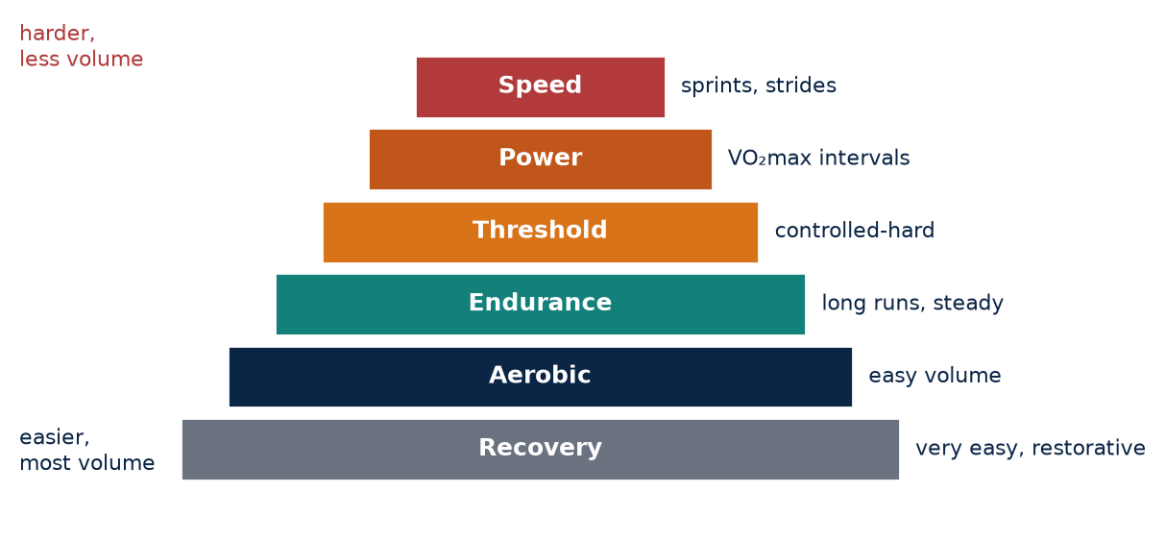
Figure 22. The six AKURA intensity domains. Most weekly volume sits at the base; harder domains are used in smaller, planned doses.

The six AKURA domains
The domains are deliberately broad. They are categories of training purpose, not precise physiological boundaries, and the transitions between them are gradual rather than sharp. The table below gives illustrative descriptions; each athlete's anchors must be established from their own testing and training history.
Domain | Main purpose | Feel (RPE 1–10) | Typical session examples
Recovery | Promote circulation and restoration | 1–2, very easy, full conversation | 20–40 min jog or brisk walk; easy cycling
Aerobic | Build aerobic base and capillarity | 3–4, easy, conversational | 45–75 min steady easy run
Endurance | Durability and fuel use over time | 4–5, comfortable but sustained | Long run 90–150 min; marathon-pace segments
Threshold | Raise sustainable pace near lactate turn-point | 6–7, comfortably hard | 3 × 10 min or 20–30 min tempo
Power | Develop VO₂max and high aerobic power | 8–9, hard, few words | 5 × 3 min or 6 × 1 km with recoveries
Speed | Neuromuscular speed and running mechanics | Fast but relaxed; not maximal strain | 8 × 100 m strides; 6 × 200 m with full recovery

KEY IDEA
Intensity domains describe the purpose of a session, not only its pace. The same pace can belong to different domains on a cool morning and a humid afternoon.

Anchoring domains to the individual
Established systems already show how current fitness can define training categories. Jack Daniels' VDOT approach, for example, derives Easy, Marathon, Threshold, Interval and Repetition paces from a recent race performance, and it remains a practical and widely used reference. Heart-rate zones based on laboratory lactate or ventilatory thresholds offer another route. RPE, meanwhile, is available to every athlete at no cost and captures internal strain that pace alone may miss.
AKURA does not need to replace these tools. The six domains can sit on top of any of them: a well-resourced athlete may have laboratory-derived heart-rate anchors, while a school athlete in a district programme may use recent race times and RPE. What matters is consistency—using the same anchoring method over time so that changes can be interpreted.
Research on intensity distribution adds useful perspective. Seiler and Kjerland's 2006 analysis of elite junior cross-country skiers found that much of the training volume was performed at low intensity, with a smaller proportion at high intensity. Such findings do not prescribe an exact ratio for every runner, but they caution against the common habit of doing most runs at a "moderately hard" pace that is too fast for recovery and too slow for high-quality stimulus.

Adding environmental and readiness context
AEI should add environmental and readiness context rather than simply creating another pace table. A threshold pace established in December in Bengaluru may be unrealistic in May in Chennai. If the athlete insists on hitting the same pace in higher heat stress, the session silently moves from Threshold into Power, with a very different cost. AKURA's approach is to hold the domain constant and let pace flex: the session's purpose is protected, and heart rate and RPE help confirm the athlete is in the intended domain.
Readiness works the same way. On a low-readiness day, the athlete may still train in the Aerobic domain but at a slower pace than usual, or a planned Threshold session may be shortened. The domain language helps the coach explain the change: "Today's purpose is still threshold—we are just protecting it."
COACH'S CORNER
When conditions are hot or humid, prescribe threshold and endurance sessions by heart rate and RPE with a pace range as a guide, not a target. Tell athletes in advance that slower pace in heat is expected and does not mean lost fitness.

Common misuses
Three misuses appear repeatedly. First, the grey zone: easy days drift into moderate effort, leaving the athlete too tired for quality days. Second, the chase: an athlete forces a pace from a watch rather than respecting the session's purpose. Third, the false precision: treating a zone boundary as a hard line, so that a heart rate two beats above the limit is judged a failure. Domains are tools for communication and planning, not tests of obedience.
CHECKPOINT
Over the last two weeks, what proportion of your athlete's runs were genuinely in the Recovery or Aerobic domains? Were any "easy" days actually moderate?

CHAPTER 56

56. The 3–3–1 Concept
PART X — TRAINING DESIGN
Weekly structure gives training its rhythm. Athletes like to know what Tuesday and Saturday will bring, and coaches need a framework that balances stress and recovery. AKURA uses a 3–3–1 concept as one possible weekly architecture. It is a starting template for thinking, not a rule to be applied identically to every athlete.
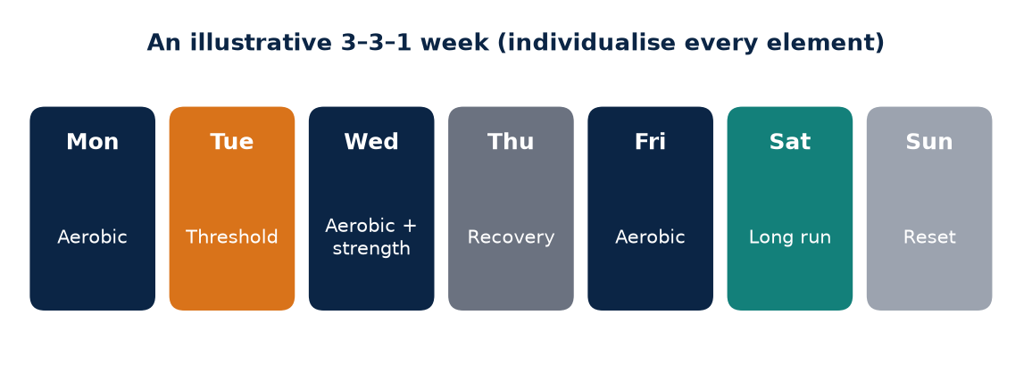
Figure 23. One possible reading of the 3–3–1 rhythm. The value lies in how load is distributed, not in the numbers themselves.

What 3–3–1 means
A 3–3–1 weekly rhythm can be interpreted as three days emphasising aerobic development, three days supporting complementary qualities or recovery, and one key recovery or reset day. The three aerobic-development days usually carry the week's main endurance stimulus: a long run, a threshold session and a steady aerobic run, for example. The three complementary days might include strength work, speed or strides, easy running, mobility or cross-training. The single reset day allows physical and psychological recovery—complete rest for some athletes, a short easy jog or walk for others.
The exact structure must be individualised. A school athlete balancing examinations, a working professional training before office hours and a full-time academy runner will not share the same week. Some athletes need two reset days; some advanced athletes may combine elements on the same day.
Day | Illustrative emphasis | AKURA domain | Example content
Mon | Reset | Recovery | Rest or 20–30 min very easy jog; mobility
Tue | Aerobic development | Threshold | Warm-up; 3 × 10 min threshold, 2 min jog; cool-down
Wed | Complementary | Aerobic + strength | 45 min easy; runner strength session (Chapter 58)
Thu | Aerobic development | Aerobic | 60–70 min steady aerobic run
Fri | Complementary | Recovery + speed | 30–40 min easy; 6–8 × 100 m relaxed strides
Sat | Complementary | Aerobic + strength | 40 min easy; short strength maintenance
Sun | Aerobic development | Endurance | Long run 90–120 min, early morning in heat season

This example week is illustrative only. It must be individualised to the athlete's training age, injury history, race calendar, climate and life commitments before use.
KEY IDEA
The value of 3–3–1 lies in how it distributes stress and recovery, not in the numbers themselves. A week is well designed when the athlete can absorb it and arrive at key sessions ready to perform.

Load distribution over labels
Two athletes with the same weekly kilometres can experience very different stress depending on intensity, hills, heat and strength work. Sixty kilometres of flat, easy running on cool mornings is not the same as sixty kilometres containing two threshold sessions, a hilly long run and afternoon runs in 34°C humidity. Kilometre totals are easy to count and easy to compare on social media, but they hide much of what the body actually experiences.
For this reason, AEI should track internal load as well as external kilometres. A practical and validated approach is session RPE: the athlete rates the whole session on a 0–10 scale about 30 minutes after finishing, and this rating is multiplied by the duration in minutes to produce a session load in arbitrary units. Session RPE, described by Foster and colleagues, requires no equipment and captures the combined effect of pace, terrain, heat and fatigue. Heart-rate-based measures can complement it where reliable data are available.

Spacing the key days
The order of days matters. Hard sessions placed back to back leave little time for recovery unless the athlete is highly trained and the second session is deliberately modest. In the illustrative week, the threshold day and long run are separated by lower-stress days, and the reset day follows the long run. Strength work sits on days when the legs can tolerate it without compromising the next key running session.
Environmental timing also belongs in the design. In much of India, the long run is best placed early on a weekend morning, before heat and humidity rise and before traffic makes roads unsafe. During monsoon months, flexible scheduling helps—moving a threshold session by a day to avoid waterlogged roads is sensible planning, not indiscipline.
COACH'S CORNER
Record session RPE for every session for four weeks, including strength and cross-training. Compare weekly load with weekly kilometres. You will often find that the "hardest" week by kilometres was not the hardest week for the athlete.

When 3–3–1 does not fit
Rigid adherence to any template can cause problems. An athlete returning from injury may need a 2–4–1 week with fewer aerobic-development days. An athlete in a taper will reduce volume while preserving some intensity. Travel weeks, exam weeks and festival periods may call for a simpler structure. The concept is useful precisely because it can flex: it reminds the coach to balance development, support and recovery, whatever the exact numbers.
CHECKPOINT
If you compared two of your athletes with similar weekly kilometres, would their internal load be similar? What in their weeks—heat, hills, intensity, strength—might explain the difference?

CHAPTER 57

57. Progressive Overload Without Blind Progression
PART X — TRAINING DESIGN
Adaptation requires progressive challenge. If the training stimulus never changes, the body has little reason to change either. But progression that ignores the athlete's response is not a strategy; it is a hope. This chapter argues for progression that is planned, monitored and reversible.

The problem with fixed percentages
A fixed percentage increase every week—such as the familiar "add 10% per week"—is easy to remember but not always appropriate. For a beginner running 15 km per week, 10% is a tiny change; for an athlete already at 120 km, it may be a large one. Percentages also ignore what the kilometres contain: adding 10% of easy running is very different from adding 10% of threshold work or hill repetitions.
The athlete's current load, recovery, injury history, race calendar and environmental stress all matter. An athlete who has recently come through a stress injury needs more conservative progression than a healthy athlete with years of consistent training. An athlete entering the hottest months may need to hold volume while the body adapts to thermal strain, even if the calendar says it is a "build" week.
MYTH VS EVIDENCE
Myth: Increasing weekly mileage by exactly 10% is the safe way to progress.
Evidence: There is no universal safe percentage. Safe progression depends on current load, training history, session content, recovery and environment, and should be adjusted to the athlete's observed response.

Load, capacity and the training–injury paradox
Gabbett's 2016 review on the training–injury prevention paradox argued that well-developed physical qualities, built through appropriately high training loads, can be protective, while rapid spikes in load relative to what the athlete is prepared for are associated with higher injury risk. The practical message is not "train less" or "train more", but "build load steadily and avoid sudden jumps". Methods used to express this relationship, such as acute:chronic workload ratios, have since been debated statistically, so they are best treated as prompts for attention rather than precise risk predictions.
KEY IDEA
The key question is not "Did mileage increase?" but "Did the athlete absorb the load and produce a better response?" Progression is earned by adaptation, not scheduled by the calendar alone.

A decision matrix for progression
Progression should be planned, monitored and reversible. At the end of each week or block, the coach can review a small set of signals: whether key sessions were completed as intended, how heart rate and RPE compared with previous weeks at similar paces, trends in sleep and resting heart rate, soreness or pain, and the athlete's own sense of how the week went. The matrix below offers an illustrative way to turn those signals into a decision.
Absorbed-load signals | Interpretation | Decision
Key sessions hit; HR/RPE stable or lower; sleep and mood normal | Load absorbed, positive response | Progress: modest increase in volume or one quality variable
Sessions completed but RPE higher than usual; mild fatigue | Load absorbed at a cost | Hold: repeat similar week before progressing
Mixed: one key session missed or cut; readiness below usual for 2–3 days | Load at the edge of tolerance | Hold or small reduction; review sleep, heat, life stress
Multiple sessions compromised; persistent fatigue; rising resting HR | Load not absorbed | Reduce: lower volume and intensity for several days
New or worsening localised pain; limping; altered gait | Possible injury warning | Reduce and seek assessment from a qualified professional

These signals and thresholds are illustrative and should be calibrated to each athlete's own baseline.

Reduction is part of adaptation
A reduction week is not failure; it is part of adaptation. Many athletes—and some coaches—feel that a lighter week wastes fitness. In reality, recovery is when much of the adaptation to the preceding training is consolidated. Planned reduction weeks, for example every third or fourth week, allow fatigue to dissipate and provide a cleaner window in which to test or observe the athlete's response. Unplanned reductions, triggered by the decision matrix, are equally legitimate: they are the plan responding intelligently to the athlete.
Reversibility also means communicating early. Athletes who know that the plan will adapt to their response are more likely to report fatigue honestly, rather than hiding it to protect their "streak".
COACH'S CORNER
At the end of each week, ask three questions: Were the key sessions completed as intended? Did the effort feel appropriate for the pace? Is anything hurting that did not hurt last week? Let the answers—not the calendar alone—decide whether next week progresses, holds or reduces.

CHECKPOINT
Look back at your athlete's last build phase. Was each increase in load preceded by clear evidence that the previous load had been absorbed? Where would a hold week have helped?

CHAPTER 58

58. Strength and Running Economy
PART X — TRAINING DESIGN
For many years, distance runners were told that strength training would make them heavy and slow. The evidence now points in a different direction. Strength training can support force production, neuromuscular coordination and resilience. It should be integrated with running rather than treated as a separate sport—and it should be judged by what it does for running, not by how much weight the athlete can lift.

What the evidence suggests
Several reviews have examined strength training in endurance athletes. Beattie and colleagues' 2014 review in Sports Medicine concluded that strength training, including heavy and explosive methods, can improve performance-related outcomes in endurance athletes, with running economy among the most frequently reported benefits. Balsalobre-Fernández and colleagues' 2016 meta-analysis of controlled trials in highly trained runners found that strength training programmes of several weeks were associated with improvements in running economy. Earlier, Paavolainen and colleagues showed that replacing part of endurance training with explosive-strength work improved 5-km time in well-trained runners, linked to improved economy and muscle power.
These findings are encouraging but should be read carefully. Study samples are often small, programmes vary, and effects on actual race performance are less consistently measured than effects on economy. The likely mechanisms—improved neuromuscular recruitment, tendon and muscle stiffness characteristics, and better force application—are plausible but not fully settled.
KEY IDEA
For distance runners, the objective is not bodybuilding volume. It is sufficient strength, control, stiffness management and movement quality without compromising key running sessions.

Designing strength for runners
Effective strength work for runners tends to share a few features: relatively low volume, emphasis on quality of movement, progressive loading of major lower-limb muscles, some plyometric or elastic work once basic strength is established, and attention to the calf–Achilles complex and hip stability that running places under repeated demand. Sessions are usually short—30 to 45 minutes—and performed two times per week in general preparation, reducing to one maintenance session during competition phases.
Exercise | Illustrative prescription | Purpose | Coaching note
Goblet or back squat | 3 × 5–6, controlled | Hip and knee extensor strength | Stop 2–3 reps short of failure
Romanian deadlift | 3 × 6 | Posterior chain, hamstrings | Neutral spine; hinge at hips
Rear-foot elevated split squat | 3 × 6 each leg | Single-leg strength and control | Knee tracks over mid-foot
Single-leg calf raise (straight and bent knee) | 3 × 10–12 each | Calf–Achilles capacity | Slow lowering; full range
Pogo jumps or low hurdle hops | 3 × 10 contacts | Elastic stiffness, ground contact | Quiet, quick contacts; add later
Side plank with hip abduction | 2 × 20–30 s each side | Lateral hip and trunk control | Stable pelvis

This session is illustrative and should be adapted to the athlete's training age, technique, injury history and available equipment. Beginners should start with bodyweight or light loads and learn movement patterns before adding plyometrics; athletes with current pain should be assessed by a qualified professional first.

Integration with the running week
Strength should be placed so that it supports, rather than competes with, key running sessions. A common approach is to schedule strength on the same day as an easy run or after a quality session, leaving the following day easy, so that the hard days stay hard and the easy days stay easy. Heavy lower-body work immediately before a threshold session or long run is usually unwise. During the hottest months, strength sessions performed indoors can also provide useful training stimulus when outdoor running volume is limited by heat.
Rønnestad and Mujika's 2014 review on optimising strength training for running and cycling highlighted the importance of maintaining some strength work during the competition season, since gains can fade when strength training stops entirely.
COACH'S CORNER
Start runners with two short sessions per week built around four or five movements. Progress load only when technique is stable and the running sessions that follow are unaffected. If key runs are suffering, reduce strength volume before reducing running quality.

What AEI should—and should not—track
AEI can track strength adherence and selected performance markers—for example, sessions completed per week, a single-leg calf raise count, a countermovement jump height or a simple loaded squat estimate—alongside changes in running economy or submaximal heart rate. These records help the coach see whether strength work is being done consistently and whether it coincides with improvements in running.
However, AEI should not assume that more strength always means faster running. Beyond a sufficient level, additional strength may offer diminishing returns for a distance runner, and extra training time spent in the gym is time not spent recovering or running. The relationship is likely non-linear and individual. The useful question is not "How strong is the athlete?" but "Is the athlete strong enough to run well, stay healthy and express their aerobic fitness efficiently?"
MYTH VS EVIDENCE
Myth: Strength training will make distance runners bulky and slow.
Evidence: Low-volume, well-programmed strength and plyometric work is associated with improved running economy in several controlled studies, with little change in body mass when combined with endurance training.

CHECKPOINT
Is strength work in your athlete's plan scheduled to protect key running sessions? Which strength marker would you track to know whether it is helping?

PART X AT A GLANCE
The key idea from each chapter, for quick revision.
54 | From AEI to Training  AEI is a decision-support loop, not a scoreboard. Performance sets the targets, readiness and environment adjust them, recovery protects them, and execution data closes the loop.
55 | Training Intensity Domains  Intensity domains describe the purpose of a session, not only its pace. The same pace can belong to different domains on a cool morning and a humid afternoon.
56 | The 3–3–1 Concept  The value of 3–3–1 lies in how it distributes stress and recovery, not in the numbers themselves. A week is well designed when the athlete can absorb it and arrive at key sessions ready to perform.
57 | Progressive Overload Without Blind Progression  The key question is not "Did mileage increase?" but "Did the athlete absorb the load and produce a better response?" Progression is earned by adaptation, not scheduled by the calendar alone.
58 | Strength and Running Economy  For distance runners, the objective is not bodybuilding volume. It is sufficient strength, control, stiffness management and movement quality without compromising key running sessions.

PART XI — CASE STUDIES
Principles become clearer when applied to an athlete. Part XI presents five hypothetical case studies, each designed to show how the AKURA Endurance Index can move a coach beyond a single headline number. We meet a runner with a high VO₂max who fades in the marathon, a runner with modest VO₂max but excellent economy, an athlete who responds strongly to heat acclimation, an athlete whose altitude exposure is measured rather than assumed, and an athlete whose fitness is high but whose readiness is low. All profiles and numbers are illustrative, created for teaching; they do not describe real individuals and must not be used as norms or diagnostic thresholds.
IN THIS PART
59 Case Study A: High VO₂max, Weak Marathon
60 Case Study B: Moderate VO₂max, Excellent Economy
61 Case Study C: Strong Heat Response
62 Case Study D: Altitude Response
63 Case Study E: Strong Fitness, Poor Readiness
CHAPTER 59

59. Case Study A: High VO₂max, Weak Marathon
PART XI — CASE STUDIES
This is a hypothetical case study. Athlete A (Chennai, 28, club marathoner) has excellent 5K performance and a high VO₂max from a laboratory test, but shows a large fall in pace over the final 10–12 km of the marathon. On paper, the athlete looks capable of a much faster marathon than they have run. The coach's first instinct—and the athlete's—is often to chase even more speed. AEI suggests a different line of enquiry.
Metric | Illustrative value | Interpretation
VO₂max (lab treadmill) | 66 ml/kg/min | High aerobic ceiling for a club athlete
5K personal best | 16:20 | Strong short-distance performance
Marathon best | 2:58, second half 8 min slower | Large positive split; poor durability
Threshold as % of VO₂max | ~76% | Relatively low fractional utilisation
Longest regular long run | 24 km, done at mixed paces | Limited race-specific durability
Race-day carbohydrate intake | Irregular, gels only after 25 km | Possible fuelling shortfall
Race conditions | Start 5:30 am, 27°C, high humidity | Meaningful thermal strain

All values are illustrative and invented for teaching purposes.

What AEI shows
AEI would not reduce Athlete A to "needs more VO₂max." Their ceiling is already high; the gap lies in how much of that ceiling can be sustained, for how long, in race conditions. The profile directs attention toward durability, pacing, substrate management and race-specific conditioning. In AEI terms, the performance layer shows high capacity, but indicators of fractional utilisation and late-race resilience lag behind—a mismatch rather than a deficiency. This reflects a point made by Joyner and Coyle in their 2008 review: endurance performance depends on VO₂max, the fraction of it that can be sustained, and running economy acting together.
KEY IDEA
A high VO₂max describes the size of the engine, not how long it can run near full power. Marathon performance depends on sustaining a large fraction of capacity for hours, often in heat.

Likely contributors
Possible contributors include insufficient long-run durability, fuelling errors, excessive starting intensity, low threshold relative to maximal capacity and environmental strain. These are hypotheses, not a diagnosis, and more than one may be operating.
- Durability: long runs have been relatively short and inconsistent, so late-race fatigue resistance may be under-developed. Maunder and colleagues have argued that "durability"—how physiological markers drift with prolonged exercise—deserves a place in athlete profiling.
- Fuelling: taking carbohydrate only after 25 km may leave the athlete short of fuel at the point where glycogen becomes limiting.
- Pacing: a fast early pace, encouraged by a strong 5K background, may produce an unsustainable first half.
- Threshold: threshold at a modest percentage of VO₂max suggests room to raise sustainable pace.
- Heat and humidity: Chennai race mornings impose thermal strain that increases cardiovascular drift late in the race.

Intervention plan (8–12 weeks)
- Weeks 1–4: extend the long run progressively from 24 km towards 30 km in the Endurance domain, early morning, with steady pacing; introduce one threshold session per week (for example 3 × 12 min).
- Weeks 1–12: practise race-day fuelling in every long run, starting carbohydrate early and aiming for a consistent intake the athlete tolerates, developed with a qualified sports nutritionist where possible.
- Weeks 5–8: add marathon-pace segments late in long runs (for example the final 8–10 km) to train pace control under fatigue.
- Weeks 5–10: progress threshold volume; reduce high-intensity Power sessions to one short session per week to preserve speed without excessive fatigue.
- Throughout: two short strength sessions per week; heat-aware pacing, with heart-rate and RPE ceilings on hot days.
- Weeks 11–12: taper; rehearse race-morning routine, including pacing plan with an even or slightly negative split target.

What to retest
- Threshold pace and heart rate (field test or laboratory) at weeks 0, 6 and 12.
- Pace–heart-rate decoupling in the last third of long runs of similar length and conditions.
- Gut tolerance and energy in the final third of long runs (athlete log).
- Pacing profile and second-half slowdown in a tune-up half marathon and the target marathon.
COACH'S CORNER
Keep a "late-race" column in the athlete's log: pace, heart rate and RPE for the final 30 minutes of every long run. Improvement in this column is often more meaningful for a marathoner than a faster 5K.

What would change our mind
If the athlete completes longer, well-fuelled, evenly paced long runs with little decoupling but still slows sharply in the marathon, the explanation may lie elsewhere—perhaps race-day heat management, a gastrointestinal problem or a musculoskeletal issue emerging late in the race. If threshold does not improve despite consistent work, the coach may need to reconsider training distribution or recovery. And if the athlete runs an evenly paced marathon only in cool conditions, heat may be a larger contributor than assumed.
CHECKPOINT
For an athlete like Athlete A, which single change—long-run length, fuelling, pacing or threshold work—would you prioritise first, and what evidence would tell you it worked?

CHAPTER 60

60. Case Study B: Moderate VO₂max, Excellent Economy
PART XI — CASE STUDIES
This is a hypothetical case study. Athlete B (Pune, 31, amateur half-marathoner and marathoner) has only a moderate VO₂max, yet runs longer races better than several training partners with far higher laboratory values. The athlete shows a very good oxygen cost at submaximal running speeds and strong threshold performance. This case demonstrates why a single physiological metric cannot define the whole athlete.
Metric | Illustrative value | Interpretation
VO₂max (lab treadmill) | 55 ml/kg/min | Moderate for a competitive amateur
Running economy at 14 km/h | ~185 ml O₂/kg/km | Low oxygen cost; efficient
Threshold as % of VO₂max | ~87% | High fractional utilisation
Half-marathon best | 1:21 | Strong relative to VO₂max
1500 m / 5K times | Modest; limited finishing speed | Low speed reserve
Training history | 8 years consistent, mostly aerobic | Deep aerobic base

All values are illustrative and invented for teaching purposes.

What AEI shows
AEI shows a profile in which economy and fractional utilisation compensate for a moderate ceiling. This athlete may outperform a higher-VO₂max runner at longer distances, because racing speed at the marathon depends on the oxygen that can be sustained and how economically it is used—not just on the maximum. Jones's analysis of the physiology of the women's marathon world-record holder illustrated how improvements in running economy and threshold, rather than VO₂max alone, can accompany performance progression.
KEY IDEA
A single physiological metric cannot define the whole athlete. Moderate VO₂max combined with excellent economy and a high threshold can produce outstanding endurance performance.

Likely contributors
- Long training history building aerobic and musculoskeletal adaptations.
- Favourable running mechanics and possibly anthropometric factors that reduce oxygen cost.
- Consistent threshold-focused training that raises sustainable pace.
- Limited exposure to Speed and Power domains, restricting finishing kick and speed reserve.
These contributors are plausible, but economy is influenced by many factors—footwear, fatigue, measurement conditions and body mass—so a single laboratory value should be interpreted with caution.

Intervention plan (8–12 weeks)
The training focus might be to preserve economy while improving speed reserve, rather than endlessly chasing maximal oxygen uptake.
- Maintain the established aerobic volume and long run; avoid dramatic changes that could disrupt what already works.
- Add regular Speed-domain work: strides after easy runs two times per week and short relaxed repetitions (for example 8 × 200 m) with full recovery.
- Include one Power session every 7–10 days (for example 5 × 3 min) to nudge aerobic power without large volume.
- Maintain two strength sessions per week, adding progressive plyometrics once basic strength is stable.
- Monitor economy-related markers so that added intensity does not degrade efficiency.

What to retest
- Running economy at the same standard speeds and conditions, ideally the same laboratory and footwear.
- VO₂max and threshold, noting whether threshold remains a high percentage of maximum.
- Short-distance performance (1500 m or 5K time trial) as a marker of speed reserve.
- Half-marathon race performance and pacing profile.
COACH'S CORNER
When an athlete's strength lies in economy, protect it. Introduce speed in small, relaxed doses and check that easy-run heart rate at familiar paces does not drift upwards as intensity is added.

What would change our mind
If added speed work increases fatigue and worsens economy or submaximal heart rate, the intervention may be too aggressive, or the athlete may benefit more from continued aerobic development. If the "excellent economy" does not reproduce on repeat testing, the initial result may reflect measurement error or favourable test conditions rather than a stable characteristic. And if longer-race results stall while speed improves, the balance may need to shift back toward threshold and endurance.
CHECKPOINT
Among your athletes, who performs better than their VO₂max would predict? What might their economy and threshold profiles reveal?

CHAPTER 61

61. Case Study C: Strong Heat Response
PART XI — CASE STUDIES
This is a hypothetical case study. Athlete C (Kochi, 24, 10K and half-marathon runner) completes a controlled heat-acclimation block before a humid coastal race season. Afterwards, the athlete shows a lower heart rate at a standard submaximal workload, improved thermal comfort and a measurable increase in plasma-volume-related markers. The case is useful not because the response is dramatic, but because it shows how to interpret a response carefully.
Metric | Before (illustrative) | After (illustrative) | Interpretation
HR at 10 km/h, 32°C, 70% RH, 30 min | 164 bpm | 151 bpm | Lower cardiovascular strain
RPE at same workload | 7 | 5 | Session feels easier
Thermal comfort (1–7 scale) | 6 (hot) | 4 | Improved perceived tolerance
Estimated plasma volume change | — | about +6% | Consistent with acclimation
Sweat rate (L/h) | 1.1 | 1.3 | Possible earlier, greater sweating
Body-mass loss in session | 1.6% | 1.8% | Hydration needs rising

All values are illustrative and invented for teaching purposes. Plasma-volume changes estimated from haemoglobin and haematocrit carry measurement error and depend on hydration status at testing.

What AEI shows
AEI's environmental layer records a clear, measurable response to a specific intervention. Heart rate and RPE fall at an identical workload in identical conditions, and markers linked to plasma-volume expansion move in the expected direction. These changes match the adaptations commonly described in heat-acclimation research, summarised by Périard, Racinais and Sawka in 2015: lower heart rate, earlier and greater sweating, plasma-volume expansion and improved thermal comfort.
The correct conclusion is not "heat made the athlete elite." It is that the athlete demonstrated a measurable response to a specific intervention. Whether that response improves race performance in the heat is a separate question requiring a separate measurement.
KEY IDEA
A good heat response is evidence of adaptation to heat, not proof of general performance improvement. Record the intervention, the test conditions and the response, then test again.

Likely contributors
- The heat-acclimation protocol itself: repeated sessions producing sustained elevation of body temperature over roughly 10–14 days.
- Standardised testing conditions that make the before–after comparison meaningful.
- Possible contributions from improved hydration habits and familiarity with the test (a learning effect).
- Seasonal change: if outdoor temperatures rose during the block, natural acclimatisation may have contributed.

Intervention plan (8–12 weeks)
- Weeks 1–2: structured acclimation block—for example 60–90 minutes of mostly Aerobic-domain running on most days in hot, humid conditions, with heart-rate and RPE ceilings and a safety plan.
- Weeks 3–8: maintenance exposures two to three times per week to help retain adaptations, since they decay without continued exposure.
- Throughout: individual hydration plan based on measured sweat rate and body-mass change; avoid large body-mass losses and also avoid over-drinking.
- Weeks 6–10: race-specific sessions in heat with heat-adjusted pacing; practise cooling strategies such as pre-cooling and ice towels.
- Weeks 11–12: taper, maintain light heat exposure, rehearse race-day routine.
COACH'S CORNER
Run heat sessions in a buddy system, with water, shade and a clear stop rule for symptoms such as dizziness, confusion, nausea or stopping sweating. Heat acclimation is a training stimulus with real risk; any athlete showing warning signs should stop and receive appropriate care immediately.

What to retest
- The same standard heat test (speed, duration, temperature, humidity, time of day, hydration state) at 2 weeks and 6–8 weeks.
- Plasma-volume-related markers under consistent conditions.
- Sweat rate and body-mass change to update the hydration plan.
- A heat-affected performance marker, such as a time trial in controlled warm conditions.
Repeat testing is required before treating the response as stable.

What would change our mind
If the heart-rate reduction disappears on a second test with stricter standardisation, the first result may have reflected day-to-day variability, hydration differences or cooler conditions. If laboratory-style markers improve but performance in hot races does not, the adaptation may be real but insufficient to change the race outcome—or other limiters such as pacing or fuelling may dominate. And if the athlete's response is much smaller in a second block, individual variability, not a stable trait, may be the better explanation.
CHECKPOINT
If Athlete C races well in Kochi next month, how would you separate the effect of heat acclimation from general fitness gains made during the same period?

CHAPTER 62

62. Case Study D: Altitude Response
PART XI — CASE STUDIES
This is a hypothetical case study. Athlete D (Bengaluru, 26, 5000 m and 10,000 m track athlete) completes a documented altitude camp. After returning, haemoglobin mass (Hb mass) has increased and a standardised submaximal test improves after sufficient recovery. The case illustrates how measurement strengthens a causal story that is often told with no data at all.
Metric | Before (illustrative) | After (illustrative) | Interpretation
Altitude exposure | — | ~24 days at ~2,100–2,200 m, ~20 h/day | Documented dose
Hb mass (CO rebreathing) | 820 g | 855 g (+4%) | Plausible haematological response
Serum ferritin (pre-camp screen) | Within adequate range | Monitored | Iron status supports adaptation
HR at standard submax speed (sea level) | 158 bpm | 152 bpm | Lower cardiovascular strain
Blood lactate at same speed | 2.8 mmol/L | 2.3 mmol/L | Improved submaximal response
10,000 m time (2–3 weeks post-camp) | 31:05 | 30:40 | Performance improvement

All values are illustrative and invented for teaching purposes. Retests assume similar conditions, time of day and recovery status.

What AEI shows
This is a stronger causal story than simply saying "the athlete trained in the hills and ran faster." The measurement separates environmental exposure from the performance outcome. We have a documented dose (time and altitude), a physiological mediator (Hb mass), a standardised submaximal response and a performance result. Each link can be examined on its own. The observed Hb-mass increase is in line with what Gore and colleagues' 2013 meta-analysis reported for similar exposures using the optimised carbon-monoxide rebreathing method, though individual responses vary widely.
KEY IDEA
Measuring the exposure, the physiological response and the performance separately turns a story into evidence. Even then, the result belongs to that athlete and that protocol.

Likely contributors
- Hypoxic stimulus sufficient in duration and altitude to increase red-cell production.
- Adequate iron availability, energy intake and recovery supporting that response.
- Training performed during the camp, which may itself have improved fitness regardless of altitude.
- Focused camp environment: fewer distractions, more sleep, structured routine.
- Race selection and conditions after the camp.
The last three contributors matter: without a comparison condition, some of the improvement may have occurred with equivalent training at home.

Intervention plan (8–12 weeks)
- Weeks 1–2 (pre-camp): baseline Hb mass, submaximal test and iron screen, with any supplementation decided by a qualified medical professional.
- Weeks 3–6 (camp): reduce intensity for the first days at altitude, rebuild volume gradually, monitor resting heart rate, sleep and oxygen saturation trends, and keep high-intensity work controlled.
- Weeks 7–8 (return): allow a period of readjustment before key tests or races; avoid judging the camp on the first few days back.
- Weeks 8–12: repeat submaximal test and Hb mass; race or time-trial in suitable conditions.
COACH'S CORNER
Log the altitude "dose" as carefully as you log training: altitude of sleeping and training locations, hours per day and number of days. Without the dose, you cannot compare one camp with another.

What to retest
- Hb mass using the same method and laboratory, allowing for its typical measurement error.
- The standardised submaximal test at sea level, controlling time of day, temperature and preceding training.
- Performance in a comparable race or time trial.
- Whether gains persist 4–6 weeks after return.

What would change our mind
If Hb mass rises but submaximal and race performance do not improve, the haematological adaptation may not have been the limiting factor. If performance improves without any change in Hb mass, other mechanisms—training quality, rest or motivation—may explain the result. If a second camp produces no Hb-mass change, the athlete's response may be less reliable than the first result suggested. Even with a clear response, this result should not be generalised to everyone: other athletes, altitudes and protocols may produce different outcomes.
CHECKPOINT
Before your athlete's next altitude or hill camp, which three measurements will you take before and after, and how will you account for the training done during the camp?

CHAPTER 63

63. Case Study E: Strong Fitness, Poor Readiness
PART XI — CASE STUDIES
This is a hypothetical case study. Athlete E (Hyderabad, 35, masters marathoner working in the IT sector) has an AEI-Fitness score that is high by their own standards: recent threshold tests and long runs show the best form in years. Yet over the past week sleep has been poor, resting heart rate is elevated relative to baseline, and subjective fatigue is high. A key threshold session is scheduled for tomorrow. The case shows why fitness and readiness must be kept separate.
Metric | Athlete baseline (illustrative) | Current week (illustrative) | Interpretation
AEI-Fitness | Personal high | Unchanged | Capacity is strong
Sleep duration (7-day mean) | 7.2 h | 5.4 h | Substantial sleep deficit
Morning resting HR | 48 bpm | 55 bpm | Elevated relative to baseline
Subjective fatigue (1–10) | 3 | 7 | High perceived fatigue
Muscle soreness (1–10) | 2 | 4 | Moderately raised
Context | — | Project deadline; late calls | Life stress increasing

All values are illustrative and invented for teaching purposes. Thresholds for concern should be set from each athlete's own baseline and variability.

What AEI shows
A readiness layer can prevent the coach from confusing capacity with today's ability to express capacity. The performance layer says the athlete can run a strong threshold session; the readiness layer says the athlete may not be able to run it well, or absorb it well, today. Several independent signals—sleep, resting heart rate and subjective fatigue—point in the same direction, which strengthens the case for caution. Reviews of athlete monitoring, including Saw, Main and Gastin's 2016 systematic review, have found that subjective self-reported measures often respond to training load and well-being changes at least as sensitively as common objective markers.
KEY IDEA
Fitness is what the athlete has built; readiness is what the athlete can express today. Treating them as the same number leads to hard sessions on the wrong days.

Likely contributors
- Sleep restriction linked to work deadlines and late calls.
- Accumulated training load from a strong build phase.
- Psychological stress, which adds to physical load.
- Possible early illness—which the coach should not diagnose, but should consider when advising the athlete to seek medical advice if symptoms appear or persist.
- Environmental strain if recent training has been in afternoon heat.

Intervention plan (8–12 weeks)
The correct intervention may be a modified workout rather than a complete programme change. The next 24–72 hours of data become part of the decision.
- Tomorrow: replace 3 × 10 min threshold with 40–45 min Aerobic-domain running plus 6 relaxed strides, or shorten the threshold work to 2 × 8 min if the athlete feels better after the warm-up.
- Next 24–72 hours: monitor resting HR, sleep and fatigue; reschedule the threshold session once two or more signals return towards baseline.
- Weeks 1–4: agree a simple readiness routine—morning resting HR, sleep hours and a one-line well-being score—and practical sleep strategies around work demands.
- Weeks 1–12: plan key sessions around predictable work peaks; place reduction weeks where deadlines cluster.
- Throughout: if symptoms such as fever, chest discomfort or unusual breathlessness appear, stop training and consult a doctor.
COACH'S CORNER
Offer the athlete a choice within a range—"today we run easy, or a shortened threshold if the warm-up feels good"—rather than a flat cancellation. Athletes who feel trusted to adjust report fatigue more honestly, and the data become more reliable.

What to retest
- Resting HR, sleep and subjective fatigue daily for the next week, compared with the athlete's own baseline range.
- Performance and effort in the rescheduled threshold session: pace, heart rate and RPE compared with recent equivalents.
- Weekly readiness trends over the 8–12 weeks to see whether work stress and training peaks are better aligned.

What would change our mind
If readiness signals return to baseline within 24–48 hours and the rescheduled session goes well, the episode was likely short-term and the programme can continue unchanged. If signals remain depressed for more than a week despite reduced load, the coach should review total training load, life stress and recovery more broadly, and encourage the athlete to seek medical assessment to rule out health issues. Sustained underperformance with persistent fatigue deserves careful attention; the consensus statement on overtraining syndrome by Meeusen and colleagues emphasises that such states require exclusion of other causes by qualified professionals. Conversely, if the athlete repeatedly performs well despite poor readiness scores, the readiness model may need recalibrating for this individual.
CHECKPOINT
When your athlete's fitness and readiness disagree, what is your agreed rule for modifying the session? How will you use the next 72 hours of data to decide what happens next?

PART XI AT A GLANCE
The key idea from each chapter, for quick revision.
59 | Case Study A: High VO₂max, Weak Marathon  A high VO₂max describes the size of the engine, not how long it can run near full power. Marathon performance depends on sustaining a large fraction of capacity for hours, often in heat.
60 | Case Study B: Moderate VO₂max, Excellent Economy  A single physiological metric cannot define the whole athlete. Moderate VO₂max combined with excellent economy and a high threshold can produce outstanding endurance performance.
61 | Case Study C: Strong Heat Response  A good heat response is evidence of adaptation to heat, not proof of general performance improvement. Record the intervention, the test conditions and the response, then test again.
62 | Case Study D: Altitude Response  Measuring the exposure, the physiological response and the performance separately turns a story into evidence. Even then, the result belongs to that athlete and that protocol.
63 | Case Study E: Strong Fitness, Poor Readiness  Fitness is what the athlete has built; readiness is what the athlete can express today. Treating them as the same number leads to hard sessions on the wrong days.

PART XII — DATA SCIENCE
An index is only as honest as the mathematics underneath it. Part XII moves from physiology to the data science that turns measurements into an AKURA Endurance Index™ score. It explains why weights must be learned rather than guessed, how variables measured in different units can be placed on a common scale, how missing data should be handled without inventing certainty, why every score needs a confidence layer, and how AEI must be validated before anyone relies on it. The theme throughout is restraint: a research system earns trust by showing what it does not know as clearly as what it does.
IN THIS PART
64 AEI Scoring: Do Not Guess the Weights
65 Normalisation
66 Missing Data
67 Confidence and Uncertainty
68 Validation Plan
CHAPTER 64

64. AEI Scoring: Do Not Guess the Weights
PART XII — DATA SCIENCE
The most dangerous part of building an athlete score is not the physiology or the software. It is the moment someone assigns attractive numbers to unvalidated concepts. A formula that gives 20% to VO₂max, 15% to running economy and 10% to heart rate variability looks scientific on a slide. It has decimal places, it adds to 100 and it can be coded in an afternoon. Yet unless those percentages were derived from data, they are arbitrary opinions dressed as measurement. This chapter explains why AEI v0.1 begins life as a data schema and research prototype, and how its weights should eventually be learned or justified.

Why guessed weights are a problem
A weight is a claim about how much a variable matters for an outcome. If VO₂max carries twice the weight of economy, the index is asserting that a unit change in one is twice as important as a unit change in the other. That assertion may be roughly true for some athletes, distances and conditions, and badly wrong for others. A marathoner with a moderate VO₂max and excellent economy, as in Case Study B, would be systematically under-rated by a formula that over-weights aerobic ceiling.
Guessed weights also hide collinearity. VO₂max, lactate threshold and recent race performance are strongly related. Adding all three with separate weights can quietly count the same underlying fitness several times, inflating the apparent precision of the score. Finally, guessed weights cannot be falsified. If nobody tested them, nobody can say whether a different set would have predicted outcomes better.
KEY IDEA
A weight in an index is a scientific claim about importance. If it has not been estimated from data or justified from strong evidence, it should be labelled as a provisional assumption, not presented as a finding.

Start with a schema, not a formula
The honest first version of AEI is a structured way of collecting and storing variables: performance results, physiological tests, training history, environment, recovery signals and context. Each field has a defined unit, a measurement method, a timestamp and a quality flag. This schema allows data to accumulate consistently across athletes and seasons. Only once enough well-described data exist can weights be estimated with any confidence.
During the prototype phase AEI can still display components separately, such as an aerobic capacity profile, an economy profile and a durability profile, without collapsing them into a single number whose weighting is invented. Coaches often find a transparent profile more useful than a composite score anyway.

Candidate modelling methods
Several statistical families can learn weights from data. Each answers a slightly different question and carries its own risks. The choice should follow the research question and the size and structure of the dataset.
Method | Typical use in AEI | Strength | Main risk
Linear regression | Predict race time from test variables | Transparent, interpretable coefficients | Overfits with many correlated inputs
Regularised regression (ridge, lasso, elastic net) | Select and shrink many candidate predictors | Handles collinearity; reduces overfitting | Shrunk coefficients harder to explain; tuning needed
Mixed-effects models | Repeated measures within athletes over time | Separates between-athlete and within-athlete effects | Needs careful specification and adequate repeats
Survival analysis | Time to injury or illness | Uses censored data; models risk over time | Outcome definitions and competing risks complicate it
Machine learning (e.g. tree ensembles) | Non-linear patterns in large datasets | Captures interactions automatically | Opaque; overfits small samples without strict testing

Regression methods and regularisation, discussed in standard texts on prediction modelling, are usually the right starting point for a modest cohort because their behaviour is well understood. Mixed-effects models suit athlete monitoring particularly well, because each athlete contributes many observations and individuals differ in their baselines. Survival analysis is the natural home for injury outcomes, where some athletes are followed without ever being injured and must still contribute information. Machine learning can find patterns that simpler models miss, but only with strict out-of-sample testing on data the model never saw during training.
COACH'S CORNER
If a platform shows you a single fitness score, ask two questions: where did the weights come from, and on what data were they tested? If the answer is "expert judgement" alone, treat the number as a conversation starter, not a verdict. Look at the underlying components before changing training.

Out-of-sample testing is non-negotiable
Any model will fit the data it was trained on. The real test is how it performs on new athletes, new seasons or new events. Cross-validation, temporal hold-out sets and, ideally, a completely separate external cohort are the tools that separate a genuine signal from a pattern the model memorised. In sports science, where samples are often small, this discipline matters even more. A model that explains 80% of variance in 40 athletes and 20% in the next 40 has taught us mainly about the first group.
Weights can also be justified without full estimation, for example by using published effect sizes or by fixing weights in advance and then testing whether the resulting index predicts outcomes. The critical requirement is that the justification is written down, the test is prospective and the result is reported whether or not it flatters the index.
CHECKPOINT
Which variables in your current athlete dashboards are combined into a single score? Can you say how each weight was chosen, and has anyone tested whether a different weighting would predict performance or injury better?

CHAPTER 65

65. Normalisation
PART XII — DATA SCIENCE
VO₂max is measured in millilitres per kilogram per minute, running economy in millilitres per kilogram per kilometre, HRV in milliseconds, sleep in hours and subjective fatigue on a rating scale. These variables use different units and ranges. Adding them directly would let whichever variable has the largest numbers dominate the result. A normalisation layer is therefore required before any variables are combined. The question is not whether to normalise but which method fits the research question.

The main options
Method | Formula in words | Best suited to | Caution
Z-score | (value minus group mean) divided by group standard deviation | Comparing athletes within a well-described cohort | Sensitive to outliers; assumes a meaningful reference group
Percentile rank | Percentage of the reference group scoring at or below the value | Communicating position to athletes and coaches | Loses information about distance between athletes
Robust scaling | (value minus median) divided by interquartile range | Skewed data or data with outliers | Less familiar; still needs a reference group
Athlete-baseline deviation | (today's value minus athlete's rolling baseline) divided by athlete's own typical variation | Readiness and day-to-day monitoring | Needs enough history to establish a stable baseline

Each method answers a different question. A z-score says how unusual an athlete is relative to a group. A percentile says where the athlete sits in a ranking. Robust scaling does the same as a z-score but resists distortion by a few extreme values, such as a sensor glitch that reports a resting heart rate of 20. Athlete-baseline deviation asks something entirely different: is this athlete unusual relative to themselves?

Population comparison versus self-comparison
For readiness, deviation from the athlete's own baseline is often more useful than comparison with a population. Resting heart rate and HRV vary widely between healthy individuals, so a value that is low for one athlete may be normal for another. Plews and colleagues, writing on HRV monitoring in endurance athletes in Sports Medicine in 2013, argued for rolling averages and individual reference ranges rather than single-day values judged against group norms. The same logic applies to sleep duration, subjective wellness and morning body mass.
For performance, age- and sex-specific reference data may be relevant, provided the dataset supports it. A 5 km time can reasonably be expressed relative to athletes of the same sex and age band. But the reference group must be appropriate. Norms drawn from a different climate, altitude, competitive level or measurement protocol may mislead more than they inform.
KEY IDEA
Normalise to the question. Compare athletes with a relevant population when asking about capacity; compare the athlete with their own history when asking about readiness.

Practical details that matter
The reference period for a baseline must be defined. A seven-day rolling average responds quickly but is noisy; a 28-day or 60-day window is steadier but slower to reflect genuine change. Many monitoring systems show both. The typical variation used in the denominator should also be the athlete's own, often expressed as a standard deviation or coefficient of variation across the baseline window, so that a change is judged against normal day-to-day noise.
Direction matters as well. For some variables higher is better (VO₂max), for others lower is better (resting heart rate), and for some the relationship is U-shaped (body mass for a given athlete). The normalisation layer should record direction explicitly so that combined scores do not accidentally reward a harmful change.
Finally, normalisation should be versioned. If the reference cohort grows or the baseline window changes, historical scores will shift. Storing the method and reference set alongside each score keeps the record reproducible.
COACH'S CORNER
For daily decisions, look at how far today's values sit from the athlete's own recent normal, not how they compare with teammates. Keep at least three to four weeks of morning data before trusting a baseline, and be cautious during travel, illness or major training changes when the baseline itself is moving.

A worked example
Consider an athlete whose morning resting heart rate over the past 28 days has averaged 52 beats per minute with a typical day-to-day variation of about 2 beats. Today it reads 57. Against a population, 57 is unremarkable and a z-score would barely register. Against the athlete's own baseline, it is 2.5 typical variations above normal, a change worth noticing, particularly if sleep was short or the athlete reports feeling unwell. Now consider the same athlete's 10 km time. Here the population comparison is useful: it tells the coach where the athlete stands relative to others of the same sex and age, which helps set realistic race goals. The two variables sit in the same system but are normalised differently because they answer different questions.
Mixing methods inside one composite score is possible, but it must be deliberate and documented. A composite built partly from percentiles and partly from baseline deviations will behave in ways that are hard to interpret unless each component's scale is shown separately alongside the total.
CHECKPOINT
For each variable you monitor, do you know whether it is being compared with a population or with the athlete's own history? Is that the right comparison for the decision you are making?

CHAPTER 66

66. Missing Data
PART XII — DATA SCIENCE
Real athletes do not produce perfect datasets. Watches fail mid-run, sleep data disappear after a firmware update, blood tests happen only a few times a year and athletes forget to enter RPE after a hard session. Any system that works with real training data must decide what to do with the gaps. The wrong answer, and the most common one in consumer products, is to fill gaps silently with "normal" values. The AKURA principle is simple: missingness must be stored explicitly, and confidence should fall when critical variables are absent.

Why missing data are not neutral
A missing value is itself information. If an athlete stops logging wellness scores during a period of heavy fatigue or personal stress, the gap is related to the very thing the system is trying to detect. Replacing it with the athlete's average would make a difficult week look ordinary. Statisticians describe three broad mechanisms, formalised by Rubin and developed in Little and Rubin's Statistical Analysis with Missing Data.
Type | Meaning | Running example | Implication
MCAR (missing completely at random) | Missingness unrelated to any data, observed or not | Watch battery dies on a random day | Complete-case analysis unbiased but loses power
MAR (missing at random) | Missingness explained by other observed variables | HR strap not worn on easy days, which are logged as easy | Can be handled with models or imputation using observed data
MNAR (missing not at random) | Missingness depends on the unobserved value itself | Athlete skips wellness entry when feeling worst | Bias likely; needs sensitivity analysis and explicit flags

In practice these categories overlap and cannot always be distinguished from the data alone. The safe assumption for readiness data is that some missingness is informative.
KEY IDEA
Missing is not the same as normal. A system that converts blanks into averages manufactures reassurance exactly when it may be least justified.

How AKURA should handle gaps
First, every record should distinguish between a value of zero, a value that was not measured and a value that was measured but rejected for quality reasons. These are three different states and should never share a code.
Second, the index should know which variables are critical for each output. A readiness assessment without any recovery signal is fundamentally weaker than one missing only a secondary variable. When critical inputs are absent, the confidence tier drops (see Chapter 67) or the output is withheld.
Third, where statistical imputation is used for research, it should be principled. Multiple imputation, which creates several plausible completed datasets and combines the results, reflects uncertainty in a way that single-value filling does not. It works best under MAR assumptions and should be accompanied by sensitivity analyses that ask how conclusions would change if data were MNAR.
Fourth, the pattern of missingness should itself be monitored. A sudden drop in logging compliance can be an early behavioural signal worth a conversation, regardless of what the numbers would have said.

No data, no false precision
The useful rule is: no data, no false precision. If an athlete has not completed a threshold test for eight months, the system should not report their threshold pace to the nearest second as though it were measured last week. Older values can be carried forward, but they should be labelled with their age and should contribute less confidence than fresh data. Occasional measurements such as blood markers should be displayed with their collection date, not blended silently into a daily score.
COACH'S CORNER
Make data entry easy and explain why it matters, but never punish an athlete for gaps. When logging stops, ask how the athlete is rather than assuming nothing has changed. A two-minute conversation often recovers more information than an imputation model.

Designing for fewer gaps
Good system design reduces missingness before statistics are needed. Short, mobile-friendly wellness questions completed in under a minute are more likely to be answered than long forms. Automatic syncing reduces manual entry. Reminders timed to the athlete's routine, such as after the morning run rather than at a fixed clock time, improve compliance. Some data are naturally intermittent: a blood panel every three to six months or a laboratory test twice a season. These should be planned as scheduled measurements with defined validity windows rather than treated as irregular gaps.
It also helps to decide in advance the minimum dataset required for each output. For example, a readiness assessment might require at least one objective recovery signal and one subjective report from the past 24 hours. If that minimum is not met, the system says so plainly rather than producing a number. Writing these rules down before analysis prevents quiet, after-the-fact decisions about which gaps are acceptable.
CHECKPOINT
In your current monitoring, can you tell the difference between a missing value and a normal one? What happens to the athlete's score on a day when the watch was not worn?

CHAPTER 67

67. Confidence and Uncertainty
PART XII — DATA SCIENCE
Every AEI output should carry a confidence layer. Two athletes can receive the same score for very different reasons. One score may rest on a race completed last month, complete heart rate data from dozens of sessions and repeated laboratory tests. Another may rest on a race from two years ago, a handful of watch-estimated values and no recovery information at all. Displaying both numbers in the same bold font, with no indication of how much evidence stands behind them, misleads the coach and the athlete. This chapter describes how AKURA should communicate uncertainty honestly.
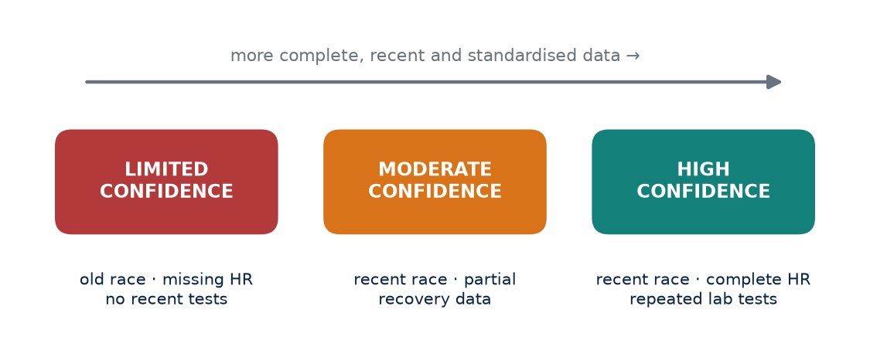
Figure 24. Every AEI output carries a confidence tier. Confidence falls when critical data are old or missing: no data, no false precision.

Sources of uncertainty
Uncertainty in an athlete score comes from several places. Measurement error arises because every device and test has limited precision; a laboratory VO₂max test is more precise than a wrist-based estimate, but neither is exact. Biological variation means that even a perfect instrument would record different values on different days because the athlete genuinely changes with sleep, hydration, heat and time of day. Data age matters because fitness drifts, so a value measured months ago describes a slightly different athlete. Model uncertainty exists because the weights and structure of the index are themselves estimates (Chapter 64), and completeness matters because missing inputs reduce what can be known (Chapter 66).
Hopkins and colleagues, in their 2009 progressive statistics guidance in Medicine and Science in Sports and Exercise, encouraged sports scientists to report uncertainty with confidence limits and to interpret changes against the smallest worthwhile effect rather than relying on bare point estimates or p-values alone. The same attitude belongs in an athlete-facing interface.

Confidence tiers
The interface does not need to show statistical intervals to every user. It can show "high confidence", "moderate confidence" or "limited confidence" without pretending that the underlying physiology is known exactly. The criteria for each tier should be explicit and consistent.
Tier | Recency | Completeness | Measurement quality | Typical use
High | Key tests or races within about 8 weeks | All critical variables present; long monitoring history | Validated tests; clean sensor data | Planning training zones and race targets
Moderate | Key data 2–6 months old | Most critical variables present; some gaps | Mix of lab and field or device estimates | General guidance with periodic review
Limited | Older data or first weeks on the system | Critical variables missing | Mainly device estimates or self-report | Orientation only; prioritise retesting

The thresholds in this table are illustrative starting points for the prototype, not validated cut-offs. They should be refined as the dataset grows and as reliability studies show how quickly each variable loses relevance.
KEY IDEA
A score without a confidence label invites over-interpretation. The confidence layer tells the coach how hard to lean on the number.

Showing uncertainty without confusing people
Several design choices help. A score can be shown with a range rather than a single point, for example "AEI-Fitness 71 (likely range 67–75)". Changes can be classified as "likely real", "possibly real" or "within normal variation" relative to the athlete's typical error. The age of each input can be displayed next to it. And the system can recommend the single most useful next measurement to raise confidence, such as a time trial or a submaximal heart rate test.
The limited-confidence tier should never be hidden or treated as a failure. For a new athlete it is simply the honest starting point. As data accumulate, the tier should rise, and the athlete should see why.
COACH'S CORNER
Treat a limited-confidence score as a prompt to gather data, not as a basis for major decisions. When confidence is moderate, make conservative adjustments and re-check within a few weeks. Reserve precise pace targets for high-confidence profiles.

Research system versus motivational score
This confidence layer is one of the major differences between a research system and a motivational score. Motivational scores are designed to engage: they change often, reward activity and rarely admit ignorance. A research system is designed to be correct over time. It will sometimes say "we do not know yet", and that admission is part of its value. Athletes are generally more comfortable with honest uncertainty than product designers assume, particularly when the system also explains how to reduce it.

Confidence as a guide to action
The confidence tier should change what the system recommends, not only how the score looks. At high confidence, the system can suggest precise training paces and race targets. At moderate confidence, it can suggest ranges and recommend a check-in test within a defined period. At limited confidence, it should focus on data collection: a standardised submaximal run, a recent race or a few weeks of consistent morning monitoring. In this way, uncertainty becomes a practical plan rather than a disclaimer. Over a season, a coach should see confidence rise as the athlete's record fills in, and should notice quickly if it falls because of injury, device changes or lapses in logging.
CHECKPOINT
For the last score you used to change an athlete's training, how recent and complete was the underlying data? Would you have made the same decision if the score had been labelled "limited confidence"?

CHAPTER 68

68. Validation Plan
PART XII — DATA SCIENCE
An index is not validated because it looks sensible, because experienced coaches like it or because it correlates with race times. AEI should be validated prospectively, with a plan written before the data are collected. The plan should start with a cohort large enough to estimate reliability, then test whether the index predicts outcomes beyond simple race performance. This chapter sets out the types of evidence required and the hardest question AEI must answer.

The validation ladder
Validation is a sequence of questions, each building on the one before. If an index is not reliable, it cannot be valid; if it is not predictive, calibration hardly matters; if it works only in the development cohort, it is not yet ready for general use.
Validation type | Question asked | Example AEI test
Test–retest reliability | Does the score repeat under stable conditions? | Two assessments a week apart with no training change
Convergent validity | Does it agree with established measures of the same construct? | AEI-Fitness versus laboratory VO₂max and threshold
Predictive validity | Does it forecast future outcomes? | Baseline AEI predicts race time or injury over the next season
Calibration | Do predicted values match observed values across the range? | Predicted 10 km times versus actual times in each score band
Subgroup analysis | Does it perform similarly across groups? | Women and men, age bands, climates, training levels
External validation | Does it work in a new, independent cohort? | Different clubs, cities or countries using the same protocol

Reliability studies typically report the typical error of measurement and intraclass correlation, following approaches described by Hopkins in Sports Medicine in 2000 and by Atkinson and Nevill in 1998. Knowing the typical error allows every later change in AEI to be judged against measurement noise.
Calibration deserves special attention because it is often ignored. A model can rank athletes correctly while systematically over-predicting performance for everyone. Good discrimination with poor calibration can still mislead individual decisions, so both must be reported.
KEY IDEA
The easy question is whether AEI correlates with performance. The hard question is whether its extra layers improve decisions or outcomes beyond what coaches already use.

The incremental-value question
AEI almost certainly will correlate with running performance if performance is one of its inputs. That correlation proves little. The research question that justifies AKURA is incremental: do the physiological, environmental and readiness layers add predictive or practical value beyond a recent race time and a simple training log?
This can be tested in several ways. Nested models can compare a baseline model containing only race performance with an extended model adding AEI components, reporting the change in prediction error on held-out data. A stronger design compares outcomes in groups coached with and without AEI-guided decisions, ideally with randomisation where ethically and practically feasible. Outcomes should include not just performance but also injury, illness, training availability and athlete-reported experience.
COACH'S CORNER
Be willing to find out that part of the index does not help. If a component adds complexity without improving decisions, removing it is a scientific success, not a failure. Share validation results with your athletes; it builds trust.

Designing a credible study
A credible validation plan pre-registers its hypotheses, primary outcomes and analysis methods. It defines inclusion criteria, the minimum follow-up period and the handling of missing data. It reports results using established guidance for prediction models, such as the TRIPOD statement. It publishes negative as well as positive findings. And it separates the people who build the model from the data used to test it wherever possible.
For AKURA in India, a realistic path is a staged one: a reliability pilot with a few dozen athletes, a development cohort spanning multiple cities and climates, and then external validation with partner clubs and institutions. Each stage should be reported openly so that coaches can judge the strength of the evidence for themselves.

Common pitfalls
Several traps recur in the validation of athlete indices. Circularity occurs when the outcome being predicted is also an input, so the index appears to predict performance simply because it contains performance. Leakage occurs when information from the test period accidentally enters model development, for example when normalisation uses statistics from the whole dataset including future data. Small samples produce unstable estimates that shrink dramatically in new cohorts. Selective reporting, where only favourable outcomes are published, distorts the evidence base. And survivorship bias arises when athletes who drop out through injury or loss of motivation disappear from the analysis, leaving a healthier and more successful group that flatters the index. A written protocol, independent analysis and transparent reporting are the main defences.
CHECKPOINT
If AEI were removed from your coaching tomorrow, which decisions would change? What evidence would convince you that those decisions are better with it than without it?

PART XII AT A GLANCE
The key idea from each chapter, for quick revision.
64 | AEI Scoring: Do Not Guess the Weights  A weight in an index is a scientific claim about importance. If it has not been estimated from data or justified from strong evidence, it should be labelled as a provisional assumption, not presented as a finding.
65 | Normalisation  Normalise to the question. Compare athletes with a relevant population when asking about capacity; compare the athlete with their own history when asking about readiness.
66 | Missing Data  Missing is not the same as normal. A system that converts blanks into averages manufactures reassurance exactly when it may be least justified.
67 | Confidence and Uncertainty  A score without a confidence label invites over-interpretation. The confidence layer tells the coach how hard to lean on the number.
68 | Validation Plan  The easy question is whether AEI correlates with performance. The hard question is whether its extra layers improve decisions or outcomes beyond what coaches already use.

PART XIII — THE AKURA MODEL
Part XIII brings the book's physiology, measurement and data science together into a working model for coaching. It begins with the principle that the athlete, not the device, is the system being studied. It then separates two questions that are often confused: what an athlete is capable of, answered by AEI, and what an athlete should do today, answered by the AISRi readiness layer. The closed-loop coaching system shows how the two interact over time, the chapter on real-world data explains why integration is not validation, and the final chapter describes what an Indian athlete profile can and cannot mean.
IN THIS PART
69 The Athlete Is the Laboratory
70 AEI + AISRi
71 The Closed-Loop Coaching System
72 Garmin, Strava and Real-World Data
73 The Indian Athlete Profile
CHAPTER 69

69. The Athlete Is the Laboratory
PART XIII — THE AKURA MODEL
Wearables, blood tests and laboratory equipment are tools. The athlete remains the system being studied. This sounds obvious, yet much of modern endurance technology quietly reverses the relationship: the device becomes the authority and the athlete becomes a source of data for it. The AKURA model starts from the opposite position. Every measurement exists to understand one specific person better, and every interpretation must return to that person's experience, context and goals.
The athlete’s body is the laboratory; data is the language.
— Kura

Measure, train, recover, retest, interpret
The best AKURA workflow is iterative. The coach measures the athlete's current state, prescribes training, allows recovery, retests under comparable conditions and interprets what changed. Then the cycle begins again. No single test or season provides the full picture; understanding builds through repetition.
Each step has its own discipline. Measurement must be standardised so that a later retest is comparable: same time of day, similar weather where possible, similar preceding training load, same protocol. Training must be recorded accurately enough that its effect can be linked to the result. Recovery must be long enough that the retest reflects adaptation rather than residual fatigue. Interpretation must consider measurement error before declaring an improvement or a decline.
KEY IDEA
One athlete measured carefully over many cycles can teach a coach more about that athlete than any population average. The workflow is a loop, not a line.

Individual response and the n-of-1 mindset
Group studies describe average responses. Individual athletes vary around those averages, sometimes widely. Hecksteden and colleagues, writing in the Journal of Applied Physiology in 2015, discussed how apparent individual differences in training response must be separated from measurement error and day-to-day variation before they are interpreted as true differences. For a coach, the lesson is twofold: individual responses are real and worth understanding, but a single before-and-after comparison is rarely enough to establish them.
Treating the athlete as a laboratory means adopting an n-of-1 mindset. Changes are introduced deliberately, preferably one at a time. Outcomes are measured repeatedly. Alternative explanations, such as a hotter test day, a new pair of shoes or a stressful work week, are recorded and considered. Over months, the coach builds a personal evidence base for that athlete: how they respond to heat, to volume increases, to altitude, to intensity blocks.

Know why each measurement exists
The coach should know why each measurement exists. Every test, device reading and questionnaire should answer a question that could change a decision. If nobody can say what action would follow from a particular result, the measurement may be adding burden without adding value.
A simple audit helps. For each variable collected, write down the question it answers, the decision it could influence and how often it genuinely needs to be measured. Many athletes are over-measured in some areas, such as daily GPS pace data, and under-measured in others, such as periodic standardised submaximal tests or honest subjective wellness reports.
COACH'S CORNER
Before adding any new test or device, write one sentence: "If this result is X, I will do Y." If you cannot complete the sentence, postpone the measurement. Schedule retests at fixed points in the training cycle so that comparisons are fair.

The athlete as a partner
The laboratory metaphor has a limit. Unlike a laboratory specimen, the athlete observes, interprets and chooses. Subjective reports of fatigue, mood and soreness have been shown in systematic review evidence to respond to training load at least as sensitively as many objective markers. The athlete's own understanding of their body is part of the data. A good AKURA workflow explains results to athletes in plain language and invites their interpretation, so that data becomes a shared language rather than a verdict delivered from outside.

Standardising the laboratory
A laboratory is useful only when conditions are controlled. For the athlete-as-laboratory model, this means agreeing a small set of standard conditions for retests: the same course or treadmill, a similar time of day, a similar warm-up, comparable footwear, and a note of temperature and humidity. In India, where seasonal heat and humidity can change dramatically between months, recording environmental conditions is essential; a slower retest in May may reflect weather rather than lost fitness. Where perfect standardisation is impossible, the next best step is to record the differences so that they can be considered when interpreting the result.
CHECKPOINT
For one athlete you coach, list every measurement you currently collect. For each, what question does it answer and when did it last change a decision?

CHAPTER 70

70. AEI + AISRi
PART XIII — THE AKURA MODEL
AEI and a daily readiness system should answer different questions. AEI asks: "What is the athlete's current capacity and profile?" AISRi asks: "Given today's recovery and risk signals, what training should be expressed today?" Keeping these questions separate is one of the central design decisions in the AKURA model. It prevents the common mistake of using one number for both fitness and readiness.
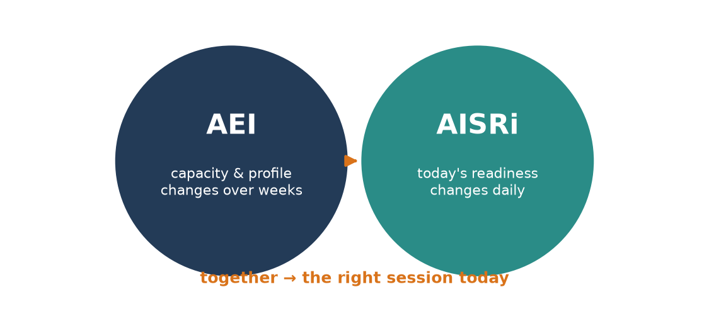
Figure 25. Two questions, two layers: AEI describes what the athlete can do; AISRi advises what the athlete should do today.

Two questions, two timescales
Capacity changes slowly. Aerobic fitness, economy and durability build over weeks and months and decline over similar timescales. Readiness changes quickly. Sleep, illness, travel, heat, emotional stress and the previous day's training can alter readiness within hours. A single score trying to represent both will either be too slow to catch a poor night's sleep or too jumpy to reflect genuine fitness.
AEI (capacity) | AISRi (readiness)
What can this athlete do? | What should this athlete do today?
Changes over weeks to months | Changes day to day
Built from races, tests, training history | Built from sleep, HR, HRV, wellness, recent load
Compared with population and own history | Compared mainly with the athlete's own baseline
Guides zones, targets and season planning | Guides session modification and risk management
Updated after retests and races | Updated every morning or before key sessions
Error: over-rating a detrained athlete | Error: ignoring a warning sign on a key day

Why one number fails
A strong athlete can be poorly recovered. A lower-fitness athlete can be very ready for today's easy run. If both situations are compressed into one number, the coach loses the information needed to respond correctly. Case Study E in Part XI illustrated the first pattern: high AEI-Fitness with elevated resting heart rate, poor sleep and high fatigue. The right response there was a modified session, not a reduction in the athlete's assessed capacity.
The reverse error is equally common. A beginner with high readiness should not be given a session designed for a far fitter athlete simply because they feel fresh. Readiness tells the coach how much of the athlete's capacity can safely be expressed today; it does not raise the ceiling.
KEY IDEA
Capacity is the size of the engine; readiness is how much of it can be used today. Measure them separately, then combine them in the decision, not in the score.

How the two layers interact
In practice the coach uses both. AEI sets the framework: training zones, weekly structure, realistic race targets. AISRi modulates the daily expression of that framework: proceed as planned, reduce volume, reduce intensity, swap sessions or rest. Over time, patterns in AISRi can inform AEI. Repeated poor readiness after certain types of session may indicate that the athlete's durability or recovery capacity is lower than their test results suggest, which in turn may justify revising the profile.
The two layers must also share a confidence logic. A readiness flag based on a single missing night of HRV data should carry less weight than one based on converging signals from sleep, resting heart rate and subjective wellness. Monitoring literature, including consensus work on training load by Bourdon and colleagues, emphasises combining internal and external load measures rather than relying on any single marker.
COACH'S CORNER
Plan the week from capacity; adjust each day from readiness. When readiness is low on a key session, move the session rather than abandoning it. When readiness is high but capacity is modest, enjoy the good day without inflating the workload.

A simple decision matrix
Combining the two layers in the decision rather than the score leads naturally to a four-way matrix. High capacity with high readiness supports the planned key session, performed as prescribed. High capacity with low readiness calls for a modified or rescheduled session while leaving the long-term profile unchanged. Modest capacity with high readiness supports the planned session at the athlete's own level, perhaps with slightly more confidence to complete it fully. Modest capacity with low readiness suggests easy running, rest or recovery work, and a conversation about sleep, stress and health. The matrix is deliberately simple. Its purpose is to make the coach's reasoning explicit and recordable, so that the closed-loop system described in the next chapter can learn from it.
CHECKPOINT
Think of the last time you changed a session because an athlete seemed tired. Were you responding to a change in capacity or in readiness, and did your records reflect that distinction?

CHAPTER 71

71. The Closed-Loop Coaching System
PART XIII — THE AKURA MODEL
A training plan written in January and followed unchanged until the race is an open-loop system. It sends instructions but does not listen to what happens. Most real coaching is already partly closed-loop: coaches watch, adjust and learn. The AKURA model makes that loop explicit and structured, so that every stage produces data that informs the next. This is the foundation for a digital coaching platform that behaves more like a longitudinal research system than a static plan generator.
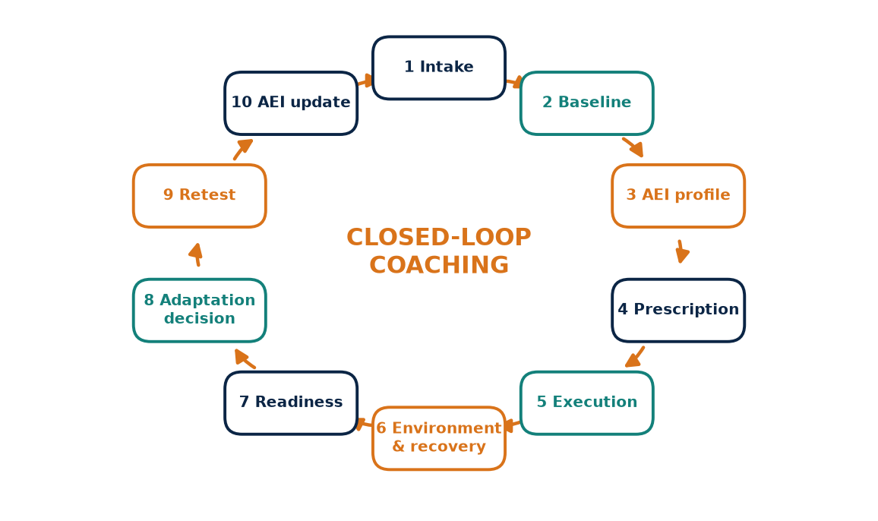
Figure 26. The ten-step AKURA closed loop: a digital coaching system that behaves like a longitudinal research study, not a static plan.

The ten steps
The complete AKURA loop has ten stages. Each one has a defined purpose, defined inputs and defined outputs.
- Athlete intake: collect history, goals, injuries, medical screening, lifestyle, occupation, climate and access to facilities.
- Baseline performance and physiology: record recent races and standardised field or laboratory tests to establish the starting point.
- AEI profile: combine baseline data into a capacity profile with a stated confidence tier.
- Training prescription: set zones, weekly structure and progression based on the profile and the athlete's goals.
- Workout execution: the athlete completes sessions, with pace, heart rate and other data captured as available.
- Environmental and recovery capture: record temperature, humidity, altitude, sleep, wellness and other recovery signals.
- Readiness assessment: AISRi compares today's signals with the athlete's baseline to judge what training can be expressed.
- Adaptation decision: the coach proceeds, modifies, moves or replaces sessions, recording the reason.
- Retest: repeat standardised tests or races at planned intervals under comparable conditions.
- AEI update: revise the profile and its confidence using new data, then return to prescription.
KEY IDEA
The loop is only closed if each decision and its reason are recorded. Without that record, the system cannot learn which adjustments worked.

Two loops running at different speeds
The ten steps contain two nested loops. The fast loop runs daily: workout execution, environmental and recovery capture, readiness assessment and adaptation decision (steps 5 to 8). The slow loop runs across weeks and months: prescription, retest and AEI update (steps 4, 9 and 10). Intake and baseline testing (steps 1 and 2) are repeated less often, typically at the start of a season, after injury or when goals change.
Separating the loops helps avoid two failure modes. The first is over-reacting: changing the entire programme because of a single poor morning reading. The second is under-reacting: ignoring several weeks of consistent warning signs because the plan says to continue. The fast loop handles day-to-day variation; the slow loop handles genuine changes in capacity.

Recording decisions, not just data
Most training platforms record what the athlete did. Fewer record what the coach intended and why the plan changed. For a closed-loop system to learn, step 8 must be documented: the planned session, the actual session, the readiness signals at the time and the reason for any change. Over months, these records allow the coach, and eventually the research team, to ask whether modifications based on readiness improved outcomes compared with sticking to the plan.
This record also protects the athlete. If a pattern of repeated modifications appears around certain sessions, the coach can identify a mismatch between prescription and capacity before it becomes an injury or a period of prolonged fatigue.
COACH'S CORNER
Add one field to your training log: "planned versus done, and why". Review it monthly. Patterns in that single field often reveal more about an athlete's needs than any new device.

Keeping the human in the loop
The closed loop is not a case for automation replacing coaches. Algorithms can flag signals, estimate confidence and suggest options, but the adaptation decision involves context that data rarely captures fully: exams, family responsibilities, motivation, a niggle the athlete mentioned in passing. The AKURA model treats software as a structured assistant to the coach and athlete, not as the decision-maker.

An example cycle
Imagine a club marathoner beginning a 16-week block. Intake records a desk job, a two-year training history and a previous calf strain. Baseline testing includes a 5 km time trial and a submaximal heart rate test on a flat loop. The AEI profile shows good aerobic capacity but limited durability, with moderate confidence. Prescription emphasises gradual long-run progression and strength work. Over the following weeks, daily readiness occasionally flags poor sleep during a busy work period, and two long runs are shortened. At week eight, a retest shows improved submaximal heart rate at the same pace. The AEI update raises durability slightly and confidence to high, and prescription adjusts for the second half of the block. Every step is recorded, so the next cycle begins from evidence rather than memory.
CHECKPOINT
Which of the ten steps are currently missing or informal in your coaching? Which one, if made systematic, would most improve your decisions?

CHAPTER 72

72. Garmin, Strava and Real-World Data
PART XIII — THE AKURA MODEL
A modern endurance system can combine structured workouts with GPS, heart rate, elevation, pace, cadence and training history. Consumer platforms such as Garmin Connect and Strava, along with many coaching platforms that connect to them, make it possible to collect this information automatically from thousands of sessions. For AKURA, integrations are valuable because they reduce manual entry and increase the amount of real-world data available. But integration is not validation. A clean API feed can still contain poor sensor data.

The promise and limits of automatic data
Automatic data collection solves one of the biggest problems in athlete monitoring: incomplete manual logs. Every run is captured with a timestamp, a route and a set of physiological signals. For an Indian research system hoping to follow many athletes across diverse climates and terrains, this is transformative.
The limits are equally real. Devices differ in sensor quality, sampling rate and processing algorithms. Firmware updates can change how a variable is calculated without notice. Estimated values, such as device-derived VO₂max or recovery time, are produced by proprietary models whose validity varies between individuals and conditions. And every sensor has characteristic failure modes that produce plausible-looking but wrong numbers.
KEY IDEA
A data feed that arrives cleanly formatted is not therefore accurate. Data quality rules must sit between the device and the index.

Data-quality rules
The table below lists common artefacts in wearable running data and how AKURA should handle them. The rules apply regardless of device brand; all manufacturers face similar physical limitations.
Artefact | What happens | Detection rule | Handling
GPS drift | Position errors inflate distance or create pace spikes, especially near tall buildings, tree cover or tracks | Implausible pace or acceleration jumps; track laps not matching 400 m | Smooth or flag segment; prefer footpod or known distance
Optical HR cadence lock | Wrist sensor locks onto step rate instead of heartbeat | HR suddenly matches cadence for a sustained period | Exclude segment from HR analysis; recommend chest strap
Missing HR | Sensor dropout or strap not worn | Gaps or zero values in HR stream | Store as missing, not zero; lower session confidence
Auto-pause artefacts | Device pauses at traffic lights or slow uphill sections | Moving time far below elapsed time; gaps in stream | Use moving and elapsed time appropriately; flag intervals
Elevation noise | Barometric or GPS elevation drifts with weather or signal | Implausible total climb for known flat route | Correct with terrain data or flag
Treadmill mis-calibration | Wrist-estimated distance differs from belt | Large mismatch with treadmill display | Use manual entry where available; flag pace data
Device or firmware change | Calculated metrics shift without training change | Step change in a metric at a known update date | Mark discontinuity; recalculate baseline

Heart rate data from wrist-based optical sensors deserve particular care during intervals, in cold conditions, with darker skin tones or tattoos and with loosely worn straps. These are known technical limitations of optical sensing, and they are a reason to validate data quality rather than a reason to exclude any athlete group.

Building a quality layer
A practical quality layer does three things. It checks each incoming session against physical plausibility rules, such as maximum realistic pace and heart rate ranges for that athlete. It assigns a quality flag to each data stream rather than a single pass or fail for the whole session. And it feeds those flags into the confidence layer described in Chapter 67, so that a score built from flagged data is labelled accordingly.
Where possible, the quality layer should also learn the athlete. A heart rate of 205 may be implausible for one athlete and routine for another. Athlete-specific plausibility ranges, built from clean historical data, reduce false alarms without letting genuine errors through.
COACH'S CORNER
Use a chest strap for sessions where heart rate matters, such as threshold tests and intervals. Run key time trials on a measured course or track rather than trusting GPS distance. When a number surprises you, look at the raw graph before changing the plan.

Estimated metrics and privacy
Many devices report derived values such as estimated VO₂max, training status, recovery time or race predictions. These estimates can be helpful for engagement and trend-watching, but they are not direct measurements. AKURA should store them as device estimates, clearly separated from laboratory or field-test values, and should not use them as primary inputs to AEI unless their agreement with measured values has been checked for the athlete concerned.
Integrations also carry responsibilities. Athletes should know which data are imported, how they are stored, who can see them and how to withdraw consent. Location data in particular can reveal home addresses and routines, so research datasets should remove or coarsen GPS traces where they are not needed for the analysis.
CHECKPOINT
Look at the last three sessions of an athlete's data. Can you spot any of the artefacts in the table? How would each have affected a score if left uncorrected?

CHAPTER 73

73. The Indian Athlete Profile
PART XIII — THE AKURA MODEL
Indian endurance athletes are not one physiological population. A distance runner training in the humid heat of Chennai, a trail athlete living at altitude in Ladakh, a masters marathoner in Bengaluru who trains before an office commute, and a young athlete in a sports hostel with limited access to laboratory testing all face different conditions and respond to training in their own ways. Climate, altitude, age, sex, nutrition, occupation, training history and access to facilities vary widely. Any system that treats "the Indian athlete" as a single type risks replacing one set of borrowed assumptions with another.

Why local longitudinal data matter
Much of the published endurance science, and many of the reference values built into consumer devices, come from populations studied in different climates, with different training cultures and different diets. Some of those findings transfer well; others may not. The honest answer is often that we do not yet know.
The value of an Indian research system is precisely that it can collect local longitudinal data instead of importing assumptions from another population. Repeated measurements of the same athletes across seasons, including pre-monsoon heat, monsoon humidity and cooler winter months, can show how environment and training interact in real Indian conditions. This is information no imported norm can provide.
KEY IDEA
Diversity within India is larger than any single average can capture. The goal is to describe variation carefully, not to create a new stereotype.

Profile variables
An AKURA athlete profile should record the context that shapes physiology and training, so that analyses can account for it rather than assume it away.
Domain | Variables | Why it matters
Demographics | Age, sex, body mass, stature | Reference ranges and training response vary
Environment | Home climate, typical training temperature and humidity, altitude of residence | Heat and altitude affect pace, HR and recovery
Training history | Years of training, weekly volume, event focus, coaching access | Explains current capacity and adaptation rate
Lifestyle and occupation | Work hours, commute, shift work, sleep pattern | Affects recovery and available training time
Nutrition | Dietary pattern (e.g. vegetarian), energy availability, iron and vitamin D status where tested | Influences adaptation, health and injury risk
Health | Injury history, menstrual health where relevant, illness, medications | Informs safe prescription and risk flags
Facilities and data access | Track, trails, gym, laboratory access, device type | Determines which tests are feasible and data quality

Recording these variables does not mean every athlete must provide all of them. Sensitive items should be optional, collected with informed consent and stored securely. The aim is to allow analyses to adjust for context and to ensure that conclusions are not driven by hidden differences in circumstances.

Avoiding stereotypes
Research on populations must never slide into assumptions about individuals. Observed differences between groups often reflect environment, opportunity, nutrition and training history far more than fixed biological traits. The AKURA dataset should be analysed with this in mind: variation within any group will usually be larger than differences between groups, and every individual athlete should be assessed on their own data.
This is also why subgroup analysis in validation (Chapter 68) matters. If AEI performs well for well-resourced urban runners but poorly for athletes from rural or less-equipped settings, the index must be improved before it is used to make decisions about those athletes.
COACH'S CORNER
Record where and when your athletes train, not just what they did. A slow tempo run on a hot, humid afternoon may reflect excellent effort. Compare each athlete with their own history in similar conditions before drawing conclusions.

An evidence base for India, open to the world
AKURA's long-term dataset should become an evidence base for Indian endurance coaching while remaining open to international comparison. Using common definitions, standard protocols and transparent reporting allows Indian findings to be compared with those from other countries, strengthening both. Over time, such a dataset could help Indian coaches move from borrowed averages to locally grounded, individually interpreted evidence.
CHECKPOINT
Which context variables do you currently record for your athletes? Which missing ones might explain differences in performance you have attributed to talent or effort?

PART XIII AT A GLANCE
The key idea from each chapter, for quick revision.
69 | The Athlete Is the Laboratory  One athlete measured carefully over many cycles can teach a coach more about that athlete than any population average. The workflow is a loop, not a line.
70 | AEI + AISRi  Capacity is the size of the engine; readiness is how much of it can be used today. Measure them separately, then combine them in the decision, not in the score.
71 | The Closed-Loop Coaching System  The loop is only closed if each decision and its reason are recorded. Without that record, the system cannot learn which adjustments worked.
72 | Garmin, Strava and Real-World Data  A data feed that arrives cleanly formatted is not therefore accurate. Data quality rules must sit between the device and the index.
73 | The Indian Athlete Profile  Diversity within India is larger than any single average can capture. The goal is to describe variation carefully, not to create a new stereotype.

PART XIV — RESEARCH PROTOCOLS
Ideas become knowledge only when they are tested in a way that another coach could repeat. This part converts the questions raised throughout the book into four practical pilot protocols: a heat-acclimation study suited to Chennai's climate, an altitude study built around Ooty and Kodaikanal, a marathon durability protocol, and a crossover design comparing heat, altitude and control blocks in the same athletes. Each chapter is written as a mini study protocol with aims, hypotheses, participants, design, measurements, outcomes, safety rules, analysis and ethics. None of these designs is final. They are starting templates, meant to be refined with qualified scientists, clinicians and an institutional ethics committee before a single athlete is tested.
IN THIS PART
74 Heat Study Protocol
75 Altitude Study Protocol
76 Marathon Durability Protocol
77 Heat Versus Altitude Crossover
CHAPTER 74

74. Heat Study Protocol
PART XIV — RESEARCH PROTOCOLS
Chennai offers something many high-performance centres pay to recreate: sustained heat and humidity for most of the year. That natural environment is both an opportunity and a risk. If AKURA wants to know whether a structured heat-acclimation block changes an athlete's physiology and performance, it must stop relying on the general impression that "training in Chennai already makes us heat-adapted" and instead run a controlled, documented, repeatable study. This chapter outlines a pilot design. It is deliberately modest: the goal is to generate clean data from a small group, learn what is practical, and prepare for a larger study.

Aim and hypotheses
The aim is to quantify the physiological and performance response of trained endurance runners to a structured heat-acclimation block, and to describe how much that response varies between individuals. Three working hypotheses guide the design. First, heart rate at a fixed submaximal pace in standardised warm conditions will fall after the block. Second, thermal comfort and perceived exertion at that pace will improve. Third, the size of the response will differ meaningfully between athletes, and part of that difference may be explained by prior heat exposure. The study does not assume that every athlete will improve, and a null or mixed result is an acceptable outcome.

Participants, inclusion and exclusion
Recruit a small pilot group (for example 12 to 20 runners) with stable training for at least several weeks, no current injury, and a recent race or time-trial result that anchors their performance level. Inclusion: adult athletes, regular training of a defined minimum weekly volume, willingness to complete all visits, and medical clearance. Exclusion: history of exertional heat illness without specialist clearance, known cardiovascular, renal or metabolic conditions, current febrile or gastrointestinal illness, medications that impair thermoregulation, and pregnancy. Record sex, age, training history, home climate and typical training time of day, because a runner who trains at 5 a.m. on the Marina and one who trains in an air-conditioned gym arrive with different heat histories.

Design and timeline
Week | Phase | Main activity
1 | Familiarisation | Consent, medical screening, practise test protocol
2 | Baseline | Standardised submaximal run and time trial in logged conditions
3–4 | Heat block | Controlled heat sessions (e.g. 8–10 sessions) with normal training
5 | Short recovery | Reduced load, no extra heat sessions
6 | Post-test | Repeat baseline tests under matched conditions
8–9 | Decay check (optional) | Repeat submaximal test to observe retention

A control or crossover condition strengthens causal inference. In the simplest version, a matched control group continues normal training without the extra heat sessions. In a stronger version, each athlete completes both a heat block and a control block in randomised order with a washout between them. Heat sessions can be outdoor runs in logged conditions, indoor sessions in a heated room, or post-exercise passive heat exposure, but the method must be fixed in advance and applied consistently.

Measurements and outcomes
Before every test record temperature, relative humidity and, ideally, wet-bulb globe temperature (WBGT), along with time of day, wind, surface and footwear. Primary outcomes can include heart rate at a fixed pace, core-temperature response where it can be measured safely and with appropriate equipment, body-mass change as a sweat-loss estimate, thermal comfort, and performance in a standardised time trial. Secondary outcomes can include plasma-volume estimates from haemoglobin and haematocrit, sweat rate, sleep and resting heart rate, and blood markers where appropriate and clinically supervised.
KEY IDEA
A heat study is only as good as its environmental log. If baseline and post-tests are run in different heat and humidity, the change in heart rate may simply reflect the weather, not the athlete.

Safety and stop rules
Each heat session requires a supervisor trained in recognising heat illness, access to shade, cooling methods and fluids, and a clear emergency plan with the nearest hospital identified. Stop a session immediately if the athlete shows confusion, unusual behaviour, loss of coordination, stops sweating or develops hot, dry skin, collapses, vomits, or reports a severe headache or dizziness; begin cooling and seek emergency medical care. Predefine upper limits for environmental conditions and, where core temperature is monitored, a termination threshold set by the medical lead. Athletes who are unwell, underslept or dehydrated on arrival do not complete the session that day.

Analysis and ethics
Report individual responses alongside group means, with confidence intervals, and compare each change against the test's typical error and a predefined smallest worthwhile change. Adjust for environmental differences where possible and state clearly what could not be controlled. The protocol must receive approval from an institutional ethics committee before recruitment, every participant must give written informed consent after a plain-language explanation of risks, and a qualified physician must provide medical oversight throughout. Participants may withdraw at any time without consequence.

Practical notes for Chennai
In Chennai the difficulty is often not creating heat but controlling it. Outdoor conditions can change sharply between a 6 a.m. and an 8 a.m. start, and sea breeze, cloud cover and pre-monsoon humidity can make two apparently similar mornings very different. For that reason the baseline and post-tests are best run indoors on a treadmill in a room whose temperature and humidity can be held steady, or outdoors only when WBGT falls within a pre-agreed band. Keep the same treadmill, footwear, time of day and pre-test meal. Ask athletes to avoid hard training for 48 hours before each test and to record their sleep for the preceding two nights. Small details like these decide whether the final data can be trusted.
COACH'S CORNER
Even without a formal study, you can borrow this structure. Test a fixed-pace run in logged conditions, add a planned heat block, then retest in similar conditions. Keep the notes; a season of carefully recorded mini-experiments is worth more than a lifetime of impressions.

CHECKPOINT
Can you name the exact conditions of your athlete's last baseline test? If you repeated it today, how would you know whether a change came from adaptation or from the weather?

CHAPTER 75

75. Altitude Study Protocol
PART XIV — RESEARCH PROTOCOLS
The Nilgiris and the Palani hills give South Indian athletes access to moderate altitude within a day's travel of Chennai. Ooty sits at roughly 2,200 metres and Kodaikanal at a little over 2,100 metres, which places both in the range often used for altitude training camps. Many Indian coaches already send athletes there. What is usually missing is measurement: a clear record of dose, a baseline, a controlled training load and a proper retest. This protocol treats an altitude camp as an experiment rather than a pilgrimage.

Aim and hypotheses
The primary question is the size and timing of each athlete's response, not whether altitude "works". The study should not begin with the assumption that performance must improve. Working hypotheses: haemoglobin mass, where it can be measured with a validated method, will show a small average increase after sufficient exposure; individual responses will vary widely; and changes in blood measures will not map perfectly onto changes in race performance. If haemoglobin mass changes but race performance does not, that is still a scientifically meaningful result.

Participants, inclusion and exclusion
Recruit trained endurance athletes who can commit to the full camp and follow-up. Inclusion: stable training, medical clearance, and baseline iron status reviewed by a clinician. Exclusion: iron deficiency that has not been treated, anaemia, known cardiopulmonary disease, previous severe altitude illness, sickle-cell trait or disease unless cleared by a specialist, recent illness, and pregnancy. Record prior altitude exposure, home altitude and any iron supplementation already in use.

Design and timeline
Week | Phase | Main activity
1–2 | Baseline (Chennai) | Blood measures, ferritin, performance test, submaximal test
3 | Pre-camp | Iron review with clinician; set sleeping and training altitude
4–6 | Camp (Ooty or Kodaikanal) | Controlled training load; daily sleep, SpO₂, RHR, wellness
7 | Return | Monitor first-week responses at sea level
8–9 | Post-test | Repeat blood measures and performance tests
10–12 | Follow-up | Observe timing of best performance and decay

Define sleeping and training altitude precisely, because "we went to Ooty" can mean very different exposures depending on where the athlete slept and where the sessions took place. Log hours per day at altitude. Control training load so that any change is not simply a result of a heavier or lighter training block. A sea-level control group training in Chennai under a similar programme, where feasible, makes interpretation much stronger.

Measurements and outcomes
Primary outcome: change in haemoglobin mass by an appropriate specialist method, or, where that is unavailable, carefully standardised haemoglobin concentration and haematocrit interpreted with caution because concentration is affected by plasma volume. Secondary outcomes: time-trial or race performance, heart rate at fixed pace, SpO₂ trend during the camp, sleep quality, resting heart rate and heart-rate variability trend, body mass, ferritin, and athlete-reported wellness. Every blood draw should follow a standard posture, time of day and hydration protocol.
KEY IDEA
Haemoglobin concentration and haemoglobin mass are not the same thing. A concentration can rise simply because plasma volume fell. Only a total-mass method tells you whether the athlete actually built more red-cell capacity.

Safety and stop rules
Altitude exposure should be medically supervised when indicated. Brief all athletes on warning signs of altitude illness: worsening headache, nausea or vomiting, unusual breathlessness at rest, a persistent cough, confusion, loss of coordination or extreme fatigue. Any of these requires the athlete to stop training, be assessed by a clinician, and descend if symptoms are serious or worsening. Reduce training intensity during the first days of the camp. Monitor iron status and sleep, and stop the study for any athlete whose symptoms or blood results raise clinical concern.

Analysis and ethics
Report individual response trajectories as well as means, with confidence intervals, and compare changes against the measurement's typical error. Pre-register the timing of retests so that the "best" post-camp result is not selected after the fact. The protocol requires institutional ethics committee approval, written informed consent, and a named physician responsible for blood testing, iron decisions and altitude illness. Blood abnormalities must be interpreted by qualified clinicians, not by the coach or the algorithm.

Practical notes for Ooty and Kodaikanal
Hill-station camps bring their own complications. Road travel from Chennai is long, and the first days are often disturbed by travel fatigue, cold nights and changed food. Terrain in both towns is hilly, so paces are not directly comparable with flat roads in the plains; use heart rate and RPE to guide intensity and record elevation gain for every session. Tourist seasons can affect accommodation, noise and sleep. Plan retesting at sea level in Chennai under the same conditions as baseline, and schedule it in advance rather than choosing the day the athlete "feels good". Finally, remember that nutrition, particularly energy and iron intake, must be adequate at altitude; an athlete who under-eats at camp may show no haematological response for reasons that have nothing to do with altitude itself.
COACH'S CORNER
Before the next camp to Ooty or Kodaikanal, write down five things: sleeping altitude, training altitude, days at camp, planned training load and the exact retest dates. If you cannot write them down, you are not yet running an experiment.

CHECKPOINT
What result would convince you that a particular athlete does not benefit much from altitude? Are you prepared to accept that result if the data show it?

CHAPTER 76

76. Marathon Durability Protocol
PART XIV — RESEARCH PROTOCOLS
Two athletes can share the same VO₂max, the same threshold pace and the same half-marathon time and still finish a marathon ten minutes apart. The difference often lies in durability: how well physiology and performance hold up as duration and fatigue accumulate. Durability has become an important topic in endurance science because traditional laboratory tests are usually performed on fresh athletes. This chapter proposes a practical protocol to measure how pace, heart rate and perceived effort relationships change with duration in real training.

Aim and hypotheses
The aim is to develop and test a repeatable method for describing durability in marathon runners. Hypotheses: first, the relationship between pace and heart rate will drift in a measurable way after a certain duration; second, the pattern of drift will differ between athletes; third, that drift will relate to how much an athlete slows in the final part of a marathon. A durability index can be built from the rate of deterioration after a defined duration, but the formula should be validated before being used as a score.

Participants, inclusion and exclusion
Recruit marathon runners with at least one completed marathon and a planned race within the study window. Inclusion: stable training, capacity to complete long runs of at least 90 to 150 minutes, medical clearance, and a heart-rate device that records reliably. Exclusion: current injury, recent illness, or any condition making prolonged exercise in heat unsafe. In Chennai, schedule long runs early in the morning and log conditions carefully, because heat is the most common confounder of any durability measure in Indian cities.

Design and timeline
Week | Phase | Main activity
1 | Baseline | Fresh submaximal test at fixed pace; time trial
2–3 | Standard long run 1 | Fixed pace, fixed fuelling, full data capture
6–7 | Standard long run 2 | Same route, time and protocol
10–11 | Standard long run 3 | Repeat to measure reliability and trend
Race | Marathon | Race data with splits, fuelling and conditions
Race + 2 | Review | Compare long-run drift with race fade

Use standardised long runs or controlled race segments. The same route, start time, target pace, footwear and fuelling plan should be used each time. A useful structure is a steady long run with short fixed-pace "probe" segments at the start and near the end, so that heart rate and RPE at identical pace can be compared fresh and fatigued.

Measurements and outcomes
Record pace, heart rate, RPE at set intervals, fuelling (grams of carbohydrate and timing), fluid intake, body mass before and after, temperature, humidity and WBGT, and a brief post-run note on muscle soreness, gut comfort and cramps. Primary outcome: change in heart rate and RPE at the fixed probe pace between early and late segments. Secondary outcomes: pace decline in the race's final 10 kilometres, cardiac drift, and athlete-reported limiters.
KEY IDEA
The most useful result may be identifying whether the athlete loses performance through metabolic, thermal, pacing or musculoskeletal pathways. Each pathway calls for a different training response.

Interpreting the pathways
A metabolic pattern may show progressive heart-rate and RPE rise with poor fuelling or low glycogen availability. A thermal pattern may show sharper drift on hotter days, larger body-mass loss and improvement when conditions are cooler. A pacing pattern may show a fast early section followed by inevitable decline. A musculoskeletal pattern may show relatively stable heart rate but rising soreness, form breakdown and pace loss. These are working categories, not diagnoses, and many athletes show a mix.

Safety, analysis and ethics
Stop a long run if heat-illness warning signs appear, if the athlete reports chest pain, fainting or unusual breathlessness, or if an injury changes running mechanics. Carry fluids and have a support vehicle or check-in points on longer routes. Analyse within-athlete changes against typical error, and check reliability across the three long runs before calculating any index. As with every AKURA protocol, obtain institutional ethics committee approval, written informed consent, and medical oversight.

Building and validating a durability index
A simple prototype index might express the percentage change in heart rate at the probe pace between the early and late segments, adjusted for temperature. Before such a number appears on any dashboard it must pass three tests. First, reliability: does it give similar values when the same athlete repeats the same long run in similar conditions? Second, sensitivity: does it change when durability is expected to change, for example after a block of specific long-run training? Third, validity: does it relate to what matters, such as the degree of slowing in the final 10 kilometres of a marathon? Only when all three questions have acceptable answers should the index be reported as a score rather than a research variable.
COACH'S CORNER
Add two short fixed-pace segments to your athlete's next long run, one early and one late. Record heart rate and RPE for both. Over a season, that simple habit will teach you more about marathon fade than any single laboratory test.

CHECKPOINT
When your athlete slowed in their last marathon, which pathway was most likely responsible? What data would you need to be sure?

CHAPTER 77

77. Heat Versus Altitude Crossover
PART XIV — RESEARCH PROTOCOLS
Throughout this book we have treated heat and altitude as separate stimuli with some overlapping effects. Both can influence plasma volume, heart-rate responses and perceived effort; altitude may also increase haemoglobin mass over sufficient exposure, while heat acclimation primarily improves thermoregulatory and cardiovascular responses to heat. For an Indian coach who can choose between Chennai's heat and the hills of Ooty or Kodaikanal, the practical question is obvious: which block, for which athlete, for which goal? A crossover study is the most informative way to ask it.

Aim and hypotheses
The aim is to compare heat, altitude and control blocks in the same athletes, so that each athlete acts as their own comparison. Hypotheses: heat blocks will produce larger changes in thermal response and heart rate in the heat; altitude blocks will produce larger changes in haemoglobin mass; both may produce changes in submaximal heart rate; and individual response patterns will differ. Outcomes should distinguish plasma volume, Hb mass, submaximal heart rate, thermal response, performance and recovery. This allows the research team to ask which adaptation overlaps and which is unique.

Participants, inclusion and exclusion
Recruit trained athletes able to commit for a long study period, ideally six months or more. Inclusion and exclusion criteria combine those of Chapters 74 and 75: medical clearance, clinician-reviewed iron status, no history of serious heat or altitude illness without specialist clearance, no relevant cardiovascular or respiratory conditions, and no current injury. Because the study is long, plan for drop-outs and seasonal race schedules.

Design and timeline
Period | Block | Notes
Weeks 1–2 | Baseline testing | Blood, heat-response test, performance test
Weeks 3–6 | Block A (randomised) | Heat, altitude or control
Weeks 7–12 | Washout | Normal training; retest at end
Weeks 13–16 | Block B (randomised) | Second condition
Weeks 17–22 | Washout | Normal training; retest at end
Weeks 23–26 | Block C (randomised) | Third condition, then final tests

Randomisation and washout are desirable where practical. Randomising the order protects against season, fitness trend and race calendar being mistaken for block effects. The washout must be long enough for the main adaptations to return towards baseline; haemoglobin mass changes, in particular, persist for weeks. Where a full three-way crossover is impractical, a two-condition version (heat versus control, or altitude versus control) is a sensible first step.

Measurements and outcomes
Use identical tests at every time point: haemoglobin mass by a specialist method where available, plasma-volume estimates, heart rate at fixed pace in both temperate and warm conditions, core or skin temperature where safely measured, sweat rate, time-trial performance, resting heart rate, heart-rate variability trend and sleep. Log training load throughout so that each block is matched in volume and intensity as closely as possible.
KEY IDEA
The value of a crossover is not only in the average result. It is in discovering which athletes respond more to heat, which to altitude, and which to neither.

Safety and stop rules
The study must be designed around safety and qualified medical oversight, particularly for hypoxic exposure and blood testing. All stop rules from the heat and altitude protocols apply. Any athlete showing heat-illness or altitude-illness warning signs stops immediately and is assessed; any abnormal blood result is referred to a clinician. Limit the total number of blood draws to what is needed and explain each one in the consent form.

Analysis and ethics
Use mixed-effects models or similar methods appropriate for repeated measures, report individual responses with confidence intervals, and account for order and carry-over effects. Be explicit that a small pilot crossover will generate hypotheses rather than definitive answers. Institutional ethics committee approval, informed consent and a named medical lead are mandatory, and participants should receive their own results in a clear, plain-language summary.

Why the comparison matters for India
Travel to hill stations costs money, time and time away from work or study, while heat is available at home for much of the year in Chennai and many other Indian cities. If a well-designed crossover showed that, for some athletes and some goals, a controlled heat block produced useful changes at a fraction of the cost, that would matter greatly for Indian endurance development. Equally, if altitude produced unique benefits that heat could not replicate for particular athletes, that would justify investment in camps. The study is not designed to declare a winner. It is designed to help coaches match the right stimulus to the right athlete at the right time, with evidence rather than habit.
COACH'S CORNER
If you cannot run a crossover, you can still think like one. Record each athlete's response to every heat block and every camp over the years. Across a career, those records form a personal crossover study.

CHECKPOINT
For your squad, do you currently know which athletes respond best to heat and which to altitude? If not, what would be the first block you could measure properly?

PART XIV AT A GLANCE
The key idea from each chapter, for quick revision.
74 | Heat Study Protocol  A heat study is only as good as its environmental log. If baseline and post-tests are run in different heat and humidity, the change in heart rate may simply reflect the weather, not the athlete.
75 | Altitude Study Protocol  Haemoglobin concentration and haemoglobin mass are not the same thing. A concentration can rise simply because plasma volume fell. Only a total-mass method tells you whether the athlete actually built more red-cell capacity.
76 | Marathon Durability Protocol  The most useful result may be identifying whether the athlete loses performance through metabolic, thermal, pacing or musculoskeletal pathways. Each pathway calls for a different training response.
77 | Heat Versus Altitude Crossover  The value of a crossover is not only in the average result. It is in discovering which athletes respond more to heat, which to altitude, and which to neither.

PART XV — IMPLEMENTATION
Research frameworks fail when they cannot be used on an ordinary Tuesday morning. This part turns AEI from a set of ideas into tools a coach can open, read and act on. It describes the AEI Athlete Card, a standard record that keeps raw data separate from derived scores; the AEI Dashboard, which answers what an athlete can do, how ready they are today and what has changed; the coach's interpretation layer, which ensures human context is never hidden by an algorithm; and the safety rules that define where automation must stop. The principle is simple: every number must be traceable, and every recommendation must be open to human review.
IN THIS PART
78 The AEI Athlete Card
79 The AEI Dashboard
80 The Coach's Interpretation Layer
81 Safety Rules
CHAPTER 78

78. The AEI Athlete Card
PART XV — IMPLEMENTATION
Every athlete in the AKURA system should have one standardised card. It is the single place a coach, scientist or clinician can go to see who the athlete is, what they have done, how they have been tested, and how confident we are in each piece of information. Without a standard card, data scatters across watches, spreadsheets, message threads and memory. With one, the athlete becomes a coherent research record that grows over a career.

What the card contains
The card should contain demographics relevant to sport, training history, recent race results, physiological tests, environmental exposure, injury and recovery flags, equipment and data confidence. The table below shows a proposed structure. It is a starting point and will change as the system learns what coaches actually use.
Section | Fields
Identity | Athlete ID, age band, sex, event focus, home city, coach
Training history | Years training, typical weekly volume, recent block summary
Performance anchor | Recent 5K/10K/HM/marathon results with date and conditions
Physiological tests | Threshold marker, VO₂-related measure, economy, Hb/Hb mass
Cardiovascular | Resting HR, HR at fixed pace, HRV trend
Environment | Heat exposure log, altitude exposure log, home climate
Durability | Standard long-run drift, marathon fade
Recovery flags | Sleep trend, soreness, illness, injury notes
Equipment | Watch, HR strap, footwear, device settings
Interventions | Heat blocks, camps, nutrition changes, with dates
Data confidence | Protocol version, missing data, quality flags
Clinical notes | Clinician-entered only; restricted access

Raw data first, scores second
The card should separate raw data from derived scores. Coaches must be able to inspect the raw measurement behind every conclusion. If the card shows an AEI Oxygen domain value, one tap should reveal the actual haemoglobin result, the date, the laboratory, the method and the protocol notes. If a durability rating appears, the coach should see the long runs from which it was calculated. This is not bureaucracy; it is the foundation of trust.
KEY IDEA
A score without traceability is difficult to trust. Every number on the AEI card must lead back to a measurement, a date and a method.

Confidence and privacy
Each field should carry a confidence marker: high when the data are recent, standardised and from a reliable device or laboratory; lower when data are old, self-reported or collected under unknown conditions. Missing data should be shown as missing, not quietly filled in. Because the card holds sensitive health information, access should be role-based. Clinical notes and blood results should be visible only to those who need them, athletes should be able to see their own card, and consent for research use should be recorded explicitly. Indian data-protection requirements should be followed, and athletes should know how their data are stored and who can see them.

Keeping the card alive
A card that is filled in once and forgotten is useless. Updating should be part of routine: race results added within a few days, test results on the day, environmental logs with every heat block or camp, and a quarterly review in which coach and athlete read the card together. Over time the card becomes the athlete's physiological biography, one that can show, for example, how a runner from Madurai responded to three successive Kodaikanal camps, or how heat tolerance changed across four Chennai summers.

Using the card in practice
Imagine a coach preparing a runner for a winter marathon. Before planning, the coach opens the card and sees the most recent half-marathon anchor with its date and conditions, the heart rate at fixed pace from the last three tests, a haemoglobin result from before the previous Kodaikanal camp, the heat-session log from the summer, and a note that the athlete had a calf strain in August. Each item shows its confidence. In a few minutes the coach can see what is known, what is uncertain and what needs testing before the key block begins. That is the purpose of the card: not to decide for the coach, but to make sure the coach decides with the full picture.
A card also makes handovers safer. When an athlete moves from a school coach to a university programme, or from a club in Coimbatore to a training group in Chennai, the new coach inherits a documented history instead of starting from guesswork. With the athlete's consent, the card can travel with them.
COACH'S CORNER
Start with a paper or spreadsheet version if needed. Fill in only the sections you can support with real data, mark everything else as missing, and review it with the athlete at the end of each training block.

CHECKPOINT
If a colleague asked you tomorrow for the raw measurement behind your athlete's most important training decision, could you find it in less than a minute?

CHAPTER 79

79. The AEI Dashboard
PART XV — IMPLEMENTATION
A card holds everything; a dashboard shows what matters now. Coaches work under time pressure, often with many athletes and limited staff. A dashboard that tries to show every metric at once becomes noise. The AEI dashboard is designed around restraint: a small number of panels that together answer the coach's most urgent questions, with the raw card always one click away.
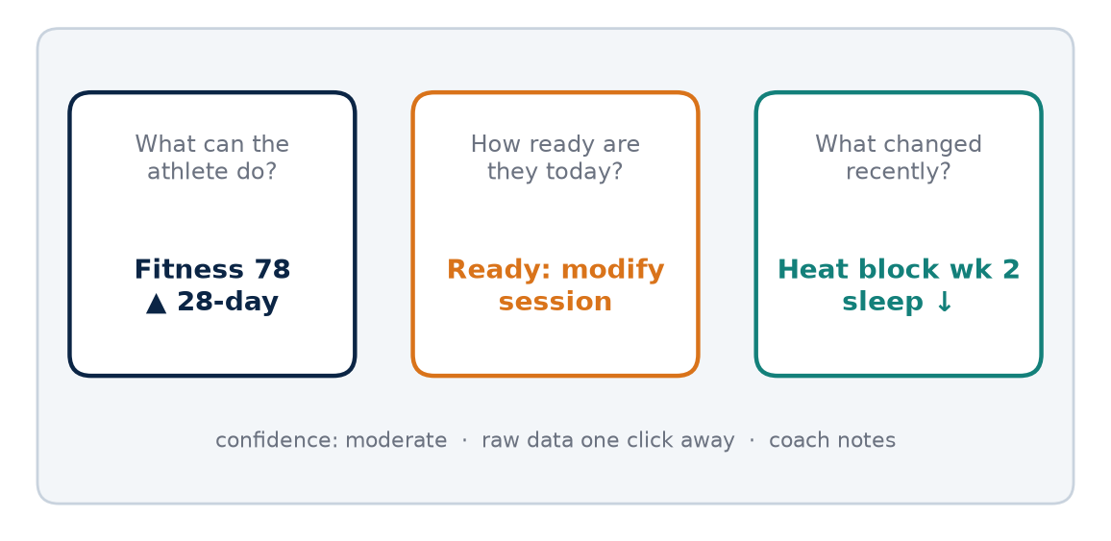
Figure 27. Dashboard concept (mock-up): three questions answered at a glance, with confidence and raw data always visible.

Three questions
The dashboard should answer three questions quickly. What can the athlete do? How ready are they today? What changed recently? Everything else is secondary. The first question is answered by the performance anchor and fitness trend. The second is answered by readiness indicators such as sleep, resting heart rate, heart-rate variability trend and subjective wellness, which in the wider AKURA ecosystem feed the AISRi daily readiness layer. The third is answered by recent interventions, environmental exposure and training-load changes.

Proposed panels
A useful dashboard should show current performance anchor, fitness trend, readiness trend, key physiological domains, environmental exposure, training load, durability, confidence and recent interventions.
Panel | What it shows | Question answered
Performance anchor | Most recent standardised race or time trial | What can they do?
Fitness trend | HR at fixed pace, threshold trend over weeks | What can they do?
Readiness trend | Sleep, RHR, HRV trend, wellness (AISRi) | How ready today?
Physiological domains | AEI domain values with confidence | What can they do?
Environment | Recent heat and altitude exposure, WBGT | What changed?
Training load | Acute and chronic load, recent changes | What changed?
Durability | Long-run drift trend | What can they do?
Confidence | Data quality and missing-data flags | How sure are we?
Interventions | Heat blocks, camps, nutrition, equipment | What changed?

Design principles
Show trends rather than single values, because a single low heart-rate-variability reading means much less than a two-week decline. Display confidence alongside every value, using clear visual cues for low-quality or missing data. Separate fitness from readiness visually, so that a tired athlete is not mistaken for an unfit one. Keep colour meanings consistent and avoid alarming reds for normal day-to-day variation. Allow the coach to annotate the dashboard directly, and make sure those annotations are saved.
KEY IDEA
A dashboard is not a verdict. It is a prompt for a conversation between coach and athlete, grounded in evidence.

Avoiding dashboard traps
Dashboards can create false precision. A number displayed to one decimal place feels more certain than it is. They can also encourage over-monitoring, where athletes become anxious about daily fluctuations. The AEI dashboard should round sensibly, show ranges where appropriate, and remind users that daily readiness signals are context-dependent. Athletes should see a simplified version focused on their own progress and practical guidance, not a wall of physiological variables.

An example morning
At 6 a.m. a coach in Chennai opens the dashboard for a squad of fifteen runners. Most readiness panels show normal variation. One athlete's resting heart rate has been elevated for three days, sleep has fallen, and the wellness note mentions a sore throat. Another athlete's fitness trend shows heart rate at fixed pace improving steadily since a heat block ended two weeks earlier. A third has a low-confidence flag because their chest strap was not worn. Within a minute the coach knows whom to call, whose session to modify, and whose data to ignore until it is fixed. That is what a good dashboard does: it directs attention, and then it gets out of the way.

Building gradually
A dashboard should grow with the data. A club with only race results and watch heart rate can begin with the performance anchor, fitness trend and training-load panels. Readiness and environment panels can be added once check-ins and environmental logs become routine, and physiological domains once standardised testing is in place. Adding panels before the data exist only creates empty boxes and false impressions of completeness.
Finally, the dashboard must be honest about what it does not know. A blank panel labelled "no recent data" is more useful than a confident-looking estimate built on stale measurements. Coaches quickly learn to distrust tools that look precise but prove wrong, and that distrust spreads to the whole system.
COACH'S CORNER
Look at your current monitoring tools and ask whether they answer the three questions within ten seconds. If they do not, remove panels until they do.

CHECKPOINT
Which single panel on your current dashboard do you look at most, and which have you never used to make a decision?

CHAPTER 80

80. The Coach's Interpretation Layer
PART XV — IMPLEMENTATION
No algorithm, however carefully validated, sees the whole athlete. It sees what it has been given. A runner's heart rate may be high because of fitness loss, but also because of a late shift at work, a family crisis, a fever starting, a new medication, a hot bus journey, or a watch strap worn loosely. The coach's interpretation layer exists so that this context is never lost and never overridden silently by a number.

Context the algorithm cannot see
No algorithm should hide context. Travel, family stress, work shifts, illness, medication, menstrual-cycle factors where relevant, equipment changes and unusual weather can alter performance. In the Indian setting, add long commutes, exam seasons for student athletes, festival periods with changed sleep and diet, monsoon disruptions and power cuts that affect sleep in hot weather. Each of these can shift the physiological signals on which AEI and AISRi depend.

Annotation and override
The coach should be able to annotate events and override a recommendation with a reason. If the system suggests a hard session but the coach knows the athlete travelled overnight by train from Coimbatore, the coach should be able to change the plan and record why. The override is not a failure of the system. It is information. Those overrides become research data themselves, because they record exactly where the model and the expert disagreed.
KEY IDEA
An override with a reason is one of the most valuable data points a coaching system can collect. It captures human knowledge the model does not yet have.

Learning from the coach
Over time, the system can learn which signals the coach repeatedly uses correctly. If a coach consistently reduces load when a particular athlete's sleep drops below a personal threshold, and those decisions are followed by better sessions, that pattern can inform future recommendations. Equally, if some overrides are followed by poor outcomes, the system can highlight this gently. The aim is mutual learning: the algorithm becomes more context-aware, and the coach becomes more aware of their own patterns and biases.

Guarding against bias
Human interpretation brings its own risks. Coaches can hold assumptions about athletes based on background, gender, region or appearance. The interpretation layer should encourage evidence-based notes, not labels. Write "athlete reported poor sleep for three nights due to exams", not "this athlete is always lazy before races". Keep annotations factual, respectful and useful, remembering that athletes may be able to read them.

Annotations in practice
A good annotation is short, specific and timed. It states what happened, when, and what was changed. For example: "Returned from wedding travel, two nights of four hours' sleep; replaced intervals with 40 minutes easy." Or: "Hot humid morning, WBGT high; moved tempo to treadmill in the evening." Standard tags such as travel, illness, work, exams, heat, equipment and menstrual-cycle note (entered only with the athlete's consent) make these notes searchable later. When the research team later analyses why a fitness trend dipped or a test result looked unusual, these annotations often provide the explanation that no sensor could.

Athlete voice
The interpretation layer is not only for the coach. Athletes should be able to add their own notes about how sessions felt, what else was happening in their lives, and what they think explains a good or poor result. Athletes often notice patterns before the data show them. Including their voice improves the data, builds trust and helps athletes develop the self-awareness that is the long-term goal of the whole AKURA approach.

When the coach and system disagree
Disagreement should be expected and welcomed. When the system and the coach point in different directions, the useful response is neither to obey the algorithm blindly nor to ignore it, but to ask why they differ. Perhaps the model lacks context; perhaps the coach is reacting to a single vivid memory. Recording the disagreement, the decision and the outcome turns each case into evidence. Over hundreds of such cases, patterns emerge that neither the coach nor the model could have seen alone, and that shared record becomes one of the most distinctive assets of the AKURA system.
COACH'S CORNER
Build the habit of a one-line note whenever you change a planned session: what you changed and why. After three months, read the notes back. You will learn a great deal about your own coaching.

CHECKPOINT
When did you last override a plan based on context the data could not see? Did you record it, and what happened afterwards?

CHAPTER 81

81. Safety Rules
PART XV — IMPLEMENTATION
Every measurement system eventually reaches a point where the right answer is not a number but a person. AKURA's safety rules define that point clearly. They apply to every protocol in this book, every dashboard, and every automated recommendation. They are not optional extras; they are the conditions under which the rest of the system is allowed to operate. Nothing in this book replaces the judgement of a qualified doctor.

The core rules
- No readiness score should override symptoms requiring medical attention. If an athlete reports chest pain, fainting, unusual breathlessness, palpitations or signs of illness, the session stops and the athlete is assessed, whatever the dashboard says.
- Heat training should be stopped when heat-illness warning signs appear. Every heat session needs supervision, cooling, fluids and an emergency plan.
- Altitude exposure should be medically supervised when indicated, especially for athletes with medical conditions, low iron status or previous altitude illness.
- Blood abnormalities should be interpreted by qualified clinicians. Coaches and algorithms may flag a result but must not diagnose or prescribe treatment.
- No supplement, iron or medication decision should be made by the AEI system. These belong to clinicians.
- Athletes must be able to stop any test or session at any time without penalty.
- Any result the system cannot confidently interpret must be flagged for human review.

Heat-illness warning signs
Stop exercise immediately, begin cooling and seek emergency medical care if an athlete shows any of the following:
- Confusion, disorientation, irritability or unusual behaviour
- Stopping sweating, or hot, dry skin
- Collapse or loss of consciousness
- Vomiting or persistent nausea
- Severe headache, dizziness or loss of coordination
Exertional heatstroke is a medical emergency. Rapid cooling and emergency care save lives. In Chennai and other hot Indian cities, every training group should know where the nearest emergency department is and how to reach it quickly.

Altitude warning signs
Stop training and arrange clinical assessment if an athlete at Ooty, Kodaikanal or higher altitude shows:
- Worsening headache that does not settle with rest
- Nausea, vomiting or loss of appetite with fatigue
- Unusual breathlessness at rest or a persistent cough
- Confusion, unsteadiness or extreme drowsiness
- Chest tightness or coughing up frothy or blood-stained sputum
Serious or worsening symptoms require descent and urgent medical care. Moderate altitudes carry lower risk than high mountains, but individual susceptibility varies and warning signs should never be ignored.
KEY IDEA
A research system must know when not to automate. The safest algorithm is the one that can say: "This result needs human review."

Defer to clinicians
This book discusses physiology to improve coaching decisions, not to diagnose disease. Where symptoms, blood results, heart rhythm irregularities, disordered eating, repeated injuries or menstrual disturbances appear, the coach's role is to refer to an appropriately qualified clinician. The AEI system should make referral easy and never make it feel like failure.

Building a safety culture
Rules on paper are not enough. Safety depends on a culture in which athletes feel able to report symptoms without being seen as weak, and in which coaches reward honest reporting. In many Indian sporting environments, athletes may hide illness or discomfort to avoid losing selection or disappointing a coach. The AKURA system should make it normal, even expected, to say "I don't feel right today". Assistant coaches and senior athletes should be trained in first response, including how to cool an athlete rapidly and how to call for emergency help. After any incident or near miss, the team should review what happened and what can be improved, without blame.

Data safety and privacy
Safety also includes the athlete's information. Blood results, menstrual-cycle notes, injury histories and mental-health comments are sensitive. They should be stored securely, shared only with those who need them, and never used against an athlete in selection or contract discussions without clear consent. Athletes should be able to see, correct and, where appropriate, withdraw their data.
COACH'S CORNER
Print the heat and altitude warning signs and keep them in your kit bag, at the track and on the team group. Brief every new athlete and every assistant coach before their first hot session or first camp.

CHECKPOINT
If an athlete collapsed during a hot session tomorrow, does everyone in your group know exactly what to do in the first five minutes?

PART XV AT A GLANCE
The key idea from each chapter, for quick revision.
78 | The AEI Athlete Card  A score without traceability is difficult to trust. Every number on the AEI card must lead back to a measurement, a date and a method.
79 | The AEI Dashboard  A dashboard is not a verdict. It is a prompt for a conversation between coach and athlete, grounded in evidence.
80 | The Coach's Interpretation Layer  An override with a reason is one of the most valuable data points a coaching system can collect. It captures human knowledge the model does not yet have.
81 | Safety Rules  A research system must know when not to automate. The safest algorithm is the one that can say: "This result needs human review."

PART XVI — PHILOSOPHY
The final part steps back from protocols and dashboards to ask what the whole enterprise is for. Endurance communities everywhere carry myths, and many contain a real observation wrapped in an inaccurate explanation. AKURA's task is not to mock those beliefs but to test them, keeping what the evidence supports and letting go of what it does not. These closing chapters set out the attitude behind the method: humility before data, respect for the athlete, and a cycle of training, measuring, understanding and adapting that continues across a career. They end with the real goal of AEI, which is not a famous number but athletes who understand themselves better.
IN THIS PART
82 From Myth to Measurement
83 Train. Measure. Understand. Adapt.
84 The Real Goal of AEI
CHAPTER 82

82. From Myth to Measurement
PART XVI — PHILOSOPHY
Every endurance community has myths. In India we hear that runners from hill regions are naturally stronger, that Chennai's heat alone makes athletes tough, that a camp in Ooty automatically adds a minute to a marathon, that a certain diet or a certain shoe is the secret. Internationally, the myths are often about East African runners, about genes, about altitude, about poverty and hunger. Some contain a useful observation wrapped in an inaccurate explanation. This book has tried to treat every such belief with curiosity rather than contempt.

The useful kernel
A myth usually survives because it contains something true. Athletes who live and train at moderate altitude do experience real physiological challenges. Athletes who grow up running long distances as children may accumulate substantial aerobic training. Hot climates do produce heat adaptation. The problem arises when a partial truth becomes a complete explanation, or when a population-level observation is turned into a statement about every individual. That is where stereotypes form, and stereotypes are both scientifically weak and unfair to athletes.

Separating observation from conclusion
The job of AKURA is not to ridicule the myth. It is to separate the useful observation from the unsupported conclusion. That requires a simple discipline: state the belief as a testable hypothesis, identify what would be measured, predict what result would support or contradict it, and then collect the data. "Altitude makes runners faster" becomes "a three-week camp at a defined sleeping altitude will increase haemoglobin mass and time-trial performance in this group, with a measurable individual response". The second statement can be wrong, and that is exactly why it is useful.
MYTH VS EVIDENCE
Myth: Athletes from a particular region or ethnic group are naturally built for endurance, so training matters less.
Evidence: Elite endurance performance is multifactorial. Training history, environment, economy, motivation, opportunity, coaching and support systems all matter, and individual variation within any group is large. No population label predicts an individual athlete's potential.

Belief and data
Belief is not the enemy of science. Coaches need conviction to commit to a plan, and athletes need belief to endure hard training. Belief is often where a good question starts. But belief cannot be the end point. The athlete deserves to know what is actually happening in their own body, and that can only come from careful measurement interpreted honestly.
நம்பிக்கையால் hypothesis உருவாகலாம். ஆனால் athlete-ன் உண்மையை data தான் சொல்ல வேண்டும்.
— Kura
In English, this means: "Belief can create a hypothesis. But only data can tell the athlete's truth." The line is written in the mixed Tamil and English that many Chennai coaches and athletes actually speak, and it captures the spirit of this book. Faith, tradition and intuition are welcome at the beginning of the research process. They generate the questions. The answer, however, must come from what the athlete's body shows when it is measured properly.

Humility in both directions
Measurement also has limits. Devices have error, tests have poor reliability when not standardised, and statistics can mislead when sample sizes are small. Moving from myth to measurement does not mean replacing one certainty with another. It means holding every conclusion with an appropriate level of confidence, updating it as new evidence arrives, and being honest when the answer is "we don't know yet".
KEY IDEA
A myth becomes useful the moment it is turned into a hypothesis that could be proved wrong.

Myths in the Indian context
Indian endurance culture has its own inherited beliefs: that drinking water during runs makes athletes weak, that pain must always be pushed through, that a particular village or state produces "natural" runners, that women should train less, or that recovery is laziness. Some of these beliefs once contained a grain of practical sense in a particular setting; others were never supported at all. Treating them as hypotheses allows coaches to keep the respect for hard work and tradition while discarding practices that harm athletes. That process should be gentle and respectful, because the people who hold these beliefs often care deeply about their athletes.
Ultimately, the move from myth to measurement is a move from arguing about who is right to asking what is true for this athlete. That shift lowers the temperature of debates between coaches, and it keeps the conversation centred on the person who matters most.
COACH'S CORNER
Write down three beliefs you hold about training that you have never tested. For each, write what you would measure and what result would change your mind. Choose one to test this season.

CHECKPOINT
Which training belief in your group is most widely accepted and least often questioned? What would it take to test it fairly?

CHAPTER 83

83. Train. Measure. Understand. Adapt.
PART XVI — PHILOSOPHY
Training without measurement can still work. Coaches have produced great athletes with a stopwatch, a notebook and years of experience. But measurement makes the learning process clearer. It shortens the time needed to discover what works for an individual, and it protects athletes from repeating mistakes that nobody noticed. Measurement without interpretation is just data. Interpretation without humility becomes dogma. AKURA's approach can be summarised in four words.
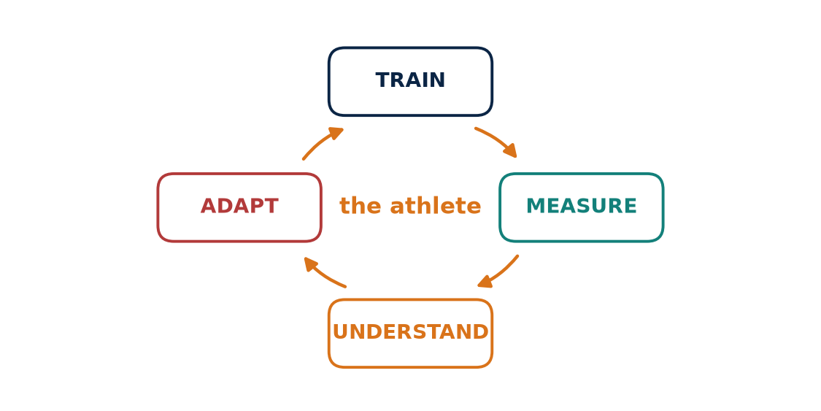
Figure 28. Train. Measure. Understand. Adapt. The cycle repeats for the athlete's entire career.

The four words
- Train. Do the work, consistently and intelligently. Training is the stimulus that drives adaptation. No amount of measurement replaces months and years of well-structured running, strength work and recovery. The training plan should be clear enough that it can be described, recorded and repeated.
- Measure. Capture what happened and how the body responded, using standardised protocols. That includes performance, heart rate, perceived effort, environment, sleep and, where appropriate, laboratory tests. Measure carefully, log context, and note the confidence of each piece of data.
- Understand. Interpret the measurements in the context of the athlete's life, history and goals. Ask what changed, why it might have changed, and whether the change is larger than measurement error. Separate fitness from readiness, adaptation from noise, and correlation from cause.
- Adapt. Change the plan based on what was learned. Adaptation applies to the athlete's body and to the coach's thinking. If the data disagree with the hypothesis, revise the hypothesis. Then return to training, and the cycle begins again.

A cycle, not a line
The cycle repeats for the athlete's entire career. Each loop adds to the athlete's record and sharpens the coach's understanding. Early loops may be crude, with few measurements and much uncertainty. Later loops can be more precise, because the athlete's baseline, typical responses and personal limiters are known. This is the practical meaning of "the athlete is the laboratory": every block is an experiment, and the results accumulate.
KEY IDEA
Train, measure, understand and adapt is a loop. Skipping any step breaks the learning: training without measuring leaves you guessing, measuring without understanding leaves you with noise, and understanding without adapting changes nothing.

Speed of the loop
Different questions run on different cycle lengths. Daily readiness decisions, the domain of AISRi, run on a loop of hours. Training-block decisions run over weeks. Questions about heat or altitude responses run over months. Questions about long-term development run over years. A good system keeps all of these loops turning without confusing them, so that a single bad night's sleep is not mistaken for a failed training philosophy.

Where things go wrong
The loop fails in predictable ways. Some coaches train hard but measure nothing, so they cannot learn from the season. Some collect vast amounts of wearable data but never interpret it. Some interpret confidently but never change their minds. And some adapt constantly, changing plans every week in response to noise. The discipline is to move through all four steps with patience, allowing enough time for training to take effect before judging it.

An example loop
Consider a club runner in Chennai preparing for a half marathon. The coach plans a four-week block of steady runs and one weekly threshold session (Train). Each week they record heart rate at a fixed easy pace on the same route before 6.30 a.m., along with WBGT, sleep and RPE (Measure). After four weeks, heart rate at the fixed pace has fallen by more than the typical day-to-day variation, while threshold sessions feel easier; the coach notes that two of the hottest mornings produced outlying values and excludes neither but annotates both (Understand). The next block increases threshold volume slightly and adds a durability probe to the long run (Adapt). Nothing about this is complicated, but it turns a season of running into a season of learning.

The loop for the coach
The same four words apply to coaches themselves. A coach trains through practice, measures through records and reflection, understands through study, mentoring and conversation with scientists and clinicians, and adapts by changing methods when evidence demands it. A coach who stops learning eventually coaches the same year over and over again. The AKURA cycle is meant to keep both athlete and coach growing, season after season, so that experience becomes expertise rather than habit.
COACH'S CORNER
At the end of each training block, hold a fifteen-minute review with the athlete using the four words as headings: what did we train, what did we measure, what do we understand now, and what will we change?

CHECKPOINT
Which of the four steps is weakest in your current coaching practice? What one habit would strengthen it?

CHAPTER 84

84. The Real Goal of AEI
PART XVI — PHILOSOPHY
It is tempting for any new index to chase attention: a single number that can be compared, ranked and shared. That is not the purpose of the AKURA Endurance Index. The real goal is not to produce a famous number. The goal is to help athletes become more understandable to themselves and their coaches. An athlete who knows why a race went well or badly, which environments suit them, how they respond to heat or altitude, and what their early warning signs of overload look like is better equipped for a long career than one who simply knows a score.

What success would look like
If AEI eventually becomes a validated index, its success should be measured by whether it improves training decisions, reduces avoidable overload, identifies useful interventions and helps athletes perform more consistently. These are practical outcomes that can themselves be studied. Do coaches using AEI make decisions they later judge to be better? Do athletes experience fewer periods of unplanned fatigue or injury? Do interventions such as heat blocks or altitude camps become better targeted? Do race performances become more predictable? If the answer to these questions is no, the index has not yet earned its place, however elegant its mathematics.

The number and the system
The number is the interface. The learning system is the product. A score is only a convenient way to summarise a large body of information. The real value lies underneath: the athlete card with traceable raw data, the standardised protocols, the environmental logs, the coach's annotations and overrides, and the accumulating record of how each athlete responds. If the score were removed tomorrow, a well-built AKURA system should still help coaches coach better.
KEY IDEA
AEI succeeds not when its number becomes famous but when athletes and coaches understand the body better and make better decisions because of it.

A national opportunity
India has vast numbers of endurance athletes training across extraordinary diversity of climate, altitude, culture and circumstance: coastal heat in Chennai and Mumbai, hill stations in the Nilgiris and the Himalaya, dry heat in the north-west, humid monsoon seasons almost everywhere. Very little of this natural variation has been studied systematically. A carefully built, ethically run, openly reported research system could turn this diversity into knowledge that benefits Indian athletes first and contributes to global endurance science as well.

Staying honest
The final responsibility of AEI is honesty. It must report uncertainty, admit when it is wrong, allow the data to disagree with its designers, and keep the athlete's health and dignity above any performance goal. It should be open to independent validation and willing to be revised or even replaced if better methods emerge. That humility is not weakness; it is what makes a research system trustworthy.

What AEI must never become
It is equally important to state what AEI should not be. It should not become a selection tool that excludes young athletes on the basis of a single test. It should not be used to label athletes by region, background or appearance. It should not replace a coach's relationship with an athlete, or a clinician's judgement about health. And it should not be used to pressure athletes into training through illness or injury because "the numbers look fine". Any use of the index that reduces an athlete's dignity, safety or opportunity is a misuse, regardless of the data behind it.

An invitation
This edition is a prototype, and prototypes are meant to be tested, broken and rebuilt. Coaches who try the protocols, athletes who keep careful logs, scientists who challenge the assumptions and clinicians who point out safety gaps all become part of the research. The long-term value of AEI will depend less on the ideas written here than on the quality of the data and the honesty of the people who collect and interpret it. If that community forms, the index will improve with every season, and Indian endurance athletes will have a research system built around their own bodies, climates and ambitions.
COACH'S CORNER
When you share any AEI or readiness number with an athlete, always pair it with an explanation of what it means for their training this week. A number without a conversation teaches nothing.

CHECKPOINT
If the AEI score disappeared tomorrow, what would your athletes still know about themselves because of the work you have done together?

PART XVI AT A GLANCE
The key idea from each chapter, for quick revision.
82 | From Myth to Measurement  A myth becomes useful the moment it is turned into a hypothesis that could be proved wrong.
83 | Train. Measure. Understand. Adapt.  Train, measure, understand and adapt is a loop. Skipping any step breaks the learning: training without measuring leaves you guessing, measuring without understanding leaves you with noise, and understanding without adapting changes nothing.
84 | The Real Goal of AEI  AEI succeeds not when its number becomes famous but when athletes and coaches understand the body better and make better decisions because of it.

Appendix A — AEI v0.1 Research Specification
AEI is proposed here as an original AKURA research framework. It is not presented as a validated replacement for VDOT, VO₂max testing, medical assessment or established performance models. The domains, fields and formula below are a research specification for prototype use only and require independent validation before any high-stakes application.
Domain | Primary examples | Interpretation | Confidence
AEI-P Performance | 5K/10K/HM/Marathon results | Current race expression | High when recent and standardised
AEI-A Aerobic | VO₂-related tests, submax HR-pace | Aerobic capacity | Protocol dependent
AEI-T Threshold | Lactate/threshold pace | Sustainable high intensity | Protocol dependent
AEI-E Economy | O₂ cost at fixed speed | Movement efficiency | Needs repeatability
AEI-O Oxygen | Hb mass, Hb concentration | O₂ transport context | Specialist testing for Hb mass
AEI-C Cardiovascular | HR, stroke-volume-related measures | Circulatory response | Context dependent
AEI-R Recovery | Sleep, HRV trend, RHR, fatigue | Today's expression capacity | Baseline dependent
AEI-H Heat | Heat exposure, thermal response | Heat adaptation | Environment must be logged
AEI-X Altitude | Sleeping altitude, Hb mass response | Hypoxic adaptation | Dose dependent
AEI-D Durability | Long-run degradation | Marathon-specific resilience | Needs standardised protocol

Proposed data fields
Category | Fields
Identification | Athlete ID, Date/time, Device, Protocol version
Session and performance | Race/test type, Distance, Time, Pace
Physiological response | HR, RPE, HRV, RHR, Body mass
Environment | Temperature, Humidity/WBGT, Elevation
Recovery and wellness | Sleep, Fatigue, Soreness
Load and inputs | Training load, Fuel/hydration
Intervention | Intervention, Pre/post status
Quality and notes | Clinician/technician note, Data quality, Confidence

Calculation philosophy
- Do not assign arbitrary weights simply to produce a 0–100 score.
- Keep raw measurements permanently available.
- Normalise within athlete and, where appropriate, against a reference population.
- Use recent performance as the primary expression anchor.
- Separate Fitness from Readiness.
- Attach confidence and missing-data penalties.
- Validate every derived score prospectively before high-stakes use.

Example research formula (prototype only)
A future AEI score could be modelled as a calibrated function rather than a hand-built average:
AEI = f(Performance, Economy, Threshold, Oxygen Transport, Cardiovascular Response, Durability, Recovery, Environment)
Here f is learned and validated from longitudinal athlete data, not chosen by hand. Until that validation exists, the components should be reported separately, each with its own raw data, date, method and confidence level.

Appendix B — Athlete Research Worksheet
Use one worksheet per athlete per intervention. Record the baseline and post-intervention values under the same protocol, note the change, and add a confidence rating and short coach note in the final column.
Field | Baseline | Post | Change | Confidence / Note
Race performance
Easy pace at fixed HR
Threshold marker
VO₂-related measure
Running economy
Hb / Hb mass
Resting HR
HRV trend
Sleep
Body mass
Heat exposure
Altitude exposure
Long-run durability

Appendix C — Heat Session Log Template
Complete one log for every heat session. Stop the session immediately if any heat-illness warning sign appears, begin cooling and seek emergency medical care.
Field | Entry
Date and start time
Location and surface
Temperature / humidity / WBGT
Session type (run, heated room, passive)
Duration and target pace or intensity
Average and peak HR
RPE and thermal comfort (end)
Body mass before / after
Fluid intake
Core or skin temperature (if measured)
Symptoms or warning signs
Supervisor and coach note

Appendix D — Altitude Camp Log Template
Complete daily during any camp at Ooty, Kodaikanal or elsewhere. Report worsening headache, vomiting, breathlessness at rest or confusion to the medical lead immediately.
Field | Entry
Date and camp day number
Sleeping altitude
Training altitude
Hours at altitude
Morning SpO₂ and resting HR
Sleep duration and quality
Session and training load
RPE and HR at fixed pace
Wellness and appetite
Iron supplementation (as prescribed)
Symptoms or warning signs
Coach and clinician note

Appendix E — Daily Readiness Check-in
A short morning check-in supports the AISRi readiness layer. It is a conversation starter, not a diagnosis; any concerning symptom should be discussed with the coach and, where needed, a clinician.
Item | Scale | Notes
Sleep duration | Hours
Sleep quality | 1 (very poor) – 5 (excellent)
Resting HR | beats per minute
HRV (if available) | Device value; compare to trend
Fatigue | 1 (fresh) – 5 (exhausted)
Muscle soreness | 1 (none) – 5 (severe)
Mood / stress | 1 (very low) – 5 (very good)
Illness symptoms | Yes / No
Menstrual-cycle note (optional) | Free text
Unusual context (travel, work, exams) | Free text

Glossary
AEI: AKURA Endurance Index; a proposed research framework for organising endurance performance data into domains. Not yet validated.
AISRi: The AKURA daily readiness and training decision layer in the proposed coaching ecosystem.
Cardiac output: The volume of blood pumped by the heart per minute; the product of heart rate and stroke volume.
Confidence interval: A range of values, calculated from data, that expresses the uncertainty around an estimate such as a mean change.
Decoupling: The drift of heart rate relative to pace (or power) during prolonged steady exercise; often used as an informal marker of aerobic durability.
Durability: The ability to maintain performance and physiological characteristics as exercise duration and fatigue increase.
EPO: Erythropoietin; a hormone, produced mainly by the kidneys, involved in red-cell production.
Erythropoiesis: The production of new red blood cells, which can be stimulated by hypoxia.
Ferritin: A protein that stores iron; blood ferritin is commonly used as an indicator of iron stores and should be interpreted by a clinician.
Fractional utilisation: The percentage of VO₂max an athlete can sustain over a given duration or race distance.
Glycogen: The stored form of carbohydrate in muscle and liver; an important fuel in prolonged and high-intensity exercise.
Haemoglobin mass: The total mass of haemoglobin in the circulation; distinct from haemoglobin concentration.
Heat acclimation vs acclimatisation: Acclimation refers to adaptation produced by artificial or controlled heat exposure (for example a heated room); acclimatisation refers to adaptation produced by natural environmental exposure.
HRV: Heart-rate variability; a context-dependent autonomic and recovery signal best interpreted as a trend.
Hypoxia: A reduced availability of oxygen to the body or tissues, as occurs at altitude.
Lactate threshold: A workload region where lactate dynamics change markedly; its exact definition depends on the protocol used.
Normalisation: Expressing a value relative to a reference, such as the athlete's own baseline or a population range, so that different measures can be compared.
Partial pressure: The pressure exerted by one gas within a mixture. At altitude the oxygen fraction of air is unchanged, but the partial pressure of oxygen falls because total pressure falls.
Plasma volume: The volume of the liquid component of blood.
RPE: Rating of perceived exertion; the athlete's subjective rating of how hard an effort feels, on a defined scale.
Running economy: The oxygen (or energy) cost of running at a given submaximal speed.
Smallest worthwhile change: The smallest change in a measure that is considered practically meaningful for performance or health.
Stroke volume: The volume of blood ejected by the heart with each beat.
Thermoregulation: The body's processes for controlling core temperature, including sweating and changes in skin blood flow.
Typical error: The typical variation in a measurement when it is repeated under the same conditions; used to judge whether a change is real.
VDOT: An established running-performance and training framework based on current running ability.
VO₂max: Maximum oxygen uptake during severe or maximal exercise.
WBGT: Wet-bulb globe temperature; an environmental heat-stress index that combines temperature, humidity, radiant heat and air movement.

Final Research Principles
- Never confuse concentration with total mass.
- Never confuse oxygen fraction with oxygen partial pressure.
- Never confuse VO₂max with complete running ability.
- Never confuse heat adaptation with altitude adaptation.
- Never treat a single wearable metric as a diagnosis.
- Never assign score weights without validation.
- Always document the protocol.
- Always separate current fitness from today's readiness.
- Always allow the data to disagree with the hypothesis.
- Always keep the athlete at the centre of the system.
These ten principles are the shortest possible summary of this book. They will outlast any particular version of AEI. Equations will be revised, devices will change and new research will overturn some of today's assumptions. What should remain is the habit of careful measurement, honest interpretation and respect for the individual athlete. If this edition helps even a few coaches ask better questions and test their beliefs more carefully, it will have done its work.

References and Further Reading
The sources below were used as starting points for the evidence discussed in this book. Readers should consult the original papers; inclusion here does not imply that the authors endorse the AKURA Endurance Index.
Armstrong LE, Casa DJ, Millard-Stafford M, Moran DS, Pyne SW, Roberts WO. American College of Sports Medicine position stand: exertional heat illness during training and competition. Medicine & Science in Sports & Exercise. 2007;39(3):556–572.
Atkinson G, Nevill AM. Statistical methods for assessing measurement error (reliability) in variables relevant to sports medicine. Sports Medicine. 1998;26(4):217–238.
Balsalobre-Fernández C, Santos-Concejero J, Grivas GV. Effects of strength training on running economy in highly trained runners: a systematic review with meta-analysis of controlled trials. Journal of Strength and Conditioning Research. 2016;30(8):2361–2368.
Bassett DR Jr, Howley ET. 2000. Limiting factors for maximum oxygen uptake and determinants of endurance performance. Medicine and Science in Sports and Exercise.
Beattie K, Kenny IC, Lyons M, Carson BP. The effect of strength training on performance in endurance athletes. Sports Medicine. 2014;44(6):845–865.
Benjamin CL, et al. Physiological Responses to Heat Acclimation: A Systematic Review and Meta-Analysis of Randomized Controlled Trials. Journal of Sports Science and Medicine. 2019. PMID 31191102.
Bouchard C, An P, Rice T, Skinner JS, Wilmore JH, Gagnon J, Pérusse L, Leon AS, Rao DC. 1999. Familial aggregation of VO₂max response to exercise training: results from the HERITAGE Family Study. Journal of Applied Physiology.
Bourdon PC, Cardinale M, Murray A, et al. Monitoring athlete training loads: consensus statement. International Journal of Sports Physiology and Performance. 2017;12(Suppl 2):S2161–S2170.
Brooks GA. 2018. The science and translation of lactate shuttle theory. Cell Metabolism.
Brown HA, et al. Quantifying Exercise Heat Acclimatisation in Athletes and Military Personnel: A Systematic Review and Meta-analysis. Sports Medicine. 2024. PMID 38051495.
Burke LM, Hawley JA, Wong SH, Jeukendrup AE. 2011. Carbohydrates for training and competition. Journal of Sports Sciences.
Casa DJ, DeMartini JK, Bergeron MF, et al. National Athletic Trainers' Association position statement: exertional heat illnesses. Journal of Athletic Training. 2015;50(9):986–1000.
Chapman RF, Stray-Gundersen J, Levine BD. Individual variation in response to altitude training. Journal of Applied Physiology. 1998;85(4):1448–1456.
Collins GS, Reitsma JB, Altman DG, Moons KGM. Transparent reporting of a multivariable prediction model for individual prognosis or diagnosis (TRIPOD): the TRIPOD statement. BMJ. 2015;350:g7594.
Coyle EF, González-Alonso J. Cardiovascular drift during prolonged exercise: new perspectives. Exercise and Sport Sciences Reviews. 2001;29(2):88–92.
Daniels J. Daniels' Running Formula. 3rd ed. Champaign, IL: Human Kinetics; 2014.
Dill DB, Costill DL. 1974. Calculation of percentage changes in volumes of blood, plasma, and red cells in dehydration. Journal of Applied Physiology.
Faude O, Kindermann W, Meyer T. Lactate threshold concepts: how valid are they? Sports Medicine. 2009;39(6):469–490.
Foster C, Florhaug JA, Franklin J, et al. A new approach to monitoring exercise training. Journal of Strength and Conditioning Research. 2001;15(1):109–115.
Gabbett TJ. The training–injury prevention paradox: should athletes be training smarter and harder? British Journal of Sports Medicine. 2016;50(5):273–280.
Gore CJ, Sharpe K, Garvican-Lewis LA, et al. Altitude training and haemoglobin mass from the optimised carbon monoxide rebreathing method determined by a meta-analysis. British Journal of Sports Medicine. 2013;47(Suppl 1):i31–i39. PMID 24282204.
Halson SL. Monitoring training load to understand fatigue in athletes. Sports Medicine. 2014;44(Suppl 2):S139–S147.
Hecksteden A, Kraushaar J, Scharhag-Rosenberger F, et al. Individual response to exercise training – a statistical perspective. Journal of Applied Physiology. 2015;118(12):1450–1459.
Holloszy JO. 1967. Biochemical adaptations in muscle: effects of exercise on mitochondrial oxygen uptake and respiratory enzyme activity in skeletal muscle. Journal of Biological Chemistry.
Hopkins WG, Marshall SW, Batterham AM, Hanin J. Progressive statistics for studies in sports medicine and exercise science. Medicine and Science in Sports and Exercise. 2009;41(1):3–13.
Hopkins WG. Measures of reliability in sports medicine and science. Sports Medicine. 2000;30(1):1–15.
Jeukendrup A. A step towards personalized sports nutrition: carbohydrate intake during exercise. Sports Medicine. 2014;44(Suppl 1):S25–S33.
Jones AM, Kirby BS, Clark IE, et al. Physiological demands of running at 2-hour marathon race pace. Journal of Applied Physiology. 2021;130(2):369–379.
Jones AM. The physiology of the world record holder for the women's marathon. International Journal of Sports Science & Coaching. 2006;1(2):101–116.
Joyner MJ, Coyle EF. Endurance exercise performance: the physiology of champions. Journal of Physiology. 2008;586(1):35–44.
Levine BD, Stray-Gundersen J. "Living high-training low": effect of moderate-altitude acclimatization with low-altitude training on performance. Journal of Applied Physiology. 1997;83(1):102–112.
Little RJA, Rubin DB. Statistical Analysis with Missing Data. 2nd ed. Hoboken, NJ: Wiley; 2002.
Lorenzo S, Halliwill JR, Sawka MN, Minson CT. Heat acclimation improves exercise performance. Journal of Applied Physiology. 2010;109(4):1140–1147.
Maunder E, Seiler S, Mildenhall MJ, Kilding AE, Plews DJ. The importance of 'durability' in the physiological profiling of endurance athletes. Sports Medicine. 2021;51(8):1619–1628.
Meeusen R, Duclos M, Foster C, et al. Prevention, diagnosis, and treatment of the overtraining syndrome: joint consensus statement of the European College of Sport Science and the American College of Sports Medicine. Medicine & Science in Sports & Exercise. 2013;45(1):186–205.
Midgley AW, McNaughton LR, Polman R, Marchant D. Criteria for determination of maximal oxygen uptake: a brief critique and recommendations for future research. Sports Medicine. 2007;37(12):1019–1028.
Paavolainen L, Häkkinen K, Hämäläinen I, Nummela A, Rusko H. Explosive-strength training improves 5-km running time by improving running economy and muscle power. Journal of Applied Physiology. 1999;86(5):1527–1533.
Peeling P, Dawson B, Goodman C, Landers G, Trinder D. Athletic induced iron deficiency: new insights into the role of inflammation, cytokines and hormones. European Journal of Applied Physiology. 2008;103(4):381–391.
Pelliccia A, Sharma S, Gati S, et al. 2020 ESC Guidelines on sports cardiology and exercise in patients with cardiovascular disease. European Heart Journal. 2021;42(1):17–96.
Périard JD, Racinais S, Sawka MN. Adaptations and mechanisms of human heat acclimation: applications for competitive athletes and sports. Scandinavian Journal of Medicine & Science in Sports. 2015;25(Suppl 1):20–38.
Plews DJ, Laursen PB, Stanley J, Kilding AE, Buchheit M. Training adaptation and heart rate variability in elite endurance athletes: opening the door to effective monitoring. Sports Medicine. 2013;43(9):773–781.
Racinais S, Alonso JM, Coutts AJ, et al. Consensus recommendations on training and competing in the heat. British Journal of Sports Medicine. 2015;49(18):1164–1173.
Rønnestad BR, Mujika I. Optimizing strength training for running and cycling endurance performance: a review. Scandinavian Journal of Medicine & Science in Sports. 2014;24(4):603–612.
Rubin DB. Inference and missing data. Biometrika. 1976;63(3):581–592.
Saltin B, Larsen H, Terrados N, Bangsbo J, Bak T, Kim CK, Svedenhag J, Rolf CJ. 1995. Aerobic exercise capacity at sea level and at altitude in Kenyan boys, junior and senior runners compared with Scandinavian runners. Scandinavian Journal of Medicine and Science in Sports.
Saunders PU, Pyne DB, Telford RD, Hawley JA. Factors affecting running economy in trained distance runners. Sports Medicine. 2004;34(7):465–485.
Saw AE, Main LC, Gastin PB. Monitoring the athlete training response: subjective self-reported measures trump commonly used objective measures: a systematic review. British Journal of Sports Medicine. 2016;50(5):281–291.
Sawka MN, Burke LM, Eichner ER, et al. American College of Sports Medicine position stand: Exercise and fluid replacement. Medicine and Science in Sports and Exercise. 2007;39(2):377–390.
Sawka MN, Leon LR, Montain SJ, Sonna LA. Integrated physiological mechanisms of exercise performance, adaptation, and maladaptation to heat stress. Comprehensive Physiology. 2011;1(4):1883–1928.
Schmidt W, Prommer N. The optimised CO-rebreathing method: a new tool to determine total haemoglobin mass routinely. European Journal of Applied Physiology. 2005;95(5–6):486–495.
Seiler KS, Kjerland GØ. Quantifying training intensity distribution in elite endurance athletes: is there evidence for an "optimal" distribution? Scandinavian Journal of Medicine & Science in Sports. 2006;16(1):49–56.
Sharma S, Drezner JA, Baggish A, et al. International recommendations for electrocardiographic interpretation in athletes. Journal of the American College of Cardiology. 2017;69(8):1057–1075.
Solomon & Laye. The effect of post-exercise heat exposure (passive heat acclimation) on endurance exercise performance: a systematic review and meta-analysis. BMC Sports Science, Medicine and Rehabilitation. 2025. PMID 39762944.
Sterne JAC, White IR, Carlin JB, et al. Multiple imputation for missing data in epidemiological and clinical research: potential and pitfalls. BMJ. 2009;338:b2393.
Stray-Gundersen J, Chapman RF, Levine BD. "Living high-training low" altitude training improves sea level performance in male and female elite runners. Journal of Applied Physiology. 2001;91(3):1113–1120.
Thomas DT, Erdman KA, Burke LM. American College of Sports Medicine Joint Position Statement: Nutrition and Athletic Performance. Medicine and Science in Sports and Exercise. 2016;48(3):543–568.
Tibshirani R. Regression shrinkage and selection via the lasso. Journal of the Royal Statistical Society: Series B. 1996;58(1):267–288.
Wilber RL, Pitsiladis YP. 2012. Kenyan and Ethiopian distance runners: what makes them so good? International Journal of Sports Physiology and Performance.
Wilber RL. Altitude Training and Athletic Performance. Champaign, IL: Human Kinetics; 2004.
Yaglou CP, Minard D. Control of heat casualties at military training centers. AMA Archives of Industrial Health. 1957;16(4):302–316.

About the Author
Kura is the founder of the AKURA Endurance Research System and the AISRi coaching ecosystem, based in Chennai, India. The work grows from years of practical involvement with endurance athletes training in South Indian heat and humidity, and from a conviction that Indian coaching can build its own evidence base rather than borrowing assumptions from elsewhere. This Prototype Edition 0.1 is offered as a starting framework for discussion, collaboration and validation with coaches, athletes, scientists and clinicians. Feedback, criticism and research partnerships are welcome.

