**06SENSE_PULSE for Speed-pulse Alarm** 17Mar2020

**Installing / connecting**

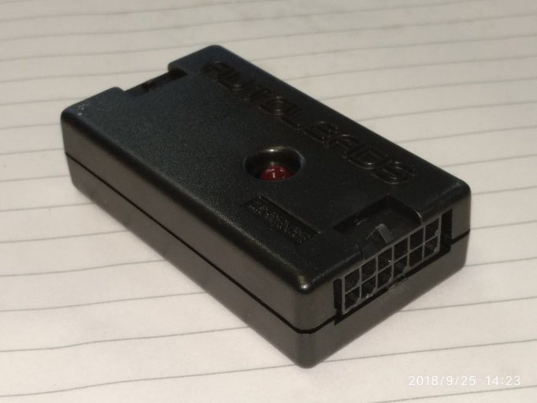

J2: 6 x 2 Microfit connector

1

6

7

12

J2-P1 bypass to J1-P1

J2-P2 blank

J2-P3 GND

J2-P4 GND

J2-P5 blank

J2-P6 blank

J2-P7 +12V

J2-P8 +12V

J2-P9 GND

J2-P10 GND

J2-P11 GP0/AN0/CIN+/ICSPDAT

J2-P12 Push button input

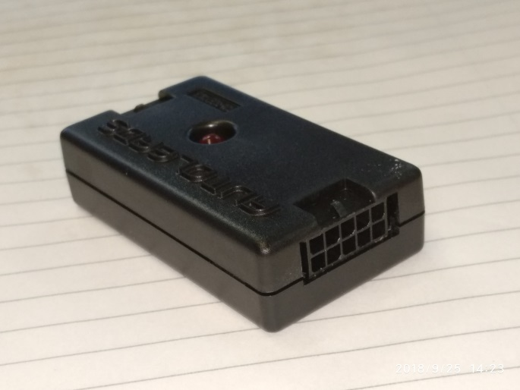

J1: 5 x 2 Microfit connector

1

5

6

10

J1-P1 bypass to J2-P1

J1-P2 Input pulse

J1-P3 GND

J1-P4 +5V

J1-P5 GP3/MCLR/Vpp

J1-P6 +12V

J1-P7 +12V

J1-P8 Output switched +12V

J1-P9 Output switched +12V

J1-P10 GND

Blue: available for further use

Brown: Input push button

Green: Power supply to this module, +12V 3A

Orange: output, switched +12V max. 3A

J1-P12

J1-P8

Switched +12V output, 3A max.

06SENSE_PULSE

LED

Set alarm level

J1-P2

Pulse max. 5V