BCBSP Speed pulse application

# Wiring

There are three Molex/Microfit headers (connectors) on the module. All of them are two-row receptacles.

|  |  |  |  |
| --- | --- | --- | --- |
| Designation | | Row x column = total positions | Usage summary |
| New | Old |
| P1 | P4 | 2 x 3 = 6 | Future use I/O |
| P3 | P6 | 2 x 6 = 12 | COM and ICSP |
| P4 | P7 | 2 x 10 = 20 | Application |

Pins are as shown below (using P4 as an example to show numbering - lower right is first number, upper left is last number, right-to-left then bottom-to-top):



Connections on P4 (20-way) are:

|  |  |  |
| --- | --- | --- |
| Position | Name | Comments |
| 1 | ANA1 | Pulse input 3V – 36V |
| 9 | GND | Signal and power common ground (0V) (also pins 11, 12, 15) |
| 10 | VCC | DC power supply positive +8V to +36V |
| 16 | RELAY_NC | “Normal-close” relay contact (to be used) |
| 17 | RELAY_NO | “Normal-open” relay contact (to be used) |
| 18 | RELAY_COM | “Common” relay contact (to be used) |

Connections on P6 (12-way) are:

|  |  |  |
| --- | --- | --- |
| Position | Name | Comments |
| 1 | RX(UART) | 5V-TTL (not standard RS-232 voltage level) |
| 2 | TX(UART) | 5V-TTL (not standard RS-232 voltage level) |
| 3 | GND | Signal and power common ground (0V) (also pins 7, 11) |
| 8 | ICSPDAT | In-Circuit Serial Programming “DATA” line |
| 9 | ICSPCLK | “CLOCK” |
| 10 | ICSPVPP | “Programming Voltage” internally connected to MCU MCLR pin |
| 12 | ICSPVDD | “Supply voltage” internally connected to MCU VDD pin |

The ICSP signals are for making production-line programming tool.

# Operation

The module demonstrates speed pulse warning. Red LED blinks once every second to indicate the underlying operating system is running. In addition to showing “system health”, this blinking red LED is also an indication of the device is in the “power on” state.

|  |  |  |
| --- | --- | --- |
|  | Blue LED | Buzzer |
| No motion (no pulse) | Off | Off |
| Slight motion (slow pulses) | Blink briefly (every 2 seconds) | Off |
| Near speed limit (pre-alarm) | Blink more prominently | Beep rapidly |
| Speeding (full-alarm) | On (lit continuously) | Beep continuously |

Alarm outputs are re-configurable.

To facilitate testing and validation, the serial COM port is opened. In future, this might change to require authentication and to have data encrypted. The COM parameters are (38400, 8, n, 1). Text commands are available to set the instantaneous speed as the pre-alarm and/or the main-alarm level – without requiring converting data between *t* and MPH/KMH. Type “help” (lower case) or “?” at the prompt follow by the “ENTER” key for more information.

The BCBSP module “operates” in the regime of pulse time period and pulse edge frequency. It has a wide range of operation from 1 pulse per 4 seconds, to hundred Hz, up to mega Hz.

# Speed

A train of pulse comprises the rising edge and the falling edge. The BCBSP module measures the time interval between alternative edges (of same directivity). By detecting the “period” of a repetitive pattern in this manner, it is not necessary to assume or require 1:1 mark-space ratio making the device more dependable.

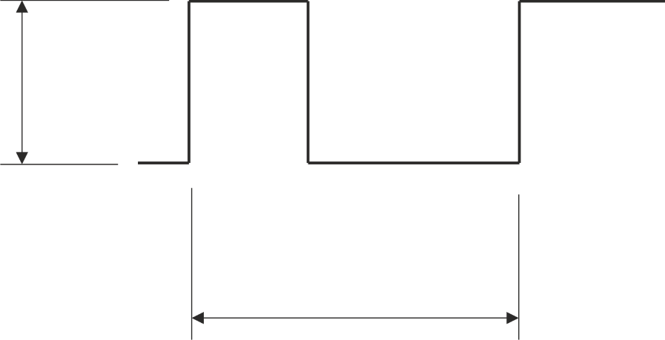

Wide-range

2V – 36V

Period counter *t*

(16 counts per µs)

Threshold

Vehicle speed *s* is inversely proportional to *t*. The speed warning (pre-alarm, full-alarm) decision will compare *t* against designated value(s). From the application program point of view, arithmetic inverse to convert *t* to *s* is unnecessary. The conversion is for us - the human user. Denominator is 16 MHz.

$$s=\frac{16×{10}^{6}}{Dt}$$

This expression is per-second (as in ms-1, S.I. unit). For per-hour values, the result of computation would divide by 3600 (there are 3600 seconds in an hour).

$$s'=\frac{16×{10}^{6}}{3600Dt}=\frac{40000}{9Dt}$$

Whether the result of evaluating *s*’ will be KM/H or MPH (both are per-hour value) depends on what unit of measurement parameter *D* is in. *D* is the “vehicle type” factor. It is a “pulse ratio” and into which the unit of distance lumped. For example, one of the Internet forums wrote that the Honda Civic counted 4000 pulse-per-mile.

$$D_{Civic}=4000$$

Since we now know the value of *D*, we can obtain *s* (mile-per-second), and *s*’ (MPH) for this vehicle for any given *t*.

Parameter *t* and related quantities can display on a COM terminal updating every second. Type “help” (lower case) or “?” at the prompt follow by the “ENTER” key for more information.

# Threshold voltage

When the instantaneous voltage rises above or falls below the “threshold” (previous diagram), such transition are pulse edges. In theory, fix threshold 2.75 volts will fit most applications regardless of pulse magnitude (but should not exceed stated limits). If necessary, select one of the following hexadecimal values for performance fine-tuning.

|  |  |  |
| --- | --- | --- |
| Index | Hex ‘0x’ | Pulse edge threshold (volts) |
| 0 | 00 | 0.50 |
| 1 | 08 | 1.63 |
| 2 | 10 | 2.75 |
| 3 | 18 | 3.88 |
| 4 | 20 | 5.00 |
| 5 | 28 | 6.13 |
| 6 | 30 | 7.25 |
| 7 | 38 | 8.38 |
| 8 | 40 | 9.50 |
| 9 | 48 | 10.63 |
| 10 | 50 | 11.75 |
| 11 | 58 | 12.88 |
| 12 | 60 | 14.00 |
| 13 | 68 | 15.13 |
| 14 | 70 | 16.25 |
| 15 | 78 | 17.38 |
| 16 | 80 | 18.50 |
| 17 | 88 | 19.63 |
| 18 | 90 | 20.75 |
| 19 | 98 | 21.88 |
| 20 | A0 | 23.01 |
| 21 | A8 | 24.13 |
| 22 | B0 | 25.26 |
| 23 | B8 | 26.38 |
| 24 | C0 | 27.51 |
| 25 | C8 | 28.63 |
| 26 | D0 | 29.76 |
| 27 | D8 | 30.88 |
| 28 | E0 | 32.01 |
| 29 | E8 | 33.13 |
| 30 | F0 | 34.26 |
| 31 | F8 | 35.38 |

# Accuracy

The closer to the upper limit it is, the more contribution to error quantization will be. At below 20 kHz the main source of error is hardware-related. Baseline accuracy is about 0.3%. Worst case would occur at elevated operating temperatures. Clock drift due to temperature is in the region of 3%.

# Characteristics

This BCBSP Speed pulse application adopts from “BP Control Box” hardware.

Key MCU features:

* Microchip PIC18F26K22 28-pin DIP
* On-chip oscillator with x4 PLL is used for 64 MHz clock, 16 MIPS
* 5V power supply (needed for 64 MHz)
* 32 k-word Program Memory (64 k-Byte, 10K cycle endurance)
* 3896 bytes Data Memory (RAM)
* 1024 bytes Data EEPROM (100K cycle endurance)
* External I2C EEPROM 24C512 size 512 k-byte (100K cycle endurance)

Key circuit features:

* Power supply endurance: 8V – 36V operating, cutoff protect 36V – 200V+
* ADC input, 36V give full ADC reading
* Red and blue LED indicator on-board
* 1 x EUSART (TX-RX pair)
* 1 x on-board buzzer-sounder
* On the edge connector more signals are unallocated and available, e.g. opto-isolated inputs, N-channel open-collector output.

Co-routine cooperative multitasking

* cocoOS RTOS kernel source code runs tasks and events.
* Semaphore and priority is kept to zero.
* The cocoOS license agreement text is source code embedded. The text will flash-write to the target device, intended by design to reside in Flash Program Memory. In the end user application, sending “eula\n” to EUSART1 to obtain the text.

**Reference**:

<https://www.steel-mate.co.uk/acatalog/Analogue-Speed-Pulse-Interface-50.html>

Steelmate Automotive advertises the “Analogue Speed Pulse Interface” at £23.40 per unit. This product that they sell is similar to our *PB Control Box - SPA*.