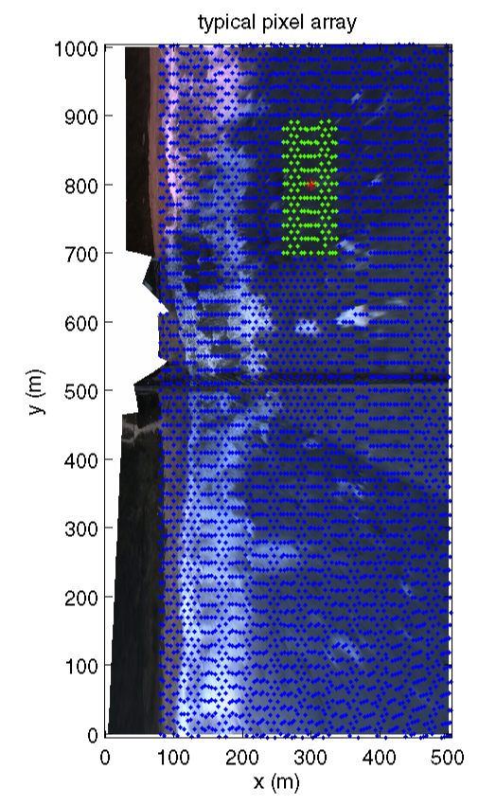

Example pixel array used for cBathy analysis. The 8600 pixels (half shown) span a 420 by 1000 m region with 5 by 10 m resolution. For each analysis point (exam- ple show by red asterisk), depth is estimated based on cross-spectral phase within a nearby region (green pixels). The background image is a rectified snapshot that merges views from the five available cameras.

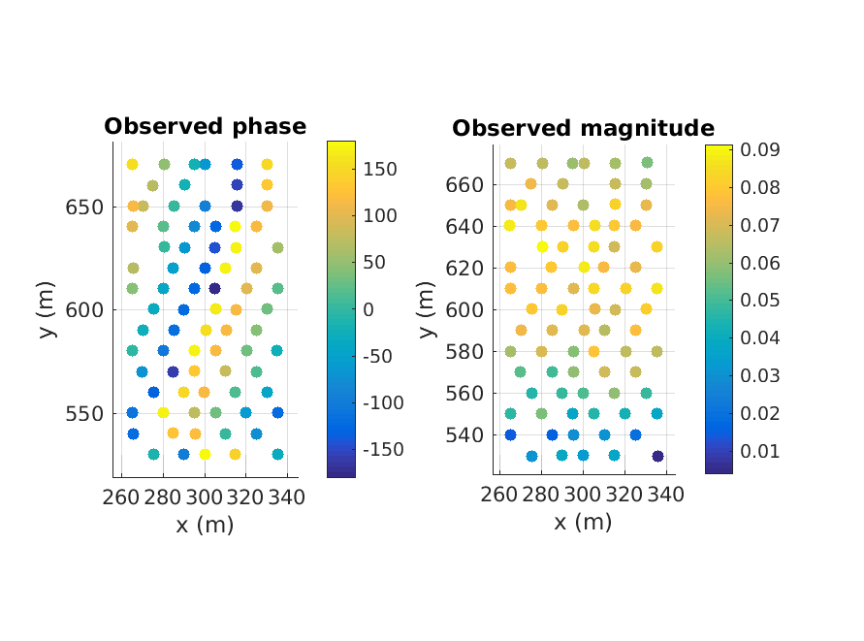

Figure 2. Example observed eigenvector. The left side shows the phase map while the right shows magnitude of each element in the eigenvector (used as a Phase I weight). Phases vary from -180° s slowly up to +180° followed by a phase jump as the waves progress from right to left (shoreward, to smaller x). The distance between bands of similar color indicate the wavelength. Alternately, the phase slope (excluding jumps) corresponds to the wavenumber.

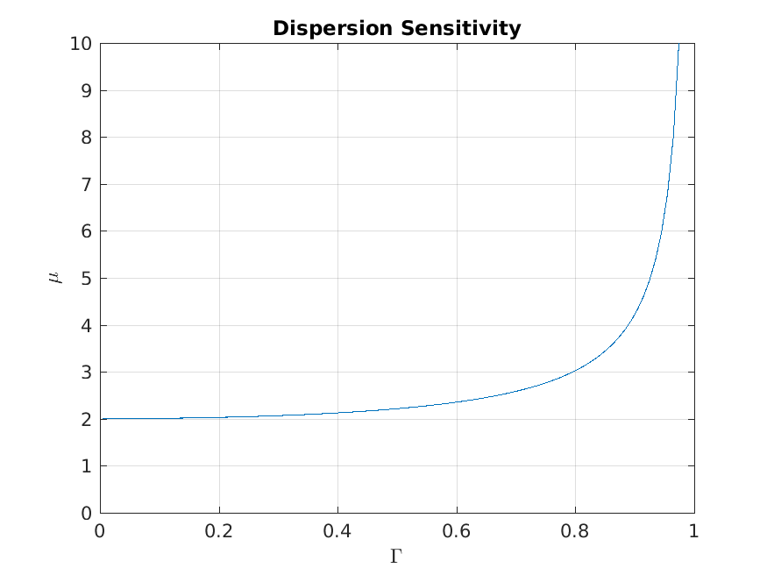

Figure 3. Sensitivity of the dispersion relationship to errors in k. The shallow water limit is a value of 2, meaning that any fractional error in k will yield twice the fractional error in depth. As the deep-water limit is approached this relationship becomes very sensitive.

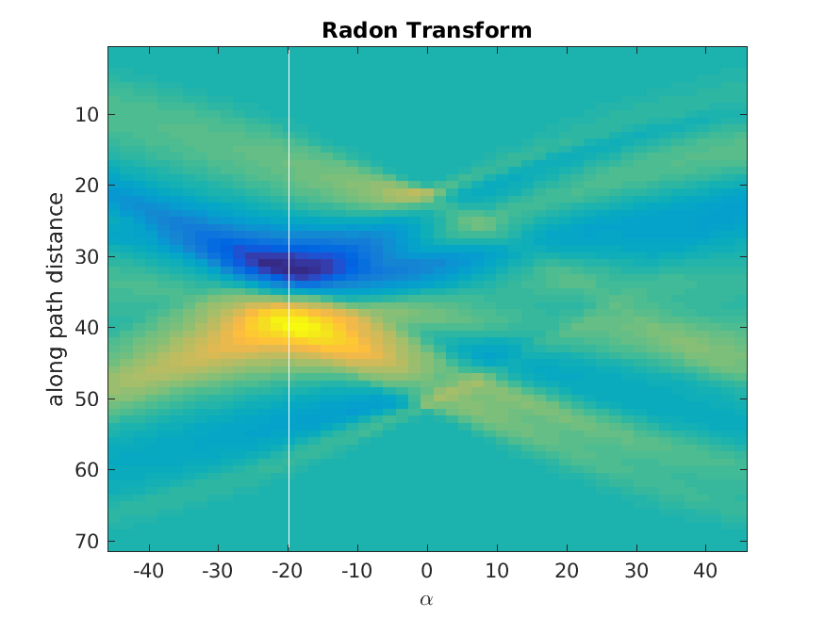

Figure 4. Example Radon transform showing a maximum variance in the down wave direction, in this case -19.8°. The x-axis is the range of investigated wave angles while the y-axis corresponds to image distance in the projected direction.