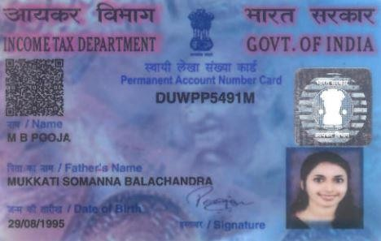

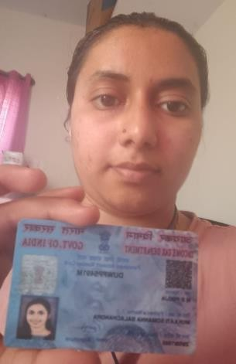

|  |  |  |  |  |  |
| --- | --- | --- | --- | --- | --- |
| **Candidate Name:** | | **M B Pooja** | | **PAN Number** | DUWPP5491M |
| **Candidate’s Preferred Location**  **/ Interview Location** | | **Bangalore/Bangalore** | | **Availability for interview on weekends / weekdays** | **Both** |
| **Talent Acquisition Consultant:** | | **Experis IT** | | **Date of Assessment:** | **16-02-2024** |
| **General Information** | | | | | |
| 1 | Registrar of Companies (ROC) Check done  (Current or Previous organization of the resource, as applicable) | | YES | | |
| 2 | Has the candidate applied for **IBM** before? | | NO | | |
| 3 | Is the resource employee of your organization | | NO | | |
| 4 | If the answer to Section 3 is “YES” Please answer below | | NA | | |
|  | What is the date of joining of the resource in your  organization | | NA | | |
|  | Which client the resource has been deployed through  your organization | | Client 1  Client 2 | | |
| 5 | Interested in relocation? | | No | | |
| 6 | Willingness to work in Shifts – Under 24/7 working  environment (with rotating shifts) | | Yes | | |

|  |  |  |  |
| --- | --- | --- | --- |
| 7 | Location | Current Location | Hometown |
|  |  | Bangalore | Bangalore |
| 8 | Role applied for | Automation Testing | |
| 9 | Total Years of experience | 5.10 Years | |
| 10 | Relevant Years of experience | 5 Years | |
| 11 | Certification if any: | NA | |
| 12 | Reason for changing the Current job / Previous Job | Looking for a better opportunity | |



|  |  |  |  |  |  |  |
| --- | --- | --- | --- | --- | --- | --- |
| 13 | Current Role | Automation Tester | | | | |
| 14 | Notice Period / Negotiable / Compensated payout | Immediate | | | | |
| 15 | Education History: | X (SSLC) | | XII/DIP | BSc |  |
|  | Percentage scored | 84.5 | | 85 | 72.6 |  |
|  | Year of Completion | 2012 | | 2014 | 2020 |  |
|  |  |  | |  |  |  |
| 16 | Have you authenticated resource’s education history  with fake list of universities published by UGC <http://www.ugc.ac.in/page/fake-universities.aspx> | Yes | |  |  |  |
| 17 | Pay-rolling company name | Vaeso India Pvt  Ltd | |  |  |  |
| General Assessment | | | | | | |
| 1 | Assessment of candidate’s general attitude (team player, willing to learn, positive attitude, responsive etc.): (score 1 to 4) | | | 3. Good - Candidate is good team player with Positive attitude. | | |
| 2 | Assessment of the candidate’s oral communication skills: (score 1 to 4) | | | 3. Good - Candidate having good  knowledge in the skill | | |
| SMEDeclaration Details | | | | | | |
| I do not know the candidate. Please certify with YES. **Yes**  I have evaluated the resume with respect to the Job Description shared. **Yes**  I have personally spoken to the candidate, assessed the candidates' skills with respect to the job description & find the candidate is suitable. I have filled in the assessment accordingly. **Yes**  I am available for clarification on any technical aspect of the profile. Below are the details:  **SME Name: Mohammad Karishma**  **SME Email id:** [**karishma.mohammad@in.experis.com**](mailto:karishma.mohammad@in.experis.com) **SME Mobile Number: 9346842073** | | | | | | |
| Others | | | | | | |
| Have you verified last 3 months of salary slip of candidate's current  company | | |  | | | |
| Have you verified current company offer letter / revised offer letter | | |  | | | |



Have you sent test mail to the resources current organization official email ID to check the authenticity ID to check the authenticity

# Identification

* 1. Name: M B Pooja
  2. Title/Position: Automation Tester
  3. PAN Number: DUWPP5491M
  4. Passport No. (blank if unavailable):

# Contact

a. Mobile: 9353837966

b. Email: [poo932005@gmail.com](mailto:poo932005@gmail.com)

c. LinkedIn profile: NA

# Experience and Skill Summary

* 1. Overall years of experience: 5.10 Years
  2. Skill level experience: 3 Years

|  |  |  |  |
| --- | --- | --- | --- |
| **Skill Name** | **Years of Experience (Only Numeric Value)** | **Last Used in Year (Only Numeric Value)** | **\*\*Vendor SME Assessment (Score 1 to 4)** |
| Automation Testing | 6 | 2024 | 3 |

** Vendor SME Assessment (Score 1 to 4)

1 - Below Average - Candidate skill level is not acceptable 2 - Average - Candidate skill level is acceptable

1. - Good - Candidate having good knowledge in the skill
2. - Excellent - Candidate is having in depth & outstanding knowledge in skill from all prospective

# Education

* 1. **Highest Qualification**

# Degree: BSC

* + - **Duration:** 2014-2017

# College/University: Mangalore University

* + - **Year of graduation:** 2017

# Additional information (certifications): NA

1. **Work Experience**

# Current Organization: Vaeso India Pvt Ltd

* + - **End Client: Vaeso India Pvt Ltd**

# Project: Implementation

* + - **Start month & year: June 2021**

# End month & year: August 2023

* + - **Technology/Tools used: Automation Testing, Java Selenium , BDD Cucumber,Cypress**

# Role/Designation: Automation Testing

* + - **Responsibility:**
      * Analysed & created manual test cases and performed execution using JIRA, X-Ray tools
      * Worked on Test artefacts, RTM and bug reports extensively with the team
      * Worked on BitBucket & Git for project upload and maintenance.
      * Automated test cases using Java Selenium with Maven & Gradle tools
      * Worked on Cypress-Cucumber framework for test automation
      * Performed demonstrations and prepared reports of the product
      * Contributed on designs & improvements for the application using various tools like Figma, InVision & Canva

# Current Organization: oppo India Pvt Ltd

* + - **End Client: oppo India Pvt Ltd**

# Project: Implementation

* + - **Start month & year: June 2019**

# End month & year: August 2022

* + - **Technology/Tools used: Automation Testing, Java Selenium , BDD Cucumber,Cypress**

# Role/Designation: Automation Testing

* + - **Responsibility:**
      * Analysed & created manual test cases and performed execution using JIRA, X-Ray tools
      * Worked on Test artefacts, RTM and bug reports extensively with the team
      * Worked on BitBucket & Git for project upload and maintenance.
      * Automated test cases using Java Selenium with Maven & Gradle tools
      * Worked on Cypress-Cucumber framework for test automation
      * Performed demonstrations and prepared reports of the product
      * Contributed on designs & improvements for the application using various tools like Figma, InVision & Canva

# Additional information (optional): NA

# Current Organization: abbo India Pvt Ltd

* + - **End Client: Abbo India Pvt Ltd**

# Project: Implementation

* + - **Start month & year: June 2018**

# End month & year: August 2019

* + - **Technology/Tools used: Automation Testing, Java Selenium , BDD Cucumber,Cypress**

# Role/Designation: Automation Testing

* + - **Responsibility:**
      * Analysed & created manual test cases and performed execution using JIRA, X-Ray tools
      * Worked on Test artefacts, RTM and bug reports extensively with the team
      * Worked on BitBucket & Git for project upload and maintenance.
      * Automated test cases using Java Selenium with Maven & Gradle tools
      * Worked on Cypress-Cucumber framework for test automation
      * Performed demonstrations and prepared reports of the product
      * Contributed on designs & improvements for the application using various tools like Figma, InVision & Canva

1. **Publications (optional)**

Title: NA

Date of publication: NA Publisher: NA Description: NA

# References (optional): NA