Ecological Datasets

Marsh - Potential Migration Impediments

This dataset shows potential marsh impediments within 50 feet of existing marsh. Impediments are defined as hardened shorelines, roads, or slopes greater than 15 degrees.

Datasets:
1. 1974 wetland inventory dataset with 1995 update for Shinnecock Bay area: NY DEC
2. 2006 Suffolk Co. LiDAR dataset: Suffolk County
3. 2008 Transportation dataset: NY DOT
4. 2008 Hardened shoreline dataset: TNC-Long Island via Chris Clapp
- Slope impediments – extracted slopes >= 15 degrees and within 50 ft. of existing marshes from slope map (slope map generated from LiDAR dataset). Converted impeding slopes from raster to vector line datasets.
- Road impediments – extracted roads within 50 ft. of existing marshes
- Hardened shoreline impediments – extracted hardened shorelines within 50 ft. of marshes

Legend:

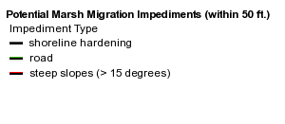

Marsh - Population Protection Potential
The population protection potential calculation is an index of marsh size and proximity to adjacent human communities. This index provides a general estimation of a marsh’s potential ability to protect adjacent human communities. Marshes perform myriad ecological services such as protecting against wave energy and cleaning local water supplies; thus, abating shoreline erosion and potentially acting as a buffer against storm surge.
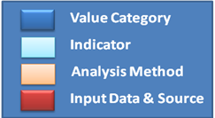
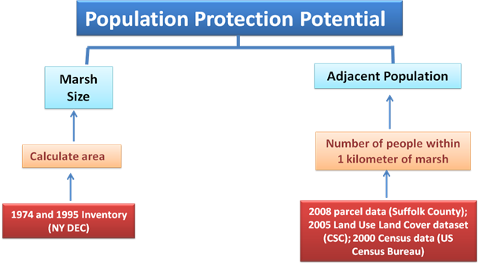
Data:
1. 1974 wetland inventory dataset with 1995 update for Shinnecock Bay area: NY DEC
2. 2009 Population Distribution dataset (TNC)
Methods:
1. Marsh size
  - Calculated marsh area based on NYDEC marsh datasets
  - Classified marsh size into 5 classes using a Jenks Natural Breaks classification technique
2. Adjacent population
  - Used parcel data to dasymetrically map US census block-scale population data using housing density values per parcel and non-developed parcels (and water) as exclusionary ‘mask’ layers. (see Population Distribution description below)
  - Summed number of people per 10m² cell within 1 kilometer of marshes
  - Classified adjacent population into 5 classes using a Natural Breaks (Jenks) classification technique
3. Added classified marsh size and adjacent population layers
4. Scaled summed layer’s data range from 0 to 20 to 1 to 10 for total Population Protection Potential calculation.
5. The 1 to 10 classification is shown in 5 classes within the Coastal Resilience web mapping tool, ranging from “Less” to “More”. These raw values are as follows: 2, 3-4, 5, 6-7, and 8-10.
Legend:
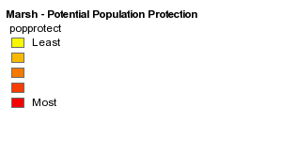
Marsh - Potential Viability
The potential viability calculation is an index of marsh size, marsh elevation, and potential migration impediments. This index provides a general estimation of a marsh’s potential viability based on best available data. To more accurately estimate a marsh’s ability to migrate - and therefore more accurately reflect it’s potential viability - we would need to use more detailed data than is currently available; data such as local marsh accretion rates and fine-scale local land cover data. Marshes….future…


Potential Viability
Marsh size
Elevation
LiDAR
Digital elevation model
1974 and 1995 Inventory
(NY DEC)
Calculate area
Potential migration impediments
LiDAR
Slope impediments
Hardened shoreline data (TNC Long Island)
Road impediments
Transportation data (NY DOT)
Hardened shorelines
Percentage of marsh perimeter potentially impeded
Data:
1. 1974 wetland inventory dataset with 1995 update for Shinnecock Bay area: NY DEC
3. 2006 Suffolk Co. LiDAR dataset: Suffolk County
4. 2009 Potential Migration Impediments dataset (TNC)
Methods:
1. Marsh size
  - Calculated marsh area based on NYDEC marsh datasets
  - Classified marsh size into 5 classes using a Jenks Natural Breaks classification technique
2. Marsh elevation
  - Calculated marsh elevation based on LiDAR elevation data
  - Classified marsh elevation into 5 classes using a Quantile classification technique
3. Potential migration impediments
  - Slope impediments – extracted slopes >= 10 degrees and within 50 ft. of existing marshes from slope map (slope map generated from LiDAR dataset). Converted impeding slopes from raster to vector line datasets.
  - Road impediments – extracted roads within 50 ft. of existing marshes
  - Hardened shoreline impediments – extracted hardened shorelines within 50 ft. of marshes
  - Summed total length of impediments within 50 ft of marshes, returning total linear distance of potential marsh impediments
  - Calculated potential migration impediments indicator by dividing summed adjacent impediments distance by total marsh perimeter (i.e. total impediments/marsh perimeter), returning percentage of marsh perimeter potentially impeded.
  - Classified potential migration impediments percentage into 5 classes using Natural Breaks (Jenks) classification technique.
- Added classified marsh size, marsh elevation, and potential migration impediments layers
- Scaled summed layer’s data range from to 1 to 10 for Potential Viability calculation.
- The 1 to 10 classification is shown in 4 classes within the Coastal Resilience web mapping tool, ranging from “Lower” to “Higher”; These raw values are as follows: 3-7, 7-9, 9-10.5, and 10.5-13.
Legend:
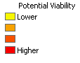

Marsh - Type
This dataset illustrates the various marsh types found within the Long Island South Shore study area. Marshes are classified by type as identified by the NY DEC in the 1974 wetland inventory dataset.

Datasets:
- 1974 wetland inventory dataset with 1995 update for Shinnecock Bay area: NY DEC
- Categorized by attribute “TWCAT” showing the following marsh types:
  - Formerly connected marsh
  - Freshwater marsh
  - High marsh
  - Low marsh
Legend:
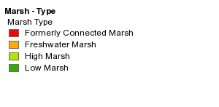
Marsh - Potential Loss

Potential marsh loss is defined as present-day marshes below mean low water for a given SLR calculation. This calculation assumes no vertical accretion or marsh migration and should be interpreted as a general estimation of potential marsh loss if the rate of SLR exceeds the rate of marsh migration/accretion.

Datasets:
1. 1974 wetland inventory dataset with 1995 update for Shinnecock Bay area: NY DEC
2. 2006 Suffolk Co. LiDAR dataset with SLR projections: Suffolk County; Columbia University, Goddard Institute
- Calculated total marsh area below mean low water for each SLR scenario. (% of marsh lost)
Example Legend:
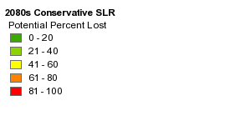

Submerged Rooted Vascular plants – (as taken from the NOAA CSC Benthic Data description)
http://www.csc.noaa.gov/digitalcoast/data/benthiccover/download.html
In June 2002, 200 1:20,000 scale conventional-color metric film diapositives for Long Island,New York were collected as part of an effort to map submerged aquatic vegetation (SAV) in Long Island's South Shore bays.They were provided by New York State Department of State's Division of Coastal Resources. Photographs were taken at low tide and during times that the growth stage of the SAV allowed for clear identification. Care was taken to minimize the effects of turbidity, sun glint, wind, and haze on the photos. The photos were scanned at a resolution of 15 microns. Ground control points were collected primarily from NYSDS 2 ft orthophotos. Additional control points were collected from USGS DOQQs where coverage from the primary source was lacking. All elevations were derived from USGS digital elevation models. A bundle block adjustment was performed using Albany and exterior orientation paramaters were calculated. Boeing/Autometric's Softplotter was used to orthorectify the photos. The images were then dodged and mosaicked using Z/I's Orthopro. No additional color-balancing was performed as the mosaic's intended purpose was the delineation of benthic habitats. The mosaic was then output into 1000m by 1000m tiles with a 0.5m pixel resolution. The naming convention uses the first 3 numbers of the UTM x coordinate followed by the first 4 numbers in the UTM y coordinate of the southwest corner. Stereo digital images were created and the habitat features were interpreted and digitized on screen using softplotter microstation resulting in accurate and efficient 3D extraction of the data. Habitats were delineated with a high level of detail with the minimum mapping unit (MMU) being 0.01 hectares(approx.10m x 10m).The digitized linework have the following specifications: Vertex Distance < 1.0 m Node Snap Distance < 4.0 m Arc Snap Distance < 4.0 m In some cases differences in color and texture between adjacent features tend to be more subtle and boundaries more difficult to detect.In these areas the boundary was delineated using the best possible line between points where the edge can be reliably determined. This line was attributed as confidence level "LOW" in the line coverage.The "low confidence" lines were found mainly in the deep water areas of the data set although they were found occasionally in areas of high turbitidy. In cases where a clear determination of a habitat boundary was made with confidence, that line was given the attribute "HIGH". The items are stored in the attribute table under 'Confidence'. This data was delivered as '2002 Long Island South Shore Estuary Benthic Habitat Line Data Set '. The collected data was converted to an ARCGIS format for quality control and delivery. The data was assessed for horizontal spatial accuracy and thematic agreement during 2003. This is a companion dataset to the polygon coverage '2002 Long Island South Shore Estuary Benthic Habitat Polygon Data Set '.
This data set was created to enable more intelligent change detection in the future. In some cases differences in color and texture between adjacent features tend to be more subtle and boundaries more difficult to detect.In these areas the boundary was delineated using the best possible line between points where the edge can be reliably determined. This line was attributed as confidence level "LOW" in the line coverage.The "low confidence" lines were found mainly in the deep water areas of the data set although they were found occasionally in areas of high turbitidy. In cases where a clear determination of a habitat boundary was made with confidence, that line was given the attribute "HIGH".
PLOVER – (taken from Seavey, Gilmer, McGarigal, & Litwin. In preparation. Climate Change Biology)
Study area
We studied the barrier island system of Suffolk County, which incorporates 93km of barrier islands and peninsulas shoreline along the southern coastline of Long Island, New York, USA (Fig.1). Multiple inlets break this barrier system into four segments (from west to east): Jones Beach Island, Fire Island National Seashore, Westhampton Island, and Southampton Beach. Current dimensions of individual islands with in the system ranges from 6km to 50km and 0.1km to 2.6km, respectively. These dimensions are not stable, as the entire island system is subject to frequent storm events that create ephemeral and dynamic island profiles which are slowly migrating in a northwest direction (McCormick et al. 1984). This barrier island ecosystem is considered a sand limited system and has historically been subject to frequent erosion activity due to its low topography and sandy soils (Schwab et al. 2000).
Response Models
We suspect three possible responses in landform and plover habitat to SLR and increased storminess on barrier islands: static landform/static habitat; static landform/dynamic habitat; and dynamic landform/dynamic habitat. In the static landform/static habitat response, climate changes occur at a rate that outpaces migration of habitat or the islands themselves. Rising sea levels submerge and storms flood islands with no change in the spatial configuration of the habitat or land form. A static habitat response is reasonable if the rate of SLR outpaces the ability of flora and fauna to migrate upslope due to life history of species and/or development intensity is so great it blocks all movement (Bush et al. 2004, Feagin et al. 2005). The validity of a static landform response is raised in a sand-limited system such as our study area where island movement is limited by a lack of substrate (Fallon and Mushsacke 1996, Schwab et al. 2000, Hartig et al. 2002, Zhang et al. 2004). Static landform response is also expected in a system like ours in the areas of high levels of development, where buildings and impervious surfaces hinder land movement (McCormick et al. 1984, Titus 1989, Hartig et al. 2002, Zhang et al. 2004, Feagin et al. 2005, Fish et al. 2005, IPPC 2007, Fish et al. 2008, FitzGerald et al. 2008). This static/static response represents the most liberal habitat loss among the three possible response types and has been used frequently in modeling climate change impacts (Titus and Richman 2001, Gornitz et al. 2002, Bush et al. 2004, Feagin et al. 2005, Weiss and Overpeck 2006, LaFever et al. 2007, Cooper and McKenna 2008, Demirkesen et al. 2008).
The second response model allows for dynamic habitat on a static landform. Under this response, habitat is able to shift upslope and is redistributed based on new values of elevation and other predictors of plover habitat. Of course, the amount of habitat movement can be influenced by development intensity and patterns, but the point of this model is that habitat is allowed to move inland as development allows. This static/dynamic response is supported by documented evidence flora moving inland and upslope with SLR (Clark and Patterson 1985, Moorhead and Brinson 1995, Michener et al. 1997, French 2001, Gilman et al. 2006).
The third response model is dynamic landform/dynamic habitat and is the most realistic as dynamic barrier islands are expected to migration landward and generally shift in both landform and habitat with climate changes (Leatherman 1979, 1985, Zhang et al. 2004). However, we did not use this model in this study as several issues surrounding the response of barrier islands to climate change remain unknown and debated among scientists. In fact, the determination of coastal response to SLR alone has been called one of the largest challenges in coastal sciences (Thieler and Hammar-Klose 2000, FitzGerald et al. 2008). Several other aspects of climate impacts, including temporal scales of change, the importance of wave action, erosion and beach profile formation processes are hotly debated in the coastal science literature (see review in FitzGerald et al. 2008). These debates have lead to a lack of consensus over how to appropriately model landform and habitat dynamics (FitzGerald et al. 2008). One point of agreement in the debate is that SLR and storminess prediction must be tailored to local conditions as much as possible (FitzGerald et al. 2008).
Because we used static landform models which ignore the evidence of landform dynamics which have historically occurred on New York’s barrier islands and are expected to continue or increase in the future, we want to urge caution in interpreting our results (McCormick et al. 1984, Titus and Richman 2001). For example, because we did not incorporate increased erosion into our model which is expected to flatten island profiles, our methods overestimate land elevations and underestimate habitat loss (Titus and Richman 2001, Cooper and McKenna 2008). In addition static elevation models do not account for local variation in how SLR may play out in a particular location due to land cover influence, especially beach erosion structures currently in place or put into place over the next 100 years (Park et al. 1991, Galbraith et al. 2002, LaFever et al. 2007). However, we feel our models represent the best available science and make an important first contribution to the understanding of climate change impacts on endangered species.
Habitat Modeling
Static habitat responses to sea-level rise were modeled based on a plover breeding habitat map created during the 2005 breeding season with global positioning system units (GPS). The delineation of the inland habitat boundary was based on the presence of dense vegetation, steeply eroded banks, or man-made structures. The ocean-side habitat edge, identified by the high water line was considered a one-day, within breeding season benchmark by which to measure relative habitat width in a dynamic system. The final format of this habitat map was a n ESRI raster grid with 5m resolution (ESRI 1999-2006). Four sea-level rise estimates were modeled with this habitat grid as described below.
The 2005 breeding habitat map also served as the response variable in a logistic generalized linear model (GLM) used to predict plover breeding habitat for dynamic habitat responses based on two independent variables: elevation and the least cost distance from the ocean to inland areas.
An elevation grid was derived from a 2006 light detection and ranging (LIDAR) digital elevation model (DEM) with 3.0m horizontal accuracy and 0.3m vertical resolution (USACE 2005). A least cost distance raster grid was created using the Cost Distance function in ArcGIS, which calculated the least accumulative cost distance from ocean cells to all other cells based on an elevation costs (ESRI 1999-2006). The cost grid was created by squaring all values of a grid where DEM values less than and equal to zero were set to one, and one was added to DEM values above zero. The ocean was identified by extracting and masking all DEM values equal to or less than zero on the ocean side of all barrier islands.
The GLM model was built from data sampled from the habitat, elevation and least cost raster grids at 2000 randomly selected points, evenly stratified between habitat and non-habitat across the entire study area. The GLM was run using R open-source software (2005) using the stats, Design, and PresenceAbsence packages. We checked our GLM for overdispersal and validated it with a bootstrapping method. Discrimination performance was measured via a receiving operating characteristic curve (ROC). Model output was transformed into a binary grid using threshold values identified through ROC analysis that maximized the Kappa value. Further support for the GLM was established by comparing the GLM model results to the results of a classification tree model, performed in R using the rpart package. The tree was grown using the gini splitting criteria, equal prior probabilities, 10-fold cross validation, and the appropriate size was obtained using the 1-S.E. rule (Breiman et al. 1984, De'ath and Fabricius 2000). We derived a p-value for the final tree using Monte Carlo resampling, using 1000 permutations of the data and comparing the R² of our tree to a random distribution.
Productivity Data
We recorded all individual plover nest locations and the number of fledged chicks at every nest in the study area during the 2003-2005 breeding seasons. Productivity was reported as count data, e.g., 0-4 chicks fledged. We considered chicks as fledged when they reached 25 days old or were observed flying. We were able to cover the entire study area each year because we obtained nest information directly from the roughly 30 plover stewards hired by land managers and conservation groups to monitor plovers along the entire barrier island system. These stewards are trained annually by state and federal plover biologists to conduct nest monitoring in a systematic and consistent manner (NYDEC 2005). Stewart-based monitoring has occurred in the area since the 1980’s and is estimated to find 95% of plover nests annually (Joe Jannsen, The Nature Conservancy, personal communication). With the aid of these stewards, in the field, we recorded breeding data with a global positioning system unit (GPS) after chicks had left the nest sites.
Sea-level Rise Scenarios
Current estimates of SLR over the next 100 years range between 0.18-1.5m (Daniels et al. 1993, Titus and Richman 2001, Overpeck et al. 2006, IPCC 2007, Rahmstorf 2007, Grinsted et al. 2009). We selected four well supported SLR scenarios, each representing a thirty-year average estimate, centered on 2080. Thirty year averages are standard climate modeling time slices aimed at reducing forecast uncertainty (NPCC 2009). Three of our four SLR scenarios are based on those used by the Intergovernmental Panel on Climate Change (IPCC) and the New York City Panel on Climate Change (NPCC). These scenarios were refined for the New York region by Columbia University Center for Climate Systems Research which is affiliated with The National Aeronautics and Space Administration Goddard Institute for Space Studies. These scenarios included components for thermal expansion of the oceans due to global temperature increases, changes in the ice mass (including Greenland, Antarctica, and glaciers) due to temperature increases, SLR due to local differences in mean ocean density and circulation changes, and local land subsidence (NPCC 2009).The scenarios, referred to here by codes given in the IPCC 2007 report, are B1 (“low”) which projects a rise of 0.38m, A1B (“medium”) which has a rise of 0.47m, and A2 (“high”) which predicts a rise of 0.5m (see IPPC 2007 for scenario details, NPCC 2009). Our fourth SLR scenario was a rise of 1.5m (“higher”) based on several recent studies which have suggested that the IPCC estimates are too conservative because they did not incorporate recently verified high rates of ice sheet loss (Grinsted et al. 2009). We further tailored all four SLR scenarios to our study area DEM by calibrating mean high tide with local data from tidal gauges located at The Battery and Montauk, which are with 40 km east and west of our study area (NPCC 2009). This calibration was carried out by subtracting 0.44m from the original DEM grid before mapping the different SLR scenarios.
The four SLR scenarios were applied to both the static and dynamic habitat response models (Table 1). For the static response, we simply inundated the 2005 habitat grids by filling the DEM values with each SLR scenario. Under the dynamic habitat model, new habitat extents were predicted for each SLR using the GLM and new scenario-specific DEM and least cost grids. For example, for the higher scenario, 1.5m was subtracted from all original DEM cell values, creating a new DEM, and with this a revised least cost distance grid was generated. These grids were run through the original GLM, generating a binary map of plover breeding habitat under the higher SLR scenario.
Storminess Scenarios
Hurricane and nor’easter activity and severity are likely to increase along the Atlantic coasts as a result of climate change (Henson 2008, NPCC 2009). To examine how increased storminess will impact plover habitat and how SLR interacts, we modeled three types of storms over three timeframes under no and high SLR with a dynamic habitat response (Table 2). The timeframes are represented by thirty-year averages centered around 2020, 2050, and 2080 (NPCC 2009). Storm types include 5-year storms, category 2 hurricanes and category 3 hurricanes. We used storm surge datasets developed via the National Hurricane Center’s Sea, Lake, and Overland Surges from Hurricanes (SLOSH) model. These datasets were provided to us by the National Oceanic and Atmospheric Administration (NOAA) Coastal Services Center (CSC) and were developed specifically for Long Island, New York to evaluate storm-surge flooding from these three storm types (Jelesnianski et al. 1992, NWC 2009). SLOSH models determine at-risk areas for storm surge via a series of hundreds of hypothetical hurricanes in each category with various forward speeds, landfall directions, and landfall locations (Jelesnianski et al. 1992). At the end of each model run, an envelope of water is generated, reflecting the maximum surge height obtained by each grid cell (Jelesnianski et al. 1992). We specifically used a model called a Maximum Envelope of Water (MEOW) which represents the maximum surge height in each grid cell for each storm type and general storm track (Jelesnianski et al. 1992).
Our methods for overlaying the SLOSH models on plover habitat were similar to the dynamic SLR, except that theoretically we viewed storm inundation as a flood event, episodic in nature as opposed to SLR inundation which permanently increased sea level. In addition, to examine how SLR may synergize with storms over time, we combined each of the three storm models individually with Columbia University Center for Climate Systems Research’s high SLR estimates in three rise increments: 2020: 0.09m, 2050:0.24m, and 2080:0.47m. Development was also incorporated as described below.
Development Intensity
Since development intensity can inhibit the upslope migration of habitat in the dynamic response to both storms and SLR, we overlaid a development density grid on the GLM predictions for each scenario. Development data incorporated buildings, roads, jetties and groins which were “heads-up” digitized at the 1:4000 scale using 2004 natural color photographs with a 0.5m resolution (NYSGIS 2004, USGS 2004). We assessed accuracy of the development map with a reference set of GPS points recorded in developed areas during the 2004 field season. A comparison of developed areas observed in aerial photos taken in 2005 lead us to conclude that development did not differ significantly in our study area over this 1 year period. A development density surface was created using the kernel procedure found in the Spatial Analysis Kernel Density function in ArcGIS, masked by the footprint of the development itself in Suffolk County (ESRI 1999-2006). Three levels of development intensity were created by evenly dividing the intensity values into three classifications: low, medium and high intensity, excluding non developed areas.
To compare the influence of each level of development on the dynamic habitat SLR models, we incorporated the three development intensities across each SLR scenario (Table 1). GLM model prediction surfaces for each SLR scenario were then modified to prohibit habitat from occurring in development grid cells.
Development intensity levels were incorporated into storm models in a staggered fashion. Among 5 year storms, all levels of development intensity were used to exclude habitat. In category two storms, medium and high intensity development levels were used based on observed loss of low density development seen on Fire Island from 1985’s hurricane Gloria and predicted impacts expected under the Saffir-Simpson Hurricane Impact Scale (Grammatico 2002, NOAA 2009). Finally, category three models only incorporated high intensity development as these catastrophic storms are expected to be unconstrained by low and medium intensity development. High density development areas are expected to exclude habitat under all storm models due to the large amount of impervious surfaces, which restrict habitat regeneration despite the condition of buildings and man-made structures. (NOAA 2009).

RESULTS
Our GLM habitat model used elevation and least cost distance to describe 79% of the variance in plover breeding habitat occurrence and had a significant model likelihood ratio (Likelihood ratio chi-square = 1797.6, p= 0). Generalized Additive Models were used in an exploratory manner to identify the appropriate shape of the explanatory variables, which were parameterized in the GLMs (Austin 2002). Elevation was found to have a Gaussian relationship with habitat and a squared term was added in the GLM equation. Overdispersal was not observed in the 0.48 ratio of residual scaled deviance to residual degrees of freedom, as the ratio is well below 1 (Crawley 2007). The final GLM model had a C index (a measure of ROC) of 0.96, indicating a strong habitat predictive performance (Elith et al. 2006). A confusion matrix of model predictions showed a commission error of 11% and omission error of 6%. Our CT model built on the same sample data resulting in a C index of 0.91 and commission error of 10% and omission error of 8%, based on the least cost distance data alone. We chose the GLM model for data analysis due to the higher C index and slightly lower omission error. We validated our GLM via bootstrapping, which resulted in a high correlation between predicted probabilities and observed responses (Somer’s D_{xy} rank Correlation= 0.95).
Static sea-level rise models showed that plover breeding habitat steadily declines in total area along the progression from none to higher sea level rise prediction scenarios (Fig. 2). The largest sea level rise scenario that we tested (“higher”) resulted in a loss of 44% of habitat. Our examination of the loss in productivity was based on 759 nests identified during the 2003-2005 seasons. Productivity followed the same pattern as habitat with “higher” losing 14% of nests and 17% of the chicks fledged. “Medium” and “high” sea level rise resulted in a 2% lost of nests and 3% of fledglings. Finally, “low” sea level rise flooded 1% of the 2003-2005 nests and 2% of the fledglings.
In contrast to the static response, the dynamic models showed that as sea-level scenarios increased, breeding habitat was gained (Figure 2). Gains were as large as a 12% increase under the “higher” sea-level rise scenario. Unlike the static model, where the percentage of the islands which were classified as habitat decreased steadily as the islands shrank under rising water, in the dynamic response models, habitat became a larger percentage of the declining land area with increasing SLR. Under the “none” model, 26% of the land area was habitat, which increased to 32-35% under “low”, “medium”, and “high”, respectively. The “higher” SLR model resulted in 65% of the total land area classified as habitat, though the total area was less than half of that under no sea level rise.
Roughly 19 percent (7,099 hectares) of Suffolk County barrier islands is developed (Table 4). While the three intensity levels were evenly divided by total development density value, they were not equally represented on the landscape. Medium intensity development made up 10% of the developed area compared to 7% for low and 2% for high intensity. Low intensity development included roads and low density residential housing. Medium intensity development included higher density residential housing and most recreational use areas. There were only two areas of high intensity development: the Ocean Beach community and Smith County Park facilities on Fire Island and …
Stuff we’ll likely be covering in the discussion/results:
-Predicted habitat response to climate change/slr of similar species (birds or other)…are there any other studies we can reference? Do our results relate/not relate to what their results say?

-Land-use policy angle? What do these results tell us with regard to how climate adaptation land-use policy should be geared for endangered species management/protection? How should land-use policy or development respond in order to allow for habitat movement? I’m sure this discussion is definitely a can of worms type discussion….maybe reference other studies discussing how wildlife management plans should incorporate climate adaptation? And you can loop back to our results, while really hammering home the drastic differentiation between plover habitat area with time to respond to SLR, and the lack of habitat area under the no time to respond scenario.

- speaking of land use policy… I’m not sure if it would be of interest to you, but we could do some quick and dirty analyses of the current zoning/land-use composition vs. future habitat as an indicator for how development could influence/prohibit habitat movement. For example, we could look at the % of future habitat occurring in residential vs. commercial vs. protected vs. vacant land to get an idea of how threatened future habitat might be (for example., if most of the future habitat area occurs in residential zones, there’s a good chance that these areas could be developed in 80 years unless local planning folks rezone this to protected, conservation easement, etc.) This would be done using the 2008 parcel database as a proxy for what type of development, if any, might be allowed. Just brainstorming here…..

-Are there areas where we might suspect over prediction or under prediction with the GLM? Places where you know, based on your local expert knowledge, that habitat would likely never move to although the model predicts it to be future habitat with the dynamic method. For example, areas dissected by roads which would potentially prevent habitat movement. Other examples, such as where the current land cover type wouldn’t realistically have enough time to transition to suitable plover habitat (i.e, forest)…. Maps?

-maybe also give the all-too-familiar ‘shout out’ to how much more accurate habitat response to climate change research would be when coupled with dynamic landform estimates, given that species’ habitats and human communities will be competing for the same upslope areas in the face of climate change and adaptation. Maybe also make the classic call for more interdisciplinary research in this area.
FIGURES AND TABLES
Figure 1. Map of study area on Long Island, New York. The regional context of the study area is in the bottom right corner, Long Island is boxed.
Figure 2. Habitat area under both static and dynamic response sea-level rise scenario model.
Figure 3. Habitat area loss and percent reduction from the no sea-level model for each static response sea-level scenario model.
Figure 4. Habitat loss (hectares) resulting from development intensity inclusion in each SLR scenario with a dynamic response. Loss measured from the no development scenario.
Figure 5. Habitat area (hectares) resulting from the three storm scenarios under no and high sea level change.
Figure 6. Comparison potential habitat (hectares) under each storm type over time with high SLR predictions
Table 1. Sea-level rise scenario modeling design showing the three levels of sea-level rise, three levels of development intensity, and both static and dynamic habitat response.
Table 2.Dynamic storminess modeling design showing three types of storms and three time frames under no and high sea-level rise.
Table 3. Amount of land area (hectares) and percent of total land area in each of the three development intensity levels.
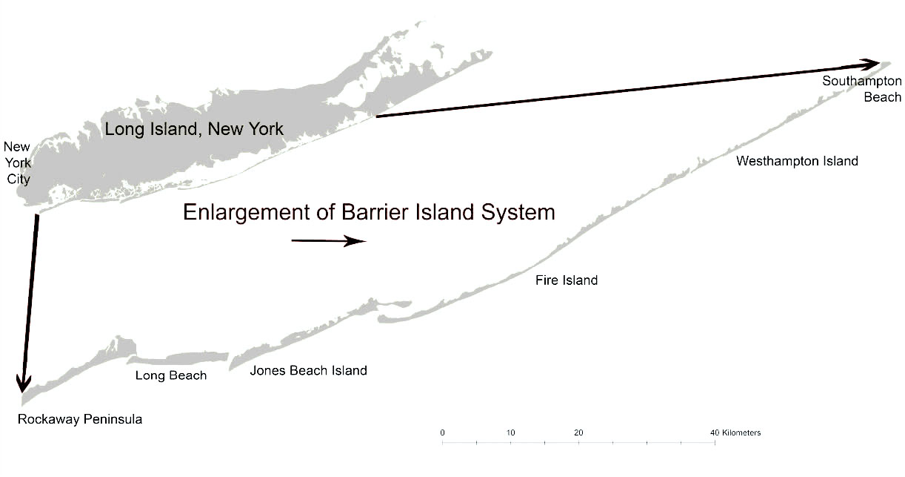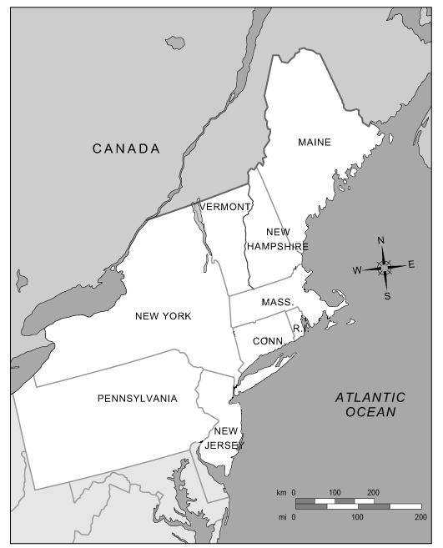
Enlargement of Long Island, New York
0
Suffolk County in circle
20
40 Km
Table 1. Sea-level rise scenario models examined for piping plover habitat change. These models combine three levels of sea-level rise, three levels of development intensity, and both static and dynamic habitat response.

Response Type | Development Intensity  Level | No SLR  (NSLR) | Low SLR  (LSLR:0.38m) | Medium SLR  (MSLR:0.47m) | High SLR  (HSLR: 0.5m) | Higher SLR  (XSLR: 1.5m)
Static Landform/ Dynamic Habitat | None | NSLR | LSLR | MSLR | HSLR | XSLR
Static Landform/ Dynamic Habitat | Low  (LD) | NSLR/LD | LSLR/LD | MSLR/LD | HSLR/LD | XSLR/LD
Static Landform/ Dynamic Habitat | Medium  (MD) | NSLR/MD | LSLR/MD | MSLR/MD | HSLR/MD | XSLR/MD
Static Landform/ Dynamic Habitat | High  (HD) | NSLR/HD | LSLR/MD | MSLR/HD | HSLR/HD | XSLR/HD
Static Landform/  Static Habitat | None | S_NSLR | S_LSLR | S_MSLR | S_HSLR | S_XSLR
Table 2.Dynamic storm models examined for piping plover habitat change. These models combine three storm categories and three time frames under no and high sea-level rise.

 | Storm Category
 | 5 year Storms | Category 2 Hurricane | Category 3 Hurricane
NSLR | 5y_NSLR | C2_NSLR | C3_NSLR
HSLR + 20 Years | 5y_HSLR_20 | C2_HSLR_20 | C3_HSLR_20
HLSR + 50 Years | 5y_HSLR_50 | C2_HSLR_50 | C3_HSLR_50
HSLR + 80 Years | 5y_HSLR_80 | C2_HSLR_80 | C3_HSLR_80
Figure 2. Estimated potential piping plover habitat (hectares) by sea level rise scenarios on the barrier islands of Suffolk Couny under both static and dynamic habitat response models.
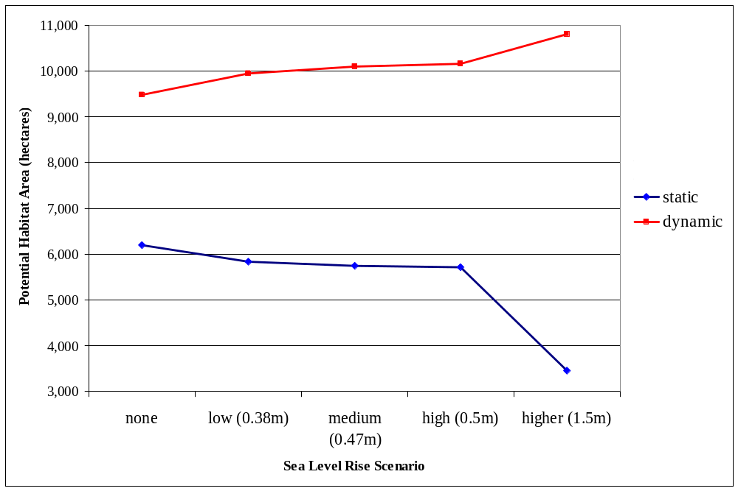
Table 3. Amount of land area (hectares) and percent of total land area in each of the three development intensity levels across the barrier islands of Suffolk County, New York.
 | Amount of land area (ha) in each Development Intensity Levels
Total Land Area | Low | Medium | High
36,600.3 | 2694.5 (7.4%) | 3617.1 (9.9%) | 787.5 (2.2%)

Figure 4. Habitat loss (hectares) resulting from development intensity inclusion in each SLR scenario with a dynamic response. Loss measured from the no development scenario.
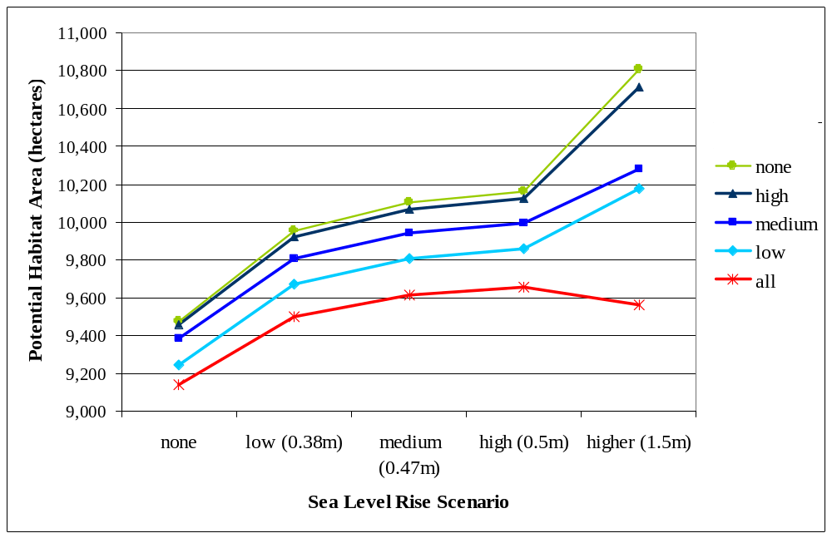
Figure 5. Habitat area (hectares) resulting from the three storm scenarios under no and high sea level change. Time 100 years
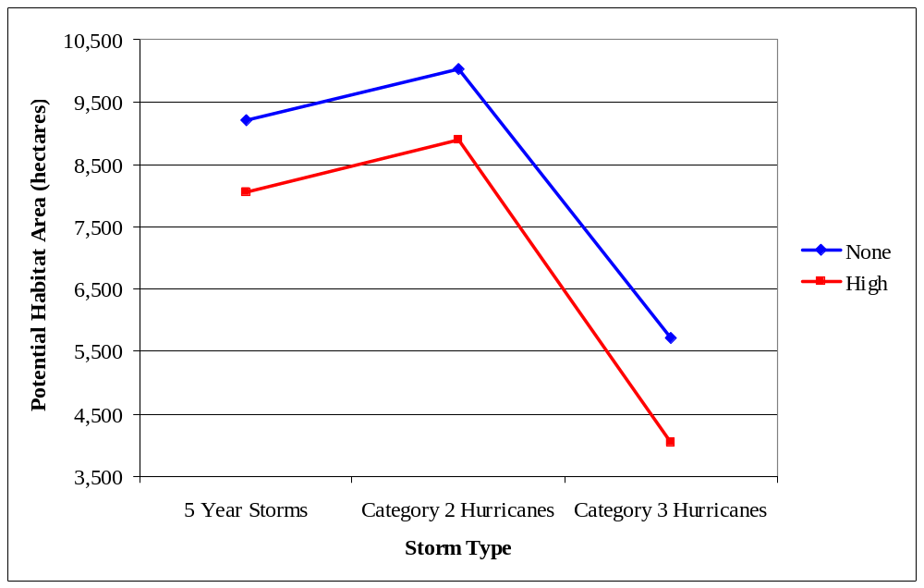
Figure 6. Comparison potential habitat (hectares) under each storm type over time with high SLR predictions
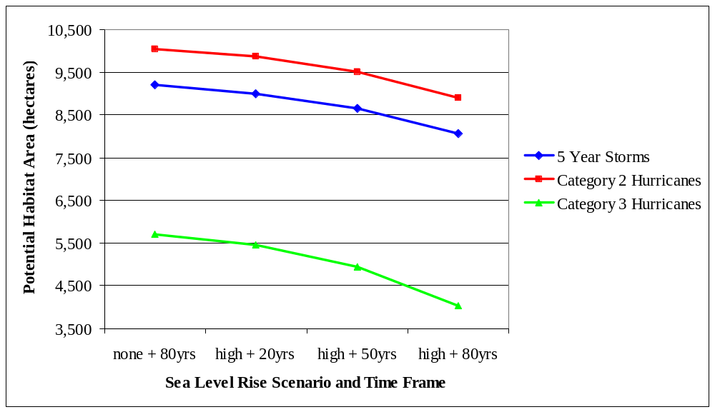

…………………..


BEACH/DUNE
The beach/dune land cover classification was created by Jennifer Seavey of the University of Massachusetts Landscape Ecology Lab. This data was “heads-up” digitized from 2004 high resolution orthoimagery provided by New York State’s Office of Cyber Security & Critical Infrastructure Coordination (http://www.nysgis.state.ny.us/gateway/mg/index.html) and the United States Geological Service’s Seamless Data Distribution System (http://seamless.usgs.gov). These natural color imagines were taken in April, and have a horizontal resolution of 0.3m.



