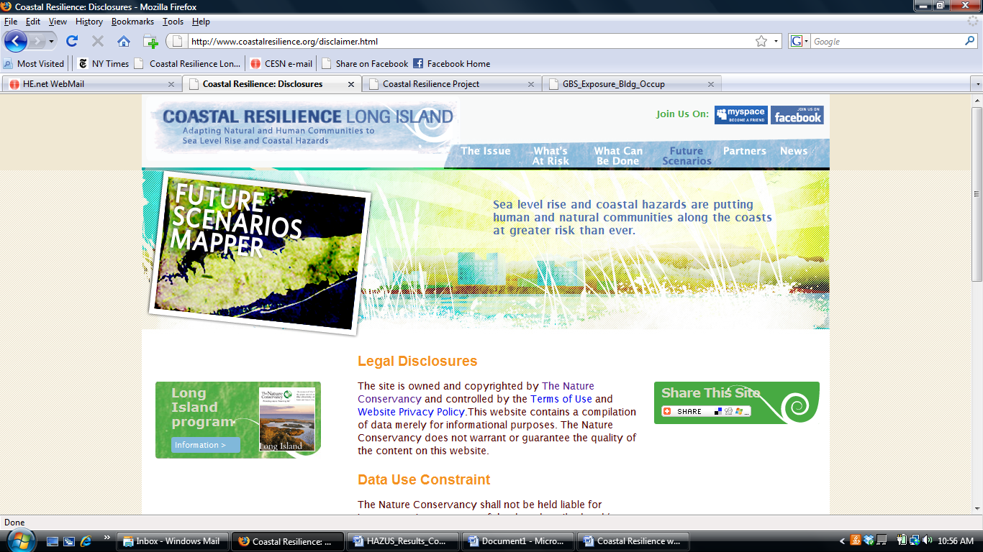

Coastal Resilience Project
The purpose of the Coastal Resilience project is to provide communities with easy access to information to assist in coastal planning, zoning, acquisition, and other management decisions regarding resources at risk from sea level rise and coastal hazards. One of the principal products of the project is a spatially explicit tool that provides forecasts of inundation on the south shore of Long Island under different sea level rise scenarios. The aim of this web mapping tool is to provide communities with easy access to information for their planning, zoning, acquisition and permitting decisions.

Parameter: Estimated Economic Exposure

Data Source: HAZUS

Date: July 15, 2009

Methods:

Six (6) scenarios were run in HAZUS based on TNC requirements for the project.
- 2008 sea level with Nor’easter storm (Category 2, 40-yr recurrence interval)
- 2020 sea level rise with Mean A2 (tide)
- 2020 sea level rise at Mean A2 (tide) with Nor’easter storm (Category 2, 40-yr recurrence interval)
- 2008 sea level with Category 3 Hurricane storm (70-yr recurrence interval)
- 2080s sea level rise with Mean HE A2 (tide)
- 2080s SLR Mean HE A2 (tide) with Category 3 Hurricane storm (70-yr recurrence interval)

HAZUS was used to calculate estimated building damage values for scenarios 1, 3, 4 and 6. Scenarios 2 and 5 do not have estimated damages because in these instances, permanent inundation was not modeled in HAZUS. However, the depth grids for scenarios 2 and 5 were run in HAZUS to determine which census blocks would be affected – these affected areas were used to indicate areas of possible mitigation for summarizing results.

HAZUS can estimate flood losses for building stock (including contents and inventory), infrastructure, and the population exposed to the flood hazard. Consequently, the HAZUS Flood Model uses a comprehensive inventory in estimating losses. This inventory serves as the default when a user does not have better data available. The inventory consists of a proxy for the general building stock in the continental United States. The model also contains national data for essential facilities (e.g., police stations), high potential loss facilities (e.g., dams), selected transportation (e.g., highway bridges) and lifeline systems (e.g., potable water treatment plants), demographics, agriculture products (e.g., corn), and vehicles. This inventory is used to estimate damage (%), and the direct economic losses for some elements (i.e., the general building stock) or the associated impact to functionality for essential facilities.

For more information, go to the complete Coastal Resilience Methods Document or the metadata for this parameter.

