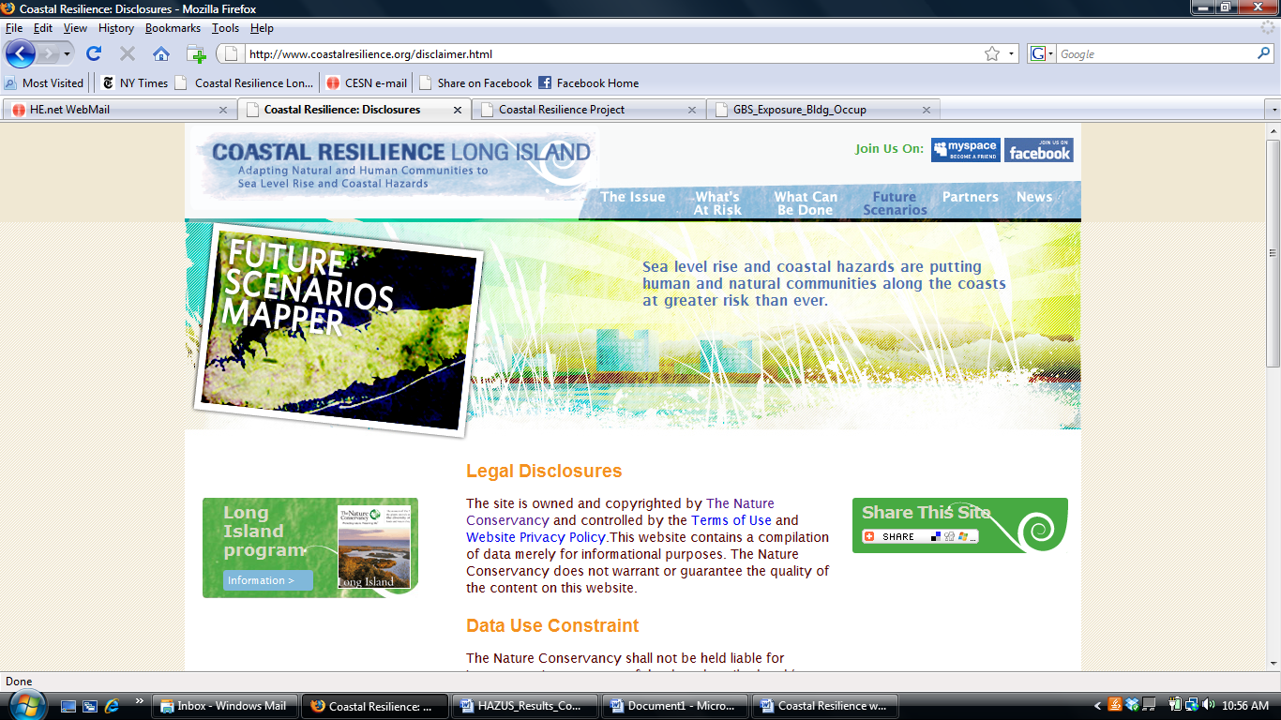

Coastal Resilience Project
The purpose of the Coastal Resilience project is to provide communities with easy access to information to assist in coastal planning, zoning, acquisition, and other management decisions regarding resources at risk from sea level rise and coastal hazards. One of the principal products of the project is a spatially explicit tool that provides forecasts of inundation on the south shore of Long Island under different sea level rise scenarios. The aim of this web mapping tool is to provide communities with easy access to information for their planning, zoning, acquisition and permitting decisions.

Date: July 15, 2009

Parameter: Economic Loss

General Description
Economic loss is the value of estimated building damage (replacement cost) by census block based on different storm and sea level rise conditions. The modeled storm surge and sea level rise flood depths were used as input to FEMA’s HAZUS-MH Flood Model to arrive at estimated building damages. All scenarios assume estimated current (2006 $) replacement cost or building values for all building occupancy types (e.g. residential, commercial, industrial, government, etc.). Values are reported in thousandths. The maximum scale these data are displayed is 1:100k due to issues of data accuracy.

Source: FEMA HAZUS-MH 2008

Caveats and limitations:
The user should always be aware that numbers produced by software models such as HAZUS
are to be used with a certain degree of caution. Uncertainty within the results can be introduced
from a number of sources including the use of national datasets to represent local conditions,
simplifications within the model introduced to allow the model to have flexibility with Level 1
users, and errors introduced as part of the mathematical processing within the software code.
Finally, user input can also have a great affect on the uncertainty associated with the results. At
this time, the flood model does not provide the user with an assessment or “treatment” of
uncertainty. As a planning tool, the consistency and value of the results developed by HAZUS
cannot be understated. When properly used, the results developed by HAZUS can allow a user
to identify and manage the flood hazard especially as it relates to development trends and the
management of fiscal resources.

Methods:

Six (6) scenarios were run in HAZUS based on TNC requirements for the project.
- 2008 sea level with Category 2 Nor’easter storm (40-yr recurrence interval)
- 2020 sea level rise with Mean A2 (tide)
- 2020 sea level rise at Mean A2 (tide) with Nor’easter storm (Category 2, 40-yr recurrence interval)
- 2008 sea level with Category 3 Hurricane storm (70-yr recurrence interval)
- 2080s sea level rise with Mean HE A2 (tide)
- 2080s SLR Mean HE A2 (tide) with Category 3 Hurricane storm (70-yr recurrence interval)

HAZUS was used to calculate estimated building damage values for scenarios 1, 3, 4 and 6. Scenarios 2 and 5 do not have estimated damages because in these instances, permanent inundation was not modeled in HAZUS. However, the depth grids for scenarios 2 and 5 were run in HAZUS to determine which census blocks would be affected – these affected areas were used to indicate areas of possible mitigation for summarizing results.

HAZUS can estimate flood losses for building stock (including contents and inventory), infrastructure, and the population exposed to the flood hazard. Consequently, the HAZUS Flood Model uses a comprehensive inventory in estimating losses. This inventory serves as the default when a user does not have better data available. The inventory consists of a proxy for the general building stock in the continental United States. The model also contains national data for essential facilities (e.g., police stations), high potential loss facilities (e.g., dams), selected transportation (e.g., highway bridges) and lifeline systems (e.g., potable water treatment plants), demographics, agriculture products (e.g., corn), and vehicles. This inventory is used to estimate damage (%), and the direct economic losses for some elements (i.e., the general building stock) or the associated impact to functionality for essential facilities.

Web links: FEMA HAZUS tool

For more information, go to the complete Coastal Resilience Methods Document or the metadata for this parameter.

