Socioeconomic Datasets
Population Distribution
Accurate depictions of human population distributions within coastal zones provide critical baseline information for assessing risk. For reasons of anonymity, the US Census Bureau aggregates household level demographic data to larger enumeration units such as the census tract and block group scales. However, these boundaries rarely reflect the natural distribution of human populations within the aggregated geographic units (Sleeter 2008). Dasymetric mapping techniques can more accurately reflect the distribution of residential populations by introducing ancillary information (i.e. residential land-use data) and redistributing population based on varying densities of residential development within the enumeration unit (i.e, census units). The transfer of population data from the census units to residential land-use classes is performed by areal interpolation (Mennis & Hultgren 2006).
Following Sleeter (2008), we used a dasymetric technique to map residential population data from the census block scale to ‘people per 10m sq.’ via areal interpolation (fig.X). Input datasets included the following:
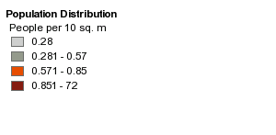
- Suffolk County, NY parcel data (2008)
- NOAA landcover data (2005)
- US Census block data (2000)
Parcel data was reclassified into high, medium, and low density residential development based on the land use type and parcel size. Approximately 7% of Suffolk County’s parcel database did not contain a land use attribute. We used the 2005 landcover dataset (NOAA-CSC 2005) to fill in missing land use attributes within the parcel database. Non-residential parcels were used as an exclusionary class in the dasymetric calculation. For more information on dasymetric mapping, see Sleeter (2008) Sleeter and Gould (2007) and Mennis & Hultgren (2006).
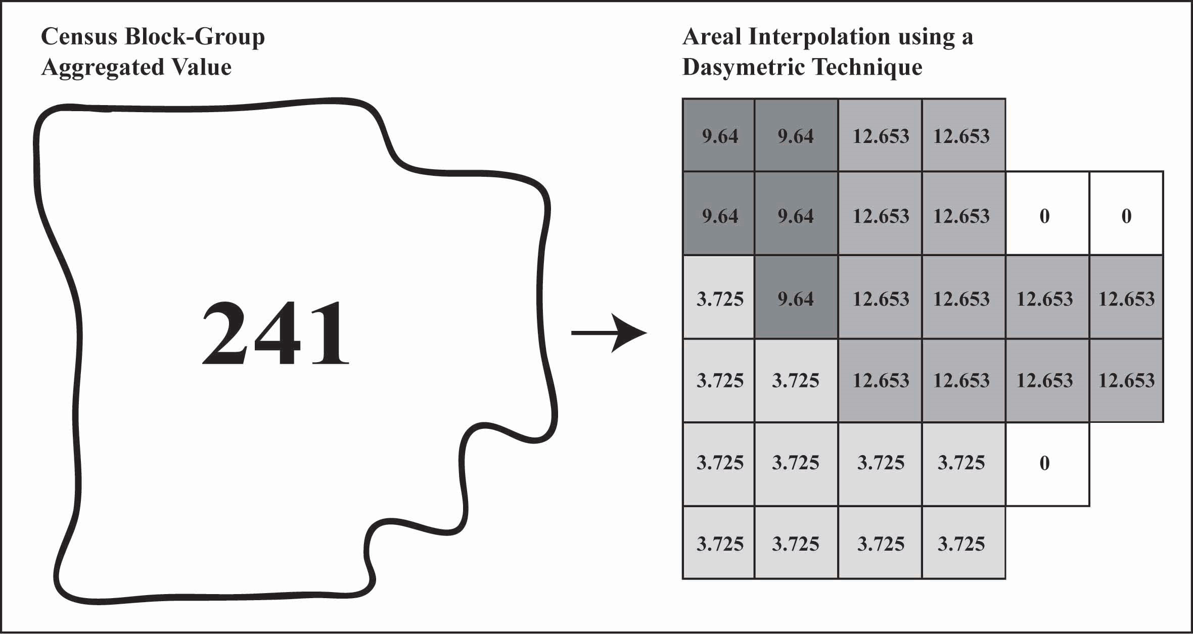 (image taken from Sleeter 2008)
Sleeter, Rachel, 2008, A new method for mapping population distribution: U.S. Geological Survey
Fact Sheet 2008-3010, 2 p. [http://pubs.usgs.gov/fs/2008/3010/].
Mennis, J. and Hultgren, T., 2006. Intelligent dasymetric mapping and its application to areal interpolation.
Cartography and Geographic Information Science, 33(3): 179-194.
Sleeter, Rachel and Gould, Michael. 2007. Geographic Information System Software to Remodel Population Data
Using Dasymetric Mapping Methods. http://pubs.usgs.gov/tm/tm11c2

Vacant Parcels
This dataset (2008) shows all parcels classified as ‘vacant’ by the Suffolk County, NY Real Property Tax Service Agency. These parcels can be residential, commercial, industrial, or municipal. http://www.co.suffolk.ny.us/departments/tax.aspx
- Suffolk County, NY parcel data (2008)

Shoreline Hardening – (taken directly from Chris Clapp, TNC-Long Island)
A shoreline analysis was conducted using ESRI's ArcMap Geographic Information Systems software. Ortho-rectified aerial photos conducted by Suffolk County in the spring of 2004 were used to identify shoreline structures. A new tool, Pictometry, which uses oblique images taken in 2006 as well as direct overhead aerial photos (also from 2006), was used to further validate a structures presence as well as what it's intended function was.
Feature Attribute Field Definitions:
BK- Bulkheads- Bulkheads are structures placed along the shore to protect the property directly behind it from the naturally erosive forces of waves and tides. These structures are generally vertical and can be constructed from wood, concrete or metal.
Boardwalk
Boat Ramp
BW- Breakwaters- Breakwaters are structures that are constructed parallel or nearly parallel to shore to block wave energy that would otherwise impact the shore or a marina basin.
Culvert
DK- Docks- Docks are structures built on pilings or floating in the water that allow access to deeper water from shore. Docks, generally have little impact on water and sediment movement.
GR- Groins- Groins are structures that are place perpendicular to short originating from the uppermost part of the beach and extend out into the water. The purpose of these structures is to trap sediment as it moves along shore. The result is a loss of sediment downdrift of the groin.
JT- Jetties- Jetties are also structures placed perpendicular to shore to stop sediment and water movement. Jetties are only used at the openings of inlets, canals, and tributaries to prevent sediment from filling in these waterways.
NS- Natural Shoreline- Portions of the shoreline that were not hardened were characterized as Natural Shoreline. This was not completed for the entire study area, and it should only be used as such (incomplete).
Piers- Piers were identified in a separate polygon file within this project due to their large size. Piers are structures that are built out into the water. A bulkhead is usually constructed and then fill is placed behind it to create more land. They can be constructed out of bulkheaded material and fill, or wood on top of pilings. Wooden piers are distinct from docks it they significantly impede water and sediment movements.

RR- Rip-Rap- Rip-rap refers to any material laid upon the shoreline to prevent the naturally erosive forces of wind and tide. Rip-rap can consist of piles of broken concrete, torn up asphalt, and quarried boulders. A more organized and effective form of rip-rap known as, gambion, is also included in this feature class. Gambion often consists of rocks and boulders packed into large wire mesh bags. These bags are then laid upon the shore and often bound together to make one larger structure.
Hardened shoreline will be calculated as the total amount of bulkheads, rip-rap and the perimeter of piers. Jetties, groins, breakwaters, and docks will be noted by amount of structures present.

Area | Total Shoreline (m) | Hardened (m) | % Hardened
Brookhaven Mainland | 94,438 | 25,140 | 27%
Brookhaven Barrier Island | 74,192 | 8,535 | 12%
Islip Mainland | 210,909 | 109,419 | 52%
Islip Barrier Island | 13,457 | 4,919 | 37%
Babylon (Inside Fire Inlet Only) | 17,750 | 6,288 | 35%
Fire Island Communities | 15,514 | 10,496 | 68%
Fire Island Public | 77,499 | 4,911 | 6%
All Public | 214,754 | 29,501 | 14%
All Private | 178,242 | 118,512 | 66%
All Shoreline with Study area | 410,746 | 154,301 | 38%

Legend:

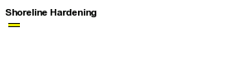

Land-Use Land-Cover - 2005 (taken directly from NOAA-CSC website)
The Coastal Change Analysis Program (C-CAP) is nationally standardized land cover and land change information for the coastal regions of the U.S. C-CAP products feature inventories of coastal intertidal areas, wetlands, and adjacent uplands with the goal of monitoring these habitats by updating the land cover maps every five years. C-CAP products are developed using multiple dates of remotely sensed imagery and consist of raster-based land cover maps for each date of analysis, as well as a file that highlights what changes have occurred between these dates and where the changes were located.
NOAA has completed two time periods (1996 and 2001) for most areas of the country and is currently working to complete a 2005 – 2006 update to these data by 2010.
- Provides the "coastal expression" of the National Land Cover Database (NLCD), and contributes to the Earth Cover layer of the National Spatial Data Infrastructure (NSDI).
- Produced through documented, repeatable procedures using standard data sources and include extensive field sampling, validation, and standard quality-control review procedures.
- Include twenty-nine categories of land cover, giving particular emphasis to more detailed, up-to-date wetland information than is currently available in other national land cover products.
- NOAA works with the U.S. Geological Survey (USGS) and several other federal programs, through the Multi-Resolution Land Characteristics Consortium (MRLC) to produce a consistent, comprehensive national land cover product.
Notes and Limitations: C-CAP data sets are not jurisdictional or intended for use in litigation. While efforts have been made to ensure that these data are accurate and reliable within the limits of current technology, the National Oceanic and Atmospheric Administration (NOAA) cannot assume liability for any damages or misrepresentations caused by inaccuracies in the data, or as a result of the data to be used on a particular system. NOAA makes no warranty, expressed or implied, nor does the fact of distribution constitute such a warranty.
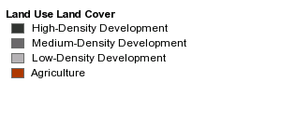
The intended use is in identifying regional landscape patterns and major functional niches (habitat), and for environmental impact assessment, urban planning, and zoning applications. C-CAP data will not indentify individual species. This is a national and regional data set that should be used only as a screening tool for very local or site-specific management decisions. Small features and changes should be verified with a higher-resolution data source.
Legend:

Boundaries and Buffers datasets
CEHA – (taken directly from New York State Department of State, Division of Coastal Resources metadata documentation)
This data set covers the southern shore of Long Island from Queens to Montauk Point. It is made up of lines representing the landward boundary of the coastal erosion hazard area. Everything between this line and the coast is classified as the coastal erosion hazard area.
The lines were digitized from 1988 coastal erosion hazard area maps which are aerial photographs overlaid by the coastal erosion hazard boundary. These maps were provided by the New York State Department of Environmental Conservation. The lines were digitized by using various landmarks on the aerial photographs as reference points. After finding the reference points in the orthoimagery, the lines were transferred to the 1994 digital orthoimagery using the graphics tools in a MapInfo map window. The data set is more accurate in highly populated areas due to the presence of more easily identified landmarks. In areas where there is no development, the accuracy is lower. The scale of the data set is 1:12,000.

Legend:
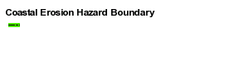
Shoreline – (taken from USGS page here: http://eros.usgs.gov/guides/dlg.html#dlg1)
The Long Island shoreline dataset was extracted from the USGS 1:24,000 DLG files.
The U.S. Geological Survey's (USGS) digital line graph (DLG) files are digital vector representations of cartographic information. Data files of topographic and planimetric map features are derived from either aerial photographs or from cartographic source materials using manual and automated digitizing methods.
The large-scale DLG data primarily are derived from USGS 7.5-minute topographic quadrangle maps at 1:24,000 and 1:25,000 scales (1:25,000 and 1:63,360 scales for Alaska).
Please see http://eros.usgs.gov/guides/dlg.html#dlg1 for more information.

Legend:

Cities, Towns and Villages -
The Cities, Towns, and Villages datasets were created by the New York State Office of Cyber Security & Critical Infrastructure Coordination (CSCIC)
This data was created as part of the Accident Location Information System (ALIS) project. ALIS is a multi-agency project involving the NYS Office of Cyber Security & Critical Infrastructure Coordination (CSCIC), the NYS Department of Motor Vehicles (DMV) and the NYS Department of Transportation (DOT). A major component of the ALIS Project was the creation of up-to-date statewide Geographic Information System (GIS) files.

Legend:


