PRODUCT CATALOG 2026
NEAGLE GOLF
Tour-Grade Golf Simulators, Launch Monitors &
Automated Ball Dispensing Systems
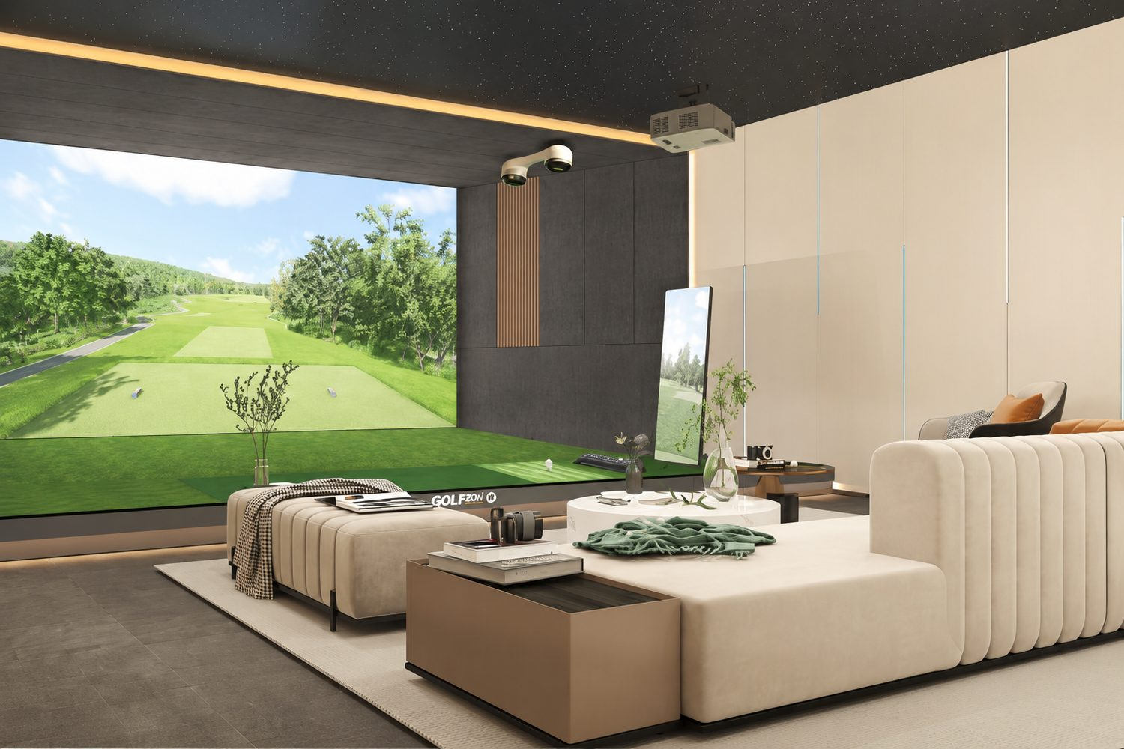
OFFICIAL SIMULATOR — VOLVO CHINA OPEN · BUICK LPGA CHAMPIONSHIP · CHINA PGA TOUR
Exported to the USA, Canada, UK, Australia, Japan and countries worldwide
neaglegolf.com WhatsApp +86 132 6156 3523

ABOUT US
Engineering the Future of
Indoor Golf
NEAGLE GOLF is a global provider of tour-grade golf simulators, launch monitors, and 4K golf simulation systems for indoor golf studios, commercial driving ranges, clubs, and private homes. Our simulation packages combine high-speed camera and radar tracking with photoreal course rendering, delivering shot data accurate enough for professional fitting and training.
Beyond simulation, we engineer automated golf ball dispensers and self-service range hardware that reduce labor costs and unlock new revenue for facility operators. Every system ships with white-glove onboarding, training, and 24/7 concierge support.
GLOBAL REACH
Our systems are in daily operation across North America, Europe, Asia-Pacific and the Middle East — exported to the USA, Canada, UK, Australia, Japan and countries worldwide — with local-language software support and worldwide shipping by sea, express sea or air.
OFFICIAL TOURNAMENT HERITAGE
RUGE RG Eagleye III is the official simulator of the Volvo China Open, the Buick LPGA Championship and the China PGA Tour — the same tour-grade technology is built into every NEAGLE system.
Get a tailored quote | WhatsApp +86 132 6156 3523 | service@neaglegolf.com | 24 h reply
NEAGLE GOLF · Product Catalog 2026 02 · neaglegolf.com

GLOBAL DELIVERY & SUPPORT
Ordered Today. Playing in Weeks.
STEP / METHOD | TIME | DETAILS
Preparation | 7 days | Order confirmed → packing & pre-shipment testing
Air Freight | ~ 7 days | Fastest option for urgent installations
Express Sea | ~ 30 days | Balanced cost & speed for most regions
Sea Freight | ~ 45 days | Most economical for full venue projects

Warranty & Repair  ✓ 1-year warranty on all systems  ✓ Lifetime repair support  ✓ RUGE RG: 2-year core hardware warranty | Installation  ✓ Remote installation included worldwide  ✓ Step-by-step engineer guidance  ✓ On-site installation available by negotiation | After-Sales Service  ✓ 7×24 hour concierge support  ✓ Free software & course upgrades (FAYA: lifetime)  ✓ Multi-language software support

Get a tailored quote | WhatsApp +86 132 6156 3523 | service@neaglegolf.com | 24 h reply
NEAGLE GOLF · Product Catalog 2026 03 · neaglegolf.com

AT A GLANCE
Seven Systems. One Concierge.
MODEL | CATEGORY | PRICE (USD)
GOLFPAI S1 | Premium Simulator | $42,516
RUGE RG Eagleye III | Tournament Simulator | $31,464
GOLFPAI A1 | All-in-One Simulator | $23,325
FAYA Motion | Dual-Sensor Simulator | $9,384
GOLFPAI X1 | Smart Range Simulator | $8,829
Ball Vending Machine | Self-Service · 24/7 | $4,830
Ball Dispenser | Auto Tee Feeding | $342
Prices are reference USD pricing. Contact us for project quotes, volume pricing and distributor terms.
Get a tailored quote | WhatsApp +86 132 6156 3523 | service@neaglegolf.com | 24 h reply
NEAGLE GOLF · Product Catalog 2026 04 · neaglegolf.com

GOLF SIMULATORS
GOLFPAI S1 · Indoor Golf Simulator
Premium indoor golf simulator with 6,000 FPS vision tracking, 4K laser projection and 110+ photorealistic courses.
REFERENCE PRICE*  $42,516 | MINIMUM SPACE  6.0 × 3.8 × 2.8 m

KEY FEATURES  • 6,000 FPS dual-camera stereo vision — 99.9%+ ball & clubhead recognition  • 8 ms ultra-low latency, 37× faster than a human blink  • 4K UHD 6,000 lm laser projection on a 200" impact screen  • 110+ world-famous courses with 4K real-scene modeling  • 3-zone hitting mat (fairway / rough / bunker) with Korean imported turf  • 32GB RAM + 1TB M.2 SSD — built for high-traffic venues | SPECIFICATIONS
  CAPTURE SPEED | 6,000 FPS binocular vision
  BALL RECOGNITION | 99.9%+
  SYSTEM LATENCY | 8 ms
  SHOT SHAPE DETECTION | 12 types
  CLUB COMPATIBILITY | 99% mainstream clubs
  COMPUTER | Intel i5-12400 + RTX 4060Ti
  MEMORY / STORAGE | 32GB DDR4 + 1TB M.2 SSD
  PROJECTION | 4K UHD laser · 6,000 ANSI lm
  CONTRAST RATIO | 3,000,000 : 1
  LIGHT SOURCE LIFE | 20,000+ hrs
  IMPACT SCREEN | 200" dual-layer anti-impact
  GOLF COURSES | 110+ 4K real-scene
  AUTO TEE | Motorized with height memory
  HITTING MAT | 3-zone Korean turf · 16 mm
* Contact us for project quotes, volume pricing and distributor terms.
NEAGLE GOLF · Product Catalog 2026 05 · neaglegolf.com

GOLF SIMULATORS
GOLFPAI A1 · All-in-One Golf Simulator
All-in-one simulator with integrated 24" touchscreen, 4K DLP laser projection and 80+ world-class courses.
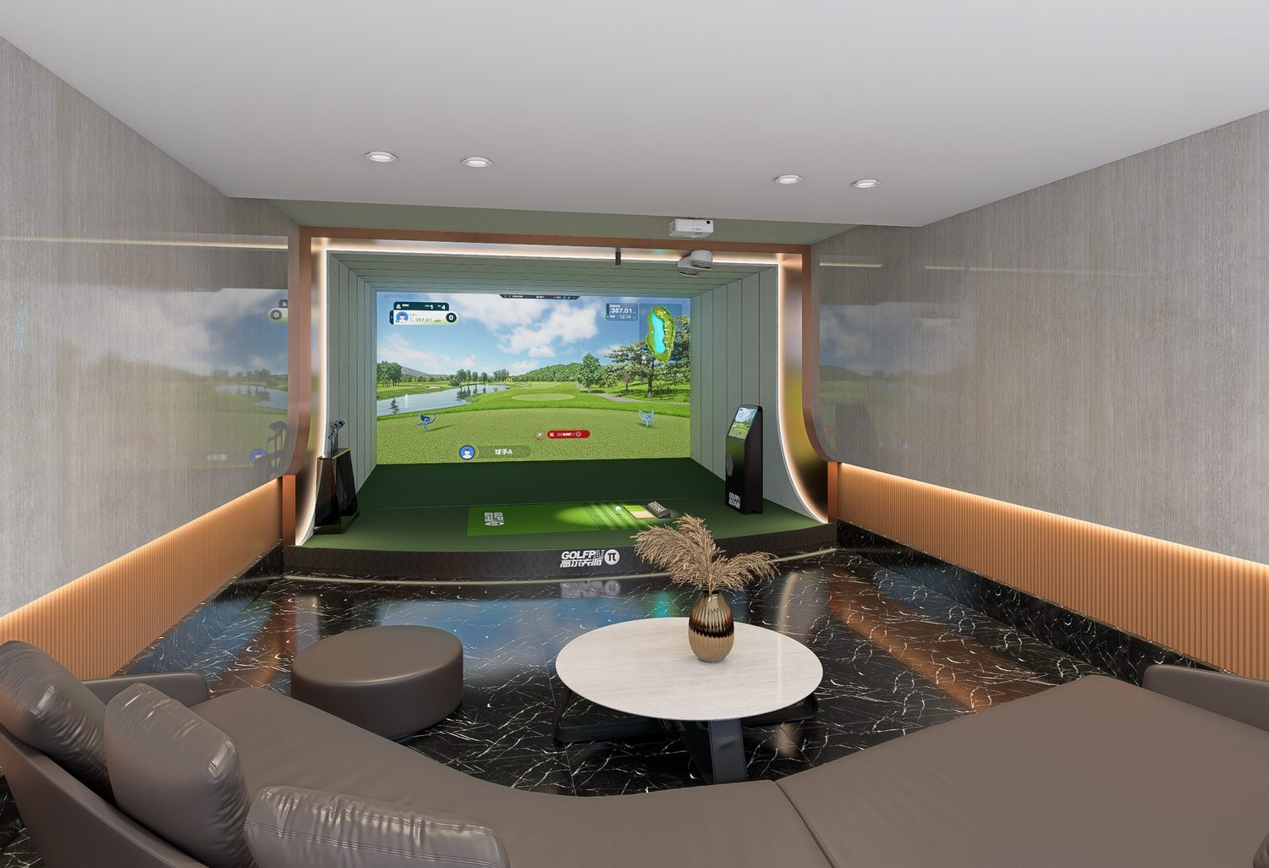
REFERENCE PRICE*  $23,325 | MINIMUM SPACE  5.5 × 3.5 × 2.8 m

KEY FEATURES  • Integrated all-in-one unit with built-in 24" touchscreen  • 6,000 FPS dual-camera vision — 99.9%+ recognition  • 4K DLP laser projection · 0.65" DMD · 30,000+ hr light source  • 80+ courses with AI caddie & kids' cartoon mode  • Cinema, KTV & meeting modes — full entertainment suite  • Compact footprint for homes, apartments & boutique studios | SPECIFICATIONS
  CAPTURE SPEED | 6,000 FPS
  RECOGNITION | 99.9%+
  CPU | Intel i5-12400F · 12-thread
  GPU | NVIDIA RTX 4060Ti 8GB
  RAM | 16GB DDR4 dual-channel
  TOUCHSCREEN | 24" integrated
  PROJECTION | 4K UHD DLP · 3840 × 2160
  BRIGHTNESS | 5,200 lm
  LIGHT SOURCE LIFE | 30,000+ hrs
  IMPACT SCREEN | 200" dual-layer
  GOLF COURSES | 80+ 4K real-scene
  MODES | Golf / Cinema / KTV / Meeting
  AUTO TEE | Motorized
  HITTING MAT | 3-zone Korean turf
* Contact us for project quotes, volume pricing and distributor terms.
NEAGLE GOLF · Product Catalog 2026 06 · neaglegolf.com

GOLF SIMULATORS
GOLFPAI X1 · Smart Range Simulator
World-first radar + vision dual-engine tracking with self-evolving AI ballistics — built for driving ranges.
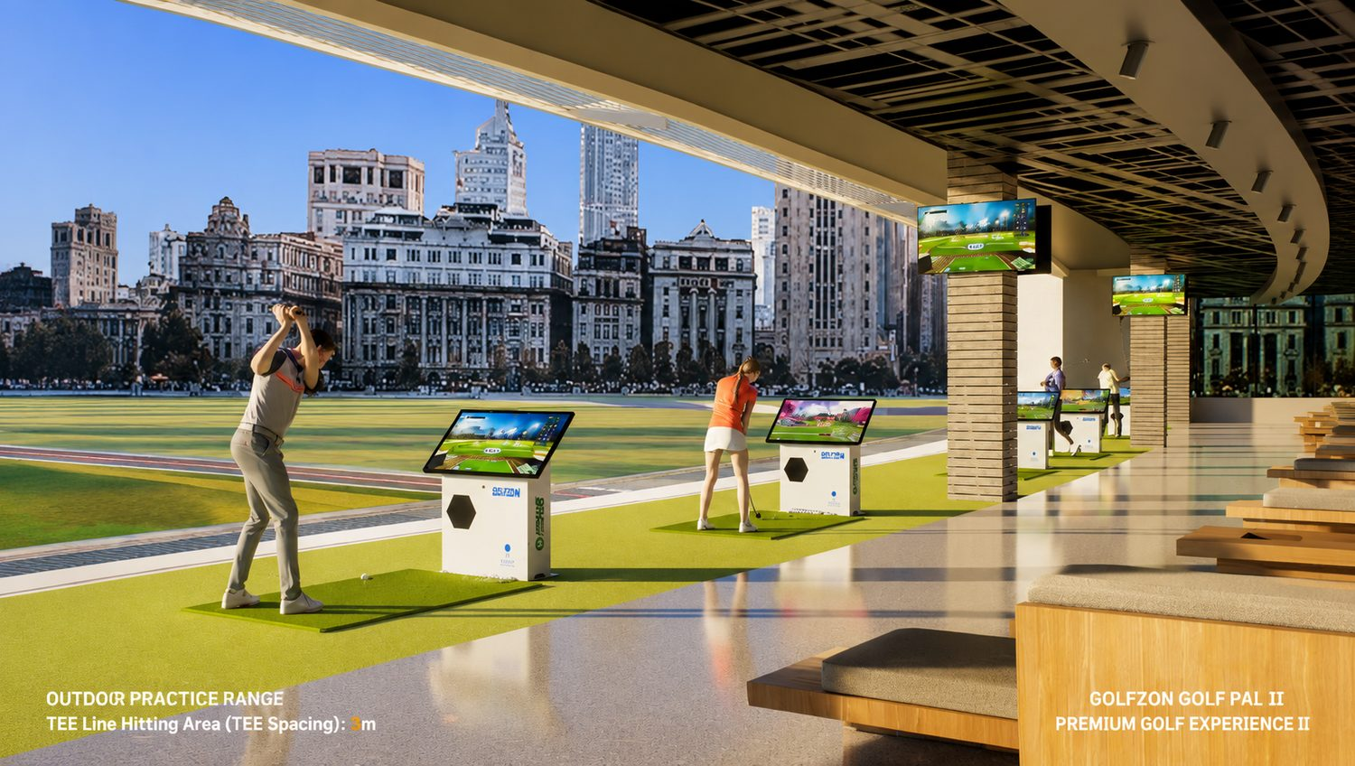
REFERENCE PRICE*  $8,829 | MINIMUM SPACE  5.5 × 3.5 × 2.8 m

KEY FEATURES  • World-first radar + vision dual-engine — up to 99.99% accuracy  • Self-evolving AI learns from every shot  • 43" high-brightness sunlight touchscreen — clear in any light  • 50+ courses · 6-player online multiplayer with video call  • Works with any standard golf ball — no custom balls needed  • Full wind / weather / altitude environment simulation | SPECIFICATIONS
  TECHNOLOGY | Radar + 6,000 FPS vision dual-engine
  ACCURACY | Up to 99.99% (self-evolving AI)
  RADAR | High-frequency Doppler
  VISION | Dual industrial cameras · 6,000 FPS
  RECOGNITION | 99%+
  BALL COMPATIBILITY | Any standard golf ball
  DISPLAY | 43" outdoor sunlight touchscreen
  CPU / GPU | i5-12400F + RTX 4060Ti 8GB
  RAM | 16GB DDR4
  GOLF COURSES | 50+
  MULTIPLAYER | Up to 6 online with video call
  TOURNAMENTS | Regular / Tour / Long Drive
  ENVIRONMENT SIM | Wind / weather / altitude
  SHOT ANALYSIS | Frame-by-frame replay
* Contact us for project quotes, volume pricing and distributor terms.
NEAGLE GOLF · Product Catalog 2026 07 · neaglegolf.com

GOLF SIMULATORS
RUGE RG Eagleye III · Tournament Golf Simulator
Tournament-proven simulator with triple-lens Eagle Eye tracking, UE5-powered 4K visuals and 180+ real-world courses.
OFFICIAL SIMULATOR — VOLVO CHINA OPEN · BUICK LPGA · CHINA PGA TOUR

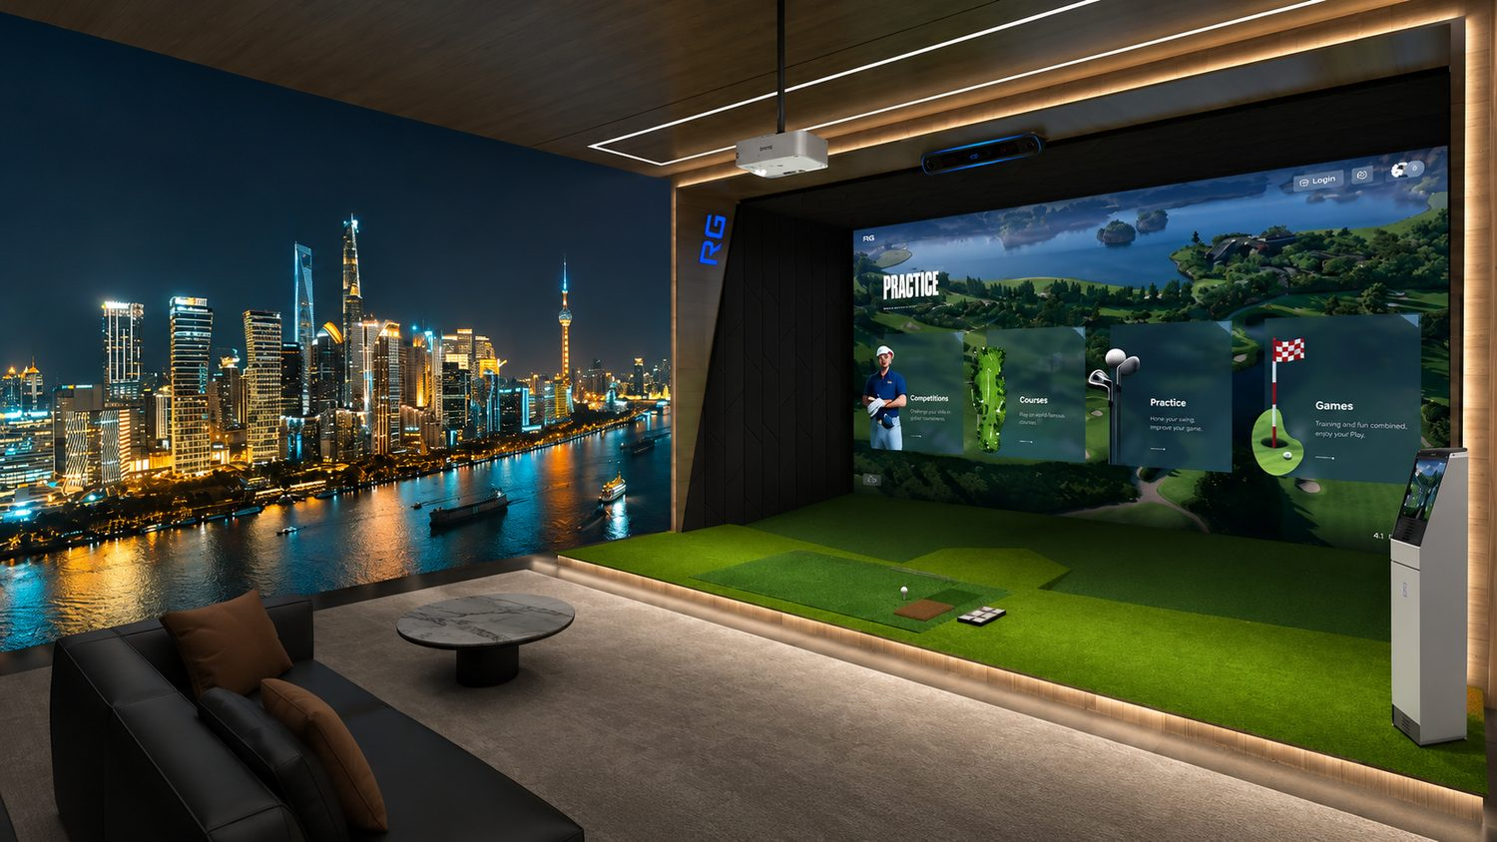
REFERENCE PRICE*  $31,464 | MINIMUM SPACE  Fully customizable

KEY FEATURES  • Official simulator of Volvo China Open, Buick LPGA & China PGA Tour  • Eagle Eye III triple-lens sensor — zero-delay ball flight with full 3D data  • UE5 engine, 2K/4K display, 180+ 1:1 real-scene 3D courses  • AIGOLF swing analysis across 6 practice modules  • Year-round online tournaments — club, team & solo events  • 7×24 hr support, 2-year core hardware warranty | SPECIFICATIONS
  SENSOR TYPE | Triple-Lens Ultra-High-Speed
  DATA OUTPUT | Ball · Club · Player 3D
  BALL FLIGHT LATENCY | Zero Delay
  BALL SPEED | 1.0–200.0 MPH (±0.5)
  CLUB HEAD SPEED | 1.6–160.0 MPH (±0.5)
  CARRY DISTANCE | 2–430 Yards (±2.0)
  LAUNCH ANGLE | 0–72° (±1.0°)
  RENDER ENGINE | Unreal Engine 5 (UE5)
  RESOLUTION | 2K / 4K HD
  COURSE REPRODUCTION | 1:1 Real-Scene 3D Modeling
  COURSE LIBRARY | 180+ Courses
  SWING ANALYSIS | AIGOLF Full-Swing AI
  PRACTICE MODULES | 6 Dedicated Modules
  EVENT FORMATS | Multi-level, Multi-format
  SIGNATURE FORMAT | 4-Ball Team Match
  REMOTE PLAY | Real-time Online 15-Hole 3v3
  CUSTOMER SUPPORT | 7×24 Hours
  WARRANTY | 1-Year + Lifetime Repair
* Contact us for project quotes, volume pricing and distributor terms.
NEAGLE GOLF · Product Catalog 2026 08 · neaglegolf.com

GOLF SIMULATORS
FAYA Motion · Dual-Sensor Golf Simulator
Professional dual-sensor simulator with full-spectrum shot data, 100+ HD courses and one-touch Golf / Cinema / KTV switching.
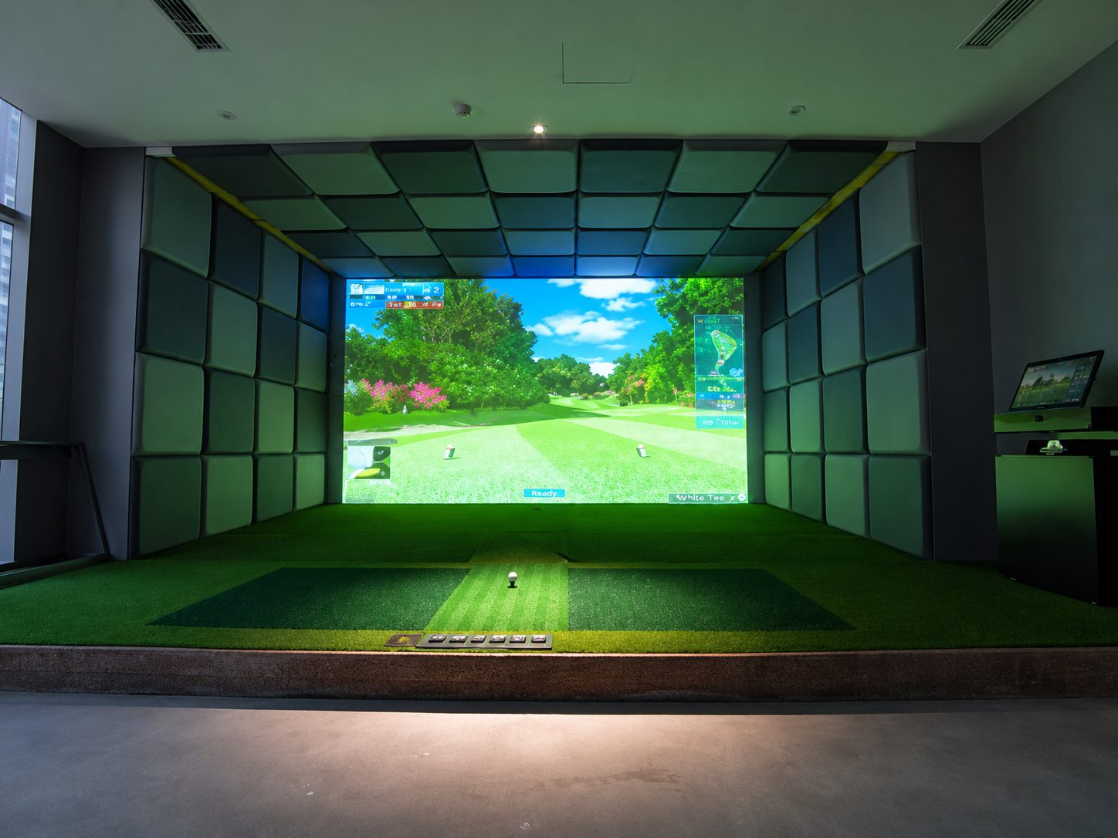
REFERENCE PRICE*  $9,384 | MINIMUM SPACE  Fully customizable

KEY FEATURES  • IDS dual-sensor core — high-speed camera + precision rotation sensor  • Full professional data: ball speed, launch angle, backspin & sidespin  • 100+ real 18-hole international courses · 64GBit 3D engine  • Golf · Cinema · KTV one-touch switching with Dolby Atmos 7.2  • Epson professional projector · Full HD 2K  • Lifetime free course & software upgrades | SPECIFICATIONS
  SENSOR | IDS dual camera + rotation sensor
  DETECTION | Full 360°, no dead zone
  HIGH-LOFT LAUNCH | 60°+
  BALL DATA | Speed / launch / backspin / sidespin
  CLUB DATA | Face angle / landing point
  PROJECTOR | Epson professional · 3,500+ lm
  RESOLUTION | Full HD 2K · 1920 × 1200
  SCREEN | Custom anti-impact acoustic
  GOLF COURSES | 100+ international 18-hole
  AUDIO | Dolby Atmos 7.2 + DTS:X
  PLAYERS | 1–8 simultaneous
  LANGUAGE SUPPORT | Chinese · Japanese · Korean · English
  PRACTICE MODES | Drive / approach / chip / bunker / putt
  UPGRADES | Lifetime free
* Contact us for project quotes, volume pricing and distributor terms.
NEAGLE GOLF · Product Catalog 2026 09 · neaglegolf.com

BALL DISPENSING SYSTEMS
Automatic Golf Ball Dispenser · Hands-Free Tee Feeding
Hands-free automatic ball feeding with dual modes, 100+ ball capacity and wide-voltage compatibility — stay focused on your swing.
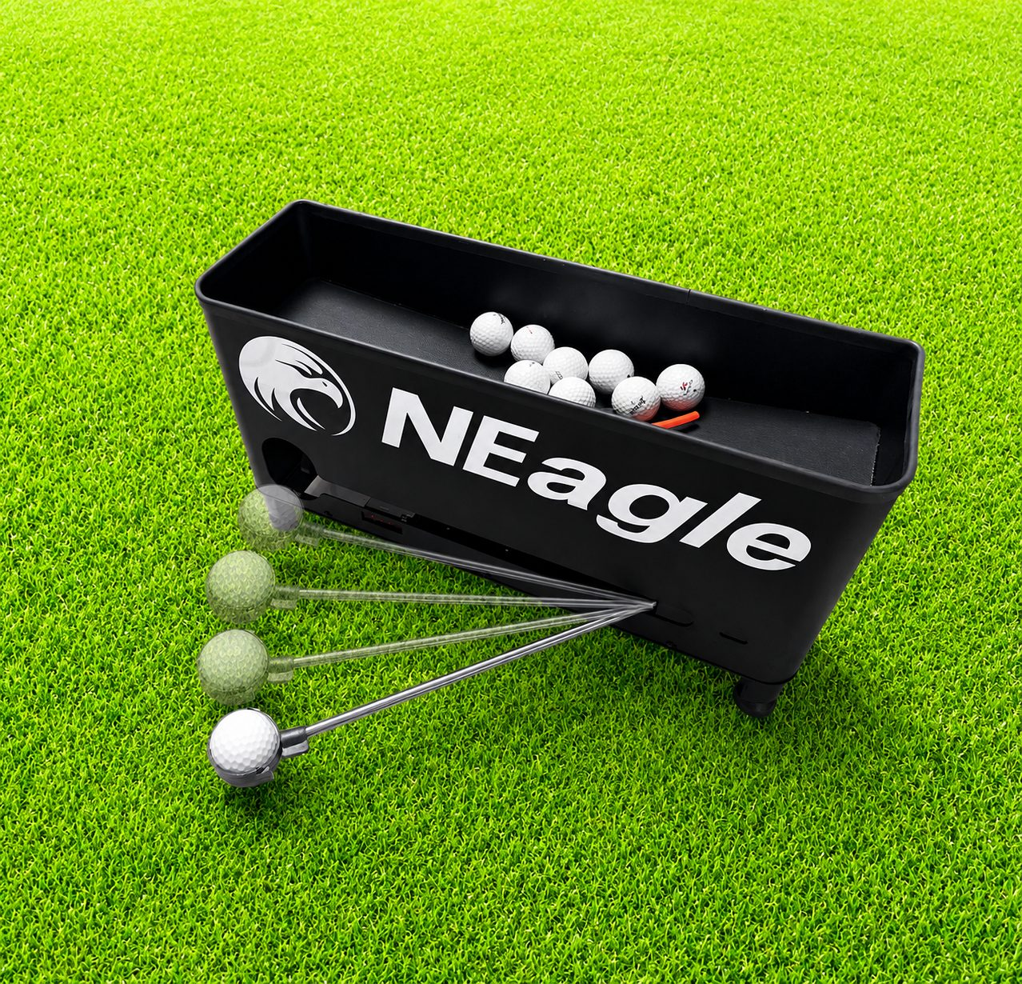
REFERENCE PRICE*  $342 | MINIMUM SPACE  0.6 × 0.2 × 0.3 m

KEY FEATURES  • Fully automatic mode — detects empty tee, feeds instantly  • Semi-auto foot-pedal mode — one press, one ball  • Feeds onto tee or hitting mat — no modification needed  • 100+ ball capacity · 20 balls per minute continuous output  • 110V–220V wide voltage — stable in any environment  • Galvanized steel body with electrostatic powder coating | SPECIFICATIONS
  OUTPUT SPEED | 20 balls / min continuous
  HOPPER CAPACITY | 100+ balls
  AUTO DETECTION | Tee-empty sensor
  MODES | Fully automatic / foot pedal
  BALL PLACEMENT | Tee or hitting mat
  VOLTAGE | 110–220V AC wide
  MATERIAL | Galvanized steel
  FINISH | Electrostatic powder coating
  ENVIRONMENT | Indoor / outdoor
  FOOTPRINT | 0.6 × 0.2 × 0.3 m
* Contact us for project quotes, volume pricing and distributor terms.
NEAGLE GOLF · Product Catalog 2026 10 · neaglegolf.com

BALL DISPENSING SYSTEMS
Automatic Golf Ball Vending Machine · 24/7 Self-Service Range
High-capacity self-service ball vending with triple smart payment and dynamic pricing — cut labor costs, maximize range revenue.
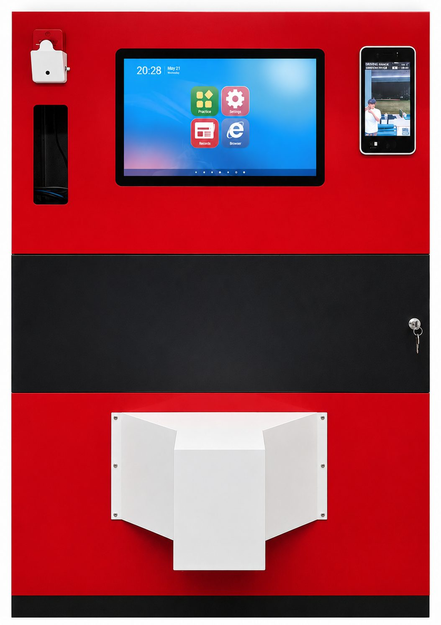
REFERENCE PRICE*  $4,830 | MINIMUM SPACE  1.3 × 1.2 × 1.65 m

KEY FEATURES  • 10,000–20,000 ball capacity · 100 balls per dispense, jam-free  • Three-in-one payment — QR code, membership card, facial recognition  • Dynamic smart pricing — member/guest tiers, peak & off-peak rates  • 24/7 unmanned operation — no attendants required  • Zero human error — every transaction automatically logged  • Instant smart upgrade for any traditional driving range | SPECIFICATIONS
  MAX CAPACITY | 10,000–20,000 balls
  OUTPUT | 100 balls per dispense · jam-free
  PAYMENT | QR / membership card / facial recognition
  PRICING | Member tiers · peak/off-peak dynamic
  OPERATING HOURS | 24 / 7 unmanned
  TRANSACTION LOGGING | All payments recorded
  STAFF REQUIRED | Zero
  USE FREQUENCY | High-frequency, high-intensity
  FOOTPRINT | 1.3 × 1.2 × 1.65 m
  UPGRADE PATH | Traditional → smart self-service
* Contact us for project quotes, volume pricing and distributor terms.
NEAGLE GOLF · Product Catalog 2026 11 · neaglegolf.com

CASE STUDIES
Venues Running on NEAGLE
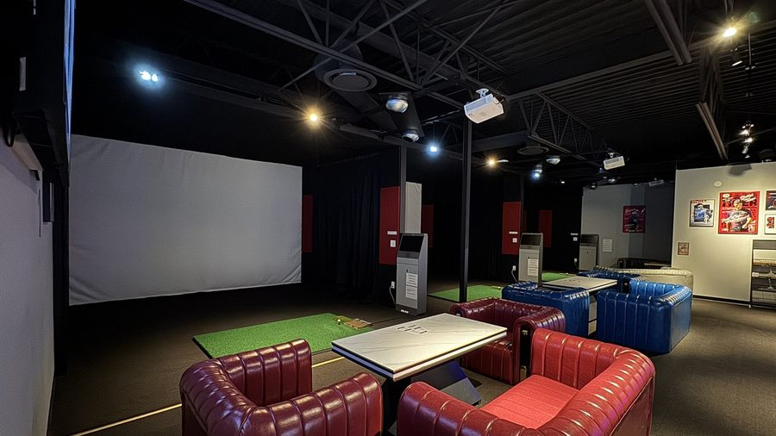  O'Clock Golf Bar — Regina, Canada  Built from a bare concrete shell into a 9-bay golf bar with 2 VIP rooms and a full-service bar. | 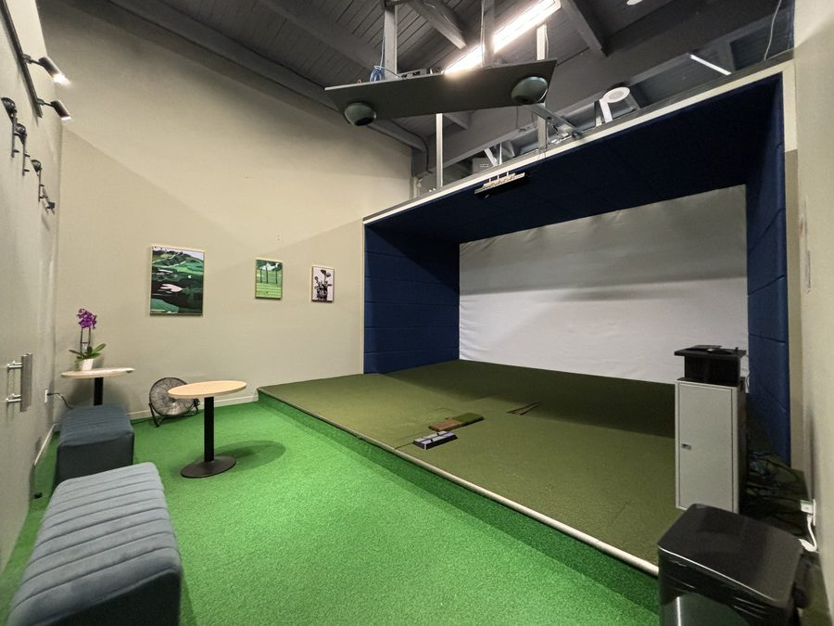  Clubhouse Indoor Golf — Richmond, Vancouver  Indoor golf entertainment center with 6 simulator bays plus 3 private VIP rooms.
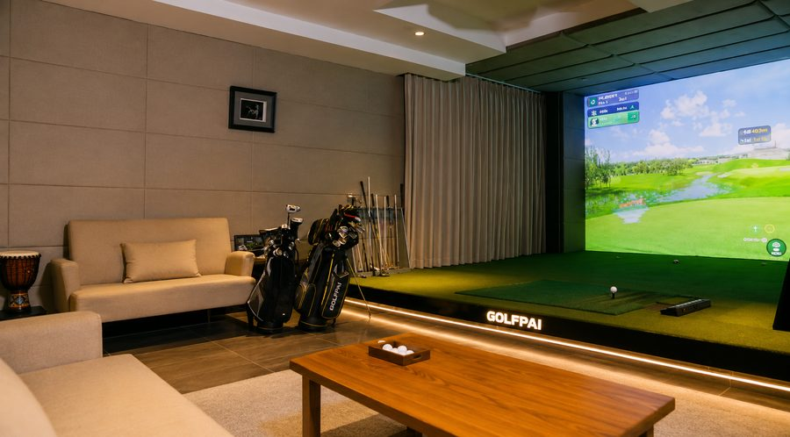  Lincoln 4S Dealerships — China  Simulators installed in two car dealerships to boost customer dwell time and lead conversion. | 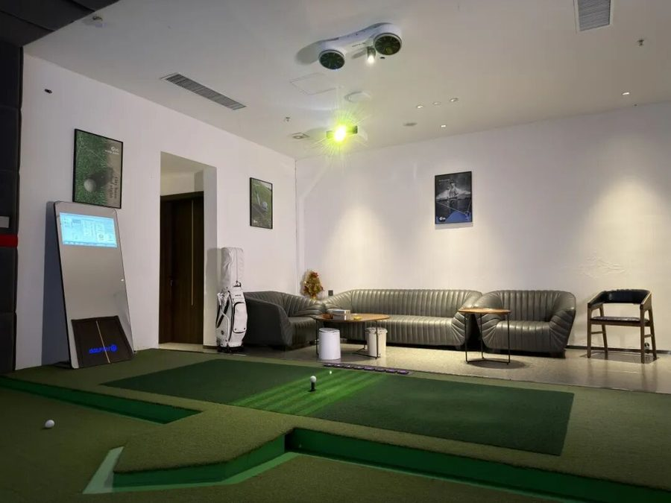  Jitang Club — Shanghai, China  Curved-screen GOLFPAI S1 bays in a bayside club combining golf, dining and events.

MORE REFERENCES
Private villa studio (Toronto) · Japanese omakase restaurant lounge · Chinese courtyard villa · and more at neaglegolf.com/case-studies/
Get a tailored quote | WhatsApp +86 132 6156 3523 | service@neaglegolf.com | 24 h reply
NEAGLE GOLF · Product Catalog 2026 12 · neaglegolf.com

CONTACT US
Let’s Build Your
Golf Venue.
Send us your room dimensions and use case —
we will reply with a tailored proposal within 24 hours.
WHATSAPP | +86 132 6156 3523
WECHAT | 132 6156 3523
EMAIL | service@neaglegolf.com
WEBSITE | neaglegolf.com

SCAN TO CONNECT
  WHATSAPP  Scan to chat now |   WECHAT  Scan to add

NEAGLE GOLFING SYSTEMS
Simulators · Launch Monitors · Ball Dispensers · Vending Systems
NEAGLE GOLF · Product Catalog 2026 neaglegolf.com

