COMP7150 Data Science  
FALL SEMESTER 2016

INSTRUCTOR: Dr. Deepak Venupogal

Sentiment Analysis of Presidential Debate 2016

Diem-Trang Pham

Quang Tran

horizontal line

The 2016 election is the most mobile and most social election in American history. Kicking and screaming, the presidential election has caterwauled online, from the primaries to the general election.The first presidential debate of the campaign is nigh, polls are tightening, and voters are listening. In this project, we investigate the sentiments from candidates based on words, sentences, time responses, and other possible factors. We also introduce an automated tool for a process input in csv format so as to

# Introduction

**Problem Definition and Algorithm**

2.1 Task Definition

Sentiment analysis is extremely useful in social media monitoring as it allows us to gain an overview of the wider public opinion behind certain topics. Sentiment Analysis recently becomes a good method to learn about other people’s insight, since the true sentiment of people is not something we can measure by asking. In the presidential debate, the moderator will open each segment with a question, after which each candidate will have two minutes to respond. Candidates will then have an opportunity to respond to each other. The moderator will use the balance of the time in the segment for a deeper discussion of the topic.

In this project, we analyze sentiment from presidential debate since we want to know how candidate react to the question and other candidate’s response. Input is a raw debate script, which is provided after every debate. Raw input is processed to organize the data by each speaker. Processed input has following features:

* Line: line of text in the raw input.
* Speaker: name of speaker.
* Text: content.
* Date: date of debate.

Outputs of this project are visualization of several different text analysis.

2.2 Algorithms

In this project, we use several algorithms and techniques to do sentiment analysis.

* Natural Language Processing techniques to process text (remove stop words, get word tokenization, word frequencies, vectorize text,...).
* Logistics Regression to predict sentiment in sentences.
* Word cloud: an image composed of words used in a particular text or subject, in which the size of each word indicates its frequency or importance.
* Other comparisons.

# Experimental Evaluation

## Methodology

In order to count characters, words, sentences, we used RegexpTokenizer.

tokenizer = RegexpTokenizer(r'\w+')

clinton_text = '. '.join(clinton_df['Text'])

trump_text = '. '.join(trump_df['Text'])

clinton_words = tokenizer.tokenize(clinton_text)

trump_words = tokenizer.tokenize(trump_text)

clin_sent_lengths =[len(tokenizer.tokenize(sentence)) for sentence in clinton_sentences]

tr_sent_lengths =[len(tokenizer.tokenize(sentence)) for sentence in trump_sentences]

To investigate further to the debate visualization, we like to know candidate is the most given to loquaciousness.

Use this function to remove punctuations and return a list with separated words.

def getWords(text):

return re.compile('\w+').findall(text)

Since time between people in the debate cannot be measured precisely, we used word count as a proxy for time.

df["Length"] = df.Text.map(getWords).map(len)

For Logistic Regression, we use a publicly uploaded data  
(https://dl.dropboxusercontent.com/u/8082731/datasets/UMICH-SI650/training.txt)   
to train the classifier. Predicted results will rely on how much similar the topic of content in training data with the input text.

## Results

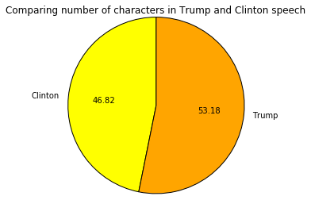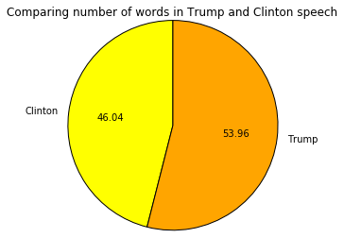

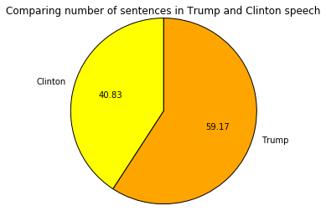

In this debate, regardless of their sentiment Trump likely made longer and more complex sentences.

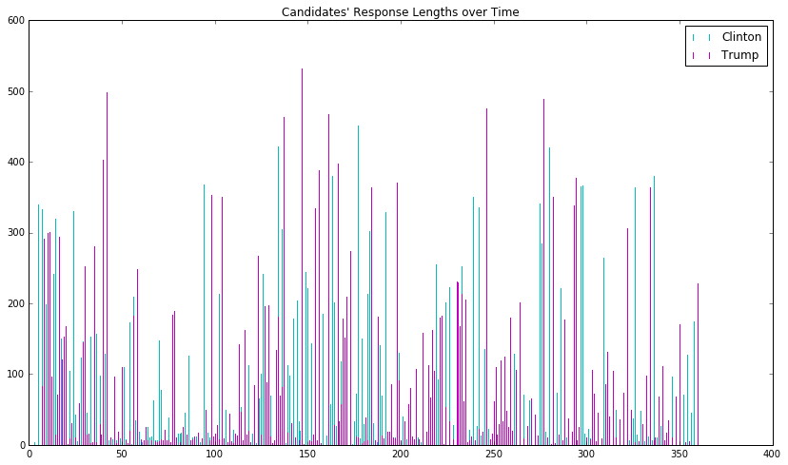

Utterances are likely expressing words that candidates may consider to value them the most in their speech. So in these figures, Clinton values “people”, “think”, and had used the word “well” as a stop-word for most of her speech. On the other hand, Trump wanted to be “going”, as well as focussed on “people”, and country.

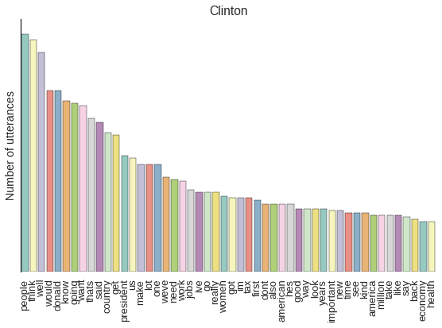

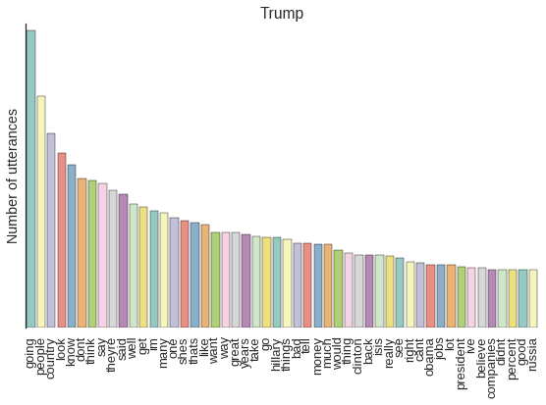

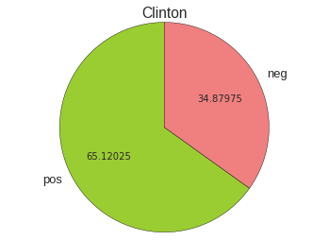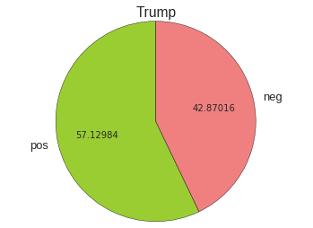

Clinton used more sentiment words, but Trump has more sentiment sentences overall. It could be because of the training data values more words or sentences related in business.

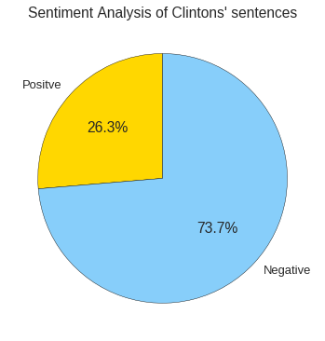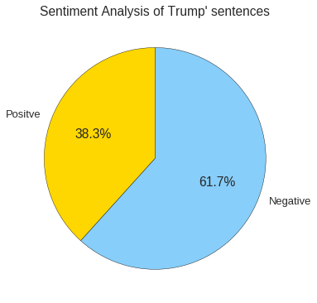

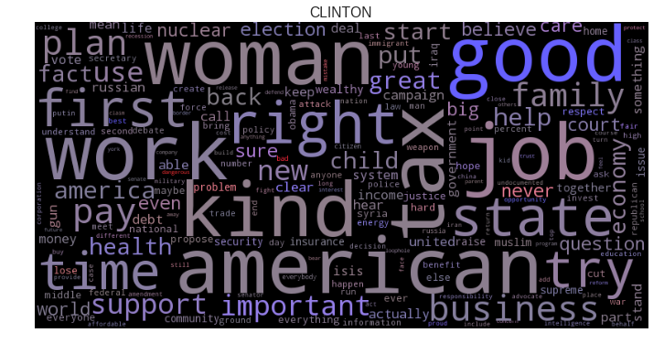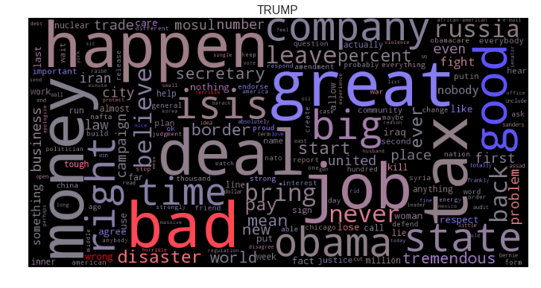

From the word cloud, Trump’s topic is more extreme while Clinton’s topic is more general. Trump’s top 10 most used frequent words are mostly related to business, such as job, tax, money, deal, company. On the other hands, Clinton mentioned variable topics, such as work, woman, American, job, tax, right, state.

# Conclusion

Sentiment analysis is a powerful tool which can be applied in different area, such as analyzing politicians’ thoughts, listening to customers’ feedback in business, or making decisions about products and advertising. You can also influence the conversation when you know which way it is trending, nudging the view to make it positive. However, automated sentiment analysis will never be as accurate as human analysis, because it doesn't account for the subtleties of sarcasm or body language.